
Mock Interview Assessment
(Job advertisement, CV and Cover Letter)
Student Name: Windjaba Balde
Student ID: 2424910
Module Code: LCLM4005
Module: Employability and Career Development
Lecturer: Richard Ashaye

Job Advertisement
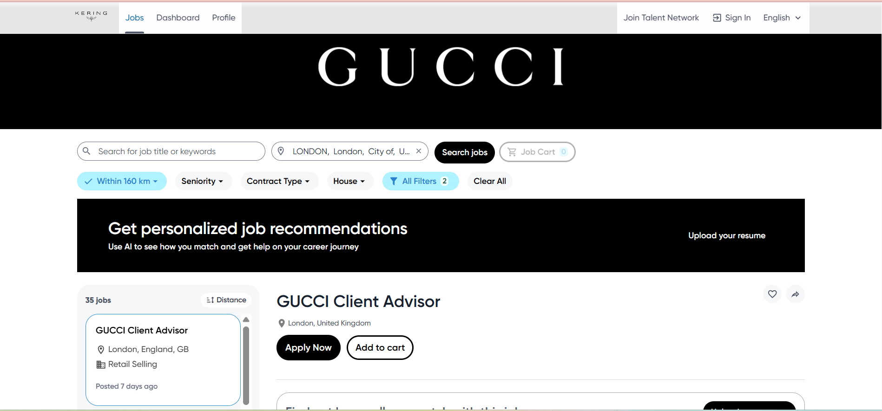

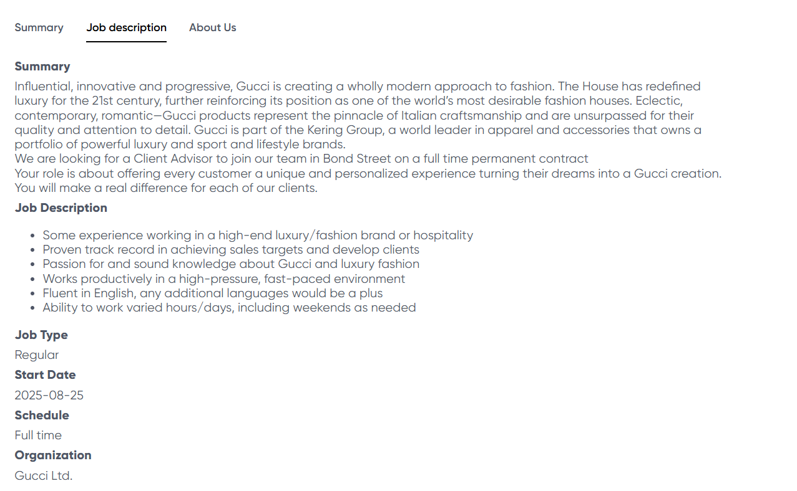

Job Application link: GUCCI JOB APPLICATION
Windjaba Balde
London, UK | Email: windjaba2001@gmail.com | Phone: 07946275119

Professional Summary
Dedicated and customer-focused professional with four years of experience in fast-paced retail environments. Skilled in delivering exceptional client service, maintaining store presentation, and supporting high-volume operations. Fluent in Portuguese and Spanish, recognised by manager for my strong communication abilities and a passion for luxury fashion retail. Currently completing a Certificate in Higher Education Business Skills for the Workplace at the University of Wales Trinity Saint David (London Campus), and now ready to grow within a prestigious brand such as Gucci.

Key Skills
- Luxury Customer Service & Styling
- Team Collaboration & Training Support
- Problem-Solving & Conflict Resolution
- Multilingual – Portuguese & Spanish
- Microsoft Office & POS Systems

- Clienteling & Relationship Building
- Sales, Upselling & Cross-Selling
- Visual Merchandising & Store Presentation
- Stock Management & Inventory Control

Professional Experience
Zara, London
Sales Assistant (DEC 2020 – DEC 2024)
- Delivered personalised shopping experiences, assisting with styling and product selection.
- Consistently supported the store in achieving and exceeding sales targets.
- Handled POS operations, cash transactions, and returns with accuracy.
- Maintained visual merchandising standards and collaborated with management on stock levels.
- Trained and mentored new team members, ensuring smooth integration into store operations.
- Took lead responsibilities during peak periods, supporting management with store coordination.
- Recognised for reliability, professionalism, and strong customer service delivery.
- Built long-term client rapport, encouraging repeat business and brand loyalty.

Professional Development
Full-Time Study — Career Development Break
Jan 2024 – Present
- ﻿﻿Focused on academic development in business, communication, and professional workplace skills.
- ﻿﻿Strengthened organisational, communication, interpersonal, and problem-solving abilities through higher education.
- ﻿﻿Preparing to re-enter the luxury retail industry with enhanced knowledge and renewed motivation.

Languages
- Portuguese (Fluent)
- Spanish (Fluent)
- English (Fluent)

References
Available on request

Cover Letter

Dear Hiring Manager,
I am writing to express my interest in the Client Advisor position at Gucci. With four years of retail experience at Zara and a strong passion for luxury fashion, I am confident in my ability to contribute positively to your team.
During my time at Zara, I consistently delivered attentive and personalised customer service, supported visual merchandising standards, and managed high customer volumes with professionalism. These responsibilities taught me how to work efficiently under pressure, maintain excellent store presentation, and deliver a client experience that aligns with the expectations of a luxury retail environment.
I am fluent in Portuguese and Spanish, which allows me to connect with international clients and contribute to an inclusive, global shopping experience. In addition to my retail background, I am completing a Certificate in Higher Education Business Skills for the Workplace at the University of Wales Trinity Saint David (London Campus). This has strengthened my communication, organisation, and business understanding, preparing me for a professional luxury retail role.
I am highly motivated to grow within Gucci and the wider Kering Group, and I would welcome the opportunity to bring my enthusiasm, professionalism, and client-focused mindset to your team.

Thank you for considering my application.
Yours sincerely,
Windjaba Balde

