Student name: | Fathi Sharif | Student ID number: | 1701105
Programme: | BSc (Hons) Computing Portfolio
Module: | Internet Technology and Security
Module code: | ACCA4018 | Contribution to Overall Module Assessment (%): | 50%
Lecturer: | Dr Carlene Campbell | Internal Verifier: | Dr Kemi Ademoye
Assignment Title: | Synthesize a solution to a potential real life scenario | Word count (or equivalent): | 2500-3000
Submission deadline: | 10th January 2019 | Return date of provisional marks & written feedback:

Abstract

the company uses cloud services to deliver IT services to their staff and clients. 95% of the company’s network is wireless based, so this could impact the company’s network in different ways. Security is the main part of network, especially securing the customers/employees and the company’s data.

over two weeks, I had investigated the security issue within network and there are two different types of attacks that the company could face, and they could come from outside or inside. The company must give the customers/employees as much access but not more than they need.

In this report study has been carried out for the issues on network and what needs to be done to achieve the security goals.

Introduction:

This company uses cloud services to carry out the services to their employees and clients. Using a cloud services, it comes with security risks and I am going to come up a way to prevent the cloud services security threats.

The company allows both its customers, employees to uses their own devices to the access the company’s network/resources. the company is worrying about the security threats that employees and customer could face.

Because the employees, client uses their devises such as laptops, tablets, smartphones to connect to internet to make payment for services and email. To prevent the security threats of devices, I will be writing a security policy, which ensure the employees and customers to use the network a safe way.

This policy covers the use of devices that owned by the employees and customer. If the customers/ employees wish to bring their own devices to access the company’s network, data and information, they will need to follow this policy, because I will include advice and guidance.

Policy

The propose of the policy is to prevent the security threats and integrity of the company, customers and employees. The employees /customers must agree to the terms and condition in this policy to be able to connect their devices to the network.

- The customers/ employees must use security features of their devices, to prevent unauthorized access. Use strong password, it must be at least six/eight characters with upper- and lower-case letters, numbers. Devices need to be locked when not in use.
- must keep the devices software up to date.
- Old devices removed from the company
- The users cannot take a code and email it.
- The users must not use a USB flash drives to carry a code.
- Everything must be encrypted by using encryption software, such as anti-virus protection or the other software’s that is available and when it saved.
- the users must install a tracking device software, because this will enable to locate the device when it should go missing.
- Every 30 days all password must be changed.
- Must use a VPN.
- If your device is lost or stolen, you must report this to the IT desk. In this event it must remote wipe.
- Users must not download, install and use any app that isn’t appear on the company’s list of accepted apps.
- All user must use (Data Security Firewalls) to prevent unauthorised access [1].

Social media security:

Social media is commonly used by hacker’s community, so they can deliver their criminal activity such as:
- Malware virus
- phishing
- stealing your data
- stealing your social media account password

To prevent these security issue, users must not access non-business-related sites.
The company blocked same non-business-related from the network and offensive websites such as pornographic ones which is risk for company’s network.

It is very important that to keep all social media accounts secure and the way that you can prevent by choosing a strong password, change the password very regularly, keep the passwords offline [2].

Creating a strong password:

Here’s how to create a strong password, you need to use common sense when choosing a strong password. Start not to use the basic combinations that are easy to guess, such as (12345678, your name or your pet name). think about something that is simple, but hard to guess like (pa($$)\/\/0rD) and your password needs to be unique, it has to has meaning. All developers must choose unique passwords for all their devices, Email accounts.

Protecting your passwords:

There are few ways of protecting your passwords and protecting your device is important to the company. Employees must not share their passwords with no one else in the company, such as managers, IT desk help, etc. Employees must not use unsecured WIFI network that doesn’t required a password to use, because all your activity can be monitored by a hacker on the some WIFI and that how he/she can get your must valuable information like credit card numbers, emails, personal information, steeling your code and most important your passwords. If you had to use a public network, just use VPN to secure your WIFI channel this will protect you from unauthorized access. [3]

Physical security:
Physical security is the protection of the customer details, employees, the company hardware, software and security Guards 24x7 Surveillance systems will prevent physical actions and events that could cause serious damage to the company.
the physical security prevents these events:

- fire
- flood
- natural disasters
- theft
- terrorism

Security software:
There are softwares that is made to enhance the security of the network and your device. There are different types of security softwares that could protect the data of the users and company.
To make sure employees still feel in control of their own technology, I’m going to recommend different softwares for the users and the softwares will be list below.
- Norton Antivirus
- McAfee Antivirus
- Webroot SecureAnywhere

I recommended this antivirus software called McAFee, it protects your devices in different ways. McAfee protects from the user’s virus and malware.
This type of software updates regularly, and the process usually happens in the background, without the need for user interference with the tasks on the computer.

Through the network users need to use VPN, Virtual private network, is means to encrypt data from one location to another or secure the data of the employees and customers to add a layer of privacy to your identity.
Without going into too much detail, this how VPN works. When you go own your device and access the internet directly through your internet server provider. Sometimes the connection may be fast or slow, but it’s rarely secured, and it’s very easily traced back to you. When you are access the internet through a VPN, imagine that your connection is routed through the internet through secure tunnel to a sever in different city or location. The good thing is that you are not only keeping your data safe, you are also masking your location by making the internet think that you are located where the server is, not your actual location [4].

The network will use firewall both software and hardware device that filters the incoming and outgoing through` the internet connections into private network. The firewall will protect the company internal network from external. The way that firewall protect the network is that it will hide the IP address to the external network, if the hacker doesn’t know the IP address, it is not possible for them to hack the company network [5].

Network physical security:
As the data on the company network becomes more valuable, hackers will try every trick that is in the book. So here are few effective ways that will decrease the chances the company getting hacked by someone with physical access to the facilities, equipment. I will restrict who can access the security offices, and the server rooms be always locked with a key card that only the people that have access can access and send records of the date and time of when they access the room to the security guards.

The company will be using CCTV cameras which allowing us to be easily let us know who enters and exit and captures a video.

All the customers and employees will have 2 hours of training, so we can show them how to spot phishing scams and what to do when they think they have spot one.
On the training days we will provide them with example, so they can understand what they are facing.

To pervert theft event, all the company devices and users’ devices will have GPS tracking. I also stated this on the policy all the users should be using GPS. All the smartphones offer this type of feature which helps you pinpoint your device lection within 100 meters

Wireless and mobile attacks:

Wireless is the one of the entry-point for hacker to get in to a network, so if 95% of the company’s network is wireless based, this will have negative impact on the company.

We all know that wired network is a lot easier to secure then wireless networks, but somewhere in the company network we must have wireless Wi-Fi, so we can allow employees and even clients of the company to access their devices using wireless Wi-Fi.

the question is how I’m going to secure the Wireless network and after using all PowerPoint presentation, I finally I come up different ways that can secure the wireless Wi-Fi and I’m going to go through them one by one.

Encrypt the Wi-Fi:
I will be encrypting the guest wireless Wi-Fi by setting the security mode to WPA2, and I know that this can be hacked, but it is going to be time consuming and difficult. Now WPA3 has just come out and somewhere in the future is an upgrade the should be useful for the company network. I’m going make sure that I disable the WPS.

Decreases the attacks:
To prevent all the attacks to the network, I’m going to make sure that the Wi-Fi router is only turned on during business hours. If the company’s routers are left on for 24/7 it increases the risk of an attack.

Securing the wireless WiFi:
I will be making sure that login name and password are secure. By setting a strong name and password which has meaning but has upper- and lower-case letters, at least couple numbers and special characters.

‘’’But in this project, I will make the passwords nice and easy, so I can remember them.’’’

Web filter:
To protect the customer and employees, we will be using through the network web filter program. Which protects the company and customer from exposed to non-business-related content by others such as porn sites, gambling, hate sites, malware, ransomware etc. web filter also delivers secure environment for the wireless Wi-Fi users and it also allows me to control the content that I want for the user to see [6].

Network redundancy:
It is very important for me to maintain the company network resource availability, one of the main security principles is availability and if the network goes offline then the company is not maintaining that idea of availability for the client and employees. Outside or inside threat could shut down the whole company network. Router or switch failure can affect the availability of the network. I’m going attempt to avoid a single point of failure by putting a place some redundancy to ensure that if a component fails the company will not lose the whole network.

I’m going to use redundant servers with failover to provide sever fault tolerance if one of the main servers is down there is mirror server that holds some data as the first sever, they always have a copy of same data.

In the company severs, I will be using redundant components like power supplies so if one power supple goes down the second power supply will power the severs until an administrator is able to replace the bad power supple.

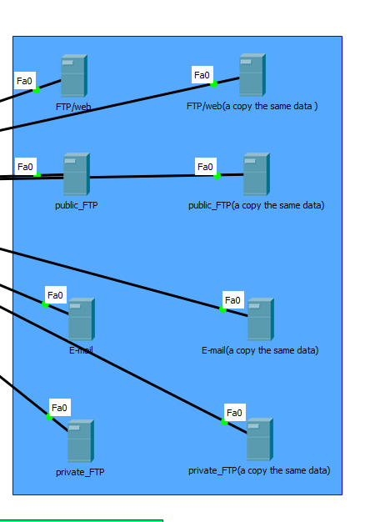
I also need to make sure that the company’s network has some redundancy built into the network connections, I can spend a lot of time setting up high availability servers. But if the company’s network connections go offline then the company network still have that single point of failure that places all the users out of service.

By preventing this disaster, I will set up redundant switches for the local area network, this way the network will have a redundant primary network path that increase the network availability and performance. Through the network there is always one path that remains available.

For the availability of the network, this company will be using cloud services to deliver services to employees and staff. this will be allowing the software developers to do their job without being in the country. For example, if employee developed a software for customer what we don’t want to do is emailing that software. So, the customer must access their secure account to see the software anywhere is Internet access.

Ruckus cloud WIFI:
Ruckus cloud Wi-Fi is a set up management. Cloud based network, this means that the IT security monitor and troubleshoot the whole company network through a website.
When the wireless Wi-Fi user connects to the wireless WLAN for the first time. The ruckus displays two options:
- Guest access
- Register device
One of the main reasons that I selected ruckus cloud Wi-Fi it allows the company to easily set up, monitor and control many WLAN, without sacrificing Wi-Fi performance [7].
So, for mobile devices it will look like something like this.

Logo
Guest access
Register device

For example, if the user chooses the guest Access button, the screen display will look like this.
Logo
Guest password:
Welcome to the guest WiFi
Log in

Mobile Device Management Software for your BYOT:
I have selected a mobile device management software for the BYOT and the mobile device management software is known as Cisco Meraki.

This software is a powerful mobile device management with strong sense checking ability, this mobile device manger is a cloud-based enterprise mobility management software that allows many solutions such as mobile device management, mobile app management, mobile contact management and a lot more solutions.

This software can manage and control all OS including Android 4 and Chrome OS, IOS, Mac, Windows and other OS phones [8].

Key benefits of this software and the reason chosen:

- One of the reasons that I have chosen this software it is let you control apps, users and devices which is a good impact for the company network.

- It is built in multi-site management and it also alerts you.

- This software is also up to date with new features.

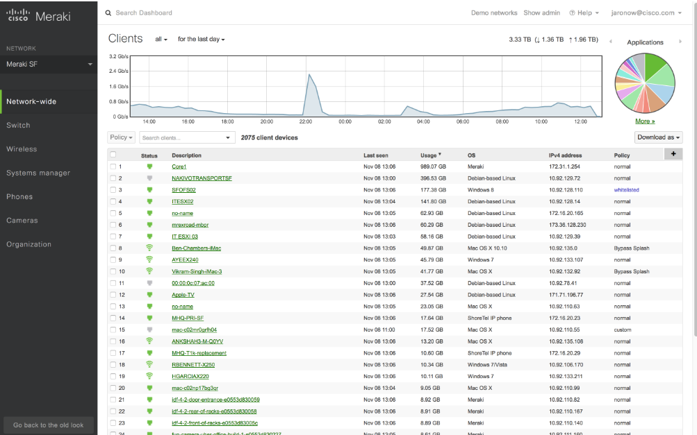
This software allows you to manage the entire network easily without having switch between many management consoles.
This picture is from website called cisco [4]

Advantages and Disadvantages of BYOD:

BYOD it allows the employees, customers to bring their personal devices into the workplace and use their devices to access the company data/resources. there are few different advantages and disadvantages of BYOD.

Advantages:

One of the main advantages of BYOD is that the company’s save a larger amount of money because they don’t have to purchase devices for employees. Employees are also will take care of their own devices, which is a win for the company.

This mothed also increases the employee productivity and this company is software company so whenever the employee feels like he/she needs to work, they will able to get work done easily. The software engineers more comfortable ad familiar with their personal devices. The employees are more satisfied because they can select the device they like.

Disadvantages:

One of the main challenges of BYOD is the problem of security. The customer, stuff will be accessing sensitive things while they are using their local network and that could be none-business-related. And, the employees and customers don’t have a lot of experience about security, so this will very difficult for them to manage the security of their device. But if they are using the policy their devices will be safe.

Another disadvantage of BYOD is that the company will need support many devices and different OS, the company may have to increase the IT staff to support the company employees and customers.

data flow diagram
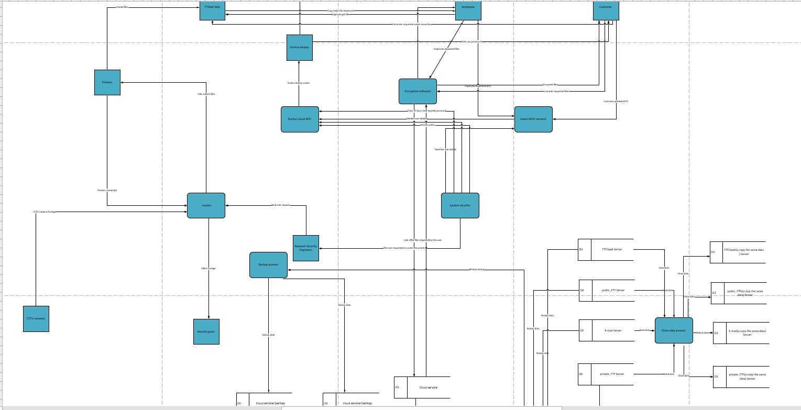

Conclusion:
The things that can be done in the future to improve on my findings will be having on the network two WIFI routers. The customers, employees will be using one of the routers and the network will be isolated from that guest Wi-Fi network, because hackers can use to gain access to company data.

The software developers are often coding outside of the office company, using their own devices through their local area network or they could be using a Starbucks free Wi-Fi which is unsecured network. It would be good if the company purchases antivirus for all the employees and able to monitor each device from the company.

marking criteria and Student FEEDBACK

This section details the assessment criteria. The extent to which these are demonstrated by you determines your mark. The marks available for each criterion are shown. Lecturers will use the space provided to comment on the achievement of the task(s), including those areas in which you have performed well and areas that would benefit from development/improvement.

Common Assessment Criteria Applied (Assignment 1) | Marks available | Marks  awarded
1. Research-informed Literature
Extent of research and/or own reading, selection of credible sources, application of appropriate referencing conventions.
Evidence of background reading. You have done in-text citation but no reference listing to determine the credibility of the sourced used. (Grade mark: 53.33%) | 15 | 8
2. Knowledge and Understanding of Subject
Extent of knowledge and understanding of concepts and underlying principles associated with the discipline.
You have demonstrated the level of understanding of the underlying concepts and principles but as stated above, unsure of the credibility of the sources. (Grade mark: 53.33%) | 15 | 8
3. Analysis
Analysis, evaluation and synthesis; logic, argument and judgement; analytical reflection; organisation of ideas and evidence
You have written on all relevant areas for this work but could do more discussion. (Grade mark: 55.00%) | 40 | 22
4. Practical Application and Deployment
Deployment of methods, materials, tools and techniques; application of concepts; formulation of innovative and creative solutions to solve problems.
A working packet tracer design with countermeasures implementation. (Grade mark: 75.00%) | 20 | 15
5. Skills for Professional Practice
Attributes in professional practice: individual and collaborative working; deployment of appropriate media; presentation and organisation.
Some grammatical errors, avoid writing in first person. Well presented. (Grade mark: 65.00%) | 10 | 6.5

Assignment Mark (Assessment marks are subject to ratification at the Exam Board. These comments and marks are to give feedback on module work and are for guidance only until they are confirmed. ) | Late Submission Penalties (tick if appropriate) |  | 59.5%
 | Up to four weeks late |  | 59.5%
 | First Attempt? |  | 59.5%

