

LEVEL/ LEFEL 4

Name: Valentina Ivanova
Student Number: 1913754
Module Title: Problem Solving and Decision Making
Module Code: BMSW4004
Module Lecturer’s Name: Adesewa Ajayi

Table of Contents
Introduction 2
Complex problem solving 2
Scope of problem solving 2
Alternative solutions to solve problems 5
Propose solution to the problem 5
Implementing problem solving plan 7
Communication to stakeholders…………………………………………………………………………………………………………8
Assessment of the plan …………………………………………………………………………………………………………………….8
Conclusion ……………………………………………………………………………………………………………………………………….8
Bibliography……………………………………………………………………………………………………………………………………..9

Introduction
This report will look at the definition of complex problem solving. Information about the motivation and lack of motivation in the workplace will be discussed. A plan for implementation of strategies to solve the complex problem will be done, and PESTLE analysis of the factors affecting the health and social care fields will also be implemented the methods of communication to stakeholders and review technique will be implied at the end.

Complex problem solving
The complexity of a problem suggests that it is not just a single issue but rather a number of issues, functions and variables and the relationship between them.
In the health and social care sector, there is a variety of jobs, including different tasks, uncertainty in the environment, complexity in the interactions. (Beaufort, 2015)
In the complex problem solving are included tasks or situations that are dynamic and require the decisions must be made at the right moment and related to the demand of the environment. According to (Attri, 2018), the complex problems as lack of motivation at work require more than one decision and involve a long sequence of decisions and the early decisions are related or lead to the later decisions. The complex problem solving may be separate from the general problem solving as it includes many steps before reaching the goal, not just a single step.
(Attri, 2018).
Scope and impact of the problem solving
According to (Quesada, 2005) the scope of a complex problem solving is very wide as it includes several elements in relation to each other and cannot be taken into account separately. Each of the segments needs to be partially resolved for the complex problem to be determined. The complex problem solving can be a very complicated system because there is a variation of the tasks and the issues that need to be resolved. (Nicholson, 2020).
The lack of employee motivation is a very complicated and broad spread problem of the new organisation. Widely spread method for motivating employees is providing financial rewards for the employees, but many other influences are affecting the employee's motivation.
In the contemporary work environment and the health and social care sector is from vital importance to have employees that are motivated. The high motivated employees can bring the organisation to its highest performance levels, and it is directly related to the profits of the business. As the employees are the most powerful engine of any organisation. (Quesada, 2005).
On the other side, as (Quesada, 2005) says, the lack of motivation in the employees leads to loss for the organisation, low profitability, high turnover of employees.
To be able to review the importance of solving the complex problem of lack of motivation of employees, the first step could be finding the input of the problem and to be able to motivate their employees in the health and social care sector. It is vital to define what the motivation as a term is.
According to (Talukder, 2014) the motivation is related to the energy within the individuals directing them and their behaviour for specific periods to achieve a definite goal. Motivation engages people to be the best in their field and achieve their goals. (Clouston, 2010)
For the understanding of motivation, there are few main theories related to an understanding of motivation. These are Maslow's need hierarchy theory, and the other is Herzberg’s two-factor theory. (Talukder, 2014)
Maslow says that employees have five needs ordered in five levels. He agreed that the lower level needs must be satisfied before the higher-level needs, and this could motivate the employees. In the lowest level on Maslow's hierarchy of needs are the physiological needs, they include payment, necessary working conditions, cafeteria. When they are satisfied, the next level of needs becomes leading. Which is safety, including insurance for medical aid, pension, safe working conditions, the stability of an organisation. They reassure the needs for security.

Figure Figure 1.

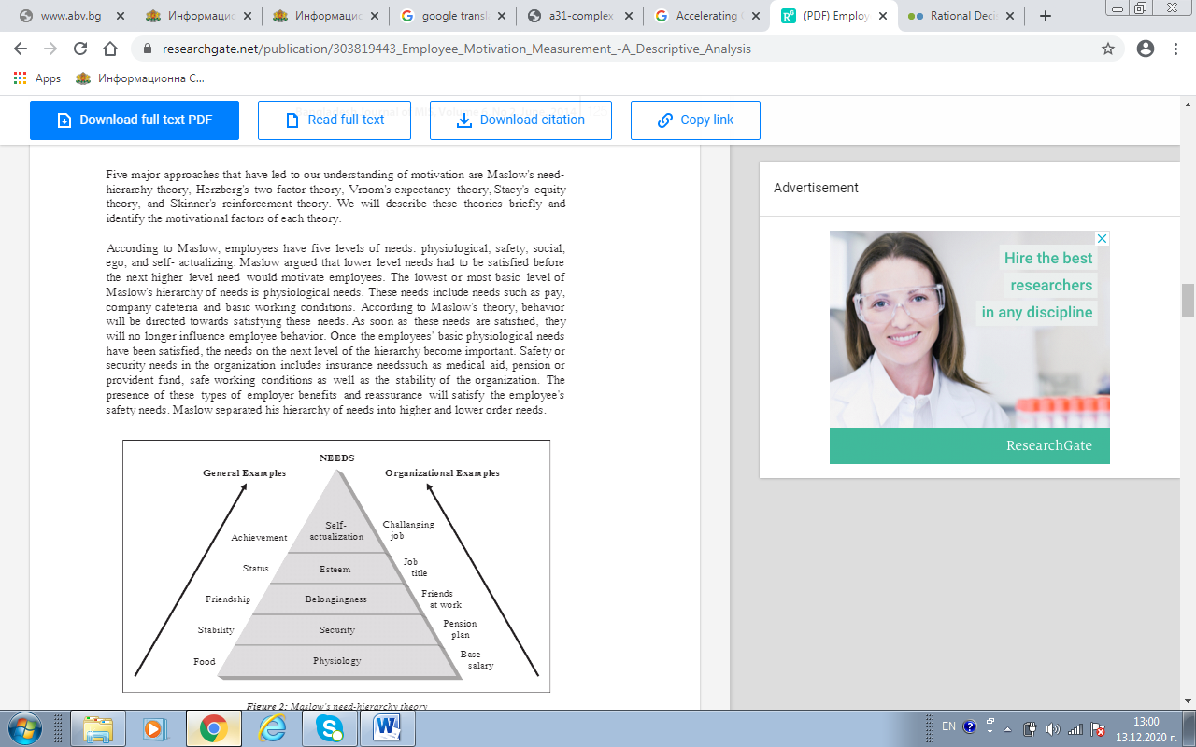

Source: (Quesada, 2005)

On the next level of the pyramid are the self-actualisation and esteem needs and include rewarding recognition of the achievements of employees and linking them to pay.
Another theory related to motivation is Herzberg's two-factor theories. The motivation factors are categorised in two groups Motivator (intrinsic factors) including recognition of achievements, job satisfaction.
The other factors are Hygiene or extrinsic; they include pay, job security.
Motivators are also known as 'growth factors'; they correlate with the nature of work; they include recognition, opportunities, achievements.
After analysing the motivations theories, it can be concluded that there are different motivational factors and the main are: salary, rewards, training and development opportunities, appreciation and recognition, growth, promotion. Motivation is a desire to be achieved a particular goal, and the motivation of the employees can be a catalyser for the success of an organisation. (Talukder, 2014)
When dealing with lack of motivation at work, even the theories have findings it is essential for the managers and leaders in the health and social to understand their employees because as individuals each employee is motivated by different things. (Talukder,2014)

Alternative solutions to solve the problem

Many factors can block people's energy to work. Sometimes the lack of motivation can come from new stress factors at home or may arise from broken promises at work over the years.
The purpose of solving the problem is to transform the negative energy into a positive attitude to the working process. The main thing here is to find the most important things that push the attention of the employees. Another important thing is to see what causes the loose of motivation. Reasons for that can be a lack of confidence about different tasks, no opportunities for career progression, high workload, filing underappreciated, unstable work environment. (Attri, 2018).

Propose solutions to the problem.

It is essential also the lack of motivation to be recognised. They can be spotted as changes in the behaviour of the employees as it is crucial for a successful manager to build a strong relationship with his subordinate. The excellent manager has to make a strong relationship with the employees as this can help the manger spot when something is not happening in the usual way. Some of the signs for lack of motivation of the staff can be. (Gilpatrick, 2013)
Being always late for work or the time from arriving at the office and starting work is increased, lack of focus on the tasks, negative comments at work, lack input on corporate meetings, lack of desire to take more responsibility than the minimum required. (Beaufort, 2015).
The demotivated employees can demotivate the whole team and create a negative atmosphere at the workplace. In some cases, the other employees start to pick this demotivating behaviour. Over time the colleagues might feel overworked and not appreciated. To resolve the complex problem of lack of motivation at work, can be put the following plan:
• The mangers have to know well their team. This would increase the supportive relationships with the subordinates, and the managers will see when the staff feel demotivated or valued.
• Transparency and support at work from the managers. Many surveys show that one of the main reasons for staff leaving a job is the problems with the managers.
The managers need to have well-built leadership skills and to be able to
communicate clearly to their staff. The companies should provide training for the managing staff and ongoing activities.
• Another vital thing is regular feedback the goals for the staff in health and social care organisation have to be measurable, realistic and time-framed. When each member of the team knows what is required from him, they can contribute and would know how necessary their skills are and will feel their skills valued.
• Offering career progression when there is a lack of possibilities for career progression, the employees will be demotivated and will look for a new job. Building a career path within the organisation, encouraging them to take part in different projects, to have more responsibilities and gain new skills. It would show the employees that the organisation values their contribution and is interested in them.
• Introduction of a flexible working scheme implementing flexible working hours, working from home opportunities for the employees will give them more freedom, better work-life balance and also they will feel trusted and valued.
• Implementing compensation package together with the other essential things, it is crucial to implement a fair compensation package for the employees, which might include additional healthcare, a competitive salary, paid holidays.
• Recognition of great work the managers can implement practice where the high performing employees can be recognised by written "Well done" or "Thank you" letters. It will show the employees that their efforts are recognised. (Nicholson, 2020).

Decision-making techniques
Cause and effect analysis –it is a technique used to identify the input or the cause of a specific problem and its output or its effect.
In this case, the input can be from different derivatives as analysed above, but the output is the lack of motivation of the employees. To implement a decision-making technique for this complex problem PESTLE analysis can be used. (Quesada, 2005)
Political factors greater choice of health and social care providers.
Expanding of non-NHS provisions in the health and social care, building of foundation trusts, encouragement of social enterprises. Globally growing opportunities for health and social care markets.
Economic factors slow recovery of the recession might lead to fewer opportunities for jobs in health and social care sectors. There is a high relation between employment and physical and mental health. The people are less likely to seek help because of financial issues. (Chang, 2004)
Social factors There is greater need of carers because of the ageing population, the number of people which are more than 65 years will increase by 20% by 2030. They will require more health and social care services. There is an expectation of having more single people also, which are more likely to need to use public health and social care services.
Technology, The development of technologies, provides a high amount of information and helps health and social care services to lower inflationary pressure.
The information can be kept safely and facilitate access to valuable information. ( Nicholson, 2020).

Implementing a problem solving plan
To implement the problem solving can be applied the following technique:
1. Conduct stay interviews
The stay interviews can be implemented to assess the feedback of the employees about the positives and the negatives in the organisation, not just exit interviews.
2. Regular feedback loop Pay to the employee's bonuses in advance.
This will make them feel good about the relationship with the organisation and will appreciate the trust of the employer in them.
3. Employing training and development opportunities
The employees can be trained from the moment they enter the organisation. Training strengthens the sense of the value of the employees and is ensuring they clearly understand the requirements of their job.
After the accomplishment of tasks discussing with the mangers about the noticed of his deviations and also giving guidelines and discussion of strengths and weaknesses of the task finalisation.
4. Providing a positive and safe work environment
These include improvement of the workplace, the layout of offices, co-worker dynamics. (Quesada, 2005)

Communication to stakeholders
The communication to stockholders is crucial for the new implementation plan to take place. The stockholders are internal. These are the participants in the program like employees and volunteers; The external stakeholders are the patients and customers, accreditation agencies, competitors. The communication to the stakeholders can be done by deriving a methodology and a written plan which will be presented to them and which they can comment on and give opinions. (Beaufort, 2015)
Assessment of the plan
The implemented plan will be assessed by feedback controls, including the following steps:
1.Establishing of certain standards of performance
2. Measurement of current performance
3. Comparison of actual performance and the desired one
4. Evaluate the reached standards and initiation of corrective actions if needed.
These steps followed can ensure that the correct implementing of the plan will be achieved. (Attri, 2018)
Conclusion
As the complex problem solving differs from common problem solving, it requires more regulated steps towards achieving a goal. To solve the problem with a lack of motivation is essential to assess what motivates the employees and then involve that in the methodology of an organisation.
When the employees are motivated, that is a base for the organisation to prosper, that is why when there is an issue with the motivation of employees, it is crucial to be resolved.

Bibliography
Attri, R. (2018). Accelerating complex problem solving. Singapore: Speed to proficiency research.
Beaufort, L. (2015). Health Program Management. San Francisco : Jossey-Bass by Wiley.
Chang, E. (2004). Social Problem Solving. New York: SAGE Publishing.
Clouston, T. (2010). Problem based learning in health and social care. San Francisco: Blackwell Publishing.
Gilpatrick, E. (2013). Quality Improvement Projects in Health Care: Problem Solving in the Workplace. New York: SAGE Publications.
Nicholson, N. (7 January 2020 r.). Human Resource Management. Изтеглено на 13 12 2020 r. от Harvard Business Review: https://hbr.org/2003/01/how-to-motivate-your-problem-people
Quesada, J. (5 January 2005 r.). Complex problem solving: finding a definition. Theoretical issues in Ergonomics science, стр. 16-27.
Talukder, A. (2014). Employee Motivation Measurement- A Descriptive Analysis. Management information systems, 3-8.

