Academic assignments 2
PCDA 2.22
STUDENT NAME:CARL DANTER
STUDENT NUMBER: 2131851

4. To what extent do the police have a role in fostering and maintaining community cohesion? You should also consider why some groups might be less willing to engage with the police, and how this might be addressed. Your answer should be based on academic research, although you may make reference to relevant case studies. (2000 words)

Community cohesion allows all members of the community to feel accepted and valued in the community they live in. This enables people from all backgrounds and minority groups to feel apart in their neighbourhood without feeling isolated, discriminated and abandoned. Positive community cohesion allows people to feel safe in their local area which increases their positive attitude on other people in the community and organisation which serve them. There is an understanding that certain communities lack trust in such organisations such as the police service due to personal experiences, experiences in which they have heard through other members of the community or fictional events. These will have a detrimental impact in building confidence and trust which will overall tarnish relationships between the communities and the police service (National Police Improvement Agency,2001). UK government have been aware of the challenges and issues with community relationships; however, this was made apparent after the serious disorders in 2001. There was numerous large scale public disorders and riots in England from Sunday 15 April to 15 July. These riots were primarily due to the heightened tensions between growing British Asian communities and the city’s white majority. This led to violent outbreaks whereby over 400 police officers were injured, and millions of pounds worth of damage was caused (UK parliament,2005). After these incidents occurred a review body was set up in December 2001 named the community cohesion review team. Their goal was to identify good practice, issues within current policies and to create new ways of improving community cohesion. “To obtain the views of local communities, including young people, local authorities, voluntary and faith organisation, in a number of representative multi-ethnic communities, on the issues that need to be addressed in developing confident, active communities and social cohesion” (Cantle, 2001). The review team identified that after the riots that there was a clear divide between white British and Asian people therefore, they introduced a concept Parallel lives. Which emphasised the two main communities which had the most severe divide. It shows the separation of communities, lack of shared experiences. However, everyone in the community should be treated with fairness and equality which was not shown which was subsequently the cause of the riots. (Cantle,2023).

There has always been issues with public trust and confidence when it comes to the police service however over recent years. Figures from 2017 to 2020 show that people aged 16 to 24 years old of the black community had a lower percentage of confidence in their local police service with 63% compared to white people with 79% and Asian people 76%. Those aged 75 years and older who are white had 82% confidence in police, the highest percentage out of all ethnic and age groups (Office for National Statistics,2021). Over the recent years there has been high scrutiny within police services especially within the black community and not just in the UK. In MAY 2020, 46-year-old George Floyd was killed when Derek Chauvin a US police officer placed his knee on Floyd’s neck for more than nine minutes which subsequently led to the death of Floyd (BBC, 2021). This sparked protests and riots mainly within the black community. In the US tens of thousands of people took to the street to support the community however this also led to shooting, vandalism and disorder in over 140 cities which resulted in the National Guard being deployed in 21 states (Taylor,2021). Although the incident occurred in the United States, the affects spread throughout and impacted the UK. Within days of Floyds death thousands of people marched in central London under the banner of Black Lives Matter. Roughly 15,000 people marched in Manchester which was one of 160 protests in that weekend alone with a total of 210,000 people attending some form of demonstrations around the county (Mohdin, Swann and Bannock, 2020). This is an indication that although the initial accident happened in US, the implications that it had was serve and people of the black community were untied, and this would ultimately result in the loss of willingness to engage with police from the black community. Although the damage was already done, and Floyd was dead the police and justice services acted promptly to bring those responsible to justice. Officer Derek Chauvin has been convicted with second degree murder whilst the other three officers present who were initially uncharged are facing charges of aiding and abetting to murder (BBC,2020). This shows accountability and integrity from law enforcement and is clear from the charges that just because they were police officers, they did not receive any special treatment. The black community and more importantly the family would have been eager to get results for Floyd. A statement which was released by the family "This is a significant step forward on the road to justice and we are gratified that this important action was brought before George Floyd's body was laid to rest." (BBC,2020). This is an indication that some faith in the Police may be restored, and the black community might be more likely to engage with police.

Another incident whereby police have been under scrutiny and have received pressure from the black community which would undermine their trustworthiness and potentially cause the black community to be less willing to engage with officers is a stop search conducted on two members of the black community. Athletes Bianca Williams and Ricardo dos Santos were stopped and searched by Met Police on 4th July 2020. This incident was captured on video and spread thoroughly on social media which prompted an investigation into the legitimacy of the stop search which was overseen by the IOPC. In a statement made by the IOPC “We know that Black people are almost nine times more likely to be stopped and searched by police than White people, and nearly nine times more likely to be searched for drugs - despite a lower find rate of drugs for Black people than White people. The officers in this case claimed they smelled cannabis in the athletes’ car despite no drugs being found in the search. “It’s figures like these and cases like Bianca and Ricardo’s which emphasise why Black people report having low trust and confidence in policing.” (IOPC, 2023). In a statement made by Williams “I feel particularly vindicated by the IOPC’s decision in light of ex-commissioner Cressida Dick’s public efforts to discredit and undermine our complaints, and to trivialise the experiences of black people in the UK and how we are policed” (Dodd, 2022). This statement supports that black people feel they treated differently, and this will overall have an impact on community cohesion within the black community and which will ultimately result in black people not willing to engage with police.

A possible way police can improve community cohesion and build relationships with ethnic minority groups is by employing police officers who represent the community they serve. South Wales Police offer a gateway for potential candidates from ethnic minority backgrounds by utilising their Positive action scheme. “Refers to a range of measures and initiatives that employers can lawfully take to actively encourage individuals from under-represented groups to apply. Having true difference in our police family brings different perspectives and help us better understand our communities. In doing so, we can innovate and respond to the needs of our ever-changing society”. By increasing those numbers within in the BAME community will reassure the community and may enhance communications as they share certain backgrounds and experiences. However there does not appear to be many BAME officers within the police services around the UK, figures show “As of December 2020, 7.5 per cent of police officers in England and Wales are BAME (1.2 per cent black, 3.2 per cent Asian, 2.2 per cent mixed ethnicity and 0.8 per cent other ethnicity), despite the current BAME population being projected at 17.2 per cent” (The Police Foundation,2021). These figures clearly show that police services around England and Wale, although have some form of representation, there is not enough. Figures also show that recruitment causes a problem “passing the initial assessment to join the police is more difficult if you are from an ethnic minority. Recent figures from the Day One Assessment Centre trial Show the pass rate for BAME candidates was 48 per cent compared to 81 per cent for white British candidates” (The Police Foundation,2021). This highlights the issues of recruitment; this indicates that white British candidates almost double their chances of passing the assessment centre. Although the figures are very poor and this will ultimately have an impact of a representative workforce, that’s why the Positive action recruitment was brought into the action, to identify and support potential candidates from BAME commutes to have a higher chance of joining the police service. This is one-way police services are addressing the issues around a representative workforce to hopefully improve that engagement and enhance community cohesion.

Another way police services can address Is by realising what issues there are and as an organisation, create action plans and set out ideas and targets to assist police in supporting groups such as the black community, create trust and confidence which should ultimately improve relations. Police and government realised there was issues between ethnic minority groups for many years and after high profile incidents like the ones stated above, police bosses have created an action plan, developed jointly by the National Police Chiefs’ Council and College of Policing with input from relevant stakeholder such as National Black Police Association (NBPA), the Independent Scrutiny and Oversight Board Chair, and the Association of Police and Crime Commissioners (College of policing, 2022). Working Collaboratively to achieve best the best outcome below is the main action plan.

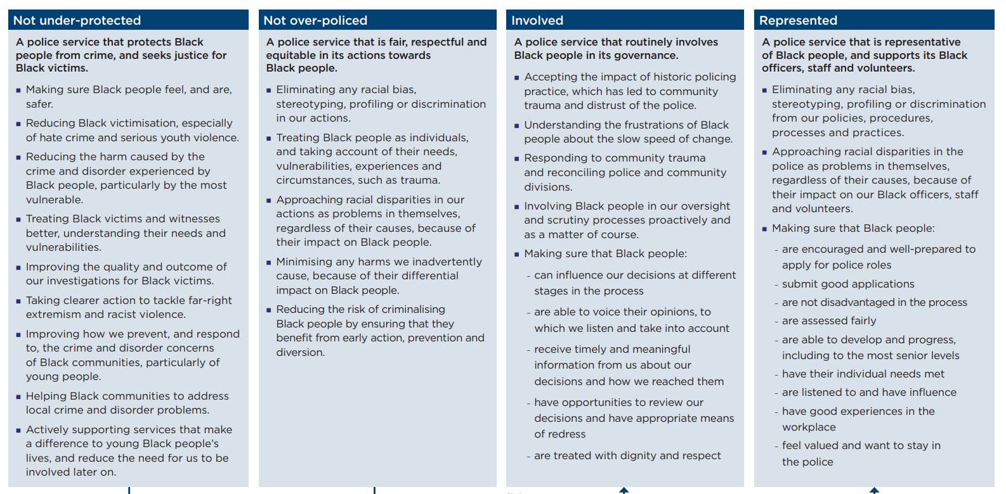
(College of policing, 2022) action plan framework

The action plan above sets out the main focuses to police services to restore positive relations with the black community, ensuring police officers utilised code of ethics and policing principles when dealing with black people whether that be from a victim, witness or suspect point of view and to also support those communities and male them feel united and safe. This should subsequently improve communications, relationships and hopefully improve community cohesion between police and the black community.

To conclude this essay there is clear signs that certain communities such as the black community who lack trust and confidence within the police, statistics support this, showing “people aged 16 to 24 years old of the black community had a lower percentage of confidence in their local police service with 63% compared to white people with 79%” (Office for National Statistics,2021). Main reasons for this is the main is the high profile incidents involving the black community and police such as the murder of George Floyd and stop search of black athletes Bianca Williams and Ricardo dos Santos both incidents had catastrophic implications in causing conflict between police and the black community which resulted in violent disorder and protests around both UK and US. In both cases police were to have acted inappropriately therefore action was taken to fire, and in Floyd’s case, charge the officers with murder. By organisations being transparent and accountable this may restore some trust in the police service. However, it would take a lot more to breakdown the barrier. Police bosses have acknowledged and identified the issues therefore in 2022 police chiefs along with government and independent boards have formulated an action plan for police services to deliver better service to black people, eliminate racism within police organisations and to also be more diverse and inclusive by employing more BAME officers and staff to represent the communities police serve. Which brings us to the positive action recruitment which allows police services to assist potential candidates from BAME communities whether it assists them in help through recruitment process, promotions. By increasing BAME officers it should build a better relationship between police and BAME communities.

Word count: 1979

6. What lessons have been learned from recent high-profile critical and major incidents, and how have these translated into best practice for policing? Your answer must be based on academic research rather than personal experience, but you may refer to recent examples of high-profile critical and major incidents (2000 words)

Police officers will often attend calls and incidents of serious nature, whereby It requires specialist resources and partner agencies to ensure these incidents are dealt with appropriately these are referred to as major and critical incidents. A critical incident is defined as “A critical incident is any incident where the effectiveness of the police response is likely to have a significant impact on the confidence of the victim, their family and/or the community” (College of Policing,2018). A major incident is defined as “A major incident is an event or situation requiring a response under one or more of the emergency services’ major incident plans. This will usually include involving large numbers of people, either directly or indirectly” (college of policing, 2018). Both categories of incidents have shaped the way police respond to incidents from past critical and major incidents and subsequently formed police practice. A way police grade calls and incidents are traditionally through the thrive approach this will decide the way police respond to these incidents. The thrive model is split into six categories, Threat, harm, risk, investigation, vulnerability and engagement (thrive) This model allows to appropriately respond to calls and gives judgement of the risk posed and gives the victim of that call individual needs and places them and the centre of that decision (HMICFRS, 2023). Historically police and emergency services have not effectively worked together, reviews into July 2005 bombings, floods across the UK in 2014 and the 2010 mass shooting in Cumbria. The review identified gaps and failings into the communications between emergency services. To achieve best practice and learn from failings, A joint emergency response approach (JESIP) was established in 2012 after reports made by police chiefs, chief fire officers and ambulance chiefs which was sent to the home secretary in April 2012 (HMICFRS, 2018).
Joint emergency service interoperability programme (JESIP) was set up 2012 “The aim of JESIP is to ensure the emergency responders are trained and exercised to work together as effectively as possible, at all levels of command in response to major or complex incidents” (JESIP, 2013). Within JESIP a framework was developed to assist emergency responders and control rooms to affectively respond to critical and major incidents, the framework and acronym METHANE.
M - Major Incident declared?
E - Exact Location
T - Type of incident
H - Hazards present or suspected
A - Access routes that are safe to use
N - Number, type, severity of casualties
E - Emergency services present and those required
(CFOA,2014).

A recent high profile critical incident whereby police were criticised after findings were published in the way police handled the incident was the disappearance of Nicola Bulley. Nicola Bulley a 45-year-old mum of two living in Lancashire who was declared missing on Friday 27th January whilst walking her dog, this prompted a large scale search with specialist search officer. Unfortunately, her body was found 23 days after she disappeared just one mile where her phone and dog were found (The Independent, 2023). A review was undertaken and found certain failings throughout this case. Although Lancashire police were praised for the search itself which was ‘well conducted and resourced’ and described as extensive and comprehensive. However, there was an issue, which was initially declaring it a critical incident, despite meeting the national definition the critical incident was declared critical almost 3 weeks after the initial missing report, this should have been declared critical as early as 30 January (BBC, 2023). However, the review also commended the early response the force utilised a search manager to assist once Nicola was deemed High risk “The initial response to a ‘high risk’ missing person enquiry, especially the use and deployment of a missing person search manager, was highly commendable. All forces should consider adopting this approach” (College of policing, 2023) This was a positive lesson learned with the recommendation for other police forces to utilise this approach for best practice. One of the main criticisms in this incident was the conflicting and misleading information, disclosures about Nicolas personal life which had no relevance which caused speculation by the press and public. The review concluded that the service should have corrected the misleading statement in the first press conference and provide police officers who may provide information to press or public to be properly trained and prepared to ensure accurate information is past. Lancashire police recommended that the constabulary “should routinely review statements made during press conferences to ensure the accuracy of comments made and, where necessary, look to clarify or retract comments at the earliest opportunity” (college of policing, 2023). These findings from the review should be fostered by police forces to unsure delivery of best practice.

A recent high profile major incident which the police received criticism for was the Manchester bombings. There found to be failings in the communication from GMP around the declaration of the major incident. Experts told the inquiry a "significant failure" in Greater Manchester Police's (GMP) emergency response to the attack, which killed 22 people on 22 May 2017 (BBC, 2021). In the enquiry a main point was the ‘breakdown in communication between the different commands, resulting in a lack of direct command and operation confusion. Scott Wilson a former counter terrorism commander explained that services should’ve been communicating with each other but wasn’t, Although the joint working between BTP, GMP and ambulance service on scene, the overall coordinated response was ineffective, and it was a “significant omission” by GMP not to declare a major incident until 150hours after the explosion (BBC, 2021). After these issues were identified in the inquiry Manchester police chief constable Stephan Watson released a statement holding accountability but reassuring the public that changes are and being made, He accepts poor communication, planning and inadequate training played a part in the failure. However, explains that they have developed a detailed memorandum of understanding with BTP for the arena site as well as other to ensure clarity in roles and responsibilities. Improved process to ensure the testing and practical awareness of multiagency communication methods, additional staff and training, improvements into debriefs of such incidents to capture and share findings and learning which will improve best practice.

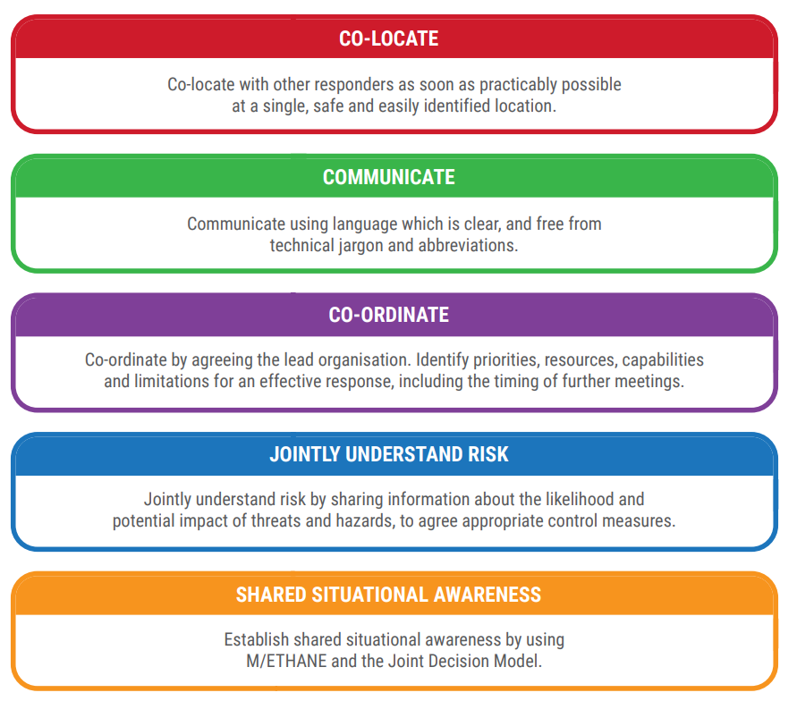
When large scale incidents like the above occur its important for police and other services to effectively communicate with another. Best practice for the principles of working together. Whether the incident is spontaneous or pre planned and regardless of scale. A multi-agency and response should be sought. Formed by JESIP, the principles shown below is how services should be following to achieve best results (JESIP,2021)

(JESIP,2021)

When a major incident is declared, it is vital that is shared with partner organisations as soon possible. This allows appropriate and sufficient resources to be put in place, this will cause pressure on control staff and first responders and commanders who will have strategic oversight may not have resources available at the time, to assist with all services and to provide consistent information of the ongoing incident, A METHANE report should be completed. Declaring a major incident at early stages means the arrangements of decisions and resources can be put in place quickly (JESIP, 2021). The above Model could have been utilised more appropriately when responding to the Manchester arena bombings as the review critiqued the lack and break down in communication around the major incident declaration between partner organisations. Major and critical indigents will most certainly require more than one organisation input, therefore JESIP formed another model, which enables best practice when dealing with such incidents this is the joint decision model.

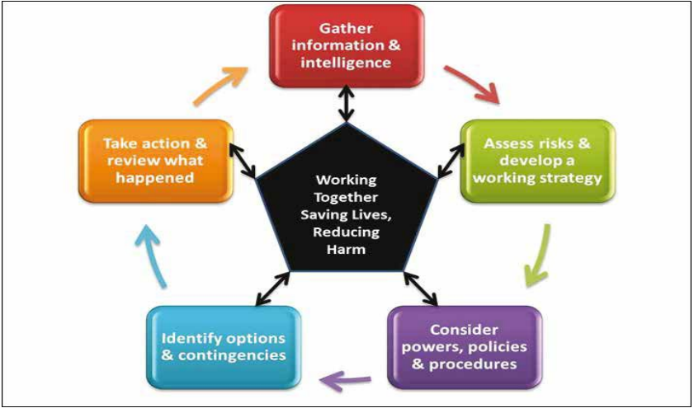

(HMICFRS, 2016)

Historically emergency services would use their own models to support decision making however, to achieve collaborative working and best practice JESIP introduced this structured approach for decision making, information gathering and structured approach. This model should also be used jointly by commanders. This model was modified from the police services national decision model (HMICFRS,2016).

Another way to assist policing when dealing with critical incidents working in conjunction both College of poling and JESIP lay out principles and guidance to police services which is known and critical incident management (College of policing, 2021) After the public enquiry into the Stephen Lawrence case caused a significant impact on the confidence of the victim, their family and the community, due to this, authorised police practice lays guidance for dealing with ‘critical incidents’. CIM is formed of 3 stages phase 1 – preparing for critical incidents. Ensuring there is leadership to manage these incidents sufficiently, learning lessons, if something has gone wrong and there are lessons to be learnt its important for forces to take on board and identify where things when wrong and rectify it using post incident evaluation and joint organisational learning laid out by JESIP. Ensuring police services have correct knowledge of policy and processes. Quality assurance, used to examine and identify good practice to ensure future decisions are identified. Making sure police officers and staff have correct training and training courses so that police officers know what they are dealing with and if it could develop into a CI and whom officers should inform if they believe a CI is taking/about to take place. Another main point is partner agencies, ensuring that people involved in CI are identified and referred to the appropriate agencies (College of policing, 2021).

The second phase is managing critical incidents. Critical incidents will normally have an affect on the individuals or community. Police should identify these and provide the right care and reassurance for those affected, on occasions a traumatic incident could have a major impact on the community, it is important for police to provide support and if necessary, family liaison officers who have additional training and best placed to support. Tensions may rise in the community if there is a poor initial police response and engagement. Therefore, it’s important for police to emphasis on community engagement. Any police officer can bring the attention of a critical incident but inspectors or a senior officer will decide whether to officially declare a CI. Command and control, emphasising JESIPs principles to ensure the right services are involved and its clear what roles they’ll have. Ensuring forces follow the victims code of practice to ensure victims get the best support and outcome. More than likely in critical incidents, there will be high media coverage therefore its important for senior officers namely gold commanders will usually take control of the media, whether that’s public statements or communications with media ensuring the public is getting necessary information but avoiding information which may hinder the CI and finally the post incident evaluation, forces to review to identify good practice and errors which will help set new guidance and create nest practice (College of policing, 2021).

And finally phase 3, restoring public confidence. Once the critical incident is closed police forces to identify why the reason public trust is lost and implement an action plan. This will need to be enforced quickly, and transparent. If police forces identify failings to issues an early apology, understand where it went wrong and review. If needed forces to refer to professional standards or IOPC. To provide support to victims and families whether that be providing a family liaison officer or referring them to relevant support services to care for the needs of those affected (College of policing, 2021). The Critical incident management (CIM) provides police services gold model and best practice to ensure they deal with critical incidents to the bets of their ability.

Word count: 1908

Bibliography.

BBC (2020). New charges brought over George Floyd’s death. BBC News. [online] 3 Jun. Available at: https://www.bbc.co.uk/news/world-us-canada-52915019.
[Accessed 20 November 2020]
‌BBC (2021). Who was George Floyd and what happened to Derek Chauvin? BBC News. [online] 24 May. Available at: https://www.bbc.co.uk/news/world-us-canada-56270334.
[Accessed 20 November 2023]
BBC (2021). Manchester Arena Inquiry told police failed in response to bombing. BBC News. [online] 15 Sep. Available at: https://www.bbc.co.uk/news/uk-england-manchester-58566067.
[accessed 25 November 2023]
BBC News. (2023). Nicola Bulley report findings at a glance. [online] Available at: https://www.bbc.co.uk/news/uk-england-lancashire-67486896.amp
[Accessed 26 Nov. 2023].

Cantle, T. (2001). Community Cohesion: A Report of the Independent Review Team Chaired by Ted Cantle. [online] Available at: https://tedcantle.co.uk/pdf/communitycohesion%20cantlereport.pdf.
[Accessed 20 November 2023]

CFOA (2014) National Inter-Agency Liaison Officer Guidance, Chief Fire Officer's Association, Tamworth, UK [online] Available at: https://files.manchesterarenainquiry.org.uk/live/uploads/2021/03/10161933/INQ040614_4-5.pdf
[accessed 24 November 2023]

College of Policing (2018). Definitions. [online] College of Policing. Available at: https://www.college.police.uk/app/civil-emergencies/disaster-victim-identification/definitions.
[accessed 24 November 2023]

College of Policing (2022). Police Race Action Plan Improving policing for Black people. [online] Available at: https://assets.college.police.uk/s3fs-public/Police-Race-Action-Plan.pdf.
[accessed 21 November 2023]

College of Policing (2021). Introduction and Types of Critical Incidents. [online] College of Policing. Available at: https://www.college.police.uk/app/critical-incident-management/introduction-and-types-critical-incidents.
[accessed 25 November 2023]
‌College of policing (2023) Independent external review of Lancashire Constabulary’s operational response to reported missing person Nicola Bulley. Available at: https://assets.college.police.uk/s3fs-public/2023-11/Nicola-Bulley-independent-external-review.pdf.
[accessed 24 November 2023]

Dodd, V. (2022). Bianca Williams decries ‘culture of racism’ as Met police officers face misconduct charges. [online] The Guardian. Available at: https://www.theguardian.com/uk-news/2022/apr/27/five-met-officers-to-face-misconduct-charges-over-bianca-williams-stop-and-search.
[Accessed 20 November]

HMICFRS (2016) The tri-service review of the Joint Emergency Services Interoperability Principles (JESIP). (2016). Available at: https://assets-hmicfrs.justiceinspectorates.gov.uk/uploads/joint-emergency-services-interoperability-principles-review.pdf.
[Accessed 25 November 2023]
‌HMICFR (2018). Joint Emergency Services Interoperability Principles. [online] Available at: https://hmicfrs.justiceinspectorates.gov.uk/our-work/article/joint-emergency-services-interoperability-principles/.
[accessed 24 November 2023]

HMICFRS (2023) Threat, harm, risk, investigation, vulnerability and engagement (THRIVE) model [Online] Available at: https://hmicfrs.justiceinspectorates.gov.uk/glossary/threat-harm-risk-investigation/

[Accessed 24 November 2023]

Mohdin, A., Swann, G. and Bannock, C. (2020). How George Floyd’s Death Sparked a Wave of UK anti-racism Protests. The Guardian. [online] 29 Jul. Available at: https://www.theguardian.com/uk-news/2020/jul/29/george-floyd-death-fuelled-anti-racism-protests-britain.
[Accessed 20 November 2023]

National Police Improvement Agency (2001) Cohesion guide: Available online
https://library.college.police.uk/docs/npia/CohesionGuide.pdf
[Accessed 20 November 2023]

Office for National Statistics (2021). Confidence in the Local police. [online] Service.gov.uk. Available at: https://www.ethnicity-facts-figures.service.gov.uk/crime-justice-and-the-law/policing/confidence-in-the-local-police/latest.
[Accessed 20 November 2023]

IOPC (2023). Statement following misconduct hearing over stop and search of Bianca Williams and Ricardo Dos Santos | Independent Office for Police Conduct (IOPC). [online] Available at: https://www.policeconduct.gov.uk/news/statement-following-misconduct-hearing-over-stop-and-search-bianca-williams-and-ricardo-dos.
[Accessed 20 November 2023]

JESIP -Joint Organisational Learning Learning Interoperability Lessons Guidance Document. (2013). Available at: https://www.jesip.org.uk/uploads/media/pdf/JOL%20Docs/JOL_Learning_Interoperabilty_L.3.pdf.
[accessed 20 November 2023]

JESIP (2021). JOINT DOCTRINE: The Interoperability Framework Edition 3 (October 2021) JESIP Joint Doctrine -Edition 3 2. [online] Available at: https://www.jesip.org.uk/uploads/media/pdf/JESIP_Joint_Doctrine_Guide_OCT21.pdf.
[Accessed 25 November 2023]
Professor Ted Cantle (2023). About Community Cohesion – Community Cohesion and Intercultural Relations | Professor Ted Cantle. [online] Available at: https://tedcantle.co.uk/about-community-cohesion/.
[Accessed 20 November 2023]

South Wales police (2023) Positive Action Support: Available online https://www.south-wales.police.uk/police-forces/south-wales-police/areas/careers/careers/positive-action/
[Accessed 21 November 2023]

Taylor, D. (2021). George Floyd Protests: a Timeline. The New York Times. [online] 5 Nov. Available at: https://www.nytimes.com/article/george-floyd-protests-timeline.html.
[Accessed 20 November 2023]
‌
The Police Foundation. (2021). Radical reform is required if the police service is to look like the society it serves. [online] Available at: https://www.police-foundation.org.uk/2021/02/radical-reform-is-required-if-the-police-service-is-to-look-like-the-society-it-serves/#:~:text=BAME%20police%20officers%20are%20less%20likely%20to%20be
[Accessed 22 Nov. 2023].

The Independent. (2023). What happened to Nicola Bulley? All we know about mother-of-two’s death. [online] Available at: https://www.independent.co.uk/news/uk/home-news/death-of-nicola-bulley-what-happened-b2450880.html
[Accessed 24 Nov. 2023].

UK parliament (2005) Community relations: existing problems and policies: Available online
https://publications.parliament.uk/pa/cm200405/cmselect/cmhaff/165/16505.htm
[Accessed 20 November 2023]

‌

