INTERNATIONAL BUSINESS
MBA (GENERAL MANAGEMENT)
COMPANY- PHILIPS
MODULE CODE- LCMB7014
LECTURER- LAN DANG
Table of Contents
1. Introduction 2
2. Main Body 3
2.1 Case Study Analysis 3
Background of the company 3
Financial performance 4
International activities 6
Competitor analysis 6
2.2 International Strategy 7
Ethnocentric Strategy 7
Definition 7
Functions 7
Example 8
Advantages and Disadvantages 8
Polycentric Strategy 8
Definition 8
Functions 9
Example 9
Advantages and Disadvantages 9
Geocentric Strategy 10
Definition 10
Function 10
Example 10
Advantages and Disadvantages 10
2.3 Application of the Strategy to the Case study 11
2.4 Contextual Factors 13
2.5. Comparing the strategies 19
Comparison based on definition 19
Comparison based on function 20
Conclusion 22
Reference List 24

1. Introduction
International business research delves into the critical choices made by companies as they expand beyond their national borders. Although these decisions may initially appear tactical, they are, in fact, strategic in nature, aimed at achieving superior performance in the global arena. Multinational enterprises (MNEs) operating in diverse social, political, and economic contexts necessitate complex and interwoven decision-making strategies (Srivastava and Dhir, 2022). These strategies are planned and functionalised based on various factors that consist of customer segmentation and external analysis of the international grounds.
Philips is a purpose-driven company committed to enhancing people's health and well-being through meaningful innovation. Their ambitious goal is to positively impact 2.5 billion lives annually by 2030, with a particular focus on reaching 400 million individuals in underserved communities (Philips, 2023). As a technology-oriented company, Philips and its brand licensees firmly believe in continuously innovating to improve people's lives. Their dedication to finding solutions that make life better underscores their commitment to creating a positive impact on a global scale.
The decision to expand into the UK comes as part of the company's ambitious growth plans and its recognition of the UK market's potential. The UK is known for its strong economy, diverse consumer base, and supportive business environment, making it an attractive destination for multinational companies seeking to tap into new markets and increase their global footprint. Phillips' expansion to the UK involves careful consideration of market research, competitor analysis, and an understanding of the regulatory landscape. The company aims to leverage its expertise in cutting-edge technology and innovation to cater to the evolving needs of British consumers and businesses.
One of the primaries focuses of Phillips' expansion is likely to be its healthcare division. The UK has a robust healthcare system with a high demand for advanced medical technologies and solutions. Phillips' reputation for producing high-quality healthcare equipment and devices positions the company well to serve the UK's healthcare sector and improve patient outcomes (Philips, 2022). Additionally, the UK's strong emphasis on sustainable and energy-efficient solutions aligns with Phillips' commitment to environmental responsibility. The company's lighting division can leverage this demand for eco-friendly products, offering energy-efficient LED lighting solutions for various applications.
As a result, in order to establish a strong strategic expansion, Philips has had the need to emphasise strongly on its international strategy depending on the various external environmental factors affecting their expansion strategy. This report will discuss Philips as the case company in order to establish a robust understanding of the various factors of internationalisation and its strategies. It will begin with a discussion about Philips and its preferred international strategy among the underlying three categories of geocentric, ethnocentric and polycentric. Further, the report will identify the various environmental factor that underpins the decision-making of the strategic movement and align their strategy with the various environmental factors.

2. Main Body

2.1 Case Study Analysis

Background of the company
Philips is mainly a Dutch multinational corporation which was established in the year 1891 in the Netherlands. The founders of the company are Anton Philips and Gerard. Even though the organisation delivers its products worldwide, the headquarter of the company is in Amsterdam which is situated in the Netherlands (Stewart, 2023). It has been taken into consideration that the company is known worldwide for intellectual property as well as home appliances, Philips is even known for selling medical equipment as well (Philips, 2023). The company has constantly inspired its employees by giving recognitions and awards based on the performances so that the employees can improve in each aspect.
One of the prime purposes of the company is to help people in improving their health as well as their well-being. The aim of the organisation is to improve the livelihood of almost 2.5 billion people by the end if the year 2030 which even involves 400 million of the underserved communities (Stewart, 2023). As it is a technology based organisation, it aims at innovating for the people so that they can consistently make their life better (Philips, 2021). Apart from that, the organisation has been successful in offering an inclusive workplace which is diverse as well where employees are respected and valued and are empowered in such a manner that can help the company to grow. From the last 130 years, with meaningful innovation, Phiolips has been serving people.

Financial performance
As per the observation of Koninklijke Philips, the company has earned a massive amount of profit by the end of the first quarter of the year 2023, March 31. It has been reported that the sales of the company was 4167 million Euro in the first quarter of the year 2023. If compared with the sales of the previous month, it was 3918 million Euro and thus, it can be stated that the company has performed well in this current year (Philips, 2023). It has also been observed that in the year 2022, the company has been able to generate a revenue of approximately 17.83 billion which is one of the highest revenue of the organisation if compared from the year 2018 till the year 2022 (Philips, 2023). In the year 2022, in the month of September, the company successfully earned 18.722 billion which has declined from one year to the other by 18.35% (Koninklijke Philips NV (PHG), 2023).

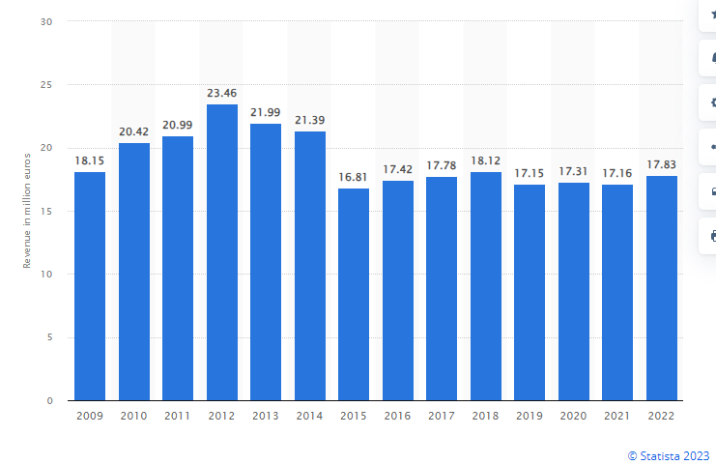
Figure 2.2.1: Financial growth of Philips
(Source: Philips, 2023)
The organisation has performed well in the market and has even been able to compete with various big companies of the industry. 42% of the global sales of Philips are generated from healthcare as the company operates its business globally. As per the report, the company has earned 14% of its annual income from the healthcare sector which is 5546 crore against that of 4883 crore (Philips, 2021). In the healthcare sector, Philips has to compete constantly with companies such as Siemens and GE Healthcare (Philips, 2023). In terms of performance, the firm has ranked 3rd in the context of Employee Net Promoter Score which is based on Comparably. Due to the sustainable growth of the firm, it is widely known across the globe. Philips is known for sustainable collaboration and for valuing its employees. The firm has become the first organisation in the health care sector that has the CO2 emission reduction target of its value chain (Philips, 2023). As the company operates with scientific based target initiatives, the organisation has been able to implement its strategic action plans effectively.

International activities
Philips is known for lighting, dictation of solutions, automotive, display of solutions and hearing solutions. The organisation tries to be keen in order to attract as well as develop talented candidates as their employees whenever the company feels that those employees share similar purposes (Koninklijke Philips NV (PHG), 2023). The firm tries to help in the growth of those employees and offers job positions as well. With the help of the usage of modern technologies, the organisation tries its best so that it can reach out and help people that are in need (Stewart, 2023). As the firm cares about the planet, through its corporate social responsibilities, Philips has been successful in reducing the emission of carbon dioxide as well as other greenhouse gases that are harmful for the environment.
The organisation has even planned that it is going to expand its business in other parts of the world through various global market strategies so that it can reach the maximum number of people (Koninklijke Philips NV (PHG), 2023). Philips even makes sure that its employees are getting proper treatment when in need. In the future the firm made sure that people do not suffer from any kind of health issues so it made the future of healthcare fresh and prosperous.

Competitor analysis
The market is massive so even if new competitions try to enter into the market, they will never be able to compete with such a vast company like Philips that has gained recognition all over the world. On the other side of the coin, the company can get major threats from companies like LG Electronics North America as this company has a massive amount of loyal customer base (Stewart, 2023). However, even though Fitbit and Samsung are some of its biggest competitors, it can never exceed the firm in terms of their gross revenue. The products that the organisation offers spin-offs other competitors in terms of their quality and services (Philips, 2021). As this company has a loyal customer base, it is able to meet the expectations of its customers in an effective manner.
Host country
The host country of Philips is the United Kingdom, to be more precise, the organisation is planning to expand its market in the United Kingdom and make the local customers of the United Kingdom aware of the products and services that Philips offers (Philips, 2021).

2.2 International Strategy

Ethnocentric Strategy

Definition
A company from one nation manages its subsidiaries there using the same goods, services, and management methods as in its home country. This method is known as the ethnocentric strategy (Sengupta et al., 2022). The company may disregard regional preferences and cultural variations by uniformly adopting the superior domestic processes that it believes to be superior.

Functions
The ethnocentric method maintains a centralised and consistent approach throughout all global businesses. It helps the parent company to exercise control over international subsidiaries, ensuring adherence to the core values, culture, and operating procedures of the company. However, the technique could make it harder to adapt to local cultures, preferences, and legal systems, which might make the market less responsive (Dobrowolski et al., 2020). This strategy promotes a consistent company identity, it may lead to missed opportunities and make it difficult to understand and successfully address the diverse needs of international markets.

Example
A multinational corporation from the USA managing its international subsidiaries utilising the same managerial practises, organisational structure, and goods on offer as in its home country is an instance of an ethnocentric approach since it assumes that its domestic method is inherently superior (Zdravkovic et al., 2022).

Advantages and Disadvantages
Advantages:
- maintains consistency in management practises, organisational values, and corporate culture across all foreign operations.
- allows for improved utilisation of resources and decision-making by giving the parent company more control over its international subsidiaries..
Disadvantages:
- Overlooks cultural differences, which could cause misunderstanding and make it challenging to adapt to local customs and preferences.
- Rigidity in responding to shifting consumer demands and emerging trends in global markets.

Polycentric Strategy

Definition
With the polycentric method, an organisation can tailor its offerings, marketing campaigns, and internal processes to the particular needs and preferences of each market it targets (Guan et al., 2022). Decentralisation is extensively promoted, and it provides its foreign subsidiaries with a great deal of discretion in making decisions. The objective of this approach is to adapt operations to local interpersonal, governmental, and customer demands while taking into account the diversity of international markets.

Functions
With the use of decentralised decision-making for overseas subsidiaries, the polycentric strategy can tailor products, marketing tactics, and management procedures to local market demands and cultural differences, improving responsiveness and market placement (Qi et al., 2020)

Example
One of the best examples of a polycentric strategy is a multinational fast-food chain that adapts its food offerings and marketing to suit regional preferences and customs in several countries (Park et al., 2020). This enables each subsidiary to decide independently depending on the particular needs of the market at hand.

Advantages and Disadvantages
Advantages
- To better service and draw clients, local tastes may be catered to.
- Decentralised decision-making offers quick responses to fresh trends and local market conditions.
Disadvantages
- Diverse practises could lead to an inconsistent business identity and operational challenges.
- Repeating product development, marketing, and research & development efforts for every market may get pricey.

Geocentric Strategy

Definition
The geocentric strategy is an approach to international company that strives to integrate global operations and resources (Kehm et al., 2022). It prioritises locating the best talent worldwide, regardless of nationality, and practises and promotes an integrated company culture that maximises success, creativity, and adaptability to regional market needs.

Function
The geocentric strategy uses the best people and techniques from around the world to create a business that is seamless and integrated on a global scale. It lays a high focus on collaboration, information sharing, and global synergies in order to create a cohesive business environment that brings together global effectiveness with regional responsiveness and maximises profitability and adaptability in a range of markets (Calderón et al., 2019).

Example
The geocentric strategy is exemplified by a global technology company that works with the best employees, regardless of their country of origin, and collaborates on projects across various countries. The company develops a shared corporate culture to foster creativity, efficiency, and market responsiveness on a worldwide scale.

Advantages and Disadvantages
Advantages
- Innovation and competitiveness are boosted by the global appeal of talent.
- Working in teams results in the application of a range of information, which generates creative ideas and improved performance.
Disadvantages
- Hiring global talent may involve challenging immigration and visa issues.
- Working together and communicating may be challenging when managing multiple teams.
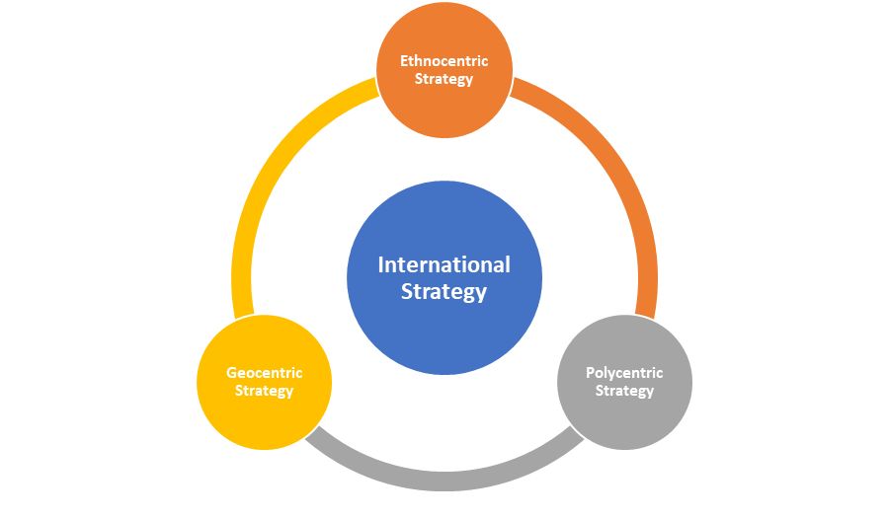

Figure 1: Different types of International Strategy

2.3 Application of the Strategy to the Case study
According to Huang et al., (2020), the corporation employs nationals of the candidates' native countries to fill positions all across the world employing an ethnocentric hiring strategy. Even though Philips had an ethnocentric viewpoint, it's possible that they offered identical services and products in the UK in the hopes that British consumers would tolerate them on a par with their domestic market offerings (Ogunsiji et al., 2022). This might include goods that have already been successful in the nation where the business is based, such as consumer electronics, home appliances, and medical equipment. Philips may only need to make minor adjustments to its product, promotion, and communication tactics when it enters the UK market if it adopts an ethnocentric strategy (Bakti et al., 2020). It can entail employing the same public relations tactics, packaging concepts, and advertising techniques that were effective in their own nation. It was likely that individuals not from the nation of the organization's origin held important positions of management in the UK company (Pawar et al., 2020). To guarantee that the corporate atmosphere and values of the concerned business are upheld in the overseas subsidiary, this is done.
It was possible that the ethnocentric strategy will give the UK subsidiary little leeway. Corporate headquarters may make crucial choices, leaving the subsidiary with less leeway to adapt to changing market conditions or client preferences (Dekhili et al., 2021). An ethnocentric strategy could lead to cultural barriers in the UK market. Misunderstandings or misunderstandings of regional conventions, preferences, or market trends may limit the company's ability to satisfy the needs of British clients. Philips fails to adequately adapt to the local market, it may miss out on opportunities to benefit from specific trends, preferences, or technological advancements in the UK (Costa et al., 2023). Competitors in the area that are more knowledgeable about the market can be ahead. If other multinational companies or local competitors adopt a more locally focused or polycentric strategy that prioritises local customization and responsiveness, they may gain an advantage in the UK market.
In order to sum up, Philips' ethnocentric approach in the UK would require few adjustments, identical goods, and little autonomy for locals. While this approach may have certain advantages in terms of consistency and alignment with the organization's worldwide aim, it might also make it challenging to recognise and satisfy the particular needs of the UK market.
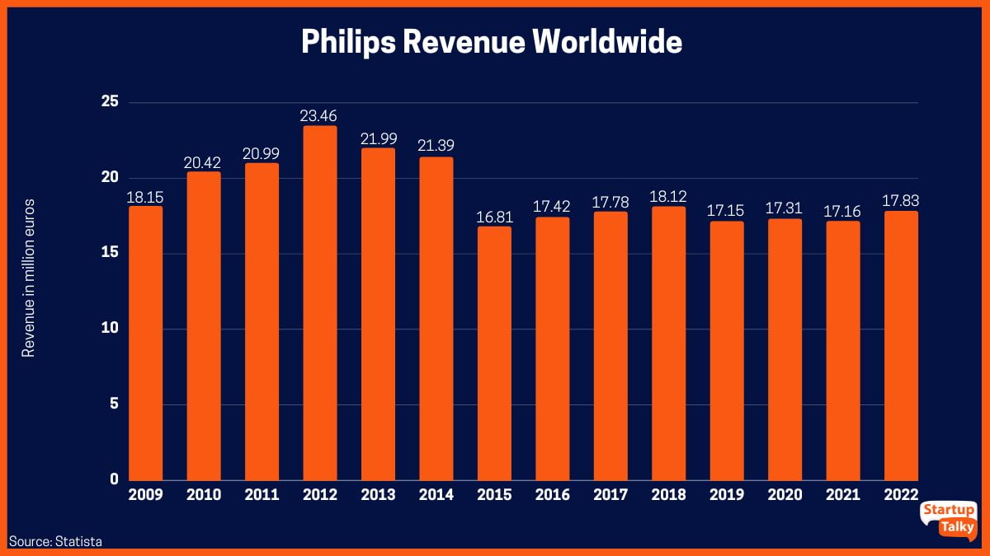

Figure 2: Philips marketing growth
(Source: Karthikeyan, 2023)

2.4 Contextual Factors
Amidst a dynamic global landscape, characterised by the influence of globalisation on consumer behaviour and constant market fluctuations, strategic agility stands out as a crucial determinant of success for international companies (Shams et al., 2021). Hence, in order to strategise the internationalisation of a business, there are various frameworks that determine several contextual factors that are essential for international expansion. Following the PESTLE Analysis, the contextual factors determined from the framework are “political”, “environmental”, “social”, “technological”, “legal” and “environmental” factors. Each of these factors defines individual units like political stability, environmental sustainability, technological adaptability, economic competence and many more for an informed expansion in the host country.
Political
Political stability in the UK is undoubtedly an advantage for businesses looking to expand into the electronics industry. According to the political stability indicator as shown in the Figure below, the average score for the United Kingdom was 0.48 points (The Global Economy, 2023). The lowest value observed was 0.08 points in 2018, while the highest recorded value was 1.03 points in 2000. As of the latest data from 2021, the score stands at 0.54 points (The Global Economy, 2023). This indicates a relatively stable political influence which initiates greater opportunities for the expansion of organisations in the UK.
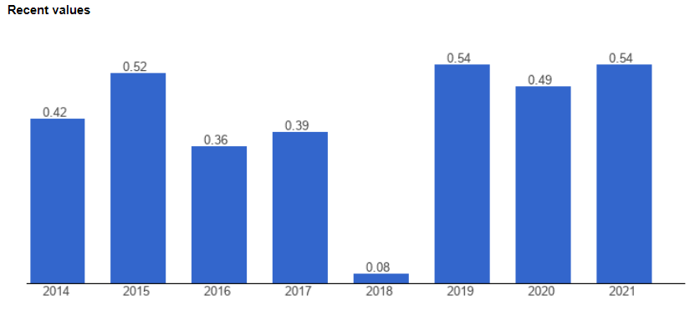
Figure 2.4.1: Political Stability in the UK
(Source: The Global Economy, 2023)
However, it's crucial to recognise that political landscapes can change rapidly, and uncertainty may arise due to factors such as Brexit or shifts in government policies. The UK's exit from the EU has caused significant and lasting uncertainty, leading to a notable decrease in investment by approximately 11% compared to what it would have been otherwise (Bloom et al., 2019). Additionally, the Brexit process has resulted in a decline in UK productivity ranging from 2% to 5% over the three years following the referendum (Bloom et al., 2019). Further, the UK is facing challenges in adapting to new paperwork and software systems post-Brexit, leaving British businesses on the sidelines (McCarthy, 2021). As shown in Figure 2.4.2, Northern Ireland, with special trade provisions, has a relatively better situation, while Gibraltar is working towards a new treaty with similar trading provisions to Northern Ireland.
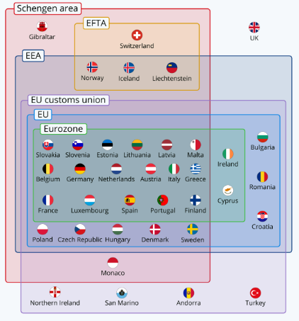
Figure 2.4.2: UK Trade agreements post Brexit
(Source: McCarthy, 2021)
Moreover, the UK's political stability is not without challenges. Geopolitical tensions, both regionally and globally, can create uncertainties in the international trade environment (Depledg et al., 2019). Companies expanding to the UK need to be aware of the potential repercussions of political conflicts or trade disputes, which could disrupt supply chains and impact their business operations.
Economic
While the UK boasts a strong and diverse economy, businesses seeking expansion in the electronics industry must be mindful of economic fluctuations and market dynamics. In May 2023, the monthly “real gross domestic product (GDP)” for the UK experienced a decline of approximately 0.1%, following a growth of 0.2% in April 2023, which remained unchanged from the previous report (Office for National Statistics, 2023). When looking at a broader timeframe, the GDP exhibited a stable and still position during the three months leading up to May 2023. The main contributing factor to the May 2023 GDP decline was the production output, which fell by 0.6%, and the construction sector also experienced a decrease of 0.2% (Office for National Statistics, 2023). As understood from Figure 2.4.3, the decline in the GDP results in a declined supply chain management and availability of resources and suppliers in the country for international business.
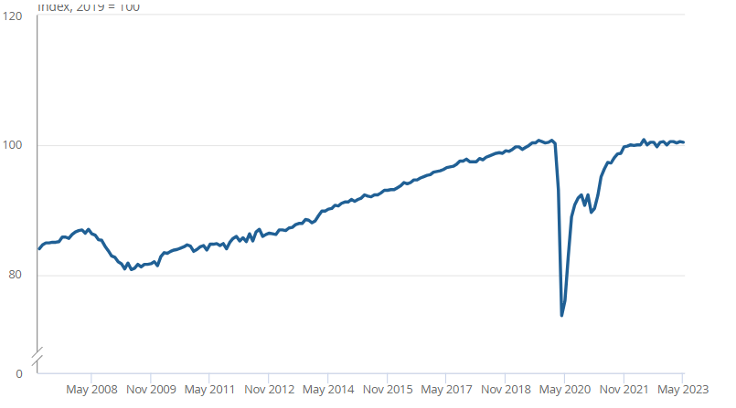
Figure 2.4.3: GDP Index for the UK
(Source: Office for National Statistics, 2023)
The decline in GDP has resulted in an increased inflation rate in the UK which provides a negative impact on companies expanding in the UK. Figure 2.4.4 shows, in the 12 months leading up to June 2023, there was a 7.9% increase in the Consumer Prices Index (CPI), showing a decrease from the 8.7% rise observed in May (Office for National Statistics, 2023a). Increasing expectations of inflation should result in reduced “real interest rates”, thereby stimulating higher spending by businesses and households (Rondinelli and Zizza, 2020). This will result in a shift in consumer buying behaviour which produces a shift for businesses to grow their opportunities in the UK industries.
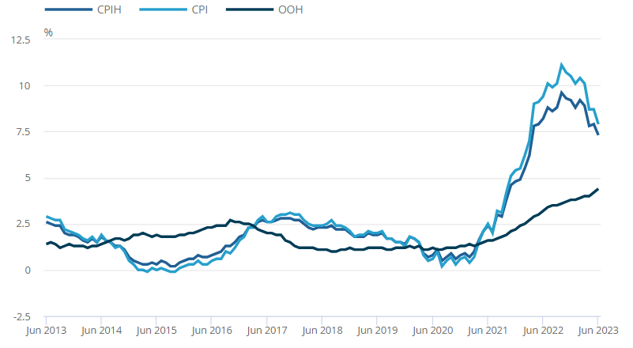
Figure 2.4.4: Inflation Rates in the UK
(Source: Office for National Statistics, 2023a)
However, the electricals market in the UK achieved a total value of GBP 24.1 billion in 2021 (The Global Data, 2023). Hence, this demonstrates a positive market for Philips as it operates solely in the electrical industry if the other factors are considered and strategised accordingly.
Social
Currently, the UK population is approximately 67.76 million with a growing movement as per the indicator (Worldometers, 2023). This develops opportunities for organisations like Philips who operate in the electric industry, as with the growing population, there will also be a significant growth in the demand for electric supplies. Electric supplies are the most common requirement for offices, schools, and households.
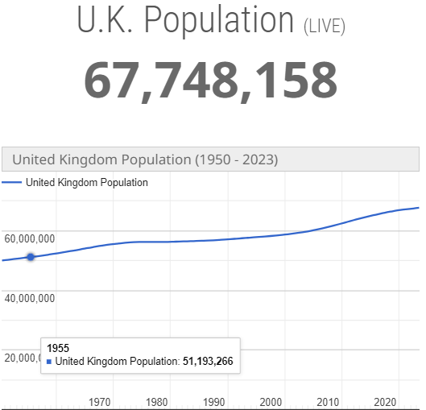
Figure 2.4.5: Population of the UK
(Source: Worldometers, 2023)
Due to the increasing demand, the projected revenue for the industry in 2022 is approximately 14 billion Pounds (Statista Industry Report, 2023). In 2021, the subindustry specializing in the "Manufacture of electric motors, generators, transformers, and electricity distribution and control apparatus" experienced growth of 0.4%, which was slower compared to the overall industry's average growth rate (Statista Industry Report, 2023). The electronics sector is highly competitive, and companies need to stay ahead of economic trends and consumer behaviour to remain successful.
Lastly, consumer behaviour in the UK has massively moved towards the sustainability of the environment and resources (Hardcastle, 2021). The emphasis on sustainability and environmental consciousness can be both an opportunity and a challenge for the electronics industry. While eco-friendly and energy-efficient products are gaining popularity, implementing such features may require significant investment in research and development. Moreover, meeting stringent environmental regulations may add to production costs, impacting product pricing and competitiveness.

2.5. Comparing the strategies
The strategy needs to be brought under direct competition in order to ensure that Philips gets a proper overview of the particular strategy that can be implemented and inaugurated into the company operations for induction into international business (Areiza-Padilla and Cervera-Taulet, 2023). This is the reason as to why comparison needs to be brought about these particular three distinctive strategies on the account of the definition functions and their benefits and disadvantages. This will not only help the company to distinguish the best possible International strategy which needs to be implemented but will also deal with the risk averting factors that can only be culminated if the most effective strategy is considered. Therefore the three strategies comparison on the basis of their aspect as a whole is explained below in a detailed manner:

Comparison based on definition
Ethnocentric strategy is seen to bear along a constant approach as far as inducing operations all over the globe is concerned. This particular strategy makes it certain that proper control is exercised by the parent company on all international subsidiaries by abiding with the international culture and values (Ramadania et al., 2023). On the other hand, polycentric strategy focuses on the particular requirements of the international market where the parent company is trying to either enter or focus upon (Pain et al., 2023). This strategy offers significant benefits to its international subsidiaries by offering them rightful laws and principal in order to make most of the decisions associated with the company expansion and business. Last but not the least geocentric strategy always tries to incorporate largely with the global resources and operations (Kant et al., 2023). This particular strategy tries to locate and hire global talent irrespective of their practices and nationality which in turn helps a company to maximise or enhance their adaptability, success and last but not the least creativity on the basis of their marketing needs. These strategies that have been discussed on the basis of the definition quite well signifies the level of distinctness each holds against the other.
Definition wise, if the three strategies need to be compared then it can be suggested that as to what global business orientation is concerned, geocentric strategy is found to be immensely cooperative in nature. This particular strategy can significantly help in using proper benefits of the global grounds based on which an international marketing policy can be designed (Panou and Korakitis, 2023). This strategy when compared with that of the rest of the two strategies suggest quite precisely that as Phillips is trying to expand its business on the international grounds this particular strategy is going to help it out on a proficient basis by keeping the parent company in sync with the International requirements.

Comparison based on function
Ethnocentric strategies, when implemented, find it immensely difficult in order to comply with the local values and approaches of the international market where the company is showing to enter or has started its operations (Areiza-Padilla and Cervera-Taulet, 2023). This particular strategy does not allow the entire market to act in a responsive manner because of the faults that are existing all around it. This strategy with its specific approach and refusal to integrate with the local culture and values majority of the time leads to missed opportunities, which can severely hamper not only the reputation of the parent company but can also bring monetary damages to the strategist (De Yusa et al., 2023). Polycentric strategy on the other hand, is quite opposite to the foremost strategy by initiating that an improved responsiveness is triggered towards the local market so that a proper understanding between the company culture and the local area can be ensured (Gatignon and Capron, 2023). This strategy is found to be immensely collaborative with that of the existing local cultures which helps a parent company to gain the local advantages to a great extent (Jordan et al., 2023). This quite well denotes the way through which an overall basis of asserting proper areas of marketing culture is found out to be an advanced one as far as polycentric strategy and its implementation is concentrated.
Geocentric strategy is to integrate seamless experience by ensuring that advanced techniques are well implemented from all over the world so that global business can be initiated. This particular strategy can be considered to be an advantageous one with reasons accounting the fact that it emphasises largely on sharing information on a global note by integrating proper team collaboration which incorporates both local and international skilled workers and last but not the least all aspects of global synergies are brought into functioning (Zhang and Mu, 2023). On the basis of the comparison that has been initiated about the three strategies on the basis of the function, it can be well suggested that geocentric strategy is found out to be the most proficient one (Li and Pilz, 2023). The reason for suggesting this particular fact or reasoning is the function and description of the geocentric strategy which completely suggest that as far as international business is concerned, it does favours global scale and seamless experience. This fact alone makes this particular strategy stand out from the rest when compared with that of the polycentric and ethnocentric strategies.
In this regard, although detailed discussion about the three strategies on the basis of the definition and function have been initiated, a picture illustration of the same will help in getting proper acknowledgement of the distinct existing among the three. Therefore the distinctive are presented below in the form of a table:

Comparison among ethnocentric, polycentric, and geocentric strategy
Ethnocentric | Polycentric | Geocentric
- Definition: It focuses on the operations and work culture of a parent company (De Yusa et al., 2023) | - It significantly emphasises on the local needs of an international market (Gatignon and Capron, 2023) | - It suggestively focuses on globalised approach in ensuring international business (Li and Pilz, 2023)
- Function: It restricts itself and the skills of the parent company (De Yusa et al., 2023) | - It significantly ensures to focus only on the specific area of marketing needs (Gatignon and Capron, 2023) | - It offers a globalised approach on an overall basis (Li and Pilz, 2023)

Table 1: Comparison of strategies
Therefore, on the basis of these comparisons, Philips should choose geocentric strategy suggestively, in order to expand its business internationally.

Conclusion
The analysis of the case study regarding international strategies for expansion reveals that different approaches can be adopted by companies depending on their objectives and market conditions. The ethnocentric strategy involves managing subsidiaries in foreign countries using the same goods, services, and management methods as in the home country. This approach promotes consistency and control but may hinder adaptation to local cultures and preferences. The polycentric strategy, on the other hand, allows tailoring products and marketing to specific market needs, providing better responsiveness, but it can lead to inconsistency and duplication of efforts. The geocentric strategy integrates global operations and resources, maximizing creativity and adaptability, but may face challenges in hiring and communication.
Applying the ethnocentric strategy to the case study of Philips, the company employs nationals from the host countries for global positions, offering identical products and services as in its home country. While this approach may result in consistency and a unified corporate culture, it might limit the company's ability to recognise and fulfil the unique needs of the UK market. The uncertainty caused by events like Brexit and the need to adapt to local customs and trends could pose challenges to Philips' expansion.
Considering contextual factors, the UK's political stability offers an advantage for expansion, but geopolitical tensions and shifts in government policies should be monitored. The economic landscape, characterized by fluctuations in GDP and inflation rates, may impact market conditions and consumer behaviour. The growing UK population provides opportunities for the electrical industry, but meeting sustainability demands could require substantial investment in research and development.
In conclusion, the international strategy a company chooses must align with its objectives, market conditions, and adaptability to local cultures and preferences. Philips' ethnocentric approach may provide consistency, but it needs to be aware of the challenges posed by Brexit and changing market dynamics in the UK. To succeed in the global landscape, companies need to be strategically agile, considering the political, economic, social, technological, legal, and environmental factors of the host country. Adapting to evolving consumer behaviour and environmental consciousness will be essential for companies to thrive in the competitive electronics industry.

Reference List
Areiza-Padilla, J.A. and Cervera-Taulet, A., 2023. Consequences of xenocentrism and ethnocentrism on brand image of Starbucks: moderating effects of national culture and perceived brand globalness between Colombia and Spain. Cross Cultural & Strategic Management, 30(2), pp.348-374.
Bakti, I.G.M.Y., Sumaedi, S., Rakhmawati, T., Damayanti, S. and Yarmen, M., 2020. The model of domestic product quality syndrome. SAGE Open, 10(4), p.2158244020972359.
Bloom, N., Bunn, P., Chen, S., Mizen, P., Smietanka, P. and Thwaites, G., 2019. The impact of Brexit on UK firms (No. w26218). National Bureau of Economic Research.
Calderón, E., De Pascale, S. and Adamou, E., 2019. How to speak “geocentric” in an “egocentric” language: A multimodal study among Ngigua-Spanish bilinguals and Spanish monolinguals in a rural community of Mexico. Language Sciences, 74, pp.24-46.
Costa, R.M. and Bruno, M.A.C., 2023. Acquisition strategy to access innovation: the EMC experience in learning lessons. Technology Analysis & Strategic Management, pp.1-15.
De Yusa, V., Mahrinasari, M.S. and Bangsawan, S., The Effect of Acculturation to Western Culture (AWC) and Consumer Ethnocentrism on Purchase Intention: A Literature Review. Strategic Alliance Between, p.99.
Dekhili, S. and Nguyen, T.P., 2021. Green consumption in Vietnam: Effects of eco-certification, brand, and moderate incongruity of their origins on purchase intent. Recherche et Applications en Marketing (English Edition), 36(3), pp.25-49.
Depledge, D., Dodds, K. and Kennedy-Pipe, C., 2019. The UK’s Defence Arctic Strategy: Negotiating the slippery geopolitics of the UK and the Arctic. The RUSI Journal, 164(1), pp.28-39.
Dobrowolski, Z. and Sułkowski, Ł., 2020. Public ethnocentrism: a cognitive orientation and preventive measures. Journal of International Studies, 13(2).
Gatignon, A. and Capron, L., 2023. The firm as an architect of polycentric governance: Building open institutional infrastructure in emerging markets. Strategic Management Journal, 44(1), pp.48-85.
Guan, X., Sun, H., Liu, N. and Zhou, H., 2022. Polycentric clustering and structural regularization for source-free unsupervised domain adaptation. arXiv preprint arXiv:2210.07463.
Hardcastle, K., 2021. Consumer Awakening: One Third Of UK Consumers Want To Shop ‘Responsibly’. [online] Forbes. Available at: https://www.forbes.com/sites/katehardcastle/2021/07/27/consumer-awakening-one-third-of-uk-consumers-want-to-shop-responsibly/?sh=2031ea867d72 [Accessed 19 Jul. 2023].
Huang, J., Wan, X., Peng, K. and Sui, J., 2020. Grey matter volume and amplitude of low-frequency fluctuations predicts consumer ethnocentrism tendency. Neuroscience Letters, 732, p.135053.
Jordan, N.R., Wilson, D.S., Noble, K., Miller, K., Conway, T.M. and Cureton, C., 2023. A polycentric network strategy for regional diversification of agriculture: Theory and implementation. Frontiers in Sustainable Food Systems, 7, p.1012759.
Kant, S., Dejene, F. and Garuma, G., 2023. Is Marketing Strategies and Business Sustainability are mediated through Entrepreneurial Innovation in Ethiopia?. Journal of Social Sciences and Management Studies, 2(2), pp.13-22.
Karthikeyan, A. (2023) Philips marketing strategy: Driving Sustainability and Sales, StartupTalky. Available at: https://startuptalky.com/philips-marketing-strategy/ (Accessed: 19 July 2023).
Kehm, A., Sánchez, L., Bloßfeld, M., Seitz, M., Drewes, H., Angermann, D. and Seitz, F., 2022. Combination strategy for the geocentric realization of regional epoch reference frames. Journal of Geophysical Research: Solid Earth, 127(10), p.e2021JB023880.
Koninklijke Philips NV (PHG), K.P.N. (PHG) (2023) Philips (PHG) Financial Summary, Investing.com India. Available at: https://in.investing.com/equities/philips-kon-financial-summary#:~:text=Koninklijke%20Philips%20N.V.%20reported%20earnings,151%20million%20a%20year%20ago. (Accessed: 19 July 2023).
Li, J. and Pilz, M., 2023. International transfer of vocational education and training: A literature review. Journal of Vocational Education & Training, 75(2), pp.185-218.
McCarthy, N., 2021. Infographic: The Consequences Of The UK’s Brexit Strategy. [online] Statista Infographics. Available at: https://www.statista.com/chart/24212/uk-status-in-european-agreements/. [Accessed 19 July 2023]
Office for National Statistics, 2023. GDP monthly estimate, UK - Office for National Statistics. [online] www.ons.gov.uk. Available at: https://www.ons.gov.uk/economy/grossdomesticproductgdp/bulletins/gdpmonthlyestimateuk/may2023. [Accessed 19 July 2023]
Office for National Statistics, 2023a. Consumer price inflation, UK - Office for National Statistics. [online] www.ons.gov.uk. Available at: https://www.ons.gov.uk/economy/inflationandpriceindices/bulletins/consumerpriceinflation/june2023#:~:text=The%20Consumer%20Prices%20Index%20(CPI [Accessed 19 Jul. 2023].
Ogunsiji, O., Ogbeide, A.E., Mukuria, V., Olugbemiro, F., Workman, A. and Dune, T., 2022. From the World to Western: A Community-Engaged Teaching Strategy to Enhance Students’ Learning of Cultural Issues Relevant to Healthcare. International Journal of Environmental Research and Public Health, 19(9), p.5114.
Pain, K., Shi, S., Black, D., Blower, J., Grimmond, S., Hunt, A., Milcheva, S., Crawford, B., Dale, N., Doolin, S. and Manna, S., 2023. Real estate investment and urban density: exploring the polycentric urban region using a topological lens. Territory, Politics, Governance, 11(2), pp.241-260.
Panou, G. and Korakitis, R., 2023. Transformation from a global spherical to an adjusted local rectangular harmonic model. Acta Geodaetica et Geophysica, 58(1), pp.123-137.
Park, K., Ewing, R., Sabouri, S., Choi, D.A., Hamidi, S. and Tian, G., 2020. Guidelines for a polycentric region to reduce vehicle use and increase walking and transit use. Journal of the American Planning Association, 86(2), pp.236-249.
Pawar, A., Sangvikar, B., Chintamani, A., Jain, S. and Pahurkar, R., 2020. Analyzing the Dynamic Behaviour towards Electronic Goods: The Consumer and Sellers Perspective. Journal of Advanced Research in Dynamical and Control Systems, 12(7), pp.2516-2525.
Philips (2021) Investor relations, Philips. Available at: https://www.philips.com/a-w/about/investor-relations?_ga=2.239927237.753462207.1689764769-42837222.1689764769 (Accessed: 19 July 2023).
Philips (2023) About philips, Philips. Available at: https://www.philips.co.uk/healthcare/about/philips (Accessed: 19 July 2023).
Philips (2023) About Us, Philips. Available at: https://www.philips.co.uk/a-w/about.html (Accessed: 19 July 2023).
Philips (2023b) About Us, Philips. Available at: https://www.philips.co.uk/a-w/about.html (Accessed: 19 July 2023).
Philips, 2022. Innovating Meaningful Healthcare | Philips Healthcare. [online] Philips. Available at: https://www.philips.co.uk/healthcare. [Accessed 19 July 2023]
Philips, 2023. About us. [online] Philips. Available at: https://www.philips.co.in/a-w/about.html. [Accessed 19 July 2023]
Qi, K., Yang, C., Hu, C., Guan, Q., Tian, W., Shen, S. and Peng, F., 2020. Polycentric circle pooling in deep convolutional networks for high-resolution remote sensing image recognition. IEEE Journal of Selected Topics in Applied Earth Observations and Remote Sensing, 13, pp.632-641.
Ramadania, R., Suh, J., Rosyadi, R., Purmono, B.B. and Rahmawati, R., 2023. Consumer ethnocentrism, cultural sensitivity, brand credibility on purchase intentions of domestic cosmetics. Cogent Business & Management, 10(2), p.2229551.
Rondinelli, C. and Zizza, R., 2020. Spend today or spend tomorrow? The role of inflation expectations in consumer behaviour. The Role of Inflation Expectations in Consumer Behaviour (April 27, 2020). Bank of Italy Temi di Discussione (Working Paper) No, 1276.
Sengupta, P., Chokshi, A., Helvaci Ozacar, B., Dutta, S., Sanyal, M. and Shanahan, M.C., 2022. Language and symbolic violence in computational models of ethnocentrism: A critical phenomenology and Southern re-orientations. International Journal of Qualitative Studies in Education, pp.1-20.
Shams, R., Vrontis, D., Belyaeva, Z., Ferraris, A. and Czinkota, M.R., 2021. Strategic agility in international business: A conceptual framework for “agile” multinationals. Journal of International Management, 27(1), p.100737.
Srivastava, S., Singh, S. and Dhir, S., 2020. Culture and International business research: A review and research agenda. International Business Review, 29(4), p.101709.
Statista Industry Report, 2023. Manufacturing of Electrical Equipment in the UK - Industry Insights & Data Analysis. [online] Statista. Available at: https://www.statista.com/study/42052/manufacturing-electrical-equipment-in-the-uk/#:~:text=Statista%20Industry%20Report%20%2D%20SIC%20Code%2027&text=In%202022%2C%20the%20estimated%20revenue [Accessed 19 Jul. 2023].
Stewart, C. (2023) Philips net income 2009-2022, Statista. Available at: https://www.statista.com/statistics/272109/philips-electronics-net-income-worldwide-since-2006/ (Accessed: 19 July 2023).
The Global Data, 2023. ShieldSquare Captcha. [online] www.globaldata.com. Available at: https://www.globaldata.com/store/report/uk-electricals-market-analysis/. [Accessed 19 Jul. 2023]
The Global Economy, 2023. United Kingdom Political stability - data, chart. [online] TheGlobalEconomy.com. Available at: https://www.theglobaleconomy.com/United-Kingdom/wb_political_stability/#:~:text=Political%20stability%20index%20(%2D2.5%20weak%3B%202.5%20strong)&text=The%20average%20value%20for%20the. [Accessed 19 July 2023]
Worldometers, 2023. U.K. Population (2019) - Worldometers. [online] Worldometers. Available at: https://www.worldometers.info/world-population/uk-population/. [Accessed 19 Jul. 2023]
Zdravkovic, S. and Gašević, D., 2022. Effects of Consumer Ethnocentrism, Cosmopolitanism and Cultural Intelligence on the Acceptance of Foreign Brands. Economic Analysis, 55(1), pp.48-62.
Zhang, T. and Mu, R., 2023. Attitude Tracking Adaptive Control of a Geocentric Polar Displaced Solar Sail. Aerospace, 10(7), p.606

