

Introduction to Public Health
LCHS4004_LONDON

Report Writing on: Mumps.
Case Study: Mary is 12 years old. One morning, Mary complained of neck pain. Her mom gave her Panadol and sent her to school. Mary complained that she had been having pain while eating her lunch and was not filling very well. She received treatment for a sore throat. The next morning, Mary woke up with a swollen neck, which was worrisome. Mary’s mom took her to the hospital where she was diagnosed with having the mumps.

Lecturer: Dr. Laila Surani

Student Name: Noyomie Palma
Student ID: 2215256

Table of Contents

Introduction …………………. 3.

Measure 4.

Monitor 5.

Control 8.

Conclusion 10.

References 11.

- Introduction:

Mumps is an illness which comes from a virus, called Paramyxovirus. This virus effects the glands in both sides of the face, the glands called parotid glands which makes saliva in our mouth. When parotid glands make saliva in our mouth- it helps digest our food, keep our mouth moist and support healthy teeth.
It is too painful to be swollen food or drinking water when mumps effects the parotid glands.
Mumps usually occurs in childhood but can occur at any ages. Especially the young children can be affected by this illness while they are in schools, colleges and universities and did not have vaccine in their childhood. Also, while travelling abroad or people are coming from different countries without vaccination, they can spread this illness to others.

In my report I will discuss below the points which is very important and challenges in the UK Government to deal with mumps infections:
- Measure
- Monitor
- Control

- Measure:

Mumps was diagnosed in the 5th Century in 1934 in China. Then this virus was affected many more countries- Afghanistan, Burkina Faso, Chad, Ethiopia, Kenya, Mali, Niger, Nigeria, Somalia, South Sudan, Sudan and Yemen.
Mumps vaccination developed was licenced for using in the United States in 1960s (1967).
Mumps was made a notifiable disease in the UK and was introduced of the MMR (Measles, Mumps and Rubella) vaccine in October 1988.
In England mumps cases were the highest in 2019 5,042 cases recorded- four times the numbers in 2018 which was 546 cases.
To measure mumps incidence in the UK, different laboratories in England worked very hard to find these infections, effected cases in different years:
- Before introducing the MMR in the UK there were five recorded deaths in a year due to encephalitis or swelling of the brain.
- Mumps usually happened in school-age children and about 85% of adults had evidence of previous Mumps infection.
- In 2017, in England and Wales, 1840 confirmed cases of Mumps.
- More than 90% of cases were confirmed in 15 years and above and among them were children under 1 year in December 2018.
- PHE confirmed 5,042 Mumps in 2019, compared to 1,066 in 2018.
- Mumps morbidity date from 2013 – 2022: notifications and confirmed cases by oral fluid testing in England by quarterly.
- In January and March 2022, 10 laboratories in England confirmed Mumps infection cases.
UK government took very challenges for the measure in every year on mumps virus and making the nation awareness the importance of vaccination.
- Monitor:
Mumps is virus infection disease. When the UK notified this disease and MMR vaccination started in October 1988- the government started monitoring this disease in different laboratories using the various options- like the ages, population, travellers.
I will show below some of the charts which will describe the different age group in different years:

- 1.1 Mumps outbreaks across England and Wales in 2004: observational study- This chart is showing below that the UK government monitored from 1970 - 1986 when there was no vaccination introduced. Mumps infection was increasing very quick and was affected very high rate of population. In 1988, when the first MMR vaccine was introduced- infection goes down and less people were getting this virus. In 1996 when second dose stared the case record shows less infected population.
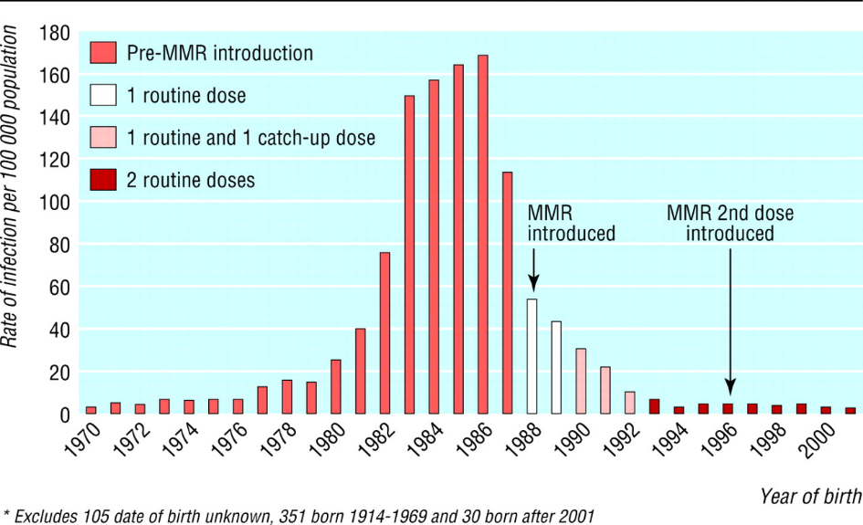
BMJ 2005

- 1.2 Mumps Monitor: United Kingdom 2004 – 2005: This chart also very notifiable in GP Surgery in England- shows that the difference rates of virus / illness between 2004 and 2005 where population were showing with and without vaccine.
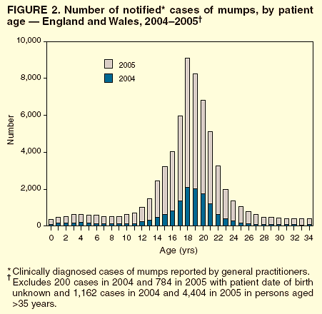
MMWR (2006)

- 1.3 Laboratory confirmed cases of mumps by quarter, England: 2012 to 2022: In England, 10 laboratories Report on mumps infections between January and March 2022 where is showing 7 out of 10 of the cases this quarter were in adults above the age of 18 years.
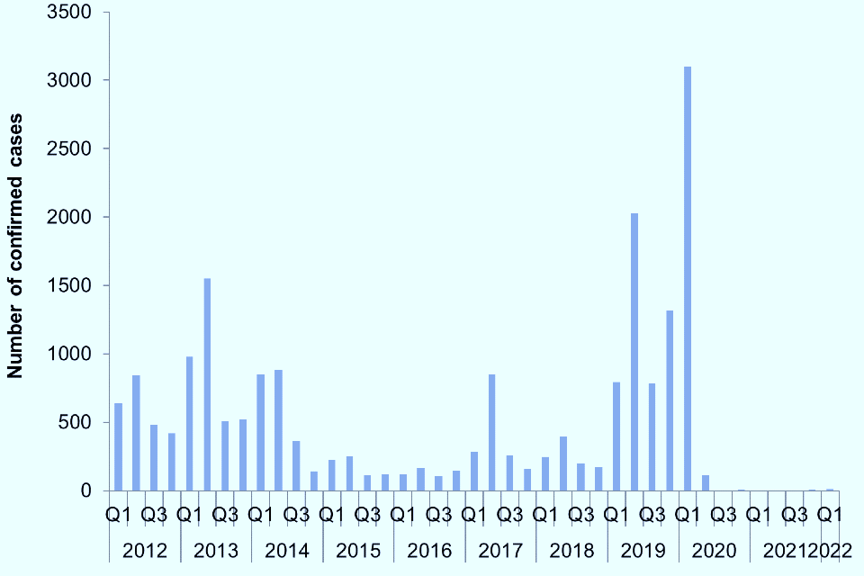
Gov UK 2022

- Control:
I am going to discuss below the strategies use in the UK to control the mumps infections: The main way to control the mumps is you must do the vaccine.

- First of all to protect the child against mumps by making sure they're given the combined MMR Vaccine for mumps, measles and rubella.
- The children should be given: Dose-1 when they're around 12 to 15 months old and a Dose- 2 booster when they are at age 4 and 6 years of age. It is very important to remember if 28 days have passed since the first dose was given, a second dose may be given before the age of 4.
- Once both doses are given, the vaccine provides around 88% protection against mumps.
- Anyone who did not have both doses of the MMR vaccine as a child can contact a GP to arrange to be vaccinated.

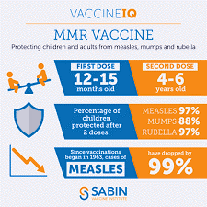
  - The chart below shows the age to take MMR vaccine:
Mayo Clinic 2022

This is especially important if you are in a high-risk setting or in an outbreak. There are some people who need to have proof of vaccination and they are:
- College students.
- People in the military.
- International travelers.
- Health care workers.

Some young children are no sure if were vaccinated- they should go for aa blood test. They can find antibodies to mumps. If they find that they have antibodies to the virus, then immune system would fight against mumps infection, and they don't need another vaccine.

UK government also care to control mumps maintaining:
- Maintaining health and safety legislation- assurance for all the people.
- Quick response of Health Protection Team- consult with health protection team (HPT).
- Proper medical care and MMR Vaccine- medical support for mump patients.
- Psychological and social support- health and hygiene and distance.
- Make people aware regarding infectious disease Mumps.
- Information should be available - everyone should act in a cooperative manner.

- Conclusion:

End of my discussion I would like to say that it is very important and challenging job for the UK government to make this illness curable. To follow the strategies of measure, monitor and control for Mumps- the GP Surgeries/ Hospitals and other medical institutions are suffering a lot. Though there are vaccination available, and it is mandatory to take to doses of MMR for mumps, but because of people faith/ religious beliefs or negative mentality- it is not possible to deliver this service to all. And government cannot force the nation to have these doses.

In the report shows us that infection of virus affected differently in past years- it is because of people awareness. Mumps is a serious virus infection - UK government has to take the challenges to make people more aware of this virus and the vaccine, so that the nation will be safe from this disease.

- References:

- GOV.UK. (2022). Mumps: notifications and confirmed cases by oral fluid testing in England, 2013 to 2022 by quarter. [Online]. GOV.UK. Last Updated: 21 September 2022. Available at: https://www.gov.uk/government/publications/mumps-confirmed-cases/mumps-notifications-and-confirmed-c (Accessed 2 April 2023).

- GOV.UK (2022) National MMR vaccination catch-up program announced in response to increase in measles cases. Available at: https://www.gov.uk/government/news/national-mmr-vaccination-catch-up-programme-announced-in-response-to-increase-in-measles-cases (Accessed 04th April 2023).

- GOV.UK (2022) Mumps: epidemiology, surveillance and control. Available at: https://www.gov.uk/government/collections/mumps-guidance-data-and-analysis (Accessed: 04th April 2023).

- M. Armstrong (2019) available on: ‘Statista’ Chart: England: how many children have had the MMR vaccine? | Statista – (accessed on 05 April 2023).

- Marck Manual Consumer Version (2015): Centers of Disease Control and Prevention: available on https://www.cdc.gov/mumps/health-departments/strategies.html – (accessed on 29 March 2023).

- Mayo Clinic Staff (2022) ‘Mayo Clinic’ available on: https://www.mayoclinic.org/diseases-conditions/mumps/symptoms-causes/syc-20375361 – (accessed on 29 March 2023)

- NICE. (December 2018). Mumps. [Online]. NICE. Available at: https://cks.nice.org.uk/topics/mumps/background-information/prevalence/ (Accessed 2 April 2023).

- Public Health England (2019) PHE STRATEGY 2020-25, P.2. Available at: https://assets.publishing.service.gov.uk/government/uploads/system/uploads/attachment_data/file/830105/PHE_Strategy__2020-25__Executive_Summary.pdf (Accessed 04th April 2023).

