BUSINESS PLAN
THE HAPPY MUFFIN



STUDENT: ANDREEA POPESCU
STUDENT NUMBER: 1913071
Date: 11.12.2020

Business plan
According to Kierulff (2008), the business plan is the document built to determine the path of an enterprise in a certain period of time. It establishes the mission, objectives, strategy and action plans for carrying out a specific activity during a determined future period, (Kierulff, 2008).
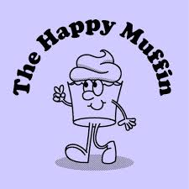

The Happy Muffin focuses on the production of multi-flavored muffins, candies and related cakes, and the sale of ice cream (especially in the summer season).
Every day needs a sweet moment, and the Happy muffin dessert shop offers this to the customers.
The Happy Muffin is a fairytale land, in a world that carries with it the best aromas of cakes, the tastiest cakes, the most delicious smell of pastries.
The store will offer the best and freshest dishes in the area to its clients. Using high-quality ingredients prepared according to the original recipes will do this.
For the most sought-after products, the menu and marketing activities will focus on maximizing sales.
The shop is constantly ready to face the fiercest challenges and transform them in real success.
The products are created to tell a delicious story, so the concern is to constantly refine the recipes to reach the tastes of each customer, to be satisfied with the products.
This is a sole trade business how aims to offer quality products and services at average prices, managing to create a stable clientele that will advise other customers to the dessert shop.
As a sole trader, you have total control of the business, "your own boss" in the ultimate sense. Is no need to consult other directors or shareholders, take their views into account or compromise your own vision for the company, which means you can grow it exactly as you want.
This business idea started because there is no direct competitor on the local market. This is a factor that can guarantee the success of the business. A retail dessert shop requires dedication, talent and a substantial investment, but it can turn into a profitable business.
Moreover, the cake recipes are the traditional ones, while the pastries are made according to old recipes and aims to recreate tasty memories.
The marketing objectives of the Strategic Marketing Plan are derived from the general objectives of the Company, which are aimed at maintaining the balance between products and markets in general (the sale of existing products, the marketing of existing products in new market segments and the development of new products in market segments) and which may include in particular, objectives relating to aspects related to promotion, human rights (Scott and White, 2014).

Objectives:
Opening a successful dessert shop with a young middle-class segment of people
In the first business year a minimum number of 70 clients / day
Developing a trusting customer relationship, so that the promotion of the shop is mainly achieved through recommendations.
Muffins (with various assortments: chocolate, cherries, blackberries, currants and ice cream with various fruits, candies and associated cakes are the main focus of the shop offer.
Marketing objectives and strategy
The aim of the company is to enter the food market, a market with visible potential to be exploited even under current economic circumstances.
The dessert shop wants a large base of loyal customers to be established and will therefore focus its marketing plan on locals, who will be the dominant target market.
A target market refers to a community of prospective buyers to whom a company wishes to sell its goods and services. Also included in this category are unique customers to which a business directs its marketing activities. To ensure business stability, this will establish a consistent revenue (Aghdaie and Alimardani, 2015).
The aim of the management is to attract and in particular, to retain middle-class customers, to offer quality products at a fair price and with impeccable service.
Happy muffin is seen as a warm and welcoming place where employees make friends with clients and establish a relationship of trust.
Competitive advantage of products and services
A marketing mix is a series of acts used by corporations and advertisers to help promote their brand or to sell a product or service they offer. It is crucial to build a marketing mix strategy when selling a new product or service that effectively combines the main marketing ingredients together to achieve the desired result (Pulido Polo, 2018).
Marketing Mix – 7s P
Price
Customers want to eat a high-quality product at an affordable price in a relaxing atmosphere. They want the experience to be unique, full of good taste. The difference between Happy muffins and other dessert shops will be affordable prices accompanied by quality.

Product
The products offered by this dessert shop will be based on differentiation. In local area there is no dessert shop to produce muffins.
The goods will be produced in an original manner, will have a pleasant appearance and will draw customers.
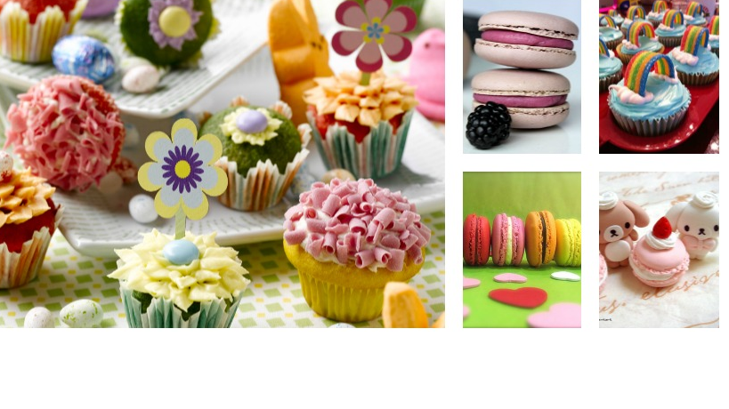

People
In particular, the clients of the 'Happy Muffin' are the people who live in the local area, but also other people who visit here and who are part of the category of the middle class, aged between 15 and 55, are trained to socialize and appreciate a quality service. Over the weekend, the highest customer traffic will be recorded. The largest sales will be made between 7-9 am and 2-6 pm during the week.
Promotion
The management wants the recommendation of satisfied customers to be the strongest mechanism to promote the dessert shop.
The dessert shop will be continuously promoted in paper and online format by leisure guides (www.justdesserts.uk, www.afterhours.uk). A short description of the shop, the services offered, its own website and a phone number will be presented through these channels.
Social media will be used for promotion.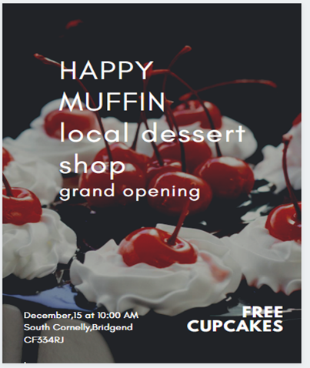
Google my business
Google my business is a free tool that allows companies to manage Google search and Google maps online presence. Google My Business Account lets you show up in search results when individuals search for you online. It is free, making it an affordable marketing tool for small and large businesses alike (What is google my business and why do I need it? 2020).
Happy muffin will take advantage of Google my business in order to increase visibility in research the shop.
The main financial aspects
The company aims to rent a space near the city center for the development of the activity, properly arrange the space and promote the shop within the targeted segment. The financial resources have the following structure:
-own: 20,000 pounds
-lending: 10,000 pounds
This project requires an amount of 30,000 pounds, detailed in the business plan.
Profitability of the company
According to Fitzpatrick (2016), a company owner must learn to achieve a satisfactory degree of profitability in a competitive marketplace. Growing efficiency includes deciding which areas of a financial plan are operating and which ones need reform. Understanding the main factors that decide profitability helps managers build an efficient profitability plan for their company (Fitzpatrick,2016).
Profitability is a measurement of efficiency – and ultimately its success or failure.
The company's successful profitability would be 80-90 percent, taking into account the openness and adaptability of the inhabitants of the local area to something new, the barriers placed on the market by the existing people and the way of working used in the dessert shop, the natural and unique way of preparing products.
Management team
The Happy Muffin is managed by the General Manager Ionescu Cristina and the shop Manager Popa Ana.
The shop manager is a dynamic, flexible individual with a wealth of experience in this field, who has accumulated years of activity and who knows the role of teamwork. She will be in charge of the shop's operational management, subordinating all employees.
Manufacturing processes involved
The necessary equipment (for preparing cakes and storing products) will be obtained directly from suppliers, on the basis of a free loan agreement (one of the parties, called the lender, transmits for temporary and free use to another party).

In this way the company, without additional costs, will own modern equipment. In addition, the suppliers will also provide staff training on the use of the devices, but also on the way the products are served.
It is possible to buy or borrow the necessary devices (for preparing cakes and ice cream) from suppliers of ingredients.
In the second case (the one selected for that undertaking), the management undertakes to buy the goods only from that supplier, which may impose a mandatory monthly target.
The benefits of working with suppliers in partnership instead of buying products such as Asda / Lidl / Tesco from a hypermarket:
• time saving - the supplier will bring ingredients / drinks at set time intervals.
• low costs - the devices are taken into custody free of charge, not purchased or rented, and the service is free; you also receive all the materials needed to serve for free (cups, trays, menus, glasses, napkins, etc.);
The quality of products
Product quality means integrating features that can meet customer expectations (wants) and provide customer loyalty by improving products (goods) and freeing them from any defects or defects (Martynova,2011).
The firm is aware that the quality of products and services is a critical point in order to create a long-term relationship with its customers.
The company relies on the quality of inputs and processes to ensure the quality of final products. The company's suppliers are therefore nationally (and even internationally recognized for the quality of the products offered.
In order to obtain maximum quality, the product preparation process will follow exactly the established parameters. The dessert shop strictly respects quality standards, requiring its suppliers and collaborators to have the same attitude.
The company will also allow direct communication with customers, through a box of suggestions / complaints in the shop, but also by posting the shop manager's phone number in a visible place. The suggestions / complaints box will be regularly consulted, the dissatisfactions and suggestions of the customers will be carefully analyzed and resolved.
Initial investment costs
The amount of money spent on the investment, the investment expenditure needed to exercise the option, the expense of turning the incentive for investment into the underlying asset of the operating project (Wallance,2012).
The arrangements will be made by Total builder Construct, according to the pre-calculated expenditure estimate on the occasion of drawing up the business plan. So:
• electrical installation: for lighting and operation of equipment: 1500 GBP
• sanitary installations, which include hot and cold-water supply and sewerage for the evacuation of domestic water: 1000 GBP
• heating / cooling system ensures comfort through temperature, constant humidity and purified air: 1500 GBP
• installation for low currents: telephone, computer, surveillance cameras, alarm, cash register, sound system, etc.: 1000 GBP
• interior design:
a plasterboard ceiling and walls: 400 GBP
designed walls and painted with washable paint: 600 GBP
a floor cleaning: 500 GBP
a replacement of 20sqm tiles: 600 GBP
• internal organization of the cafe:
Storage spaces - 4 sqm:
- 1 refrigerator for soft drinks - provided free of charge by the supplier of soft drinks,
- ice cream fridge / freezer - provided free of charge by the ice cream supplier,
- refrigerated display case for food and cakes - 300 GBP
- oven: 150 GBP,
- planetary mixer 50 GBP
- sing 20 GBP,
- ice making machine: 150 GBP,
- technological furniture: worktables, cabinets, shelves: 1500 GBP.
Locker room for employees - 3 sqm: furniture - 200 GBP
- Reception and serving spaces: 80 sqm (40 - 35 places):
- tables: 15 pcs x 100 GBP / pcs = 1500 GBP
- armchairs: 30 pcs x 50 GBP / pcs = 1500 GBP
- corner sofa (2 people): 2 pcs x 300 GBP / pcs = 600 GBP
- TV (LCD): 2 pcs * 250 GBP / pcs = 500 GBP
- interior decorations (flower vases, indoor plants, paintings, curtains, decorations, supports, etc.): 500 GBP
video surveillance, monitoring and recording system: 1,500 GBP
Serving inventory (dishes):
- dessert plates: 40 * 2 GBP/ piece = 80 GBP
- cutlery (set: forks + knives + teaspoons): 40 x 4 GBP/ set = 160 GBP
- glasses for soft drinks, ashtrays, napkins, trays, menu holders
Storage room: shelves - 200 GBP
Office - 4 sqm
a computer: 500 GBP
a printer / copier / fax / scanner: 300 GBP
a telephone: 100 GBP
various - office supplies (files, paper, pens, etc.): 100 GBP
Total investment costs: 17,010 GBP

SWOT ANALYSIS
Strengths:
- Originality (special product design, loyalty programs, related services)
- quality of products and service
- experience of the person in charge
- profit
- location.
Weaknesses:
- lack of reputation on dessert shop in the area
- lack of experience of the shareholder in this type of business
- insufficient initial own funds
Opportunities:
- further reduced number of dessert shops
- a trip to the dessert shop involves a lower cost than a trip to the restaurant
- a greater openness of consumers to socializing outside the home
- consumer tastes have evolved, they now appreciate a cake and a service they prefer quality
- increasing the share of customers who take the cake in the package
- decrease of rent for commercial spaces
- a greater ease of finding a commercial space compared to previous years.

Threats:
- a possible decrease in consumption in frequency and quantity
- low liquidity on the market
- increasing the cost of raw materials.

Cash flow
Cash Flow is the rise or decrease in the amount of money that a business, organisation or person has. The term is used in finance to describe the amount of cash (currency) produced or consumed during a given period of time (Vadilyev,2014).

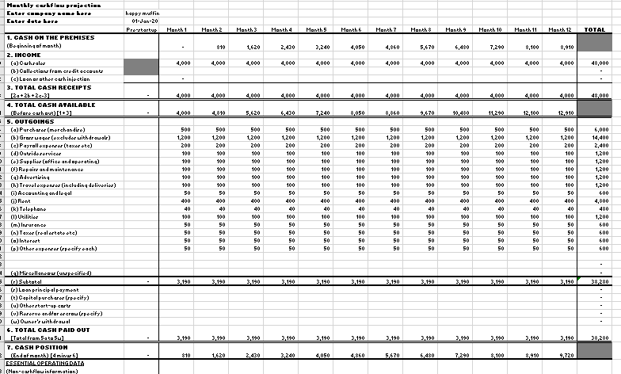

Reference list

Aghdaie, M.H. and Alimardani, M. (2015). Target market selection based on market segment evaluation: a multiple attribute decision making approach. International Journal of Operational Research, 24(3), p.262.
Fitzpatrick, K., (2016). Moving science forward in a competitive marketplace. Lipid Technology, 28(8-9), pp.141-143.
Horton, M. (n.d.). The Difference Between Profitability and Profit. [online] Investopedia. Available at: https://www.investopedia.com/ask/answers/012715/what-difference-between-profitability-and-profit.asp#:~:text=Definition%20of%20Profitability&text=Profitability%20is%20a%20measurement%20of [Accessed 1 Dec. 2020].
Kierulff, H., (2008). What a Business Plan Must Show. Economics and Organization of Enterprise, 2(2), pp.54-61.
Martynova, O. (2011). Aspects of Product Quality Control: Determination of Quality Components and Product Quality Factor. Social and Natural Sciences Journal, 2.
Pulido Polo, M., (2018). Acts or events? A perspective from the marketing mix. IROCAMM-International Review of Communication and Marketing Mix, (1), pp.56-66.
Scott, K. and White, M., (2016). Mere Exposure as a Signal: Company Objectives and Research Propositions. Journal of Marketing Theory and Practice, 24(4), pp.411-421.
Vadilyev, A. (2016). Cash Flow Environment and Saving-Cash Flow Sensitivity. SSRN Electronic Journal.
Wallace, S. (2012). Competition and Cost Management Investment. SSRN Electronic Journal.
Wordstream.com. (2020). What Is Google My Business & Why Do I Need It? [online] Available at: <https://www.wordstream.com/blog/ws/2020/06/08/what-is-google-my-business> [Accessed 10 November 2020].

