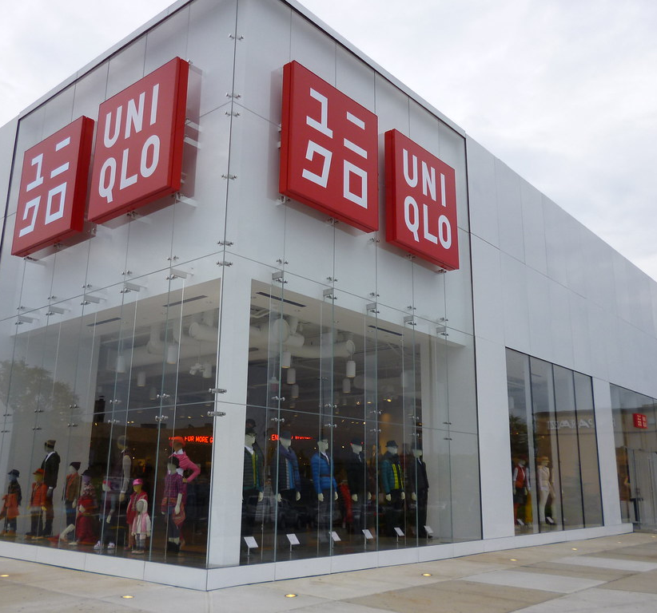
Marketing Fundamentals
LCBB4004
Blogging to Communicate
Student: Anca Mirela Dula (2112863) | Date: 07/01/2022 | Lecturer:  Tushara Balendran

The H history about Uniqlo
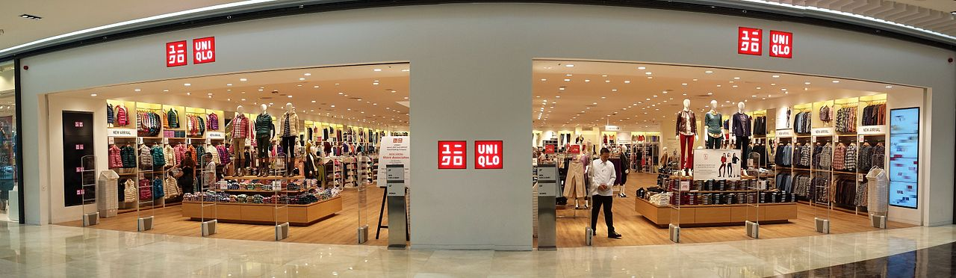
Uniqlo is a Japan company founded in Yamaguchi, in 1949 as a textile, manufacturer business, in the present is a retail company across the word with over 1900 stores. The first doors were opened in June 1984 and has a real success because they were providing a good control of process from, production, distribution, planning and marketing.

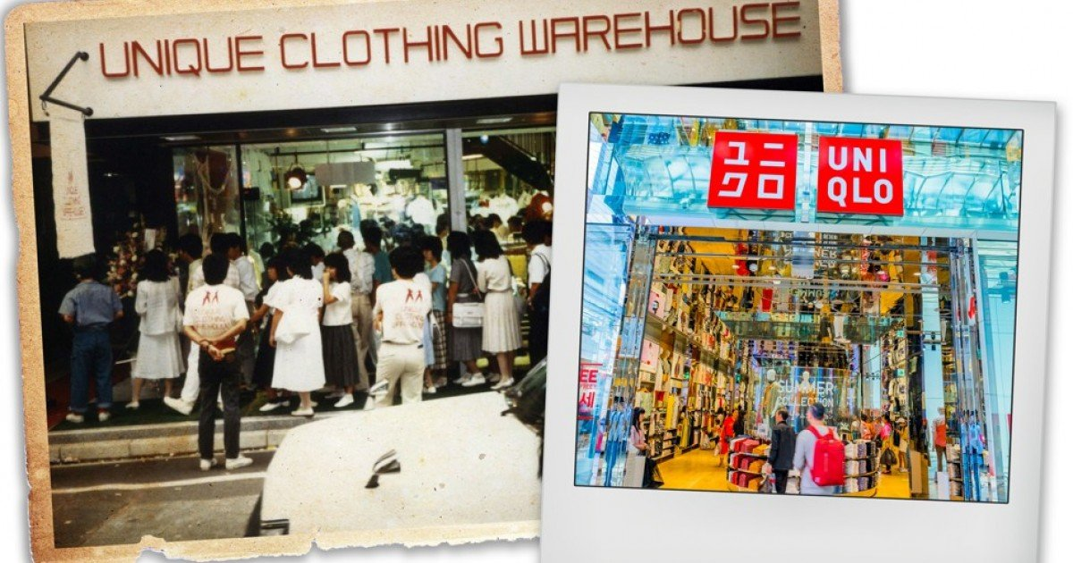

The first store was open under
the name “Uniqlo Clothing
Warehouse” and was offering
an affordable price for women’s,
means and kids. Further to this,
the brand states that” Uniqlo is
more that a just a clothing brand,
but a way of thinking. A steady
consciousness of constant changes,
diversity, and the challenging of
When decide to expand the business internationally, it was not expecting that thinks would go wrong, unfortunately they should close 16 of stores, another three left was still going on. After log investigation and new plans and strategy the company start to gain more and more trust from customers and they reopen again more shops in the UK, fifteen so far.
convention.”

The Logo
Uniqlo Logo is create from two colours, red and white which, richness in contrast saturation, making you to be attracted and to capture your attention. Also, the logo “unique clothing” is short and easy to memorize and make customer to feel incomparable. Uniqlo create and two version of the logo, one in English with” q” instead of “c”, and Japanese one with “c” instead of “q”.


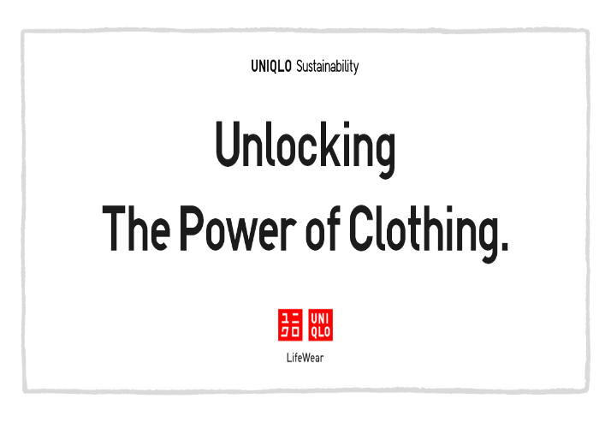
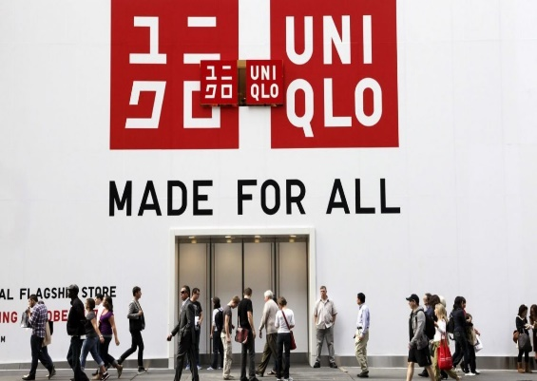

Uniqlo-Mission and Vision
Mission
Uniqlo mission is says “We provide high quality; trendy and basic casual wear the lower prices a casual wear that any body can wear whenever and whoever. The company wants to achieve their goals and strengthen people, planet, and community.

Vision
Uniqlo vision statemen is “To become the number one clothes retail in the word”, believing in their strategy, good organisation, and providing high standard through customer satisfaction.
The Uniqlo brand vision include some elements:

Some of the component of Uniqlo mission are:

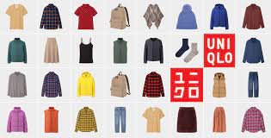
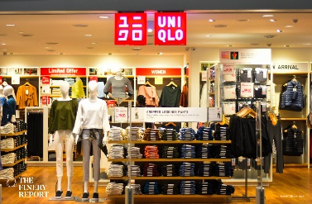
Product
For Uniqlo the products means more than an items for sale, means a whole technological process of knowing the materials, the way of manufacturing, the final design, and the last and the important one is customer satisfaction, after trying on. For business these aspects are very important and Uniqlo does not produce quantity it produces quality at affordable price for each person.
Are focussed to create the best quality of fabric, longevity clothes for women, mean and kids, during the year has some special collection brand which include maternity collection, swimwear collection, new arrivals and the most special and unique collection is Heattech.
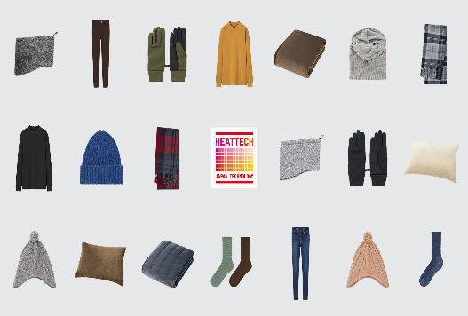
Heattech
Heattech is a special material made from polyester, rayon and acrylic which keep your body warm and moisture converting kinetic energy into heat. The collection includes leggings, sweater, undershirt, hat, glove, underwear and more and have three types of heattech: regular, extra-warm and ultra-warm.

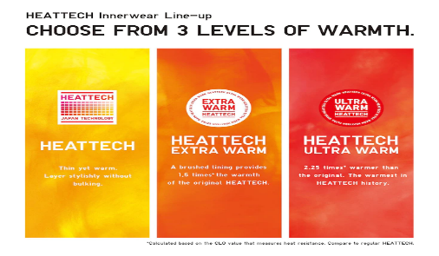

Benefits
The benefits to wear and to buy a heattech are many, but main once is, affordable price, comfortable, lightweight. quick dry and fashionable.

Features
The characteristics of the Heattech make the product unique through design and components, in fact it brings a benefit to the company because no one on the market produces a similar product.

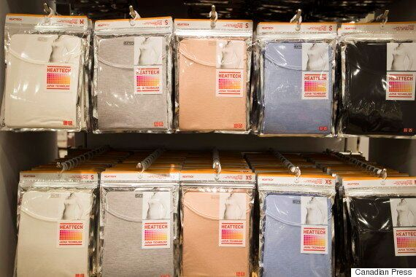
Packaging
For Heattech is use plastic packaging and helps the company to create a grate value for company and help environment and its more efficient, practical and look more organized in the shop.

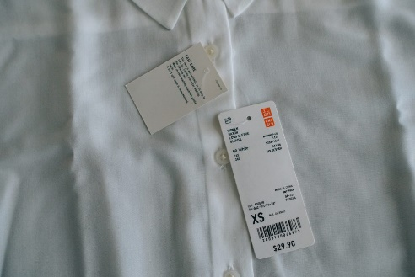
Prices
Uniqlo prices are the same as quality, and its use the same prices for online and offline store, because usually consumers are used to compare the prices. Other businesses use to change the price in the physical store because the expenses are higher, but Uniqlo take care of customers and keep same price.

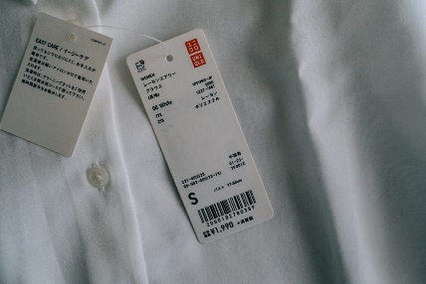

Pricing Strategy

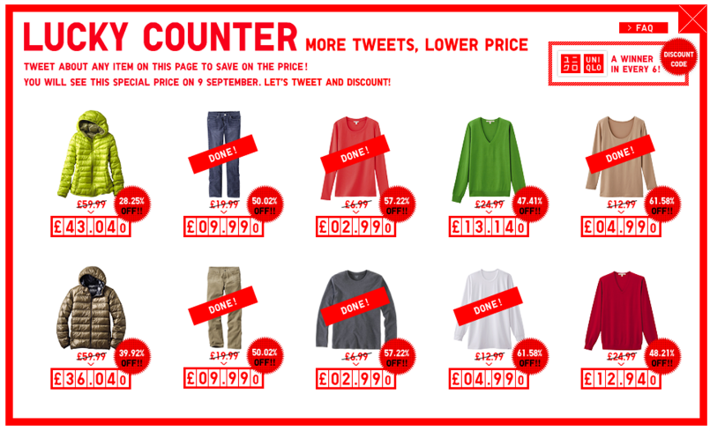

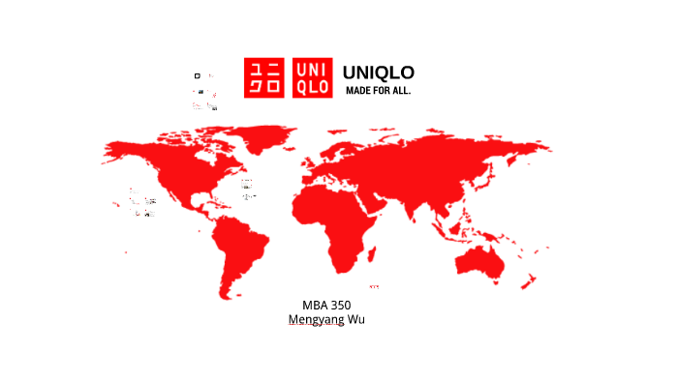
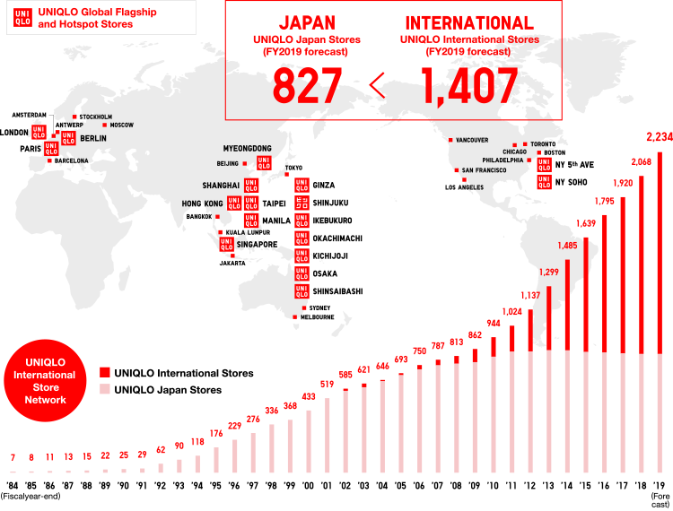
Uniqlo’s Location and Distribution
During the time Uniqlo opened the doors in more than 2000 stores across the world, more that 800 stores are open in Japan and the rest are over 25 markets worldwide.
Uniqlo uses its own direct channel to sell the products, this strategy is in favour for company because it helps them to control and manage sales, profit, the customer service quality and to have total control over brand image of company.

Its

The company disperses its products to its customer with several offline retail stores and online store. I will leave here some places across the world where operate. One of Uniqlo’s main brand communication methods is its in-store environment. Through its wide aisles, bright lights, neatly stacked shelves, and beautifully presented displays creating a comfortable and welcoming shopping experience.

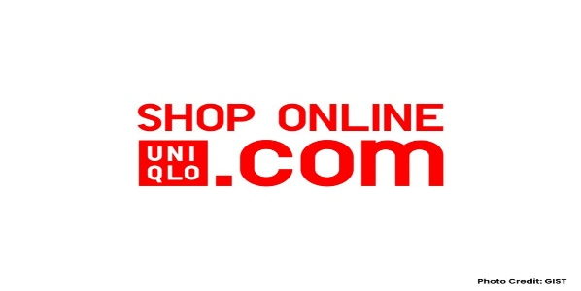
Uniqlo’s offline store
Uniqlo try to keep the same standards and innovation technology, to adapt to new strategy and to make online store according to customer preferences and to enjoy the fact delivery to our house or to collect to the near store.

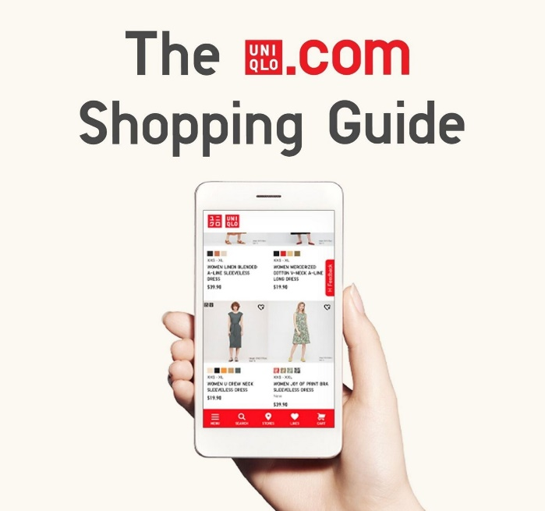

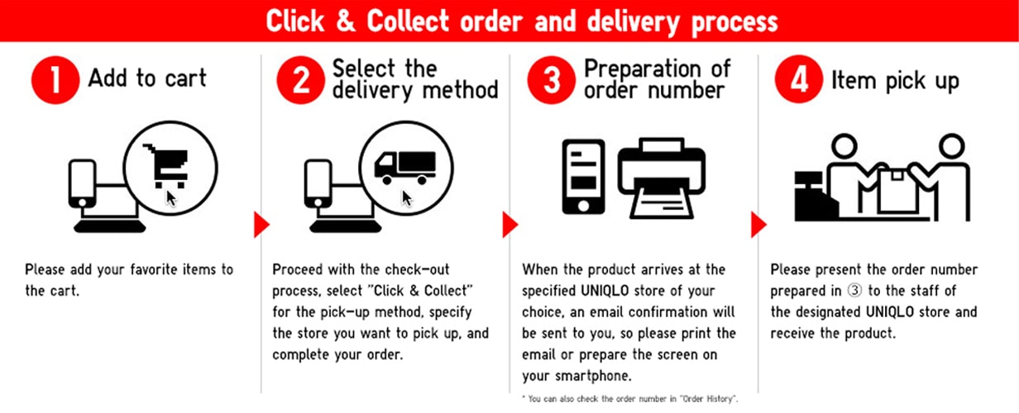

Uniqlo Promotion
Uniqlo has adopt fast in every country when took about promotion marketing strategy, with many ears ago when start wasn’t like now to have access to internet and all social media. Before was using newspaper, magazine, television, and flyers.
Over the time technology has advanced and now promote the products through Uniqlo website and Apps, Facebook, Instagram, and Twitter.

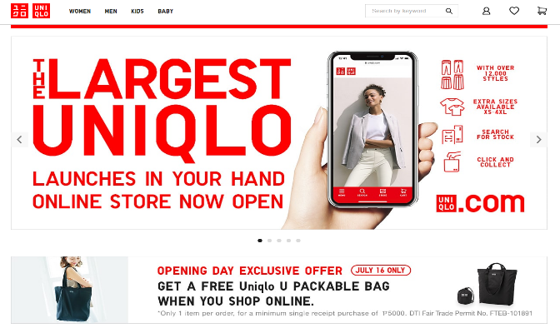
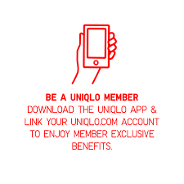

Today the company is using celebrity brand ambassador, collaborate with design and brand campaigns. The most important attributes are to look after brands ambassadors are with a strong character, in present Uniqlo has six global ambassadors. The ambassadors representing the UK are tennis champions Roger Federer and Kei Nishikori, another ambassador is Snowboarder champion Ayumu Hirano, tennis champions Shingo Kunieda and Gordon Reid and pro golfer champion Adam Scott.

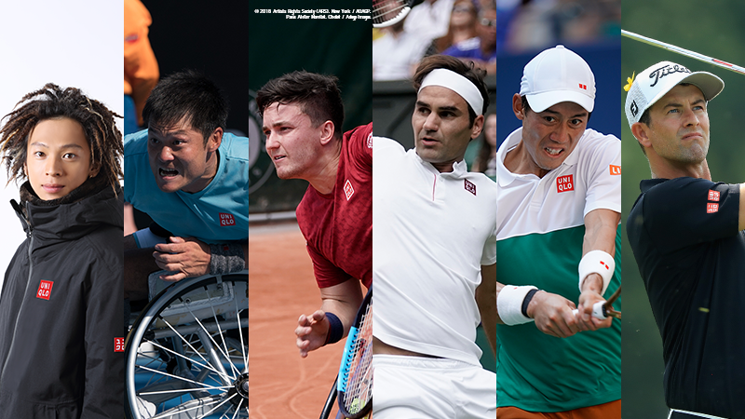
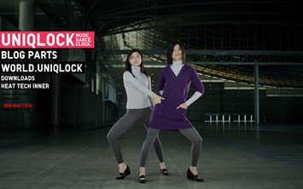
In 2007 Uniqlo successfully launched the digital marketing campaign “Uniqlock”, this project was designed to grow internationally, it consisted of a clock made of choreographing dancing and captivating music, all matching the ticking of the clock. After this great success around the world Uniqlo win numerous awards such us: Grand Prix and Cannes Lions Festival and more.

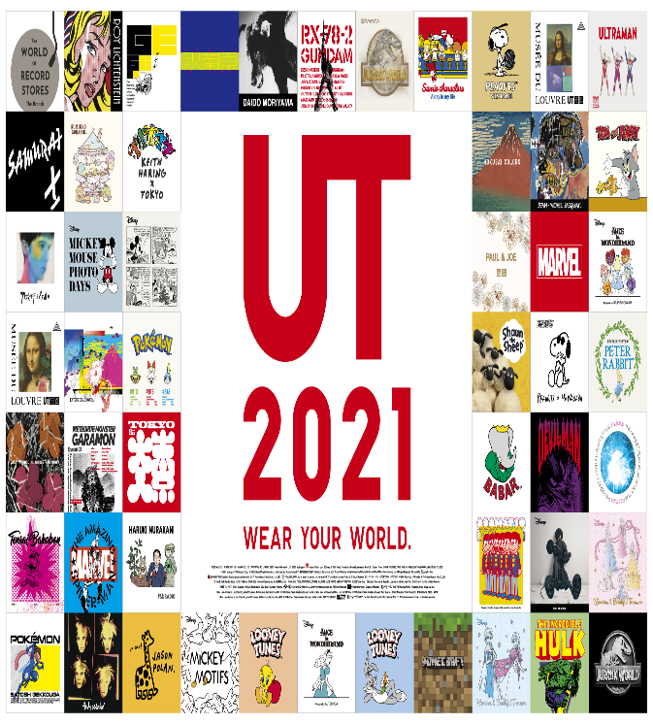

Collaboration with designers help the brand image od company and bring new customer because the products have high quality and had exclusive design.
Some of the collaborator which Uniqlo done in recent years are Theory’s “T Down, NIGO’s “UT”, Lemaire’s “Uniqlo U”, Uniqlo x Marimekko.

In 2016 Uniqlo launched the first global brands campaigns with tittle “The Science of Life Wear”, was showing people on the street wearing simple but chic clothes.

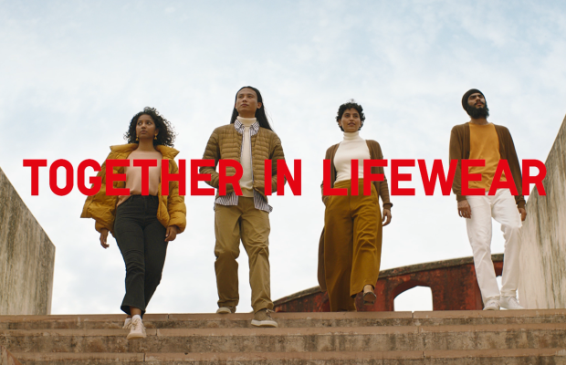

Uniqlo’s SWOT Analyses
Strengths of Uniqlo
- Is one of the largest retail brands in the world
- Has a physical and online store
- Had a strong supply chain
- Focus on innovation and has a high dedication level
- Cheeps products and chic
Weaknesses of Uniqlo
- Has been slower to adapting to new trends
- The brand has a low market share in USA market
- Stores from UK are more concentrate around London
Opportunities of Uniqlo
- Innovative technology is growing very fast
- Bringing sustainable product to European market
Threats
- Highly competitive retail industry
- Heavy impact on sales and operation due to COVID-19
- Slow down of China negatively affecting Uniqlo

Doing a thorough SWOT analysis can help business with their position and gain a better image of the brand. Identifying opportunities and strengths helps the company to make better decisions to progress and make the best plans.
We at SWOT aim to aid the understanding of the multifaceted business world by presenting a list of diverse companies from across the globe. Business organizations today cannot function in ways that ignore the surroundings that they are set in. SWOT makes a keen observation into this aspect and accounts for factors affecting such businesses.

Recommendation

In my opinion if Uniqlo wants to be number one they should continue to keep up with all new trends. Now they don’t do so many accessories and shoes, if they will start to be more focused on this aspect, I think that in the future they will have more chances to become number one in retail.
Uniqlo is doing very well when we speak about technology, and my suggestion is to introduce a vending machine and the customer can personalize t-shirt.
Also, they should continue to be more focus on online market because this is the future.
To create more discount for loyal customer, and for everybody who join in the company and as well for students, which in the present they don’t do it like another company.

References
Bhasin, H. (2019). Marketing mix of Uniqlo. [Online]
Available at: https://www.marketing91.com/marketing-mix-of-uniqlo/
[Accessed 02 12 2021].
Ismael, A. (2020). Uniqlo's Heattech clothing is my secret to staying warm in the winter without bulky layers. [Online]
Available at: https://www.insider.com/guides/style/uniqlo-heattech-review
[Accessed 11 12 2021].
Lamare, A. (2018). A brief history of Uniqlo, the clothing company that's changing everything. [Online]
Available at: https://www.businessofbusiness.com/articles/history-of-uniqlo/
[Accessed 03 12 2021].
M, F. (2007). Uniqlo-the generic brand with mass appeal. [Online]
Available at: www.insideretailing.com.au
[Accessed 04 12 2021].
Mishra, R. (2020). Marketing Mix of Uniqlo with Updated Company Overview and Explanations. [Online]
Available at: https://iide.co/case-studies/marketing-mix-of-uniqlo/#:~:text=Pricing%20Strategy%20of%20Uniqlo,-Uniqlo%20has%20mid&text=The%20brand%20always%20wishes%20to,standards%20of%20quality%20are%20respected.
[Accessed 04 12 2021].
Nash, R. (2020). Uniqlo Mission Statement Analysis and Vision. [Online]
Available at: https://www.itstimeforbusiness.com/uniqlo/
[Accessed 14 12 2021].
Roll, M. (2021). Uniqlo: The Strategy Behind the Global Japanese Fast Fashion Retail Brand. [Online]
Available at: https://martinroll.com/resources/articles/strategy/uniqlo-the-strategy-behind-the-global-japanese-fast-fashion-retail-brand/
[Accessed 10 12 2021].
Shia, W. L. a. A.-S. (2020). On Marketing Strategies of Uniqlo: An Analysis of Online and Offline Integration, London: Macro think Institute.
Teoh, K. (2017). Usability Competitive Analysis: Uniqlo. [Online]
Available at: https://medium.com/@keat_sweat/usability-competitive-analysis-uniqlo-ce229ed4647a
[Accessed 18 12 2021].
Uniqlo, 2020. About us. [Online]
Available at: https://www.fastretailing.com/eng/about/
[Accessed 14 12 2021].

