University of Wales Trinity St David
Programming Assignment 1
Mike Dacey - Programming 1 (ACCA4004)
Jack Rawlins - 1707007

Contents
Part A: 1
Part B: 2
Part C: 3
Exercise 1: 3
Exercise 2: 4
Exercise 3: 5
Exercise 4: 6
Exercise 5: 6
Exercise 6: 7
Exercise 7: 8
Appendix 8
Appendix 1: 8
Appendix 2: 9
Appendix 3: 10
Appendix 4: 10
Appendix 6: 11
Appendix 7: 15

Part A:
- A variable is a name for something that can store a value and retain that value until the value is changed or removed this is very useful in programming as it means that we can store any value like a char, Boolean, integer and more and allows us to call it when we need it later in the code.

- A for-loop can be referred to as a counting-loop because it will start from a number and will then increment by however much the user has put and will stop once the condition is met, for example if you wanted a for-loop the counted to from 0 to 4 you would do something like this:
for (int i = 0; i < 5;i++)
{
cout << i << endl;
}
- You can use arguments in functions by returning the argument from the function to where it received the arguments, the arguments can be anything form numbers to words or chars meaning that you are able to use functions whenever you notice that you are doing the same equation or something similar to save time and will be more efficient.
- A class is used in Object Oriented Programming and are able to store attributes, constructors, properties and methods as well as giving the ability to adjust the access levels of what it contains such as private, public or protected which is useful when working as it means if something is private it can’t be changed unless you change it within the class itself, using a class also means you are able to access and use it at any time while coding and can be used in just about any way you need it to be making it efficient and versatile.

Part B:
This code is meant to be able to have a menu where a user can select what they would like to do the first option is to receive numbers that a user has input, the second is to display the smallest number, the third is display the highest number, the forth is display the entered numbers and the finial option is to quit the program, most of the variables are stored in a header file that the source file #includes at the start.
The menu is done by using a switch which uses cases to determine what it does, in this code it waits for the user to input the number to decide which case to use then proceeds.
For “case 1” the user is asked to input numbers it does this by calling a function and creating an array then stores them in the array and only allows the correct amount of numbers to be input into the array by using a for-loop that counts up to whatever the total size of the array is (this array can store 3 numbers) once these numbers have been inputted it will return the user to the menu.
For “case 2” it will display the smallest number out of the numbers input, it does this by calling a function and assuming that the first number in the array is the smallest and makes another variable called “smallest” the same number and then puts it through a for-loop which compares it to the next number using an “if” statement if the number is smaller than that number is stored in “smallest” and then it will do it for the next number and once again will replace it if the number is smaller, for-loop uses the variable that is the size of the array to stop it once it reaches it so that it doesn’t exceed it will then return the smallest variable and will print it then will return to the menu.
For “case 3” it will display the highest number it is done a very similar process to the smallest number except it gets the highest number by calling a function and assuming that the first number in the array is the biggest and makes another variable called “largest” the same number and then puts it through a for-loop which compares it to the next number using an “if” statement if the number is larger than that number is stored in “largest” and then it will do it for the next number and once again will replace it if the number is larger, for-loop uses the variable that is the size of the array to stop it once it reaches it so that it doesn’t exceed it will then return the largest variable and will print it then will return to the menu.
For “case 4” the code doesn’t give the correct result as it is meant to display the numbers that have been input however instead it just gives the same result as “case 5” which exits the program.
For “case 5” the program will call a “IsQuitting” function which will prompt the user to say they are sure they want to quit and will require “YES” to be typed in making the “quit” Boolean true then it return to the menu where it checks if quit is true and when it is will just end the program.
There are many bugs in this program such as “case 4” should display the numbers that have been inputted however it instead does the same as “case 5” which is the option to quit the program, it also has a way of catching any inputs that isn’t one of the cases and will loop until a the user enters a number that is displayed. Decimals do not work if you try to input them into the menu then it will ignore the decimal and just use the first number e.g. If you input 2.2 it will just do case 2, if you try and enter a decimal into case 1 then it will once again just use the number that came first and the next number will defaulted to -1 skipping it and only allowing for 2 numbers to be inputted and if it is input at the third or last number entered it will input a number into the menu making it display a “unknown number message”. Quitting the game is very hard as it needs the user to input “YES” exactly to quit and the user would have no way to know this and could be trapped in the program until to leave. When entering numbers if the user puts in charters or words it will ignore this and just default to -1.

Part C:

Exercise 1:
The code for exercise 1 is Appendix 1
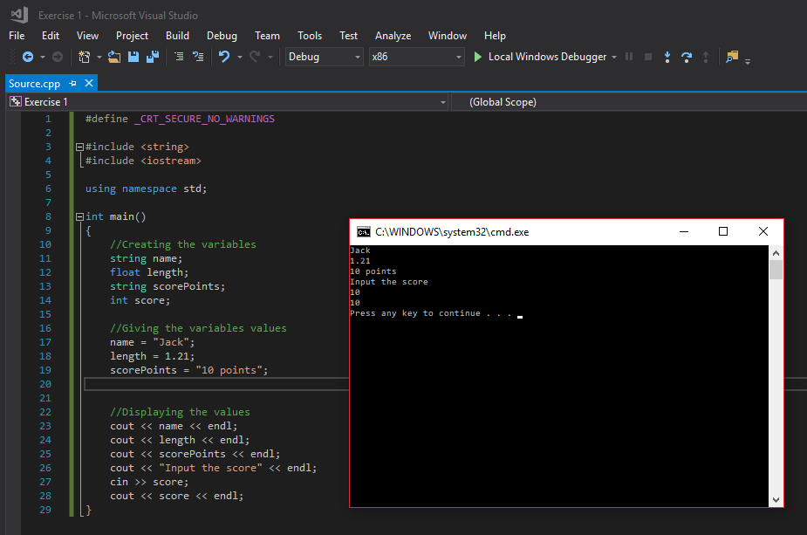

This how you store different values in variables and display them, this was done by first creating the variables that I was going to use, then giving each of them their own value and outputting them.

Exercise 2:
The code for exercise 2 is Appendix 2
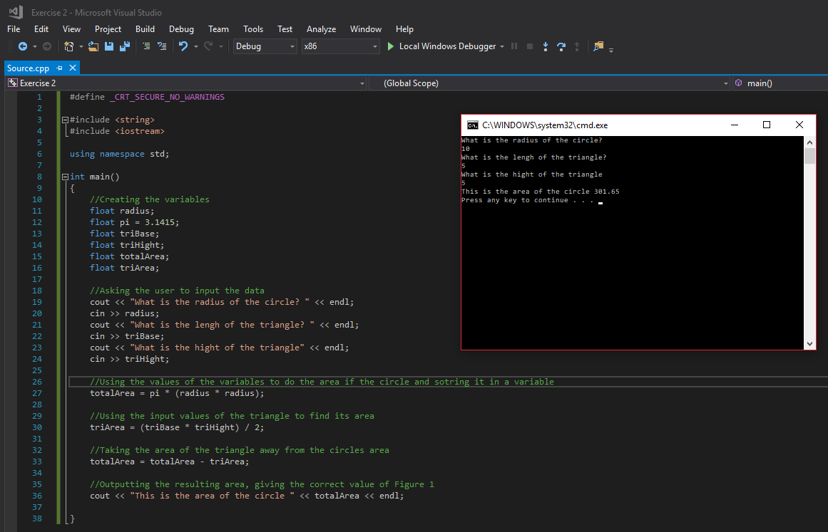

This is how I found the area of a circle with a triangle removed from it, I received the values form the user then used some math equations to find the area of the circle and the triangle then took the triangles area from the circles.

Exercise 3:
The code for exercise 3 is Appendix 3

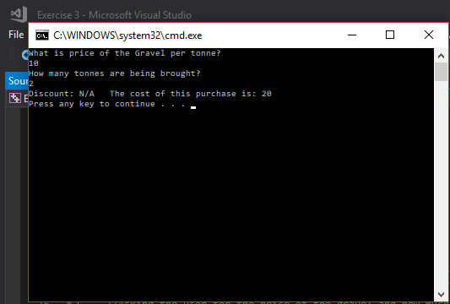
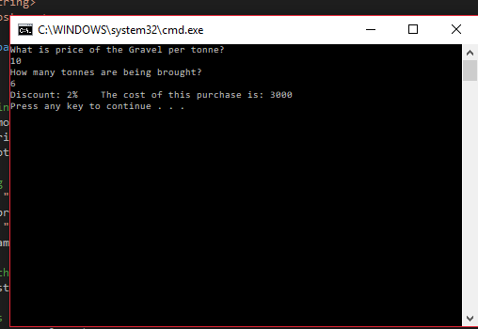
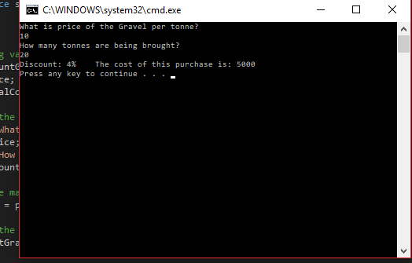
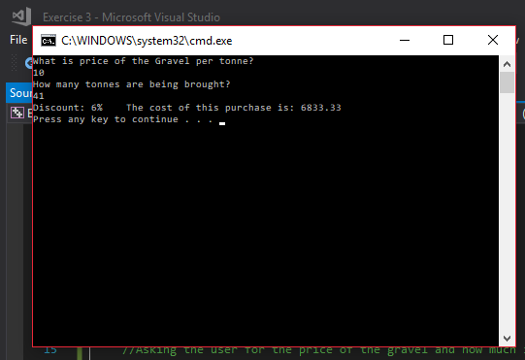
In this one I got the user to input the cost of the gravel and how much was being brought and used that amount to apply the discount using an if statement to the end cos, by starting with variables I was able to do this by identifying that I needed such as only applying the correct discounts and then after knowing what I needed to do stated to implement it. In first image I am testing for the statement for no discount, then in the second I was testing for the 5 to 8 statement, then the 9 to 40 and the 40 and above and they all gave the expected result.

Exercise 4:
The code for exercise 4 is Appendix 4
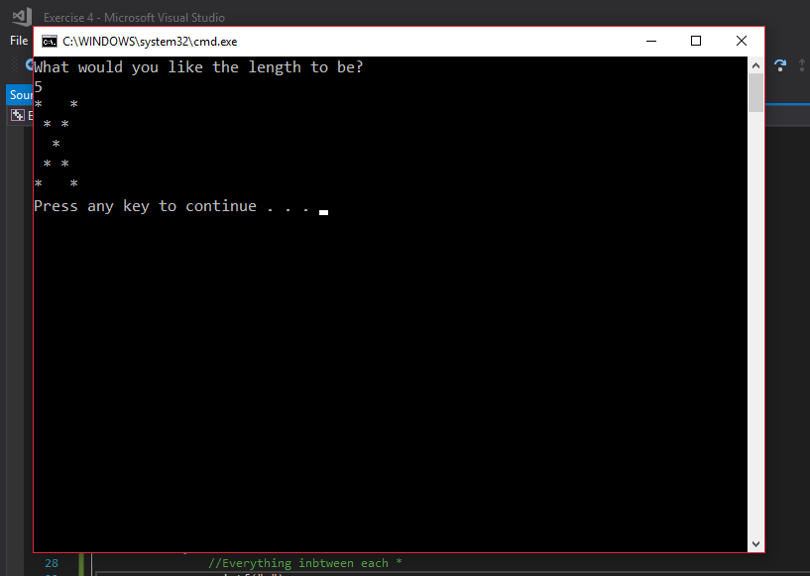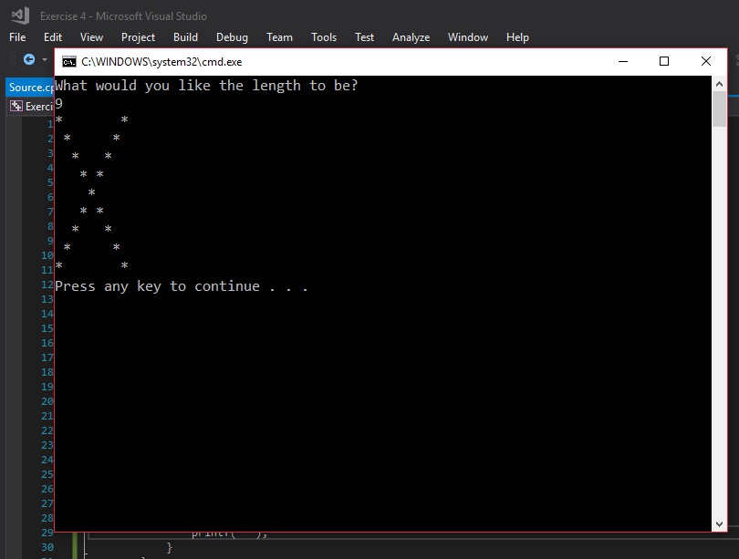
In this I used a nested for-loop to create a cross shape by getting it to print * and black spaces, it can work with any number that the user enters I knew I needed for-loops so that any number could be entered and it means that its more efficient than typing out each row every time and here I tested it out with 2 different inputs to show that it works however when I started I tried to get the rows to work then the columns and put them together to help solve it easier.

Exercise 5:
For

Exercise 6:
The code for exercise 6 is Appendix 6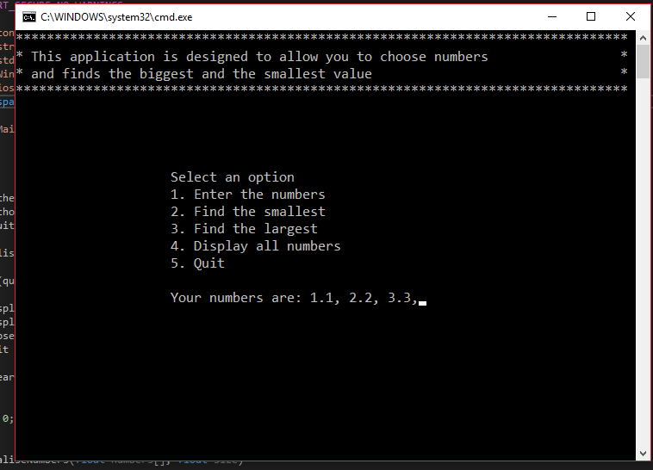 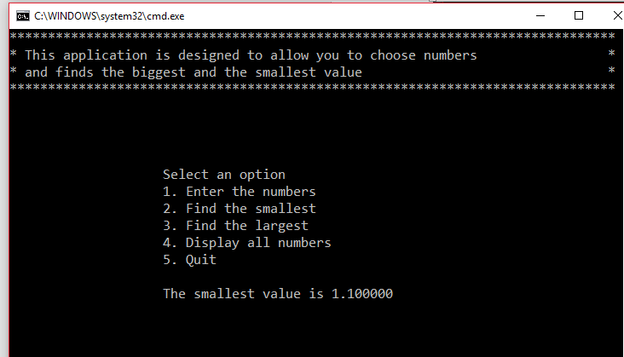
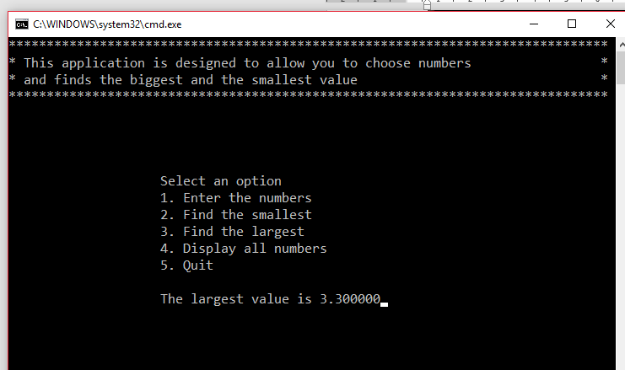
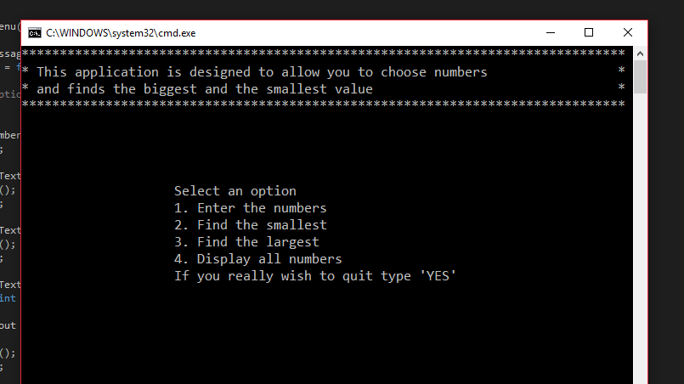
As you can see in the screenshots I’ve tried to fix the errors that I found earlier and it works, you are now able to see the numbers you entered (option 4), I have also made it so that you can have decimal numbers work in Option 1, 2 and 3 and will output the correct value, I have also clarified option 5 as now it tells the user to type “YES” if they want to leave meaning less people will get trapped.

Exercise 7:
The code for exercise 7 is Appendix 7
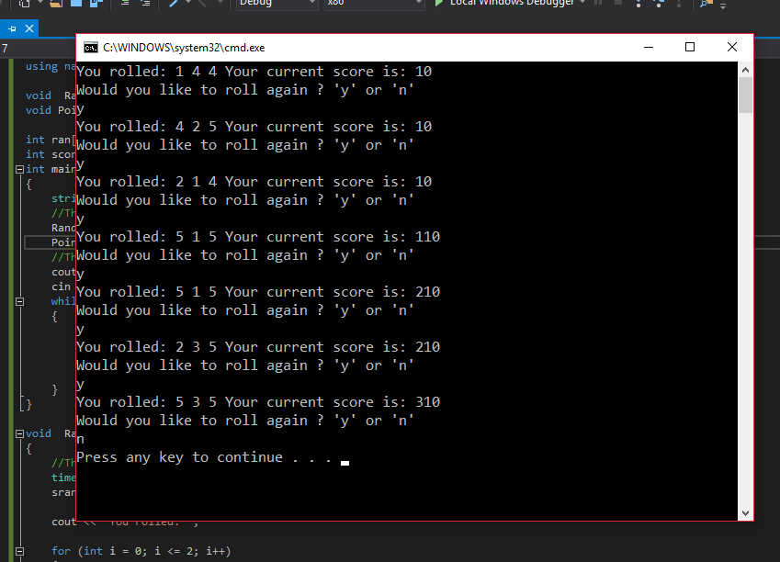
For this one I first created a way to get random numbers and stored them into an array after which I gave each outcome a tally in a different array allowing me to only give points if any of the tallies had 2 or more allowing me to adjust score accordingly if the number was 5 as that gives bonus points and gave the user a way to repeat the program if they wanted.

Appendix

Appendix 1:
#define _CRT_SECURE_NO_WARNINGS

#include <string>
#include <iostream>

using namespace std;

int main()
{
//Creating the variables
string name;
float length;
string scorePoints;
int score;

//Giving the variables values
name = "Jack";
length = 1.21;
scorePoints = "10 points";

//Displaying the values
cout << name << endl;
cout << length << endl;
cout << scorePoints << endl;
cout << "Input the score" << endl;
cin >> score;
cout << score << endl;
}

Appendix 2:
#define _CRT_SECURE_NO_WARNINGS

#include <string>
#include <iostream>

using namespace std;

int main()
{
//Creating the variables
float radius;
float pi = 3.1415;
float triBase;
float triHight;
float totalArea;
float triArea;

//Asking the user to input the data
cout << "What is the radius of the circle? " << endl;
cin >> radius;
cout << "What is the lengh of the triangle? " << endl;
cin >> triBase;
cout << "What is the hight of the triangle" << endl;
cin >> triHight;

//Using the values of the variables to do the area if the circle and sorting it in a variable
totalArea = pi * (radius * radius);

//Using the input values of the triangle to find its area
triArea = (triBase * triHight) / 2;

//Taking the area of the triangle away from the circles area
totalArea = totalArea - triArea;

//Outputting the resulting area, giving the correct value of Figure 1
cout << "This is the area of the circle " << totalArea << endl;

}

Appendix 3:
#define _CRT_SECURE_NO_WARNINGS

#include <string>
#include <iostream>

using namespace std;

int main()
{
//Creating variables
float amountGravel;
float price;
float totalCost;

//Asking the user for the price of the gravel and how much is being brought
cout << "What is price of the Gravel per tonne? " << endl;
cin >> price;
cout << "How many tonnes are being brought? " << endl;
cin >> amountGravel;

//Does the math to find out how much it will cost in total
totalCost = price * amountGravel;

//Checks the amount of gravel being brought and applies the discount accordingly using an if statement
if (amountGravel < 5)
{
cout << "Discount: N/A The cost of this purchase is: " << totalCost << endl;
}
else if (amountGravel >= 5 && amountGravel <= 8)
{
cout << "Discount: 2% The cost of this purchase is: " << totalCost / 0.02 << endl;
}
else if (amountGravel >= 9 && amountGravel <= 40)
{
cout << "Discount: 4% The cost of this purchase is: " << totalCost / 0.04 << endl;
}
else if (amountGravel > 40)
{
cout << "Discount: 6% The cost of this purchase is: " << totalCost / 0.06 << endl;
}

}

Appendix 4:
#define _CRT_SECURE_NO_WARNINGS

#include <string>
#include <iostream>

using namespace std;

int main()
{
//Only need to create one variable to store the users input
int length;

//Ask the user the length they would like and store it in length
cout << "What would you like the length to be? " << endl;
cin >> length;
//Here I use 2 for-loops to create the cross shape
for (int rows = 1; rows <= length; rows++)
{
for (int columns = 1; columns <= length; columns++)
{
if (rows == columns || columns ==(length+1)-rows)
{
//Print the *'s for the cross
printf("%s", "*");
}
else
{
//Everything in-between each *
printf(" ");
}
}
//This will create the next line/column
printf("\r\n");
}
}

Appendix 6:
Main.h
#pragma once

const int MAXNUMBERS = 3;
const float MAXINPUTCHARS = 100;

void InitialiseNumbers(float numbers[], float size);
void DisplayHeader(void);
void DisplayMenu(void);
float ReadNumber(string prompt);
void IgnoreInput(void);
void ClearText(int x, int y, int length);
bool ProcessMenu(int option, float numbers[]);
void GetNumbers(float numbers[]);
float FindSmallest(float numbers[]);
float FindLargest(float numbers[]);
bool IsQuitting();
void WriteText(string text, float x, float y);
void SetCursorPosition(float x, float y);
string FormatText(const char *format, ...);
void ClearConsole(void);
void Pause(void);
Source.cpp
// AssignCode_Menu.cpp : Defines the entry point for the console application.
//

#define _CRT_SECURE_NO_WARNINGS

#include <conio.h> // For pause
#include <string>
#include <stdarg.h>
#include <Windows.h> // To change cursor position
#include <iostream>
using namespace std;

#include "Main.h"

int main()
{
float theNumbers[MAXNUMBERS];
float chosenOption = 0;
bool quit = false;

InitialiseNumbers(theNumbers, MAXNUMBERS);

while (quit == false)
{
DisplayHeader();
DisplayMenu();
chosenOption = ReadNumber("Please choose an option: ");
quit = ProcessMenu(chosenOption, theNumbers);

ClearConsole();
}

return 0;
}

void InitialiseNumbers(float numbers[], float size)
{
for (int index = 0; index < size; index++)
{
numbers[index] = 0;
}
}

void DisplayHeader(void)
{
WriteText("*******************************************************************************", 0, 0); // Top left hand corner of screen is x = 0, y = 0
WriteText("* This application is designed to allow you to choose numbers *", 0, 1); // Next line down is x = 0, y = 1, etc
WriteText("* and finds the biggest and the smallest value *", 0, 2);
WriteText("*******************************************************************************", 0, 3);
}

void DisplayMenu()
{
WriteText("Select an option", 20, 8); // Display menu at x = 20, y = 8
WriteText("1. Enter the numbers", 20, 9);
WriteText("2. Find the smallest", 20, 10);
WriteText("3. Find the largest", 20, 11);
WriteText("4. Display all numbers", 20, 12);
WriteText("5. Quit", 20, 13);
}

float ReadNumber(string prompt)
{
float number = -1;
float inputCharCount;

WriteText(prompt, 20, 14);
inputCharCount = scanf("%f", &number);
if (inputCharCount == 0) // Wasn’t a number, so ignore what they typed in!!
{
IgnoreInput();
}

ClearText(20, 14, prompt.length() + inputCharCount); // Clear the text at this line

return number;
}

void IgnoreInput(void)
{
char ch;
while ((ch = getchar()) != '\n' && ch != EOF);
}

void ClearText(int x, int y, int length)
{
// Write space ' ' characters starting at x, y for 'length' times
string spaces(length, ' ');
WriteText(spaces, x, y);
}

bool ProcessMenu(int option, float numbers[])
{
string message;
bool quit = false;

switch (option)
{
case 1:
GetNumbers(numbers);
break;
case 2:
WriteText(FormatText("The smallest value is %f", FindSmallest(numbers)), 20, 15);
Pause();
break;
case 3:
WriteText(FormatText("The largest value is %f", FindLargest(numbers)), 20, 15);
Pause();
break;
case 4:
WriteText(FormatText("Your numbers are:"), 20, 15);
for (int index = 0; index < MAXNUMBERS; index++)
{
cout << " " << numbers[index] << ",";
}
Pause();
break;
case 5:
quit = IsQuitting();
break;
default:
WriteText("Unknown option value entered", 20, 15);
Pause();
break;
}

return quit;
}

void GetNumbers(float numbers[])
{
for (int index = 0; index < MAXNUMBERS; index++)
{
numbers[index] = ReadNumber("Enter number: ");
}
}

float FindSmallest(float numbers[])
{
float smallest = numbers[0];

for (int index = 0; index < MAXNUMBERS - 1; index++) // <-- subtract 1
{
if (numbers[index + 1] < smallest)
{
smallest = numbers[index + 1];
}
}

return smallest;
}

float FindLargest(float numbers[])
{
float largest = numbers[0];
for (int index = 0; index < MAXNUMBERS - 1; index++) // <-- subtract 1
{
if (numbers[index + 1] > largest)
{
largest = numbers[index + 1];
}
}
return largest;
}

bool IsQuitting()
{
char input[100];
string response;
bool quit = false;
WriteText("If you really wish to quit type 'YES' ", 20, 13);
scanf("%99s", input);
response = input;
if (response == "YES")
{
quit = true;
}
return quit;
}

void WriteText(string text, float x, float y)
{
SetCursorPosition(x, y);
printf(text.c_str());
}

// JUST USE THIS FUNCTION
// This function positions cursor in Console window,
// and you DON'T need to understand it!!!
void SetCursorPosition(float x, float y)
{
static HANDLE handle = NULL;
if (!handle)
{
handle = GetStdHandle(STD_OUTPUT_HANDLE);
}
COORD coords = { x, y };
SetConsoleCursorPosition(handle, coords);
}

// JUST USE THIS FUNCTION
// This function does create a string
// using a format string and values i.e.
// FormatText("Number is %i", 5) returns "Number is 5",
// and you DON'T need to understand it!!!
string FormatText(const char *c_format, ...)
{
char ch[100];
va_list args;
va_start(args, c_format);
vsnprintf(ch, 100, c_format, args);
va_end(args);
return string(ch);
}

// JUST USE THIS FUNCTION
// This function clears the screen,
// and you DON'T need to understand it!!!
void ClearConsole(void)
{
system("cls");
}

void Pause(void)
{
// Pause
while (1) { if (_kbhit()) break; }
_getch(); // Clear the keypress
}

Appendix 7:
#define _CRT_SECURE_NO_WARNINGS

#include <string>
#include <iostream>
#include <time.h>

using namespace std;

void RandomValue();
void PointsCal();

int ran[3];
int score = 0;
int main()
{
string again;
//This calls the functions for the first time
RandomValue();
PointsCal();
//This allows the user to roll again if the like and will exit
cout << "Would you like to roll again ? 'y' or 'n' " << endl;
cin >> again;
while (again == "y")
{
RandomValue();
PointsCal();
cout << "Would you like to roll again ? 'y' or 'n' " << endl;
cin >> again;
}
}

void RandomValue()
{
//This gets the random numbers for the slot machine
time_t theTime;
srand((unsigned)time(&theTime));

cout << "You rolled: ";

for (int i = 0; i <= 2; i++)
{
int randNum = (rand() % 5) + 1;
ran[i] = randNum;
cout << ran[i] << " ";
}
}

void PointsCal()
{

int count[5];
//This sets all the values in the count array ready to be used later
for (int n = 0; n < 5; n++)
{
count[n] = 0;
}
//This increase each matching array each time a number appears (tallying them up)
for (int i = 0; i < 3; i++)
{
for (int n = 0; n < 5; n++)
{
if (ran[i] == n + 1)
{
count[n] = count[n] + 1;
}
else
{
count[n] = count[n] + 0;
}
}
}
//This will then increase score if a number has appeared twice or three times unless its 5
for (int i = 0; i < 4; i++)
{
if (count[i] == 2)
{
score = score + 10;
}
else if (count[i] == 3)
{
score = score + 20;
}
}
//Becuase 5 gives a different amount of points it is done seprately from the rest
if (count[4] == 2)
{
score = score + 100;
}
else if (count[4] == 3)
{
score = score + 2000;
}
//This prints out the curret score
cout << "Your current score is: " << score << endl;
}

