


Assessment 1: Module 2
Digital Strategy Development
Sheiladen Aquino
2115317
Table of Contents
1 Introduction 3
1.1 Policy Aims 3
Prudent Health Care 3
1.1.1 Value Based Health Care 3
1.2 Service Improvement 4
2 Method 5
2.1 Data collection 6
3 Results 7
3.1 Digital Technology Requirements 7
3.1.1 Functionality 7
3.1.2 Non- functional Requirements 7
3.1.3 Data Collection and Analysis 8
3.1.4 Knowledge Management 8
3.1.5 Technical Standards data structures, terminology, interoperability 8
3.2 Gap Analysis 8
3.3 Options Appraisal 9
3.3.1 Build 10
3.3.2 Buy 10
3.3.3 Combination 10
4 Discussion 10
4.1 Acquisition and Implementation Strategy 10
4.2 Evaluation 11
5 Bibliography 11

Introduction
The following section will describe two Welsh health policy aims, namely Prudent Health Care and Value Based Health Care. The policies’ rationale and relevance to advancing the health and social care agenda in Wales will be discussed. To implement this policy, service improvement in the form of electronic Patient Reported Outcome Measures (PROMS) and Patient Reported Experience Measures (PREMS) will be explored.

Policy Aims

Prudent Health Care

To address the increasing demands and cost of health and social care in Wales, independent experts of the Bevan Commission published Prudent Health Care as an adjunct to the government’s long term policy plan, A Healthier Wales (Welsh Government, 2014). This policy proposed four principles: co-production, prioritisation, evidence, and reducing waste.

The first principle of Prudent Health Care is co-production. Service users are given opportunities to participate in the design, delivery and evaluation of health services in partnership with the health care provider (Aylward et al., 2013). Co-production places the service user and health staff in an equal relationship to collaborate in the planning and delivery of care. This principle ensures that provided services match the patients' needs, priorities, and values. Information and decision-making are shared to promote an equal balance of power and authentic participation from service users

The second principle is to care for citizens who have the greatest needs first and make the more effective use of available resources and skills. There needs to be an accurate information flow to identify who are those requiring the utmost care and how to maximise limited resources to meet these needs(Bevan Commission, 2015).

The third aim of Prudent Health Care is to do the minimum to achieve the maximal patient benefit and to do no harm. The third aim of Prudent Care is based on the availability of objective evidence that can positively impact the efficacy of treatment, the safety of procedures, and reduce the risk of adverse effects(Welsh Government, 2016).

The final aim of Prudent Health Care is to reduce waste and inappropriate variation using evidence based practice(Nuti et al., 2018; Improvement Cymru, 2021). Initiatives need to reduce unnecessary procedures with insufficient evidence and ensure that effective and adequate systems are consistent and transparent.

    - Value Based Health Care
Another policy that has taken a similar ethos to Prudent Health Care and compliments A Healthier Wales is the Value Based Health Care. Value Based Health Care (VBHC) focuses on patient health outcomes(Compton-Phillips, 2020). Instead of traditionally measuring the number of care activities or volume of health related procedures, the VBHC sets out a model that attributes greater value to patient outcomes(Nuti et al., 2018). Porter, (2010) defined it as “health outcomes per dollar of cost” because the value is achieved from the health outcomes against the costs of delivering those outcomes. In addition, the definition of value includes the patients’ perception of outcomes as they are the end user(Gray, 2016).

Service Improvement
The aims of Prudent Health Care and VBHC can be realised by using Patient Reported Outcomes Measures (PROMS) or Patient Reported Experience Measures (PREMS)(de Rosis et al., 2020).

PROMS are questionnaires or clinical evaluations retrieved from health-related symptoms from the patients’ perspective(Churruca et al., 2021). These are based on patients’ impressions regarding the outcome of the care that they received (de Rosis et al., 2020). This is often conducted before and after (sometimes even during) an intervention to identify any related factors that affect change.

A growing literature reports how pleasant experiences have a direct relationship with clinical outcomes, especially when trust and rapport with clinicians are pertinent in care provision clinicians (Black et al., 2014). On the other hand, PREMS measures the patients experience of care(de Rosis et al., 2020). Examples of these measures include timeliness, staff conduct, safety, communication and dignity to name a few (O’Connell et al., 2018).

Both PREMS and PROMS provide a mechanism for patients and their families to engage in co-production to inform improvements in health and social care(Joda et al., 2018). It provides opportunities for patients and families to share their opinions and experience from their perspectives. Health and social care staff can piece together information from patients’ experiences on the multifaceted aspects of their care (Watson et al., 2021). These are practical tools for identifying pertinent issues and patients' priorities to aid in prioritizing the most significant need (Kunavisarut et al., 2022). This feedback can also be used to identify practices with poor outcomes, thereby removing low-value procedures to reduce waste and improve the efficiency of care(Bishti et al., 2021). Through benchmarking, patterns of positive results can be standardized to decrease the variability of care. And lastly, as patient reports the impact of disease on their daily functioning, a more holistic cost analysis framework can be developed to match against the value of care they received (Damman et al., 2020).

NHS England has been collecting PROMS and PREMS since 2009 and has used these data to meet the principles of Prudent Health Care and VBHC(NHS England, 2017). Outcomes from the PROMS data in Northumbria NHS Trust were used to improve procurement processes, and costs by bulk ordering preferred implant brands and effective standardized procedures for hip and knee replacements (Basser, 2015).

In 2009, the Health Improvement and Patient Outcome (HIPO) Project in Cardiff and Vale University Health Board collected quality of life and patient satisfaction PROMs in paper format (Cardiff and Vale University Health Board, 2010). The results within orthopedics have identified and reduced the need for low-value appointments by 70%, thereby significantly decreasing waste and improving the efficiency of care.

In 2015, the Welsh Government developed an electronic system to ensure widespread standardized collection of PROM data using technology(O’Connell et al., 2018). The PROMS, PREMS, and Effectiveness Programme replaced the paper-based PROMS system to facilitate large-scale data collection across the health board and multiple medical conditions. The program's goal was to collect both generic and condition-specific PROMS and PREMS from secondary care services in Wales. The platform was also developed with the PROMS data and other clinical data for immediate analysis.

The generic electronic PROMS is available in five of the seven Welsh Health Boards (O’Connell et al., 2018). However, condition-specific PROMS are still only available for secondary care in selected clinical disciplines, namely orthopedic conditions, pediatric tonsillectomy, lung cancer, asthma, and cataracts.

For the Prudent Health Care and VBHC policies to be realized, electronic PREMS and PROMS should also be gathered from patients receiving services from the community across various clinical conditions, particularly those receiving both health and social care (Damman et al., 2020). Input from these patients will then be used to improve decision making, improve service delivery and facilitate communication between health and social care organizations. A systematic collection of PROMS and PREMS in the community can promote coordinated engagement of patients to reduce cost and improve quality (Kunavisarut et al., 2022). This can also identify those with the greatest need and encourage practice standardization to ensure safety.

This paper will present a strategy for acquiring and rolling out electronic PROMS and PROMS in the community integrated health and social care services.

Method
A review of literature on electronic PREMS and PROMS was conducted. Several methods were used to gather information about the digital technology requirements stated in the Results section of this document. Refer to the PRISM Flow diagram below.

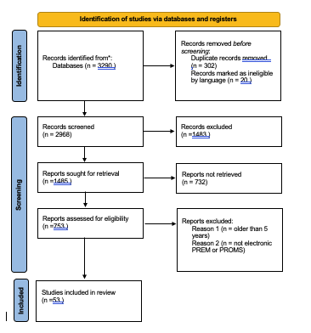
Figure 1 – PRISM Flow Diagram of Review of Literature
Several informal interviews were conducted to gain information regarding the digital technology requirements for electronic PREMS and PROMS. This includes (1) the Programme Manager of PREMs Civica, from VBHC Cwm Taf Morgannwg University Health Board (CTMUHB), Samantha Connell; (2) Senior Data Scientist for the PROMS data from the National Value in Health Programme, Cedar Health Technology Research Centre, Dr. Rob Palmer ; (3) Head of Value-Based Health Care CTM UHB, Denise Lowry. I have also used the current web-based PROMS and PREMS available in Wales: PPEP and Civica.

Data collection
The interviews were recorded, and answers were noted to correspond with categories relating to functionality, non-functional requirements, data collection and analysis, knowledge management, and technical standards.

The gap analysis is conducted using a four-step approach: first, the current situation is identified based on the author’s observation and recent experience in the integrated health and social care practice; second, the desired state is postulated using specific, measurable, achievable, relevant and time-sensitive goals; third, the gap is identified to get to the source of the issue; the fourth and final stage is to establish a plan to close the existing holes (Leonard and Bottorff, 2022).

Market analysis of the current PREMs and PROMs available within CTM UHB have undergone information governance standards and procurement processes. Several steps were conducted to undertake an options appraisal to decide whether to build or buy the solution. A set of criteria was developed based on the digital technical requirements, and relative weighing was conducted based on the importance of these criteria in the overall aim of the service improvement. Lastly, the overall score for each option is gained and interpreted with a rationale to arrive at the preferred option.

Results
The section below will discuss the various requirements for a successful PREMS or PROMS utilized in the community for health and social care end-users as per the interviews conducted above.

Digital Technology Requirements

Functionality
The PREMS and PROMS system needs to be simple, uses straightforward questions and gather qualitative and quantitative data. It needs to facilitate a good user experience e.g. adaptable interface, readable text size, easy to use platform. There needs to be an information section to explain the purpose of the PREMS and PROMS system and a consent section to gain the patient and family members’ agreement to gather data, to what degree of use, e.g., service development, research, and to access contact details.

The specific survey needs to be automatically generated with complete sets of questions. There needs to be little or no input required from the clinician as this can cause errors with data gathering. O’Connell et al. (2018) reported a high likelihood of mistakes when staff was asked to input patient information and choose the PROM questionnaire.

Algorithms need to be built to prompt patients and families at pre-defined intervals (pre, post, or during ) intervention to ensure they complete the electronic questionnaire at the right time of their care journey. A robust sampling methodology must be built into the system when questionnaires are generated from a cohort to minimize bias.

Non- functional Requirements
The tool needs to be reliable and works across various clinical settings in the community e.,g, home, community hall, and GP clinics. It needs to be user-friendly: if staff are not available, patients or their families would be able to use them easily. Education needs to be available to all users.

Data security is essential and needs to comply with regular penetration testing. It needs to be easily maintained and scaled up to accommodate other teams in eh health and social care team. In addition, the Welsh Language Act necessitates that all services must be available and validated in English and Welsh language.

If buying, the software cost would include licensing fees and permission if standardized PROM questionnaires will be utilized. Ideally, equipment and WiFi could be provided by staff if patients do not have access to these technologies.

Data Collection and Analysis
We have standardized data collection across different clinics, hospitals, and health boards to allow aggregate data analysis.

The system can accommodate patients that have multiple PROM pathways at various time maps.
The system needs to store data with accuracy, especially for patients with multiple PROM or PREM requests due to chronic or complicated medical conditions.

Knowledge Management
Ease of reporting or visualization of data is paramount for ease of interpretation. Reports are in an easily accessible format and should be easily downloaded and shared with all stakeholders, including patients and families.

Commutation points should be included in the patient journey to have reporting systems for clinicians, managers, and patient families

Technical Standards data structures, terminology, interoperability
Coons et al. (2009) reported the need to adhere to the ISPOR Guidelines to ensure consistent equivalence between the paper-based PROMS and the electronic PROMS to guarantee validity. Data storage needs to comply with national standards and GDPR guidelines. Interoperability between electronic care records within and between health boards is required to ensure accurate data flow.

Gap Analysis
Currently, there is no electronic PREMS or PROMS available to be used by patients and their families who are accessing services from the community health and social care team. This is exacerbated by the absence of an interoperable system that connects all the various digital clinical systems. The desired state is to have integrated PREMS that can be used across the clinical context of community care. There needs to be a clinical pathway that will incorporate PREMS and its analyzed results to be embedded in operational management reporting systems. There needs to be a collaboration between the Welsh Digital Health and Social Care, the VBHC team, the community integrated team, and end-users.

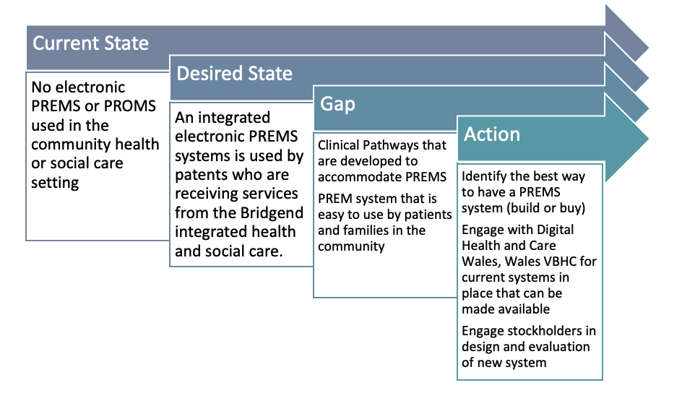
Figure 2 – Gap Analysis using the 4 step process

Options Appraisal
Following the methodology described previously to gain a decision to build or buy, the table below shows that there is no significant difference in making a conclusive decision.

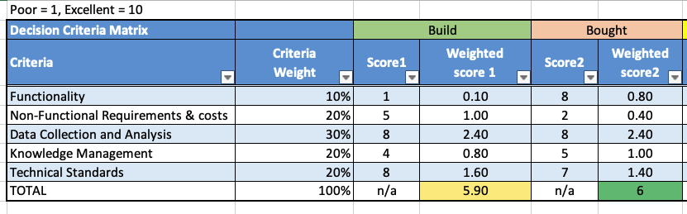
Figure 3 – Options Appraisal
A new decision process was used to identify critical criteria for deciding whether to buy or build the PREMS system with a mid-way option.

BUY | Commercial PREMS with an In House IT Team | Build
PREMS and PROMS system stable, not subject to volatility | Modification needed to reflect the need for service but ecosystem stable and reliable | Rapid change to meet demands or evolving users
Commercial PREMS availability in the market | Several Health Boards have used commercial PREMS like with positive results | Lack of mass marker product
Generic questions | Flexible for modifications | High demand for personalized questions

Build
An in-house electronic solution can target nuances of the organization it is built for, especially for complex organizations such as health and social care. However, this might not be easily scalable to an all-Wales population across various Health Boards.

Buy
Commercial PROMs systems are readily available; however, they are not designed for specific conditions and are difficult to modify to suit multiple medical requirements or clinical contexts.
Ongoing cost implications may not make this option sustainable and cost-effective. In addition, there might be risks associated with data security and non-adherence with GDPR.

Combination
This option postulates that a PREM system can be bought commercially but can be modified with the support of an in-house IT team.

Discussion

Acquisition and Implementation Strategy
﻿
Following interviews from the National VBHC team, accessing the in-house PREMS system is more straightforward than designing and developing a new system to be used in the community teams. A business case will need to be forward to the team who will develop on boading strategies to identify community teams that are best suited to pilot the system. Support will be provided to develop questionnaires, identify clinical areas and target user groups. Pathway design and development will be done collaboratively with the integrated team and family or patients.

User requirements need to be constantly reviewed in close collaboration with service managers, clinical leads, IT teams, value-based health care officers, and patients and their families.
Consideration of the layout will be tested especially for elderly clients, e.g., how many questions per page and type of responses are required. User engagement at various stages of design, implementation, and evaluation will be paramount to the successful pilot of the PREMS and PROMS system.

Members of the Digital PROMS program management team need to be available for any pathways or technical issues and support interpreting results and developing individualized dashboards.

Pathways are in place to quickly communicate any problems and difficulties to the software supplier and developers. System updates and fixes need to be implemented at regular points and in time with the onboarding new clinical groups and services in the community. Regular staff training and support from VBHC program managers and IT support teams will be in place. For a digital PROM collection to be successful, close collaboration between all stakeholders, including IT support, a software company, clinicians, and patients and their families, is needed to ensure that the system is easy to use and fit.

Evaluation
Having an electronic PREMS and PROMS has benefits because of consistent validity across electronic and paper based (Langella et al., 2021; Kunavisarut et al., 2022). However to achieve impact on the desired service improvement and policy aims, longitudinal evaluation is needed to reveal added value and limitation of the system (Pennucci et al., 2020). Regular reviews and modifications to ensure efficacy of use for all stakeholder is paramount to ensuring that this technology is fit for purpose. Core outcome dataset should be set out at the beginning of the project to ensure that baseline and performance trends are standardised features of the evaluation (Beckers, 2021). Systems should be in place to facilitate ease of identifying technical problems to promptly provide solutions.

Like any digital health systems, there will be a group of patients that might be excluded in this pathway due to digital literacy and access. Education sessions and provision of appropriate support in the community will help dissolve this barriers (Meirte et al., 2020).

Bibliography
Aylward, M., Phillips, C. and Howson, H. (2013) “Simply Prudent Healthcare – achieving better care and value for money in Wales – discussion paper.” (December), pp. 1–10.
Beckers, L. (2021) “Transparency and standardization in using digital patient reported outcome measures ( PROMs ).” 34, pp. 497–498. doi: 10.1002/ejp.937.
Bevan Commission (2015) “A Prudent Approach to Health : Prudent Health Principles.”, pp. 1–15. Available at: http://www.bevancommission.org/en/prudent-healthcare.
Bishti, S., Tuna, T., Rittich, A. and Wolfart, S. (2021) “reported outcome measures ( PROMs ) of implant- supported reconstructions using digital workflows : A systematic review and meta- analysis.” 32(July), pp. 318–335. doi: 10.1111/clr.13846.
Churruca, K. et al. (2021) “reported outcome measures ( PROMs ): A review of generic and condition- specific measures and a discussion of trends and issues.” (October 2020), pp. 1015–1024. doi: 10.1111/hex.13254.
Compton-Phillips, A. (2020) “Spreading at Scale: A Practical Leadership Model for Change.” NEJM Catalyst 1(1). doi: 10.1056/cat.19.1083.
Coons, S.J. et al. (2009) “Recommendations on evidence needed to support measurement equivalence between electronic and paper-based patient-reported outcome (PRO) measures: ISPOR ePRO good research practices task force report.” Value in Health 12(4), pp. 419–429. doi: 10.1111/j.1524-4733.2008.00470.x.
Damman, O.C. et al. (2020) “The use of PROMs and shared decision-making in medical encounters with patients: An opportunity to deliver value-based health care to patients.” Journal of Evaluation in Clinical Practice 26(2), pp. 524–540. doi: 10.1111/jep.13321.
Gray, M. (2016) “Designing healthcare for a different future.” Journal of the Royal Society of Medicine 109(12), pp. 453–458. doi: 10.1177/0141076816679781.
Improvement Cymru (2021) Achieving Quality and Safety Improvement. Available at: https://phw.nhs.wales/services-and-teams/improvement-cymru/about-us/improvement-cymru-strategy/.
Joda, T., Ferrari, M., Bragger, U. and Zitzmann, N.U. (2018) “Patient Reported Outcome Measures ( PROMs ) of posterior single ‐ implant crowns using digital workflows : A randomized controlled trial with a three ‐ year follow ‐ up.” (June), pp. 954–961. doi: 10.1111/clr.13360.
Kunavisarut, C., Jarangkul, W. and Pornprasertsuk-damrongsri, S. (2022) “Patient-reported outcome measures ( PROMs ) comparing digital and conventional workflows for treatment with posterior single-unit implant restorations : A randomized controlled trial.” Journal of Dentistry 117(August 2021), p. 103875. Available at: https://doi.org/10.1016/j.jdent.2021.103875.
Langella, F. et al. (2021) “The use of electronic PROMs provides same outcomes as paper version in a spine surgery registry . Results from a prospective cohort study.” European Spine Journal 30(9), pp. 2645–2653. Available at: https://doi.org/10.1007/s00586-021-06834-z.
Leonard, K. and Bottorff, C. (2022) Conducting A Gap Analysis: A Four-Step Template. Available at: https://www.forbes.com/advisor/business/gap-analysis-template/ (Accessed: 5 May 2022).
Meirte, J., Hellemans, N., Anthonissen, M., Denteneer, L. and Maertens, K. (2020) “Benefits and Disadvantages of Electronic Patient-reported Outcome Measures : Systematic Review Corresponding Author :” 3. doi: 10.2196/15588.
NHS England (2017) National PROM Guidance. Guidance to support the collection and reporting of data through the administration of PROMs questionnaires to patients in receipt of relevant NHS-funded care. Available at: https://www.england.nhs.uk/ourwork/insight/proms/.
Nuti, S., Noto, G., Vola, F. and Vainieri, M. (2018) “Let’s play the patients music: A new generation of performance measurement systems in healthcare.” Management Decision 56(10), pp. 2252–2272. doi: 10.1108/MD-09-2017-0907.
O’Connell, S., Palmer, R., Withers, K., Saha, N., Puntoni, S. and Carolan-Rees, G. (2018) “Requirements for the collection of electronic PROMS either ‘in clinic’ or ‘at home’ as part of the PROMs, PREMs and Effectiveness Programme (PPEP) in Wales: A feasibility study using a generic PROM tool.” Pilot and Feasibility Studies 4(1), pp. 1–13. doi: 10.1186/s40814-018-0282-8.
Pennucci, F., Rosis, S. de and Passino, C. (2020) “Piloting a web- based systematic collection and reporting of patient- reported outcome measures and patient- reported experience measures in chronic heart failure.”, pp. 1–9. doi: 10.1136/bmjopen-2020-037754.
Porter, M. (2010) “What is value in health care?” The New England Journal of Medicine 363(26), pp. 2477–2482.
de Rosis, S., Cerasuolo, D. and Nuti, S. (2020) “Using patient-reported measures to drive change in healthcare: The experience of the digital, continuous and systematic PREMs observatory in Italy.” BMC Health Services Research 20(1), pp. 1–17. doi: 10.1186/s12913-020-05099-4.
Watson, L., Delure, A., Qi, S., Link, C., Chmielewski, L., Photitai, É. and Smith, L. (2021) “Utilizing Patient Reported Outcome Measures ( PROMs ) in ambulatory oncology in Alberta : Digital reporting at the micro , meso and macro level.” Journal of Patient-Reported Outcomes 5(2), pp. 1–9. Available at: https://doi.org/10.1186/s41687-021-00373-3.
Welsh Government (2014) “Making prudent healthcare happen A new online resource –.”, pp. 1–16. Available at: http://www.wales.nhs.uk/sitesplus/866/opendoc/249335%5Cnwww.prudenthealthcare.org.uk.
Welsh Government (2016) “Prudent Healthcare Securing Health and Well-being for Future Generations.” Prudent Healthcare in NHS Wales , p. 23. Available at: www.prudenthealthcare.wales.

