Darren Michael Hembrow
Student: 1908926
Coaching and Mentoring
RAL Essay
Word Count 6588

Index:
Page 3: Introduction
Page 6: Personal Experience
Page 5: Metamemory and Learning Process
Page 9: Reflection
Page 10: What strategies I adopted to identify themes for your Learning Areas?
Page 10: Challenges and Successes
Page 11: Celebrate your successes or moments of ​clarity:
Page 12: How did these contribute to my overall learning?
Page 13: Application of knowledge:
Page 13: Consideration of specific examples or scenarios ​where the module's content is directly relevant.​
Page 15: Impact on your personal career plans / professional goals​
Page 15: Conclusion
Page 18: References

Introduction:
This essay will critically focus on my progression as a coaching business owner, which started in 2018 when I first qualified as a coach whilst working as a police officer for South Wales Police. The decision to leave the police in 2022 under medical retirement was pivotal in my professional development, as it allowed an opportunity to set up my own business and acquire academic underpinning through university studies.
Reflection has brought about an understanding and awareness that may otherwise stunt both my academic and non-academic growth and would have stopped my progress. Biggam (2015) questioned as to how one can reflect upon something that is part of our lives. Cottrell (2023) will state that reflection seems an easy process, however, has many challenges within it. By further interrogation and examination into the wider study of Cottrell (2023), I would agree that on its surface, reflection is easy. I have formed an opinion that analysing any reflection is a deeper process to gain benefit from it. I have had to learn to critically analyse my complex feelings and trajectory as a coach. I have examined and evaluated the reflective models based on Gibbs (1988) and Kolb (1984) and creating a hybrid of their models. I have also highlighted a reflective model by Driscoll (1994) to create an alternate view of reflection.
I discovered that I began to naturally apply reflective processes in my coaching and learning undertakings. At this level of thought, I critically reflect on the sessions I run, with consideration to several elements therein. One of which is my medication, I am on some very strong pain medications, some of which are anti-depressants which create an emotionless feeling. The medical profession calls this sensation as being flat. Through this experience, I discovered there is a link between medical treatment, neurochemical medications, and that of actual perception. Without researching and reflecting, I would not have understood this.
To support this discussion, a 2019 study by Fonzo et al. hypothesised that there is a correlation between the use of anti-depressants and that of brain activity deactivation in areas, for example, the frontal lobe. In order that the client will understand my listening techniques whilst I feel flat, I can add key words into the conversation, as an example: “I sense the dilemma”. This is a deliberate adaptation of my vocabulary to improve the coaching sessions.
In contrast to feeling flat, I also experienced imposter syndrome, which has created pauses my progression. To critically analyse this inner conflict of being flat and experiencing imposter syndrome, I believe that it stems from feelings of “am I enough” or “am I the right person for this”.
Despite these thoughts, I have developed coping strategies to achieve my own goals. Clance and Imes (1978) analysed people with imposter syndrome, stating that this thinking is negative in foundation, in case their subjects were found to be imposters and not qualified despite qualifications and experience (web: www.researchgate.net October 2025).
I recalled that this journey began with a sense of apprehension and uneasiness in depicting myself as a professional coach. I associated confidence and capability to engage with others as a barrier. Although these feelings were uncomfortable, I recognised that these were a natural reaction to stepping out of my comfort zone with my lack of experience. However, this was a learning opportunity to allow progression.
Reflective Models of Gibbs (1988) and Kolb (1984)
Upon exploring Gibbs (1988) cycle, I have been able to distinguish the internal feelings I had at the time of starting my business, mainly being nervous aligned with lack of knowledge on how to set up my own company.
Further exploration and analyses of Kolb’s (1984) learning theory, I began to recognise that negative self-talk was holding me back by creating a lack of confidence. Dr. Joseph Murphy (2014) stated ‘In the science of imagination, you eliminate all the mental impurities, such as fear, worry and destructive self-talking.’
Cottrell (2023) states that reflective practice takes time and will take the effort of the reflector to use their mental and emotional responses and is intensive. This can be as intensive as the reflector allows themselves to be, and, if guided by a supervisor, the reflection can be supported in relation to its depth. Learning reflective practice has been an essential part in my development as a business owner and a coach. Thompson and Thompson (2023) maintain that reflective practice is not a new idea. I have had to develop a way to understand my own process by gaining an understanding in how I function as a coach.
Thompson and Thompson (2023) declared that it is important to develop analytical thinking but not attached to everything. Engaging with reflection creates a cycle of positive development and new ways of directing thoughts. It stands that if we are too routine in our thinking, we will develop a single focused thought process. Körkkö (2019) clarified that we need to carry out reflective exercises to create reflection as an internal construct. I would agree with this, as we will also feel the progress and not just have a general awareness thereof.
Though Körkkö (2019) conducted their study involving the reflective practice of teachers, the underlying theory is the same per se. Körkkö (2019) has argued that reflection is holistic, as in, the whole: from experience to classroom experience. In my case, my holistic aspects would be generating awareness of my business. Moon (2004) would argue that reflection and learning is under the privacy of the learner.
To analyse Moon’s (2004) contention, I would also add that reflection may well be a personal attribute that someone will go through, it does not necessarily mean that it needs to be private. To synthesise Moon (2004) with Körkkö (2019) together, I would opine that with open dialogue and support structures in place with tutors or coaches can offer help and assistance in deepening the reflective practice. This can only be obtained by speaking with honesty.
This can easily fall under the self-actualisation of Maslow’s hierarchy of needs (1954), in that, I am becoming the best version of myself. I have also recognised the developing changes within my mentality from being an officer to a coach. As a police officer, my engagement with people could have been authoritarian and harsh. As a coach, I am far more supportive and sensitive to the needs of the client. I can recognise that my actual tone towards people has changed.
Metacognition
Initially, I had anticipated the volume of work would be overwhelming, mainly translating experience into academic critical writing would be difficult to achieve However, the more I have worked at this unit, the more beneficial I have found it to be.
The feelings of overwhelm and that of cognitive development would very easily fall under the remit of metacognition. Metacognition is a theory in that one would think about thinking by having an awareness of thought. Ahmet Oguz Akturk and Ismail Sahin (2011) contended that it is something in which has many diverse meanings. I would add that from further reading, metacognition has branches in which supports other areas; as in metamemory, which I will explain further on.
The examination of metacognition by Shea et al. (2014) finds that our thought processes can be changed with discussion with other people and diverse stimuli can affect the way in which we think. I would not agree with this in totality, as our deep thoughts can be affected by several component areas, and not always in a positive way:
- Triggers from past events.
- Actions of others.
- Past actions of the learner.
- Lack of knowledge or education on topic, with unwillingness to learn.
- Not being able to understand learning.
These are just some examples of how metacognition can be affected negatively, whereby, to further critique this, for each point, it is possible that the learner could be encouraged to develop positive thinking strands and accept learning.

Metamemory:
Meunier-Duperray et al. (2023) carried out studies in relation to memory in older adults with a comparison to younger adults, as many of my clients often state the memory is not what it was. Meunier-Duperray et al. (2023) concluded that in some cases, the older person’s memory may not be effective as a young person, however on some areas of memory, they are equal. This is just one study, but it is an important study as I have issues with my memory, it is also important to recognise others might too, for various reasons.

Personal Experience: ​
What were my initial thoughts, ​feelings, and challenges?
My initial thoughts were marred by trying to remember a lot of what I have done as I have some memory issues caused by medication, pregabalin being one of several.
Upon leaving the police, one of the first things I considered was to set up as a coach. I explored the internet on how to set up my own coaching business, coming across a company called The Coaching Masters. They had several courses to qualify people as coaches, Neurolinguistic Programming, Course Creating and Launching your business. I followed their process by creating my business. Though the training was good and detailed, the courses would fall under continuous professional development as opposed to an academic qualification.
Wac & Wulfovich (2022) argued that there can be a cognitive decline due to fatigue and the causes of it. This will support that I have memory issues due to my disability. Therefore, I may not be in a linear timeline when thinking about running a sole trader business; ‘the process of cognition is perceived as involving the overall functioning of a complex system of unobservable mental abilities (remembering, reasoning, etc.) which is key to the manipulation of information’ (Curzon, L. B., 2007, p. 91). Curzon (2007) also supported the concept of training the memory, which will be easier for students to accept, when the ideals of remembering and forgetting have been explained. Though this is regarding classroom-based learning, I would contend that it can be adapted to align to lifelong learning principles.
I found that documenting areas of consideration assisted the reflective process. It allowed me to recall and critically evaluate the initial steps in setting up my business by assimilating the knowledge of The Coaching Masters. The journaling has also helped in synthesising the theory and the practical elements of establishing a business.
Consequently, I researched and examined reflective models as to which one would best suit me as there are many to choose from, including Gibbs (1988), Kolb (1984) and Driscoll (1994). All the models are good, however, by exploring the models, I found that switching between differing sections therein a lot better than just working on one. Eventually by amalgamating them to create a solid foundation in which I could relate to more easily. This helped on the internal reflection throughout my work.
I propose that there is a simple crossover between learning and reflection:
Learning
Action - Internal Process - Action
Reflection

Fig. 1 Learning/Reflection Crossover. Darren Hembrow 2025
Guo (2022) stated ‘reflection benefits learning, the notion of reflection has been described, defined and deployed in different ways across different domains and for different purposes’, this will support the blending and assimilation of the reflective models to create a fourth, unified one, more suitable for my current style of reflection.
I have questioned my ability and capacity to analyse and synthesise the theories and practices. This also made me question my ability as a coach, as to whether I was doing it correctly, as I did not always reflect upon my sessions/training as robustly as I currently do. Dr. Joseph Murphey (2014) alluded that a genius is a person who is aware of their subconscious mind, and within mine, I have also discovered that my doubts are only internal feelings. This discovery has had a positive impact on me on several levels, from increasing my confidence to being more empathic with my clients. This is an important recognition of my expanding mindset. Being aware that there is another layer to thought and perception supports the idea that they are not fixed and can be systematically enhanced by reflective practice.
I needed to engage with and adopt theoretical knowledge by researching the information, which, until I started this unit, had no idea existed. The gap in knowledge was not necessarily just within academia, but equally within my experience. I have noted a developing positive shift in my feelings. Guo (2022) argued that many studies align to an evolving process. Kellard & Śliwa (2016) contended that it becomes more difficult to separate the theory from the practical. I would agree and align with this argument, as I feel that I am developing and adapting to this. It is having more of a positive impact it is having on my practice.
I have only been able to acknowledge this due to sustained and continual reflective practice. Therefore, reflection has been transformational for me. The learning process I’ve been through has been crucial in my understanding in building up my reputation with others and building my ability to be a coaching business owner. Curzon (2007) contended that learning is a process that leads to a change in behaviour, this may be the case; however, I propose that learning can also change mindset. Bovaird & Loeffler (2015) critiqued the mindset of having a strategic plan as old and may not be relevant for today’s dynamic world. I would argue that Bovaird & Loeffler (2015) though the concept may be old, new ideas are formed frequently as learning from the past can create new thinking.
I had many preconceptions in relation to entering this module, mainly because I have previously failed a piece of work on a non-related course, which has undermined my confidence in academic writing. ‘Recognition that RPL is a valuable learning experience in its own right’ (Claridge, M. & Felce, A. E. 2017. p4) a citation that will counter my mindset. To synthesise Claridge & Felce (2017) with my reflective model, change can occur by the development of new thinking pathways. This has allowed me to engage more critically with the learning materials, ascertaining if the published works fit in with my work as a coach, allowing me to make robust and justifiable decisions.
I recognised that at times, I do struggle to articulate feelings, however, I ask myself “if I were a client and then asked that client how are they feeling? how would I respond?” My answer would not just be in relation to feelings and experiences, but also to adopt the deeper understanding that the literature can bring forward, creating higher-order thinking. In essence, experience, feelings and academia support one another equally:
Academic/Experience

Practice

Academic Reflection

Practice

Figure 2: Cycle: Darren Hembrow (2025)
When we learn through education, it is often for some form of vocational need, I had to become familiar with the learning outcomes, as stated by Simosko, S., & Cook, C. (2013). I recognised that the real-world situations are important to strengthen the underpinning knowledge gained in the classroom.

Learning Process: ​
On evaluation, the exploration of my understanding of ‘experiential ​learning’ and ‘reflection’ has evolved over the duration of the module. I had no knowledge of experiential learning, although, I do recall that when I started in the police my class had an input on reflective practice. This is no longer taught, as I designed the lesson plans before I left the police. From memory, reflective cycle that was taught in the was akin to the Driscoll Model (1994), which the learner answers three what questions:
- What?
- So what?
- Now what?
In recognised that experiential learning for me is to learn by experience, however, I have started to develop a reflective thought process to the experience. This development is due to this module. It has also created a better mindset to enhance the sessions I run.
Work Related Experience

What happened within?
Thought process

What have I learned?

Figure 3: Experiential Learning Flow. Darren Hembrow 2025
I have critically explored the learning cycles of Kolb (1984) and Gibbs (1988). As a critique to them, I would opine that someone may learn about the role they hold within the work environment, it does not mean that the employee reflects upon their learning, the same could be stated about the classroom.
Previously, I have completed the Honey and Mumford (1984) learning styles questionnaire, to which, I have always been shown to be a Reflector or Theorist as an answer, often arriving at the same marks. To offer a critical position of the Honey and Mumford (1984) process, I don’t align to the fact it has shown that learning has occurred. It only shows a trait on which we are. To build on this, even though we can reflect on experience, where does the actual learning take place? Experience may not necessarily be assessed as a learning experience per se. However, one trait is that of a reflector, which aligns with the learning objectives of this module.
Dewhurst & Fitzpatrick (2007) maintained the concept that the “one size fits all” may not work, as one trait for a colleague may not suit my/your particular trait. The overall benefits, as written by Simosko, S. & Cook, C. (2013) indicate that prior learning has over 20 years of research to support the academic and experiential knowledge. This will demonstrate that from the inception of this module, I have critically analysed my professional development. It has allowed me to synthesise theory into practical management. This will exemplify that experience and correlated reflective learning is not a fixed concept, but one of evolutionary discovery.

Reflection:
​Before this module, my reflective practice was minimal. The input from my tutors and comments made by my peers has helped me reflect on how I perform as a coach. I have ‘drawn on good practice’, as cited by Simosko, S. & Cook, C (2013). This has led me to become more aware of decision making as they used to be reactive and impulsive, without consideration of outcomes. I now think, reflect and work things out, especially potential outcomes; Reece and Walker (2007) stated: ‘Decision: upon a course of action from among several possibilities’; I have developed the following mentality: if the outcome is determined to be a failure, work in the opposite methodology to make it a success.
I do not always write ideas down; however, journaling ideas has been used as a dynamic tool to help move forward and not just be a historical reference book. Osteneck (2020) stated that journaling can ‘be utilised to achieve various results.’

What strategies I adopted to identify themes for your Learning Areas?
Curzon (2007) has stated that a student’s attitude to learning has a foundation in motivation, which will lead to the direction and style of their approach. I can align to this way of thinking. I have adopted an analytical methodology to identify the Learning Areas. This was based on how I started my business under the teachings of The Coaching Masters: ‘building an online coaching business takes more than just passion – it takes access to the right tools, expert knowledge, support, and a thriving community’ (Web: The Coaching Masters. Oct 2025). Therefore, I needed to explore and examine the niche market, their background and their demographics to synthesise my learning.
With a new awareness and knowledge of metacognition, I explored various learning objectives to connect the practical areas of my professional development and to correlate it with the necessary academic frameworks. Cameron (2021) stated ‘traditionally, learning was seen as acquiring knowledge’; I will accept this citation as a recognition of the correlation between experience and theoretical understanding being synthesised into one cognitive process. This has reshaped on how I integrate new information with a deepening thought process.
Subsequently, this led me to adapt my business development, to become aware of the themes of self-awareness and emotional intelligence and resilience, overcoming barriers, both within my mindset and those that are external to my thinking.
Challenges and Successes: ​
Addressing any challenges I encountered during the module. How I overcame them, and what did I learn from those experiences?
I was unaware of how deep this module would be, therefore, this element of work was not anticipated, although I have enjoyed the challenges and learning.
To offer an example of another challenge I faced was the professionalisation of my social media platforms and the content for public engagement (see appendix 1). Being so shy, I have previously and purposefully taken a back step away from people. In essence, self-promotion in this digital age is not something I was comfortable with.
I learned to push myself, as the training offered business owners to become a celebrity within their social media presence. I know this would add to my credibility as a coach, and now do it automatically, thus, I have developed my coping skills and professionalism.
One task that was of particular concern, whereby I felt as though all eyes were going to be on me, was to post short online videos across all my platforms. This was deeply uncomfortable. I have since become accustomed to doing it, though I remain uneasy about presenting myself to the wider public.
Mundelsee & Jurkowski (2024) drew a contention from Schmid and Buss (2010) stating that those who maintain a distance from others prefer limited social exposure often exhibit introverted tendencies. I resonate with this premise on a personal level. Consequently, through self-reflection, I have begun to deconstruct and reframe these negative traits and created a new mindset.
I noticed a shift in doubt and vulnerability. Both of which one may think are negative traits, however, I have actioned the thinking around them and noted that the doubt shifted to confidence. This will indicate growth, both mentally and in practice. To assist in the reflective process, of which, I had little knowledge of, I read up on reflection by Moon (1994) as well as several online books, journals and peer-reviewed articles via the university library system to gain a wide understanding from several applications.
Osteneck (2022) alluded that ‘Journalling can be used both as a learning and as a teaching tool. Writing promotes learning through reflection.’ This citation will support the concept that through this unit, I am not just learning but teaching myself within learning activities.
Through the further reading of Moon (1994), I was able to think differently about my emotions, to understand they are both humanistic and encouraging. Since starting as a coach, I have formed the opinion that vulnerability, nerves and imposter syndrome can be used as a catalyst for growth and development. This is in sharp contrast to my normal way of thinking that I best be left alone.

Celebrate your successes or moments of ​clarity:
Whilst travelling through this module, I have recognised that I have made several achievements:
- The establishment of my business was the first element of my success. With the support of The Coaching Masters training programmes, I developed my courage and self-belief. I have often found it very unnerving to accept praise, as success for me is just completing a process. I still do not see it requiring or warranting recognition. I am now reflecting on this to change my mentality and mindset in this area.
- By attending university and continuing my studies are a key element within my personal life, which then reflects heavily onto my professionalism. I made a choice as someone who has disabilities: stay at home or to seek opportunities that would enhance both my cognitive and analytical skills.
I chose the latter, Dawson (2014) argued that developing cognitive abilities is an important area for lifelong learning and self-improvement.
- By integrating my coaching business within evidence-based methodology, I have developed my niche market in the ageing well community, in partnership with Swansea Council (see appendix 3 and 4). The amalgamation of personal insight, growth and recognition has underpinned my practice.
- The Over 50s wellbeing group has been very successful, with continual demand from the attendees. The sessions are grant funded and the community support one another, which adds to the overarching learning gleaned by all. As the sessions are grant funded, it is free at point of access (see appendix 5).
The successes have been subtle, and I needed to recognise comments as positive aspects of my work. For example, the fact that some of the over 50s continually attend my sessions speak for itself. This has helped me to strengthen my personal identity as a business owner. I have needed this more than I have needed external validation of my academic and coaching experience ‘you won’t be known for the place that you work, you will be known for the people you connect to’ (Priestly, D, 2014, p.18)
This module has given me the internal feeling of an ability to understand some complex issues. I have found that internal validation has given me the sense of ‘YES!!! I HAVE DONE IT’ for the first time.
The training with The Coaching Masters highlighted that we are not perfect, and that we do not need to be, as many of the staff use the phrase, we are perfectly imperfect, which also takes pressure off how we should perceive ourselves. The clarity came when I realised that I don’t need to be perfect to be a good coach.
Combining all the elements together within this module has been invaluable in my progression and seeing myself differently. It has enhanced my critical thinking skills within my personal, professional and academic life.

How did these contribute to my overall learning?
Initially, experiential learning, critical thinking and reflective practice felt strange to me, however, the more I explored the concepts and internalised the methodology, it became easier to understand. Reflection has become second nature to me now. I am doing it naturally without much effort in its basic implementation.
I have developed a deeper mindset input to the over 50s group. As an example, Bernard and Scharf (2007) stated that in the USA, ageing well is based on medical models. I would argue that although medical models may be necessary, not every older person requires medical intervention, even when they do, it may not necessarily be age related. This discovery will require further research at a later stage.
The very nature of reflection has made the experiences far more relevant. I used to be very sensitive towards negative comments about myself; however, I am stoic when I receive criticism or other forms of feedback. A 2015 study by Esdale, L. Jahoda, A. & Pert, C in relation to sensitivity to criticism, showed that when praised, their participants with some form of intellectual disadvantage believed the praise more than those without. I can now accept the feedback in a professional manner (see appendix 2).

Application of knowledge: ​
Discuss how the knowledge gained from reflecting on your practice can be applied in your professional context? ​
I have explored the insight into my professional practice, which has helped to create additional skills. I developed strategies for posing questions to the over 50s group to allow thought, reflection and deeper ways of understanding. These questions are often dynamic and based on comments from the attendees.
I have found this to be one of the better ways to encourage communication between all, and I have also had learning from those who attend. The answers can sometimes be challenged to facilitate their mindset change into a more positive way of thinking. In essence, this has been an area of experiential learning, personal growth and development,
Tantawy et al. (2025) conducted a study suggesting that employees who demonstrate innovative thinking are more likely to succeed in their tasks and are also inclined to challenge hierarchical structures when necessary. It became evident that the value of adaptive practice is a key component of my questioning and creating that positive mindset. Blaga (2020) contends that a business is in a state of continual change, which includes elements such as the performance of staff/owner, technical advancement and the development of all staff.
I have found that analysing and adopting Blaga (2020) into my coaching and academic practices has expanded my knowledge in running a business. I also note that this is ongoing, as my development is supported and underpinned by ethical awareness which is necessary to manoeuvre through running a professional business (see appendix 7).
Consideration of specific examples or scenarios ​where the module's content is directly relevant:​
Whilst developing an Over50s programme, I have engaged in reflection and the practice therein as described by Schön’s (1983) concepts of reflection-in-action and reflection-on-action.
I have learned to adapt my delivery style since the inception of the sessions, especially as I recognise the internal dynamics of the group, whereby some people have a stronger personality than others.
I reflect on the sessions and ascertain the points of development, tone of speech from myself and support offered. This assists me to critically evaluate the effectiveness of the overall session. This process also aligns with Mezirow’s (1991) theory of Transformative Learning. This process to assess my thoughts and ideas of the sessions to generate a stronger method of inclusion and better levels of engaging the clients.
I have noted that most of the attendees have a fixed mindset, which may be more than ideal for them, however, I have further observed that even with a fixed mindset, many are open to change. This observation indicates that the sessions work well and that the mindset is flexible.
Brookfield (1995) argued that ‘we need to see ourselves from unfamiliar angles’, which indicate that I need to see myself as an attendee as well as a facilitator of the sessions I run to obtain a deeper understanding.
After one incident, I developed a conscious strategy to manage my responses to attendees, especially those with opposing views. A lady who attends my group on a regular basis, who can only be described as a militant atheist gave opinions, to which I immediately challenged her world view.
I learned on reflection that her world view, though does not align with mine, did not need to be challenged. Instead of facilitating open dialogue, I argued. I did offer her a sincere apology, and we are friends, nonetheless. The learning for myself indicates that people are going to have a different world view to myself. As a coach, I need to support the client, not change them to my way of thinking. My learning from this experience will align with Clutterbuck and Megginson (2009) whereby they contend that looking back can make way for future development of the learner. They further content that this will fall under the remit of positive psychology.
I would agree with this theory as reflective practice is based on experience, the past. Critically analysing this experience has enhanced my professional competence and strengthened my ability to hold inclusive, psychologically safe spaces for all attendees. I also feel my emotional intelligence has increased, as I am better at dealing with the negative elements that have become apparent within my sessions. I have had two incidents to deal with:
- One male attendee made sexual comments about females, and I had no option but to stop him attending the group. This was a tough decision to make, but I had to consider the overall group and their welfare.
- Another attendee spoke about suicidal thoughts. I had to, also with this individual’s permission, make a referral to his support workers within the council. Though I insist on confidentiality, this is an incident in which I needed to consider the welfare, both physical and mental, of the person in question.
‘Put support systems in place to deal, in confidence if requested, with individual troubles or concerns as they arise’ (Whitmore, J. 2009, p. 146), the citation will show that it is important to have a support system in place should any negative issues arise and may need more than one person to deal with. In the examples given, I required partnership working: ‘it is pretty obvious that you can only benefit from what you are consciously aware of.’ (Harris, J. 2014, p.119).
Overall, this module has helped my capacity in working as a coach, Neill (2006) states ‘they also allow us to learn from our own best practices; what we do in those areas of our life where we are extremely effective as opposed to those in which we are generally pretty ineffective’.
Impact on your personal career plans / professional goals​
I have plans moving forward:
- Engagement with children aged 6 – 7 to help with resilience, and to help reduce the ‘bad belly’ days. Though I need to research this more, I would say that the bad belly days are due to anxiety and may be the only way children of that age can articulate this.
- GCSE year age group, to help in preparation for the exams, and to build resilience should the students not get the grades they need. Should they not achieve, them they should know it is okay and that they can obtain the qualifications later, though, the earlier the better.
- Working with a single parent charity for emotional support to attendees. Some of the attendees have deep rooted issues and as such, may need the support.
- Continuation of supporting the bereaved and terminally ill. This will need further understanding on the death and dying processes.
By focusing on these, building on my qualifications, experience and proficiency, I will be able to bring a new sense of purpose, not just to my work, but also to those I engage with.

Conclusion
I have learned to acknowledge my progress and recognised the evolving internal dialogue. I am no longer impulsive but have developed more patients with myself. The cognitive shift from always being self-critical to creating a higher thought process of acceptance will reflect my positionality within work.
By aligning to the European Mentoring and Coaching Council, it has helped me to further integrate the Code of Ethics, which is an underpinning element to my practice. Analytically, my background also shapes my positionality. As someone once positioned as an authority figure, I am aware that certain clients — particularly those from vulnerable or marginalised backgrounds — may perceive me through a different lens. I also prioritise transparency during contracting and invite feedback.
This awareness reflects ethical sensitivity and aligns with European Mentoring Coaching Councils’ emphasis on inclusivity and cultural awareness within the coaching relationship. This will also align with the International Coaching Federation’s ethos, and in particular, their Coaching Week ‘ICW is a powerful catalyst for personal and professional transformation across cultures, industries, and communities.’ (web: coachingfederation.org October 2025).
I have also perceived the evolving connection between my education, emotions and experience on both professional and personal levels. This interconnectivity has created a balance between my confidence, reinforcement of learning and practice being a dynamic attribute to a lifelong learning mechanism. I am aware that reflection of my work will not end with this module and will carry it forward, especially with the projects I am developing.
McLeod (2006) observed it is easier to remain focused on failures and ignore, or rather, not recognise the success that occurs. This observation, in my opinion, settles easily into reflective practice. The overall engagement with this module has enabled me to reframe the understanding I had as to what success is.
A positive attribute from my background as a police officer, is that I had to develop listening and reasoning skills as part of the job role. This I still carry with me, as I find it difficult not to do so. The major negative in this situation is my questioning, as I am used to developing questions that challenge accounts given by suspects. I have had to learn not to be so harsh when speaking to people. Parnaby et al (2020) carried out research in relation to police officers in relation to Role Residual, whereby, those who were officers revert to type, whether unemotionally, cognitively or behaviourally. This would include authoritarian tone. Parnaby et al (2020) pulled several studies together that ex-officers have been studied, however, I agree with Parnaby’s et al (2020) critique in that researchers had varying understanding of role residual.
It was interesting to observe that Parnaby et al (2020) also significantly focused on other industries and roles. A clear example of this was retired athletes still crave competition and the pressure of training and succeeding in their discipline.
I would create an understanding that institutionalisation is a psychological factor that those in disciplinary based occupations will align to and will need to actively think and behave opposite to their training and work-based ideals to combat this phenomenon. This would require further research across a wider range of participants.
As a police officer, my interaction was mainly problem solving, advising and directing/signposting public as necessary. Whilst I also had control over situations, coaching in many ways is the opposite. I acknowledge the fact that the clients need to search for their own way forward, myself being the support.
Nonetheless, I still have a great following from the over 50s, which highlights the dynamic I have with them. It is a collaborative connection in which growth occurs with both my clients and me. This would tie in with Schön’s (1986) article in which he stated that in relation to problems or mindset, there is a ‘turn around’ within the realms of practice and practitioner. I can agree with this, as, I am aware of these changes and that I continue to progress.
One major change is in relation to social media analyses, is something I have had to learn to do and scrutinise. To accomplish this, I have been able to create a bespoke advertising campaign to meet my ideal audience. Consequently, I explored and reviewed my advertising options, especially in relation to the costs and other areas such as the demographic necessities of my target audience. I was able to integrate this approach due to the reflection and the continual professional development I was undertaking (see appendix 6).
Bee and Bee (2007) suggest that technology advancements has created the need for ongoing learning and development. I have adopted this mentality and is an ongoing adaptation of my psyche. This ongoing development will also be supported by evidence-based research by those who publish academic works as well as reviewing their website frequently.
I now prioritise transparency during contracting, engagement in reflective supervision to check the impact of my language and presence. This awareness reflects ethical sensitivity and aligns with EMCC’s emphasis on inclusivity and cultural awareness within the coaching relationship.

References
Ahmet Oguz Akturk, Ismail Sahin. (2011) Literature Review on Metacognition and its Measurement, Procedia - Social and Behavioral Sciences, Volume 15.
Balloch, S., & Taylor, M. (Eds.). (2001). Partnership working: policy and practice (1st ed.). Policy Press.
Barrow, C., Barrow, P., & Brown, R. (2021). The business plan workbook: a step-by-step guide to creating and developing a successful business (Tenth edition.). Kogan Page.
Bee. F. & Bee. R. (2007). Learning Needs Analysis and Evaluation. Chartered Institute of Personnel and Development. London.
Bernard, M., & Scharf, T. (2007). Critical perspectives on ageing societies (1st ed.). Policy. https://doi.org/10.56687/9781847422392
Biggam, J. (2015) Succeeding with your Master’s Dissertation, a step-by-step handbook. Open University Press, Berkshire, England
Blaga, P. (2020). The Importance of Human Resources in the Continuous Improvement of the Production Quality. Procedia Manufacturing, 46, 287–293. https://doi.org/10.1016/j.promfg.2020.03.042
Bovaird, T., & Loeffler, E. (Eds.). (2015). Public management and governance (Third edition.). Routledge, an imprint of Taylor and Francis. https://doi.org/10.4324/9781315693279
Brookfield, S. (2017). Becoming a critically reflective teacher (Second edition.). Jossey-Bass.
Cameron, S. (2021). The business student’s handbook: skills for study and employment (Seventh edition.). Pearson Education, Limited.
Claridge, M., & Felce, A. E. (2017). Raising Awareness, Facilitating Access, Creating Opportunity, Enabling Achievement: making RPL accessible. Widening Participation and Lifelong Learning, 19(3), 85–97. https://doi.org/10.5456/WPLL.19.3.85
Clutterbuck, D. and Megginson, D. (2009) Further techniques for coaching and mentoring. 1st ed. Amsterdam ; Butterworth-Heinemann.
https://coachingfederation.org/ (October 2025)
Cottrell, S. (2023). Critical thinking skills: effective analysis, argument and reflection (Fourth edition.). Bloomsbury.
Curzon, L. B. (2007) Teaching in Further Education, An Outline of Principles and Practice. Continuum, London.
Danielson, M., & Ekenberg, L. (2023). Real-Life Decision-Making. (1st ed.). Taylor & Francis Group.
Dawson, C. (2014). The Mature Student’s Study Guide: Essential Skills for Those Returning to Education or Distance Learning. Constable & Robinson.
Dewhurst, S., & Fitzpatrick, L. (2007). WHY LEARNING IS A MATTER OF PERSONAL PREFERENCE. Strategic Communication Management, 11(3), 14.
www.emcc.org & Global Code of Ethics - EN v3.pdf : EMCCDrive (August, September and October 2025)
Esdale, L., Jahoda, A., & Pert, C. (2015). Coping With Criticism and Praise. American Journal on Intellectual and Developmental Disabilities, 120(3), 258–268. https://doi.org/10.1352/1944-7558-120.3.258
Fonzo, G. A., Etkin, A., Zhang, Y., Wu, W., Cooper, C., Chin-Fatt, C., Jha, M. K., Trombello, J., Deckersbach, T., Adams, P., McInnis, M., McGrath, P. J., Weissman, M. M., Fava, M., & Trivedi, M. H. (2019). Brain regulation of emotional conflict predicts antidepressant treatment response for depression. Nature Human Behaviour, 3(12), 1319–1331. https://doi.org/10.1038/s41562-019-0732-1
Gottlieb, M. (2023). When I say … imposter syndrome. Medical Education, 57(11), 1008–1009. https://doi.org/10.1111/medu.15160
Guo, L. (2022). How should reflection be supported in higher education? - A meta-analysis of reflection interventions. Reflective Practice, 23(1), 118–146. https://doi.org/10.1080/14623943.2021.1995856
Harris, J. (2014) Lift Your Life. Amazon Publishing
Honey & Mumford Learning Styles, totally explained [with theory diagram] — BiteSize Learning October 2025
Kellard, N. M., & Śliwa, M. (2016). Business and Management Impact Assessment in Research Excellence Framework 2014: Analysis and Reflection. British Journal of Management, 27(4), 693–711. https://doi.org/10.1111/1467-8551.12186
Körkkö, M. (2021). Towards Meaningful Reflection and a Holistic Approach: Creating a Reflection Framework in Teacher Education. Scandinavian Journal of Educational Research, 65(2), 258–275. https://doi.org/10.1080/00313831.2019.1676306
Lewis, L. (2020). Relational feedback: why feedback fails and how to make it meaningful. Routledge.
Models of reflection - Reflective Practice Toolkit - LibGuides at University of Cambridge Subject Libraries (November 2025)
McLeod, A. (2006) Performance Coaching. Crown House Publishing LTD. Carmarthen
Meunier-Duperray, L., Souchay, C., Angel, L., Fleming, S., Bastin, C., & Moulin, C. (2023). Situating metamemory within metacognition in healthy aging. Brain and Cognition, 170, Article 106048. https://doi.org/10.1016/j.bandc.2023.106048
Mezirow, J., & Taylor, E. W. (2010). Transformative learning in practice : insights from community, workplace, and higher education (1st ed.). Jossey-Bass.
Moon, J. A. (2004). Reflection in learning & professional development: theory & practice. RoutledgeFalmer. https://doi.org/10.4324/9780203822296
Murphy, J. (Dr) (2014) Believe in Yourself. Prancing Pony Press. USA
Neill, M. (2006) You can have what you want. Hay House Publishing. London
Osteneck, U. (2020). Adult Journalling: A Method of Learning and of Assessment. Journal of Higher Education Theory and Practice, 20(4), 123–131. https://doi.org/10.33423/jhetp.v20i4.2991
Palmer, S., & Whybrow, A. (Eds.). (2019). Handbook of coaching psychology: a guide for practitioners (Second edition). Routledge.
Parnaby, P. and Weston, C. (2020) ‘Rethinking Role Residual: Retired Police Officers and the Inertia of Habitus’, The Canadian review of sociology, 57(2), pp. 223–242. Available at: https://doi.org/10.1111/cars.12278.
Price, M. (2017). Psychiatric Disability in Law Enforcement Officers. Behavioral Sciences & the Law, 35(2), 113–123. https://doi.org/10.1002/bsl.2278
Priestly, D. (2014) Key person of interest. Rethink Press, Great Britain.
Reece, I. & Walker, S. (2007) Teaching, Training & Learning. A Practical Guide. Business Education Publishers. Tyne & Wear.
www.researchgate.net – Clance and Imes 1978 (October 2025)
Shea, N., Boldt, A., Bang, D., Yeung, N., Heyes, C., & Frith, C. D. (2014). Supra-personal cognitive control and metacognition. Trends in Cognitive Sciences, 18(4), 186–193. https://doi.org/10.1016/j.tics.2014.01.006
Schon, D. (1986). [Rev. of Schon, DA. The Reflective Practitioner: How Professionals Think In Action // Review]. Canadian Journal of Education, 11(2), 184.
Simosko, S., & Cook, C. (2013). Applying APL principles in flexible assessment : a practical guide (Second edition.). Routledge. https://doi.org/10.4324/9781315041865
www.simplypsychology.org/gibbs-reflective-cycle.html (October 2025)
www.simplypsychology.org/learning-kolb.html (October 2025)
www.simplypsychology.org/maslow.html (October 2025)
Tantawy, M. M., Foord, D. J. A., Jimenez‐Moro, E., Piperopoulos, P., & McNally, J. J. (2025). Continuous improvement strategies towards energy transition: The importance of individual employees’ entrepreneurial orientation and learning processes. Business Strategy and the Environment, 34(1), 1320–1337. https://doi.org/10.1002/bse.4026
The Coaching Masters (September & October 2025)
Thompson, S., & Thompson, N. (2023). The critically reflective practitioner (Third edition.). Bloomsbury Academic.
Wac, K., & Wulfovich, S. (2022). Quantifying Quality of Life: Incorporating Daily Life into Medicine (1st ed.). Springer International Publishing AG.
Whitmore, J. (2009) Coaching for Performance. Nicholas Brearly Publishing. London.
Yeager, D.S. and Dweck, C.S. (2020) ‘What Can Be Learned From Growth Mindset Controversies?’, The American psychologist, 75(9), pp. 1269–1284. Available at: https://doi.org/10.1037/amp0000794.

Appendix 1:

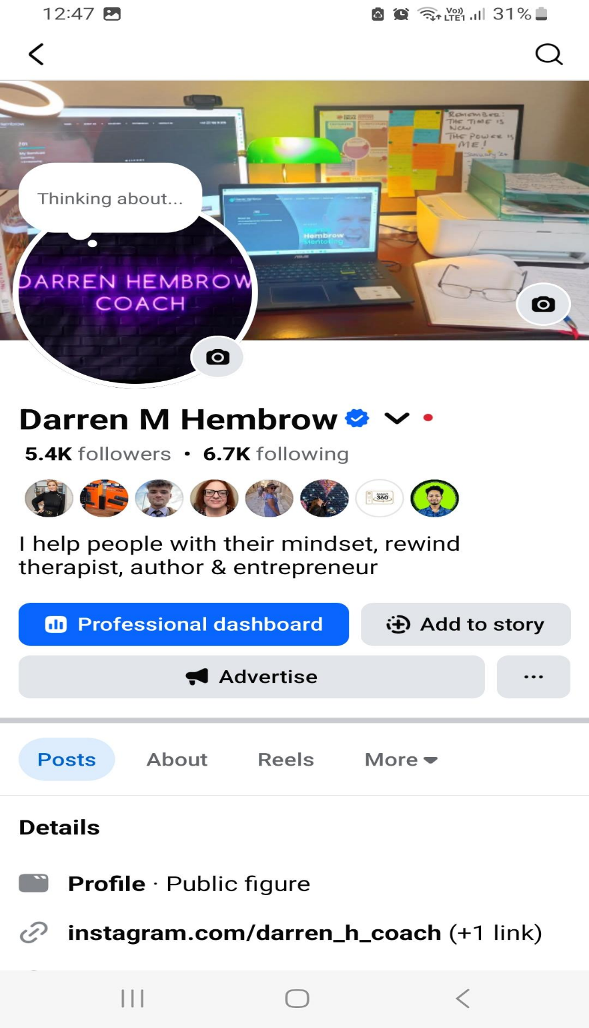
Figure 1: Professionalisation of Social Media. Web: Facebook/Darren Hembrow Nov 2025)

Appendix 2:
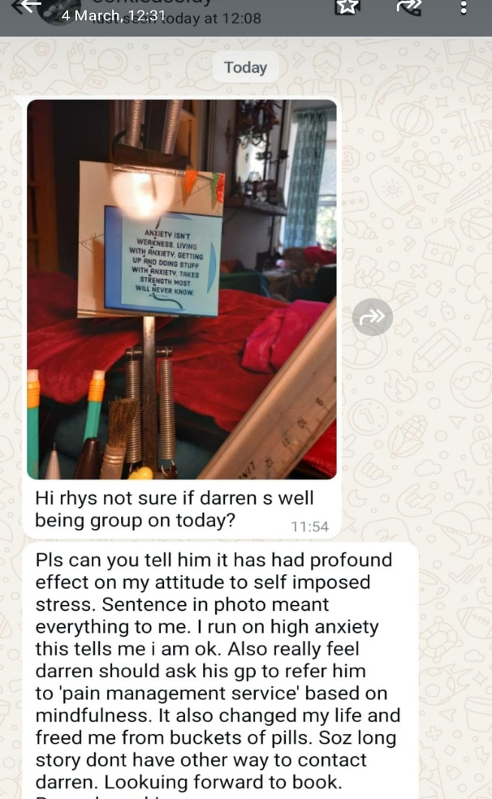

Figure 2: Feedback from an attendee at one of my sessions.

Appendix 3:
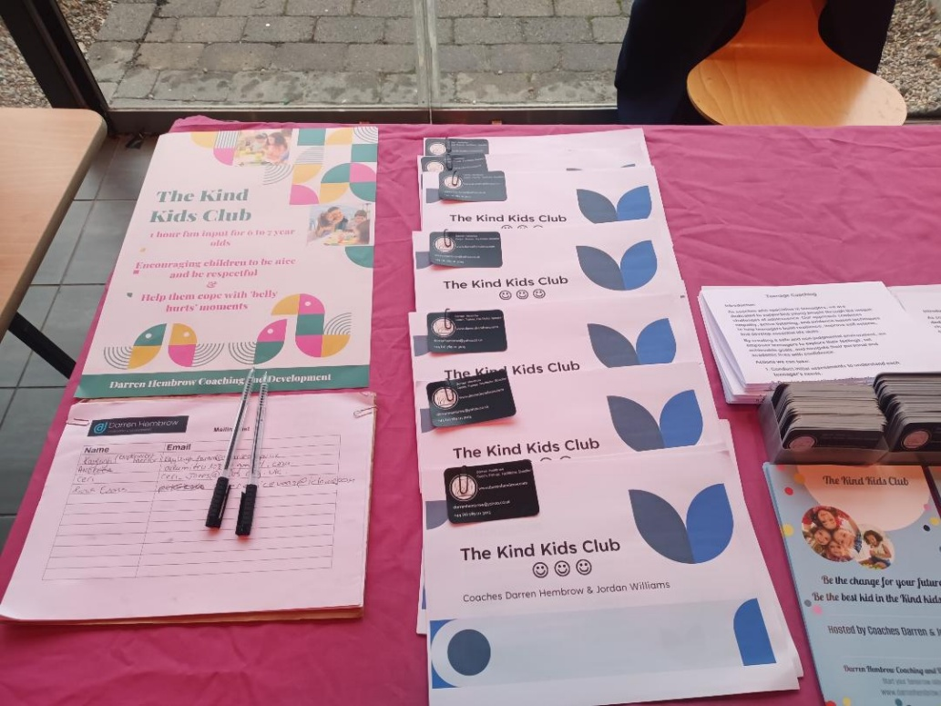
Figure 3: Engagement table, with business cards, email form and leaflets. This is from a one stop shop organised by Swansea Council.

Appendix 4: Confirmation of working with Swansea Council email
Julie Gosney
From:julie.gosney@swansea.gov.uk
To:Darren Hembrow
Cc:Rhys Thomas
Fri, 21 Nov at 13:40
Hi Darren,

Hope you’re well!

I apologise for the delay in providing this confirmation e-mail to support your University studies.

I can confirm that Darren Hembrow has been facilitating “Positive Mindset & Wellbeing” sessions, each Tuesday from 2pm to 4pm and these sessions started about 18 months ago.

The sessions have been really well received in the community and supported a number of participants from both our “Ageing Well” and “Disability Network” groups. Over this time participants have shared the positive influence that these sessions have had and the discussions and skills learnt had enabled them to reflect and think differently about difficult experiences in their lives.

If you require further information then please do not hesitate to come back to me.

Julie
Julie Gosney
Partnership & Involvement Team Manager
Rheolwr Tîm Partneriaeth a Chyfranogaeth

( 07814105956
* julie.gosney@swansea.gov.uk

Appendix 5: Funding application cover sheet.

Winter Wellbeing Grant 2025
Section 1 - About your organisation
Contact name | Darren Hembrow
Name of organisation | Darren Hembrow Coaching and Mentoring
Organisation address
Address | 21 benthall place  st thomas
Postcode | SA1 8AY
Email | darrenhembrow@yahoo.co.uk
Telephone | 07891113015
Status of organisation | Private, however, offering free at point of access to 50+
When was your organisation established? (optional) | 2023-07-01
Does your organisation have a bank account in its name requiring authorisation of two signatures for withdrawals or an appropriate business bank account? | Yes

DECLARATION
I confirm | Yes
Applicant full name | Darren Hembrow
Role in organisation | Owner
Secondary / alternative contact name (optional) | Jordan Williams
I confirm I am happy for my application and attachments to be sent to all grant funding panel members, which may include people outside of the council.
I confirm on behalf of my group that I am authorised to sign this declaration and that to the best of my knowledge all information within this application is accurate.
I understand that the grant must be spent for the purpose for which it is awarded otherwise it may be subject to repayment in part or in whole.


Appendix 6:
Rewind Therapy Qualification obtained under Continuous Professional Development
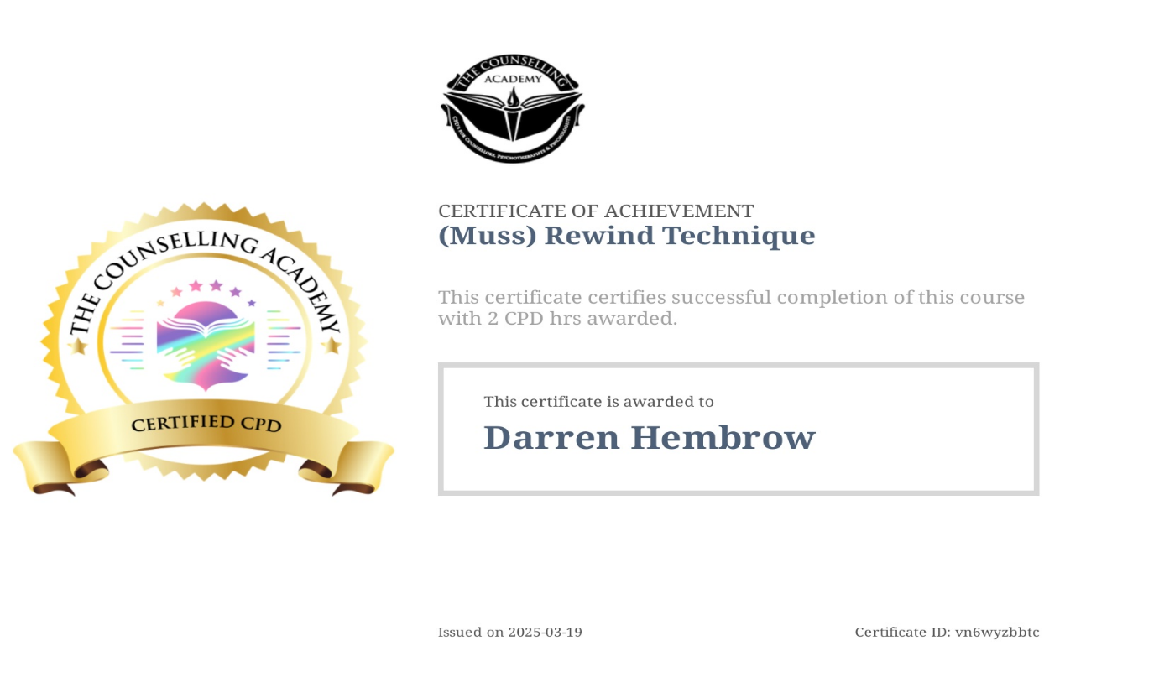

Appendix 7:
Three emails highlighting professional practice:
- Jordan Williams
Ref
Yahoo/Inbox
Jordan Williams
From:jordonwills12@gmail.com
To:Darren Hembrow
Sun, 26 Oct at 12:50
Darren Hembrow's coaching has been a life changing experience for me. With his coaching style, pinnacle questioning and references through useful quotes, psychology theories, human biological explanations combined with allowing me space to really look deeper at myself and all the options available. His patients and understanding is second to none. As a coach darren has gone over and above while always being reliable, punctual and great communication. Thanks to Darren I am now exactly where i thought I would never be. I highly commend darrens skills and anyone who would choose to miss out on this would be vastly missing out.

Jordan WIlliams,
07454471454,
jordonwills12@gmail.com

- Sharon Monk:

Reference for Darren Hembrow ~ Coaching
Yahoo/Inbox

monk.sharon@sky.com
From:monk.sharon@sky.com
To:Darren Hembrow
Fri, 31 Oct at 19:54
To Whom It May Concern,

Re: DARREN HEMBROW

I was firstly introduced to Darren during 2020 by a mutual friend on social media. This was during the Pandemic, and unfortunately my mental health was not very good and I was suffering from extreme severe depression, on medication but felt very isolated and alone.

Darren is extremely approachable and after the initial message I sent him, he replied with such kindness, understanding and no judgment. I really do feel very blessed that our paths have crossed.

Since then, I have remained friends with Darren and have been so proud of his journey.
Darren is very honest, trustworthy and reliable. I wasn’t in a good place, very low self-esteem and absolutely no confidence.
As a coach Darren guides me with ideas rather than being dictated to like previous professionals had. He also had a fabulous way of encouraging me to set targets that are achievable rather than me trying to do so many things resulting in me becoming overwhelmed and then giving up.
I have always wanted to help others, but I didn’t know where to start or even if I was capable of becoming a Coach. Again, Darren saw my potential and assisted me with overcoming my fears f meeting knew people, working well with them all, and thoroughly enjoyed the Coaching Course that Darren did.
Learning with Darren, I found I was really looking forward to to our classes. He was absolutely amazing when teaching us. Nothing was to much trouble. He made me feel at ease when I didn’t understand something or forgot what something meant and was always there to help and explain.
Darren really is without doubt someone I would and will continue to go to, whether it be as a Coach or my friend. He really does brighten my day if I’m having a down one, and my confidence is starting to shine again.

I wish him all the very best for his future and know he will succeed and help others.
Kind regards,
Sharon Monk

- Lewis Mason

lewis mason
From:loda@hotmail.co.uk
To:darrenhembrow@yahoo.co.uk
Sat, 15 Nov at 18:43
Darren's attention to detail adds a sense of tailored approach to all his sessions. Exploring all avenues that promotes development and long term goals. I highly recommend Darren as a coach and mentor.

