Assignment 2:
Future Developments in the Field of Marketing
(Individual Report)

Marketing Management BMMB7012

Ffion Cumberpatch 1551691
Christopher Wilkin

Wordcount:

Executive Summary

Table of Contents
Executive Summary 2
Introduction 4
Internal and External Analysis – The 5 C’s 4
Company (Internal Analysis) 5
SWOT Analysis 8
Customers (External Analysis) 10
Segmentation: Geographic, Demographic, Psychographic, Behavioural 10
Competitors (External Analysis) 12
Porters Generic Strategies (Porter, 1960) 13
Collaborators (External Analysis) 15
Climate (External Analysis) 16
Conclusion 18
Recommendations 19
RACE 19
Reference List 21

Introduction
The purpose of this report is to critically evaluate the role and activities of the Marriott marketing department and outline future developments to address the earlier identified challenges. To effectively evaluate the role and activities of Marriotts marketing department a situational analysis will be used to identify the internal and external factors that could impact Marriott’s marketing strategy (Corporate Finance Institute, 2022). Through conducting this situational analysis early in this report, the findings can then be used to provide recommendations.

Internal and External Analysis – The 5 C’s
A situational analysis is a critical tool of the marketing planning process in this report the model will be used to understand the current marketing environment and identify opportunities and challenges that could affect Marriotts marketing efforts.
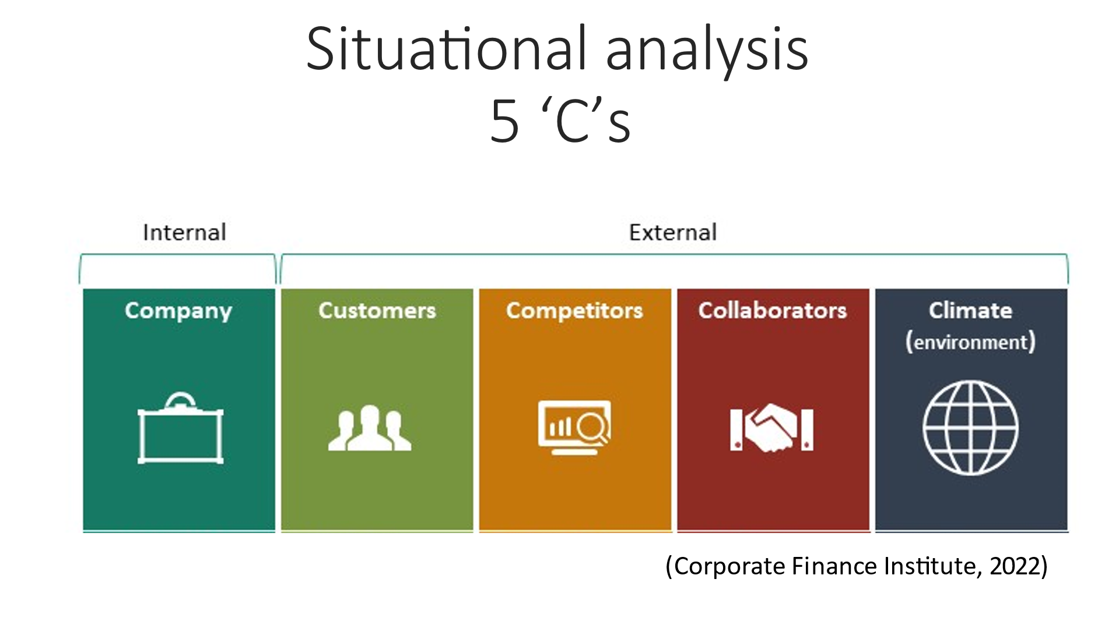

Company (Internal Analysis)

7 P’s Marketing Mix (Booms & Bitner, 1981)
In order to conduct an internal analysis of the Marriott organisation, this report uses Booms & Bitners (1981) 7Ps model, a framework designed to expand on the original 4Ps by McCarthy (1960) and includes People, Process and Physical Evidence. The 7Ps model is it is a customer centric approach to marketing and allows and organisation to be in better alignment with their marketing activities and business objectives. This leads to an improved brand image, increased consumer loyalty and a competitive advantage in the market.
Product: Marriott International boasts and impressive portfolio of 31 hotel brands across over 8,500 properties across 138 countries. Each brand is classified as either luxury, premium or select-service and unique with features and amenities to attract and appeal to their ideal target market. For example, Moxy, one of Marriotts newer brands are designed to appeal to a Millennial market, and therefore include abundant USB ports and Flat-screen HDTVs with YouTube and Netflix casting capability (Moxy, 2023). Marriott’s product strategy includes continuous innovation and improvement to meet the changing needs of their consumers, even introducing a modern design lab in Bethesda where they are testing new room designs and food options (O’Neill, 2022).
Price: Marriott’s pricing strategy varies based on the brand of hotel and its location as it has brands that cater to more restrictive budget like Fairfield, which offers comfortable amenities with good value and high end luxury brands like Autograph Hotels, for guests who want forward-thinking experiences, as well as design-crafted spaces at a high end price tag (Hollander, 2022).
Marriott also utilises dynamic pricing to adjust room rates based on marked demand and seasonality. For example, in 2017 Swansea Marriott increased prices to £4,650 per night due to demand for the Champions League Final (Youle, 2017). The marketing team must be aware of this, as that incident attracted bad press to the hotel from consumers and the community.
Place: Marriott has a global presence and uses a variety distribution channels to make its products available to their target consumers. Marriott does encourage direct books via their online booking platform and mobile app and recently launched an ad campaign “Room Around The World” suggesting you can find a room anywhere in the world to suit your budget on the app, so why would you book anywhere else (O’Neill, 2023). More direct books would benefit Marriott and therefore ad campaigns encouraging this is positive.
However, Marriott still use online travel agencies (OTAs) like Booking.com and Expedia which provide additional channels for consumers to book Marriott locations.
Promotion: Marriott’s promotional activities are vast and include advertising, public relations, and direct marketing. Marriott uses various channels to reach it is target audience, for example social media where a good portion of their website traffic originates.
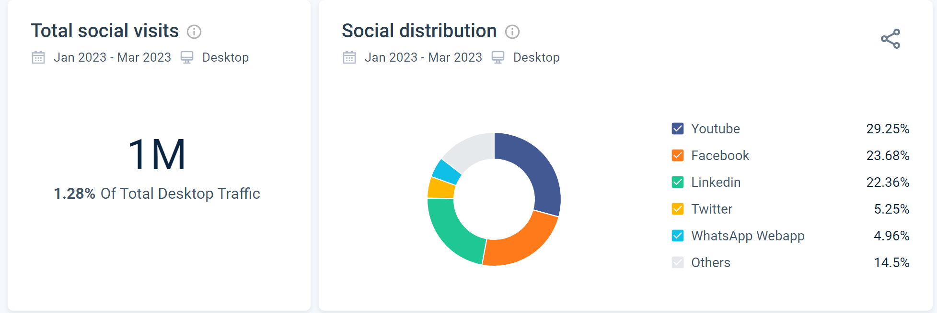
In 2022, Marriott launched a social media campaign on TikTok one of the most popular social media platforms called “30 stays, 300 days”, a successful campaign which saw 142.6million views (Campbell, 2022).

Marriotts Social Media Banner for 30 Stays, 300 Days TikTok Campaign
Marriott have also been capitalising on the recent increase in Formula 1 popularity with their 2022 campaign with George Russell “Marriott Bonvoy membership means traveling better. Just ask George Russell” (Marriott Bonvoy, 2022). Marriott are incredibly good at identifying their target consumers interests and using them to create eye catching promotions and should continue to do so.

Screenshot from Marriotts Advert with George Russell
However, if we consider crisis situations like the data breach of 2018 previously presented, this event and the aftermath highlights the importance of effective marketing communications in crisis situations. Marriott was criticised for its delayed response to the incident and lack of transparency, which could have been detrimental to its reputation. As such, it is essential for Marriott to have a crisis management plan, which includes marketing in place to respond promptly and transparently to any future incidents.
People: Marriott’s employees are critical to the organisations success and their culture is built around looking after their associates. The employee culture emphasises employee development and excellent customer service, consistently investing in training and development programs that ensure their employees are equipped with the right skills and knowledge to deliver exceptional customer experiences. One tool widely used among all staff is the Marriott credo card which outlines company values and mission, a constant reminder to employees to how to act and behave (Marriott, 2021).
Process: Marriotts service delivery process includes a combination of traditional and digital processes to manage operations and provide excellent customer service. For example, Marriott still have front desks in many of their properties but also offer a digital/mobile check in. Marriott has also introduced technology solutions such as keyless entry and Alexa for Hospitality to improve customer experience and streamline operations (Marriott, 2021).
Physical Evidence: Marriotts physical evidence includes hotel properties, amenities, and customer service. The organisation routinely invests in their property upgrades and in renovations to maintain a competitive position in the market. An example of this is the Cardiff Marriott who have recently undergone a renovation, with renovations to begin this year on Swansea Marriott.
Overall, Marriotts internal analysis using Booms and Bitner’s (1981) 7Ps marketing mix demonstrates a strong emphasis on consumer relationship, experience, and satisfaction. The organisation’s approach to the 7Ps is in alignment with their brand strategy and people-centric approach to business.

SWOT Analysis

SWOT Analysis (Humphrey & Goa, 2016)
The SWOT analysis is a popular tool for strategic planning and in this report is used as a tool to conduct a second internal analysis of Marriott (Humphrey & Goa, 2016).
Strengths: Marriott has a strong brand recognition and reputation within the hospitality industry, among the workforce and their target consumers (Luo & Bhattacharya, 2019). With their diverse portfolio of hotels, including luxury and budget options Marriott can cater to different segments of the market, essentially having a “Room anywhere for any budget” (Marriott International, 2021). Marriott have always had a good loyalty programme, and with the recent revamp to the programme Marriott Bonvoy was born, a robust program with over 147 million members worldwide (Marriott International, 2021).
Marriott put an emphasis on sustainability and corporate social responsibility through SERV360, with initiatives such as reducing environmental impact and supporting local communities (Marriott International, 2021).
Weaknesses: Marriott is incredibly dependent on the United States (US) market as this accounts for a sizeable portion of Marriotts revenue. If an event were to impact the US market, then Marriott may find themselves in financial difficulty.
Marriott is constantly competing with other major hotel chains such as Hilton, Hyatt, and Accor, as well as from alternative accommodations such as Airbnb (Luo & Bhattacharya, 2019). Marriott is very dependent on third party booking platforms which leads to reduced control over customer experience and pricing, despite their best efforts with their current advert campaigns (Gretzel et al, 2015).
Due to the data breaches in 2018 and 2020 there has been a negative impact on reputation and a lack of consumer trust, poor response to the breaches means it is taking longer to recover trust (Zhang et al., 2020).
Opportunities: There is an increasing demand for more sustainable and eco-friendly accommodation and with the number of renovations currently planned there is opportunity for Marriott to consider adding innovative and sustainable amenities (Booking.com, 2021). This could also be an opportunity to introduce further technology such as artificial intelligence and augmented reality to enhance customer experience (Alenazy et al, 2019).
Threats: One of Marriotts threats currently is economic downturns and political instability in key markets, which could lead to reduced demand for travel (MarketLine, 2021). For example, the current war in Ukraine impacts Marriott properties there and in the surrounding area. Meanwhile changing consumer behaviour and preferences threaten Marriott along with shifting market trends (Luo & Bhattacharya, 2019).
Marriott's data breach is still a threat potentially affecting its marketing activities. The data breach occurred in 2018 and affected over 500 million customers, making it one of the largest data breaches in history. The incident raised concerns over Marriott's security measures and ability to protect customers' personal information, which could lead to a loss of trust and loyalty among customers (Zhang et al, 2020)

Customers (External Analysis)

Segmentation: Geographic, Demographic, Psychographic, Behavioural
The concept of market segmentation has been around for years dating back as far as 1956 to an article written by Wendell R. Smith where he suggested organisations could increase profits by identifying and targeting different consumer groups. One popular way to do this is through understanding consumers in the following segments geographic, demographic, psychographic and behavioural.
Geographic: The Marriott organisation operates in 138 countries and territories with a specifically strong presence in North America, Europe, and the Asia Pacific regions. However, in terms of website traffic it appears to be the United States, Canada and India closely followed by the United Kingdom that are the countries with the most interest in the Marriott brand (Similar Web, 2023).
Marriott segments their consumers based on their geographic location which allows the organisation to tailor their marketing efforts or services accordingly. For example, Marriott hotels in Asia offer traditional tea ceremonies and other local cultural experiences, while hotels in Europe offer wine tastings or cooking classes. These are pushed in front of the correct segment via email marketing and social media posts (Marriott International, 2021).
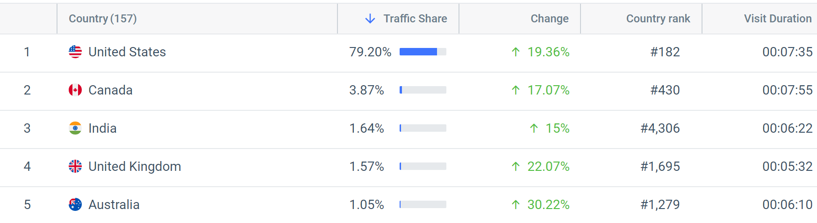
Geographic Website Traffic (Similar Web 2023)
Demographic Segmentation: Marriotts 31 brands have been created to fulfil the needs of consumers demographic characteristics such as age, gender, income, and occupation. Using gender and age as an example, the data from Similar Web (2023) demonstrated almost a 50/50 gender distribution, suggesting that Marriott needs to ensure their brands meet the needs of both genders. Meanwhile age reflects 25 – 34 to be the most popular age group for Marriott. The newer brands Marriott have introduced including Moxy and Aloft to appeal to a younger market (Gigante, 2014).
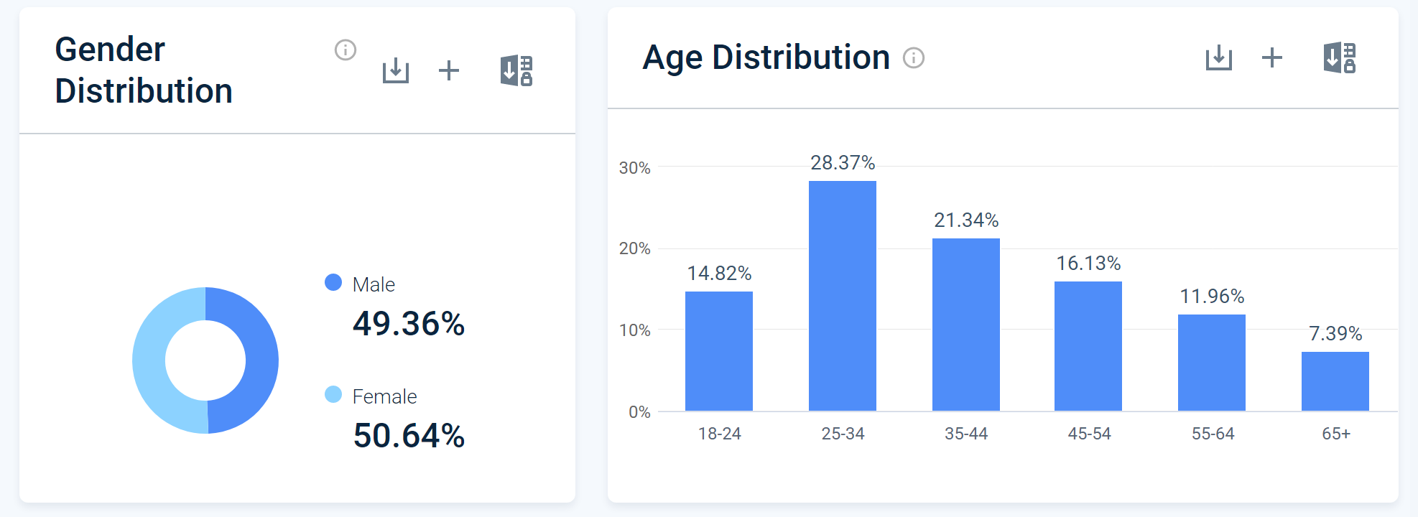
Marriott Demographics (Similar Web, 2023)
The company offers a range of brands and services that cater to other consumer groups. For example, the Ritz-Carlton brand targets high-end luxury travellers, while the Courtyard brand focuses on the needs of business travellers and families.
Psychographic Segmentation: Through its variety of brands Marriott is also able to target their consumers based on psychographic characteristics, for example lifestyles, values and personality. They can also target consumers with specific interests, preferences, and motivations (Prochaska & Diefenbach, 2019). From the data collected from Similar Web (2023) the most popular topics of interest include Finance, Travel, and the News. This is congruent with Marriotts large consumer base of business travellers.
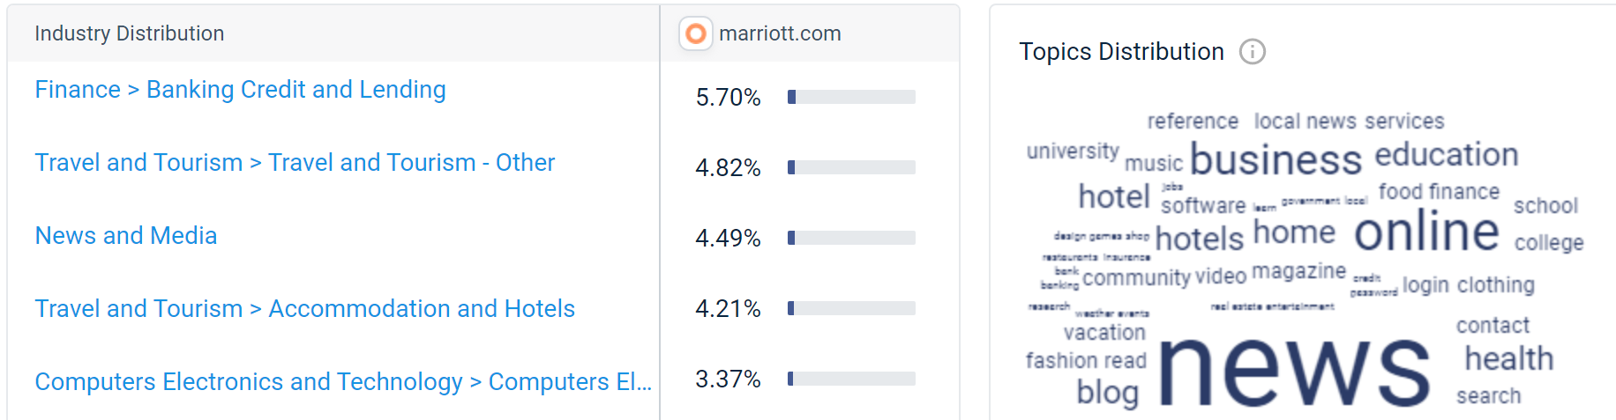
Audience Interests for Marriott (Similar Web, 2023)
Within the topic distribution data there also appears to be younger themes, community, music, fashion, health. Marriott recognises this and has introduced young brands congruent with this segment of consumers. For example, the Aloft brand, which boasts urban-inspired spaces and vibrant social scenes for the next-gen traveller. It is a music inspired brand, attracting those interested in staying somewhere different.
Behavioural Segmentation: Marriott also segments consumers based on behaviour like travel frequency, loyalty, and purchase history. Its Marriott Bonvoy programme is the primary way Marriott fulfils the needs and wants of this segment by rewarding consumers with personalised experiences and benefits. For example, with in room gifts, late check outs and room upgrades.
In conclusion, Marriott has successfully implemented segmentation strategies and identifying and targeting specific groups of consumers with brands, amenities, loyalty benefits. Through reviewing this information, it appears Marriott understands and is working towards meeting the needs of their consumers.
However, in terms of marketing activities, the data breaches should be considered as it could impact Marriott's ability to attract and retain customers, as consumers may be hesitant to provide their personal information to the company. Marriott needs to implement effective strategies to rebuild trust with its customers, these have already been mentioned above such as offering incentives, however, Marriott also needs to improving security measures, and transparently communicating its efforts to prevent future incidents.

Competitors (External Analysis)
The travel and accommodation segment of the hospitality market is very competitive, and Marriott are in constant competition with brands such as Hyatt, InterContinental Hotels Group, Accor, and Wyndham Hotels and Resorts. These organisations also have loyalty programmes, marketing campaigns and pricing strategies that compete with Marriott. Marriott also need to consider newer competitors such as AirBnB and other vacation rental platforms as these are disrupting the hotel industry and should be considered as competitors (Similar Web, 2023).

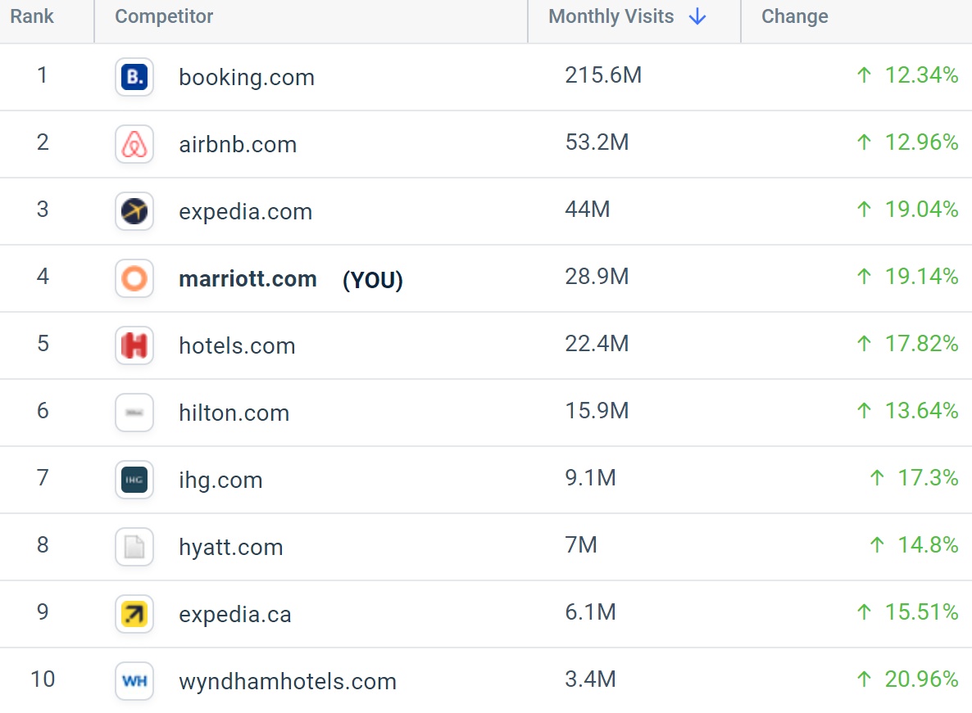
Marriott Competitors (Similar Web, 2023)

Porters Generic Strategies (Porter, 1960)

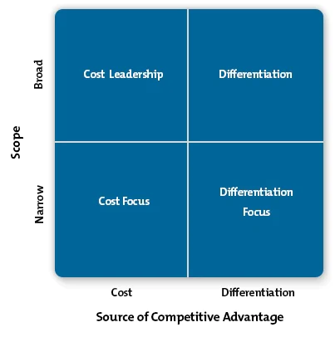
Within this report the advantages of Marriotts 31 brands have been explored in relation to other models, when it comes to competitive advantage this is no different. By providing unique and exceptional services and amenities to cater to the needs and wants of their customers Marriott differentiates themselves their competitors. Marriott being a global hospitality company employs a broad differentiation strategy primarily to gain that competitive advantage using their portfolio catering for high-end luxury travellers to budget-conscious guests.
Marriotts differentiation strategy, particularly with its luxury and lifestyle brands for example W Hotels and The Ritz Carleton is strong, targeting specific segments such as the high-end consumers and through these brands they provide unique, personalised experiences to guests whilst charging a premium and enhancing overall profitability.
Marriotts differentiation strategy is supported further by their focus on innovation and technology as mentioned previously. These advancements enhance consumer experience and helps distinguish Marriott from their competitors.
Through the differentiation strategy Marriott has been able to gain a competitive advantage over its competitors. However, the industry continues to change, spearheaded by consumer changes and behaviour so Marriott must continue to be creative and innovative with their ad campaigns to stay ahead of competitors.

Collaborators (External Analysis)
Marriotts stakeholders include their customers, employees, investors, suppliers, partners, franchisees, shareholders, and the communities where its hotels are located.
Marriott has 5,493 franchisees who own and operate its hotels under the Marriott brand. For example, Marriott Swansea and Cardiff are both franchises. 53% of Marriott hotels are franchised whilst 47% are operated by Marriott (Erie Times News, 2022). Franchisees are an important part of the company's business model and contribute significantly to its success. Therefore, Marriott work with leading management companies and owners to provide comprehensive training, tools, and resources to help ensure each hotel's success. In addition to access to Marriott's diverse brand offerings and strong global base of loyal guests, franchise partners can take advantage of our powerful global sales and marketing systems and our innovative resources and programs designed to consistently drive strong results (Marriott, 2023).
Marriott has formed partnerships with brands from a variety of industries to enhance their marketing efforts. For example, Marriott has partnered with companies like Coca-Cola, Netflix, Amazon and more recently the Mercedes AMG-Petronas team to offer unique experiences and services to their consumers.
Marriotts Corporate Social Responsibility Plan is Serve 360, within the plan they highlight various environmental schemes and incentives to promote sustainability and social responsibility. Their goal is reducing its environmental footprint and supporting their local communities, something they do with their long standing relationships with various charitable organisations and causes. They do this through their Marriott International Foundation, which supports organisations that focus on education, the environment and community development. For example, they raised millions for the Al Jalila Foundation (Corder, 2023).
Marriott also partners with organisations like the Red Cross to provide disaster relief and support for those in need. For example, during the Covid pandemic Marriott assisted the Red Cross with a blood shortage in Thailand (Paul, 2020).

Climate (External Analysis)
STEEPLE (Social, Technological, Economic, Environmental, Political, Legal and Ethical) is an extension of the PEST (Political, Economic, Social, and Technological) analysis and is a useful tool to conduct an external analysis on the external macro-environment factors that could impact Marriotts strategy and operations (Jackson & Bray, 2007).
Social: Millennials are now the largest generation, with this increase in number their preferences for unique and personalised experiences must be considered and the development of the Moxy and Aloft brand. Despite this change Marriott must not forget the aging population and the need for comfortable and accessible accommodations.
After the pandemic there was an increasing interest in travel experience rathe than material possessions. Marriott must consider embracing the experiential travel further, focusing on culture immersion and adventure tourism as part of their product and in their marketing campaigns.
Technological: Technology is rapidly evolving including mobile devices and social media. Marriott must consider continuous improvements to their apps and in room technology. They have began introducing Alexa for Hospitality in their properties, consideration must be made for a wider roll out. However, with this comes customer discomfort as to if Marriott will be able to keep their data and security safe in the use of technology if they have had previous security and data breaches.
Advancements in artificial intelligence (AI) and machine learning for personalised marketing are applying pressure to organisations including Marriott for data analysis and AI to offer customised recommendations and tailored experiences.
Economic: Fluctuating exchange rates and global economic conditions will always pose a threat to global organisations such as Marriott. In terms of the competitiveness of the hospitality industry since the pandemic there has been a plateau in the openings of new competitors which provides Marriott with breathing room. There is the risk of recession in the United Kingdom which could impact consumer spending patterns and travel budgets, this requires Marriott to be flexible in their pricing and marketing strategies to cater for a potential change in consumer behaviour.
Environmental: There is a growing concern for environmental sustainability and eco-tourism and whilst Marriott has Serve 360, the organisation is still at risk of being branded as “not doing enough” and therefore must consider communicating sustainability efforts in advertisements.
Political: Changes in immigration and travel policies can impact Marriotts strategy, if countries with Marriott hotels choose to restrict travel this could see a drop in visitors and potentially harm any marketing campaigns running for that destination. This proves a similar issue when it comes to trade agreements and political instability affecting travel patterns and destinations. For example, the current war with Russia in Ukraine.
Government regulations and taxes can impact Marriott and require Marriott to increase prices to cover tax increases or wage increases.
Legal: Marriott is particularly good at complying with laws and regulations, however changes in consumer protection laws and regulations could serve as challenge for Marriott.
Intellectual property rights and copywriting and marketing materials is another challenge, with a global presence and varying laws the potential for Marriott to experience lawsuits is increased.
Employment laws and regulations impacting the workforce is another factor. Marriott's need to comply with employment laws related to working hours, minimum wage, and discrimination.
Ethical: There has been an increased focus on ethical marketing practice and transparency. Marriott should be transparent in it is marketing practices and ensure that the advertising and promotions are truthful and accurate. There is also growing concerns over the impact of tourism on local communities and cultures, therefore Marriott needs t be mindful of the impact of its operations on local communities and cultures and work to minimise negative effects. Marriott should maintain ethical supply chains and fair labour practices.
To conclude the STEEPLE analysis, Marriott's marketing department must stay up to date with changes in social, technological, economic, environmental, political, legal, and ethical factors to ensure successful marketing strategies and campaigns and avoid bad press and PR disasters.

Conclusion
To conclude, Marriott is performing well with their marketing efforts, however, the multiple data breaches that occurred highlight the importance of having a comprehensive marketing strategy. While Marriott has taken steps to address the data breaches, such as offering free identity theft protection and implementing stronger security measures, their response has been criticised for being slow and inadequate. The negative publicity surrounding the breaches has long-lasting effects on the brand's reputation. Their poor response highlights the importance of clear and transparent communication during times of crisis. The data breaches at Marriott serve as a reminder of the importance of cybersecurity in today's digital age and that the role of the marketing department is not just initiative-taking but also needs to be sufficiently reactive to crisis situations.

Recommendations

RACE

RACE Model (Chaffey, 2010)
The RACE model was developed by Dave Chaffey in 2010 and is a customer centered tool to plan, manage, and optimise digital marketing. This should be part of their current strategy and to some extent their crisis management plan. For this case study only relevant parts of the model have been used RCE.
R – Reach: Marriott must focus on rebuilding the trust of the consumer by being transparent about the security measures and regularly communicating any updates or changes. This should be done through targeted digital advertising campaigns, social media posts and email marketing. This poses very little risk as this is something customers would expect and welcome. In terms of feasibility, it would not increase cost to focus on this alongside the latest trend perhaps even a cross campaign.
C - Convert: Marriott would be wise to offer incentives for customers to return, such as discounts or loyalty program points, this would assist in rebuilding customer loyalty and trust.
E - Engage: Marriott should engage with customers through personalised messaging and offers based on their preferences and past behaviours. As discussed in this report Marriott are being initiative-taking with this through targeted email campaigns, social media interactions, but could consider more personalised content on the company's website.
Overall, Marriott should focus on rebuilding trust and confidence with its customers by prioritising data security and being transparent about its efforts via their ad campaigns. By doing so, the company can regain customer loyalty and protect its reputation in the long term.

Reference List

McCarthy, E. J. (1960) Basic Marketing a Managerial Approach. Homewood Ill: R.D. Irwin.
Alenazy, R., Teixeira, R., & Vrontis, D. (2019). The Role of Artificial Intelligence and Augmented Reality in Enhancing Customer Experience: The Case of Marriott Hotels. In V. V. Das (Ed.), Contemporary Perspectives on Technological Innovation, Management and Policy pp. 168-184.
BBC News. (2020). Marriott Hit by Second Data Breach in Two Years. Available at: https://www.bbc.com/news/technology-52005103 [Accessed 6 May 2023]
Bhandari, S. (2021). Marriott's Digital Marketing Strategy: An Overview. Business 2 Community. Available at: https://www.business2community.com/digital-marketing/marriotts-digital-marketing-strategy-an-overview-02415094 [Accessed 6 May 2023].
Bolton, R. (2020). Marriott data breach: How did it happen and what was the impact? Available at: https://www.computerweekly.com/news/252480408/Marriott-data-breach-How-did-it-happen-and-what-was-the-impact [Accessed 6 May 2023]
Booms, B. H., & Bitner, M. J. (1981). Marketing strategies and organization structures for service firms. Marketing of Services, American Marketing Association. (pp.47-52).
British Library (ND) What is SWOT analysis? British Library. Available at: https://www.bl.uk/business-and-ip-centre/articles/what-is-swot-analysis#:~:text=The%20SWOT%20framework%20is%20credit,the%201960s%20and%20early%201970s. [Accessed: 6 May 2023].
Campbell, K. (2022) 30 stays, 300 days: Inside Marriott's viral marketing campaign, 30 Stays, 300 Days: Inside Marriott's Viral Marketing Campaign. Cvent Blog. Available at: https://www.cvent.com/en/blog/hospitality/30-stays-300-days-marriott-marketing-campaign [Accessed: 6 May 2023]
Chen, K. Y. (2019). A labor shortage is forcing hotels to rethink amenities. Available at: https://www.bloomberg.com/news/articles/2019-06-12/a-labor-shortage-is-forcing-hotels-to-rethink-amenities [Accessed on 6 May 2023]
Conlon, M. (2021). Marriott's marketing chief on how the hotel giant has pivoted its strategy during Covid. Campaign. Available at: https://www.campaignlive.co.uk/article/marriotts-marketing-chief-hotel-giant-pivoted-strategy-during-covid/1703721 [Accessed 6 May 2023].
Corder, J. (2023) Marriott continues guido de Wilde's road to awareness, raising millions ..., Hotelier. Available at: https://www.hoteliermiddleeast.com/news/marriott-continues-guido-de-wildes-road-to-awareness-raising-millions-for-al-jalila-foundation (Accessed: 6 May 2023).
Corporate Finance Institute.(2023) 5Cs Analysis. CFI. Available at: https://corporatefinanceinstitute.com/resources/management/5c-analysis-marketing/ [Accessed: May 6, 2023].
Erie Times-News. (2019) Marriott Investors Sleep Easy. Erie Times-News. Available at: https://eu.goerie.com/story/business/2019/04/28/marriott-investors-sleep-easy/5321912007/ (Accessed: 6 May 2023).
Gigante, J. (2014) Marriott evolves to accommodate younger guests. MDG Solutions. Available at: https://www.mdgsolutions.com/learn-about-multi-location-marketing/marriott-evolves-to-accommodate-younger-guests/ (Accessed: 6 May 2023).
Gordon, S. (2021). Eco-friendly hotels: How Marriott, Accor and IHG are tackling sustainability. Available at: https://www.reuters.com/article/us-hotels-environment/eco-friendly-hotels-how-marriott-accor-and-ihg-are-tackling-sustainability-idUSKBN2BI0J1 [Accessed 6 May 2033]
Hollander, J. (2022) All of Marriott's Hotel Brands explained. Hotel Tech Report. Available at: https://hoteltechreport.com/news/marriott-hotel-brands [Accessed: 7 May 2023].
Humphrey, A. and Gao, S., 2016. A Guide to Writing Your Dissertation: SWOT analysis. Research Methods for Business and Management. pp.43-55.
Jackson, S. E., & Bray, M. J. (2007). High performance organizations: A review and research agenda. Journal of Management. 33(4), 664-690. https://doi.org/10.1177/0149206307302554 [Accessed: 6 May 2023]
Jiang, Y., & Li, X. (2019). The impact of online intermediaries on hotels' profitability: A global investigation. Journal of Hospitality and Tourism Management. 39, 92-103.
Luo, Y., & Bhattacharya, C. B. (2019). Marriott International: Mapping the hospitality industry. Journal of Business Research. 98, 117-126.
MarketLine. (2021). Marriott International, Inc. Company Profile. Available at: https://advantage.marketline.com/Product?pid=MLIP0882-0047 [Accessed on 6 May 2023]
Marriott (2023) Hotel Marketing Platform. Marriott. Available at: https://www.hotel-development.marriott.com/hotel-development (Accessed: 6 May 2023).
Marriott Bonvoy membership means traveling better. just ask George Russell. 🚁 #abudhabi #f1 (2022) YouTube. Available at: https://www.youtube.com/watch?v=40ZqBNVO0zo (Accessed: 6 May 2023).
Marriott International. (2021). Annual Report. Marriott. Available at: https://marriott.gcs-web.com/static-files/3167a914-2d07-484a-a64c-23d7f5a2a71e [Accessed 6 May 2023]
Marriott International. (2021). Loyalty. Marriott. Available at: https://www.marriott.com/loyalty.mi [Accessed 6 May 2023].
Marriott International. (2021). Marketing Strategy. Marriott. Available at: https://www.marriott.com/marriott-brands-marketing.mi [Accessed 6 May 2023].
Marriott International. (2021). Marriott's Commitment to Excellence: Our Credo. Marriott. Available at: https://www.marriott.com/about/culture-and-values/marriott-culture.mi [Accessed 6 May 2023]
Marriott International. (2021). Serve 360: Doing good in every direction. Marriott. Available at: https://serve360.marriott.com/ [Accessed: 6 May 2023]
Marriott. (2020). Form 10-K 2020. Marriott. Available at: https://www.sec.gov/ix?doc=/Archives/edgar/data/1048286/000104828621000010/mar-20201231.htm [Accessed 6 May 2023]
Moxy Hotels (N.D) Moxy Stylish Budget Hotels. Marriott Hotels. Available at: https://moxy-hotels.marriott.com/ [Accessed: 6 May 2023].
O'Neill, S. (2022) Marriott Elevates Design Lab at New Headquarters in Innovation Push. Skift. Available at: https://skift.com/2022/08/16/marriott-elevates-design-lab-at-new-headquarters-in-innovation-push/ [Accessed: 6 May 2023].
O'Neill, S. (2023) Marriott's new ad campaign touts its loyalty program in a murky direct booking future. Skift. Available at: https://skift.com/2023/04/18/marriotts-new-ad-campaign-touts-its-loyalty-program-in-a-murky-direct-booking-future/ [Accessed: 6 May 2023].
Paul, M. (2020) How Marriott teamed up with Red Cross to alleviate blood shortage crisis in Thailand during covid-19. Travel Daily. Available at: https://www.traveldailymedia.com/how-marriott-teamed-up-with-thai-red-cross-to-host-blood-donation-drive/ (Accessed: 6 May 2023).
Porter, M. E. (1980). Competitive Strategy: Techniques for Analyzing Industries and Competitors. New York: Free Press.
Prochaska, F., & Diefenbach, T. (2019). How psychographic targeting helped the Marriott International increase bookings. Journal of Hospitality and Tourism Insights 2(2), 167-178. https://doi.org/10.1108/JHTI-06-2019-0088 [Accessed 6 May 2023]
Smith, W. R. (1956). Product differentiation and market segmentation as alternative marketing strategies. Journal of Marketing. 21(1), 3-8.
Statista. (2021). Marriott International: key figures. Statista. Available at: https://www.statista.com/statistics/225395/revenue-of-marriott-international-worldwide/ [Accessed 6 May 2023].
Youle, R. (2017) City Hotels' £4,650 room for Champions League Final Night. Wales Online. Available at: https://www.walesonline.co.uk/news/wales-news/swansea-hotel-charging-4650-per-13039524 [Accessed: 6 May 2023].
Zhang, Y., Ye, Q., Law, R., & Li, Y. (2020). The Impact of Cybersecurity Incidents on Hotel Guest Loyalty: The Moderating Role of Hotel Brand Equity. Journal of Travel Research. 59(2), 221-236.

