
BMIH6004
Hotel Placement- Managing Hotel Administration
Level 6
Module Lead
Jessica Newport BA (Hons)
Student name & ID: Marius Lupoae; 2127268
Words: 1,339

Table of Contents
Introduction 3
Section 1: Reflection on Experience and Personal Development 4
Section 2: Critical Analysis of Work-Based Skills and Technical Knowledge 5
Section 3: Reflection on Organisational Issues 6
Conclusion and Action Plan 8
References 9

Introduction
The Front Office management at Delta Marriott Hotel Swansea is crucial for the day-to-day activities that directly interact with the customer, providing necessary support through reservation and communications. I decided to concentrate on Front Office Management operations because these are core to any hotel because they dictate the guest satisfaction levels. The most important reason is to achieve my objective of career progression in the capacity of a hotel administrator.
Learning Objectives for Placement:
- Observe and understand the administrative flow in Front Office operations.
- Develop technical knowledge and practical skills in guest service and administrative efficiency.
- Enhance communication and teamwork through collaboration with supervisors and team members.
- Identify and analyse an administrative issue, proposing practical improvement solutions.

Section 1: Reflection on Experience and Personal Development
Observing a supervisor in Front Office administrative tasks is one of the best ways to closely study the general managerial competencies needed for efficient hotel management. Using Kolb’s Learning Cycle (1984)—Concrete Experience, Reflective Observation, Abstract Conceptualisation, and Active Experimentation—I strengthened my understanding of guest service in a fast-paced environment (Veine et al., 2020).

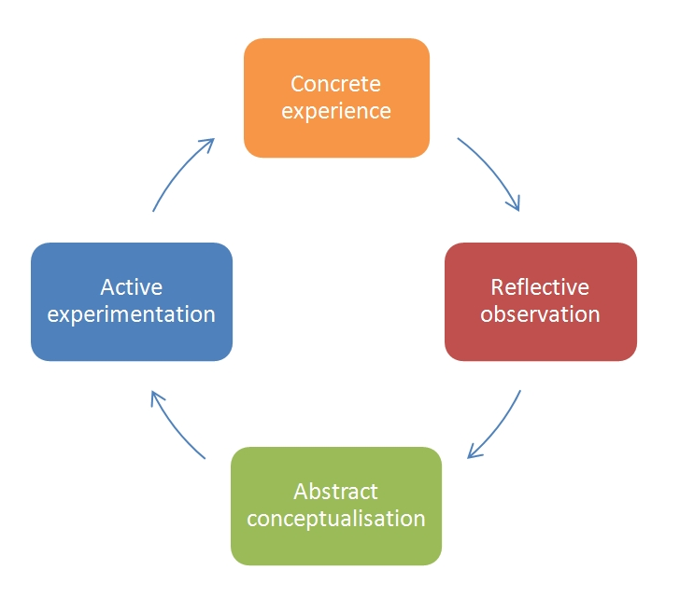
Figure 1: Stages of Kolb's Reflection Model (Veine et al., 2020)
An event happened during a shift change and the team was overwhelmed with guests checking in and out, during such time my supervisor remained extremely professional, and coordinated with the housekeeping and guest services. This moment promoted the idea of proactive communication and decision-making to solve unexpected issues. I realised that dealing with stressful situations with effective communication is ideal for both the guests and the team’s morale (ASET, 2017).
Reflecting on this occurrence, I realised that being efficient keeps track of different tasks and focuses on the ones that are most relevant to the guest experience in Front Office. This taught me how to think about how one might deal with such situations because good interpersonal skills, and a certain amount of flexibility, cannot be underestimated.
In Abstract Conceptualisation, Connecting this to customer service theories I learn how important communication and technical skills work hand in hand to deliver a guest service. From this viewpoint, it was clear that each communication encounter with the guests, even if brief, contributes toward their impression and subsequent level of satisfaction.
Finally, Active Experimentation allowed me to apply these skills independently. Since then when I had to coordinate for various matters like housekeeping for room readiness I followed what my supervisor was doing and kept the lines of communication open, with any issue solved immediately. This has built my confidence every time am faced with similar situations and I have learnt how administrative activities contribute to a good guest experience.

Section 2: Critical Analysis of Work-Based Skills and Technical Knowledge
The technical skills and experience related to the workplace are therefore important in hotel management. In this paper, I applied Kolb’s Learning Cycle to the following skills and gained a clear understanding of how to handle guest expectations and improve operations.
In the Concrete Experience stage, as part of my work in the Front Office, I saw how correct coordination between the staff is crucial. For example, there was a guest who complained about dissatisfaction because of a mistake made on the booking; then I saw my team leader address the man in a concise, compassionate consideration.

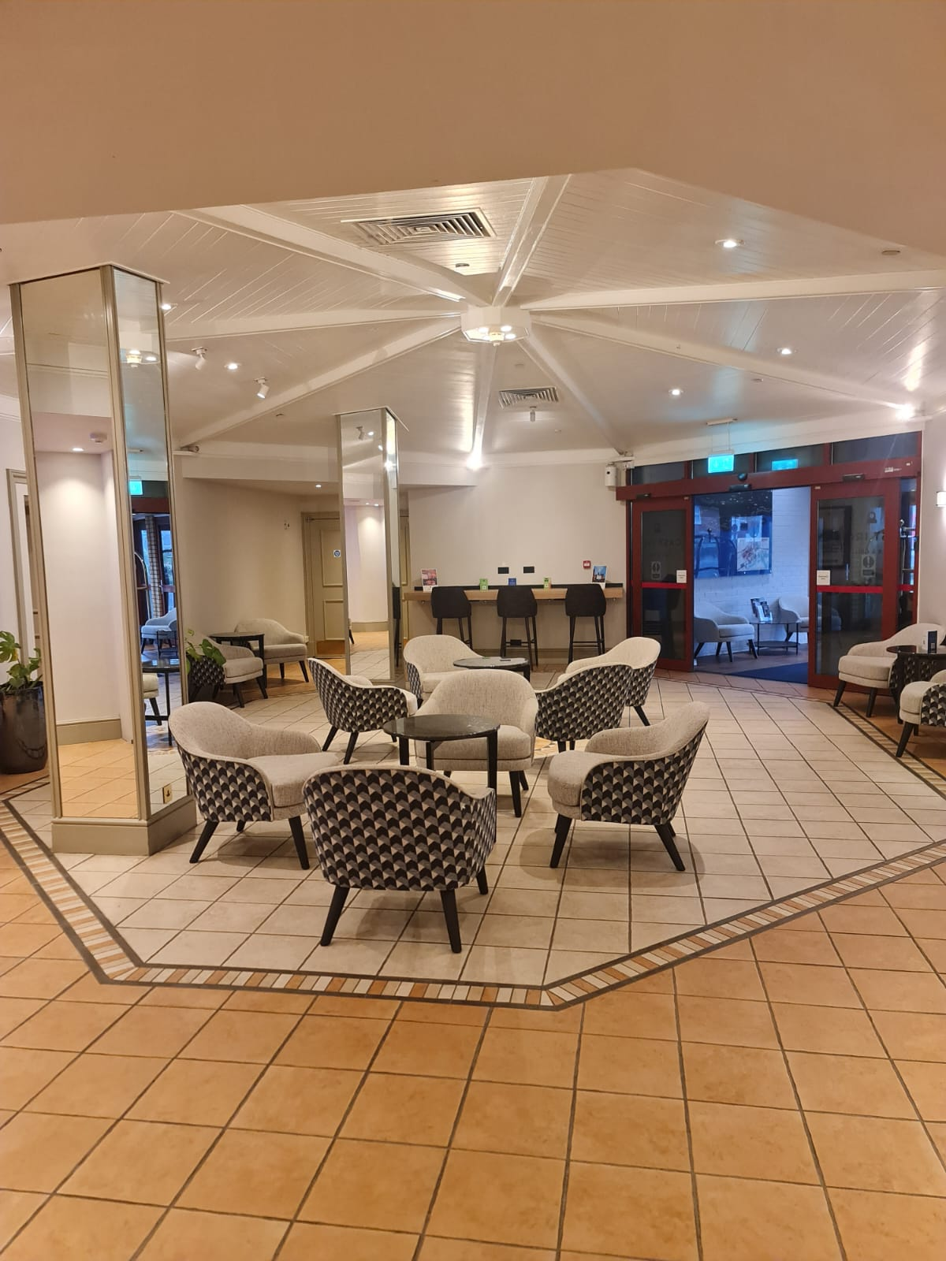
Figure 2: Placement Hotel (Source: Self- Captured)
Reflective Observation helped me see that strong administrative performance involves more than technical expertise; it requires interpersonal skills and adaptability (Casado, 2012). When thinking about this experience, I concluded that the elements of booking are only not all in managing the guests. Just as important is ‘people skills' – to listen to each guest’s issues and solve them without getting into an altercation.
In Abstract Conceptualisation, when relating this to the theories of customer satisfaction, I realised how important for the Front Office staff it is to try to predict guests’ needs ahead of time. This understanding requires me to enhance my communication and interpersonal skills as I accord with the guest's expectations (Hagg, 2013). The staff has to be proactive in emerging problems; this is enforced by good communication and administrative skills.
In Active Experimentation, When I was provided with small tasks to perform a week later such as registering guests and working with housekeeping I ensured that I followed my supervisor’s example of professional and articulate communication with other employees. This approach made me better at handling activities and it equally provided a good experience when relating with the guests (Wood, 2013). Thus, by enhancing these work-related skills as well as my knowledge, I am ready to benefit from a guest-oriented, productive administration setting.

Section 3: Reflection on Organisational Issues
In my work experience during the placement, I realised there was a problem dealing with the communication between departments within a counterproductive organisation. However, conflicts between the updating of room statuses and the synchronisation of the reservations system led to convenience and efficiency issues for guests and staff (QAA, 2018).
Based on Kolb’s Learning Cycle, I was able to break down this problem into sets of stages. In the Concrete Experience stage, a common problem I noticed was the lack of cooperation between housekeeping and the Front Office over room status. For instance, a room was taken and agreed that it was ready while out of surprise the guest arrived only to find that preparation was still under-way. I understood how important it is for teams to be in phase in order not to miss things like this.
Through Reflective Observation, I observed that any miscommunication, no matter how small, will be seen by the guests and may hinder team workflow. I found it more than educational in exposing me to the potential effect of unstructured communication protocols and thinking about what might be done to reduce such an occurrence. (Fallon & Rutherford, 2010). The experience revealed to me that coordination is critically important to prevent drawbacks and provide timely service.
During Abstract Conceptualisation, I related this issue to Lean Management principles and communication theories that emphasise the importance of streamlining processes for efficiency. Probably, clear real-time communication on whether a room is ready or not would avoid such problems (Johnston et al., 2012). Also, I thought about Herzberg’s Two Factor Theory which states that bringing down stress at work can increase productivity and satisfaction.
In Active Experimentation, I proposed implementing a shared checklist system for housekeeping and the Front Office to confirm room status updates. With this solution, there could be less possibility of mistakes and efficient communication between departments and teams. This experience was good for interpersonal communication in administering a hotel since it showed that proactive coordination can be effective and that guest satisfaction, as well as the employees’ performance, can be improved through efficient communication (Vallen & Vallen, 2014).

Conclusion and Action Plan
Through this placement, I have become very desperate to acquire skills in proactive problem-solving the community commonly faces and appropriate communication. In the future, I hope to develop concepts that will improve inter-departmental cooperation and guarantee that all the departments communicate effectively in real-time, as these are the skills which are most valuable towards maximising efficiency and guest satisfaction.
As a result of this, I became more determined to enhance administrative skills that enhance orderliness in the overall running of a hotel. In the future, the applicant will pay more attention to such soft skills as time management, flexibility, and communication to be successful in guest-oriented positions.
Objective | Specific | Measurable | Achievable | Relevant | Time-Bound
Strengthen proactive problem-solving skills. | Identify potential issues during shifts and propose immediate solutions. | Track the number of proposed solutions implemented successfully each week. | Consult with the supervisor for feedback and improvement. | Problem-solving enhances adaptability and improves guest satisfaction in high-pressure situations. | Within 4 weeks
Enhance teamwork through cross-departmental understanding. | Shadow housekeeping and guest services teams to gain insight into their workflows and challenges. | Long hours spent with each department and insights gained weekly. | Schedule shadowing sessions during off-peak hours with department heads. | Understanding different departments enhances teamwork and coordination within front-office operations. | Complete within 8 weeks.

References
ASET (2017). Good Practice Guide for Work-based and Placement Learning in Higher Education. Sheffield: ASET.
Bardi, J. (2010). Hotel Front Office Management. London: Wiley.
Casado, M. (2012). Housekeeping Management. London: Wiley.
Hagg, E. (2013). Internship Guide: Work Placements Step by Step (5th ed.). The Hague: Eleven International Publishing.
QAA (2018). UK Quality Code, Advice and Guidance: Work-based Learning. London: QAA.
Fallon, M., & Rutherford, D. (2010). Hotel Management and Operations. London: Wiley.
Johnston, R., Clark, G., & Shulver, M. (2012). Service Operations Management: Improving Service Delivery (5th ed.). London: Pearson.
Vallen, G.K., & Vallen, J.J. (2014). Check-In Check-Out: Managing Hotel Operations (9th ed.). Harlow: Pearson Education Limited.
Wood, R.C. (2013). Key Concepts in Hospitality Management. London: SAGE Publications Ltd.
Veine, S., Anderson, M.K., Andersen, N.H., Espenes, T.C., Søyland, T.B., Wallin, P., & Reams, J. (2020). Reflection as a core student learning activity in higher education—Insights from nearly two decades of academic development. International Journal for Academic Development, 25(2), pp. 147-161.

