
Applied Leadership and Management in the Workplace
Module Assignment Submission
Student Name: | Nicola Powell
Student Number: | 2433701
Module No: | BMSK4014
Module Title: | Problem Solving

Statement of Confirmation of Authenticity
By the act of making this submission, the student declares that this is the work of the student named above. The work has not, in whole or in part, been knowingly presented elsewhere for assessment, or where assessment has been built on a previous assessment, this has been identified. Where materials have been used from other sources it has been properly acknowledged. If this statement is untrue, the student acknowledges that an assessment offence has been committed.
Attention is drawn to the plagiarism and unfair practice policies of both the University and of ILM.

Table of Contents Page
- Introduction 3
- Definition of the Complex Problem 4
2.1 Description of the Problem 4
2.2 Scope of the Problem 4
2.3 Impact of the Problem 4
- Analysis of the Problem 5
3.1 Information Gathering
3.2 Root Cause Analysis (5 Whys) 5
3.3 Fishbone (Ishikawa) Diagram 6
- Alternative Solutions 7
4.1 Proposed Solutions 8
4.2 Grid Analysis of Solutions 8
4.3 Cost-Benefit Analysis 10
- Evaluation and Decision-Making 11
5.1 Decision Criteria
5.2 Selected Solution
- Implementation Plan 12
6.1 Action Plan 12
6.2 Gantt Chart 12
- Communication Plan 14
7.1 Stakeholder Identification 14
7.2 Communication Strategy 14
7.3 Communication Plan Table 15
- Monitoring and Review 16
8.1 Monitoring Techniques 16
8.2 Review Mechanisms 16
- Conclusion 17
- References 18

1. Introduction
Problem solving is a critical element in small business operations, particularly within the service sector where customer satisfaction and reputation are central to long-term success (Brans & Mareschal, 2005).
As the owner of a mobile hair extension business, I am directly responsible for ensuring that the products I source and the services I deliver meet the high expectations of my clients. Recently, a complex issue has emerged when a batch of hair extensions I fitted for multiple clients was found to be of inconsistent quality. This has not only resulted in customer dissatisfaction but also raised concerns regarding supplier reliability, potential reputational damage, and financial loss.
The aim of this report is to apply structured problem-solving methodologies to identify the root causes of this issue, propose a range of possible solutions, evaluate those solutions using recognized decision-making techniques, and ultimately develop a detailed implementation and communication plan. In addition, the report will explore monitoring and review mechanisms to ensure the chosen solution is effectively executed.
This analysis will not only address the immediate issue of the faulty hair extensions but will also highlight how small businesses can adopt systematic problem-solving approaches to manage risks, protect brand reputation, and ensure customer satisfaction.

2 Definition of the Complex Problem
2.1 Description of the Problem
The complex problem at the centre of this report concerns a faulty batch of hair extensions that were fitted for clients through my mobile hair extension business. Shortly after application, several clients reported that the extensions were tangling excessively, shedding more than usual, and losing their smooth finish after only a few washes. In some cases, the extensions became visibly damaged, compromising the overall hairstyle.
This situation is complex because it involves multiple interconnected elements i.e product quality, supplier accountability, customer trust, and the operational sustainability of my business. The extensions had been sourced from a supplier that had previously provided acceptable products, making this sudden failure unexpected. Furthermore, as a sole trader offering a service that depends on the perceived quality of materials used, the consequences extend beyond simple product replacement. They directly threaten customer satisfaction, business reputation, and financial stability.
2.2 Scope of the Problem
The scope of the problem is significant. It affects:
- Clients – who have received faulty hair extensions and experienced dissatisfaction, leading to complaints, potential refund requests, and reputational risks through negative word of mouth or social media feedback.
- The Business Owner (myself) – as the service provider, I face financial losses from refunding or replacing the extensions, as well as loss of time and resources in correcting the problem.
- Suppliers – whose accountability and reliability come into question, raising the issue of whether future batches will be consistent in quality.
- Wider Market/Brand Image – the reputation of my mobile hair extension business could be damaged, limiting future growth and repeat custom.
This scope indicates that the problem has both internal (operational and financial) and external (customer and market-facing) impacts.
2.3 Impact of the Problem
The impact of the faulty batch of hair extensions is both immediate and long-term.
- Financial Impact – Losses are incurred through refunds, product replacements, and the cost of additional labour to re-fit new extensions. There is also the risk of losing loyal clients and reducing future revenue streams.
- Reputational Impact – In the beauty industry, reputation is central to customer retention. One poor experience can lead to negative reviews, which are difficult to mitigate in a digital and word of mouth driven market.
- Operational Impact – Time spent resolving the issue reduces availability for new bookings and limits business growth.
- Customer Trust Impact – Clients confidence in the quality of both products and services is undermined, potentially leading them to competitors.
Overall, the problem affects all core aspects of the business’s financial sustainability, customer satisfaction, operational capacity, and long term strategic growth.

3. Analysis of the Problem
3.1 Information Gathering
Before conducting a formal root cause analysis, it is necessary to gather data and insights regarding the faulty batch. Information was collected from the following sources:
- Customer feedback – Several clients reported tangling, shedding, and dryness within a short time after fitting.
- Supplier information – The supplier confirmed no change in their stated quality assurance process but could not provide a clear explanation for the decline in quality.
- Industry standards – Research into hair extension supply chains shows that quality can be affected by factors such as chemical processing, sourcing inconsistencies, and inadequate storage (Zhou et al., 2021).
- Personal inspection – On examination, the hair fibres lacked the usual smoothness and coating, suggesting either processing or storage failures.
This information pointed towards a systemic issue that could involve multiple causes rather than a single identifiable fault.
3.2 Root Cause Analysis (5 Whys)
A 5 Whys analysis was applied to trace the underlying cause of the problem:
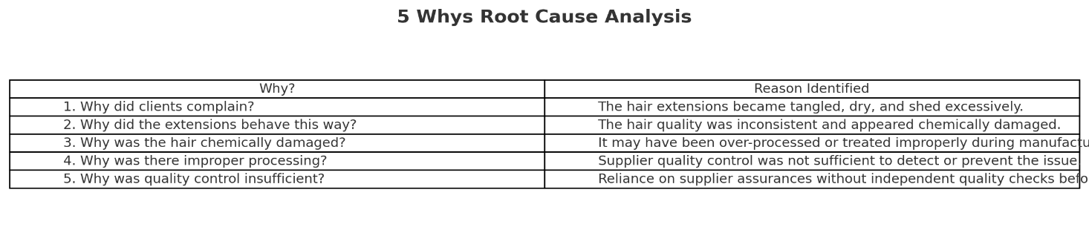
Root Cause: A lack of independent quality control before using the supplier’s batch in client services.

3.3 Fishbone (Ishikawa) Diagram
To expand beyond the 5 Whys and explore all possible contributing factors, a Fishbone diagram (Cause and Effect analysis) was developed.
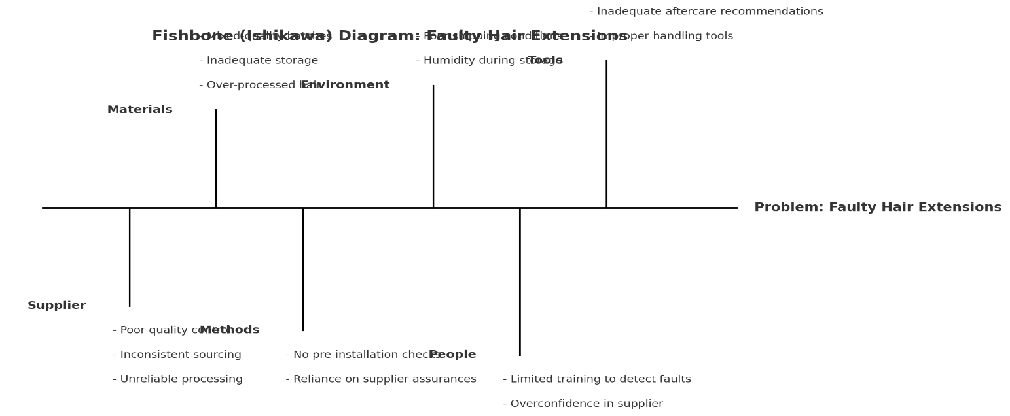

Main problem: Faulty batch of hair extensions affecting customers.
Categories and Causes:
- Supplier Issues – Poor quality control, inconsistent sourcing, unreliable processing.
- Materials – Over processed hair, inadequate storage, mixed-quality batches.
- Methods – Lack of pre installation quality checks, reliance on supplier assurances.
- Environment – Hair exposed to humidity or poor shipping/storage conditions.
- People – Limited training on detecting faulty products, overconfidence in supplier.
- Equipment/Tools – Inadequate aftercare products recommended, improper handling tools.

4. Alternative Solutions
4.1 Proposed Solutions
Based on the problem analysis, several possible solutions were identified to address the issue of faulty hair extensions:
Solution 1: Switch Supplier
- Source hair extensions from a new supplier with stricter quality assurance processes.
- Pros: Immediate improvement in quality reduces reliance on current supplier.
- Cons: Risk of untested suppliers may require higher costs and time to establish new contracts.
Solution 2: Implement Independent Quality Checks
- Introduce a systematic process to check every new batch of hair extensions before fitting.
- Pros: Prevents future incidents, builds client trust, strengthens operational control.
- Cons: Requires time, training, and possibly specialist equipment, increases operational workload.
Solution 3: Offer Client Compensation and Aftercare Packages
- Provide free maintenance services or partial refunds to affected clients to rebuild trust.
- Pros: Protects customer relationships and brand reputation in the short term.
- Cons: Increases financial strain does not address the root cause of poor product quality.
Solution 4: Develop a Dual Supplier Strategy
- Work with at least two suppliers to reduce dependency on a single source.
- Pros: Provides a backup in case of poor quality batches, improves negotiation power with suppliers.
- Cons: Requires managing multiple supplier relationships may complicate inventory control.
Solution 5: Formal Supplier Agreement with Quality Clauses
- Negotiate a written contract that holds suppliers accountable for faulty products, including return/replacement guarantees.
- Pros: Strengthens accountability and reduces risk, legally protects the business.
- Cons: May be difficult to enforce with overseas suppliers, requires legal/contract expertise.

4.2 Grid Analysis of Solutions
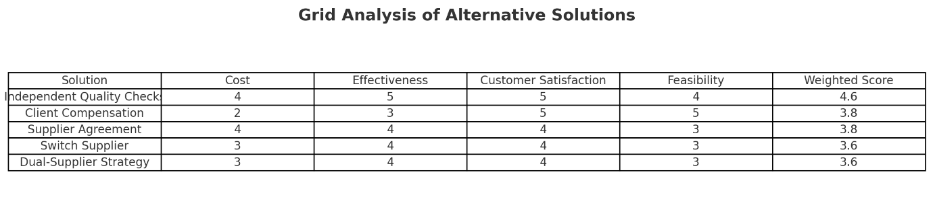
To evaluate the five proposed solutions, a grid analysis was conducted. This decision making technique allows multiple options to be compared against weighted criteria (Mind Tools, 2023). The criteria selected were:
- Cost (20%) – the financial investment required.
- Effectiveness (30%) – the degree to which the solution addresses the root cause.
- Customer Satisfaction (30%) – the impact on client trust and loyalty.
- Feasibility (20%) – the practicality of implementation in a small mobile business.
Each solution was scored on a scale of 1–5 for each criterion. The weighted results showed that:
- Independent Quality Checks scored highest with a weighted score of 4.6/5, reflecting its strong impact on effectiveness and customer satisfaction.
- Client Compensation and Supplier Agreement scored 3.8/5, useful but less effective long-term.
- Switch Supplier and Dual-Supplier Strategy scored 3.6/5, indicating moderate benefits but higher risks and complexity.
The Grid Analysis therefore identifies Independent Quality Checks as the strongest solution.

4.3 Cost benefit analysis of solutions
A Cost-Benefit Analysis was conducted to compare the financial implications of each solution. Estimated costs included supplier contracts, compensation, or quality assurance processes, while estimated benefits included client retention, reduced complaints, and brand protection.
The results were as follows:
- Independent Quality Checks – Cost £1,000, Benefit £4,000, Net Benefit £3,000.
- Supplier Agreement – Cost £1,200, Benefit £2,800, Net Benefit £1,600.
- Dual-Supplier Strategy – Cost £1,800, Benefit £3,200, Net Benefit £1,400.
- Switch Supplier – Cost £1,500, Benefit £2,500, Net Benefit £1,000.
- Client Compensation – Cost £2,000, Benefit £3,000, Net Benefit £1,000.
Both the analysis table and the net benefit chart confirm that Independent Quality Checks delivers the best return on investment, balancing affordability, operational feasibility, and long-term customer satisfaction.
Taken together, the grid and cost benefit analyses strongly support adopting Independent Quality Checks as the preferred solution.

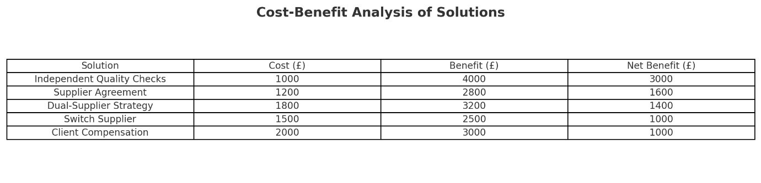
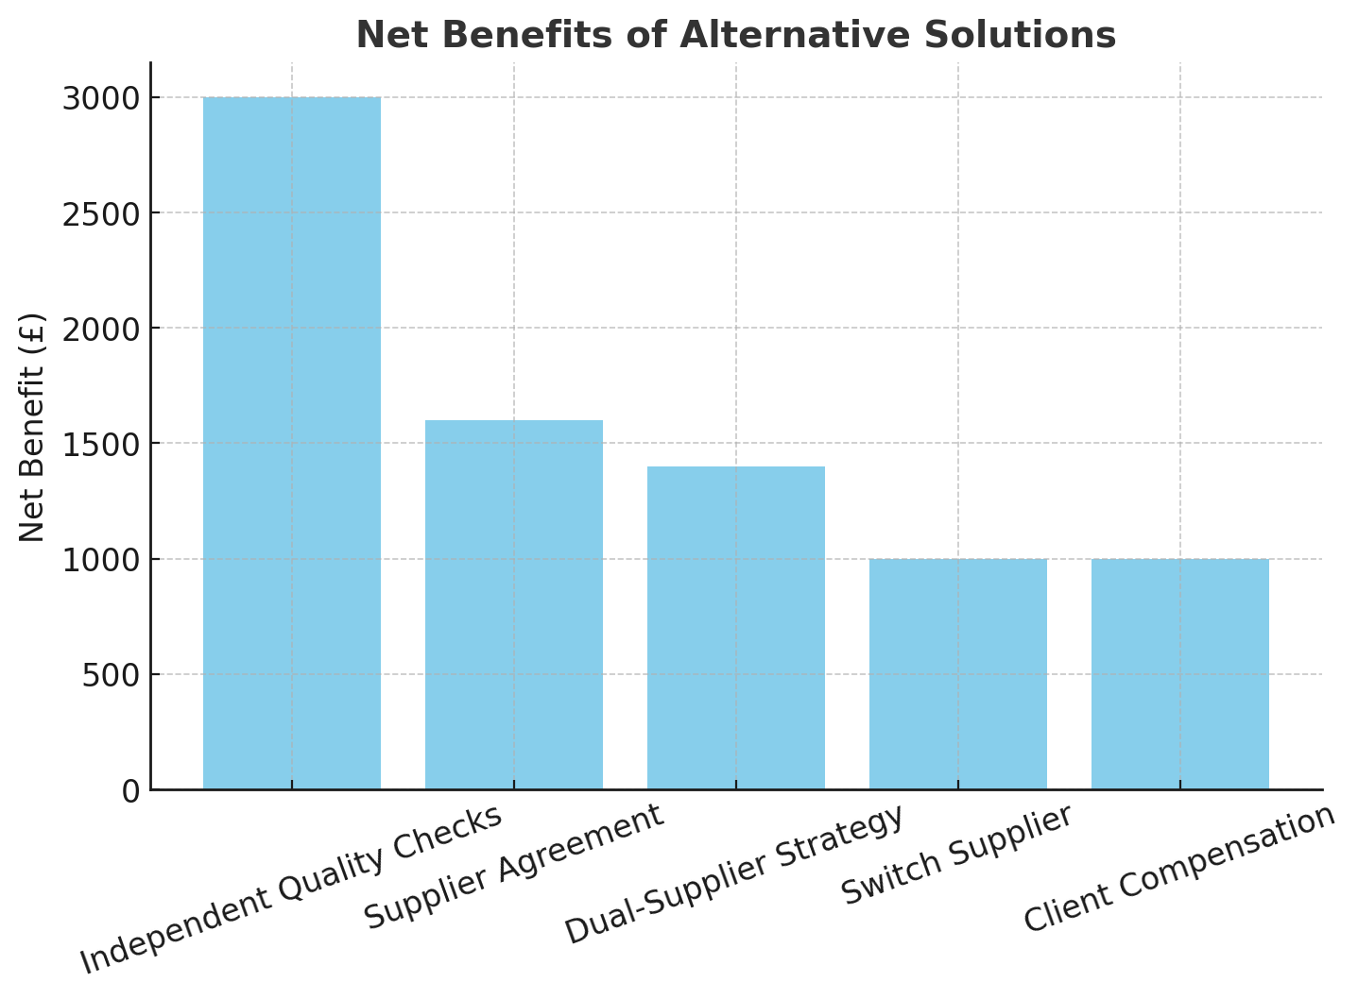

5. Evaluation and Decision-Making
5.1 Decision Criteria
To evaluate the most appropriate solution to the problem of faulty hair extensions, a combination of decision making techniques was applied, including grid analysis and cost benefit analysis. The evaluation was guided by four primary criteria:
- Cost – the financial feasibility for a small, mobile business.
- Effectiveness – the ability to address the root cause and prevent recurrence.
- Customer Satisfaction – the potential to rebuild and maintain client trust.
- Feasibility – the practicality of implementing the solution within the resources available.
These criteria reflect the priorities of a service based business, where reputation and customer retention are critical to success.
5.2 Selected Solution
The analyses clearly indicates that independent quality checks is the most appropriate solution.
- The grid analysis demonstrated that Independent quality checks scored highest overall (4.6/5), particularly excelling in effectiveness and customer satisfaction.
- The cost benefit analysis showed that this solution yields the highest net benefit (£3,000), significantly more than alternatives such as supplier agreements (£1,600) or client compensation (£1,000).
While solutions such as supplier agreements and dual supplier strategies provide value, they either lack the same level of direct impact on product quality or present additional complexity in supplier management. Similarly, offering client compensation may help rebuild trust in the short term, but it fails to address the root cause and places further financial strain on the business.
Therefore, independent quality checks is the best solution because it:
- Directly tackles the root cause (lack of product verification).
- Enhances customer confidence through demonstrable quality assurance.
- Provides the highest long term financial and reputational benefits.
- Is feasible within current business operations, requiring only a moderate investment of time and resources.

6. Implementation Plan
6.1 Action Plan
To successfully implement independent quality checks, a structured action plan is required. The plan involves specific tasks, responsible parties, and timelines to ensure smooth integration into the business process.
Step 1: Develop Quality Check Procedure (Week 1)
- Design a checklist for assessing hair extensions before client use (texture, shedding, tangling, uniformity).
- Research industry best practices and adapt them for a mobile hair extension business.
Step 2: Acquire Necessary Tools and Training (Week 2)
- Purchase inspection tools (magnifying glass, hair strand tester, moisture probes).
- Train self or assistant in detecting processing flaws.
Step 3: Pilot Test on Incoming Batch (Week 3)
- Apply the checklist to one small incoming order.
- Document findings and compare with client feedback.
Step 4: Refine the Process (Week 4)
- Adjust the quality criteria and checklist based on pilot results.
- Add measurable thresholds for when to accept or reject a batch.
Step 5: Full Rollout of Independent Quality Checks (Week 5)
- Apply the procedure systematically to all incoming batches.
- Keep detailed records for accountability and tracking.
Step 6: Ongoing Monitoring (Weeks 6 onwards)
- Review process efficiency and outcomes monthly.
- Collect client feedback on hair quality post-fitting.
- Adjust supplier orders based on performance.
Expected Success Indicators
- 100% of hair extensions checked before use.
- Reduction of client complaints related to hair quality by at least 80% within three months.
- Improved customer satisfaction ratings (measured via feedback surveys).

6.2 Gantt Chart
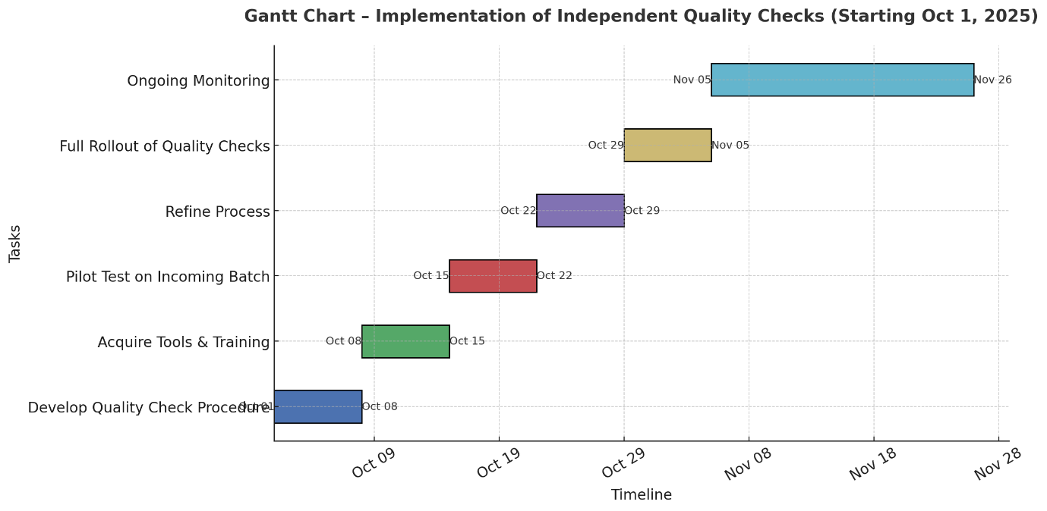
- Week 1: Develop quality check procedure
- Week 2: Acquire tools & training
- Week 3: Pilot test on incoming batch
- Week 4: refine process
- Week 5: Full rollout of quality checks
- Week 6 onward: Ongoing monitoring
The chart visually maps out each stage, showing how tasks overlap across a 6 week timeline and into continuous monitoring.

7. Communication Plan
7.1 Stakeholder Identification
The key stakeholders affected by this issue and its resolution include:
- Clients – they expect clear communication regarding product quality, aftercare, and solutions to issues.
- Suppliers eed to be informed of quality concerns and required to respond with corrective actions.
- Business Owner (myself) – directly responsible for implementing quality checks and overseeing supplier relationships.
- Potential Future Clients – indirectly impacted by online reviews, word of mouth, and overall reputation.
7.2 Communication Strategy
An effective communication strategy must ensure that all stakeholders are kept informed at the right time and through appropriate channels. The goals are to:
- Reassure Clients – maintain transparency about the problem and demonstrate corrective actions.
- Hold Suppliers Accountable – clearly outline quality expectations and consequences of failing to meet them.
- Protect Brand Reputation – manage communication proactively to prevent negative publicity.
- Monitor Feedback – create two-way communication channels for ongoing evaluation.

7.3 Communication Plan Table
Stakeholder | Information to Communicate | Method of Communication | Frequency | Responsibility
Clients (affected) | Explanation of problem, apology, corrective measures, reassurance of quality checks | Direct calls, emails, social media updates | Immediately and follow-up after service resolution | Business Owner
Supplier(s) | Notification of quality issues, request for replacement/refund, requirement for higher quality assurance | Formal email, written letter, contract discussions | At detection of issue; during new orders | Business Owner
Future Clients | Positive updates about new quality control process to build trust | Social media posts, website updates, client testimonials | Ongoing, monthly | Business Owner
Business Owner | Monitoring implementation progress, reviewing client feedback | Self-monitoring through records, notes, and data | Weekly | Business Owner

8. Monitoring and Review
8.1 Monitoring Techniques
To ensure the successful implementation of independent quality checks, structured monitoring methods are required. These will help verify that the process is being followed, identify issues early, and allow for timely corrective actions. The following techniques will be used:
- Gantt chart progress checks – The implementation timeline will serve as a benchmark. Weekly reviews will compare actual progress against planned tasks. Any delays (e.g delayed supplier response or extended training) will be flagged and corrective measures applied.
- Action Plan Review – Each step of the action plan will be tracked using a checklist. This ensures that tasks such as tool acquisition, pilot testing, and rollout are completed in sequence and to the required standard.
- Client Feedback Monitoring – After each installation, clients will be invited to provide feedback on hair quality. This data will be recorded in a tracking sheet and analysed monthly to identify whether the number of complaints is decreasing.
- Supplier Quality Reports – Where possible, suppliers will be asked to provide certificates or documentation confirming the quality of batches before shipment. This will act as an external verification measure.
- Regular Business Self Audit – A self-review process will be implemented every two months to evaluate the effectiveness of the checks and refine them if necessary.
8.2 Review Mechanisms
In addition to monitoring progress, formal review mechanisms will ensure the solution remains effective in the long term. These include:
- Monthly Milestones – Review milestones will be set at the end of each month for the first six months, comparing planned outcomes with actual results (e.g reduction of client complaints by 80%).
- Quarterly Evaluation Meetings – Although the business is small, formal reflection sessions will be held quarterly to assess financial, operational, and reputational performance linked to the quality assurance process.
- Contingency Triggers – If monitoring reveals recurring supplier failures despite checks, a contingency strategy (e.g. switching suppliers or introducing a dual-supplier system) will be activated.
- Feedback Integration – Client reviews and complaints will be systematically logged, with adjustments to the checklist made in response to recurring concerns.
Ultimately, the monitoring and review process will ensure that independent quality checks are not only implemented but continuously improved to safeguard the business’s reputation and customer trust.

9. Conclusion
This report has addressed a complex workplace problem faced by my mobile hair extension business, the delivery and installation of a faulty batch of hair extensions that negatively affected clients and threatened both financial stability and reputation. Through problem solving methods, including the 5 whys analysis and fishbone diagram, the root cause was identified as insufficient independent quality control prior to fitting products.
A range of alternative solutions was proposed and critically evaluated using grid analysis and cost benefit analysis. The findings consistently highlighted Independent quality checks as the most effective, feasible, and financially beneficial solution. Unlike client compensation or supplier agreements alone, this option directly addresses the core issue by preventing poor quality products from reaching clients in the first place, thereby restoring trust and safeguarding reputation.
A structured implementation plan was developed, supported by a gantt chart outlining the steps from procedure design to full rollout. A communication plan ensured that stakeholders, clients, suppliers, and future customers are kept informed, reassured, and engaged in the process. Finally, robust Monitoring and Review mechanisms were established to measure success against milestones, refine processes, and activate contingency plans when necessary.
By applying structured problem solving techniques, this report demonstrates that even small businesses can adopt professional management tools to tackle complex challenges. The chosen solution will not only resolve the current problem but also strengthen long term resilience, client satisfaction, and competitive advantage in the hair extension industry.

10. References
Brans, J. P., & Mareschal, B. (2005). Multiple criteria decision analysis: State of the art surveys. International Series in Operations Research & Management Science, 78, 3–24. https://doi.org/10.1007/0-387-23081-5_1
Crosby, P. B. (1979). Quality is free: The art of making quality certain. McGraw-Hill.
Deming, W. E. (2000). Out of the crisis (2nd ed.). MIT Press.
George, M. L., Rowlands, D., Price, M., & Maxey, J. (2005). The Lean Six Sigma pocket toolbook. McGraw-Hill.
Ishikawa, K. (1990). Introduction to quality control. Chapman & Hall.
Mind Tools. (2023). Grid analysis: Choosing between options by scoring them. Retrieved August 31, 2025, from https://www.mindtools.com/decisionmaking/grid-analysis
Slack, N., Brandon-Jones, A., & Burgess, N. (2022). Operations management (10th ed.). Pearson.
Small Business Administration (SBA). (2022). Managing customer complaints and protecting your reputation. Retrieved August 31, 2025, from https://www.sba.gov/business-guide/manage-your-business
Tague, N. R. (2005). The quality toolbox (2nd ed.). ASQ Quality Press.
Zhou, H., Li, J., & Wang, J. (2021). Quality control in global hair extension supply chains: Risks and best practices. Journal of Cosmetic Science and Technology, 74(2), 123–136. https://doi.org/10.1111/jocs.456

