INTERNATIONAL MARKETING
Executive Summary
Marketing conventions are extensively essential for enterprises to catapult more considerable market domination in different external markets as well as obtain competitive leads. This report has illustrated distinct standpoints on marketing activities and delivers a prominent examination of two nations incorporating Canada and China. It has scrutinised procedures of trade in the background of Rolls Royce and its developed functional establishments across separate geographical territories. Different viewpoints on marketing campaigns have been discussed in this paper, which also provided a noteworthy analysis of the two nations that make up China and Canada. It has been looking at marketing strategies in the context of Rolls Royce, which has expanded its operational facilities across several geographical areas. The connection between cultural communities and human perspectives of the Canada and China has been examined in this research paper below. One of the principal terms that has been reciprocated to have the greatest plausibility to define distinct dimensions is Hofstede's cultural dimensions has been described in the context of the Rolls Royce business operation in the Canada and China market region.

Table of Contents
Introduction 4
Macro Environment Analysis 4
PESTEL of China 4
PESTEL of Canada 5
Micro Environments Analysis 7
SWOT Analysis of Rolls Royce in China 7
SWOT Analysis of Rolls Royce in Canada 7
Porters Five Force 8
Porter's Five Forces of Rolls Royce in China Market 8
Porter's Five Forces of Rolls Royce in Canada Market 9
Ansoff Matrix 10
Ansoff matrix of Rolls Royce in China 10
Ansoff Matrix of Rolls Royce in Canada 11
Comparison between the impact of differences and similarities of marketing practices 11
The connection between cultural communities and human perspectives 14
Cultural communities 14
Human Perspectives in Canada and China 16
Differences between market strategies across the nations 17
Segmentation of Roll Royace in Canada 17
Segmentation of Roll Royce in China 18
Positioning maps in Canada 20
Positioning map in China 21
4P 21
Directional strategy 23
Identification of contemporary ethical approaches to develop marketing plan 24
Conclusion 25
References 26

Introduction
Marketing practices are widely crucial for brands to obtain larger market capitalisation in different foreign markets as well as gain a competitive advantage. This report would describe different perspectives on marketing exercises and produce a distinguished analysis of two countries comprising Canada and China. It would examine practices of marketing in the context of Rolls Royce which has expanded operational facilities across different geographical regions. Market structures and segmentation have also been integrated into the report in line with the geographical boundaries of these countries. A notion of demonstration has been presented in the context of the contemporary ethical framework regarding the marketing exercises.

Macro Environment Analysis

PESTEL of China

PESTEL | Factors | Impacts
Political | - China is one of the politically unstable country.  - China's corruption index rank is 65 (Transparency.org, 2022). | Negative
Economical | - China's GDP growth rate records at 5.5% first half of the year (China-briefing.com, 2023). | Positive
Social | - The population growth rate has been decreased by 0.06% in the year 2022 (Statista.com, 2023). | Negative
Technological | - China has secured the 10th rank in the global innovation index (Wipo.int, 2022). | Positive
Legal | - China has provided the Protection of Rights and Interest of Women (China.org.cn, 2023). | Positive
Environmental | - Both winter and summer have been proclaimed as normal.  - China's government has introduced a climate policy to protect the environment (Chinadialogue.net, 2022). | Positive
Table 1: PESTEL
(Source: Self-developed)
The above table demonstrated the overview of the PESTEL analysis of China. In addition, it has been found that China's political condition has been found unstable due to several geopolitical tension. In addition, the economic factors of China have a positive impact on the business operations of Rolls Royce. Furthermore, the social factors have the negative impacts to the business operation of Rolls Royce. The advancement of a variety of different industries is facilitated by financial investments in research and development.

PESTEL of Canada

PESTEL | Factors | Impacts
Political | - Canada is one of the political stable country.  - Canada corruption index rank is 14 (Transparency.org, 2022). | Positive
Economical | - Canada GDP growth rate records at 3.4% (Statista.com, 2023) | Positive
Social | - The population growth rate has been increased by 0.7% in 2022 (Statcan.gc.ca, 2023). | Negative
Technological | - Canada has secured the 9th rank in the global innovation index (Wipo.int, 2022). | Positive
Legal | - Canada has provided the equal right to the all working employee with the provision of Section 15 – Equality Rights (Justice.gc.ca, 2023). | Positive
Environmental | - Both winter and summer have been perceived as normal.  - “The Canadian Net-Zero Emissions Accountability Act” protect climate pollution activity (Climate-laws.org, 2023). | Positive
Table 2: PESTEL
(Source: Self-developed)
The political climate of Canada has been found to be stable, which helps create a favourable environment for business and inspires trust in investors. In addition, the growth of the Canadian economy has an impact on consumer spending, the demand in the market, and overall company potential. Hence, the GDP of Canada has been recorded as 3.4% (Statista.com, 2023). The different demographics of Canada have an impact on consumer preferences, as well as market segmentation and marketing techniques. The proliferation of digital technology calls for increased attention to cyber security in order to safeguard the private information and digital assets by the Canadian Government. The Rolls Royce has been able to expand their business operation effectively in the Canadian market.

Micro Environments Analysis

SWOT Analysis of Rolls Royce in China

Strength | Weakness
- Capturing the predominating position in the China Auto market.  - Rolls Royce produces high-quality craftsmanship in China's Auto Market (Wuori, 2023). | - The car prices have been found more expensive for the Chinese consumer.  - Rolls Royce has not to meet the cultural preferences requirements (Lai and Lai, 2021).
Opportunities | Threats
- Rolls Royce getting the advantage to grow in China market due to the economic growth of China.  - Rolls-Royce is able to target wealthy customers in China's second-tier cities. | - Other Luxury brands such as BMW, Aston Martin and many more captured a portion of the auto market.  - The import and export of luxury vehicles in China could be affected by the regulatory law of China.
Table 3: SWOT
(Source: Self-developed)
The name Rolls-Royce is recognised all over the world as a symbol of luxury, exclusivity, and handcrafted quality. The prestige and history of the brand have the potential to entice wealthy Chinese consumers who place a high value on luxury and status.

SWOT Analysis of Rolls Royce in Canada

Strengths | Weakness
- Rolls-Royce is one of the globally renowned luxury craftsmen.  - It faces the limited competition in the Canadian market (Williamson and De Meyer, 2020). | - Rolls-Royce vehicles have been found it more expensive for the Canadian people (Reese, 2022).  - The company has a limited market share.
Opportunities | Threats
- Rising demand of the luxury car in the Canadian market.  - Rolls-Royce is able to target wealthy consumers in the country of Canada's major urban centres. | - Canada regulations and policies regarding the imports and exports of the vehicle impacted the coampny portfolio.  - Cultural diversification has created several threats for Rolls Royce.
Table 4: SWOT
(Source: Self-developed)
It has been discovered that the cost of ownership for Rolls-Royce automobiles is higher in Canada. In addition, the corporation only holds a little portion of the market.

Porters Five Force

Porter's Five Forces of Rolls Royce in China Market
Threat of New Entrants
The threats of new entrants of Rolls Royce have been found low in the respective of the China market. Rolls-Royce faces just a little amount of competition from new companies looking to break into the ultra-luxury automobile industry, particularly in the sector that it dominates.
Bargaining Power of Suppliers
The bargaining power of suppliers could be perceived as high in the China market regarding luxury car. Rolls-Royce provides a large amount of room for customization, which may necessitate the use of specialised suppliers.
Bargaining Power of Buyers
Rolls-Royce's reputation for exclusivity and high quality for customers in the ultra-luxury market has little room for negotiation when it comes to price in the market. Therefore, the bargaining power of the buyer could be proclaimed as low.
Threat of Substitute Products
Threat of Substitute Products of Rolls Royce in China market has low due to the low degree of competitive pressure from alternative products.
Intensity of Competitive Rivalry
Competitive Rivalry has been noted for Rolls Royce in China market has been proclaimed as low and negligible competition has been found.

Porter's Five Forces of Rolls Royce in Canada Market
Threat of New Entrants
The possibility of new competitors entering the ultra-luxury automobile market in Canada is low, in comparison to other markets.
Bargaining Power of Suppliers
The bargaining power of suppliers has been found as high in the Canda market due to the varieties and customisation of luxury car brands.
Bargaining Power of Buyers
Bargaining power of buyers has been associated with low impacts due to the company brand prestige value and high level of luxury cars manufactured by the company
Threat of Substitute Products
In Canada, the threats of the substitutes have been conceived as low for the Rolls Royce due to the less competition in the market.
Intensity of Competitive Rivalry
The level of competitive rivalry that Rolls Royce faces in the Canadian market has been assessed as being minimal, and almost nonexistent levels of competition have been discovered.

Ansoff Matrix

Ansoff matrix of Rolls Royce in China
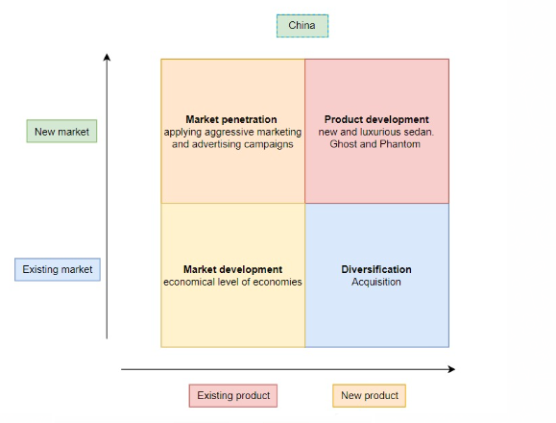
Figure 1: Ansoff Matrix of China
(Source: Self-developed)
Market Penetration
Rolls-Royce is able to concentrate on expanding its market share within the already established premium automotive industry in China.
Market Development
Within the Chinese market, Rolls-Royce could target new consumer categories or geographic regions to sell its products.
Product Development
Rolls-Royce might release whole new models or upgrade existing ones that are more suited to the tastes and requirements of the Chinese market.
Diversification
Rolls Royce has been targeting to diversify their product in the China market to expand their business operation.

Ansoff Matrix of Rolls Royce in Canada
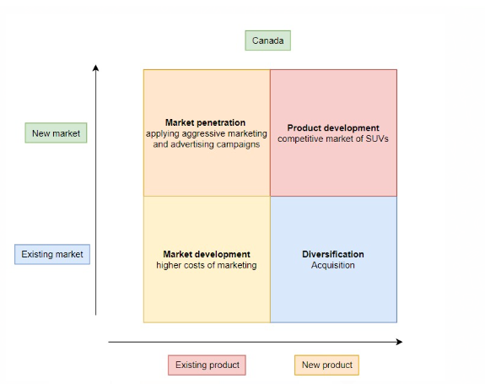
Figure 2: Ansoff Matrix of Canada
(Source: Self-developed)
Market Penetration
Rolls-Royce might want to concentrate on expanding its portion of the existing luxury automotive market in Canada in order to better position itself there.
Market Development
Within the Canadian market, Rolls-Royce may decide to investigate new consumer categories or geographic regions.
Product Development
Rolls-Royce might enter the Canadian market with brand-new or redesigned models that are specifically geared to this market.
Diversification
Rolls-Royce has made it a priority to broaden its product offering in the Canada market as part of its effort to expand its business activity there.

Comparison between the impact of differences and similarities of marketing practices
Different perspectives share a closer association to restructure marketing practices of firms across different foreign marketplaces. China’s luxury car market has reflected a strong uprise as the country’s economy has shown spiral growth across the decade. It has been identified that 57% of luxury car owners are private entity proprietors and entrepreneurs in the Chinese market (Guo, 2021). Moreover, these markets have continued to show a strong rise in recent years as well as influencing luxury car brands' performance in the marketplace. On the Other hand, the Canadian luxury automobile market also showed an upliftment of 12% in the year 2018 (Rajeshni Naidu-Ghelani, 2018).
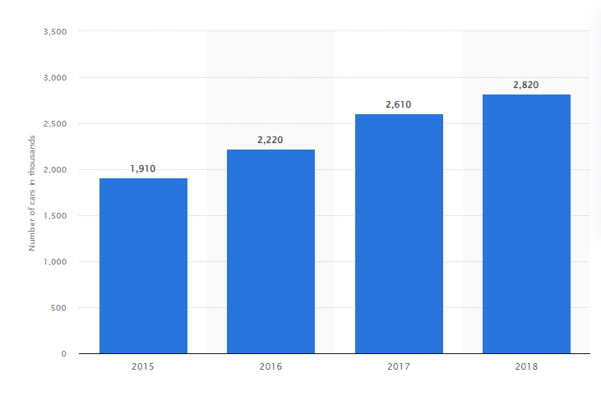
Figure 3: Chinese luxury car sales over the years
(Source: Statista.com, 2023a)
The aforementioned figure demonstrates the sales volume of luxury cars in the Chinese marketplaces ranging from the year 2015-2018. In the year 2017, luxury car sales volume in the Chinese market figured at $ 2.6 million that increased by $ 2.8 million in the year 2018 (Statista.com, 2023a). These figures posed a strong evidence of the robust growth of the Chinese luxury car market in the recent times. While as luxury car sales volume in the Canadian market consists of 242 million during the same duration against the Chinese marketplace (Statista.com, 2023b). These figures described that the Canadian market has many drawbacks in front of the Chinese market in terms of sales volumes of luxury automobiles.
Political terminologies are considered to be the foremost denominator in shaping the marketing exercises of firms in their respective countries. China’s political system is dominated by one-party administration that reduces bureaucratic obstacles for companies to operate in the country (Nasirova et al. 2021). It is also free from political disparities of different parties as well as government policy measures have larger uniformity. On the other hand, Canada comprises of parliamentary democracy that is subject to many parties' involvement in decision-making (Cassola et al. 2022).
China is the 2nd largest economy in the world with an annual GDP growth rate of 8.1% in the year 2021 (Worldbank.org, 2021). Canada’s GDP growth rate stood at 4.5% that relatively lower than China (Worldbank.org, 2018). Comparatively, China has been able to pose more extensive economic growth than its Canadian counterpart. An inflation rate of 1.97% has been recorded in the consumer market of China based on the estimation of 2022 (Statista.com, 2019). On the other hand, Canada registered an annual inflation rate of 2.50% in the same year (Evans, 2023). In terms of inflation rate China also outplayed Canada as well as offered better positive support for brands to grow their sales volumes in the country. China comes in the top 3 markets for Rolls Royce in terms of sales figures accounting for 25% of the global sales of the company (Frank, 2023). These assortments have decimated that the Chinese market upholds higher growth prospects for Rolls Royce as well as would assist them to obtain more sales figures.
Social and demographical factors are translated to be predominant factors that support firms to obtain robust growth possibilities and grip on the foreign markets. China is considered to be one of the most populous countries in the world with a figure of 1.4 billion people while Canada's population stood at 3.82 billion (Theworldbank.org, 2021). China offers Rolls Royce a vast number of consumer base as compared to the Canadian marketplace. Canada holds a larger degree of diversity than China that comprises of 69.8% of the ethnic population in the demography (Statcan.ca, 2022). Canada aids brands to assemble a diverse organisational culture within their geographical stratifications than China. However, China has a much larger diversity within the country that numbered around 55% of regional ethnic groups across different regions (Zhao et al. 2021). Therefore, it can be stated that both of the countries hold a comprehended degree of diverse population nevertheless, Canada’s ethnic groups could be defined as more diverse.
People's perspectives in China are widely stringent in response to purchasing luxury cars from renowned brands (Ye and Titheridge, 2019). Moreover, it has been witnessed that citizens in China provide more preference for luxury cars over the buying of second-hand cars. Middle-income and upper-middle-income groups in China have also been identified to have more attention to the luxury car purchase rather than the second-hand car purchase. Around 58% of citizens in China have opined that they would opt for luxury cars for more comfort and hassle-free driving experience apart from an old car (Ye and Titheridge, 2019). Apart from that, the Canadian people’s approach towards luxury cars is to develop their status in the society rather than frequent purchase decisions of replacing cars (Babin and Harris, 2023). As environmental concerns gather a considerable portion of attention from different fields of the world, consumers also seem to be much more influenced by those congruence’s. Around 71% of people in China are more likely to spend extra expenses on green functionalities integrated with luxury cars (Ali et al. 2019). Canadian consumers have also shown some extent of sustainable consumption practices regarding the luxury cars. The incentive of C$ 1000 for electric cars has reflected an annual increase of 5 to 8% in sales increase combined grew green car sales by 35% (Azarafshar and Vermeulen, 2020). Therefore, it can be stated that both of the markets have concerned about sustainability whereas Canada shows a much more sales growth rate than China. This has been considered as one of the key motivators for global luxury car brands to expand their operational functionalities into the Chinese marketplace. Rolls Royce's robust sales figures are also have been scrutinised by the behavioural traits of Chinese citizens and able to obtain more comprehensive growth prospects.

The connection between cultural communities and human perspectives

Cultural communities
Cultural determinants are key influencers on the marketing practices of firms in different foreign markets and strive them to obtain growth prospects. The Hofstede Cultural dimensions are one of the foremost terminologies that reciprocated to have the most viability to describe different dimensions (Iancu and Badea, 2020). It defines cultural dimensions between different regions based on distinguished factors that make a brief portrayal of thorough understandings of cultural perspectives. Different dimensions including individualism, power distance, and masculinity that are demonstrated as the key denominators for the culture of a territory. The framework procures different scores in response to different cultural dimensions with the conjugation of different cultures.
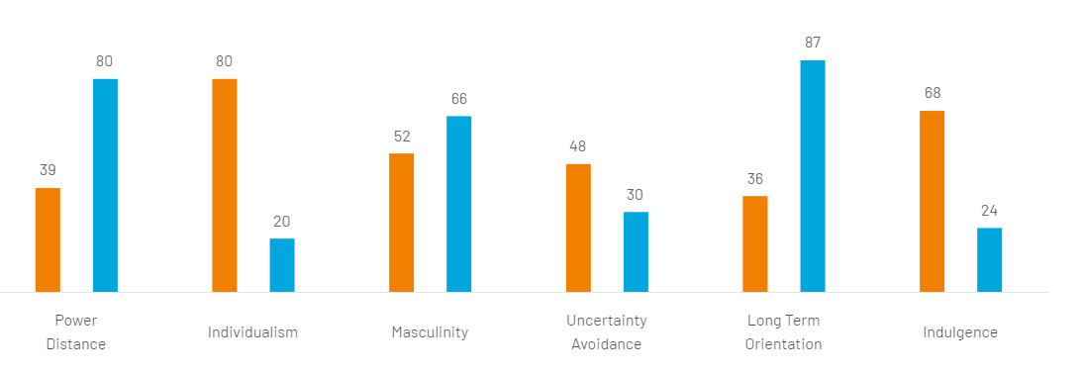
Figure 4: Cultural Dimensions of China and Canada
(Source: Hofstedeinsights.com, 2023)
The aforementioned figure describes the degree of cultural dimensions based on a considerable comparison between China and Canada across different stratifications.
Power Distance
Power distance is the representation of the degree of equality persistent in the societal backgrounds of the country and the distribution of powers lies across different institutions. It has been perceived to also be an annotation of inequalities accepted among people in the country. China scored 80 in this segment while Canada scored 39 that reflects that both the society considered inequality as an acceptable form in their societal background (Hofstedeinsights.com, 2023). In the Chinese culture subordinate and superior of top-tier management is considered to have the most respectable terminologies across organisations. Canada is much more supportive and also feels that inequality required to be treated with more collectiveness.
Individualism
defines the quantity of "interdependence" and "collectivism" in the community of the nation. China has an assertive existence of "collectivism" in their culture. It is positively "interdependent" on individuals within societal obstacles. China upholds the score of 20 that shows it is conditional on group action within the community (Hofstedeinsights.com, 2023). It deliberates that China is conditional on societal movements and guarantees the larger participation of individuals. While Canada is a Western nation that scored 80 in individualism that shows it has a more increased numeral of citizens who looks for their "self-interest". It reflects that Canada holds lesser approval for collectivism in the community.
Masculinity
Masculinity refers to a comprehended degree of showcasing success and orientation to the success-driven factors present in the cultural background of the country’s society. Canada scores 52 in the segment while China's 66 scores in the segment that portrays both the country's people are driven by sucess (Hofstedeinsights.com, 2023). However, China’s higher score in the dimension reflects that success is worshipped in China more comprehensively as well as people are more oriented to the success factors.
Uncertainty avoidance
The dimension refers to people’s proximity to accepting uncertain conditions and opting for new innovations as well as their implementation in the broader context. Canada scores 48 and China 30 in the cultural dimension that represents both the culture are acceptable for others (Hofstedeinsights.com, 2023). Nevertheless, Canadians are reciprocated to have more association with uncertainties as well as they are more willing to try innovative things and implementation.
Long-term orientation
It defines the notion of people’s perspectives in the past and the utilisation of those experiences to sort out modern context. Moreover, it also defines the orientation of truth in response to the context as well as the situational atmosphere. China scored 87 in the dimensions and Canada scored 36 in the segment that reflects China has a maximum long-term orientation (Hofstedeinsights.com, 2023). Chinese society believes that truth is being shaped by the situational proceedings and contextual backgrounds. Canadian people believe that consolidated truth must be established in the societal backgrounds. Moreover, Chinese people are more concerned with their past rather than Canadians.
Indulgence
The degree of indulgence describes people’s freedom to optimise their thoughts and beliefs as well as the pursuit of dreams. Canada scored 68 and China scored 24 in the dimension that shows Canada has a higher degree of freedom on an individual’s desire (Hofstedeinsights.com, 2023).

Human Perspectives in Canada and China
Many people in Canada enjoy the country's multicultural identity and value the variety of cultures, languages, and histories that coexist inside the nation (MM, 2019). This is something that many Canadians value. In addition, it has been perceived that the Canadian people have been becoming more conscious regarding the environmental issue and sustainability concerns in the societies (Alam, 2022). On the other hand, a big population, a rich history, quick development, and cultural diversity have all contributed to China's status as a diverse and complex nation that is home to a wide spectrum of viewpoints (Wu et al. 2022). The rapid urbanization and economic development that China has experienced in recent decades have resulted in a culture that places a high emphasis on progress, technical innovation, and higher levels of living (Wu et al. 2022). Many people in China view modernity as a constructive force that raises their standard of living and should be encouraged. Hence, it has been perceived that the people in China have been changing their livelihood regarding the concern of modernisation and inclining towards the high level of the living societies (Wang et al. 2023).However, in the case of Canadian human perspectives, it has been noted that the Canadians who live in metropolitan centres and those who live in rural areas may have very different points of view on a variety of issues (Dijkstra et al. 2019).

Differences between market strategies across the nations

Segmentation of Roll Royace in Canada
Market segmentation | Target area | Target customers
Demography | - Age  - Customers  - Income | - 45 to 52 years of old  - Male and female both  - Higher income group
Geography | - Location | - Canada
Psychographic | - Lifestyle | - Entrepreneurs, elite athletes and entertainers
Behavioural | - Brand image | - Luxury automobile maker

The above table describes the target market of Roll Royace in Canada through segmentation. Therefore, a bigger market is divided into more manageable groups based on the traits and characteristics that they share. Businesses has been adopting to enhance target particular client segments with their products, services, and marketing initiatives. The target market for this campaign is Canada, and within this market, Rolls-Royce focuses on those aged 45 to 52 who are from better socioeconomic strata and are both male and female. The psychographic component of this strategy explores the way of life of the target market, which consists of businesspeople, professional athletes, and entertainers. These people prize the pinnacle of wealth and status.

Segmentation of Roll Royce in China
Segment | Characteristics | Target Criteria
Demographic | Age: 35 - 50+ years | Affluent individuals
 | Gender: Both male and female | High-income bracket
 | Income: High income group
Geographical | Location: Throughout China | Urban and upscale areas
Psychographic | Lifestyle: Successful professionals, | Value luxury and prestige
 | entrepreneurs, executives | Seek status and exclusivity
 | Interests: Luxury goods, fine living | Appreciate craftsmanship
Behavioral | Brand Image: Luxury and exclusivity | Aspirational and status-driven
 | Buying Behavior: Purchasing high-end | Emphasis on brand reputation
 | luxury products
The accurately planned market segmentation strategy adopted by Rolls-Royce in China strives to successfully connect with the company's target client base. It is identified that the target market will be divided into various segments as part of the plan. In terms of demographics, Rolls-Royce focuses on those between the ages of 35 and 50, including both men and women, who are part of the affluent class and have high-income levels. Geographically, the business wants to be present throughout China, with an emphasis on metropolitan and affluent regions where there is a concentration of potential high-net-worth clients.

Positioning maps in Canada
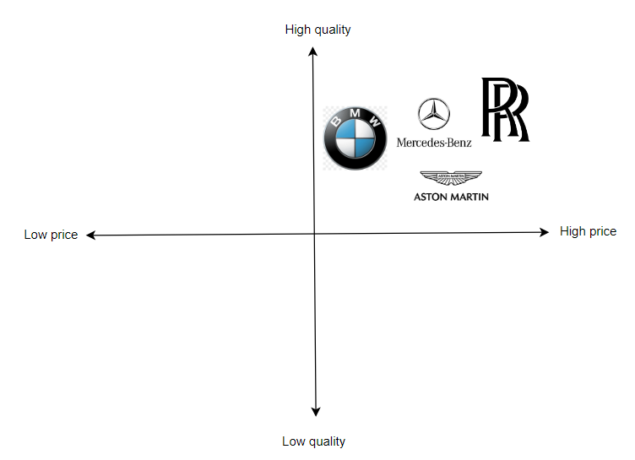
Understated or muted are often employed to describe Aston Martin designs. The sports vehicles and SUVs in the present collection resemble those of other companies, such BMW, notwithstanding occasional additions. However, every Rolls-Royce is instantly recognizable as a unique supercar with the weight and momentum of a fast locomotive. A Rolls-Royce has a stronger road presence than an Aston Martin because to its emphasis on elegance over ostentation.

Positioning map in China
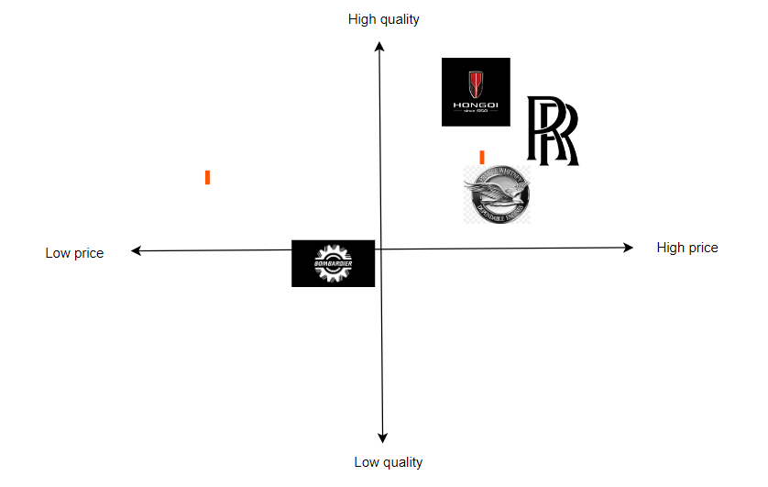
Hongqi H9's measurements. The H9 offers a huge price advantage over rivals like the Rolls-Royce Phantom, with prices ranging from 309,800 yuan to 539,800 yuan. It is to be noted that China's oldest automobile manufacturer is the Hongqi brand. On the other hand, The Rolls-Royce Phantom has a price tag of about $460,000 for purchase while being recognized for its elegance. In contrast, the Hongqi H9, a Chinese ultra-luxury vehicle, costs roughly five million Chinese Yuan, or 780,000 USD. The Hongqi H9 is now among the most costly vehicles on the market due to its placement.

4P
Products
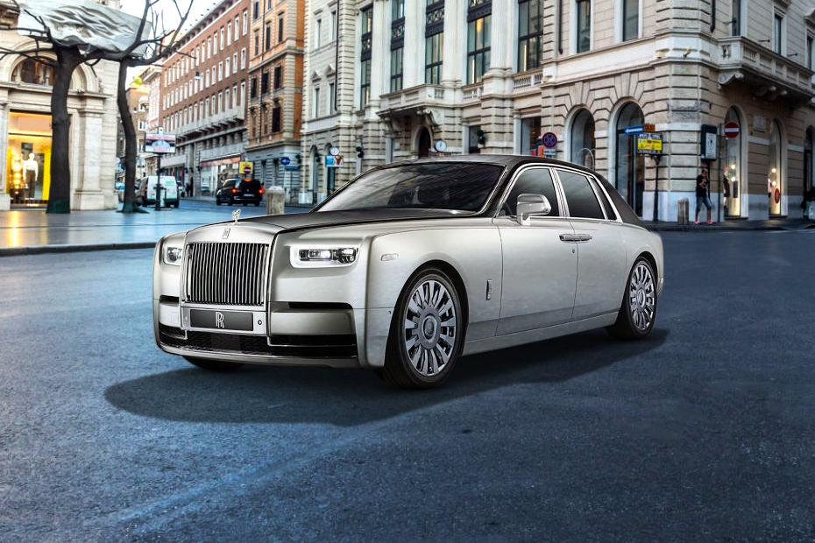
Figure 5: New Phantom model of Rolls Royace
(Source: ZigWheels.com, 2022)
Rolls-Royce's flagship model is the “Phantom”, and it is renowned for the extravagant luxury, cutting-edge technology, and exquisite craftsmanship that it offers. It is available with both a normal and an extended wheelbase, and both variants include an interior that is roomy and opulent. In addition, Car features have described the car performance in the business market. Polished disc wheels measuring 22” in diameter provide the appearance of being clean, regal, and attractive. These wheels encircle the marque's self-levelling monogram (Rolls-roycemotorcars.com, 2023). As the automobile moves forward, the seats rotate in such a way that they appear to be floating above the ground. This provides passengers with the famous "Magic Carpet Ride" feeling.
Price
The price has been seen as the major factor for Rolls-Royce to sell out the car in the Canadian market and Chinese business market. In addition, it has been proclaimed that the Car prices have been set up by the company management in the Chinese market at $460,000. On the other hand, Roll Royce has set up the price in the Canadian market at $465,000.
Place
Rolls Royce has operated the business in the China market with the acquisition of the targeting the high class of people and focusing on urban and upscale areas to deliver the services (Kang et al. 2022). In addition, the China market has been considered as the most expensive market in the world as compared to the other countries in the Asia regions. Furthermore, it has been observed that Rolls Royce targeted 35 + age group consumers with both males and females in the business societies of China. Hence, Roll Royce has been comprehending the significance of the digital channel in the China business market atmosphere to perform the business outcomes effectively (Wuori, 2023).
Promotion
Rolls Royce has been acquired the platform to present the brand images efficiently in front of the consumer and prepare the showcase of the product before launching the products in the business market of China. However, in the case of Canada, Rolls Royce has been focusing on “Entrepreneurs, “elite athletes” and “entertainers” that come in the high-income group in the Canadian region (Waddell, 2020). Rolls-Royce has historically presented itself as a symbol of luxury, exclusivity, and status in the automotive industry. It's possible that they focused their marketing efforts in Canada on highlighting the brand's pedigree, craftsmanship, and meticulous attention to detail (Sakowski, 2019).

Directional strategy
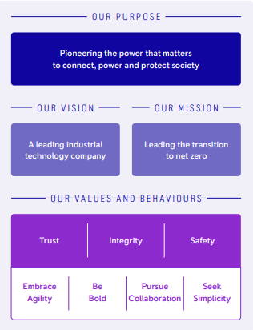
Figure 1: Rolls Royce vision and mission
(Source:Rolls-royce.com, 2021)
The aforementioned figure has delineated the overview of Rolls Royce vision and mission in the business market territory. In addition, it has been perceived that Rolls-Royce has been targeted to manufacturing the car with the acquisition of the leading technology in the business market spheres (Rolls-royce.com, 2021). Furthermore, it has been adjudged that the company's trust, integrity and safety have been maintained is the main task for the company to perform the business in the business market atmosphere. Moreover, the company's mission has targeted to achieve the transition of net zero in the business market atmosphere (Rolls-royce.com, 2021). Hence, the company's major business performance has been generated with the view of collaborating on the integrity of the business values in the business market territory.
The business marketing strategies of Rolls Royce have been adopted to explore business products in Canada and the Chinese market (Kang et al. 2022). Hence, it has been observed that the luxury product branding has been targeted by the company to promote the product acquisition through “social media campaigns”, “influencer collaborations”, and “online advertisements”.

Identification of contemporary ethical approaches to develop marketing plan
Ethical prospects are conjugated with more extensive marketing channels and drive to the development of a comprehensive marketing plan. Contemporary ethical aspects comprise of different ethical structures delineated by utilitarianism, deontology and virtue ethics in the marketing prospects (Abbas et al. 2020). In order for businesses to successfully build trust, cultivate long-term consumer relationships, and make a constructive contribution to society, it is essential for them to develop a marketing strategy that is compatible with contemporary ethical principles (Rauschnabel et al. 2022). In addition, in the process of developing, manufacturing, and distributing products, companies should put an emphasis on environmentally responsible practices. Spread the word about the efforts being made to cut down on waste and lower one's carbon footprint (Katsikeas et al. 2020). Greenwashing, which consists of misleading clients with false claims of sustainability, should be avoided. In marketing materials, make sure to represent a wide variety of ethnicities, backgrounds, and points of view. In order to reach a larger audience, it is important to work together with a variety of artists and influencers (Asqarova et al. 2021). Get customers' informed consent before collecting and exploiting their personal data.
The Utilitarianism marketing ethical practices promote the disbursement of customer-centric services for organisations as well as look after to all of their different needs against some cost (Efurhievwe and Okpeki, 2023). The utilitarianism ethical approach demonstrates that actions are only promogulated through the consequences and practices of consumers in the marketplace (Parsons, 2021). Moreover, an annotation of the production of a maximised number of commodities is mostly aimed to have beneficial for a greater number of consumers in the business atmosphere.
The deontological approach demonstrates that a larger adherence is required to be paid to the key ethical motivators as well as an assessment of whether the decisions are accurate or error (Sirait, 2022). The deontology ethical approach also paid adequate notion of light to the human conduct and morality and their influence on the marketing practices in the business atmosphere (Tjandra et al. 2020). These ethical codes also satisfy the construction of greater levels of personal responsibility to pay attention to all the different perspectives of key principles in marketing terminologies.
A virtue-based ethical terminology presents a brief annotation of focus to agents who are associated with the production of marketing content and construction with the degree of truth (Laczniak and Murphy, 2019). In addition, it also pays appropriate attention to the truth and integrity during the portrayal of contexts to a larger portion of the audience. The Virtue-based ethical approach initiates fair practices of advertising and accurate procurement of information to consumers based on the moral grounds (Steen et al. 2021). The Virtue of ethical procedure assists firms to obtain a grand degree of reputation by providing larger integrity and portrayal of promotions along with accurate information (Gal et al. 2020).

Conclusion
Conclusively, marketing practices are absolutely necessary for brands in order to get a larger market capitalization in a variety of international marketplaces and to achieve a competitive advantage in the business markets of Canada and China. This research has provided a distinguished analysis of two countries, Canada and China, in addition to describing various points of view on marketing activities. In the context of Rolls Royce, which has grown its operational facilities throughout a variety of geographical regions, it has been investigating the marketing practices that are now in place. In addition, market structures and segmentation have been incorporated into the study in a manner that is consistent with the geographical borders of these nations.

References
Abbas, A., Nisar, Q.A., Mahmood, M.A.H., Chenini, A. and Zubair, A., 2020. The role of Islamic marketing ethics towards customer satisfaction. Journal of Islamic Marketing, 11(4), pp.1001-1018. https://www.emerald.com/insight/content/doi/10.1108/JIMA-11-2017-0123/full/html
Alam, A., 2022. Investigating sustainable education and positive psychology interventions in schools towards achievement of sustainable happiness and wellbeing for 21st century pedagogy and curriculum. ECS Transactions, 107(1), p.19481. https://iopscience.iop.org/article/10.1149/10701.19481ecst/meta
Ali, A., Xiaoling, G., Ali, A., Sherwani, M. and Muneeb, F.M., 2019. Customer motivations for sustainable consumption: Investigating the drivers of purchase behaviour for a green‐luxury car. Business Strategy and the Environment, 28(5), pp.833-846. https://onlinelibrary.wiley.com/doi/abs/10.1002/bse.2284
Asqarova, A.M., Xonkeldiyeva, K.R., Abdukarimova, R.A., Xudoyberdiyeva, X.B. and Egamberdiyeva, N.B., 2021. Theories Of Marketing Strategies To Increase The Competitiveness Of Light Industry Enterprises. The American Journal of Management and Economics Innovations, 3(01), pp.40-42. https://inlibrary.uz/index.php/tajmei/article/view/12480
Azarafshar, R. and Vermeulen, W.N., 2020. Electric vehicle incentive policies in Canadian provinces. Energy Economics, 91, p.104902. https://www.sciencedirect.com/science/article/pii/S0140988320302425
Babin, B.J. and Harris, E.G., 2023. CB Consumer Behaviour. Cengage Canada. https://books.google.com/books?hl=en&lr=&id=mEy-EAAAQBAJ&oi=fnd&pg=PA3&dq=Canada+people+behaviour+to+luxury+car&ots=9MP6hRLyG6&sig=d2VdFX9e3FvWWVLpdVSQIqCakqA
Cassola, A., Fafard, P., Nagi, R. and Hoffman, S.J., 2022. Tensions and opportunities in the roles of senior public health officials in Canada: A qualitative study. Health Policy, 126(10), pp.988-995. https://www.sciencedirect.com/science/article/pii/S0168851022001907
China.org.cn, (2023).Content. Available from http://www.china.org.cn/english/government/207405.htm. Accessed on 21.08.2023
China-briefing.com, (2023). China H1 2023 Economic Roundup: GDP Grows 5.5% on Steady Path to Recovery. Available from. https://www.china-briefing.com/news/china-h1-2023-economic-roundup-gdp-grows-5-5-on-steady-path-to-recovery/#:~:text=China%20GDP%20growth%20accelerates%20in,reached%20RMB%2059.3%20trillion%20(approx. Accessed on 21.08.2023
Chinadialogue.net, (2022). How China’s courts implement climate policy. Available from https://chinadialogue.net/en/climate/how-chinas-courts-implement-climate-policy/. Accessed on 21.08.2023
Climate-laws.org, (2023). Canadian Net-Zero Emissions Accountability Act. Available from https://climate-laws.org/document/canadian-net-zero-emissions-accountability-act_d275. Accessed on 21.08.2023
Dijkstra, L., Poelman, H. and Veneri, P., 2019. The EU-OECD definition of a functional urban area. https://www.oecd-ilibrary.org/content/paper/d58cb34d-en
Efurhievwe, M.A. and Okpeki, P.I., 2023. ETHICAL INTERFACE OF MARKET SOCIETIES AND MUSIC PRODUCTION IN NIGERIA. Journal of Dharma, 48(2), pp.249-260. https://dvkjournals.in/index.php/jd/article/view/3890
Evans, P. (2023). Canada’s inflation rate falls to 2.8%. [online] CBC. Available at: https://www.cbc.ca/news/business/canada-inflation-rate-june-1.6909635#:~:text=6008- [Accessed 11 Aug. 2023].
Frank, R. (2023). Rolls-Royce sees record sales in 2022, no slowdown in spending by the wealthy. [online] CNBC. Available at: https://www.cnbc.com/2023/01/09/rolls-royce-2022-sales-soar-ceo-says-no-slowdown-in-spending-by-the-rich.html#:~:text=Still%2C%20the%20U.S.%20was%20the [Accessed 11 Aug. 2023].
Gal, U., Jensen, T.B. and Stein, M.K., 2020. Breaking the vicious cycle of algorithmic management: A virtue ethics approach to people analytics. Information and Organization, 30(2), p.100301. https://www.sciencedirect.com/science/article/pii/S1471772720300257
Guo, J. 2021. Analysis of the Marketing Strategies of Luxury Cars in China—Porsche as an Example. [online] www.atlantis-press.com. doi:https://doi.org/10.2991/assehr.k.211209.156.
Hofstedeinsights.com (2023). Country comparison tool. [online] www.hofstede-insights.com. Available at: https://www.hofstede-insights.com/country-comparison-tool?countries=canada%2Cchina [Accessed 11 Aug. 2023].
Iancu, D. and Badea, D., 2020. Empirical analysis of the influence of culture in managerial processes based on the hofstede model. In International Conference Knowledge-based Organization (Vol. 26, No. 1, pp. 205-210). https://sciendo.com/downloadpdf/journals/kbo/26/1/article-p205.pdf
Kang, I., Koo, J., Han, J.H. and Yoo, S., 2022. Millennial consumers perceptions on luxury goods: capturing antecedents for brand resonance in the emerging market context. Journal of International Consumer Marketing, 34(2), pp.214-230. https://www.tandfonline.com/doi/abs/10.1080/08961530.2021.1944832
Kang, I., Koo, J., Han, J.H. and Yoo, S., 2022. Millennial consumers perceptions on luxury goods: capturing antecedents for brand resonance in the emerging market context. Journal of International Consumer Marketing, 34(2), pp.214-230. https://www.tandfonline.com/doi/abs/10.1080/08961530.2021.1944832
Katsikeas, C., Leonidou, L. and Zeriti, A., 2020. Revisiting international marketing strategy in a digital era: Opportunities, challenges, and research directions. International Marketing Review, 37(3), pp.405-424. https://www.emerald.com/insight/content/doi/10.1108/IMR-02-2019-0080/full/html
Laczniak, G.R. and Murphy, P.E., 2019. The role of normative marketing ethics. Journal of Business Research, 95, pp.401-407. https://www.sciencedirect.com/science/article/pii/S0148296318303552
Lai, H. and Lai, H., 2021. Cultivation Methods of Chinese Local New Luxury Brands: A Perspective of Design Driven Innovation. Chinese Local New Luxury Brands in a Digitally Empowered Era: Cultivation, Transformation and Upgrading, pp.61-92. https://link.springer.com/chapter/10.1007/978-981-16-2145-1_4
MM, D., 2019. Managing Cultural Diversity. World Affairs: The Journal of International Issues, 23(4), pp.26-35. https://www.jstor.org/stable/48566195
Nasirova, S.A., Hashimova, S.A. and Rikhsieva, G.S., 2021. The influence of the political system of china on the formation of social and political terminology. Journal of Central Asian Social Studies, 2(04), pp.10-17. http://orientalresearch.uz/index.php/jcass/article/view/104
Parsons, T.D., 2021. Ethics and educational technologies. Educational Technology Research and Development, 69(1), pp.335-338. https://link.springer.com/article/10.1007/s11423-020-09846-6
Rajeshni Naidu-Ghelani (2018). Luxury vehicle sales in Canada still booming but higher interest rates could pose challenge. [online] CBC. Available at: https://www.cbc.ca/news/business/luxury-retail-cars-canada-1.4517386 [Accessed 11 Aug. 2023].
Rauschnabel, P.A., Babin, B.J., tom Dieck, M.C., Krey, N. and Jung, T., 2022. What is augmented reality marketing? Its definition, complexity, and future. Journal of business research, 142, pp.1140-1150. https://www.sciencedirect.com/science/article/pii/S0148296321010043\
Reese, P., 2022. Sir Henry Royce: Establishing Rolls-Royce, from Motor Cars to Aero Engines. The History Press. https://books.google.com/books?hl=en&lr=&id=duZdEAAAQBAJ&oi=fnd&pg=PT8&dq=Rolls-Royce+vehicles+have+been+found+it+more+expensive+for+the+Canadian+people&ots=_balMa6GA5&sig=frIt0JgH3uDYywuKNZwFEZ9bUL4
Rolls-royce.com, (2021). Empowering through digital. Available from https://www.rolls-royce.com/innovation/digital/digital-platforms.aspx#tab-navigation-3. Accessed on [11 August 2023]
Rolls-roycemotorcars.com, (2023). A HAVEN OF SERENITY AWAITS.
PHANTOM EXTENDED SERIES II. Available from https://www.rolls-roycemotorcars.com/en_GB/showroom/phantom-extended.html. Accessed on [11 August 2023]
Sakowski, P., 2019. A Bargain with Justice: A Perspective on Canada's New Remediation Agreements. Man. LJ, 42, p.365. https://heinonline.org/hol-cgi-bin/get_pdf.cgi?handle=hein.journals/manitob42&section=38
Sirait, F.E.T., 2022. Political Campaigns and Actor Populism Strategies: A Deontological Ethical Approach. Jurnal Netralitas Dan Pemilu, 1(1), pp.65-79. https://journal.bawaslu.go.id/index.php/JNP/article/view/182
Statcan.ca (2022). The Daily — The Canadian census: A rich portrait of the country’s religious and ethnocultural diversity. [online] Statistics Canada. Available at: https://www150.statcan.gc.ca/n1/daily-quotidien/221026/dq221026b-eng.htm [Accessed 11 Aug. 2023].
Statcan.gc.ca, (2023). Canada's population estimates: Record-high population growth in 2022. Available from https://www150.statcan.gc.ca/n1/daily-quotidien/230322/dq230322f-eng.htm. Accessed on 21.08.2023
Statista.com (2019). China: Inflation rate 2019 | Statista. [online] Statista. Available at: https://www.statista.com/statistics/271667/monthly-inflation-rate-in-china/ [Accessed 11 Aug. 2023].
Statista.com (2023a). China: number of luxury cars sold 2018. [online] Statista. Available at: https://www.statista.com/statistics/799545/number-of-luxury-vehicles-sold-in-china/ [Accessed 11 Aug. 2023].
Statista.com (2023b). Luxury Cars - Canada | Statista Market Forecast. [online] Statista. Available at: https://www.statista.com/outlook/mmo/passenger-cars/luxury-cars/canada [Accessed 11 Aug. 2023].
Statista.com, (2023). Canada: Real gross domestic product (GDP) growth rate from 2018 to 2028(compared to the previous year). Available from https://www.statista.com/statistics/263603/gross-domestic-product-gdp-growth-rate-in-canada/. Accessed on 21.08.2023
Statista.com, (2023). Population growth in China from 2000 to 2022. Available from. https://www.statista.com/statistics/270129/population-growth-in-china/?kw=&crmtag=adwords&gclid=Cj0KCQjw84anBhCtARIsAISI-xcLLB2VN2zac-Zj1KJgwA-aV9qyZ2SYxUg8m2Cn-wRUB-H6PeEjnVcaAuXaEALw_wcB. Accessed on 21.08.2023
Steen, M., Sand, M. and Van de Poel, I., 2021. Virtue ethics for responsible innovation. Business and Professional Ethics Journal, 40(2), pp.243-268. http://www.pdcnet.org/pdc/bvdb.nsf/showfreearticle?open&url=/8525737F0058014C/file/3ED834DD6AA68A63852586AA00438090/$FILE/bpej_2021_0040_0002_0117_0142.pdf
The World bank.org (2021). Population, total - China | Data. [online] Worldbank.org. Available at: https://data.worldbank.org/indicator/SP.POP.TOTL?locations=CN [Accessed 11 Aug. 2023].
Tjandra, N.C., Aroean, L. and Prabandari, Y.S., 2020. Public evaluation of the ethics of tobacco marketing in Indonesia: symbiotic ethical approach. Qualitative Market Research: An International Journal, 23(4), pp.603-626. https://www.emerald.com/insight/content/doi/10.1108/QMR-01-2020-0011/full/html
Transparency.org, (2022). CORRUPTION PERCEPTIONS INDEX. Available from https://www.transparency.org/en/cpi/2022/index/can. Accessed on 21.08.2023
Transparency.org, (2022). CORRUPTION PERCEPTIONS INDEX. Available from https://www.transparency.org/en/cpi/2022/index/chn. Accessed on 21.08.2023
Waddell, C., 2020. Digital Journalism: The Canadian Media’s Struggle for Relevance. Digital Politics in Canada: Promises and Realities, p.159. https://books.google.com/books?hl=en&lr=&id=19AMEAAAQBAJ&oi=fnd&pg=PA159&dq=Rolls+Royce+marketing+strategy+in+canada+&ots=U_avDNre7f&sig=XFpf7KY17yptvitlvR21QFYHEP4
Wang, Y., Xu, Y. and Tan, R., 2023. Yan Zhu. Peng Dehuai nianpu. https://www.researchgate.net/profile/Yuwei-Xu-2/publication/371510546_ReConstructing_equality_diversity_and_inclusion_in_Chinese_childhoods_Intersectional_perspectives_and_transdisciplinary_approaches/links/64884f2679a72237652c2cea/ReConstructing-equality-diversity-and-inclusion-in-Chinese-childhoods-Intersectional-perspectives-and-transdisciplinary-approaches.pdf?origin=journalDetail&_tp=eyJwYWdlIjoiam91cm5hbERldGFpbCJ9
Williamson, P.J. and De Meyer, A., 2020. Ecosystem Edge: Sustaining competitiveness in the face of disruption. Stanford University Press. https://books.google.com/books?hl=en&lr=&id=3E_VDwAAQBAJ&oi=fnd&pg=PT3&dq=Rols+royce+faces+the+limited+competition+in+the+Canadian+market&ots=d2Y27o6ey_&sig=365SKSbheTo274P88maZGtHfg0U
Wipo.int, (2022). CANADA. Available from https://www.wipo.int/edocs/pubdocs/en/wipo_pub_2000_2022/ca.pdf. Accessed on 21.08.2023
Wipo.int, (2022). CHINA. Available from https://www.wipo.int/pressroom/en/articles/2022/article_0011.html. Accessed on 21.08.2023
Wu, F., Zhang, F. and Liu, Y., 2022. Beyond growth machine politics: Understanding state politics and national political mandates in China’s urban redevelopment. Antipode, 54(2), pp.608-628. https://onlinelibrary.wiley.com/doi/abs/10.1111/anti.12781
Wuori, P.E.M., 2023. Analysing the Differences Between Luxury and Premium in Marketing–Case Study: BMW and Rolls-Royce. https://www.theseus.fi/handle/10024/802349
Wuori, P.E.M., 2023. Analysing the Differences Between Luxury and Premium in Marketing–Case Study: BMW and Rolls-Royce. https://www.theseus.fi/handle/10024/802349
Ye, R. and Titheridge, H., 2019. The determinants of commuting satisfaction in low-income population: A case study of Xi’an, China. Travel behaviour and society, 16, pp.272-283. https://www.sciencedirect.com/science/article/pii/S2214367X17301175
Zhao, X., Hong, F., Yin, J., Tang, W., Zhang, G., Liang, X., Li, J., Cui, C., Li, X. and China Multi-Ethnic Cohort (CMEC) collaborative group, 2021. Cohort profile: the China Multi-Ethnic cohort (CMEC) study. International journal of epidemiology, 50(3), pp.721-721l. https://academic.oup.com/ije/article-abstract/50/3/721/6000341
ZigWheels.com (2022). New Rolls-Royce Phantom Series II Breaks Cover With Subtle Updates - ZigWheels. [online] ZigWheels.com. Available at: https://www.zigwheels.com/news-features/general-news/new-rolls-royce-phantom-series-ii-breaks-cover-with-subtle-updates/45655/ [Accessed 21 Aug. 2023].

