

UNIVERSITY OF WALES TRINITY SAINT DAVID
MBA Business Research | BMMB7028

Frontline Employee Perceptions of Diversity, Equity, and Inclusion Initiatives: A Qualitative Study of Staff in the UK Hospitality Industry

A Research Proposal Submitted in Partial Fulfilment of the Requirements for the MBA

Student Name: Md Rakibul Hasan
ID: 2438287
Module Code: BMMB7028
Module Title: Business Research

Table of Contents
1.0 Introduction 2
1.1 Contextual Background 2
1.2 Statement of the Research Problem 3
1.3 Significance of the Research 4
1.4 Definition of Key Terms 4
1.5 Research Aim 5
1.6 Research Objectives 5
1.7 Research Questions 5
2.0 Literature Review 6
2.1 Theoretical and Conceptual Foundations 6
2.2 Critical Review of Existing Empirical Research 7
2.3 Contextual Review: The UK Hospitality Sector 9
2.4 Identification of the Research Gap 10
3.0 Research Methodology 11
3.1 Research Philosophy 11
3.2 Research Approach 12
3.3 Methodological Choice and Research Strategy 12
3.4 Critical Evaluation of the Methodology 13
3.5 Data Collection Methods 14
3.6 Sampling Strategy and Target Population 14
3.7 Data Analysis 15
3.8 Ethical Considerations 16
3.9 Limitations of the Study 17
4.0 Outcomes and Timetable 18
4.1 Expected Outcomes and Contribution 18
4.2 Gantt Chart and Timeline Narrative 19
Appendix 29

1.0 Introduction

1.1 Contextual Background
The UK hospitality sector is among the most diverse and largest sectors of employment. The UK Hospitality (2024) states that the industry has over 3.5 million workers, and frontline workers in hotels and food service organisations are grossly underrepresented in ethnic, migrant, and socially disadvantaged employees. According to statistics provided by ONS (2024), the minor ethnic workers are not only hugely overrepresented in elementary and service jobs in hospitality, when compared with their percentage within the overall labour market, but also underrepresented in supervisory and managerial roles. The Fair Work Convention (2024) has documented systemic problems of low wages, limited career progression, and ongoing discrimination against frontline hospitality workers in the UK. The following structural context has been exacerbated by labour-market shocks, post-Brexit, which have broken recruitment channels, leading to a situation of greater dependency on a residual, heterogeneous labour force. It is on this basis that the issue of whether organisational DEI efforts are truly helpful to the employees to which they are allegedly targeted is timely and consequential (Deloitte, 2023
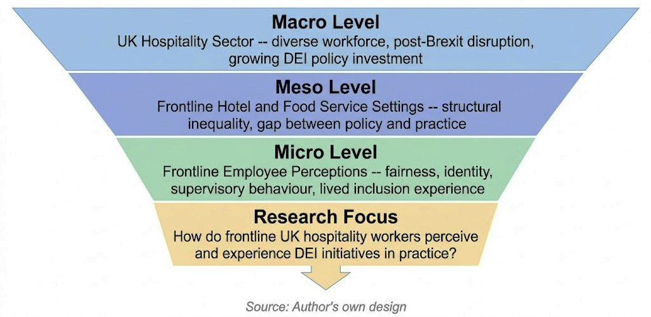
Figure 1: Narrowing from macro sectoral context to specific research focus (Author's own design)

1.2 Statement of the Research Problem
DEI has received much research in the areas of organisational policy, corporate strategy, and managerial implementation. According to a recent systematic literature review of the notion of DEI in the hospitality and tourism sector (Koç et al., 2025), quantitative, managerial, and corporate-level studies prevail in the scholarly field. The point that remains to be well known is how frontline employees, who are most directly affected by decisions that presuppose DEI fairness, task allocation, and inter-team relations, perceive, evaluate, and experience such initiatives in their work. This is not a matter of mere omission by scholars. Mistry et al. (2021) identified that the most frequent narratives of DEI by employees of hospitality institutions were symbolic exercise of top-down, not a real cultural reality. This discrepancy between the rhetoric of institutional DEI and lived experience at the frontline is an important research problem to the nature of organisational inclusion programs, but has not been given the proper attention in qualitative research in the UK.

1.3 Significance of the Research
Academically, this research paper fills a clear and verifiable gap: the lack of qualitative research grounded in the frontline perspective on DEI in the UK hospitality sector. Liu et al. (2025) establish that qualitative research remains a minority in the DEI hospitality literature and that employees' perspectives on this in UK contexts are underrepresented. Similarly, Mohammadi et al. (2022) note that the past 20 years of research on diversity in the hospitality industry have paid excessive attention to managerial perspectives, with frontline voices given low priority. In practice, the results will be directly relevant to hospitality professionals, human resources managers, and decision-makers who aim to develop DEI interventions that staff members, to whom they are to be applied, will find credible and meaningful, rather than compliance actions. Ferrazza (2025) argues that, to truly be included in the world of European hospitality, motivational and relational conditions that are often lacking are required; the current research will establish the empirical specificity needed to act on such an argument.

1.4 Definition of Key Terms
Three constructs support this question. According to Shore et al. (2011), inclusion refers to the extent to which an individual perceives that their membership in a work group is marked by both a sense of belonging and a sense of uniqueness, rather than by demographic diversity. According to Cropanzano et al. (2007), organisational justice is a subjective evaluation of the fairness of workplace decisions and the organisation's treatment of employees in four dimensions: distributive, procedural, interpersonal, and informational justice. According to Nishii (2013), the inclusion climate is the perception that all members of a work group hold about the organisational climate, in which the atmosphere facilitates equitable treatment and the inclusion of different identities in teamwork. These definitions are field-specific and peer-reviewed, and can be directly operationalised in the suggested interview design.

1.5 Research Aim
This study critically analyses the perceptions and experiences of frontline employees working in hospitality organisations in the UK regarding Diversity, Equity, and Inclusion initiatives, with particular emphasis on perceptions of fairness, identity-based dynamics, and the effects of supervisory behaviour on creating an inclusion climate at the operational level.

1.6 Research Objectives
This goal is operationalised by four non-overlapping objectives, which are discrete:
- To investigate the subjective ratings of frontline hospitality workers regarding the fairness and relevance of policies and practices of the DEI in their organisation.
- To understand how the traits of identity, i.e. ethnicity, gender, and migration status, influence inclusion and exclusion experiences of employees in the workplaces in the UK hospitality industry.
- To examine the impact of supervisory and managerial behaviour on either strengthening or weakening inclusion climate at the frontline operational level.
- To determine felt disjunctions between declaratively enshrined organisational DEI promises and the lived frontline reality of frontline employees.

1.7 Research Questions
The aim is operationalised into four research questions, each of which is specific to one objective:
- RQ1: What is the perceived fairness and relatability of the DEI initiatives of their organisations by the frontline hospitality employees in their daily working experience?
- RQ2: How are identity-based attributes related to the inclusion experiences and sense of belonging of frontline hospitality employees?
- RQ3: Does supervisory behaviour play a role in, or undermine, a climate of inclusion at an operational level of UK hospitality organisations?
- RQ4: Where do frontline employees perceive a gap between their organisation's stated DEI commitments and their experience of inclusion in the workplace?

2.0 Literature Review

2.1 Theoretical and Conceptual Foundations
This paper draws on four complementary frameworks: Organisational Justice Theory, Social Identity Theory, the Inclusion Climate construct, and Inclusive Leadership Theory. They are arranged in different levels that include Organisational Justice Theory, which is used to evaluate DEI; Social Identity Theory, which is the theory of the identity influencing those evaluations; the Inclusion Climate construct places the analysis at the work-group level; and the Inclusive Leadership Theory is the theory of the supervisory behaviours that connect policy to frontline climate.
Cropanzano et al. (2007) developed an Organisational Justice Theory that distinguishes between distributive, procedural, interpersonal, and informational justice. Its power is granularity, as employees can process results but deny the process and treatment. Its weakness, to which Roberson (2019) draws attention, is that it was developed primarily in white-collar environments in North America and has not been uniformly tested in frontline, low-wage, diverse work environments.
The Social Identity Theory, as operationalised by Bergami and Bagozzi (2000), suggests that group membership is a determinant of self-concept and that marginalised identities in dominant cultures may lead to diminished belonging, psychological safety, and commitment. This is why, until DEI initiatives use identity salience, they can seem irrelevant or even off-putting. Nevertheless, as Jonsen et al. (2013) observe, its in-group/out-group logic may be simplistic about intersectional identities. Intersectionality Theory (Parker, 2004) was found to be less operationalisable, and though it is more sensitive, it was considered less applicable to this study, which is based on interviews.
The most readily applicable framework is the Inclusion Climate construct coined by Nishii (2013) and elaborated by Chung et al. (2020). Its essence dimensions are: integration of differences, decision making and fair employment practices. Chung et al. demonstrate that inclusion appears to be most immediate at the work-group level and is influenced by supervisors.
Randel et al. (2018) developed the Inclusive Leadership Theory, according to which supervisors create an inclusive climate primarily through the use of belonging and valuing uniqueness as central mechanisms. Ferdman et al. (2020) also endorse the view that inclusive leadership entails structural responsibility. However, this requires supervisors to be motivated and for the organisation to allow them to be inclusive, which is not the case in lean, high-turnover hospitality environments. The connection between these frameworks is depicted in the conceptual framework below.
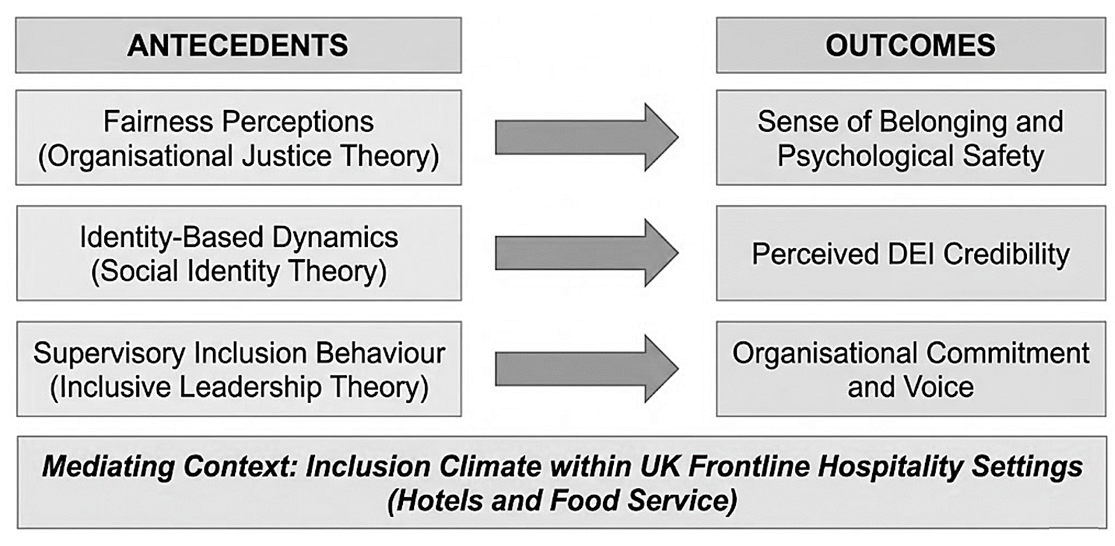
Figure 2: Proposed Conceptual Framework: Antecedents and Outcomes of Frontline DEI Perceptions (Author's own design)

2.2 Critical Review of Existing Empirical Research
Since the middle of the 2000s, DEI studies have increased significantly. Park et al. (2025) note a shift from models driven by compliance to models grounded in culture and identity. It is important because diversity and inclusion are distinct, and inclusion is a subjective experience that is also difficult to measure through surveys. Nonetheless, qualitative, frontline-based research is minimal.
A formal diversity programme is one of the most controversial matters. As Kalev et al. (2006) concluded, such policies changed the composition of work only in case they were supported by structural accountability; otherwise, the training and policy statements turned out to be more symbolic. As Noon (2017) makes clear, one cannot say that unconscious bias training relies on solid evidence and can create the illusion of change. Equally, Pressman et al. (2018) emphasise that implicit bias management cannot be resolved solely through awareness training; it must be addressed at the structural and organisational levels. It is especially applicable to the hospitality industry, where DEI programmes are usually reactive and poorly maintained (Mistry et al., 2021).However, in comparison, Wang et al. (2023) identified small positive returns from well-structured, multi-session antiracism programmes, indicating that outcomes depended on programme quality and implementation circumstances.
Such divergence is an indicator of a methodological controversy. The positive results of DEI in studies are usually based on self-report questionnaires in organisations with well-developed DEI infrastructure (Fitriana, 2023; Goyal, 2025), whereas the neutral or negative results are more frequently based on the administrative or interview-based data, which reveal the gaps between the proclaimed and experienced inclusion (Showkat and Yahya, 2025). According to Kochikunnel and Benty (2025), this asymmetry is one of the key contributors to conflicting findings. The majority of evidence is based on the corporate setting rather than on the UK frontline hospitality.
Studies of the results of DEI are also disputed. Rosenzweig et al. (2024) found that frontline perceptions of service equality policies were largely contingent on whether supervisors served as role models of fairness norms. Transparent diversity communication, demonstrated to be a stronger way to create organisational identification and voice by Men et al. (2024), and backlash when improperly developed DEI initiatives weaken commitment are documented (Showkat and Yahya, 2025). Such results confirm the need to study DEI on the experiential level.
There is uneven identity-specific research. Hospitality management has been studied on gender diversity (Poquiz et al., 2023) and generational diversity (Sakdiyakorn and Wattanacharoensil, 2017), but the qualitative elements of race and ethnicity are relatively understudied in frontline hospitality in the UK. Hussein (2022) revealed considerable disparities among British minority ethnic workers. In contrast, Ozturk et al. (2024) demonstrated that UK organisations frequently face inadequate language and support to engage in non-binary inclusion.
Poor inclusion climates have well-known consequences on well-being. Saito et al. (2024) consider the inclusion climate to be a powerful predictor of frontline psychological well-being. In contrast, Ariza-Montes et al. (2018) reveal that job demands and perceptions of fairness are different among hospitality roles. This helps to sample housekeeping, food and beverage, and front-of-house jobs.
Table 1: Scholarly Debates and Divergent Positions in the DEI Literature
Debate | Position A | Position B
Efficacy of DEI training | Training produces minimal change without structural accountability (Kalev et al., 2006; Noon, 2017) | Well-designed, multi-session programmes yield modest attitudinal change (Wang et al., 2023)
Impact of DEI on outcomes | Transparent communication raises identification and voice (Men et al., 2024; Rosenzweig et al., 2024) | Poorly designed DEI generates backlash, reducing commitment (Showkat and Yahya, 2025)
Measurement approach | Survey instruments capture aggregate attitudinal change (Fitriana, 2023; Goyal, 2025) | Qualitative inquiry reveals policy-experience gap (Kochikunnel and Benty, 2025; Mistry et al., 2021)
Table 1: Key scholarly debates in the DEI literature relevant to the proposed study (Author's own compilation)

2.3 Contextual Review: The UK Hospitality Sector
Studies of the UK hospitality industry point to structural conditions that differ from those in the wider corporate and financial services literature. High percentages of migrant workers, historically of Central and Eastern European origin, and more of the South and Southeast Asian community, are also found in the workforce in urban hotel and restaurant environments. These structural conditions have been a persistent feature of UK hospitality employment (Lucas, 2019). Janta et al. (2011) established that marginalisation through linguistic differences, cultural misidentification, and exclusionary management practices was generated and was not addressed by formal diversity policies. The study was conducted before Brexit, but its results are still applicable, as labour-market changes have not reduced inclusion pressures; on the contrary, they have increased them.
Baum et al. (2020) demonstrate that the COVID-19 pandemic exacerbated existing inequalities in the hospitality sector, as minority ethnic and migrant frontline workers experienced a disproportionate number of redundancies, furloughs, insecurity, and the absence of workplace communication. This is important because it implies that, when implemented in hospitality, DEI structures tend to crumble under the pressure of operations, demonstrating a performative rather than an embedded nature. Similar results are demonstrated by Shehawy and Abouzied (2022), who indicate that the disruption of the pandemic period aggravated inequalities among lower-paid, client-facing employees. Collectively, these papers highlight the frailty of DEI promises in the industry and support frontline-based investigations into how employees themselves assess them.
There is limited sector-specific literature on DEI, which is increasing. Gehrels and Suleri (2016) explain diversity and inclusion as signs of sustainable HRM, but their analysis is mostly at the policy level. According to Manoharan et al. (2023), the recurrent issues include demographic diversity without actual inclusion, the absence of an accountability mechanism, and positioning DEI as an HR concern rather than a leadership task. Ponting and Dillette (2023) also found that apparent leadership commitment and open communication were perceived as the most credible indicators of genuine inclusion of frontline workers. Fogle et al. (2025) also recognise the gap in knowledge regarding the practical application of DEI principles in hospitality education and management.
Another dimension is that of well-being literature. According to Dwertmann et al. (2016), there is a distinction between the fairness and synergy views of diversity climate, as minority employees evaluate it based on justice rather than productivity. This implies that frontline workers will evaluate DEI not so much on whether it benefits the organisation, but rather on whether it treats them fairly. The Equalities and Human Rights Commission (2023) also attests to the persistence of ethnic employment disparities in the UK, validating the relevance of the justice-focused DEI inquiry.

2.4 Identification of the Research Gap
There are three apparent gaps in the literature. First, studies in hospitality DEI research are still characterised by the predominance of quantitative designs that aggregate responses and the suppression of the contextual meanings of fairness and inclusion across identity positions (Koç et al., 2025; Liu et al., 2025). Second, managerial and organisational standpoints take a leading position in the field, whereas frontline workers remain under-researched, as the majority of the sector's workforce are low-level staff (Mohammadi et al., 2022; Nkomo et al., 2019; Mor-Barak, 2022). Third, recent qualitative research has not received sufficient attention in the UK context, as it addresses post-Brexit labour changes, pandemic disruption, and the Equality Act 2010 (GOV.UK, 2010).
There is thus a notable difference in qualitative, employee-focused research on DEI perceptions amongst frontline hospitality workers in the UK. Specifically, little has been identified to describe the dynamics between fairness, identity-based dynamics, and supervisory behaviour in influencing inclusion in UK hotels and food service organisations. The proposed research fills the aforementioned gap by producing empirically based, situation-specific knowledge that cannot be obtained through quantitative, managerially driven research studies.

3.0 Research Methodology
This study relies on the Research Onion methodology (Saunders et al., 2019), in which each decision is derived from and coherent with the decision made at the next highest level. As shown by the diagram below, the entire methodology architecture of the proposed study is presented in advance and then discussed in prose in the subsequent sub-sections.
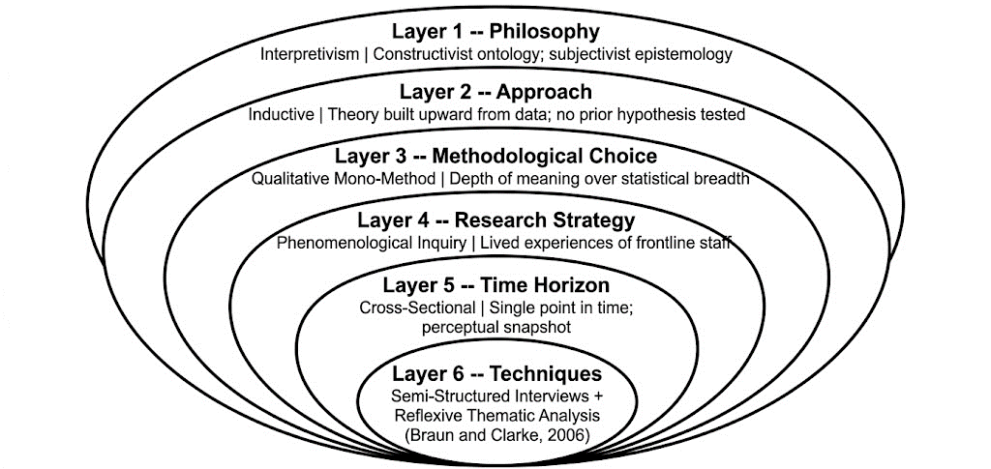
Figure 3: Research Onion - Full Methodological Architecture of the Proposed Study (Adapted from Saunders et al., 2019)

3.1 Research Philosophy
The research philosophy is interpretivist, grounded in a constructivist ontology and a subjectivist epistemology. According to constructivist ontology, social realities (such as inclusion and exclusion in the workplace) are neither objective facts nor inherent to people but instead constructed during interaction, language, and institutional context (Bryman, 2016). The subjectivist epistemology also presumes that such realities may only be comprehended in terms of the sense people give their experiences, rather than in terms of external, objective measurement (Denzin and Lincoln, 2011). Interpretivism thus places greater emphasis on contextual revelation than on causal prediction, making it well-suited to exploring DEI as frontline hospitality employees interpret it.
Other jobs were considered but declined. Positivism would be appropriate for a study that quantifies attitudes toward DEI, infers relationships among variables, and produces statistically generalisable outcomes. This research aims to examine how and why workers perceive DEI within a particular organisational context. A mixed-methods design may be supported by pragmatism. Still, all four research questions are explorative and focus on meaning, which is why a pure qualitative study would be more appropriate and analytically deeper. The research is hence strongly interpretivist.

3.2 Research Approach
This research is not a test of any hypotheses, but an inductive one, which develops theoretical knowledge on the basis of empirical data. The research questions aim to provide contextually based understanding of the perception and experience of a specific group with regards to DEI in a specific environment. According to Creswell and Poth (2018), induction is suitable when the process of how a lived experience is to be explained is considered as the primary concern of the interpretivist qualitative inquiry, as opposed to prediction.
The theoretical frameworks presented in Section 2.1, including organisational justice, social identity, inclusion climate, and inclusive leadership, serve to sensitise to these notions. They direct the design of the interviews and give preliminary analytical vocabulary without being closed to being revised or criticised based on the narratives of participants reflecting the iterative logic of reflexive thematic analysis (Braun and Clarke, 2022).

3.3 Methodological Choice and Research Strategy
The design applied is a qualitative monomethod design, which is in line with the inductive and interpretive orientation of the study. The best-suited methods are qualitative ones where the objective is to study more intricate social phenomena using the views of participants and coming up with more contextual understanding as opposed to representative statistics (Silverman, 2017; Gwele, 2009). Each of the four research questions deals with perceptions, meanings, and experiences which can not be captured under numbers. Quantitative design would place pre-determined categories of subjective experience before the voices of the participants could be heard properly.

It is a phenomenologically informed interpretive inquiry that is based on the lived experience tradition (Denzin and Lincoln, 2011). It is not a formal method such as Interpretative Phenomenological Analysis which would reduce the sample and concentrate on singular subjectivity. Rather, it allows studying personal meaning-making and the overall organisational and social context in which it is produced, which means that both psychological and structural aspects of the DEI perceptions can be explored through this method.

3.4 Critical Evaluation of the Methodology
The qualitative interpretivist design has its obvious advantages. The semi-structured interviews promote subtle, contextual narratives of fairness, identity and supervisory behaviour, which include the ability of the participants to articulate ambiguity and dissent in ways that are not possible when using structured questionnaires (Kallio et al., 2016). They are also highly appropriate to delicate issues like discrimination and exclusion where flexibility and trust are vital. More essentially, interpretivism will be consistent with the phenomenon itself, because the perception of DEI is a construct and not an objective quantification.

Several limitations apply. The results of 8 to 10 respondents are not statistically generalisable; the research is analytic instead of population-wide generalisable. There is the possibility that social desirability bias causes the participants to become soft in negative statements in order to preserve workplace relationships. Positionality is bound to influence data collection and interpretation by the researcher but this is overcome by reflexive practice.

Other designs were taken into consideration. Ethnography would be more appropriate in capturing behaviour naturally occurring yet it was discarded because it was not practically feasible to conduct a field work at a commercial hospitality place over an extended period and because it was ethically wrong to inflict uninformed coworkers. An example of a quantitative survey that would enhance statistical generalisability but would not yield the detail and contextual richness the research questions require would be based on validated instruments like the Organisational Diversity and Inclusion Scale (De Simone et al., 2024). Semi-structured interviews will be the best and the most viable decision.

3.5 Data Collection Methods
Primary data will be gathered using semi-structured interviews of 20 to 40 minutes, either face to face or through video conferencing, so as to ensure the least level of discomfort and power distance. Pilot data may be held in case, however, slight revisions are required prior to testing the coherence and sensitivity of the guide by means of a pilot interview. All interviews will be audio-taped with written consent and transcribed word-for-word, including appropriate non-verbal signals. Member checking will enable the participants to contest and explain their accounts. Findings will be contextualised with secondary data, such as peer-reviewed literature and industry sources, such as UK Hospitality (2024), Fair Work Convention (2024), ONS (2024), and Equalities and Human Rights Commission (2023).

3.6 Sampling Strategy and Target Population
The target audience is frontline employees at the UK hotel and food service establishments, such as housekeepers, room attendants, waitstaff, food and beverage staff, and front-of-house receptionist. The supervisory staff members are not involved to preserve a frontline focus but one supervisory participant can be involved as a comparison case.
The purposive sampling will take place because it is the most suitable sampling method to interpretivist qualitative research aimed at obtaining theoretically relevant but not statistically representative samples (Ahmad and Wilkins, 2024). Diversity in terms of type of roles, organisation, gender and ethnicity will be desired. A sample size of 8 to 10 is just sufficient because thematic saturation is usually achieved by between 9 and 17 interviews (Squire et al., 2023). The participants should also work in the UK in a frontline hospitality position at present and be capable of introspection concerning DEI experiences. Managers or corporate employees and non-hotel or food service sub-sectors are not included.
The unpredictability of shift patterns and long and protracted corporate approvals will pose a risk to access, so a tiered contingency plan will be employed. Large chains will be approached first by HR gatekeepers, and then independent operators will be approached in the case of the delay of corporate access exceeding two weeks. The snowball referral and outreach via hospitality worker networks such as union chapters and online forums will be operated as a concurrent channel to ensure that the target sample is acquired within the intended fieldwork period.
Table 2: Participant Inclusion and Exclusion Criteria
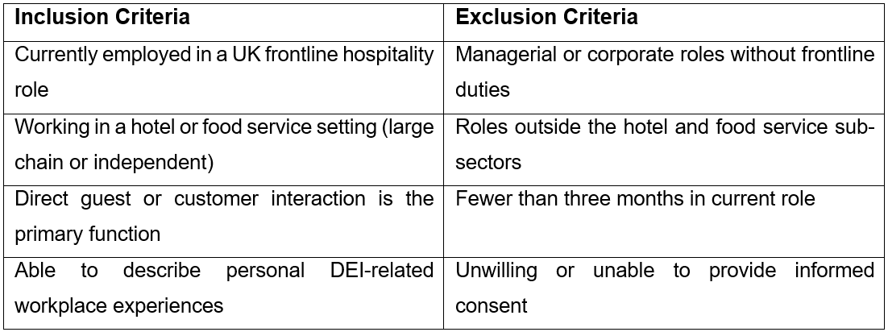
Table 2: Participant Inclusion and Exclusion Criteria (Author's own design)

3.7 Data Analysis
As Braun and Clarke (2006) formulated and Braun and Clarke (2019) justified, reflexive thematic analysis will be used as the method of its analysis. This is epistemologically in line with the interpretivist philosophy of the study. In contrast to content analysis or framework analysis, which are deductive and require a priori categories to establish and define the themes, reflexive thematic analysis approaches theme building as an interpretive, active, and recursive process that accepts the theoretical sensitivity and reflexive position of the researcher as constitutive of the analysis and not as a contaminant to it (Braun and Clarke, 2022). This coincides with the inductive reasoning behind the research study and the constructivist epistemological commitment to acknowledge the role of the researcher in the production of knowledge.
The analysis will be carried out in six stages. The researcher will accomplish familiarisation with the entire data set in Phase 1 by repeatedly reading all the transcripts and preparing the first reflective notes. During Phase 2, the first codes will be systematically created across the entire dataset by annotating all data units relevant to the research questions. Phase 3 will entail grouping related codes under them into candidate themes, and coming up with a thematic map of the relationship between the codes and the themes. The fourth phase will entail the verification of the candidate themes with the code data extracts, as well as the whole set of data, to determine the consistency, coherence, and coverage. The fifth phase will include narrower definition of each theme, and a title that corresponds to the contents of its analysis, instead of a subject. Phase 6 will involve the process of writing up the analysis and that data pulls and commentary analysis are integrated in a way that will allow a clear and traceable interpretive argument. Additional trustworthiness suggestions that are provided by Nowell et al. (2017) include reporting coding decisions and maintaining audit trails; these practices are going to be proposed with the help of reflexive journaling and all coding records.

3.8 Ethical Considerations
This research study will adhere to the British Psychological Society (2021) Code of Human Research Ethics and the UK General Data Protection Regulation (ICO, 2023). Five moral dimensions are covered.
To start, informed consent will be obtained using a Participant Information Sheet (PIS), which will be provided before data collection. PIS will discuss the purpose of the study, research design, requirements for participation in the study, time commitment, voluntary participation, use and destruction of data, contact details of the researcher and supervisor, and the rights of participants. Written or electronic consent for the recording must be obtained, and consent to participate and record audio must be obtained separately.
Second, in both the PIS and verbal form at the time of the interview, participants will be notified that they have an unconditional right to withdraw at any time without consequence and may seek deletion of their data within two weeks of the interview.
Third, it is confidentiality, not anonymity, since face-to-face or video interviews are conducted. The identities of the participants will consequently be accessible to the researcher, but safeguarded using pseudonyms and the elimination or masking of identifying information such as employer names, specific job titles, and other information that could be recognised, in accordance with provisions of equality acts and general research ethics practice in GOV.UK (2010).
Fourth, all information, in the form of recordings and transcripts, will be stored on a secure, encrypted, password-protected system approved by the university, with access limited to the researcher and supervisor. Recordings will be deleted after verbatim transcription, and anonymised transcripts will be stored for up to 5 years, as suggested by ICO (2023).
Fifth, the safety of the researcher will be ensured through conducting in-person interviews in a public or semi-public environment, communication with a colleague (trusted) on the date and place of the interview, communication via institutional email, as well as the presence of an exit strategy in case an interview turns distressing or hostile. When participants report discrimination or distress, the researcher will refer them to relevant support materials without pressuring them to pursue formal redress.
Ethical practice is also grounded in researcher reflexivity. According to Dodgson (2019), reflexivity enhances analytical rigour by ensuring that positionality is brought into the light and questioned. A reflexive journal will thus be kept throughout the data collection and analysis process, particularly to record assumptions derived from prior exposure to the DEI literature.

3.9 Limitations of the Study
There are three limitations to consider. First, the cross-sectional design will capture perceptions at a single point in time. It will not be able to determine how DEI has changed across employment relationships, promotion cycles, changes in managers, and organisational changes. This is a typical limitation of qualitative research at the proposal stage (Bryman, 2016), and longitudinal research would require further investigation.
Second, a sample of 8-10 people is suitable for interpretive qualitative inquiry. Still, it limits the range of perceptions that can be expressed and does not allow the generation of statistically generalisable results. The purposive sample will maximise variation, yet some experiential positions will not be represented. According to Silverman (2017), this does not matter as long as the analytical claims are limited to the context and sample. The research is thus analytical and conceptual generalisation, rather than statistical representativeness.
Third, interpretivist inquiry has a fundamental weakness: researcher positionality. Work on DEI, organisational justice, and inclusive leadership literature may influence the extent to which organisational justice was foregrounded in participants' accounts. Sections 3.7 and 3.8 (member-checking, reflexive journaling, and transparent reporting of coding decisions) are measures to safeguard against this risk, but they cannot eliminate it. It is not specific to the study but, rather, with transparency, which is an epistemological feature of interpretivist research, addressed by methodological denial.

4.0 Outcomes and Timetable

4.1 Expected Outcomes and Contribution
The proposed study will seal a qualitative literature gap regarding the qualitative research of DEI, as it will produce frontline-level evidence within the UK hospitality industry, where this type of inquiry is limited at the worker level (Koç et al., 2025; Liu et al., 2025).
The research will expand the Organisational Justice Theory, Social Identity Theory, and the Inclusion Climate framework application to a UK low-level hospitality setting, where the synergistic worth of both approaches has not been previously experimented on. It will affirm the argument of Manoharan et al. (2023) that DEI in hospitality needs to be perceived in lived, everyday experience rather than just policy and meet the need of Nkomo et al. (2019) of a more contextually and identity-sensitive diversity scholarship.
The results will determine the credibility of practices in terms of DEI that frontline workers believe and that they perceive as performative, and the impact of supervisory behaviour on the latter. This will be used directly to inform the redesign of Dei induction programmes, supervisor training, and performance evaluation frameworks in line with workforce preferences in the UK Hospitality (2024), and the frontline worker voice in the Fair Work Convention (2024).

4.2 Gantt Chart and Timeline Narrative
The proposed study will run for 20 weeks and be structured into 11 consecutive stages. The timeline is planned with the express consideration of two structural dependencies: the ethics approval should be given before primary data collection, which means that there must be a minimum of two to three weeks between the ethics submission and the process of fieldwork; and the transcription is intensive and requires around four hours of processing time per hour of the recorded interview (Saunders et al., 2019). These are expected to experience cancellations and rescheduling among participants, and a one-week cushion has been included in the data collection process. The thematic analysis stage is given four weeks, during which the recursive and iterative nature of the reflexive thematic analysis will be carried out in accordance with the recommendations of Braun and Clarke (2006). The presentational quality is significant at Level 7, as reflected in the two weeks allowed for proofreading and formatting before final submission.
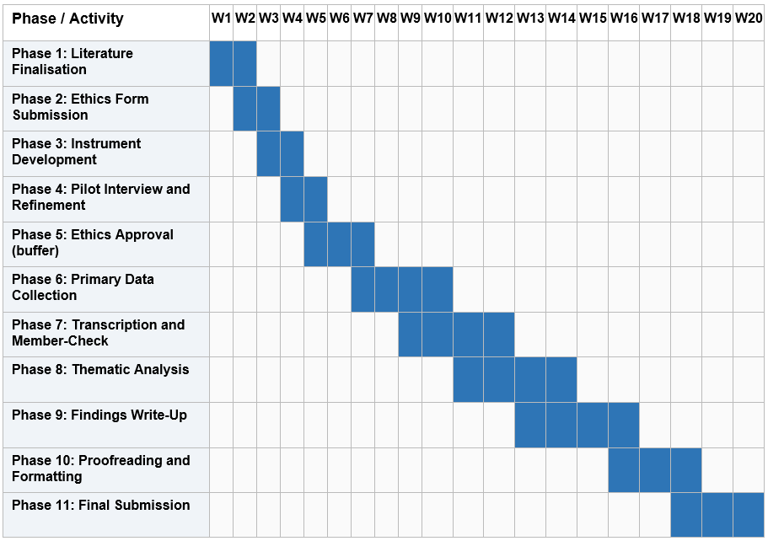
Table 3: Research Gantt Chart (Self-made)
Word Count: 5197

Reference List
- Ahmad, M. and Wilkins, S. (2024) 'Purposive sampling in qualitative research: a framework for the entire journey', Quality & Quantity, 59(2). doi:https://doi.org/10.1007/s11135-024-02022-5.
- Ariza-Montes, A., Arjona-Fuentes, J.M., Han, H. and Law, R. (2018) 'Work environment and well-being of different occupational groups in hospitality: Job Demand–Control–Support model', International Journal of Hospitality Management, 73, pp.1–11. doi:https://doi.org/10.1016/j.ijhm.2018.01.010.
- Baum, T., Mooney, S.K.K., Robinson, R.N.S. and Solnet, D. (2020) 'COVID-19's impact on the hospitality workforce – new crisis or amplification of the norm?', International Journal of Contemporary Hospitality Management, 32(9). doi:https://doi.org/10.1108/ijchm-04-2020-0314.
- Bergami, M. and Bagozzi, R.P. (2000) 'Self-categorization, affective commitment and group self-esteem as distinct aspects of social identity in the organization', British Journal of Social Psychology, 39(4), pp.555–577.
- Braun, V. and Clarke, V. (2006) 'Using thematic analysis in psychology', Qualitative Research in Psychology, 3(2), pp.77–101. doi:https://doi.org/10.1191/1478088706qp063oa.
- Braun, V. and Clarke, V. (2019) 'Reflecting on reflexive thematic analysis', Qualitative Research in Sport, Exercise and Health, 11(4), pp.589–597. doi:https://doi.org/10.1080/2159676X.2019.1628806.
- Braun, V. and Clarke, V. (2022) 'Toward good practice in thematic analysis: avoiding common problems and be(com)ing a knowing researcher', International Journal of Transgender Health, 24(1), pp.1–6. doi:https://doi.org/10.1080/26895269.2022.2129597.
- British Psychological Society (2021) Code of Human Research Ethics. Leicester: The British Psychological Society. Available at: https://www.bps.org.uk/sites/www.bps.org.uk/files/Policy/Policy%20-%20Files/BPS%20Code%20of%20Human%20Research%20Ethics.pdf.
- Bryman, A. (2016) Social Research Methods. 5th edn. Oxford: Oxford University Press.
- Chung, B.G., Ehrhart, K.H., Shore, L.M., Randel, A.E., Dean, M.A. and Kedharnath, U. (2020) 'Work group inclusion: test of a scale and model', Group & Organization Management, 45(1), pp.75–102. doi:https://doi.org/10.1177/1059601119839858.
- Creswell, J.W. and Poth, C.N. (2018) Qualitative Inquiry and Research Design: Choosing Among Five Approaches. 4th edn. Los Angeles: Sage Publications.
- Cropanzano, R., Bowen, D.E. and Gilliland, S.W. (2007) 'The management of organizational justice', Academy of Management Perspectives, 21(4), pp.34–48. doi:https://doi.org/10.5465/amp.2007.27895338.
- De Simone, S., Menatta, P. and Borgogni, L. (2024) 'Organizational Diversity and Inclusion Scale (ODIS): a multilevel approach', European Review of Applied Psychology, 74(5), p.101009. doi:https://doi.org/10.1016/j.erap.2024.101009.
- Deloitte (2023) Inclusive or Isolated? New DEI Considerations When Working from Anywhere. Available at: https://www.deloitte.com/us/en/insights/topics/diversity-equity-inclusion/diversity-and-inclusion.html.
- Denzin, N.K. and Lincoln, Y.S. (2011) The SAGE Handbook of Qualitative Research. 4th edn. Thousand Oaks: Sage Publications.
- Dodgson, J.E. (2019) 'Reflexivity in qualitative research', Journal of Human Lactation, 35(2), pp.220–222. doi:https://doi.org/10.1177/0890334419830990.
- Dwertmann, D.J.G., Nishii, L.H. and van Knippenberg, D. (2016) 'Disentangling the fairness & discrimination and synergy perspectives on diversity climate', Journal of Management, 42(5), pp.1136–1168. doi:https://doi.org/10.1177/0149206316630380.
- Equalities and Human Rights Commission (2023) Our Workforce Diversity Report 2023 to 2024. Available at: https://www.equalityhumanrights.com/about-us/transparency-and-corporate-reporting/our-workforce-diversity-report-2023-2024.
- Fair Work Convention (2024) Hospitality Industry Inquiry. Available at: https://fairworkconvention.scot/hospitality-industry-inquiry/.
- Ferdman, B.M., Prime, J. and Riggio, R.E. (2020) Inclusive Leadership: Transforming Diverse Lives, Workplaces, and Societies. New York: Routledge.
- Ferrazza, A. (2025) 'Beyond compliance: investigating the motivational power of equality, diversity and inclusion (EDI) in European hospitality', ICHRIE Research Reports, 10(6). doi:https://doi.org/10.61701/556443.208.
- Fitriana, R. (2023) 'Cultivating inclusivity: a comprehensive study of diversity, inclusion initiatives and employee satisfaction', Journal of Administrative and Business Studies, 9(3). doi:https://doi.org/10.20474/jabs-9.3.2.
- Fogle, E.V., Min, H. (Kelly) and Zhang, J. (2025) 'Enhancing diversity, equity, and inclusion in hospitality and tourism education: key attributes and strategic implementation', Journal of Hospitality & Tourism Education, pp.1–14. doi:https://doi.org/10.1080/10963758.2025.2533836.
- Gehrels, S. and Suleri, J. (2016) 'Diversity and inclusion as indicators of sustainable human resources management in the international hospitality industry', Research in Hospitality Management, 6(1), pp.61–67. doi:https://doi.org/10.2989/rhm.2016.6.1.8.1296.
- GOV.UK (2010) Equality Act 2010. Available at: https://www.legislation.gov.uk/ukpga/2010/15/contents.
- Goyal, A. (2025) 'Diversity and inclusion in recruitment practices: an empirical analysis of organizational commitment, efficacy, and psychological barriers', International Journal of Research Publication and Reviews, 6(12), pp.2197–2207. doi:https://doi.org/10.55248/gengpi.06.1225.4139.
- Gwele, N.S. (2009) 'Diversity management in the workplace: beyond compliance', Curationis, 32(2). doi:https://doi.org/10.4102/curationis.v32i2.899.
- Hussein, S. (2022) 'Employment inequalities among British minority ethnic workers in health and social care at the time of Covid-19: a rapid review of the literature', Social Policy and Society, 21(2), pp.316–330. doi:https://doi.org/10.1017/s1474746421000841.
- ICO (2023) UK GDPR Guidance and Resources. Available at: https://ico.org.uk/for-organisations/uk-gdpr-guidance-and-resources/.
- Janta, H., Ladkin, A., Brown, L. and Lugosi, P. (2011) 'Employment experiences of Polish migrant workers in the UK hospitality sector', Tourism Management, 32(5), pp.1006–1019. doi:https://doi.org/10.1016/j.tourman.2010.08.013.
- Jonsen, K., Tatli, A., Özbilgin, M.F. and Bell, M.P. (2013) 'The tragedy of the uncommons: reframing workforce diversity', Human Relations, 66(2), pp.271–294. doi:https://doi.org/10.1177/0018726712466575.
- Kalev, A., Dobbin, F. and Kelly, E. (2006) 'Best practices or best guesses? Assessing the efficacy of corporate affirmative action and diversity policies', American Sociological Review, 71(4), pp.589–617. doi:https://doi.org/10.1177/000312240607100404.
- Kallio, H., Pietilä, A.-M., Johnson, M. and Kangasniemi, M. (2016) 'Systematic methodological review: developing a framework for a qualitative semi-structured interview guide', Journal of Advanced Nursing, 72(12), pp.2954–2965. doi:https://doi.org/10.1111/jan.13031.
- Koç, D.E., Solanas, J., Dağıstan, S.Y. and Arici, H.E. (2025) 'Diversity, equity, and inclusion in the hospitality and tourism workplace: a quantitative systematic literature review', International Journal of Hospitality Management, 128, p.104171. doi:https://doi.org/10.1016/j.ijhm.2025.104171.
- Kochikunnel, A. and Benty, N.M. (2025) 'Understanding diversity, equity, and inclusion (DEI): employee impact on social sustainability, and implementation challenges', International Scientific Journal of Engineering and Management, 04(09), pp.1–9. doi:https://doi.org/10.55041/isjem.eseh033.
- Liu, S., Hao, F. and Qiu, X. (2025) 'Diversity, equity, and inclusion (DEI) research in tourism and hospitality: insights from bibliometric analysis', International Journal of Contemporary Hospitality Management. doi:https://doi.org/10.1108/ijchm-11-2024-1638.
- Lucas, R.E. (2019) 'Hospitality industry employment: emerging trends', International Journal of Contemporary Hospitality Management, 5(5). doi:https://doi.org/10.1108/09596119310046925.
- Manoharan, A., Madera, J.M. and Singal, M. (2023) 'Diversity, equity, and inclusion management in the hospitality industry', in Routledge eBooks, pp.3–7. doi:https://doi.org/10.4324/9781003285687-2.
- Men, L.R., Thelen, P.D. and Qin, Y.S. (2024) 'The impact of diversity communication on employee organizational identification and employee voice behaviors: a moderated mediation model', Public Relations Review, 50(4), p.102492. doi:https://doi.org/10.1016/j.pubrev.2024.102492.
- Mistry, T.G., Okumus, F. and Orlowski, M. (2021) 'Employee perceptions of diversity management in the hospitality industry', International Hospitality Review, 37(2). doi:https://doi.org/10.1108/ihr-05-2021-0041.
- Mohammadi, Z., Bhati, A. and Ng, E. (2022) '20 years of workplace diversity research in hospitality and tourism: a bibliometric analysis', Equality, Diversity and Inclusion: An International Journal. doi:https://doi.org/10.1108/edi-02-2022-0046.
- Mor-Barak, M.E. (2022) Managing Diversity: Toward a Globally Inclusive Workplace. 5th edn. Los Angeles: Sage Publications.
- Nishii, L.H. (2013) 'The benefits of climate for inclusion for gender-diverse groups', Academy of Management Journal, 56(6), pp.1754–1774. doi:https://doi.org/10.5465/amj.2009.0823.
- Nkomo, S.M., Bell, M.P., Roberts, L.M., Joshi, A. and Thatcher, S.M.B. (2019) 'Diversity at a critical juncture: new theories for a complex phenomenon', Academy of Management Review, 44(3), pp.498–517. doi:https://doi.org/10.5465/amr.2019.0103.
- Noon, M. (2017) 'Pointless diversity training: unconscious bias, new racism and agency', Work, Employment and Society, 32(1), pp.198–209. doi:https://doi.org/10.1177/0950017017719841.
- Nowell, L.S., Norris, J.M., White, D.E. and Moules, N.J. (2017) 'Thematic analysis: striving to meet the trustworthiness criteria', International Journal of Qualitative Methods, 16(1). doi:https://doi.org/10.1177/1609406917733847.
- ONS (2024) Labour Force Survey Annual Tables 2023. Available at: https://www.gov.uk/government/statistics/labour-force-survey-annual-tables-2023 [Accessed 25 March 2026].
- Ozturk, M.B., Rumens, N. and Tatli, A. (2024) 'Diversity and inclusion practitioners and non-binary employees in the UK: a Bourdieusian analysis', International Journal of Human Resource Management, pp.1–22. doi:https://doi.org/10.1080/09585192.2024.2305377.
- Park, C.H., Park, S. and Kwon, B. (2025) 'Forty-five years of research on diversity, equity and inclusion in management', Management Decision, 63(13), pp.66–95. doi:https://doi.org/10.1108/md-11-2023-2181.
- Parker, P.S. (2004) Race, Gender, and Leadership. New York: Psychology Press.
- Ponting, S.S.-A. and Dillette, A. (2023) 'Diversity, equity, and inclusion practices: a Delphi study to build a consensus in hospitality and tourism organizations', International Journal of Contemporary Hospitality Management, 35(11). doi:https://doi.org/10.1108/ijchm-11-2022-1503.
- Poquiz, M.R., Hassan, R. and Ahmed, S. (2023) 'Gender diversity management practices in the hotel industry: an analysis of Philippine hotel industry', International Journal of Management Thinking, 1(1), pp.41–50. doi:https://doi.org/10.56868/ijmt.v1i1.12.
- Pressman, R., Kornbluth, S. and Cochrane, G. (2018) 'Managing implicit bias with diversity and inclusion', SSRN Electronic Journal. doi:https://doi.org/10.2139/ssrn.4264898.
- Randel, A.E., Galvin, B.M., Shore, L.M., Ehrhart, K.H., Chung, B.G., Dean, M.A. and Kedharnath, U. (2018) 'Inclusive leadership: realizing positive outcomes through belongingness and being valued for uniqueness', Human Resource Management Review, 28(2), pp.190–203. doi:https://doi.org/10.1016/j.hrmr.2017.07.002.
- Roberson, Q.M. (2019) 'Diversity in the workplace: a review, synthesis, and future research agenda', Annual Review of Organizational Psychology and Organizational Behavior, 6(1), pp.69–88. doi:https://doi.org/10.1146/annurev-orgpsych-012218-015243.
- Rosenzweig, E.D., Kelley, K. and Bendoly, E. (2024) 'Diversity in frontline employee perceptions: policies and procedures, training, and leadership as drivers of service equality', Production and Operations Management. doi:https://doi.org/10.1177/10591478241252150.
- Saito, H., Brozović, D. and Baum, T. (2024) 'Well-being of hospitality employees: a systematic literature review', International Journal of Hospitality Management, 124, p.103955. doi:https://doi.org/10.1016/j.ijhm.2024.103955.
- Sakdiyakorn, M. and Wattanacharoensil, W. (2017) 'Generational diversity in the workplace: a systematic review in the hospitality context', Cornell Hospitality Quarterly, 59(2), pp.135–159. doi:https://doi.org/10.1177/1938965517730312.
- Saunders, M., Lewis, P. and Thornhill, A. (2019) Research Methods for Business Students. 8th edn. Harlow: Pearson.
- Shehawy, Y. and Abouzied, F. (2022) 'The impact of Covid-19 pandemic crisis on tourism industry: current issues in tourism employment', International Journal of Tourism and Hospitality Management, 5(1), pp.106–136. doi:https://doi.org/10.21608/ijthm.2022.239639.
- Shore, L.M., Randel, A.E., Chung, B.G., Dean, M.A., Holcombe Ehrhart, K. and Singh, G. (2011) 'Inclusion and diversity in work groups: a review and model for future research', Journal of Management, 37(4), pp.1262–1289. doi:https://doi.org/10.1177/0149206310385943.
- Showkat, M. and Yahya, A.T. (2025) 'The backlash effect: how diversity, equity, and inclusion programs influence employee engagement and organizational commitment', Cogent Business & Management, 12(1). doi:https://doi.org/10.1080/23311975.2025.2598192.
- Silverman, D. (2017) Doing Qualitative Research. 5th edn. London: Sage.
- Squire, C.M., Giombi, K.C., Rupert, D.J., Amoozegar, J. and Williams, P. (2023) 'Determining appropriate sample size for qualitative interviews: code saturation', Journal of Medical Internet Research, 26. doi:https://doi.org/10.2196/52998.
- UK Hospitality (2024) Hospitality Workforce Strategy. Available at: https://www.ukhospitality.org.uk/work/hospitality-workforce-strategy/.
- Wang, M.L., Gomes, A., Luiza, M., Copeland, P. and Santana, V.M. (2023) 'A systematic review of diversity, equity, and inclusion and antiracism training studies: findings and future directions', Translational Behavioral Medicine, 14(3), pp.156–171. doi:https://doi.org/10.1093/tbm/ibad061.

Appendix
The following questions are indicative. All interviews will be preceded by a verbal briefing, a review of the Participant Information Sheet, and written consent confirmation. Questions will be adapted contextually during each conversation.
Table A1: Interview Guide
Section | Interview Question | Research Question Link
Opening | Could you describe your current role and how long you have worked in this organisation? | Contextual -- all RQs
DEI Awareness | Does your organisation have a diversity, equity, and inclusion policy or programme? If so, how does it show up in your day-to-day work? | RQ1
Fairness Perceptions | Do you feel that employees are treated fairly regardless of their background in your workplace? Could you give a specific example? | RQ1, RQ2
Identity Experience | Have there been times when your background -- such as your ethnicity, gender, or where you are from -- has affected how you are treated at work? | RQ2
Inclusion Climate | Would you say your team or work group is a place where people feel free to be themselves? What makes you say that? | RQ2, RQ3
Supervisory Behaviour | How would you describe the way your manager or supervisor handles issues related to fairness and inclusion within your team? | RQ3
Policy vs. Reality | In your view, is there a difference between what your organisation says it does about diversity and inclusion and what actually happens in practice? | RQ1, RQ4
Closing | Is there anything else about your experience of diversity and inclusion in this organisation that you would like to share? | All RQs
Source: Author's own design. Questions are indicative; probes will be developed contextually during each interview.

