University of Wales Trinity Saint David

Wales Institute of Science & Art

Electronic Ignition & Fuel Injection Systems
ACHA4010

Dylan Joseph Arthur
2004556
April 2022
Contents
1.Introduction 3
2. An introduction to LE3 and Motronic systems. 4
2.1 Bosch LE3. 4
2.2 Bosch Motronic. 4
3. Testing Process. 5
3.1 Health and Safety. 5
3.2 Testing equipment chosen. 5
3.3 Testing Procedure. 6
3.3.1 LE3 Testing. 6
3.3.2 Motronic Testing. 6
4. Results. 7
4.1 LE3 sensor readings. 7
4.2 Motronic Sensor Readings. 10
4.3 Waveform Analysis and Comparison. 14
4.3.1 Fuel Injector signal 14
4.3.2 Spark and Ignition signal 15
4.2.3 Crankshaft sensor signal 16
4.2.4 Lambda signal. 17
17
4.2.5 Rotary Idle Valve. 18
5. Improvements 19
5.1 Diagnostics and engine management improvements. 19
5.2 Sensor Improvements 19
6. Conclusion. 21
7. References. 22
7.1 References 23
7.2 References. 24

1.Introduction
A modern vehicle utilizing an internal combustion engine must be adaptive to a multitude of different operating conditions, these include different ambient and engine temperatures, and loads placed on the engine. Much of these variables are adapted to by adjusting the spark duration and the injection on time of the engine, as well as many other methods, accordingly, to allow the engine to operate as smooth and efficiently as possible even in challenging conditions. Many of these variables will be investigated in depth throughout this report, looking at data values and also voltage waveforms gathered during practical testing of Bosch Motronic and Bosch LE3 engine control systems on Vauxhall engines. These systems and the readings taken when testing can then be compared to one another, detailing how the various engine management systems affect their efficiency, economy and emissions and explain how these systems can be modernised to improve these factors and which particular changes can be made to the systems to do so. The individual sensors will also be analysed, assessing their functions and how they act to make specific changes on the engine when exposed to different operating conditions.

2. An introduction to LE3 and Motronic systems.

2.1 Bosch LE3.
The LE3 Jetronic system is an electronic control unit used primarily in gasoline injection engines from 1989-1991, it is a simplified version of the L Jetronic system and is split into two electronic control units, the first of which controls the fuelling of the engine and the second controls the ignition and spark advance required for the engine. The LE3 system being tested uses a vane type mass air flow sensor to measure air flow into the engine and adjust fuelling to maintain the correct air to fuel ratio. The position of the vane is controlled by the quantity of airflow and a position sensor at the base of the vane provides a signal of the air flow quantity which then adjusts fuelling and supplies just the right amount fuel for the optimal air to fuel. When combined with an air temperature sensor just before the air flow sensor, the air density and therefore oxygen content of the air can be detected which also affects the quantity of fuel injected to improve air fuel ratio (Engineering Explained, 2012).

2.2 Bosch Motronic.
The Bosch Motronic system combines both the fuel supply and ignition control into one unit, allowing for precise control over the air fuel ratio and also the ignition and combustion of the mixture to optimise economy, reduce emissions and improve performance output. With the addition of a Lambda sensor and Lambda control unit in the system the emissions control is far superior to that of the LE3 (Bosch, R. 2000). The Motronic 4.1 system being assessed also uses a vane type air mass meter and air temperature sensor to calculate fuel requirements and shares many other sensor types with the Bosch LE systems. One key difference to the LE3 is that It is also compatible with the first generation of on-board diagnostics (OBD), which regularly examines signals from engine sensors and logs code for when a fault is present, this fault can then be identified through the use of an OBD code reader.

3. Testing Process.

3.1 Health and Safety.
Before starting the testing procedure on the LE3 and Motronic systems health and safety must be assessed as testing a running engine can be dangerous if not correctly prepared and safe working practices are not considered. Some health and safety measures that need to be considered for testing can be seen in Table 1 below.
Table 1 – Heath and Safety risk assessment.
Hazard | How to prevent hazard and reduce risk of injury. | Risk of occurring (1=low,5=high)
Heavy objects falling. | -Ensure all test equipment is securely placed.  -Wear steel toe footwear at all times. | 2
Loose items or clothing being caught in moving engine components. | -Do not reach over engine while running.  -Remove any loose items i.e. ties, lanyards etc and wear lab coats at all times. | 2
Coolant or fuel line bursting. | -Check all connections and lines are in good working condition before testing.  -Do not stand too close to engine while running.  -wear lab coats and safety goggles at all times. | 1
Burning on hot engine components. | -Keep hands away from exhaust and other engine components that will get hot throughout the testing procedure. | 3
Carbon Monoxide exposure when testing engine indoors. | -Keep ventilation pipe turned on and clamped onto exhaust at all times while engine is running.  -Open a door to provide some ventilation if possible. | 2

3.2 Testing equipment chosen.
The equipment chosen to use to complete the first tests which involves testing various contacts on the control system such as ECU pins, injectors, rotary idle valve and other sensors when the engine was on and off and for this a digital Multimeter was used. The digital multimeter was chosen for its fast and accurate reading of voltage, current and resistance values over a large size range which made testing the various voltages and resistances very efficient. The next tests involving looking at and analysing scope patterns for spark duration, injector on time and a range of other values that will be explained in detail in the experimental procedure section. For measuring the voltage and reading the scope pattern the Bosch FSA 700 series measuring system was used. This was chosen because it uses a 2-channel oscilloscope with a 50ms sample rate (Bosch, n.d.) and a variety of other testing equipment all in one, also with a screen to make reading and comparing scope patterns very fast and efficient. These two pieces of equipment made the testing process accurate and easily reproducible.

3.3 Testing Procedure.

3.3.1 LE3 Testing.
With equipment and safety considered the testing procedure could begin. The first system tested was the LE3 system when cold and with the ignition off, taking voltage readings using the multimeter from each pin on the Ignition ECU, Fuel ECU, and amplifier, this was then repeated with the ignition on and noted down all values. The next test on the LE3 system involved testing some resistances from various contacts around the engine using the multimeter. These included the throttle switch, Auxiliary air valve and Injectors. One thing to keep in mind when testing resistances is to measure the resistance in the wires first, in this case it was 0.2 Ohms therefore this is to be subtracted from every value to give the true resistance. The only other resistance values required are those of the NTC2 which is a dynamic test, starting from cold (20°C) and measuring in 10°C increments up to 60°C which can be completed after the engine has been started. To measure engine temperature the dipstick was removed and replaced with the temperature probe on the measuring system.
With all of the cold tests completed the engine could be cranked for the first time, looking first at the waveform of injector on time during cold start to see how the injector on time is adapted to turn over the engine in cold conditions. With this fuel time value recorded the NTC2 tests can begin, taking resistance and voltage readings at pin 8 and time readings at pin 3 from 20°C to 60°C in 10°C intervals.

3.3.2 Motronic Testing.
Moving onto the Motronic system the same voltage readings were gathered using the multimeter across all pins 1-55 with ignition off and then ignition on, due to the Motronic only using one ECU and no separate amplifier the only other voltage readings required are that of the battery. Next the resistance measurements could be gathered using the multimeter from the components on the engine, for the Motronic system these include the throttle potentiometer at the different terminals when throttle is closed or fully open, Air flow sensr, idle speed control valve, injectors, Lambda sensor, and the rotary idle valve.
Once again after the resistance and voltage values were recorded the cold crank and NTC2 tests could begin. Cranking the engine from cold and inspecting the injector waveform to see the on time during cold start and analysing the on time as the engine warmed up, then similarly to the LE3 the NTC2 readings were gathered starting at 20°C to 80°C in 10°C increments, taking voltage and resistance readings from pin 45, speed from pin 16, % from pin 4, on/off status from pin 5 and switching status from pin 28.

4. Results.

4.1 LE3 sensor readings.
Table 2 – LE3 Ignition ECU Voltage readings.
Pin | Off (V) | On (V)
Battery | 12.27 | 12.27
1 | 0 | 0.06
2 | 0 | 12.11
3 | 0 | 0
4 | 0 | 0.02
5 | 0 | 0.03
6
7
8 | 0 | 0.67
9 | 0 | 0
10 | 0 | 0.15
11
12 | 0 | 12.15
13
14 | 0 | 4.98
15 | 0 | 0.02
Table 3 – LE3 Fuel ECU Voltage readings.
Pin | Off (V) | On (V)
1 | 0 | 0.03
2 | 0 | 0.03
3 | 0 | 12.02
4
5 | 0 | 0.06
6 | 0 | 0.02
7 | 0 | 1.11
8 | 0 | 0.94
9
10 | 0 | 0.03
11 | 0 | 0.03
12 | 0 | 0.06
13 | 0 | 0.13
14 | 0 | 4.98
15 | 0 | 0.15
Table 4 – LE3 Amplifier Voltage readings.
Pin | Off (V) | On (V)
1 | 0 | 12.02
2 | 0 | 0.02
3 | 0 | 12.02
4 | 0 | 0.13
The Ignition ECU when the ignition is on the only pins shown to be a closed circuit and therefore turned on are pin 2 (Amplifier), pin 12 (Fuel ECU terminal 10), and pin 14 (Throttle Switch Terminal 3). The Amplifier is powered because it is used to convert the signal from the distributor into a signal capable of inducing high tension in the coils (pistonheads, 2009), even though the circuit is complete no current is applied until the coil is pulsed to earth by the amplifier (Equiptech, n.d.). Pin 12 shows 12V because it is the voltage supply to the Fuel ECU. Pin 14 reads 5V with ignition on because that is the supplied voltage to the sensor which due to changes in resistance returns different voltage values, often 4.5V at full load and 0.7V at idle for example (Autoditex, n.d.). This then communicates the throttle position back to the ECU. The amplifier reads 0V when off and 12V at pins 1 and 3 when ignition is on, pins 1 and 4 show if the injectors are switched on or off and pins 2 and 3 are the earth and supply of the amplifier.

The next data is that collected through the component tests and can be seen in table 5 below
Table 5 – LE3 Component resistance readings.
Component | Recommended Reading (Ω). | Measured Reading (Ω).
Throttle switch (2&18) | 0 | 0.2
Throttle switch (3&18) | INF | INF
Auxiliary Air Valve | 40 | 45.7
Injector 1 | 15-17 | 15.7
Injector 2 | 15-17 | 15.6
Injector 3 | 15-17 | 15.6
Injector 4 | 15-17 | 15.7

The Resistance readings show that all components tested lie within or close to the manufacturer recommended values provided, the only value reading higher is the auxiliary air valve. Although this reading isn’t hugely off, as the Auxiliary air valve adapts the quantity of air depending on temperature which helps to keep air-fuel mixture optimal, a small discrepancy may cause uneven running of the engine if the Auxiliary air device is performing incorrectly (Bosch, 1982). During the tests however the engine started, idled, and ran fine with no misfiring or hesitation showing that this resistance reading of 45.7 Ohms is okay. All other readings lie within manufacturer tolerances to give readings as expected.

Table 6 – LE3 NTC2 Dynamic test results.
Engine Temperature (°C) | Resistance – pin 8 (Ω) | Voltage – pin 8 (V) | Time – pin 3 (ms)
20 | 1940 | 1.7 | 3.7
30 | 1018 | 1.2 | 3.1
40 | 762 | 0.9 | 3.0
50 | 500 | 0.7 | 2.7
60 | 375 | 0.5 | 2.6
The results from the NTC2 test can be seen above and show the expected relationship between resistance and temperature. The negative temperature coefficient (NTC) sensors work by using a thermistor made from ceramic and metal composite material which specifically decreases its electrical resistance with an increase in temperature (Emerson, 2018). This change in resistance in turn alters the voltage return and relays the temperature of air back to the ECU, the relationship can be better seen in figure 1 below.
Figure 1 – LE3 NTC2 Resistance & voltage against temperature
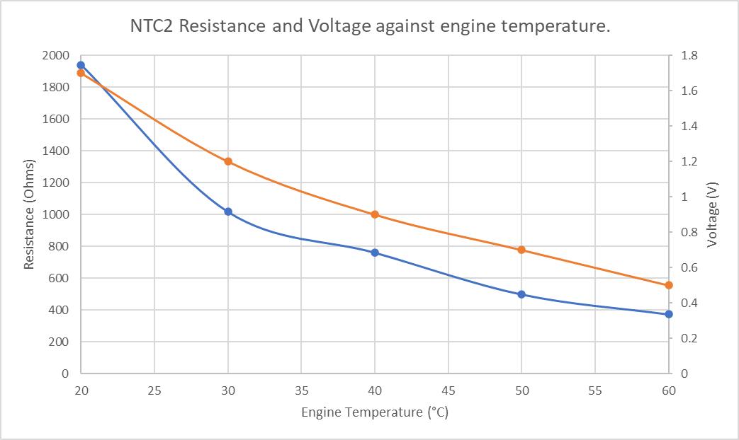

4.2 Motronic Sensor Readings.
Pin | Off | On
1 | 0 | 12.63
2 | 0 | 0.02
3 | 0 | 12.48
4 | 0 | 10.02
5 | 0 | 12.38
6 | 0 | 11.68
7 | 0 | 0.3
10 | 0 | 0
12 | 0 | 5.04
13 | 0 | 10.34
14 | 0 | 0.02
16 | 0 | 12.29
17 | 0 | 12.29
18 | 12.88 | 12.3
19 | 0 | 0.02
22 | 0 | 0.9
24 | 0 | 0.02
26 | 0 | 0.05
27 | 0 | 12.34
28 | 0 | 0.45
32 | 0 | 11.55
36 | 12.34 | 0.28
37 | 0 | 12.26
40 | 0 | 0.05
41 | 0 | 0.05
42 | 0 | 0.02
44 | 0 | 3.5
45 | 0 | 1.17
46 | 0 | 0.11
48 | 0 | 0.05
49 | 0 | 0.1
53 | 0 | 0.62
55 | 0 | 11.22
Moving onto the Motronic sensor readings, although the system used is a 55-pin unit only 33 of the pins are used which is shown below.
Table 7 – Motronic ECU voltage readings.

The only two seen to be powered when ignition is off are pins 18 and 36, pin 18 is a permanent live for the memory and pin 36 is the control circuit for supply to the auxiliaries and ECU. One reading that a higher value would be expected is pin 45 which is the output from NTC2 which would be expected to be higher and closer to the voltage of the NTC1 output which is pin 44. This could either indicate an error made whilst measuring the voltage or that there is an error with the component that needs to be diagnosed.
Component | Recommended Resistance | Measured Resistance
Throttle potentiometer (1&2) | 1900-2000 | 2000
Throttle potentiometer (1&3) | 1000-2000 | 2580
Air flow sensor (4&2) | 8-2500 | 33.8
Air flow sensor (4&3) | 300-550 | 560
Rotary idle valve | 8 | 8.2
Injector 1 | 15-17 | 16.6
Injector 2 | 15-17 | 16.5
Injector 3 | 15-17 | 16.5
Injector 4 | 15-17 | 16.5
Moving on to the components test of the Motronic system the measured resistance compared to the recommended resistances can be seen below.
Table 8 – Motronic Component resistance readings.

There are some measured values that lie out of the recommended ranges for resistance, firstly the Throttle potentiometer when measured from pins 1&3 gave a reading 580 Ohms above the recommended range. Because it is a position sensor that relies on this aspect to give an accurate reading, an inaccurate resistance would lead to an inaccurate throttle position being relayed to the ECU, this could cause an issue with acceleration and idle. The air flow sensor at pins 4&3 is slightly high but all other values lie close to or within the recommended values, including the injectors all of which lie in spec.
The final test completed on the Motronic system before analysing the waveforms was to test the NTC2 sensor through the range of 20-80°C, also looking at the use of the lambda sensor which the LE3 system does not use. These readings are seen below.
Table 9 – Motronic NTC2 Dynamic test results.
Temperature (°C) | Pin 45 (Ohms) | Pin 45 (V) | Pin 16 (ms) | Pin 4 (%) | Pin 5 status | Pin 28 status
20 | 1954 | 3.3 | 3.3 | 45 | Off
30 | 1019 | 2.5 | 3.2 | 45 | Off | Switching
40 | 670 | 2.1 | 3.2 | 46 | Off
50 | 464 | 1.6 | 3.3 | 43 | On
60 | 320 | 1.2 | 2.6 | 43
70 | 239 | 1.0 | 3.2 | 45
80 | 218 | 1.0 | 3.1 | 44

Once again, the NTC2 sensor shows the expected relationship of decreasing resistance and voltage with an increase in engine temperature from pin 45, pin 16 shows a discrepancy with the injector on time where it seems to drop at 60°C compared to the rest of the values.
The value of 2.6ms is closer to what is expected compared to the other values up to 3.3ms which shows the engine to be running too rich, and it experienced running difficulties during these tests once again indicating a possible problem with the fuel management system. Some of the symptoms of a bad throttle position sensor are jerky and hesitant power delivery as well as running too rich (Wooten, D. 2016) which match those encountered during testing therefore this could be part of the problem. Another point to note is that the fan switched on at 70°C engine temperature.
Figure 2 – Motronic NTC2 resistance and voltage against temperature.
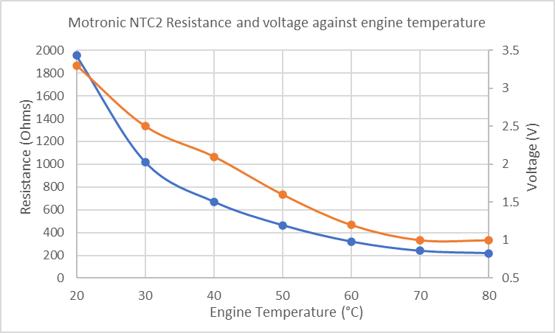

Figure 2 shows the expected patterns as detailed earlier and similar to those of the LE3 system with the only main difference being the steeper curve of resistance for the Motronic which is explained by the higher temperature of 80 vs 60 of the LE3 and that resistance has an exponential relationship with temperature in an NTC sensor.
Figures 1, 2, and 3 below show the difference in relationship between the LE3 and Motronic NTC2 tests and also compared to an example relationship between resistance and temperature. Both the LE3 and Motronic values recorded fit this pattern.

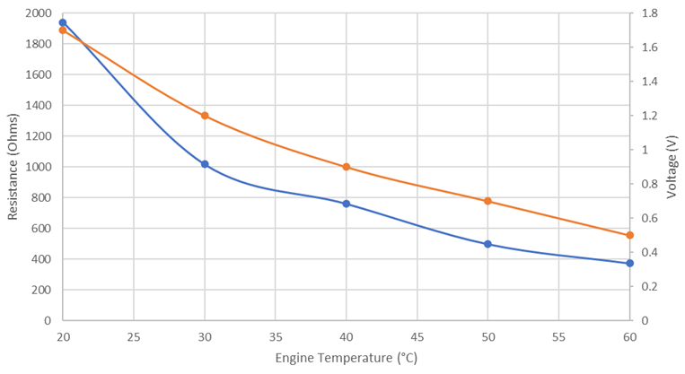
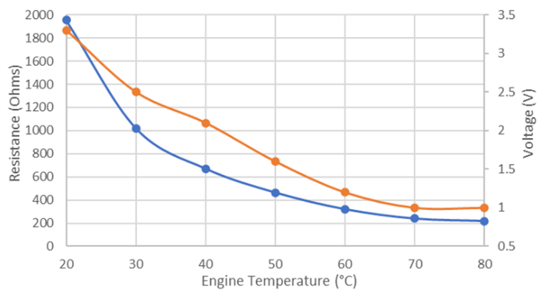
Figure 3 – Example NTC2 resistance and temperature relationship (Northstarsensors, n.d.)
Figure 2 – Motronic NTC2 Resistance & Voltage against temperature
Figure 1 – LE3 NTC2 resistance & voltage against temperature
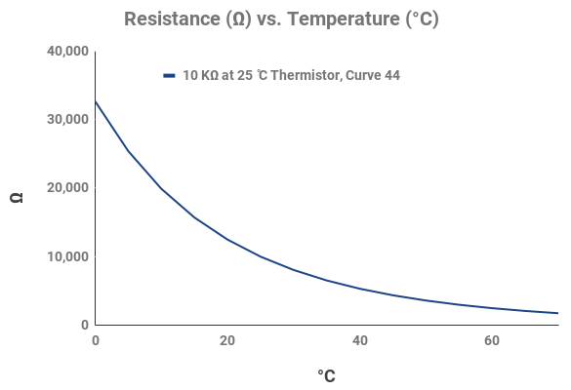

4.3 Waveform Analysis and Comparison.

4.3.1 Fuel Injector signal
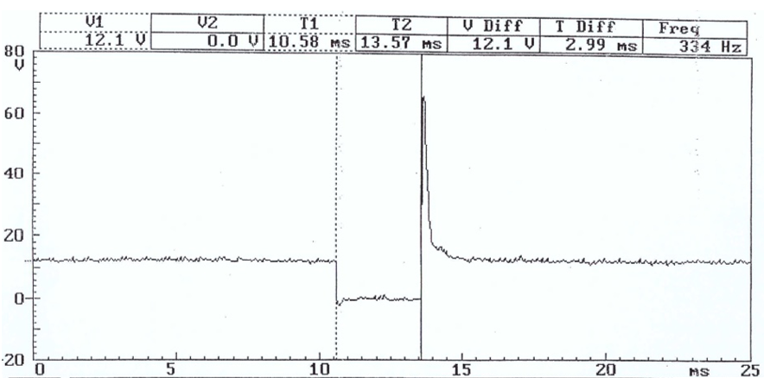
The first scope pattern investigated was that of the fuel injector from a cold start to see how the system adapts to start the vehicle from cold. The LE3 Injector on time when cranking the engine was found to be 75.3ms at an ambient temperature of 19.3°C, and the Motronic was found to be 28.8ms at 18.2°C.
Figure 5 – Motronic Injector idle waveform.
Figure 4 – LE3 Injector idle waveform.
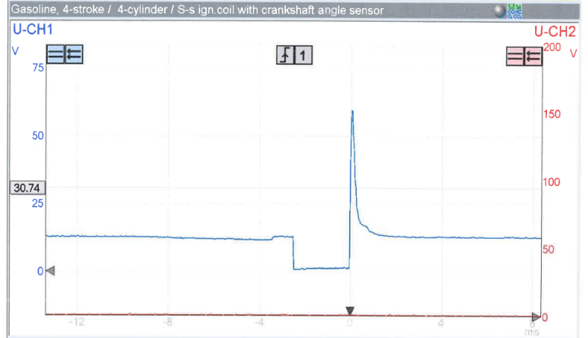
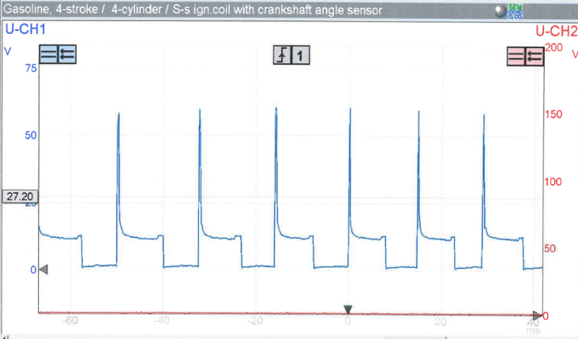
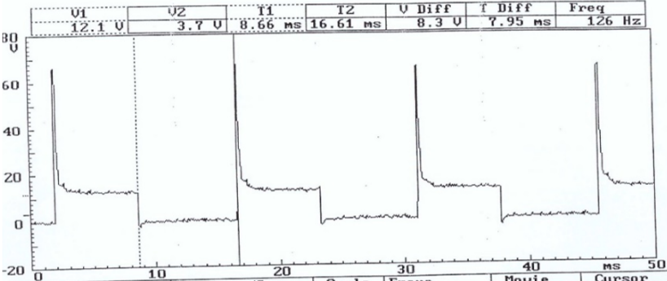
Example waveforms of the injectors of both engines at idle can be seen above, with the bottom section of the pattern being the injector on time where the injector is pulsing fuel after the transistor is on after the circuit is completed to ground. The voltage then spikes after the transistor is turned off and the small hump seen at the bottom of the spike is known as the ‘pintle hump’ where the injector pintle disrupts the magnetic field when passing through the solenoid winding when closing (Smith, S. 2001). When viewing the LE3 injector waveform as the engine warmed the on time quickly dropped after initial start-up and gradually decreased to a normal idle value of around 2.5-3ms, and a voltage spike of around 60V as can be seen in the pattern, With the Motronic idling at around 3ms on time and a spike of closer to 70V. When under acceleration the on time will greatly increase, up to almost 8ms for the Motronic and the frequency of injection pulsing increases also as engine speed increases, as shown in figures 5 and 6 below.
When decelerating not only does the on time greatly decrease but the voltage spike also decreases, instead reading around 55V for both systems, with a larger drop from the Motronic system. The on time decreases because when decelerating the throttle was closed and therefore the air flow detected by the Mass Air Flow sensor reaching the engine decreased greatly and to stop the engine running rich the fuel injected must decrease alongside it to keep a good air fuel ratio.
Figure 6 – Motronic Injector idle waveform.
Figure 5 – LE3 Injector accelerating waveform.

4.3.2 Spark and Ignition signal
Figure 7 – LE3 primary spark waveform.
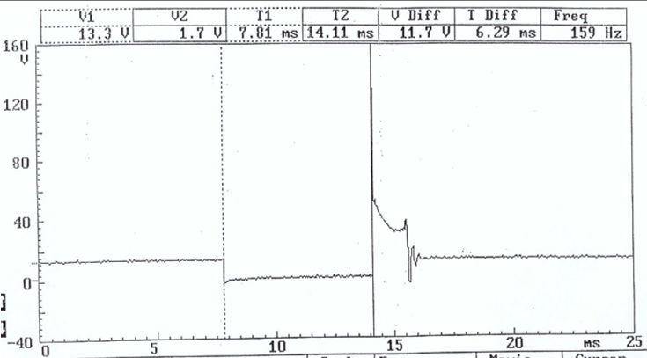
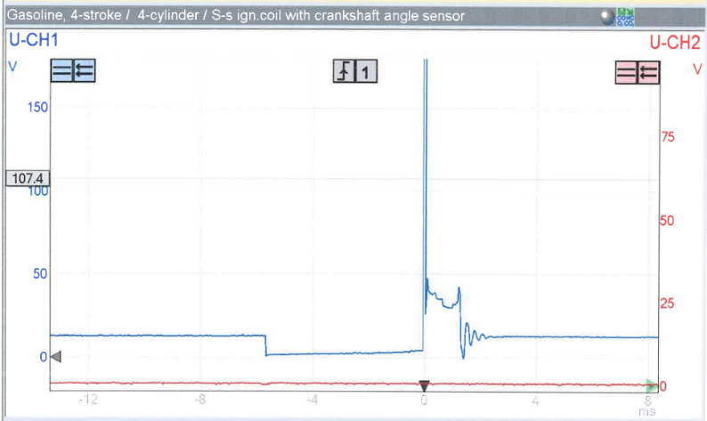
Figure 8 – Motronic primary spark waveform.

Figures 7 and 8 above show the scope pattern for the primary waveforms of both engines, The primary is the the lower section on both is the dwell time meaning it is the time period when electric current is applied to the coil to build up the maximum amperage and magnetic flux (Denso, 2021) before the spark is discharged and air-fuel mix ignited, the dwell time is seen to be just under 6ms for the LE3 and 6.29ms for the Motronic. The spike in voltage following this is the ‘back emf’ generated and opposes the direction of the flow of current, this works on Lenz’ law stating that a change in the magnetic environment in a coil will cause a voltage (EMF) to be induced (Collins, D. 2016). The back EMF recorded from the tests were 129.2V for the Motronic and the LE3 cannot be seen exactly as it went off the scale used but was clearly over 180V, indicating a higher current in the coil of the LE3 system. The section between the back EMF spike and the smaller second spike is the spark duration or burn time, this measured around 1.2ms for the LE3 system and 1.47ms for the Motronic system. The LE3 waveform also showed some turbulence during the burn time, this could be conditions within the cylinder such as compression or pressure (Thompson, B.C. 2005). The smaller second spike is the final amount of spark discharge at the end of the burn, this is followed by coil oscillations which is the energy left over in the coil (Markel, A. 2018).

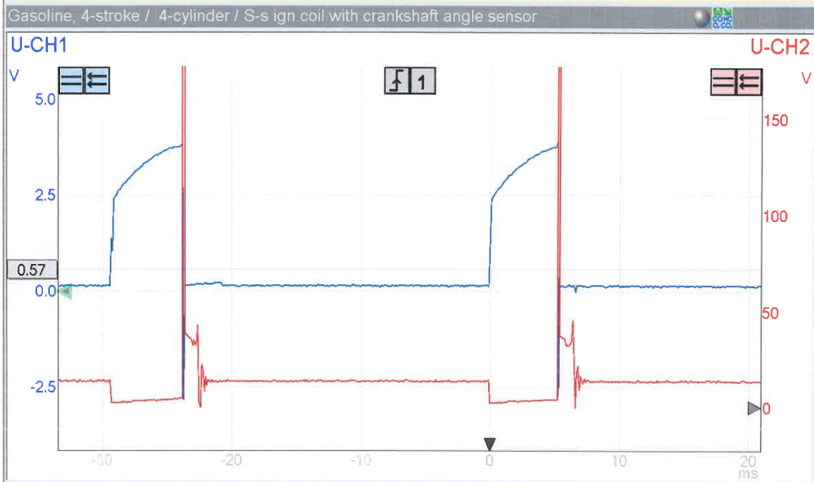
Figure 9 – LE3 spark advance and primary spark waveforms.

The next waveform investigated was the spark advance signal from the LE3 system which can be seen above and shows the spark advance signal when compared to the primary spark waveform. Spark advance is how much the spark comes before the piston is at top dead centre, measured usually in crankshaft rotation relative to top dead centre in degrees (Ribbens, W.B. 2017). The waveform shows the spark advance rise in line with the dwell time of the primary coil and drop at the start of the burn time when the spark has begun.

4.2.3 Crankshaft sensor signal
Figure 10 – Motronic crankshaft sensor waveform.
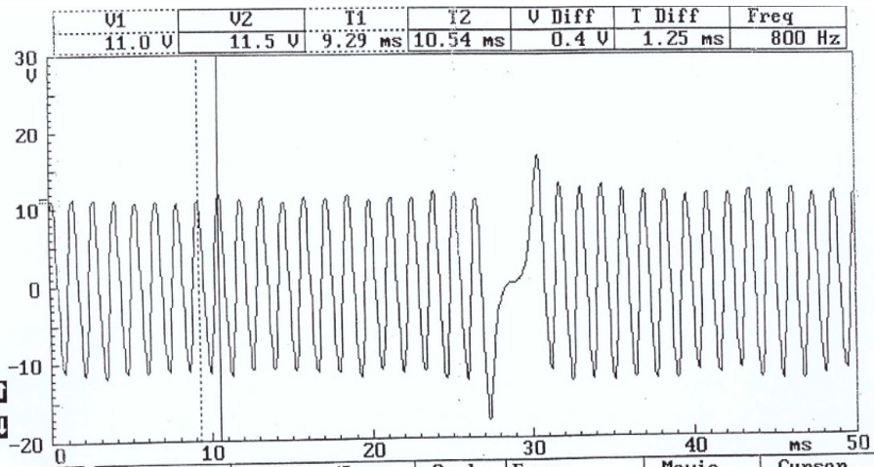

The next waveform investigated are the crankshaft signals, shown above is the crankshaft position sensor reading from the Motronic system, which uses the hall effect to read the crankshaft angle which in turns gives the position of the pistons in the bore allowing fuel and spark to be applied at the correct time (driving4answers, 2021). The sensor works in conjunction with a trigger wheel made of a ferrous metal with a missing tooth which when passing the sensor alters the signal and relays the crankshaft position back to the ECU and (Denso, n.d.).
This can be seen in the scope pattern with the regular wave pattern, and the change in pattern signifying the missing toothed section.

4.2.4 Lambda signal.
The function of the Lambda sensor Is to read and relay the oxygen content of the exhaust gases back to the ECU, this aids in maintaining as close to a stoichiometric air-fuel ratio as possible and stop the engine from running too rich or too lean. The LE3 system does not utilise a catalytic converter or a lambda sensor however the Motronic system tested does.
Figure 11 – Motronic Lambda sensor waveform.
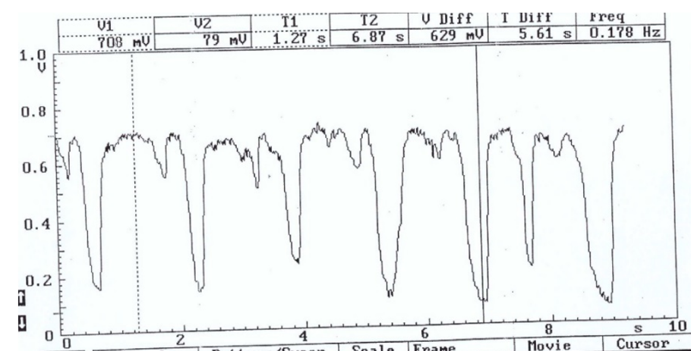

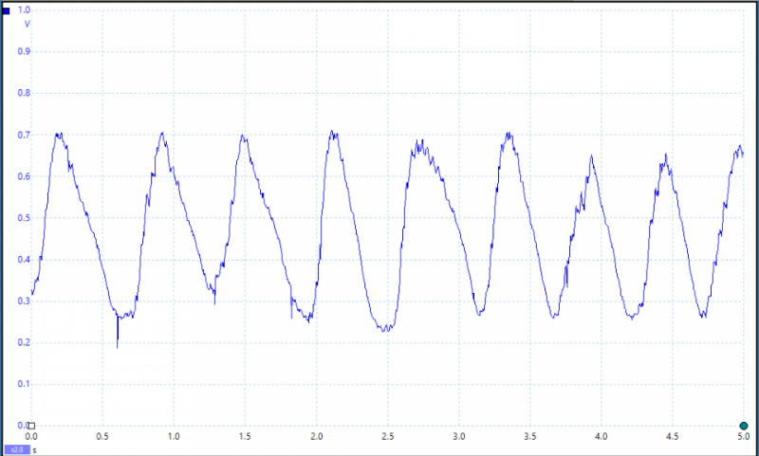
Figure 11 shows the voltage pattern of the Lambda sensor, with the fluctuations being small adjustments made to the air fuel ratio keeping it in an optimal range. The Lambda sensor was seen in testing to begin switching at 20-30°C engine temperature once it had become closed loop, it gave an output of approximately 0.1-0.8V with the lower values indicating a leaner mix and higher values indicating a richer mix (Bosch, 2018). The example waveform below shows the voltage output of a lambda sensor working correctly, the consistently higher readings of the Motronic sensor indicate the engine is running richer as the wave is not oscillating smoothly and averaging a higher value.
Figure 12 – Example Lambda sensor waveform, (picoauto, n.d.)

4.2.5 Rotary Idle Valve.
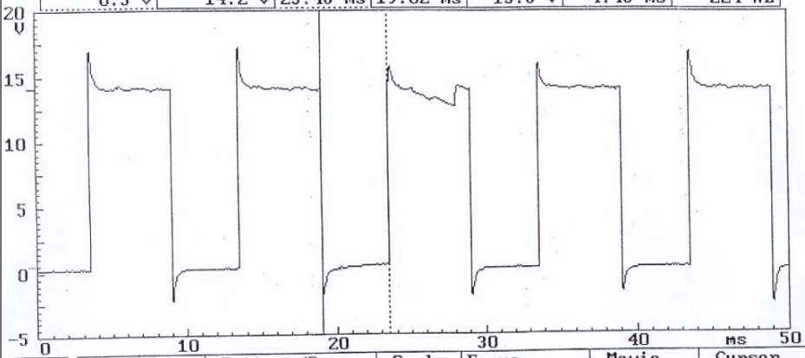
The rotary idle valve used on the Motronic system seen below is shown to be a cyclic pattern, switching between around 15V with short spikes up to around 17V and down to 0.5V with spikes down to around 3V. The cycling seen is it switching between battery positive (15V) and battery negative (0.5V) (Picauto, n.d.).
Figure 14 – Motronic rotary idle valve waveform.
Figure 13 – rotary idle valve example waveform (picoauto, n.d.)
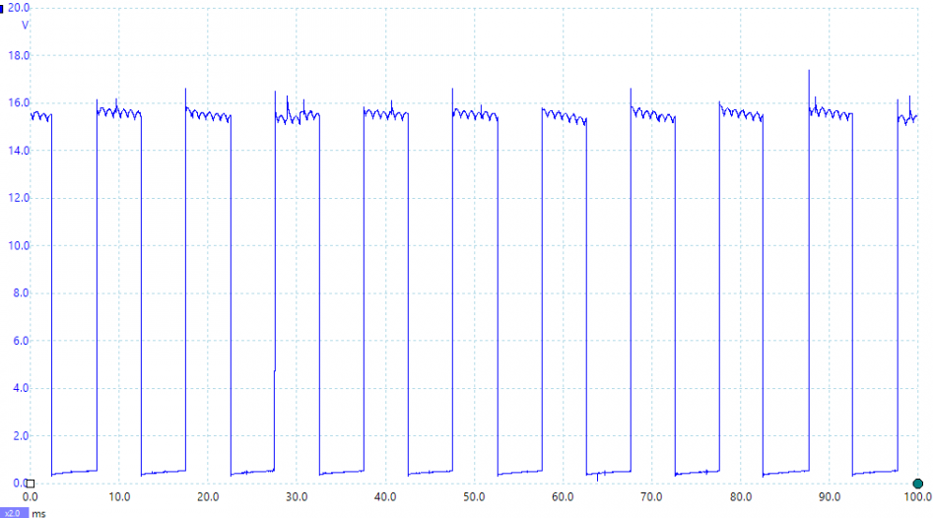
When compared to an example waveform of a rotary idle valve that is working correctly the Motronic matches it very closely showing it is functioning as intended and maintaining the idle at the desired rpm, with a full cycle taking around 10ms (Picauto, n.d.). The waveform was captured when the engine was idling at approximately 80°C.

5. Improvements

5.1 Diagnostics and engine management improvements.
Both fuel and ignition systems tested could be improved in many ways to improve their efficiency, fuel economy and emissions. Starting with the diagnostic aspect, the Motronic system uses the first generation On Board Diagnostics (OBD) to allow for easy reading of trouble codes and although it allows for useful diagnostic feedback it is heavily outdated when compared to the more modern OBD2 system which was mandated on new cars since 1996 starting in the United States (Klinedinst, D. King, C. 2016). Some improvements OBD2 has made over OBD1 include being able to monitor emission system malfunction, deterioration as well as component and electrical failures whereas OBD1 can only detect component and electrical failures (EPA, 2003). Another benefit of OBD2 is that it is standardised across manufacturers including both the plug as well as the trouble codes, whereas OBD1 often uses manufacturer specific plugs and trouble codes (Miller, T 2021). OBD2 also allows for real time viewing of diagnostic data allowing for very specific data analysis in particular scenarios. The LE3 system does not have any form of On Board Diagnostics so both LE3 and Motronic would benefit greatly from an upgrade to OBD2, which would make a significant difference to the diagnostic capabilites of the control system.
One aspect which is improved in the Motronic system but still could be improved on the LE3 is that the LE3 uses two separate Control Units to control the fuelling and ignition of the engine whereas the Motronic has both combined making the system much simpler and therefore making maintenance and diagnostics easier.

5.2 Sensor Improvements
The first sensor that could be improved is the Lambda sensor, The Motronic uses a Zirconium Lambda sensor which are the cheapest and most common Oxygen sensors used. Although they work well the accuracy and speed can be improved by upgrading to a wide band, or 5 wire, Lambda sensor which monitor the air-fuel ratio to a higher accuracy to improve efficiency and emissions control (NGK, 2014). A more expensive but further improvement on this would be to use a Titanium oxygen sensor, one large improvement with a titanium-based sensor is its lack of requirement for reference air meaning it is not susceptible to water content in the air or other contaminants like Zirconium sensors are (NGK, 2014). To add to this they are faster to feedback meaning they can provide even more effective air-fuel ratio control.

The Mass airflow sensors on both engines also can be improved, they both utilise a vane type airflow sensor which have many negative aspects. Firstly they act as a resistor on air flow which in turn reduces potential engine performance and efficiency, and also because it is a mechanical component Inertia affects the vanes response to the flow of air making it inaccurate at times (Picoauto, n.d.). An excellent improvement to the vane type airflow sensor is to use a manifold absolute pressure (MAP) sensor instead, which works by using a small silicon chip with a current running through it, and a change in manifold pressure flexes the chip, altering the resistance and relaying the mass air flow back to the ECU (Engineering Explained, 2012). These are much less restrictive than a vane type and give faster feedback.
The idle valve is another area that could be improved on both engines, modern systems utilise solenoid systems for the idle control valve. There are many advantages of using solenoid valves as opposed to the rotary systems used in the tested engines, these include having an incredibly fast response time and a very wide temperature range which contribute to make it a faster and more effective choice, further increasing the adaptability and response time of the control system.

6. Conclusion.
From testing and investigating both the LE3 and Motronic systems in detail a lot of useful information was gathered around how they both function and most importantly how they could be improved. The testing practical session gave an excellent insight into how the ECUs use sensors to adapt to different scenarios such as changes in temperature and load, and also areas where the adaptability of the systems could be improved to make them more responsive to change and see how newer, more modern systems have improved to help this. From looking at scope patterns and researching the types of systems and sensors used in both engine management systems a lot of the various sensors were found to be quite outdated and the performance, efficiency, fuel economy and emissions control could all be improved heavily on both engines. The LE3 which is the more outdated system would benefit hugely from a more modern emissions control system as the lack of catalytic converter causes its emissions to be very poor and damaging to the environment. The majority of other improvements detailed would be beneficial to both engines, including improving the Lambda sensor and using a more modern and Mass air flow, or Manifold absolute pressure sensor would restrict the engine far less and make it even faster to respond and adapt to different scenarios.

7. References.
1. Mass Air Flow Sensor – Vane – Explained, Engineering Explained (2012). https://www.youtube.com/watch?v=uNaJSAejzCM (accessed 15/03/22)
2. M-Motronic Engine Management-technical instruction, Bosch (2000) (accessed 15/03/22)
3. FSA 740 Measuring system, Bosch aftermarket (n.d.) https://www.boschaftermarket.com/gb/en/diagnostics/engine-service/vehicle-systems-analysers/fsa-740-without-kts-560/ (accessed 15/03/22)
4. What Does the Ignition Amp do?, Pistonheads (2009) https://www.pistonheads.com/gassing/topic.asp?h=0&f=9&t=707576 (accessed 15/03/22)
5. Bosch LE Jetronic (BMW), Equiptech (n.d.) http://www.k100.biz/pdf/ELE/LEJetronic_note.pdf (accessed 17/03/22)
6. Throttle Position Sensor (TPS), Autoditex (n.d.) https://autoditex.com/page/throttle-position-sensor-tps-22-1.html (accessed 17/03/22)
7. Technical instruction – L-Jetronic, Bosch (1982). (accessed 21/03/22)
8. How do negative temperature coefficient sensors work?, Emerson Electric Co (2018) https://climate.emerson.com/documents/how-do-ntc-sensors-work-en-us-3676892.pdf (accessed 21/03/22)
9. Symptoms of a Bad or Failing Throttle Position Sensor – YourMechanic, Wooten, D (2016). https://www.yourmechanic.com/article/symptoms-of-a-bad-or-failing-throttle-position-sensor?clickid=XjuWZETKMxyIRSdxSGSHCU9fUkGXzQUdGQJkQ00&irgwc=1&mktg_channel=affiliate&utm_medium=adgoal%20GmbH&utm_source=impact (accessed 21/03/22)
10. Calculating Temperature from Resistance, North star sensors (n.d.) https://www.northstarsensors.com/calculating-temperature-from-resistance (accessed 21/03/22)
11. Ford Fiesta 1.3 16V Misfire – Picoauto, Smith, S (2001). https://www.picoauto.com/library/case-studies/ford-fiesta-misfire-techniques#:~:text=The%20injector%20pintle%20hump%20is,in%20the%20induced%20voltage%20decay. (accessed 02/04/22)
12. Everything you need to know about ignition coil charge-up – Denso, (2021) https://www.denso-am.eu/news/deneur21_08_ignition-coil-charge-up (accessed 02/04/22)

7.1 References
13. Back EMF definition in electrical engineering, Collins (n.d.). (accessed 05/04/22)
14. Fire in the Hole – Understanding Ignition Waveforms - Thompson, B,C (2005) (accessed 05/04/22)
15. Scoping and Interpreting secondary ignition waveforms - Auto success, Markel A (2018) https://www.autosuccessonline.com/scoping-and-interpreting-secondary-ignition-wave-forms/ (accessed 05/04/22)
16. Understanding Automotive electronics – The basics of electronic engine control, Ribbens, W,B (2017). (accessed 09/04/22)
17. Every engine sensor explained – driving 4 answers (2021) https://www.youtube.com/watch?v=dK4mb1yS0dY&t=291s (accessed 09/04/22)
18. Camshaft and Crankshaft sensors, Denso (n.d.) https://www.denso-am.eu/products/engine-management-systems/camshaft-crankshaft-sensors#:~:text=The%20crankshaft%20position%20sensor%20is,on%20its%20360%2Ddegree%20rotation. (accessed 09/04/22)
19. Lambda sensors, Bosch aftermarket (2018)
https://www.boschaftermarket.com/xrm/media/images/country_specific/sg/services_and_support_6/downloads_18/lambda_sensors.pdf (accessed 09/04/22)
20. Oxygen sensor (zirconia) , picoauto (n.d.) https://www.picoauto.com/library/automotive-guided-tests/zirconia/ (accessed 09/04/22)
21. Idle speed control valve – rotary solenoid, picoauto (n.d.) https://www.picoauto.com/library/automotive-guided-tests/rotary/ (accessed 12/04/22)
22. On Board Diagnostics: Risks and Vulnerabilities of the Connected Vehicle – Software engineering institute, Klinedinst. D, King. C (2016). https://resources.sei.cmu.edu/asset_files/whitepaper/2016_019_001_453877.pdf (accessed 12/04/22)
23. On-Board Diagnostic (OBD) Regulations and Requirements: Questions and Answer – EPA (2003). (accessed 14/04/22)
24. OBD1 vs OBD2: what nobody told you before – OBD Advisor, Miller. T (2021) https://www.obdadvisor.com/difference-obd1-obd2-scanners/ (accessed 14/04/22)

7.2 References.
25. NTK Oxygen sensors – NGK Spark plugs (2014). https://ngksparkplugs.com/wp-content/uploads/2019/04/Oxygen-Sensors.pdf (accessed 19/04/22)
26. Air flow meter – air vane, picoauto (n.d.) https://www.picoauto.com/library/automotive-guided-tests/air-vane/ (accessed 19/04/22)
27. MAP sensor – manifold absolute pressure sensor – explained, Engineering Explained (2012) https://www.youtube.com/watch?v=gq4szm5Re0g (accessed 19/04/22)

