
\

Student name: Ana Filipa Vaz Ferraz
Student ID: 2321715
Module name: Changemakers: Building your Personal Brand for Sustainable Employment
Module code: BMHP5015
Lecturer name: Caroline Salami

A Self-Reflective Examination of Skills, Networking and Professional Progression

Introduction
This assignment reflects on the four units in this module and their impact on my personal and professional development. It highlights key learnings about building a personal brand, understanding global connections in Health and Social Care (HSC), and identifying career opportunities while prioritising well-being. Concepts such as resilience, adaptability, ambition, and boundaryless careers are examined, alongside the importance of a positive mindset and digital competence for future employment. Additionally, I discovered that having transferable skills and being authentic can lead to a variety of opportunities, such as global connections or career mobility.
The units encouraged a growth mindset, mentoring, and networking, emphasising the value of flexibility and transferable skills. I will also discuss how these units inspired me to question limiting ideas, adopt a growth mindset, and utilise strategies such as networking and mentoring to create new opportunities.
These subjects inspired me to reflect on my motivations and recognise the importance of flexibility in a world where careers are no longer confined to a single company. Additionally, I discovered that having transferable skills and being authentic can lead to a variety of opportunities.

Reflection on Unit 1: Brand You
Unit 1 has provided me with perspectives that help me improve the way I utilise my personal skills, traits, and qualities to personally brand myself, which is crucial for a successful career. Exploring the key concepts in Unit 1 influenced my understanding of how to present myself authentically in a competitive environment. Three main concepts that have shaped my perspective are autonomy, emotional intelligence, and a boundaryless career.

Autonomy has helped me recognise the importance of taking initiative, being independent, and continuously improving my skills (Cambridge Dictionary, 2025). Pink's Theory of motivation suggests that autonomy and mastery are core drivers of an effective and satisfying workplace (Nasrudin, 2025). In practice, autonomy allows me to make informed decisions that prioritise my studies and improvement, as well as my wellbeing, without being strictly controlled (Cambridge Dictionary, 2025). Meanwhile, mastery encourages me to continue improving my competencies in areas such as communication, safeguarding, and person-centred care.
Having a clear purpose gives direction and helps maintain motivation during tough times (Bitesize Learning, 2015).
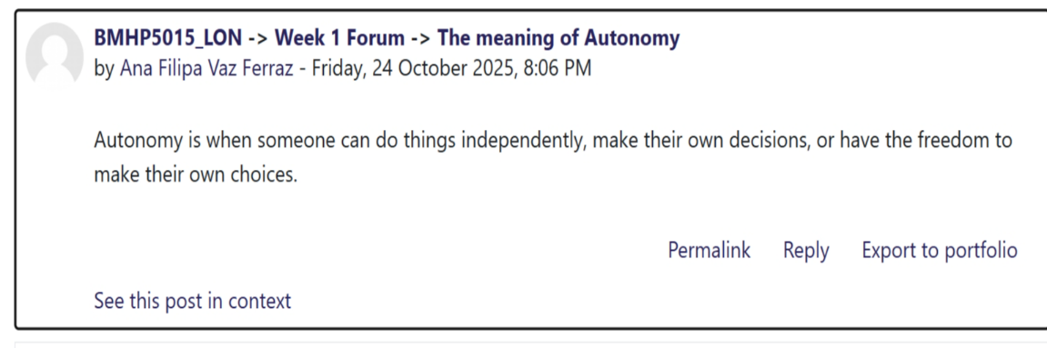
Image 1, week 1 forum submission: The meaning of autonomy

The concepts of boundaryless careers and the gig economy highlight that modern career paths are flexible and non-linear. Guan et al. (2019) define boundaryless careers as involving movement across roles, employers, and sectors, reducing reliance on traditional paths. This perspective helps me remain open to diverse Health and Social Care opportunities, such as working in hospitals, community services, or specialised care. For example, travel nurses accept short-term assignments across locations to meet service demands. While this flexibility promotes lifelong learning and networking (Henry, 2024), it also presents challenges, including loneliness, a lack of support, and precarious contracts (Guan et al., 2019).
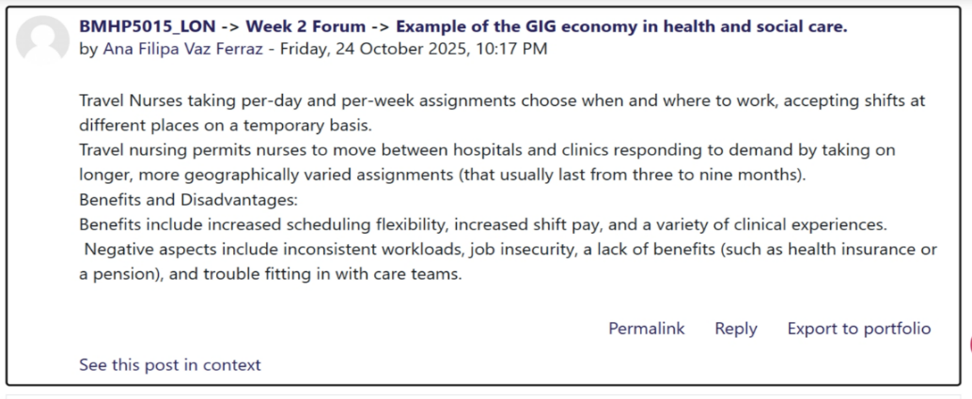
Image 2, week 2 forum submission: Example of the GIG economy in Health and social care

Learning about emotional intelligence and self-awareness has significantly improved my conduct. For example, sometimes people may feel vulnerable or anxious; by being aware of my own emotions, I can manage stress better and maintain professionalism. By understanding others’ emotions, I can respond sensitively and with empathy (Craig, 2019). Daniel Goleman's Theory of emotional intelligence explains that emotional intelligence enhances the ability to recognise emotions in oneself and others, leading to more effective and empathetic interactions. This is especially important in health and social care, where it is needed to recognise our own strengths and limitations and be willing to consider new ideas (Craig, 2019).
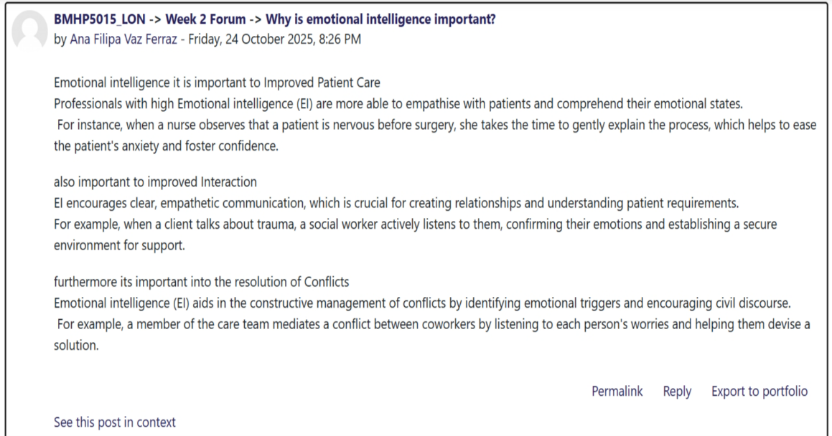
Image 3, week 2 forum submission: Why is emotional intelligence important?
Reflection on Unit 2: It is a Small World
Unit 2 emphasised how online platforms transform professional relationships, making networking essential for sharing information and accessing collaborative opportunities in Health and Social Care (Royal College of Nursing, 2025). Diverse networks and ethical persuasion foster creativity and inclusion, encouraging engagement with individuals from varied cultural backgrounds (Raya, 2023). The Connecting People Model emphasises the significance of meaningful relationships in enhancing overall well-being (Webber, 2024). Additionally, exploring evaluation types reinforced the need for clear goals and measurable outcomes to ensure effective practice (Bjerke, 2017). Key concepts that shape my perspective include evaluation, networking, and the importance of building strong connections.

Evaluation refers to assessing a program's effectiveness by determining whether its objectives have been met (Bjerke, 2017). There exist different types of evaluation, one of which is a goal-based evaluation that is SMART (specific, measurable, achievable, relevant, and time-bound), ensuring clarity and viability, making goal-based evaluation effective (Bjerke, 2017).
However, if objectives are unclear or fail to account for unexpected results, such as increased community involvement or policy changes, they may be restrictive (Bjerke, 2017).
According to Sanderson et al. (2024) and through the Care Act 2022, I saw how legislation supports outcomes-based evaluation and integration. The Act mandates that Integrated Care Systems remove bureaucratic barriers and enforce accountability between the NHS, local authorities, and the communities.
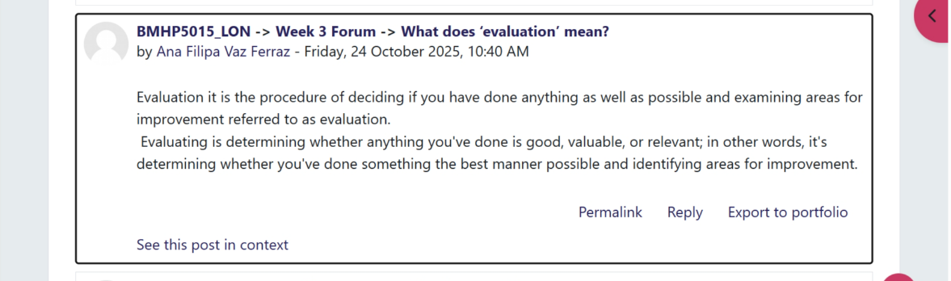
Image 1, week 3 forum submission: What does evaluation mean?

According to the National Careers Service (2025), Networking is essential for career growth because it builds relationships and shares knowledge. In Health and Social Care, networking can lead to collaboration, mentorship, and access to diverse roles. Networking provides access to forums, conferences, and resources that improve skills and keep practitioners updated (Royal College of Nursing, 2025). For example, attending a professional HSC conference may connect you with a senior social worker who later recommends you for a job. Benefits include skill development and increased visibility. However, disadvantages exist, such as over-reliance on contacts or engaging in superficial connections that lack genuine value. Effective networking requires authenticity and professionalism to ensure long-term, meaningful relationships that support personal and professional development (Royal College of Nurses, 2025).
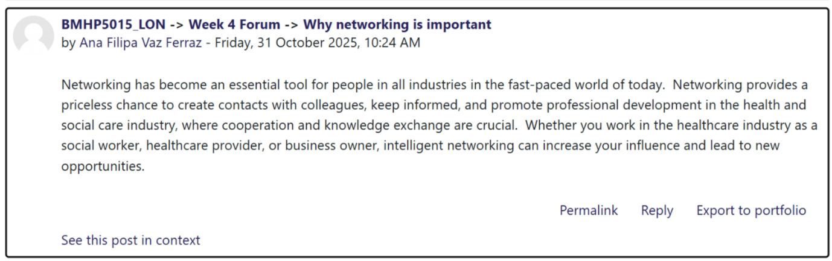Image 2, week 4 forum submission: Why is networking important?

Making connections is essential for HSC professionals as it promotes collaboration and holistic, patient-centred care. However, barriers such as time constraints, unequal inclusion, and role instability can limit these benefits (Henry, 2024). Webber’s (2024) Connecting People Model emphasises building meaningful relationships based on trust and shared goals rather than network size. For example, practitioners and service users work together to set realistic, achievable objectives, creating supportive networks that enhance wellbeing and improve care outcomes.
I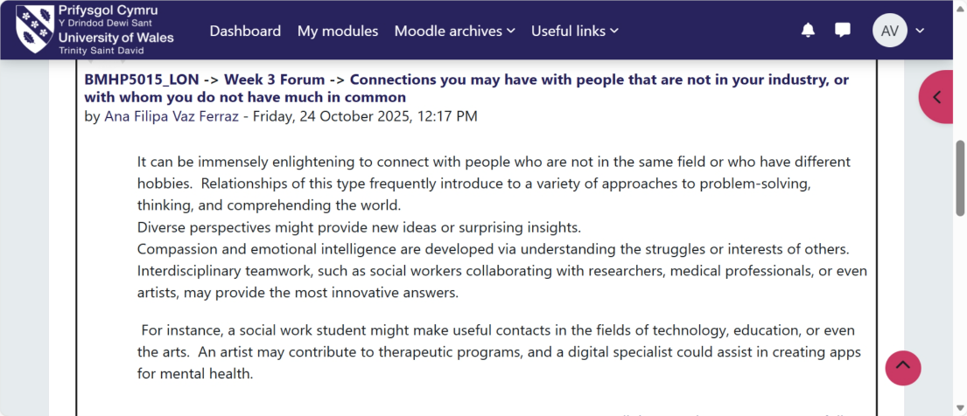
Image 2, Week 3 Forum Submission: Connections with people who do not share many commonalities with me.
Reflection on Unit 3: Opportunity Knocks
Unit 3 emphasised shifting perspectives to recognise opportunities, stay prepared, and embrace serendipity where intentional actions lead to positive, unexpected outcomes (Bush, 2020). Stretch goals, when supported, foster creativity and growth, shaping my career plans (Raya et al., 2023). Career conversations and mentoring enhanced my confidence and digital skills, enabling me to engage proactively in HSC. Understanding the distinction between modern and traditional recruitment reframed my CV and networking approach, clarifying both my intrinsic and extrinsic work values and thereby strengthening my job fit. Building a professional online presence enhances employability signals (National Careers Service, 2025). Collectively, these insights enable me to seize opportunities that align with my goals.

Stretch goals are ambitious, challenging objectives that lie beyond current capabilities, playing a decisive role in both personal and professional development. They spark motivation, creativity, and skill growth by pushing individuals to extend their limits and explore new strategies (Growth Tactics, 2023). According to recent research, stretch goals significantly enhance performance and innovative creativity by promoting calculated risks and imaginative thinking when combined with flexible thinking. However, they can also cause stress, burnout, and unethical behaviour, especially when resilience or resources are low (Zhang et al., 2024). For example, in healthcare, stretch goals require error reduction or efficiency improvements to yield results only when organisations have performance protection and resource availability (See et al., 2023). Thus, stretch goals are most effective, balanced by readiness, support, adaptability, and practical strategies (Growth Tactics, 2023).
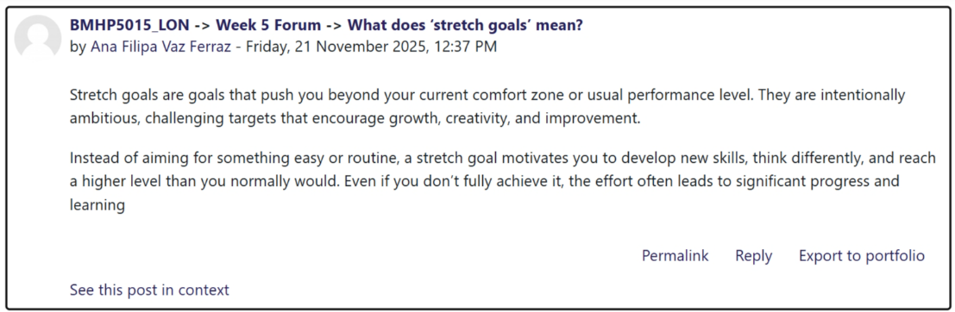
Image 1, week 5 forum submission: What does “stretch” goals mean?
According to Lee (2021), effective communication is foundational for success; it builds trust, empathy, and collaboration while minimising conflict and boosting performance. In healthcare and social work, communication training enhances self-efficacy, patient satisfaction, safety, and service outcomes. Systematic reviews confirm that communication skills, training, competence, and empathy contribute to workplace success. Recognising this, I focused on active listening, clarity, and empathetic dialogue, which led to stronger relationships, increased confidence, and improved opportunities in both academic and professional contexts (Lee, 2021).
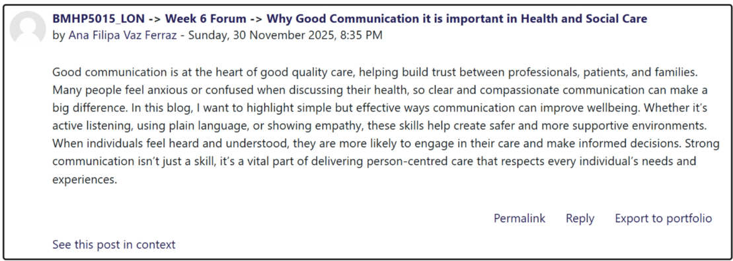
Image 2, week 6 forum submission: Why is effective communication important in HSC?
In those days, one could open doors to job opportunities through networking, mentorship, guidance, and proactive career conversations, as well as digital branding, which is essential for personal and professional development. Mentorship and peer relationships foster self-initiated career behaviour, partnership, and access to unadvertised roles. Active engagement in employability-building activities, such as internships and career counselling, correlates with a stronger professional identity and better job outcomes (Klinge, 2015). A proactive mindset drives opportunity, recognition and initiative, improving career attitudes and performance. Notably, social media use cultivates self-efficacy and diverse professional options. (Li et al. 2025). Those insights have guided my efforts to initiate conversations, build networks, and refine online presence to access and convert relevant opportunities for growth.

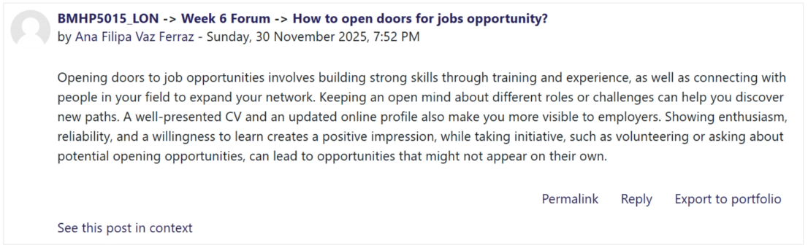
Image 3, Week 6 Forum submission: How to Open Doors to Job Opportunities?
Reflection on Unit 4: The Pursuit of Happiness
People study to gain knowledge, improve career prospects, and achieve personal growth (Keinanen, 2023). However, limiting beliefs such as “I am not capable” can block progress and reduce confidence (Wooll, 2022). Learning to deal with failure builds resilience, helping us adapt and grow stronger. A positive mindset is crucial for changing careers, as it fosters flexibility and persistence. Technology is transforming HSC, requiring digital skills and adaptability for future employment (Li, 2025). Understanding these factors helped me stay open-minded, embrace learning, and prepare for tech-driven opportunities.
Three main concepts that have shaped my perspective are limiting beliefs, the importance of mentoring in the HSC, and the benefits of having a mentor in the HSC.

According to Wooll (2022), limiting beliefs are negative thoughts that hold us back, such as “I am not smart enough” or “I cannot change careers.” These beliefs can stop us from trying new things or reaching goals. Reasonable beliefs, such as “I can learn,” help growth, while bad ones create fear and self-doubt. Albert Bandura explains how thoughts shape feelings and actions, and changing these thoughts can improve confidence (Garrido, 2025). For example, replacing “I will fail” with “I will learn from mistakes” builds resilience and a growth mindset. Understanding this helped me challenge my doubts and capitalise on opportunities for personal and professional growth (Wooll, 2022).
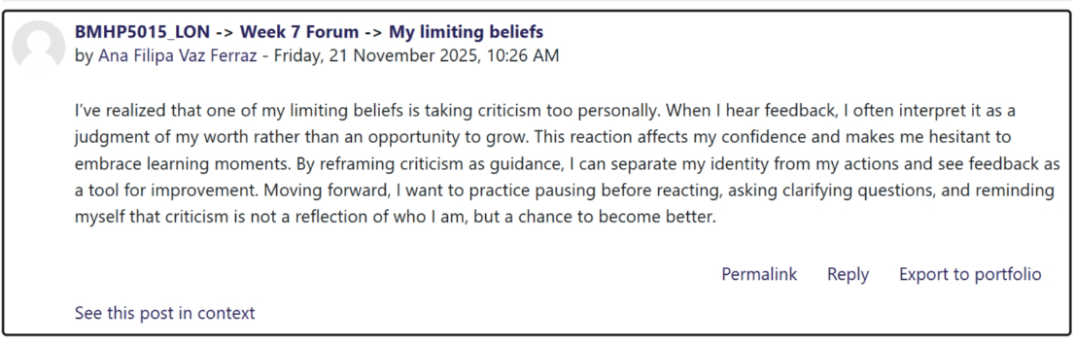
Image 1, Week 7 Forum: Limiting beliefs.

Mentoring is vital in HSC, providing guidance, emotional support, and skill development, which enables mentees to adapt to complex roles by supporting their learning, confidence, and career progression (Keinanem, 2023). For example, a mentor can coach a new social worker on managing challenging cases, reducing stress and improving practice. Poor mentoring, such as a lack of feedback or unclear expectations, can lead to frustration and disengagement (Keinanem, 2023). Social Learning Theory (Bandura, 1977) explains how mentees learn through observation and modelling, making mentoring a powerful tool for professional growth (McLeod, 2025). This understanding encouraged me to seek out mentors, which in turn enhanced my resilience and employability.
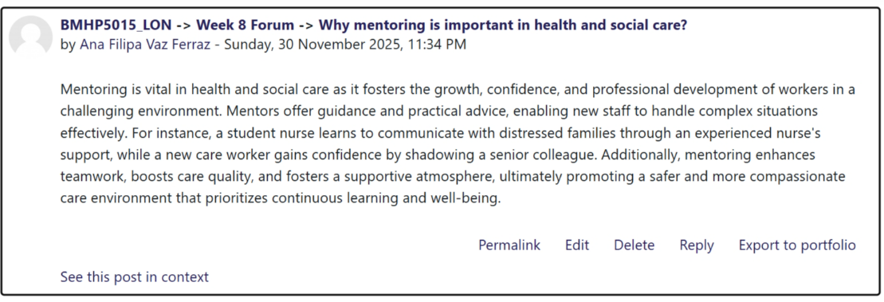
Image 2, Week 8 Forum submission: Why mentoring is important in health and social care?

According to Keinanem (2023), having a mentor in HSC is important because it provides guidance, collaboration, and support, helping to develop a professional understanding of their functions within the organisation. A good mentor offers clear advice, feedback, and role modelling, which improves confidence and competence (For example, a mentor can teach a new nurse how to handle stressful situations, reducing errors and anxiety.
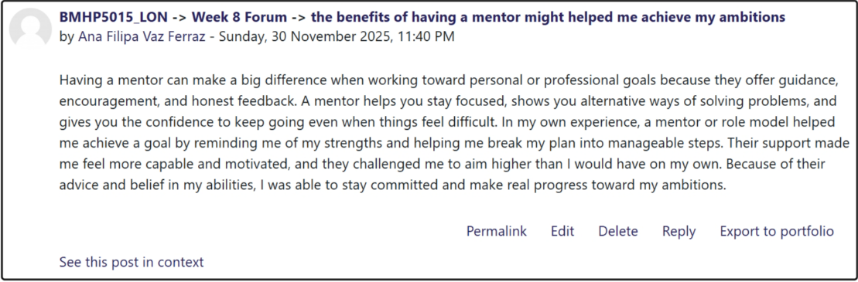
Image 3, Week 8 Forum submission: The benefits of having a mentor.

Conclusion
Reflecting on the four units of this module has highlighted key lessons that will shape my future in HSC. I learned that ambition drives me and is essential for career success, while boundaryless careers and skills emphasise adaptability and lifelong learning. Moreover, networking and global connections taught me the importance of building relationships and embracing diversity to access opportunities. By recognising and creating opportunities, developing a strong online presence, and opening doors through proactive strategies, I strengthened my employability (Li et al., 2025). Planning, maintaining resilience, and learning from mentors reinforced the importance of perseverance and overall well-being.
These insights will help me develop crucial skills for HSC, including communication, digital literacy, and resilience. I now understand how to challenge limiting beliefs, adopt a positive mindset, and utilise strategies such as mentoring and networking to thrive in a technology-driven sector. By applying these lessons, I feel prepared to adapt to change, seize new opportunities, and build a sustainable career that aligns with my values and professional goals.

References
Alasqah, S.S. (2022). Goal Orientation and Its Impact on University Students’ Academic Achievement During the COVID-19 Pandemic. SAGE Open, 12(2), p.215824402210936. Doi: https://doi.org/10.1177/21582440221093617.

BiteSize Learning (2024). BiteSize Learning. [online] BiteSize Learning. Available at: https://www.bitesizelearning.co.uk/resources/lockes-goal-setting-theory-explained (Accessed 20 November 2025).

Bitesize Learning (2023). Autonomy, mastery, and purpose: three motivators defined, according to Daniel Pink’s ‘Drive’. [online] BiteSize Learning. Available at: https://www.bitesizelearning.co.uk/resources/autonomy-mastery-purpose-motivation-pink (Accessed 20 November 2025).

Bjerke, M.B. and Renger, R. (2017). Being smart about writing SMART objectives. Evaluation and Program Planning, 61(1), pp.125–127. Doi: https://doi.org/10.1016/j.evalprogplan.2016.12.009.

Busch, C. (2020). How to Create Your Own Career Luck. [online] Harvard Business Review. Available at: https://hbr.org/2020/08/how-to-create-your-own-career-luck (Accessed 20 November 2025).

Cambridge Dictionary (2019). AUTONOMY | meaning in the Cambridge English Dictionary. [online] Cambridge.org. Available at: https://dictionary.cambridge.org/dictionary/english/autonomy (Accessed 15 November 2025).

Craig, H. (2019). The Theories of Emotional Intelligence Explained. [online] PositivePsychology.com. Available at: https://positivepsychology.com/emotional-intelligence-theories/ (Accessed 15 November 2025).

Garrido, G.L. (2025). Bandura’s Self-Efficacy Theory of Motivation in Psychology. [online] Simply Psychology. Available at: https://www.simplypsychology.org/self-efficacy.html (Accessed 20 November 2025).

Growth Tactics. (2023). What Are Stretch Goals: Tips, Examples, and How to Set Them. [online] Available at: https://www.growthtactics.net/what-are-stretch-goals/ (Accessed 15 November 2025).

Guan, Y.G., Arthur, M.B., Khapova, S.N., Hall, R.J. and Lord, R.G. (2019). Career boundarylessness and career success: A review, integration and guide to future research. (“Career boundarylessness and career success: A review, integration and ...”) Journal of Vocational Behavior, [online] 110(https://doi-org.ezproxy.uwtsd.ac.uk/10.1016/j.jvb.2018.05.013), pp.390–402. Doi:https://doi.org/10.1016/j.jvb.2018.05.013.

Keinänen, A.-L., Lähdesmäki, R., Juntunen, J., Tuomikoski, A.-M., Kääriäinen, M. and Mikkonen, K. (2023). (“Effectiveness of mentoring education on health care professionals ...”) Effectiveness of mentoring education on healthcare professionals' mentoring competence: A systematic review. Nurse Education Today, 121(121), p.105709. Doi: https://doi.org/10.1016/j.nedt.2023.105709.

Klinge, C.M. (2015). A Conceptual Framework for Mentoring in a Learning Organization. Adult Learning, 26(4), pp.160–166. Doi: https://doi.org/10.1177/1045159515594154.

Kumar, K. (2024). The Importance of Trust and Authenticity in Healthcare - Karan Kumar. [online] Karan Kumar. Available at: https://talktokaran.com/the-importance-of-trust-and-authenticity-in-healthcare/ (Accessed 2 December 2025).

Latham, G.P. (2016). Goal-Setting Theory: Causal Relationships, Mediators, and Moderators. Oxford Research Encyclopedia of Psychology. [online] Doi: https://doi.org/10.1093/acrefore/9780190236557.013.12.

Learning theories. (2014). Self-Determination Theory (Deci and Ryan) - Learning Theories. [online] Available at: https://learning-theories.com/self-determination-theory-deci-and-ryan.html (Accessed 20 November 2025).

Lee, E. (2021). Effective Communication in Health and Social Care. [online] CPD Online College. Available at: https://cpdonline.co.uk/knowledge-base/care/effective-communication/ (Accessed 2 December 2025).

Li, F., Shi, M. and Feng, R. (2025). Social media use and job choices: the mediating roles of work values and self-efficacy. Frontiers in Psychology, 16. doi:https://doi.org/10.3389/fpsyg.2025.1485663.

McLeod, S. (2025). Albert Bandura’s Social Learning Theory. [online] Simply Psychology. Available at: https://www.simplypsychology.org/bandura.html (Accessed 2 December 2025).

Nasrudin, A. (2021). Pink’s Theory of Motivation: Elements and A Brief Explanation. [online] Penpoin. Available at: https://penpoin.com/pinks-theory-of-motivation/ (Accessed 20 November 2025).

Nationalcareers.service.gov.uk. (n.d.). Networking | Careers advice | National Careers Service. [online] Available at: https://nationalcareers.service.gov.uk/careers-advice/networking (Accessed 20 November 2025).

Practice guidance. (n.d.). Available at: https://connectingpeople.net/wp-content/uploads/2018/10/Connecting-People-PG-brochure.pdf (Accessed 15 November 2025).

Rayá, M., Ogunyemi, A., Veronica Rojas Carstensen, Bröder, J., Maryenela Illanes‐Manrique & Rankin, K.P. (2023). The reciprocal relationship between openness and creativity: from neurobiology to multicultural environments. Frontiers in Neurology, 14(https://doi.org/10.3389/fneur.2023.1235348). Doi: https://doi.org/10.3389/fneur.2023.1235348.

Royal College of Nursing (2024). Networking | Careers Resources | Royal College of Nursing. [online] The Royal College of Nursing. Available at: https://www.rcn.org.uk/professional-development/your-career/networking (Accessed 15 November 2025).

Sanderson, M., Hammond, J., Surgey, M., Aktas-Vincent, P., Wattal, V., Sutton, P., Checkland, K., Allen, P., Macinnes, J., Peckham, S., Petsoulas, C. & Warwick-Giles, L. (2024). Post Implementation Review of the Health and Care Act 2022 Phase 1: Interim Report *Non peer reviewed Working Paper* Report Version v1 Original submission. [online] Available at: https://pru.hssc.ac.uk/assets/uploads/files/hca22pir-interim-report-v1.2-working-paper.pdf (Accessed 15 November 2025).

See, K., Miller, C.C. and Sitkin, S.B. (n.d.). "Stretch goals have enduring appeal, but are the right organisations using them?" (“Stretch Goals as a Method for Leveraging Opportunities Created by ...”) [online] Available at: https://bmjleader.bmj.com/content/7/4/255 (Accessed 15 November 2025).

Webber, M. & Shires, K. (2024). Implementing Connecting People in Adult Mental Health Social Work Practice: A Thematic Analysis of Postgraduate Student-Assessed Placement Reports. The British Journal of Social Work, The British Journal of Social Work, Volume 55, Issue 1(https://doi.org/10.1093/bjsw/bcae140). Doi: https://doi.org/10.1093/bjsw/bcae140.

Wooll, M. (2022). Don’t let limiting beliefs hold you back. Learn to overcome yours. [online] BetterUp. Available at: https://www.betterup.com/blog/what-are-limiting-beliefs (Accessed 1 December 2025).

Zhang, Z., Chen, C. and Jia, M. (2024). Double-edged sword effect of stretch goal: is stretch goal a burden or boost to employees? Asia Pacific Journal of Management, 2025. Doi: https://doi.org/10.1007/s10490-024-09956-2.

Zhuang, Y., Zhao, T. & Shao, X. (2021). Mechanism of WeChat’s Impact on Public Risk Perception During COVID-19. Risk Management and Healthcare Policy, Volume 14(2021 Oct 8;14:4223–4233. Doi: 10.2147/RMHP.S328175), pp.4223–4233. Doi: https://doi.org/10.2147/rmhp.s328175.

