Portfolio part one: Document report
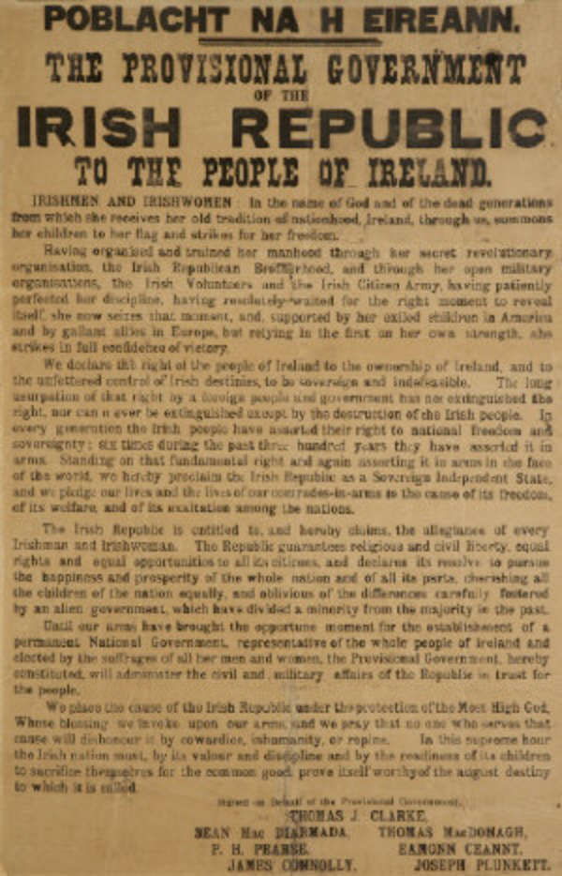
1

The document which I will be reviewing is the poster which was “read aloud by Patrick Pearse outside Dublin’s General Post Office (GPO) at the beginning of the 1916 Easter Rising”² on the 24th of April 1916 known as the poblacht na heireann or the proclamation of independence, which was composed by Pearse who also received contributions from James Connolly and Thomas MacDonagh² as part of the provisional government of the Irish republic’s plan to declare the republic of Ireland an independent and sovereign state. The document itself, begins by acknowledging Irish citizens by saying “To the people of Ireland”³, this statement in the document is clearly addressing everyone who live in Ireland, this document parallels a similar poster done by the British military two yars prior to this document being printed the poster which can be seen in figure 1. The British poster famously depicts “Field Marshal Lord Kitchener, appealing for people to join the British Army”⁴, from these posters a number of similarities can be seen for example, in both posters the heading of the text is both in bold with a clear aim of attracting the attention of its target audience through directly addressing the peoples of each country, with the provisional government of the Irish republic’s poster with the having the text of the headline being bold and in a significantly larger font than the rest of the document, making it a focal point for the readers which includes part of the headline directly addressing the Irish people with the phrase “To the people of Ireland”³, the poster in figure 1 has a similar preface with the poster having a simple one word heading addressing the British people simply stating “Britons”⁴ in addition to the headline having a larger font than the subsequent text, both of these posters are looking to attract the attention of their target audience by trying to address them directly through the mention of their nationalities, on the other hand whilst both posters aimed to unite people under a common cause, the Irish through declaring independence and the British through recruiting more soldiers to fight in the war, the way that each poster presents its information, this is primarily down to their overall purpose, the recruitment poster’s primary purpose is to be as noticeable as possible, because of this it limits its text to a couple of short phrases to emphasize the message to the reader, whereas the provisional government of the Irish republic’s poster is designed to be a declaration of independence in addition to attempting to recruit people to their cause, this also means that the language that they use is very formal in addition to this the amount of text used in order to get the aims of the declaration known. At the time of the document being printed, Ireland was going through a period of civil unrest known as the troubles, during this time the “Irish Republican Brotherhood, or IRB rose in rebellion against the British”⁵ in order to gain independence, because of this it can be suggested that the opening lines of the document were meant to spark interest in Irish citizens in order to receive more attention from the public to promote a greater interest in the party’s agendas. The document also goes on to detail the rights of the Irish people that the provisional government of the Irish republic aimed to achieve which includes “religious and civil liberty, equal rights and equal opportunities to all its citizens, and declares its resolve to pursue the happiness and prosperity of the whole nation and of all its parts”³, this statement also refers to the “discrimination against Catholics, against dissenters and radical Protestants, humiliation, religious and ethnic oppression, absentee landlords, restricted civil rights, and the exploitation of the whole island for English interests”⁵ which subsequently led the nationalist party to pursue a violent rebellion against the English, following on from this statement the document may have also have intended to spark outrage within the community by claiming that the differences which caused tensions within the Irish community had been “carefully fostered by an alien Government, which have divided a minority from the majority in the past”³ this statement shows that the provisional government of the Irish republic are using the English government as a political target in which to blame for the tensions which had risen between the classes in Ireland. In addition to this the document also mentions that the “right of the people of Ireland to the ownership of Ireland and to the unfettered control of Irish destinies”³ which suggests that the English government has been oppressing the Irish people and taking advantage of Irish land as well as the territories which the provisional government of the Irish republic believe to belong to Ireland. With both of these statements there is a clear message being presented by the writer, which is that Ireland and its peoples have been oppressed by the English government and that the Irish people should rebel against this, through the use of force.
In conclusion I believe that this document’s purpose was to make a political statement in order to declare independence as well as attempting to recruit as many people as possible to their cause, I believe that this document achieves this through the use of language by using phrases such as “the right of the people of Ireland to the ownership of Ireland and to the unfettered control of Irish destinies”³ and “The Irish Republic is entitled to, and hereby claims, the allegiance of every Irishman and Irishwoman”³ they use this language to effectively present their message to the public.
Word count: 946

Figure 1
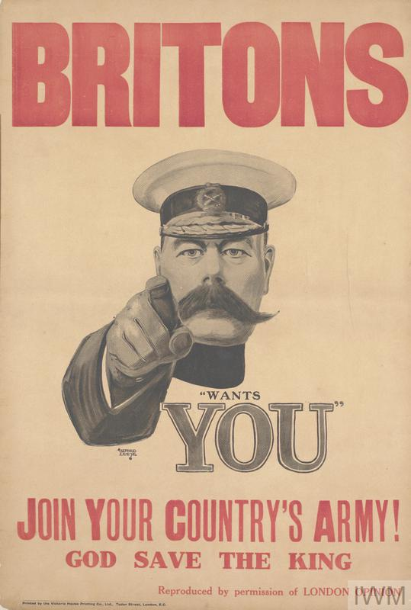
4

Portfolio part two: Book review
The book which I will be reviewing is A War Imagined written by Samuel Hynes in 1990, in this book Hynes explores the social changes which took place in England during the First World War and the years which followed and how these changes altered the English people’s views on war and the consequences of this, Hynes explores this topic through the use of a variety a sources such as poetry, paintings, films, personal diaries, letters in addition to many others sources as well.
Looking into the author of this book, Samuel Hynes “was born in Chicago in 1924 and was educated at the University of Minnesota and Columbia University. He has taught at Swarthmore College, Northwestern University and Princeton University. From 1943 to 1956, and again in 1952-3, he served as a pilot in the United States Marine Corps.”⁶, being born after the First World War he was not able to experience the social impacts that the arrival of the First World War, which is why Hynes used personal accounts from the diaries of those who had lived through that period of time, however Hynes grew up during the aftermath of the first world war, because of this he was able to gain a first hand experience of the social impact of the First World War on everyday life. Unfortunately though, Hynes was born and raised in the United States which means that despite having experience of the social impact that had come about as a result of the First World War, due to this Hynes did not have the same experience as someone who grew up during this period of time as a person who grew up in Britain, on the other hand by growing up outside of England it has allowed him to look at the social changes which occurred within English culture in an impartial manner. In addition to this, Hynes was also a pilot in the unites states armed forces during World War Two where Hynes likely interacted with soldiers from the British forces meaning that he would have likely experienced the results on the changes to English culture which was caused by the First world War first hand from the soldiers themselves. Moving on from this, Hynes had written this book in 1990 not long after the fifty year anniversary of the second world war as well as the upcoming fiftieth anniversary of the end of the Second World War, during this time there was an increase in the awareness for remembrance of past conflicts which occurred, more specifically the two world wars which occurred in between the years of 1914 and 1945 at the time of this book being published it was unusual for a book focussing around the first world war to have it centre of study based around the cultural changes that was caused by the effects of the Great War due to the focus of many other books whose focus was on the First World War primarily being on the conflicts which occurred as well as the statistics being them such as Randal Gray’s Chronicle of the First World War which was published in 1990, the same year as Hynes’ A War Imagined in Gray’s novel he details the “chronology of the war, statistics, and an index of people and events”⁷ another example of this would be, J Philip Haythornthwaite’s The World War One Source Book⁷ which was published in 1993, three years after Hynes’ novel this book also details similar subjects to Gray’s novel, with the novel being “comprised of summaries of Allied and Central military operations and country studies. There is additional coverage of weapons, statistics, and recommended reading”⁷. This means that, for historians Hynes’ novel is an invaluable learning resource, which would allow historians to study in detail areas of everyday life that previously were overlooked, in addition to this it also allows historians to look at the cultural changes within English society in a much broader range than previous renditions due to the numerous sources that Hynes used such as Alec Randall’s Poetry and Patriotism⁸, Rodger Smither’s A wonderful idea of the fighting⁸ and Timothy Materer’s Pound/Lewis: The Letters of Erza Pound and Wyndham Lewis⁸. Furthermore, the way that Hynes presents his information is simple and clear to understand, making it highly accessible to people of all abilities in this subject as well as providing a clear focus of study from the beginning of the novel in addition to this Hynes had structured the book into four parts, with each part being divided even further still with the main sections of the book having a clear focus on a particular period in the war or a specific aspect of how English culture viewed the conflict and thus the factors which led to this cultural change and the consequences of this, the smaller sections of the four parts of this novel go into greater detail on the subjects which each part overlays. By structuring the novel in this manner, it allows the reader to easily locate the desired information in addition to this by structuring the four novel into four separate parts it has allowed Hynes to remain focussed on the aspects of English culture that he wished to explore and present it in a clear and precise manner. On the other hand, the target audience is very unclear this is due in part because of the fact that in parts of the novel where the subjects could have been written in more detail has been generalised in order to allow a less knowledgeable reader have a better clarity of the subject matter this has also been noted by Margaret R. Higonnet in the The Journal of Modern History Vol. 65 where she comments that “it is unclear, however, for what audience Hynes has written, with obvious consequences for his methods of analysis and his ability to demystify”⁹. Furthermore, Hynes message throughout the book appears to be that whilst England as a country remembers the events which occurred during First World War as well as the lives that were lost during it, as a culture the English have caused the memory of this event to be viewed in many different ways, but these views scale along two extremes, either in a very macabre light where the war was a terrible tragedy, where over a million people was lost their lives over small amounts of land and young men being sent to their deaths by uncaring or incompetent generals or that those who served in the war did so in a noble manner and that those who fell had sacrificed themselves for the greater good of all and that both the soldiers who lived through the conflict as well as those did not were protectors of their country and that the war was an unavoidable tragedy. However, Hynes concludes in the epilogue of the book what I believe to be his opinion on how the war is viewed by people he states that “In our reality, here at the century’s end, the First World War remains a powerful imaginative force, perhaps the most powerful force,in shaping not only of our conceptions of what war is, but of the world we live in- a world in which that war, and all the wars that have followed it, were possible human acts”⁸ which is a part of our world’s reality which is “to be comprehended, to be imagined, and to be understood in the imaginings of others”⁸ I agree with this conclusion due to the way we remember the First World War, in addition to this I believe that his final note on the perception of the first world war is correct due to each person having their own unique way of imagining the war which others may not understand fully due to their own notions of what the First World War was.
Overall, I believe that as an academic aid Samuel Hynes’ A War Imagined is highly useful to historians due to it providing clear, concise points as well as providing detailed arguments on many overlooked aspects of the First World War during the time of this book being published. In addition to this, the structure that Hynes has used to convey the information that he has collected to both the general public and academic circles has been done in a clear and precise manner allowing people of all abilities in this subject to easily understand the information presented by Hynes as well as allowing those with a more specific interests to be able to find the relevant information will little difficulty. Finally, I also believe that Hynes’ conclusion on how English culture views the First World War, very accurately as well as accurately noting the differing views which have occurred within the English culture and society.
Word count: 1473

Bibliography
- James Adam & Sons Ltd Fine Art Auctioneers and Valuers, 2009 < https://www.adams.ie/The-Proclamation-of-the-Irish-Republic-Rory-O-Connor-s-copy-executed-1922-Poblacht-na-hEireann-The-Provisional-Government-of-the-Irish-Republic-to-the-People-of-Ireland-Irishmen-and-Irishwomen-In-the?Itemid=&ipp=50&keyword=&view=lot_detail> (Accessed 5th November 2019)
- S.Mawe, Among the Nations: Poblacht na hÉireann, 2016 < https://www.tcd.ie/library/1916/among-the-nations-poblacht-na-heireann/> accessed 06/11/2019)
- <http://www.firstdail.com/?page_id=75> (accessed 06/11/2019)
- Imperial war museum, First World War Recruitment Posters, 2019,< https://www.iwm.org.uk/learning/resources/first-world-war-recruitment-posters> (accessed 07/11/2019)
- Dr. J. Bowyer Bell, The Irish Troubles Since 1916, p.1
- Penguin books, authors, Samuel Hynes https://www.penguin.co.uk/authors/1007087/samuel-hynes.html?tab=penguin-biography (accessed 11/11/2019)
- The library of congress, World War I: An Annotated Bibliography, <loc.gov/rr/main/ww1/books.html> (accessed 13,11/2019)
- Samuel Hynes, A war imagined, 1990
- Margret R. Higonnet, A War Imagined: The First World War and English Culture by Samuel Hynes, in The Journal of Modern History Vol. 65, No. 3 (Sep., 1993), pp. 606

