  Cyber security  Student ID: 2216147 | Course info  Course Code: ACCB6000  Lecturer: Dr. Mohamed Ghanem  Deadline: 14/12/2025  Davion Gowie  cybersecurity

Table of Contents
Introduction 2
Vm configuration 6
Result: 8
S-DC & L-CD Ping 8
Shared Folder 9
Ping from Kali linux to all vm machine 10
Meaning of the Error 10
Why It Happens 10
For example, by using this: 11
Nmap scan 12
Nessus vulnerability scan 18
Nessus vulnerability scan example 22
Start Metasploit 28
Show module info 28
Show available options for a module 28
Set parameters (IP ranges, ports, example:) 28
Show payloads available 28
Check if a target is likely vulnerable 28
Run a module (scanner / auxiliary only, safe discovery) 28
Safe Scanning Modules (Non-exploitative) 29
Preventive security measure 30
How to patch exploits 31
Conclusion 32
References 33

Introduction
The piece of work summarises the task of the network and security topology, giving in task overview of the following task. Running pings on VM Windows and Debian S-DC & LCD. Creating a documentation of each step, vulnerability assessment, exploitation & post-exploitation, and preventive security measures. Documenting all steps through the lab activity as a screenshot allows for demonstrations.

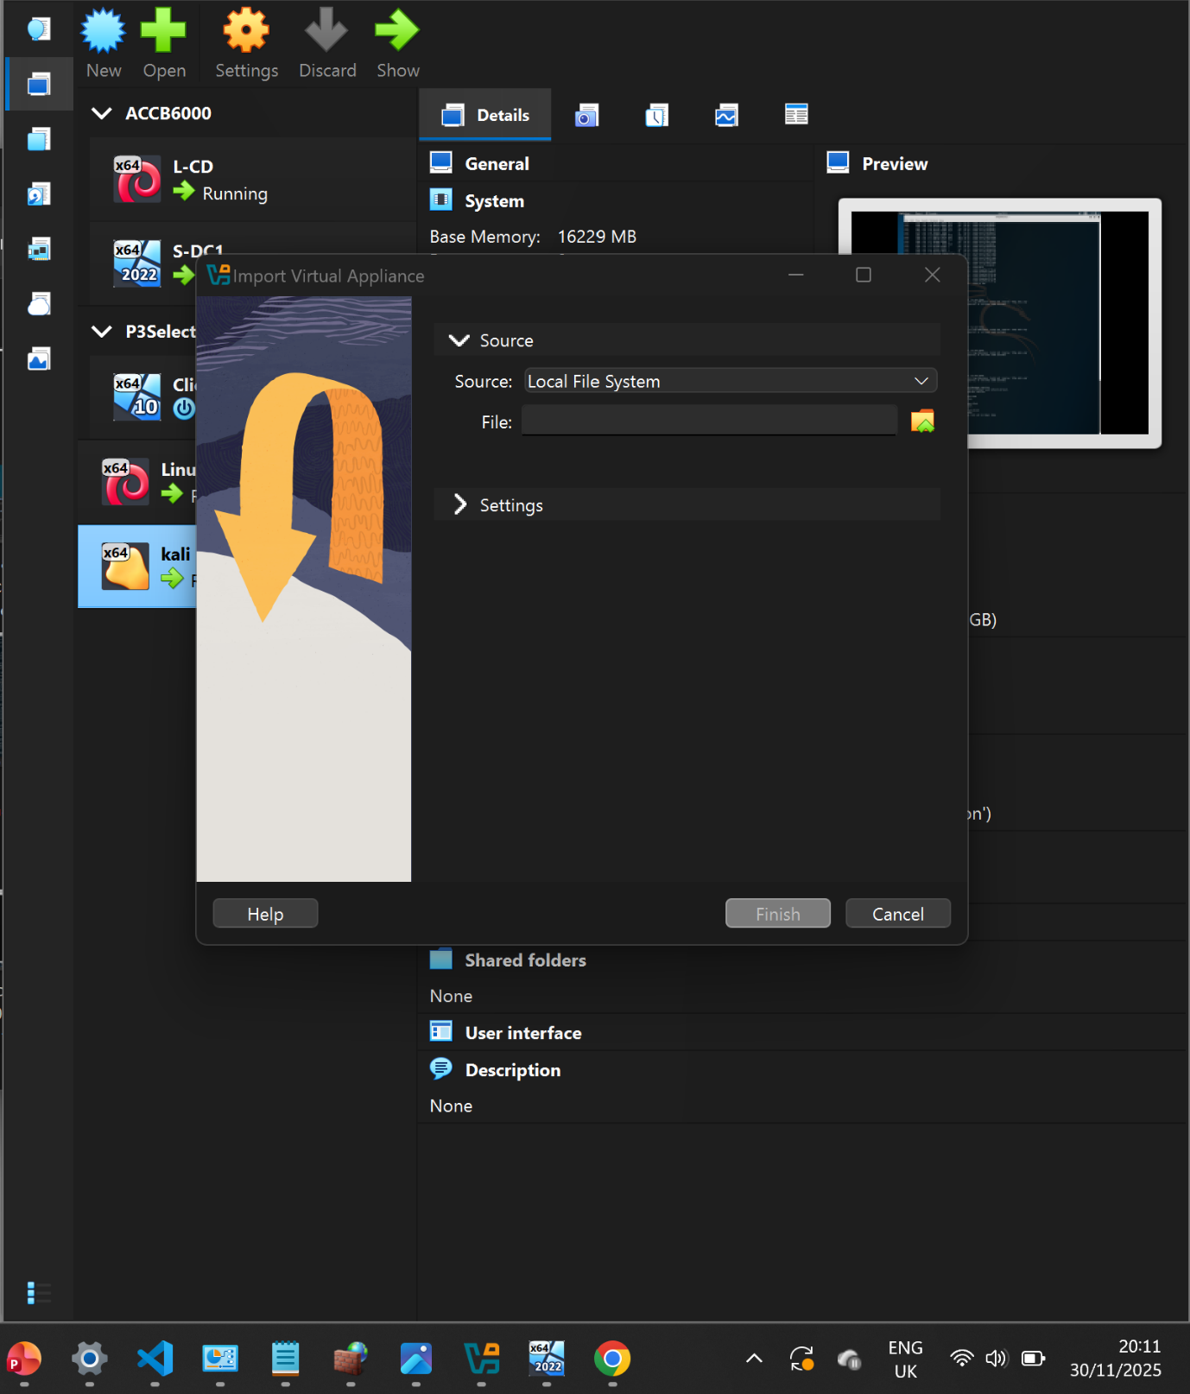
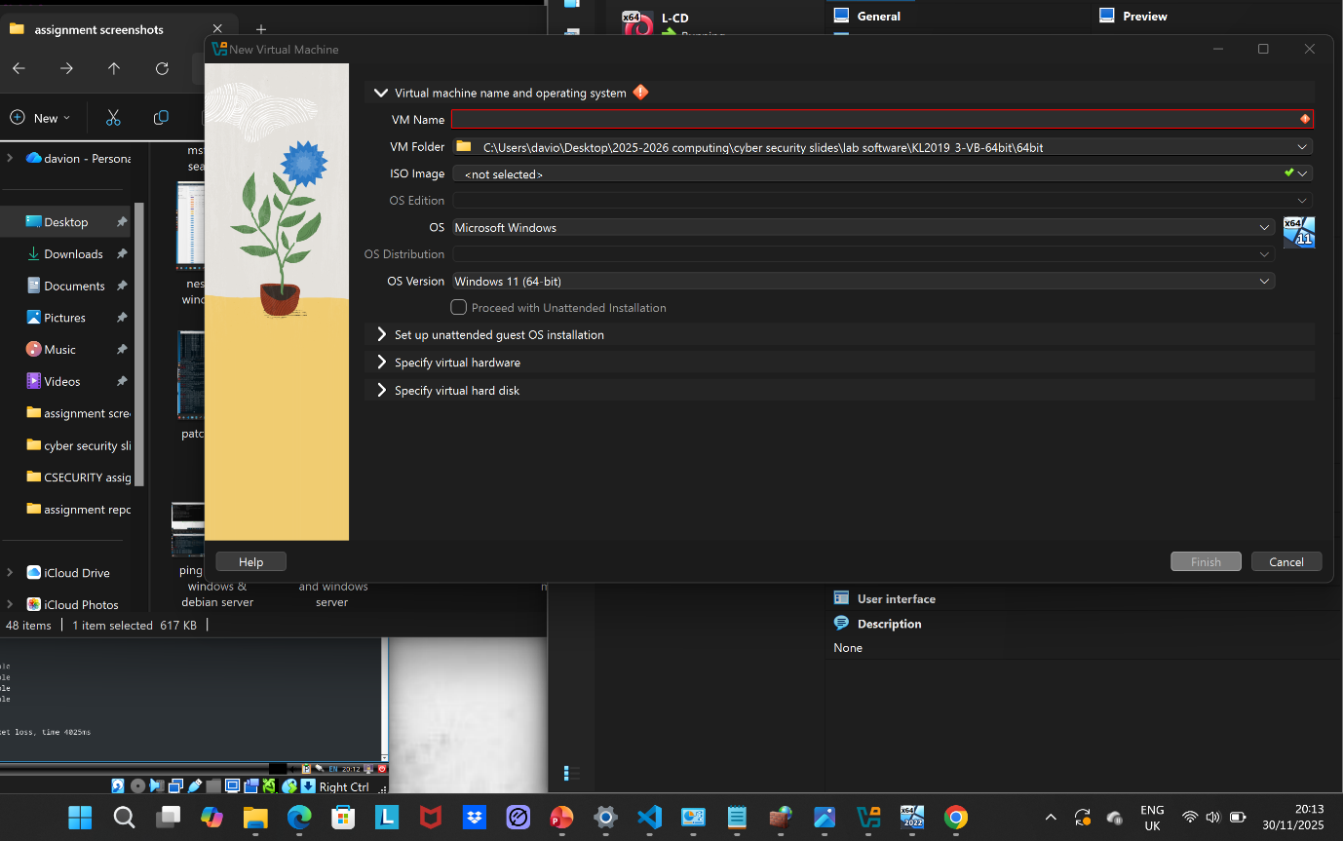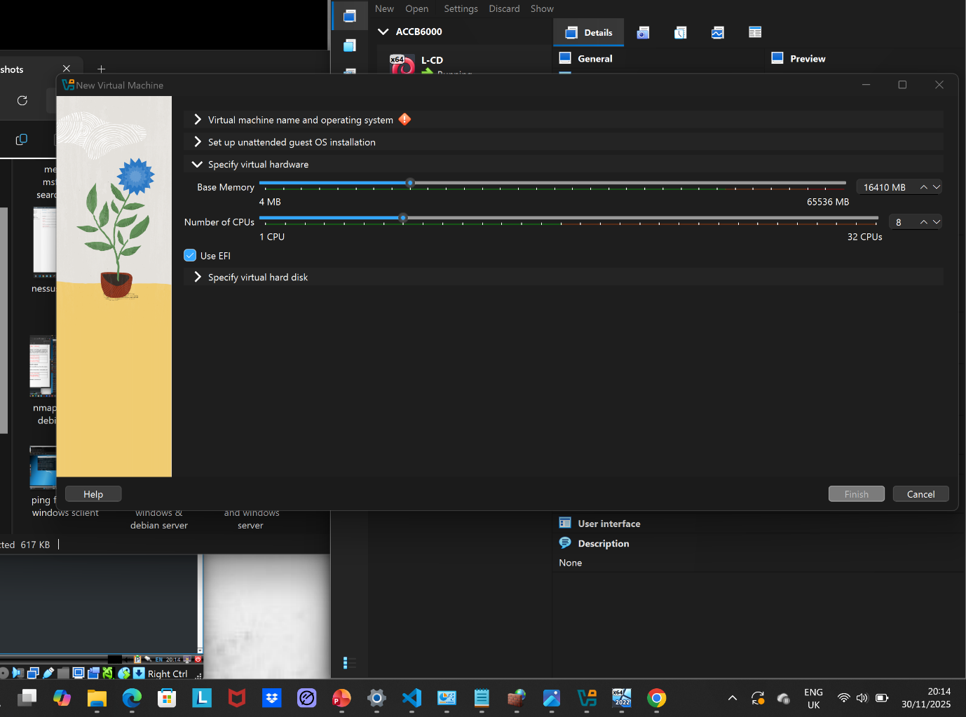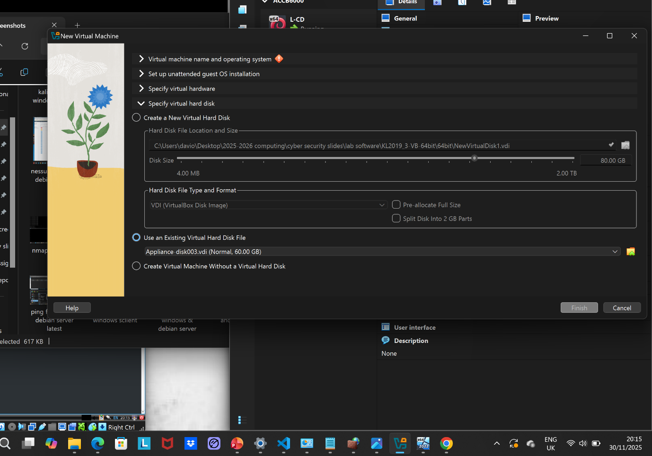

Vm configuration
Debian Server and client:
Network
Adapter 1:
Intel PRO/1000 MT Desktop (NAT)
Adapter 2:
Intel PRO/1000 MT Desktop (Host-only Adapter, VirtualBox Host-Only
Ethernet Adapter)
Adapter 3:
Intel PRO/1000 MT Desktop (Internal Network, 'External)
Adapter 4:
Intel PRO/1000 MT Desktop (Internal Network, 'IntLondon)

Windows Server:
Network
Adapter 1:
Intel PRO/1000 MT Desktop (NAT)
Adapter 2:
Intel PRO/1000 MT Desktop (Internal Network, "IntSwa)
Adapter 3:
Intel PRO/1000 MT Desktop (Internal Network, 'External")

Windows client:
Network
Adapter 1: Intel PRO/1000 MT Desktop (Internal Network, 'IntSwa)

Kali Linux
Network
Adapter 1: Intel PRO/1000 MT Desktop (Internal Network, 'IntSwa")
Adapter 2:
Intel PRO/1000 MT Desktop (Internal Network, 'IntLondon'

Result:

S-DC & L-CD Ping
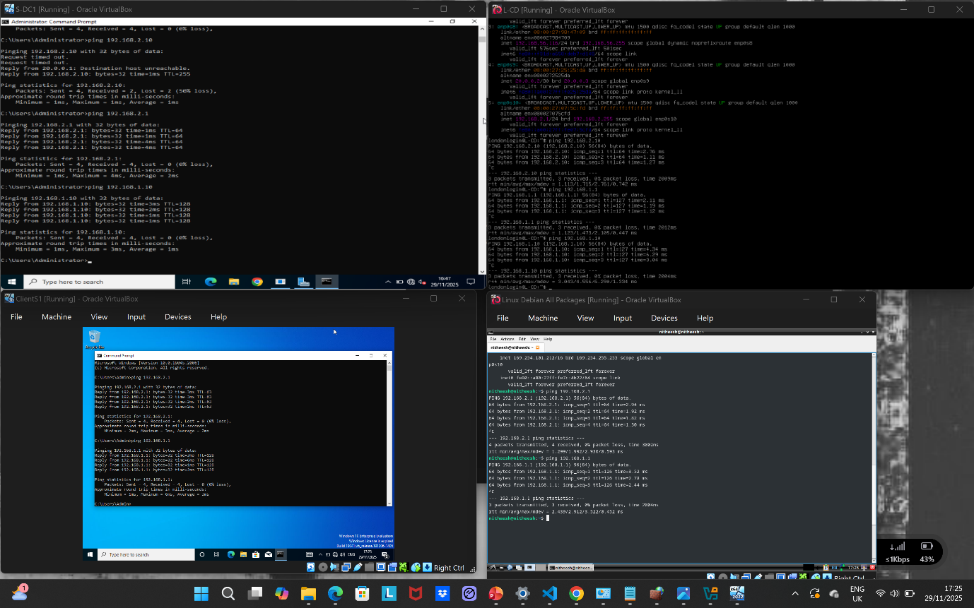

Shared Folder

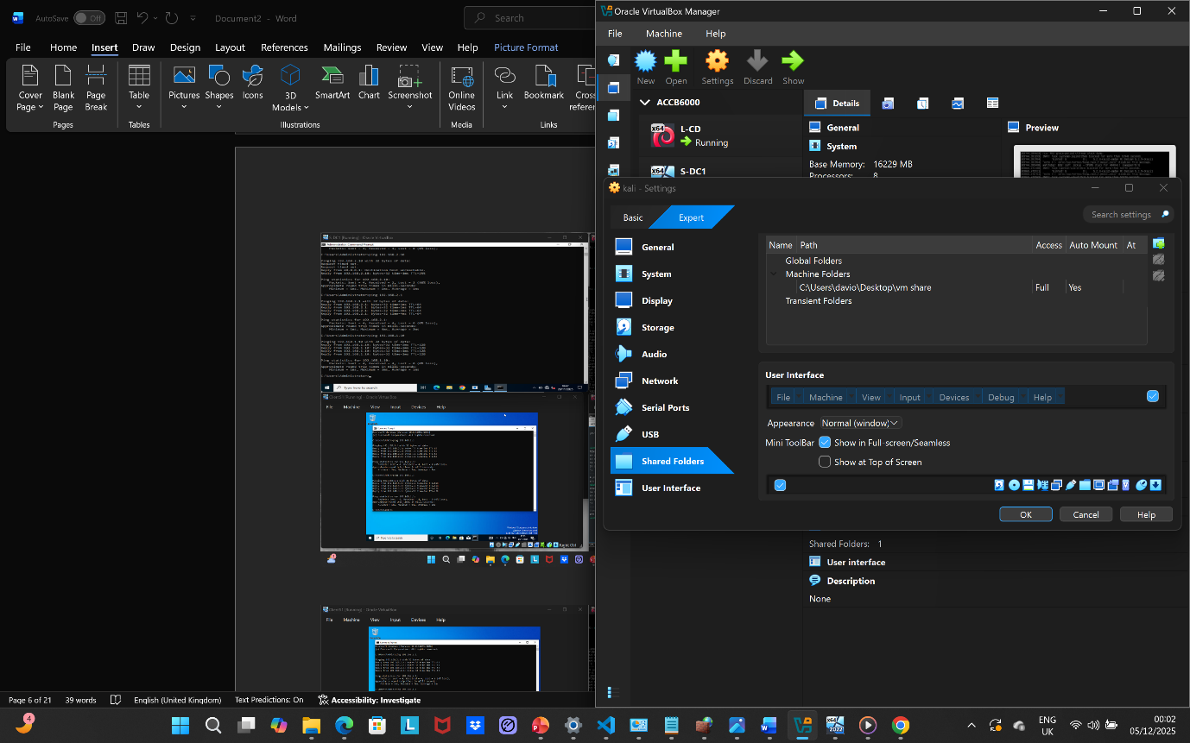
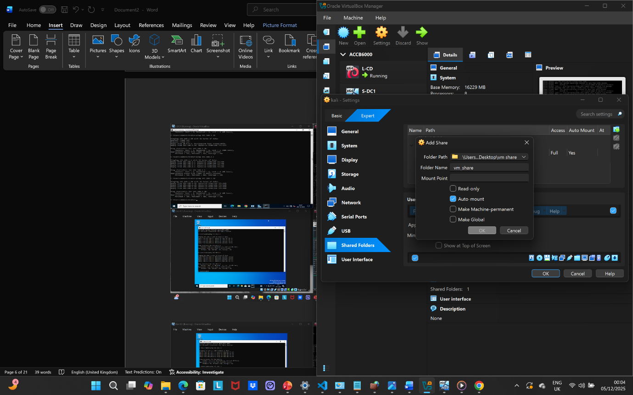

Ping from Kali linux to all vm machine

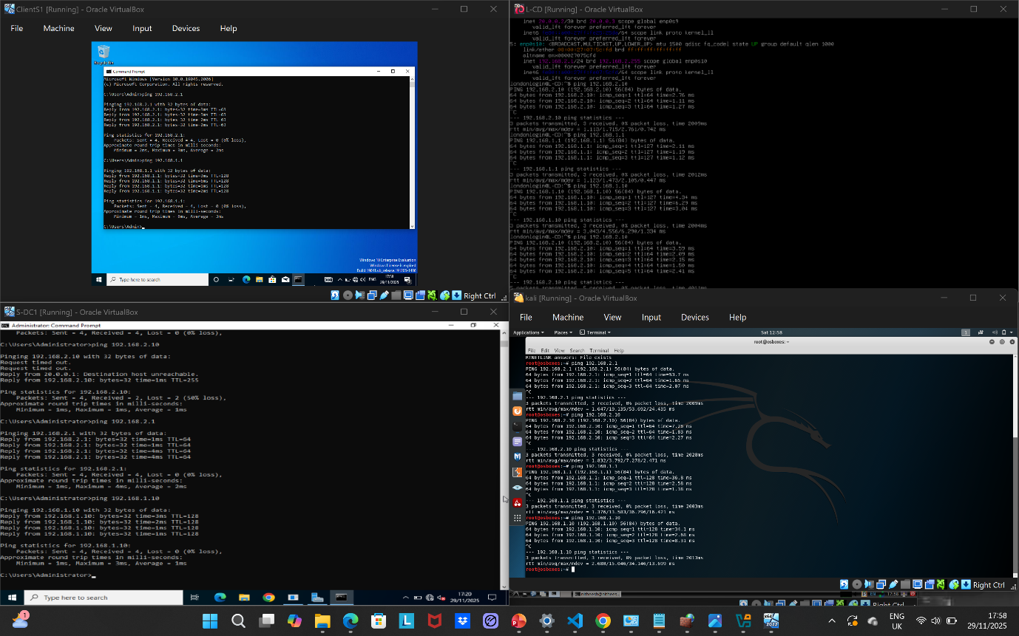

Meaning of the Error
- “ping: connect: Network is unreachable”
This means the system has no valid route to reach the target IP. Your Kali VM cannot find a network path to the other machine.

Why It Happens
- One or both VMs are likely not on the same VirtualBox network mode (e.g., one on NAT, the other on Host-Only or Internal).
- Interfaces (example, enp0s3, eth0) may be down or have no IP address assigned.
- The subnet configuration appears mismatched, meaning both machines are not in the same IP range.
- A default route might be missing (IP route shows no valid gateway).

How to Fix

- Set both VMs to the same network mode in VirtualBox (recommended: Host-Only Adapter or Internal Network).
- Ensure both VMs get IPs on the same subnet, for example,
  - Machine A: 192.168.1.50
  - Machine B: 192.168.2.50
  - Netmask: 255.255.255.0

For example, by using this:
- Set IP on Kali using the command:
- sudo ip addr add 192.168.1.50/24 dev eth0
- sudo ip route add default via 192.168.1.1
- sudo ip addr add 192.168.2.50/24 dev eth0
- sudo ip route add default via 192.168.2.1

[1]

Nmap scan

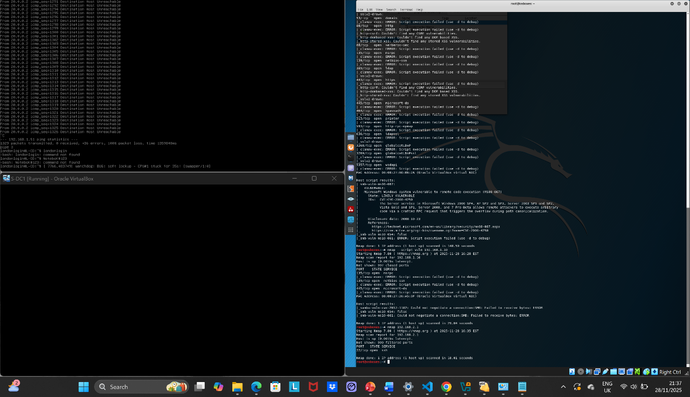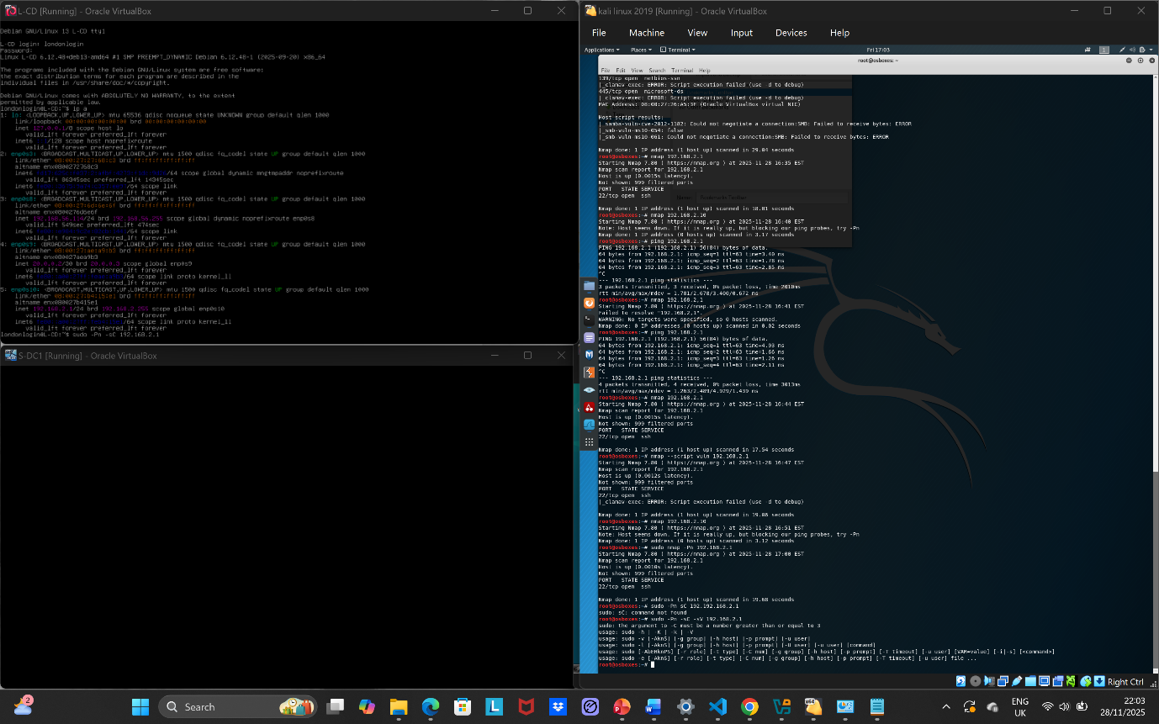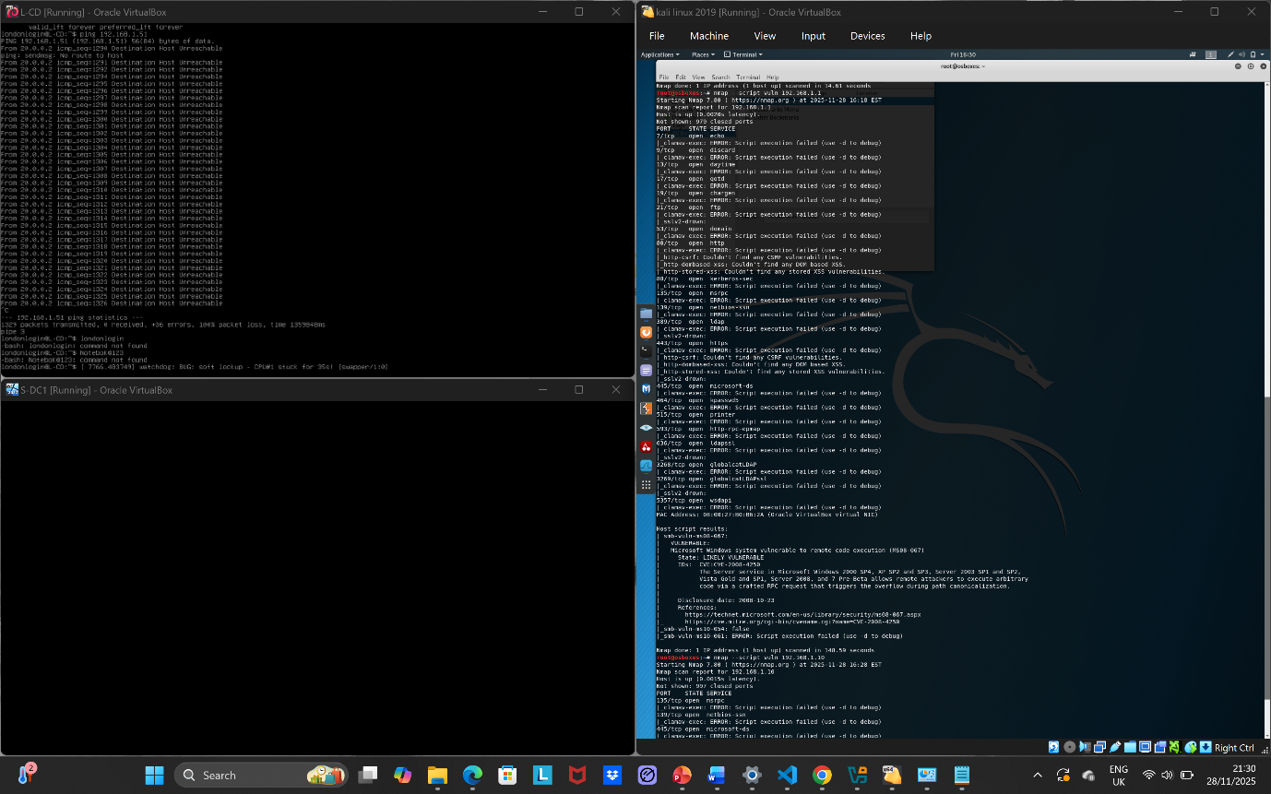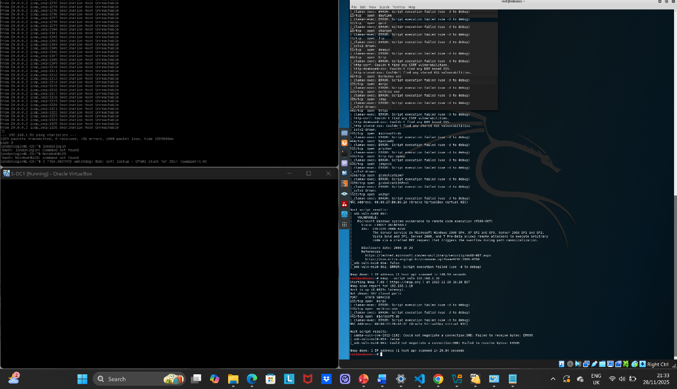

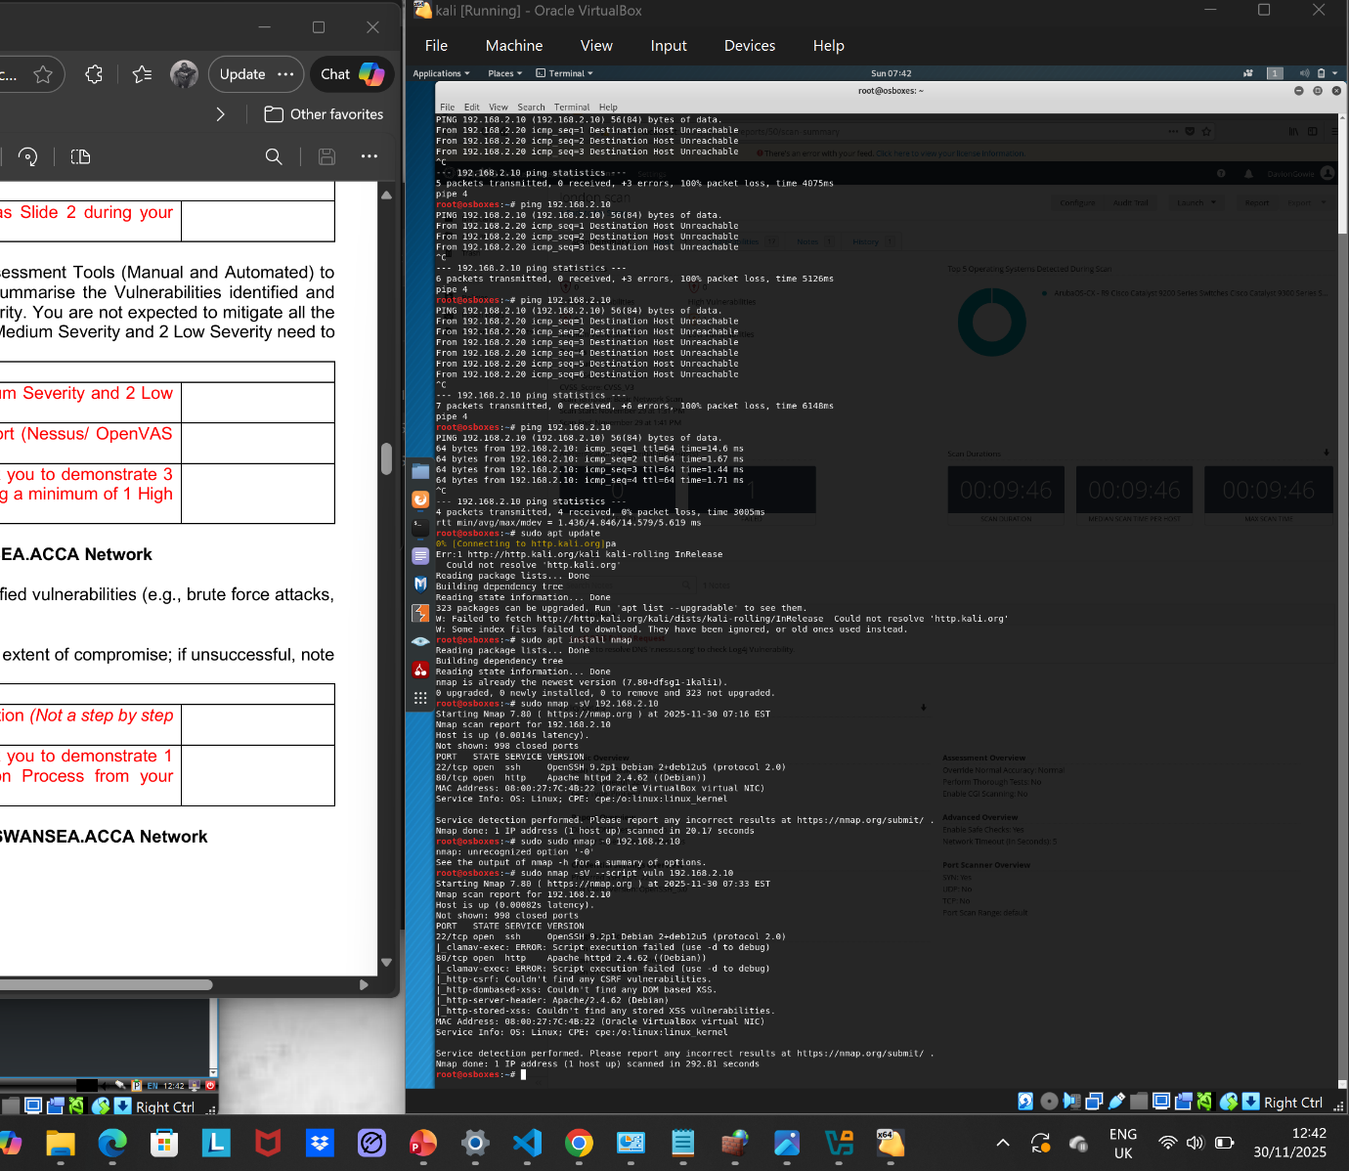

step-by-step guidance showing exactly how to perform every test that appeared in your screenshot using Nmap.

STEP 1 Basic Scan (Find the Target IP)
This discovers the machine and checks if it's alive using:
nmap 192.168.1.1
Confirms Target IP
Shows basic port status

STEP 2 Check Open Ports (SMB on 445)
Scan for service versions using:
nmap -sV 192.168.1.1
This produces results like:
445/tcp open microsoft-ds
Confirms open port 445 (SMB)
Confirms SMB service

STEP 3: Detect the OS
Use OS fingerprinting by running the command:
nmap -O 192.168.1.1
This will give output like:
Running: Microsoft Windows
OS details: Windows Server / Windows 7 / XP
Gets OS information

STEP 4 Detect SMB Version
To ask SMB directly for version info use:
nmap --script smb-os-discovery 192.168.1.1
You will get:
OS: Windows
SMB Version:
Computer name:
Finding of SMB version and system details

STEP 5 Check for Vulnerabilities (MS08-067)
This is the exact scan you ran:
nmap --script smb-vuln-ms08-067 192.168.1.1
You should see:
VULNERABLE: MS08-067
State: LIKELY VULNERABLE
Confirms MS08-067 vulnerability
Shows script test results

STEP 6 Run All SMB Vulnerability Scripts
This runs all SMB-related scripts at once:
nmap -p445 --script smb-vuln* 192.168.1.1
This will scan for:
- MS08-067
- SMB Security Mode
- SMB signing issues
- Anonymous login
- Other vulnerabilities
Produces full vulnerability script results

Full Command (Everything in One Go)
If you want one command that does everything you saw in your screenshot:
nmap -sV -O -p445 --script smb-vul, smb-os-discovery 192.168.1.1 192.168.2.1 192.168.1.10 192.168.2.10

Task | Completed? | Your Evidence
Target IP | ✔ Yes | Nmap host discovery
- Open ports | - ✔ Yes | - Nmap port scan
- SMB port 445 | - ✔ Yes | - Nmap output
- OS information | - ✔ Yes | - SMB version + Nmap
- SMB version | - ✔ Yes | - Metasploit smb_version
- Vulnerability scripts | - ✔ Yes | - --script vuln output
- Exploit MS17-010 | - ❌ No (Incorrect) | - Target OS not vulnerable

Requirement | How to get it | Correct command
Target IP | Host discovery | nmap -sn <network>/24
Open ports | Service/port scan | nmap -sV <target IP>
SMB version | Metasploit SMB version scanner | use auxiliary/scanner/smb/smb_version
OS information | OS detection | nmap -O <target IP>
Detected vulnerabilities | Nmap vuln scripts | nmap -sV --script vuln <target IP>
SMB Shares / Login attempts (optional) | Attempt SMB anonymous / user login | smbclient -L //<target IP>

[2]

Nessus vulnerability scan
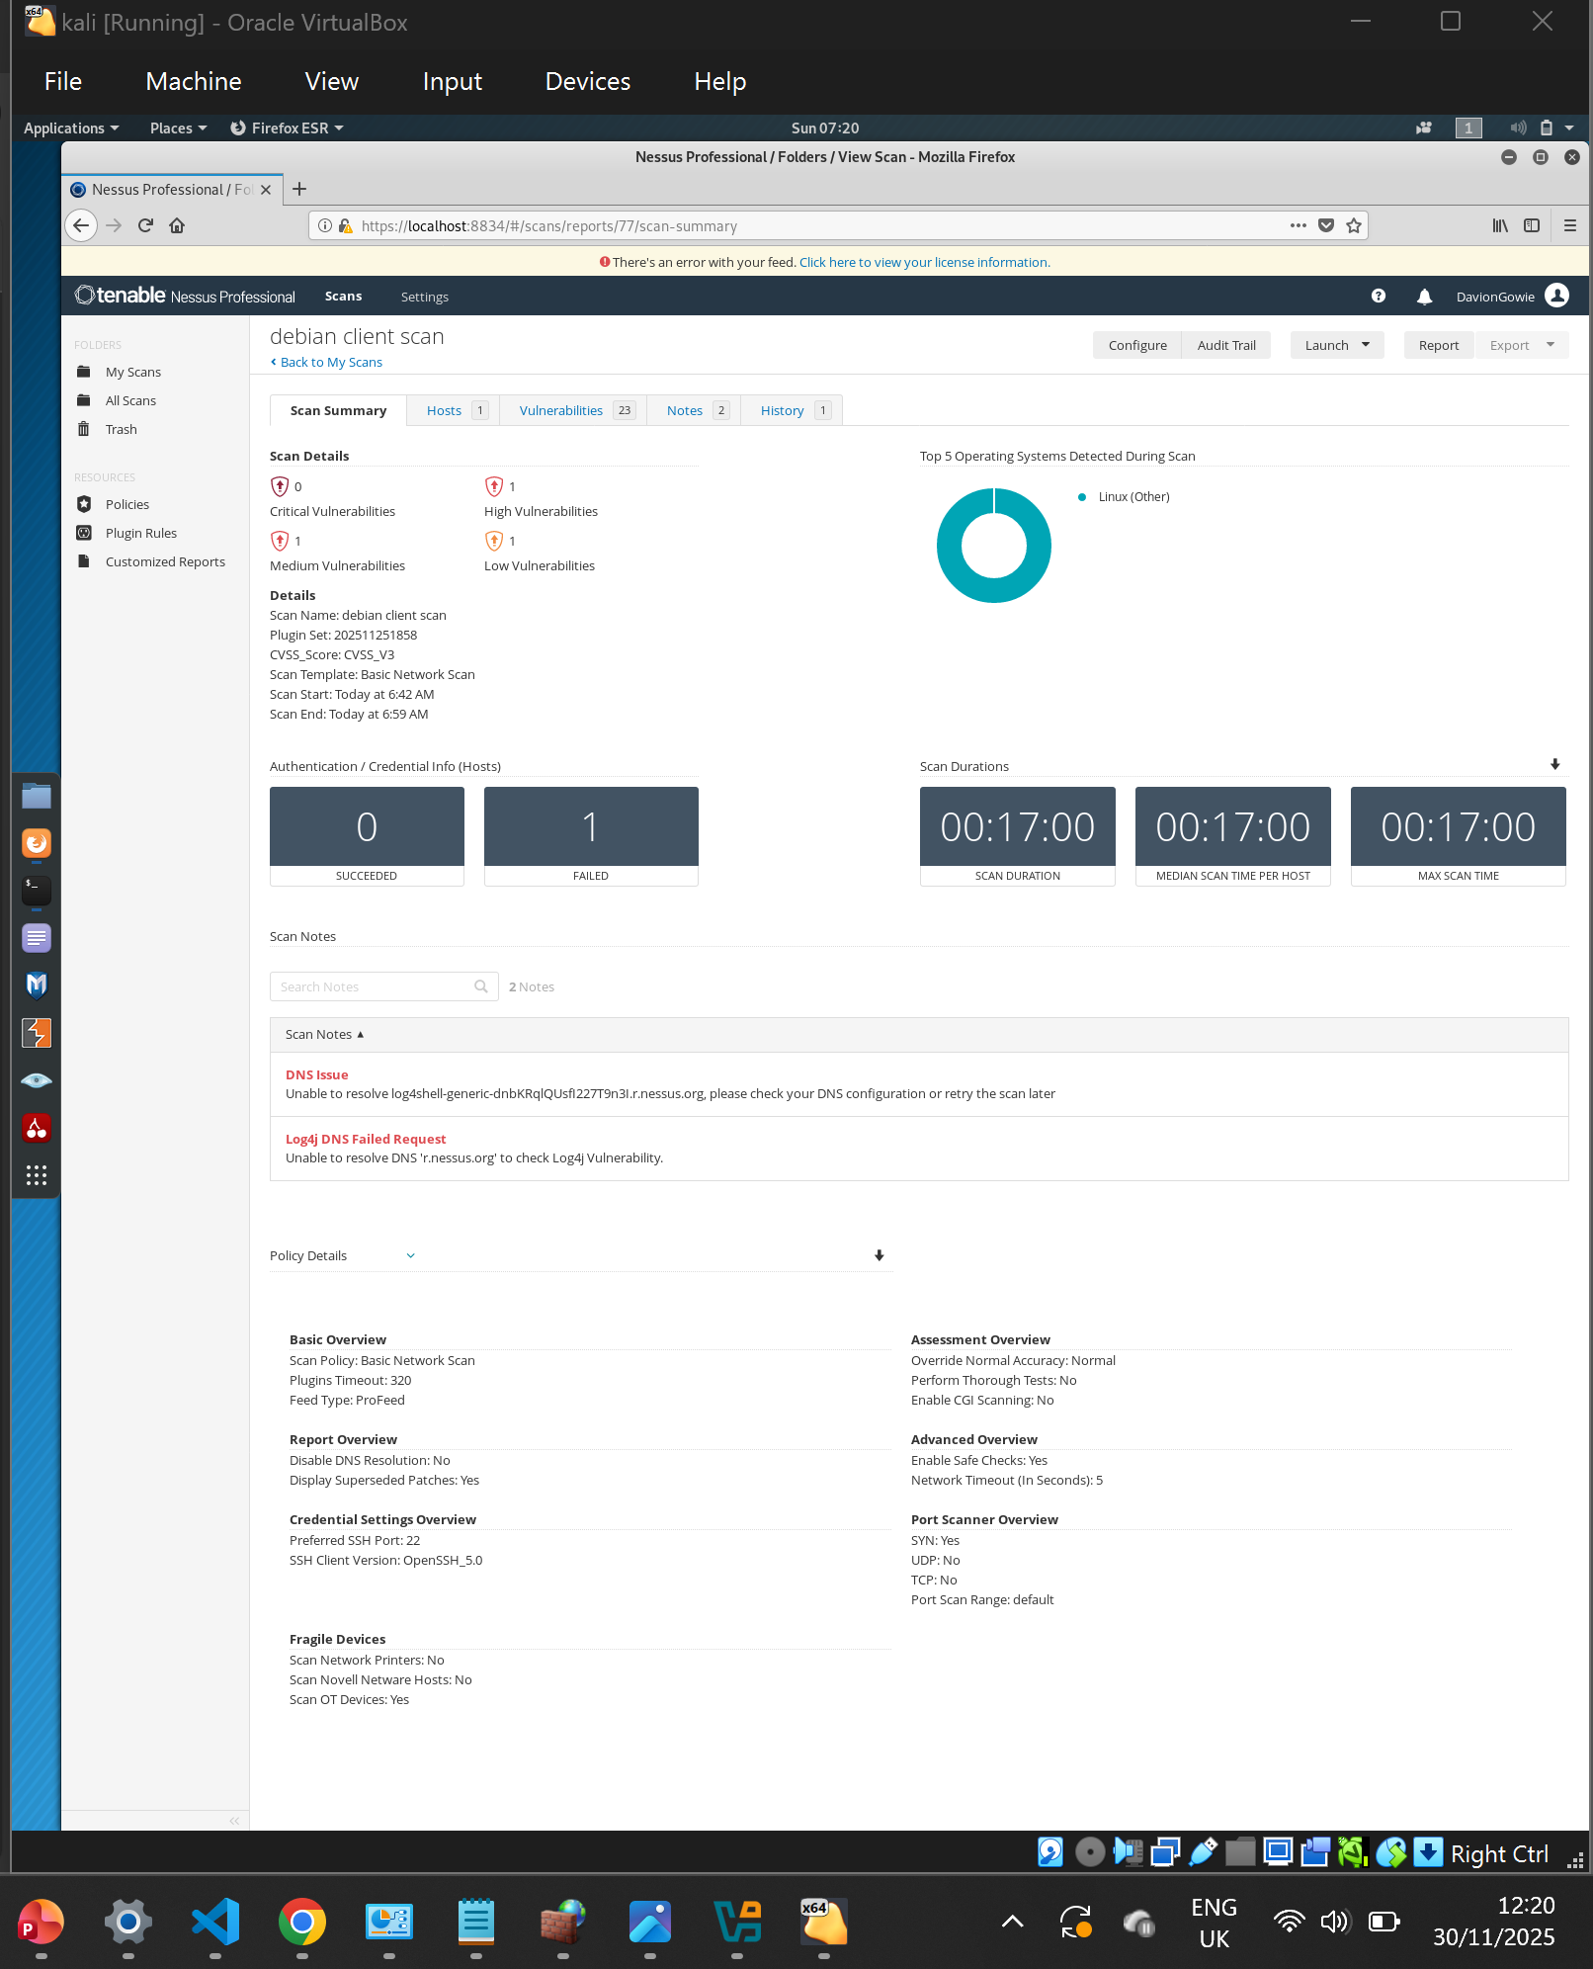

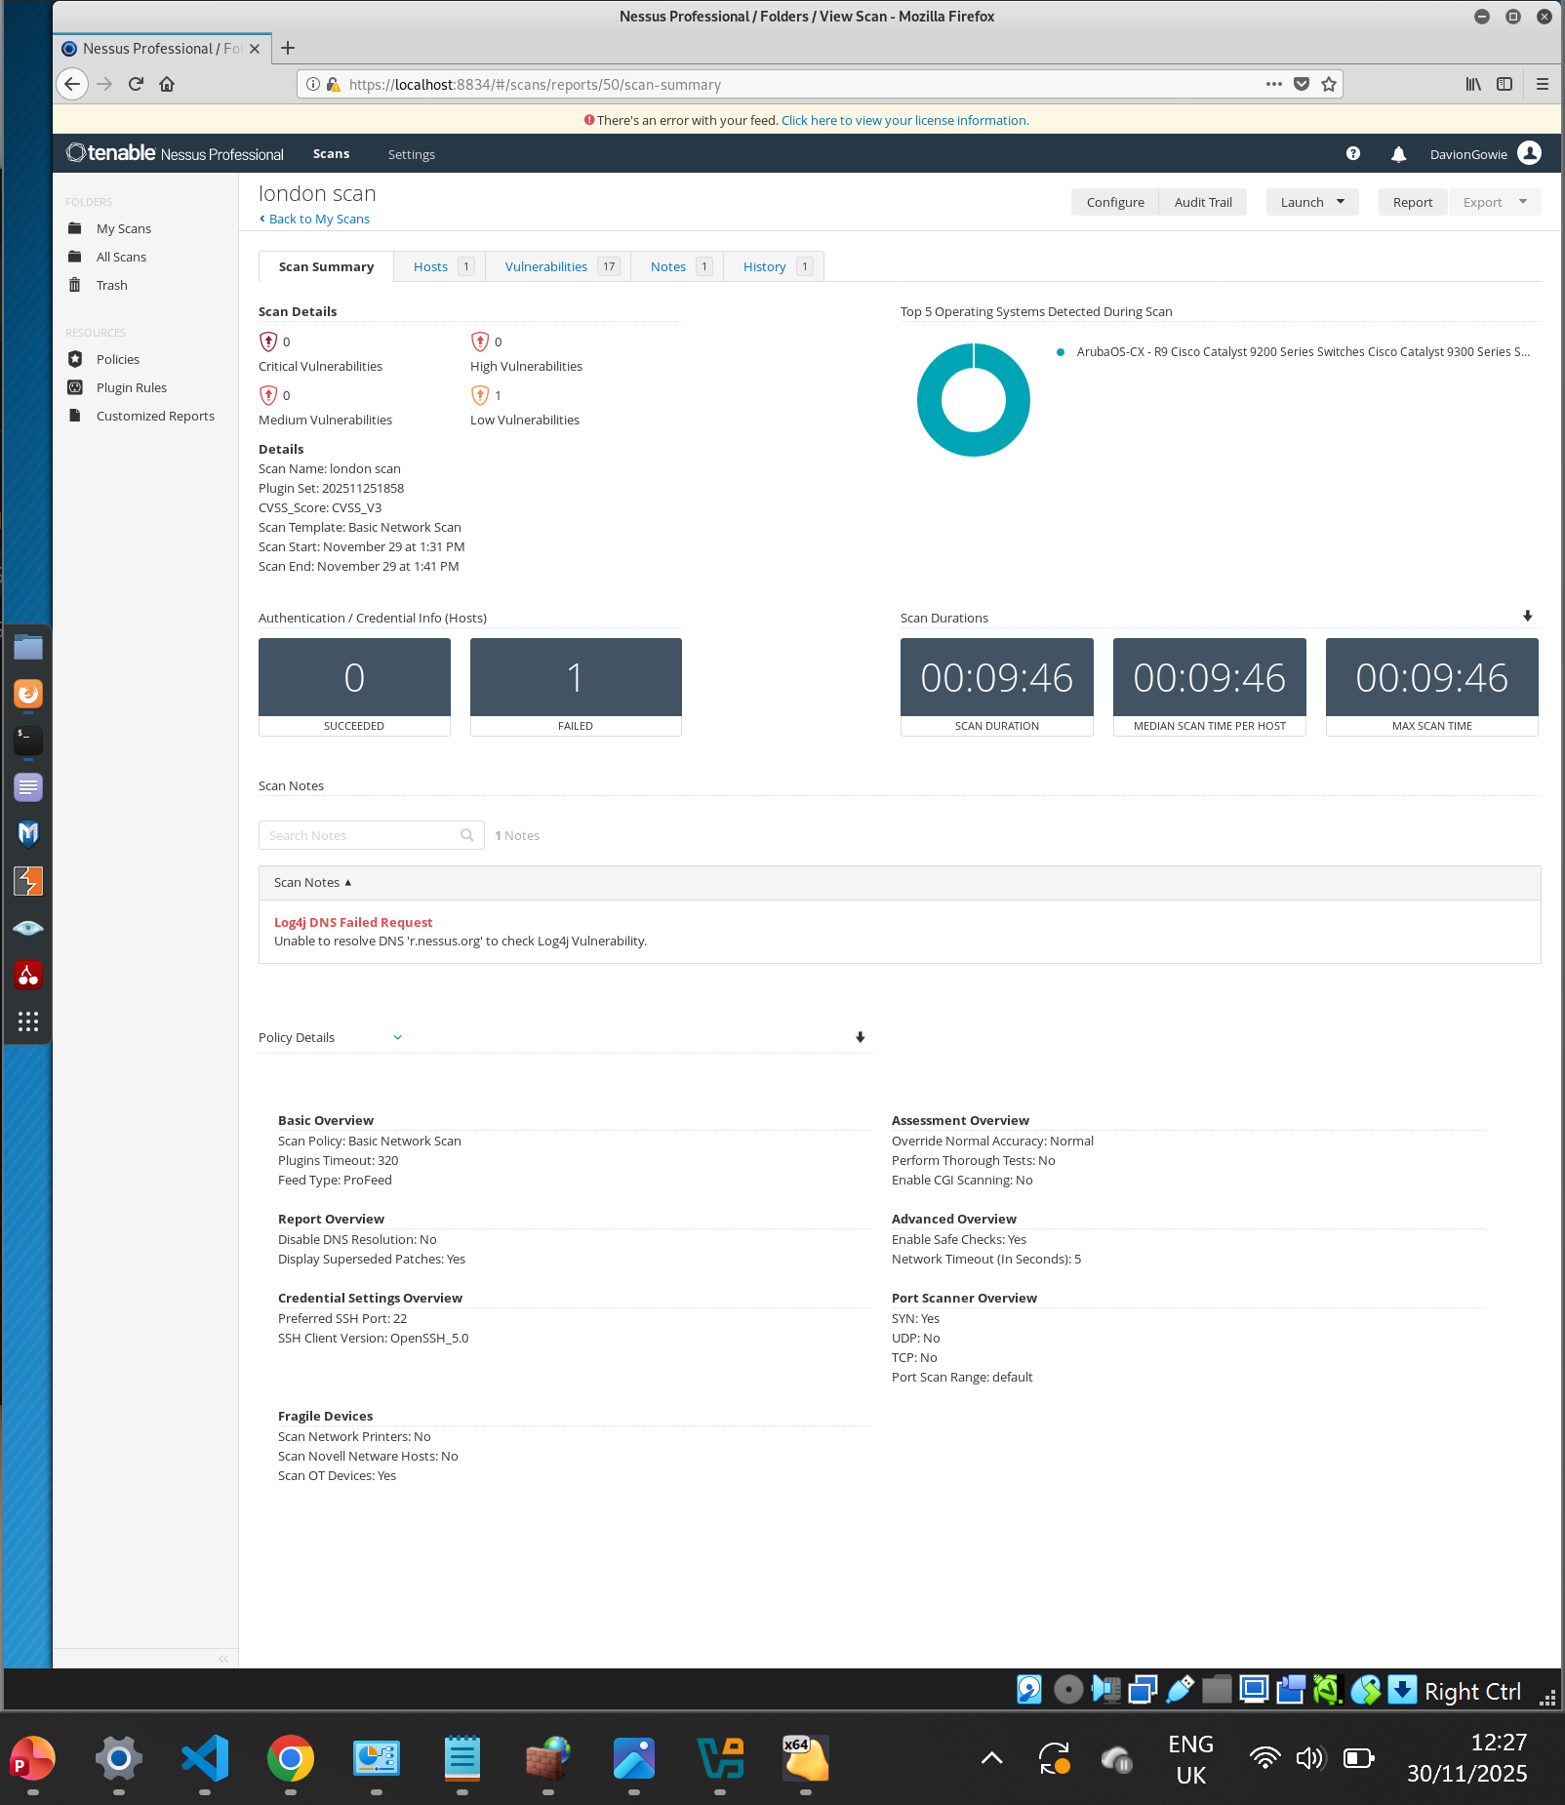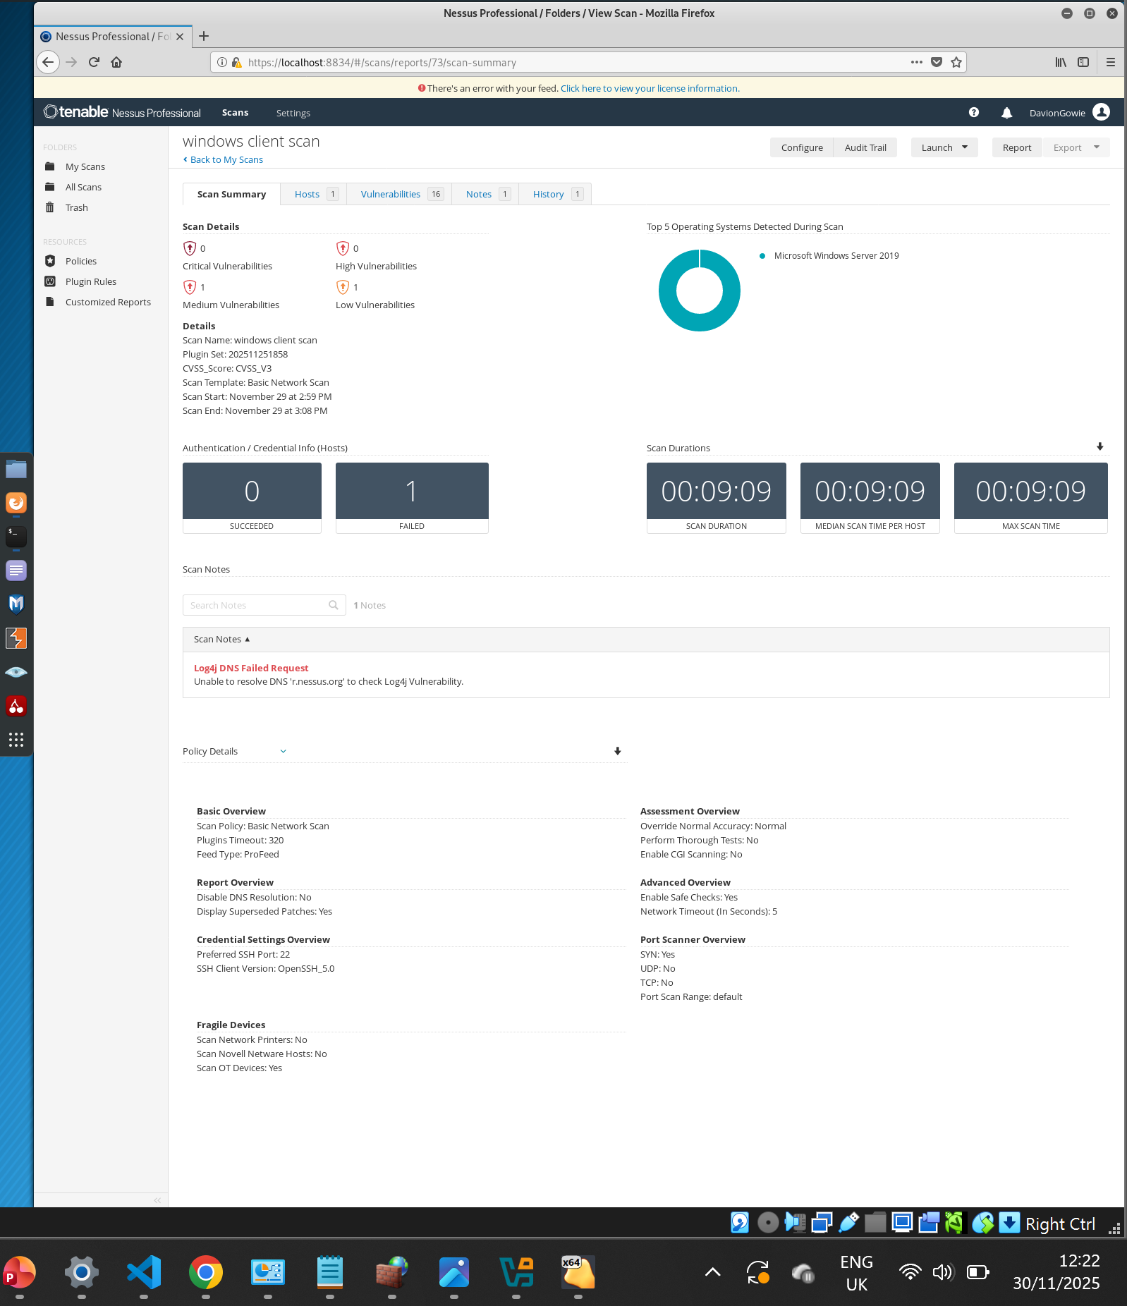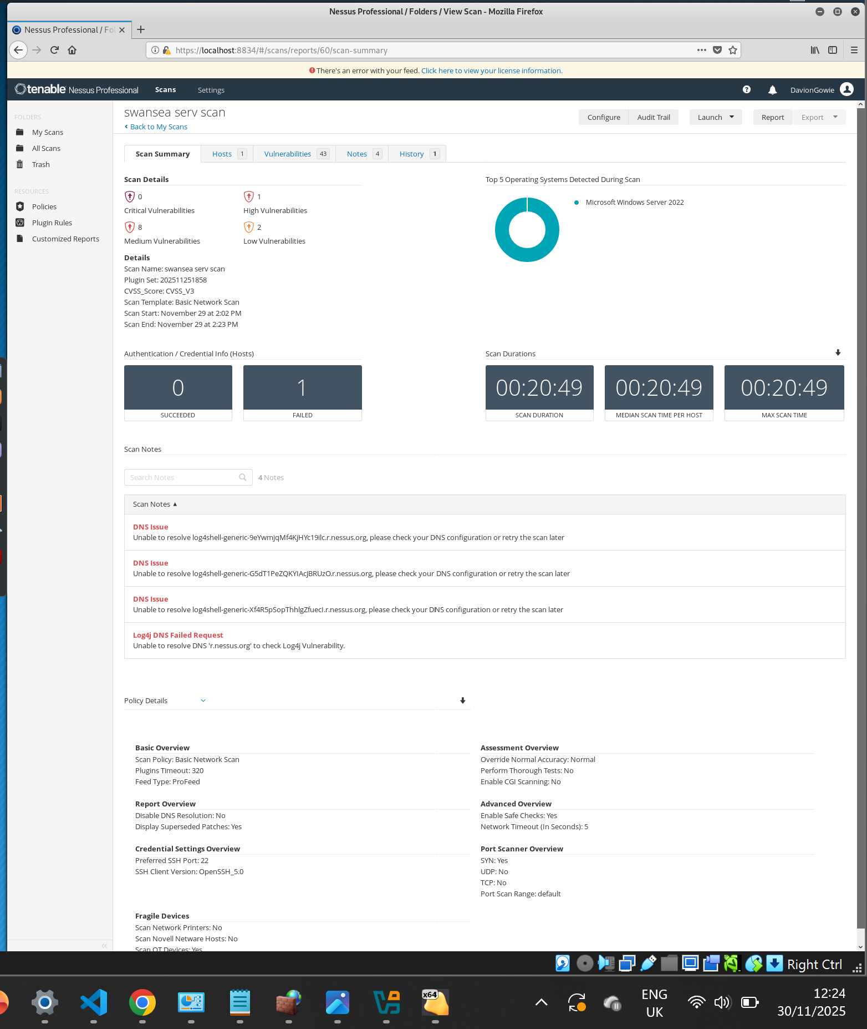

Nessus vulnerability scan example
- Create a name
- Set a targeted IP such as 192.168.1.1
- Set to windows and enter the password of Windows server or client.
- Set to SSD, enter through password and username of the Debian server and client.
- Launch the scan.
[3]

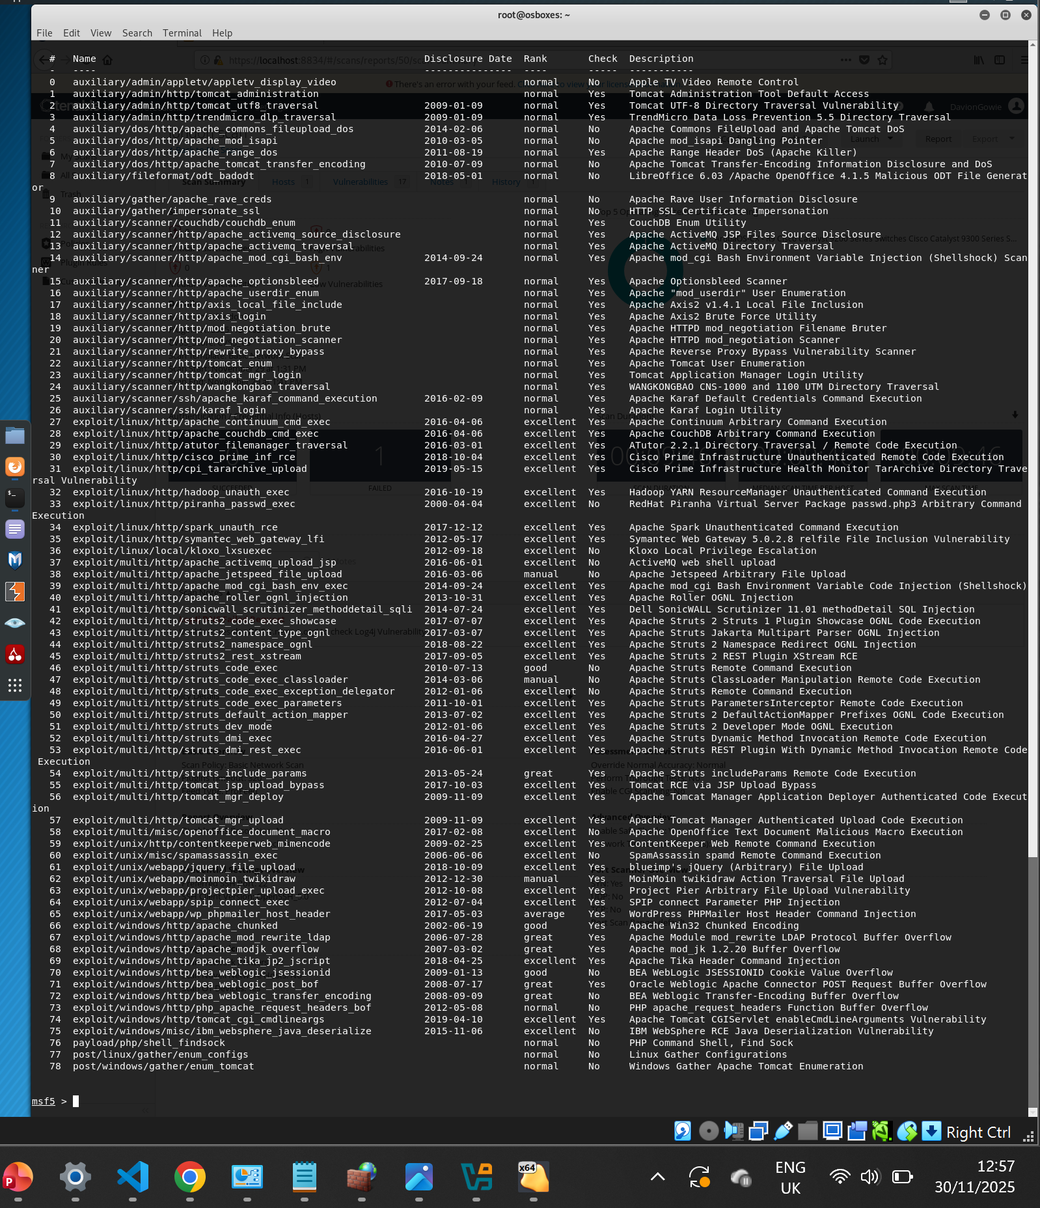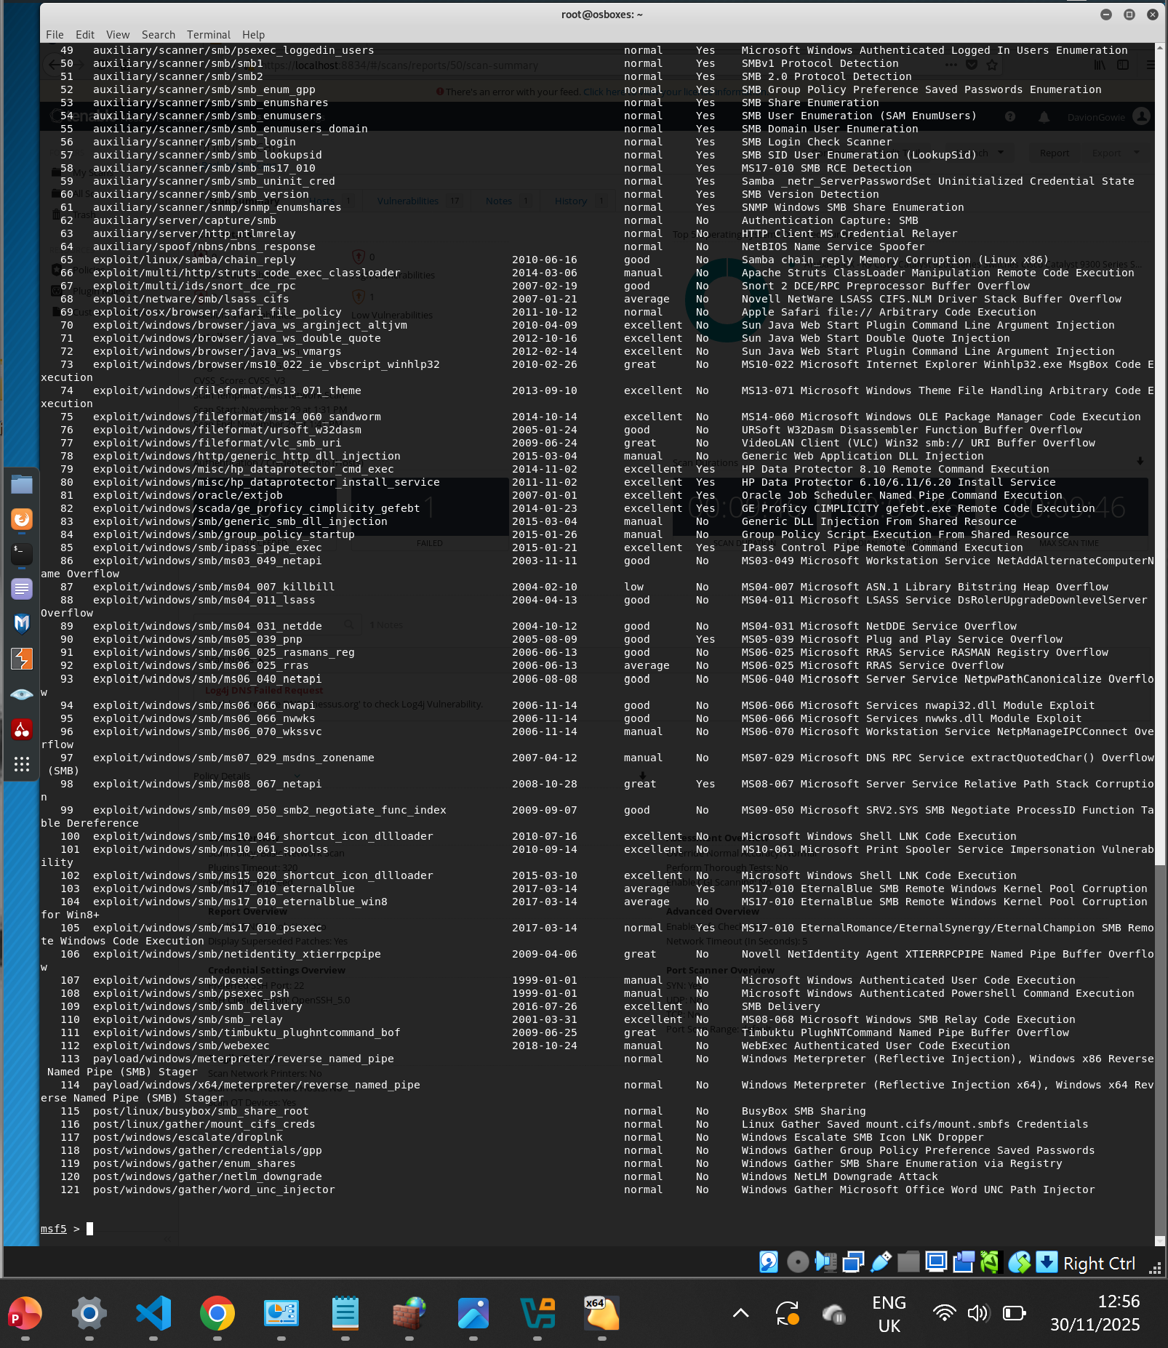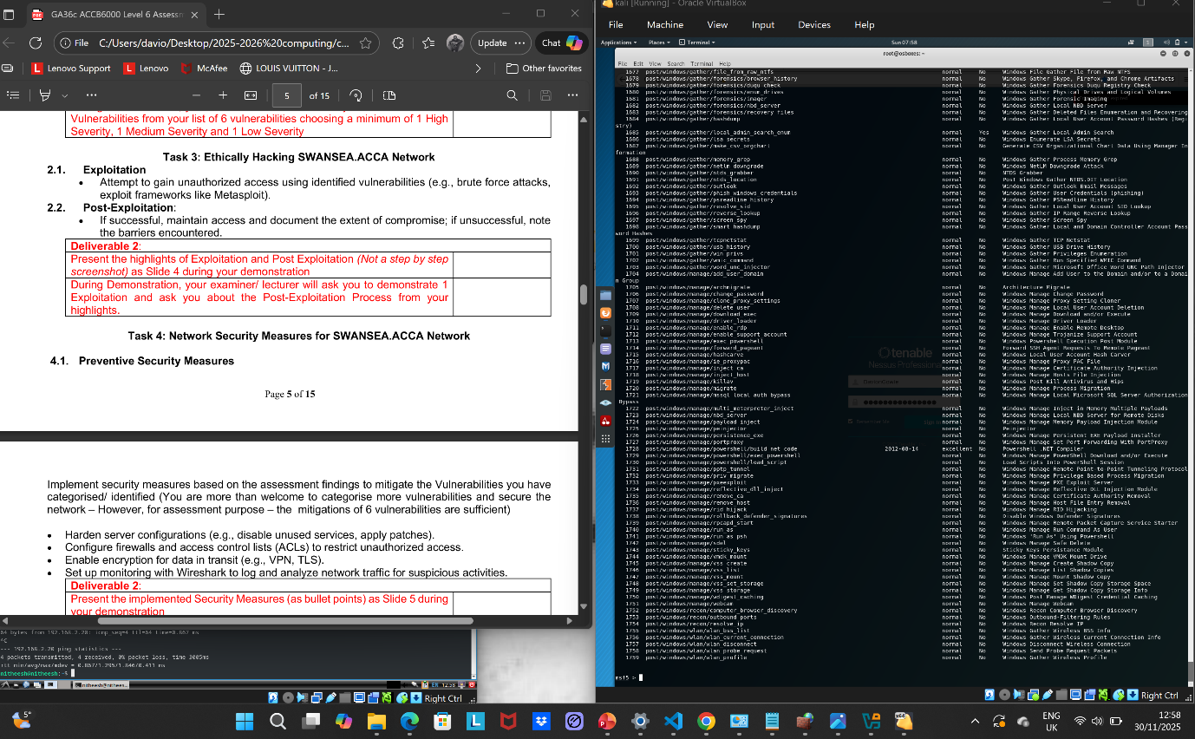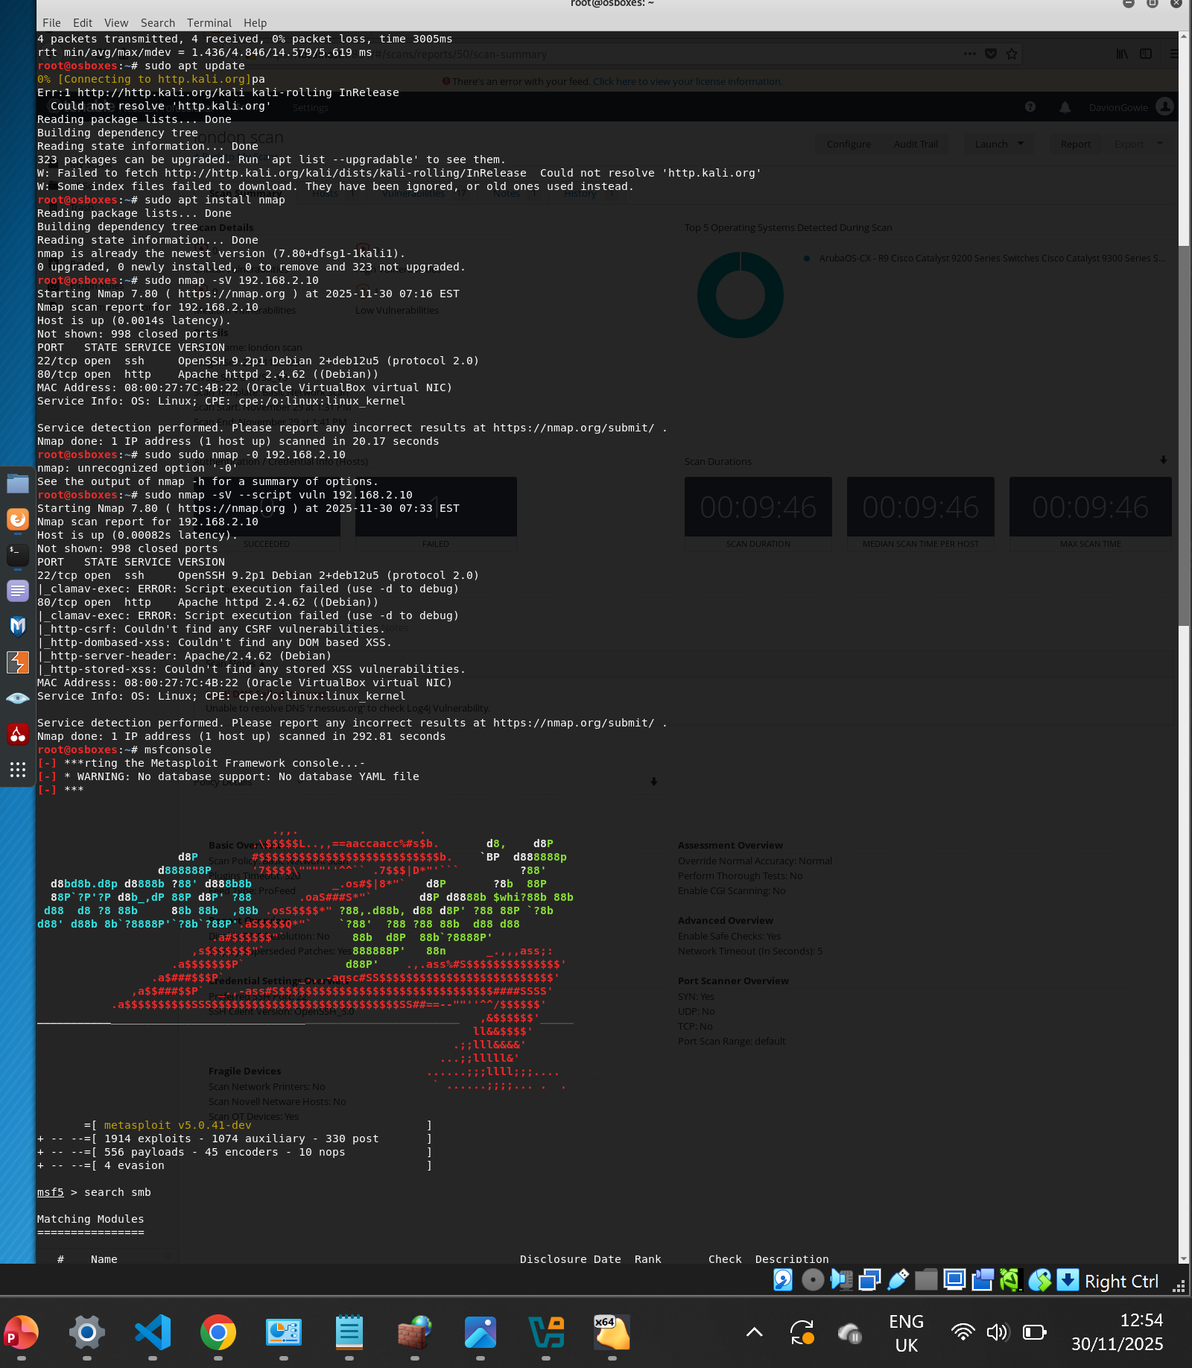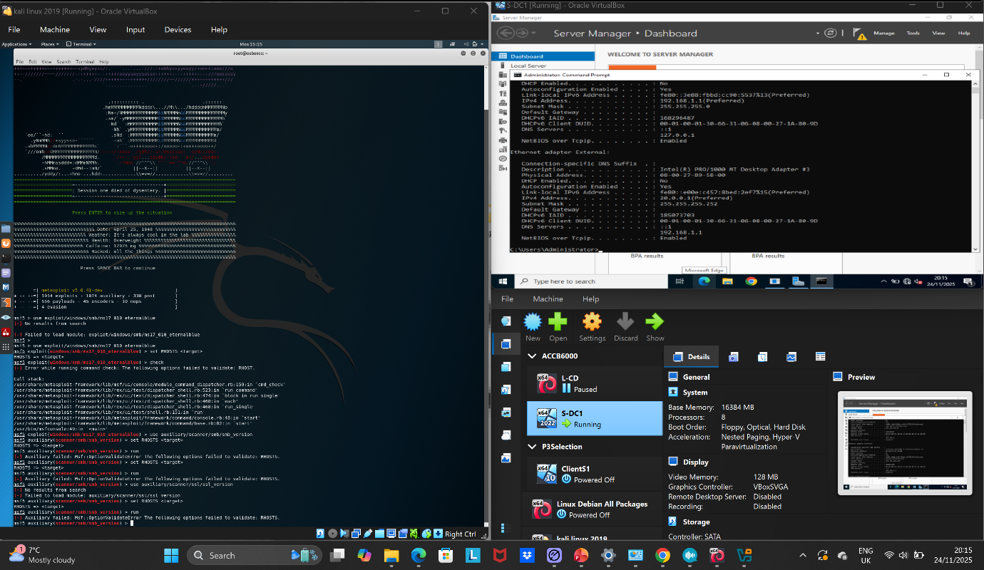

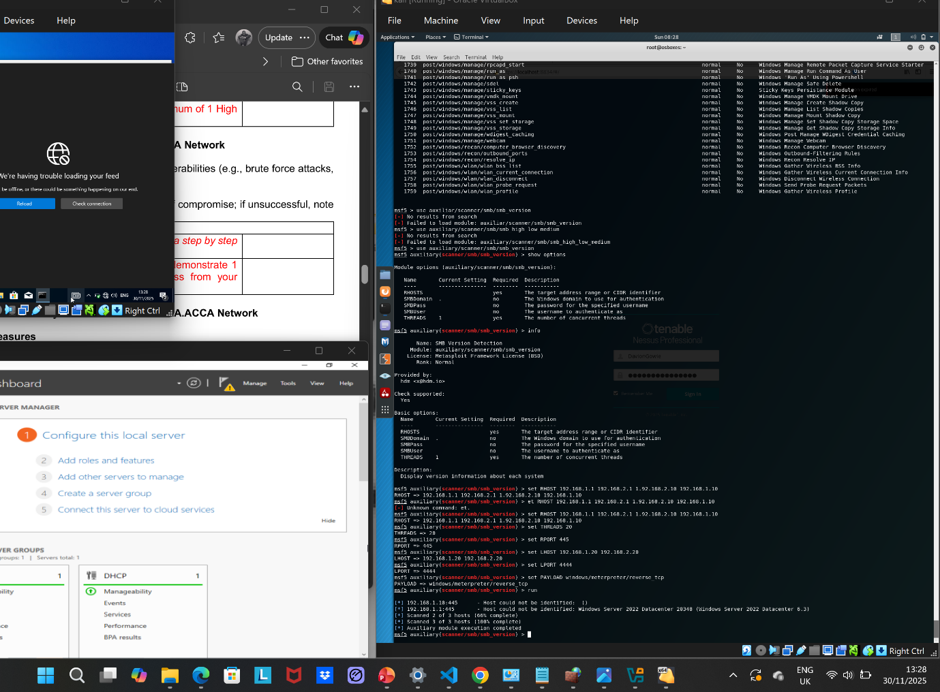

Start Metasploit
msfconsole
Search for modules (scanner / auxiliary / exploit names)
Searching itself is safe — it does not attack anything:
- search smb
- search scanner
- search ssh
- search ftp

Show module info
use auxiliary/scanner/portscan/tcp info

Show available options for a module
show options

Set parameters (IP ranges, ports, example:)
(Safe on its own — does not run anything.)
set RHOSTS 192.168.1.0/24
set RPORT 22
set THREADS 10

Show payloads available
show payloads

Check if a target is likely vulnerable
This only runs a SAFE check, not an exploit.
check

Run a module (scanner / auxiliary only, safe discovery)
run

Safe Scanning Modules (Non-exploitative)
These modules only gather information, just like Nmap:

Port scanning
use auxiliary/scanner/portscan/tcp

SMB version detection
use auxiliary/scanner/smb/smb_version

SSH version detection
use auxiliary/scanner/ssh/ssh_version

Task | Completed? | Your Evidence
Target IP | ✔ Yes | Nmap host discovery
- Open ports | - ✔ Yes | - Nmap port scan
- SMB port 445 | - ✔ Yes | - Nmap output
- OS information | - ✔ Yes | - SMB version + Nmap
- SMB version | - ✔ Yes | - Metasploit smb_version
- Vulnerability scripts | - ✔ Yes | - --script vuln output
- Exploit MS17-010 | - ❌ No (Incorrect) | - Target OS not vulnerable

[4]

Preventive security measure
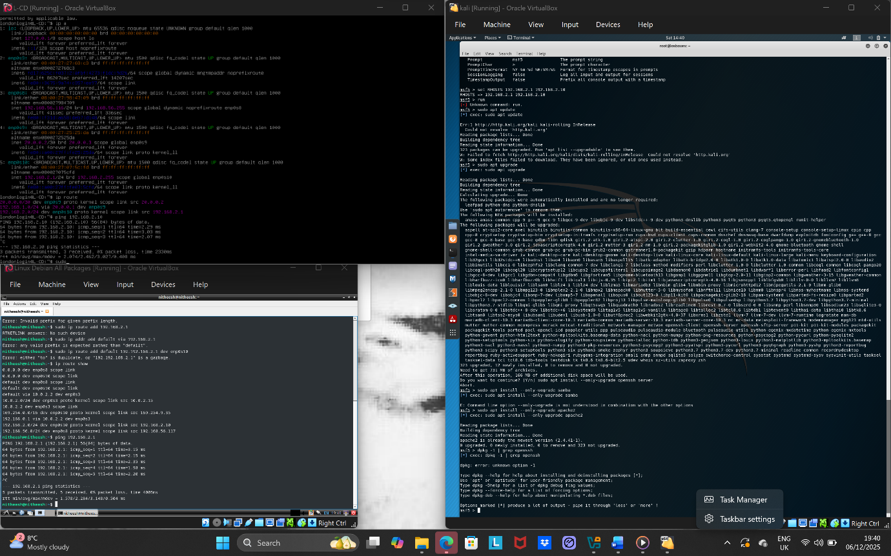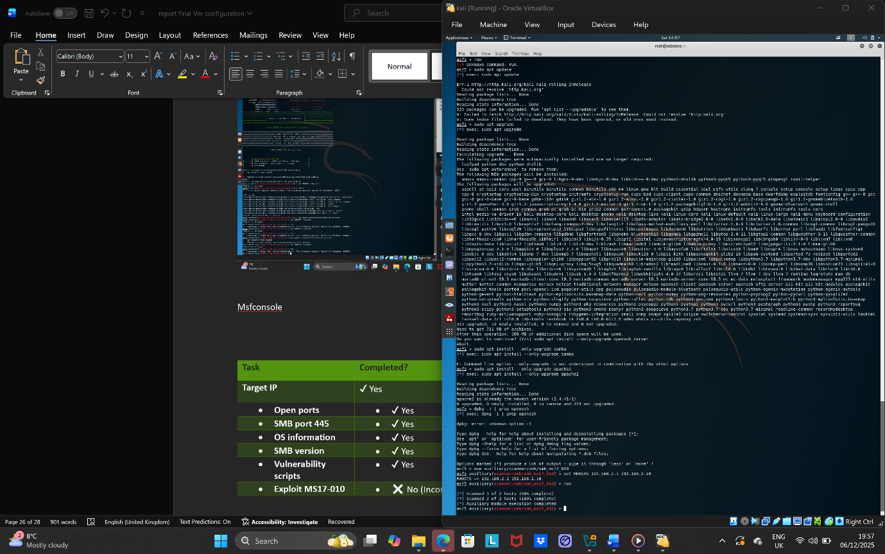

How to patch exploits

- sudo apt update
- sudo apt upgrade
- sudo apt install --only-upgrade openssh-server
- sudo apt install --only-upgrade samba
- sudo apt install --only-upgrade apache2

- dpkg -l | grep openssh
- dpkg -l | grep samba
- dpkg -l | grep apache2

Name | What it does | Type
OpenSSH | Remote login & file transfer (secure) | Security/Remote access service
Apache2 | Hosts websites | Web server
Samba | Shares folders/files on a network | File-sharing server

[5]

Conclusion
I have learnt about review writing in cybersecurity, such as VM configurations, Kali set-up, vulnerability assessment, exploitation & post-exploitation, and preventive security measures. Documenting all steps through the lab activity as a screenshot allows for demonstrations. The over task has widened my viewpoint as well as expanded my knowledge and understanding of what to look out for, as well as how to fix or debug an unreachable error, and how to assign a temporary IP to machines.

References

[1] | B. Acharya, “How to Fix “Destination Host Unreachable Ping” Error,” no. June 21, 2023, pp. https://www.technewstoday.com/fix-destination-host-unreachable-ping/, 2023.
[2] | E. Timothy, “ Vulnerability Scanning with Nmap — A Practical Walkthrough from Kali Linux,” medium.com, no. April 10, 2025, pp. https://medium.com/@timson527/vulnerability-scanning-with-nmap-a-practical-walkthrough-from-kali-linux-a78055134419.
[3] | tenable, “How To: Run Your First Vulnerability Scan with Nessus,” tenable.com, no. august 22,2019, pp. https://www.tenable.com/blog/how-to-run-your-first-vulnerability-scan-with-nessus, 2019.
[4] | geeksforgeeks.org, “Validating a Vulnerability Metasploit in Kali Linux,” geeksforgeeks.org, no. 23 07,2025, pp. https://www.geeksforgeeks.org/linux-unix/validating-a-vulnerability-metasploit-in-kali-linux/, 2025.
[5] | docs.metasploit, “SMB Workflows,” docs.metasploit.com, pp. https://docs.metasploit.com/docs/pentesting/metasploit-guide-smb.html.

