Title page

  - Table of contents
Contents
e-portfolio link : 3
Screenshot of task 1 4
Screen shot of mind map 5
Screenshot of the academic poster 7
Screenshot of automatic referencing tool 10
Screenshot of each page of e-portfolio 11

e-portfolio link :
  - screenshot of e-portfolio cover page/ welcome page
McKauley-Manning.co.uk
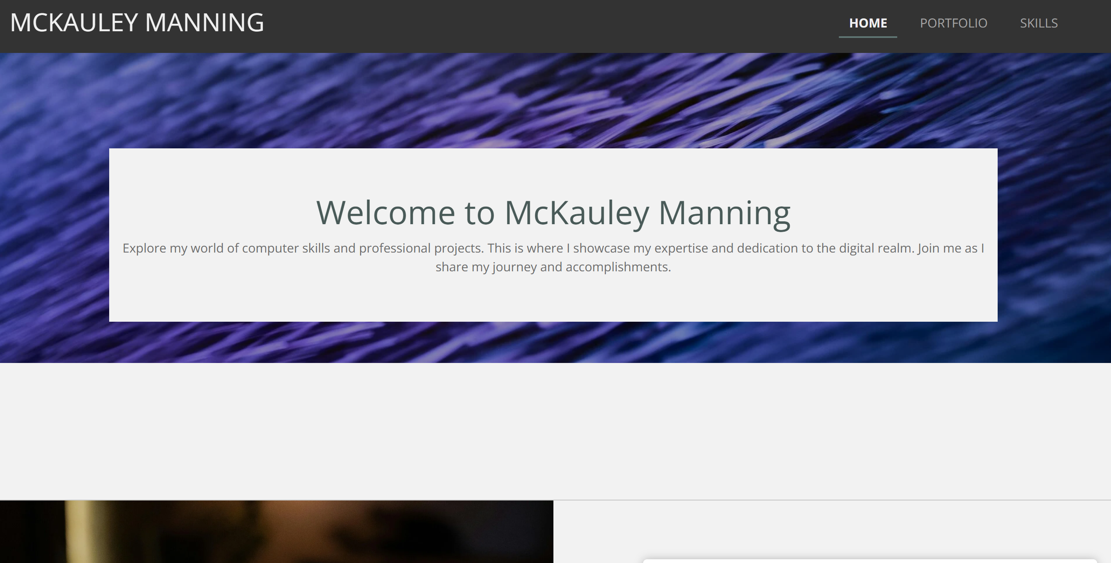
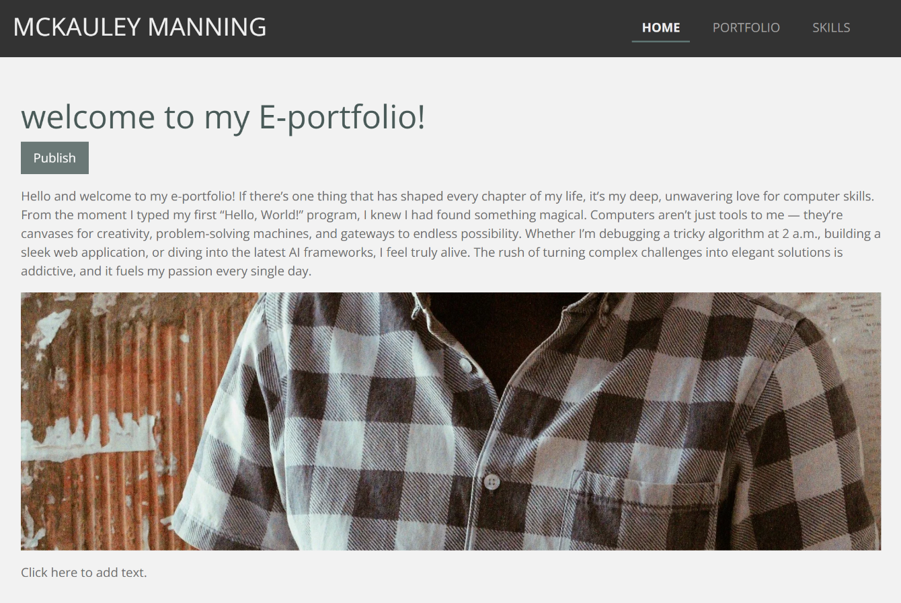

Screenshot of task 1
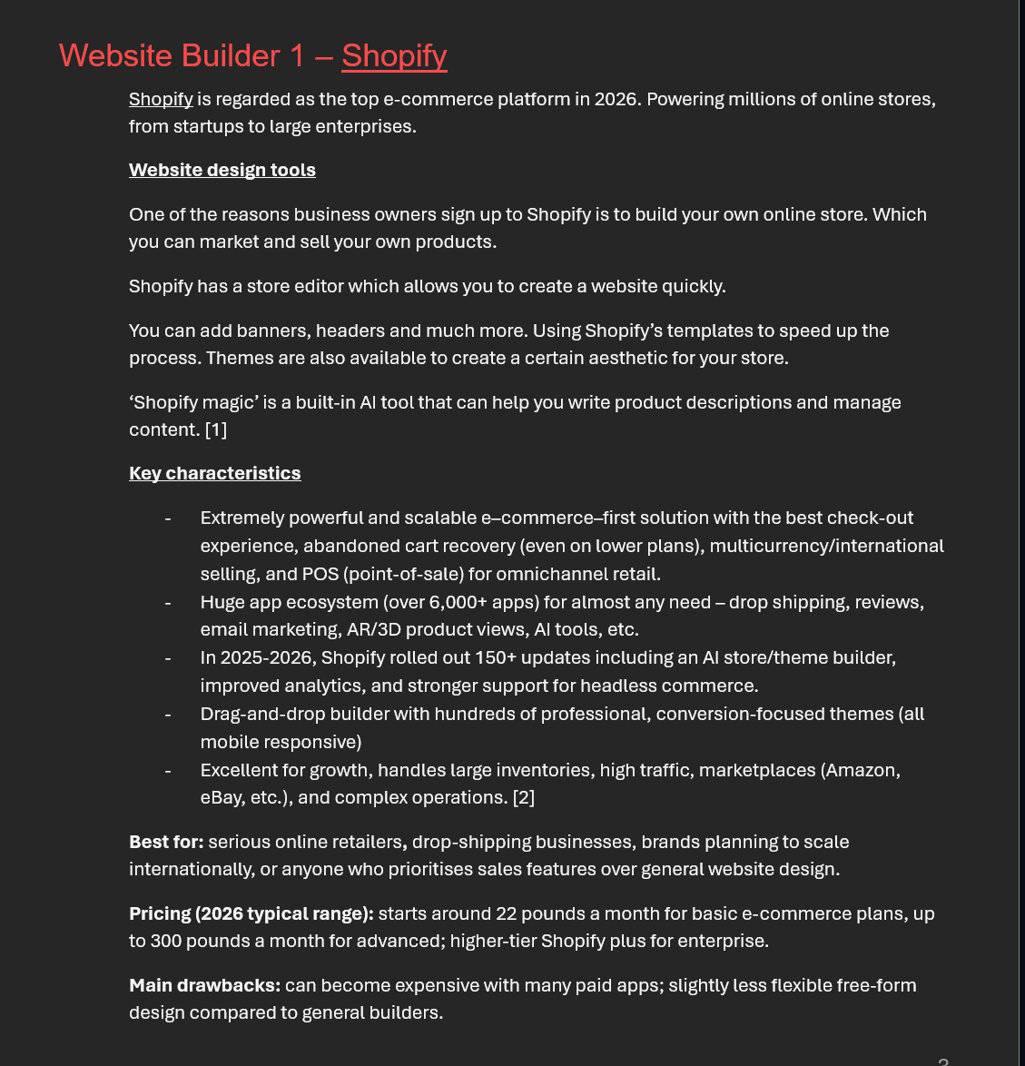

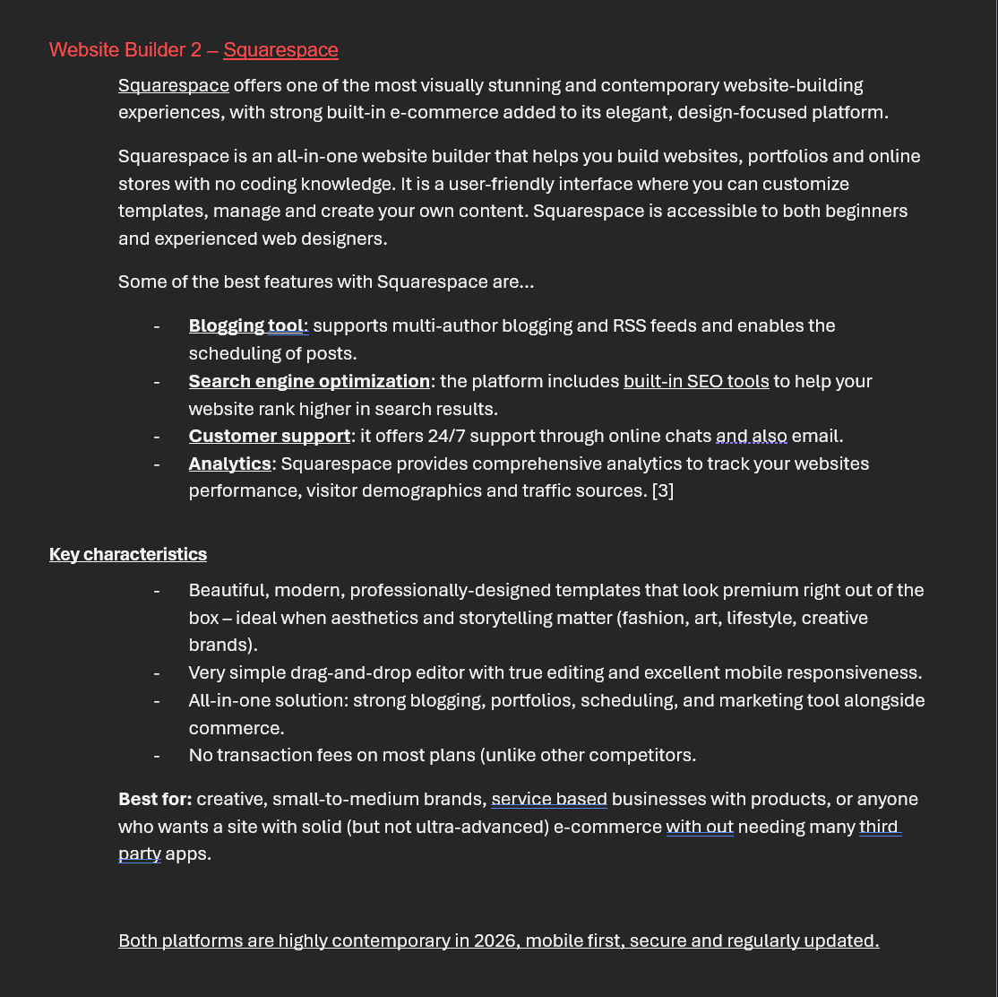

Screen shot of mind map
  - Link to mind map

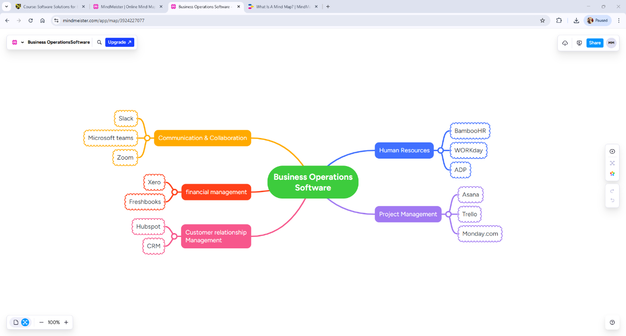

Screenshot of the academic poster

  - And link

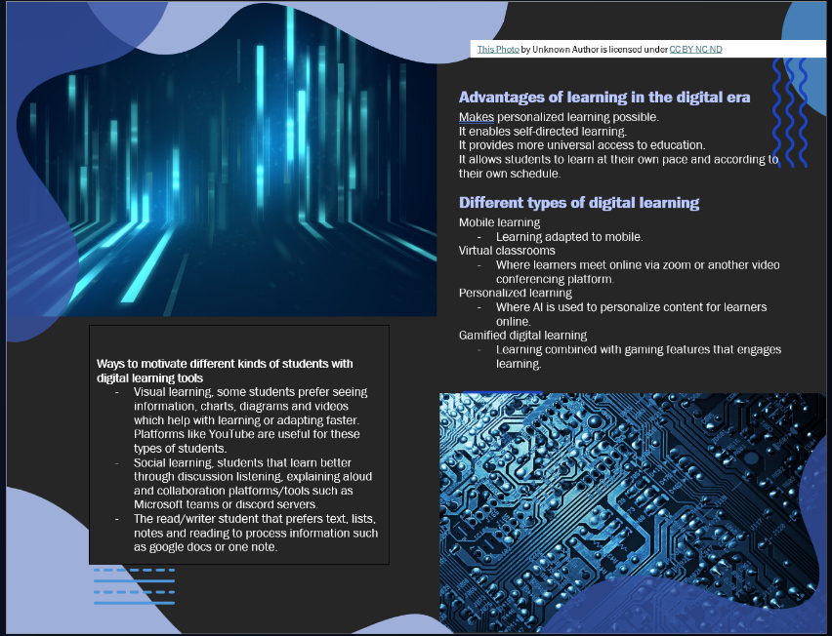

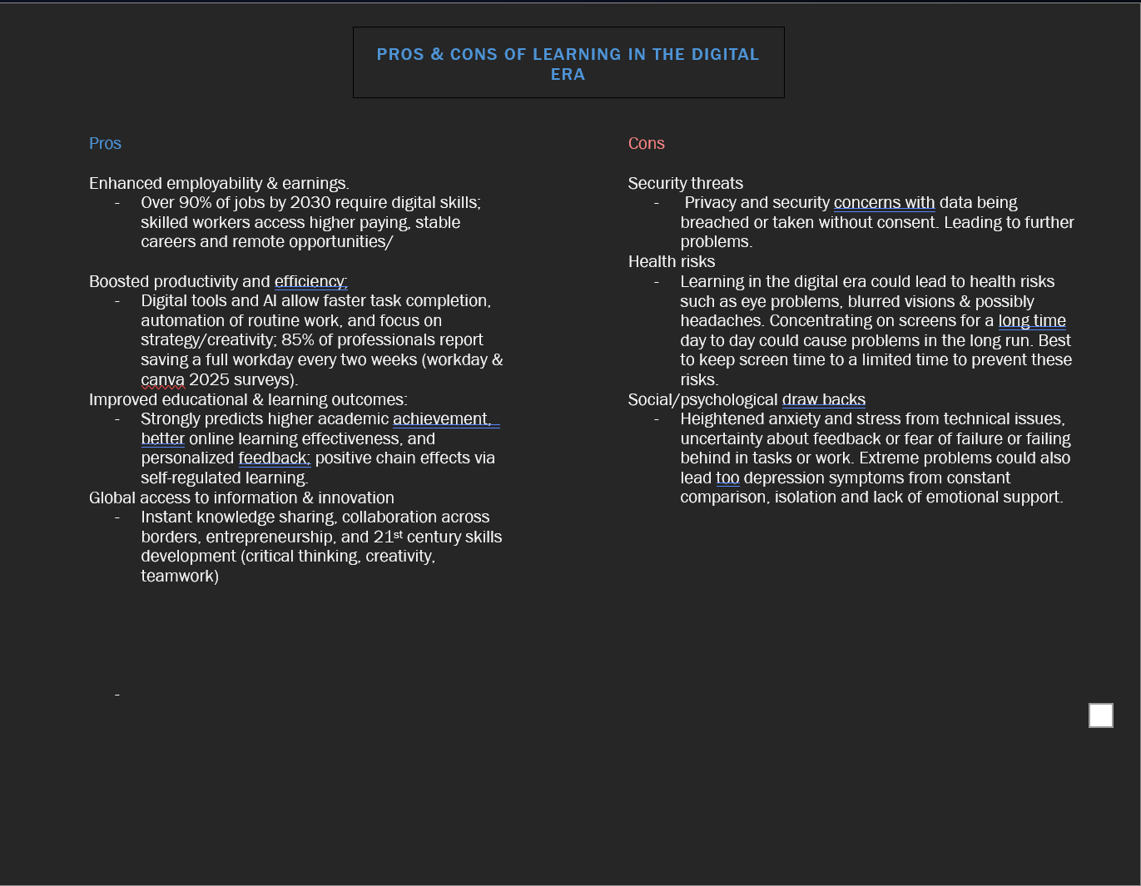

Screenshot of automatic referencing tool

Screenshot of each page of e-portfolio



