Master’s Degrees by Examination and Dissertation
Declaration Form
1. This work has not previously been accepted in substance for any degree and is not being concurrently submitted in candidature for any degree.
Name..……Sian Moran
………………………………………………………………………...
Date …31 August 2022………………………………………………………………………...

2. This dissertation is being submitted in partial fulfilment of the requirements for the degree of ………Master of Arts…-Local History………………………………………………..................................
Name… …Sian Moran …………………………………………………………………….
Date 31 August 2022…………………………………………………….…………..…………...

3. This dissertation is the result of my own independent work/investigation, except where otherwise stated.
Other sources are acknowledged by footnotes giving explicit references.
A bibliography is appended.
Name…Sian Moran …………: ……………………………………………….……………….
Date: …31 August 2022

4. I hereby give consent for my dissertation, if accepted, to be available for photocopying, inter- library loan, and for deposit in the University’s digital repository
Name…
Sian Moran
Date……31 August 2022……………………………………….……………………………..
Supervisor’s Declaration.
I am satisfied that this work is the result of the student’s own efforts.
Signed: Lester J Mason…………………………………………………………………………...
Date: …31 August 2022……………………………..

The Jews of Swansea

Siân E. Moran

Dissertation submitted in fulfilment
of an MA in Local History
University of Wales Trinity Saint David
Aug 2022

List of Contents Page

Abstract 1
Acknowledgements 3
Glossary 4
List of illustrations 5
List of maps 9
List of tables

Introduction 11
Aims, Methodology and Literature Review 14

Chapter One: 16
Chapter Two: 26

Chapter Three: 58

Conclusion 74

Appendices 75

Bibliography 111

In Memory of my mother
Mrs Shirley M Williams 1937-2021

Acknowledgements

I would like to thank my initial Tutor Conway Davies and his successor, Lester Mason for their help and advice. I would also like to thank the course Directors at the UWTSD, who allowed me to continue with my dissertation after I had to abandon it temporarily to care for my terminally ill mother, who was unexpectedly diagnosed with a brain tumour. I would also like to thank the staff at the West Glamorgan Archives, Swansea for their help during the period when the Archives were closed during the Covid-19 pandemic.

Glossary
spellings sometimes varies due to transliteration ot Hebrew and or Yiddish terms.

Achei Brit – the Jewish equivalent of a friendly society, providing insurance and mutual aid (translated as Brothers of the Covenant)
Allyah – call to te Reading of the Law
Ba'alei batim - A term that was in use in the nineteenth century to describe members of the congregation who through paid membership had full voting rights and were eligible to hold executive officer positions.
Baal Koreh – Reader of the Law
Baltekea – One who blows the ram’s horn
Baltifila - Reader
Barmitzvah – coming of age religious ceremony for boys who attain the age of thirteen
Bima – a centrally located, raised platform in the synagogue, from which the principal services are conducted.
B’nai B’rith (Children of the Covenant)
Brot – the ceremony of circumcision
Chazan – a Cantor or prayer leader
Cheder - The Hebrew religious school, usually attended by children in the evening and on Sundays.
Chevra – name for a small congregation (plural - chevrot)
Chupah – Wedding canopy under which the ceremony takes place
Ketubah – A marriage contract
Hazan- see Chazan
Matzos – the biscuits that are unleavened and eaten especially at Passover
Mikvah – Ritual bath
Minyan – Ten adult males aged 13 or over that are needed for a formal Jewish service, also sometimes used to describe a small congregation that meets regularly for prayer
Mohel – One who is qualified to perform circumcisions
Offerings – Gifts to the synagogue
Pesach – Passover festival, held in the spring to celebrate the exodus of Hebrew slaves from Egypt
Porger -Assistant Sochet
Rosh Hashannah - the Jewish New Year (in or around September), lasts two days.
Sephardi – A Sephardic Jew is descended from Jews from Spain and Portugal, but also sometimes used or Jews from the Middle East or the Orient
Shammas – Beadle
Shochet – Ritual slaughterer
Shul - Synagogue
Sifrei Torah – Scrolls of the Law
Torah – The first five books of the Bible
Yom Kippur – Day of Atonement the most solemn Fast day, which takes place on the tenth day of Ten Days Repentance (that with Rosh Hashanah.)

List of Illustrations

Fig. 1 Photo of Memorial Plaque Page 19

List of Table and Graphs

Fig.2 Occupations of Jewish Men & Women 1841 Page 28
Fig.3 Jews in Pawnbroking Graph 1841-1911 Page 33
Fig.4 Male & Female Jewish Pawnbrokers 1841-1911 Page 33
Fig.4 Total Jewish Population Over Time 1841 – 1911 Page 35
Fig.6 Line graph of Number of Jewish Families 1841-11 Page 35
Fig.7 Line Graph of Birthplaces 1841-1911 Page 37
Fig.8 Languages Spoken by Jews Page 69
Fig.9 Foreign Languages Spoken Page 69
Fig.10 Jewish Households Page 72
Fig.11 Membership of SHC Page 73
Fig.12 SHC Members Seat Holders Page 74
Fig.13 Occuaptions of Jewish Men & Women Page 75
Fig.14 Occupations of Swansea Jews 1851 Page 76
Fig.15 Occupations of Men & Women 1851 Page 77
Fig.16 Occupations of Men & Women 1861 Page 78
Fig.17 Occupations of Jewish Men & Women 1871 Page 82
Fig.18 Occupations of Jewish Men & Women 1881 Page 81
Fig.19 Occupations of Jewish Men & Women 1891 Page 82
Fig.20 Occupations of Jewish Men and Women 1901 Page 83
Fig.21 Occupations of Jewish Men 1911 Page 84
Fig.22 Occupations of Jewish Women 1911 Page 85
Fig.23 Jewish Population Line Graph Page 86
Fig.24 Number of Jewish families Line graph Page 86
Fig.25 Households with Servants Table Page 87
Fig.26 Birthplaces 1841 Pie Chart Page 88
Fig.27 Birthplaces 1851 Pie Chart Page 89
Fig.28 Birthplaces 1861 Pie Chart Page 89
Fig.29 Birthplace 1871 Pie Chart Page 90
Fig. 30Birthplaces 1881 Pie Chart Page 90
Fig.31 Birthplaces 1891 Pie Chart Page 91
Fig.32 Birthplaces 1901 Pie Chart Page 91
Fig.33 Birthplaces in 1911 Pie Chart Page 92
Fig. 48 Countries of Birth 1841-1911 Page 103
Fig. 49 Countries Birth of Foreign Born 1841-1911 Page 104
Fig. 50 % of Jews Born in Outside of Glamorgan Page 105
Fig. 51 % of Jews of Jews Born in Swansea Page 105
FIg. 52 % of Foreign Born Jews Page 106
FIg. 53 % of Glamorgan Born Jews Page 106

List of Maps
Fig.34 Locations of Jewish Families 1841 Page 93
Fig.35 Locations of Jewish Families 1851 Page 94
Fig.36 Locations of Jewish Families 1861 Page 95
Fig.37 Locations of Jewish Families 1871 Page 96
Fig.38 Locations of Jewish Families 1881 Page 97
Fig.39 Locations of Jewish Families 1891 Page 98
Fig.40 Locations of Jewish Families 1891 Page 98
Fig.41 Locations of Jewish Families 1901 Page 99
Fig.42 Locations of Jewish Families 1901 Page 99
Fig.43 Locations of Jewish Families 1901 West Page 100
Fig.44 Locations of Jewish Families 1901 West Page 101
FIg, 45 Locations of Jewish Families 1901 Page 101
Fig. 46 Locations of Jewish Families 1901 Page 101
Fig. 47 Locations of Jewish Families 1911 Page 102

Abstract

This dissertation examines the development of the oldest Jewish congregation that was founded in Wales in around 1830. It looks at the actors that may have influenced the growth of the congregation from its inception the end of the First World War. Through the use of a wide range of primary and secondary sources that included the decennial censuses, it was possible to identify and trace the individuals who were Jewish and likely to have been members o the Swansea Hebrew Congregation that established a Synagogue in Goat street which was to serve the congregation until it was destroyed by German bombs in World War Two.
With Jewish communities in Britain all considered as being an part of an Anglo-Jewry, the Swansea Congregation was examined to try and determine if the Jewish Jews of Swansea viewed themselves as being English Jews or Welsh Jews. Over time it was possible to see that the unique factors in that shaped it into one that in spite of any similarities with other small Jewish communities, still made it different but also helped to shape Swansea itself and created a Congregation that was English in outlook as it entered the difficult time leading up to the first World War, when so many economic and societal changes brought problems for some communities that may have brought ant-Semitic tension to the surface in places such as Tredegar. While Swansea did not seem to suffer from such events, it was nevertheless affected by other economic changes that created challenges for it.

Introduction
This study looks at the experiences of the Jewish community of Swansea in South West Wales, from its establishment in approximately 1730, to 1920 after the end of the First World War.
My interest in the Jewish community of Swansea developed as a result of helping a descendant of one of the founding families with their family history. This led to a wider exploration of the development of the community and the historiography of the Jews in South Wales.
While there were records of Jews in west Wales at Carmarthen and Haverfordwest in the 1730’s, Swansea is considered to be the first place in Wales where a Jewish community became established. Although there is conjecture regarding why and when this occurred, the first surviving records date from 1768, when land at Swansea’s Townhill was leased to David Michael, for the purpose of establishing what is thought to be the oldest Jewish burial ground in Wales. It was here that Levi Michael, the first Jew to be born in Wales is buried.
Swansea is considered by some as the first industrial centre in Wales and the world centre for copper smelting. Like other industrial parts of Glamorgan, its population increased rapidly, rising from 21,172 in 1811 to 31, 816 in 1831. It became an important trading town with the import and export of copper ore and increasingly of coal. The prospect of trade in an expanding economy and growing population may well have attracted the first Jewish settlers. Jewish settlers were provided with great business opportunities, establishing themselves in those trades for which Jews were stereotypically associated, such as merchants, pawnbrokers, jewellers, silversmiths, watchmakers, furniture makers and tailoring trades.
Jews in Britain fared better than those in many parts of Europe, where they were often persecuted and generally barred from possessing land and property and restricted to certain occupations. At a time when it was difficult gain entry into legal, medical professions and Jews were barred from holding positions of public office, the Jews in Swansea overcame such obstacles. Entry into the legal and medical professions in Britain required the swearing of a Christian Oath of allegiance which was incompatible with their faith and beliefs. Douglas Cohen of Swansea was however able to obtain his medical qualification and several descendants of the SHC were to hold positions of public office in Swansea before the 1858 Jewish Disabilities Act which when allowed Jews to take up such positions without having to abjure.

It was the experience and fortunes of the three main pioneer founding Jewish families in Swansea, (the Michael, Cohen and Moseley families), which laid the foundations for the formation of other Jewish communities throughout South Wales as well as the development and prosperity of Swansea town itself.
From humble beginnings when the Swansea Hebrew Community (as it was known and henceforth referred to as SHC) had opened its first wooden structured Synagogue in Waterloo Street in 1789, these pioneer families were to play an important part, not only in the development of the SHC, but of Swansea town itself, as well as the formation of new Jewish communities in south Wales.
By 1840 descendants of the SHC had developed Wales’s largest Jewish community at Cardiff. From its estimated population of three or four families, subsequent waves of Jewish immigrants fleeing persecution and pogroms in countries such as Poland and Russia led to an increase in the size of the community. By the early twentieth century, several other smaller Jewish communities were developing in areas adjacent to Swansea and in the expanding industrial coalfield valleys of south east Wales. By this time, Swansea had two Synagogues, catering for a community undergoing successive demographic and cultural changes.
The history of the small Jewish communities not only of Swansea, but of Wales in general has been neglected in the past. Swansea’s Jewish population was thought to have been half the size of Cardiff’s 2000 in 1914. With such small population numbers, the history of Welsh Jewry has therefore been viewed as being synonymous with the history that represents what is considered an overall “Anglo-Jewry”. British Jewish historiography is in fact not only Anglo-centric, relating to the Jewry of England, but also concentrated almost entirely on London’s Jewish community. Some studies have been undertaken of Jewish communities in smaller provincial cities in England, but the Jewish communities of Wales have been largely overlooked within Anglo-Jewish historiography. Cecil Roth dedicates only four brief paragraphs to the Jewish community in Swansea, and a mere sentence relating to Wales’s largest Jewish community in Cardiff, in his book ‘The Rise of the Provincial Jewry’. In more recent years there has been an interest in Welsh Jewish history. Ursula Henriques and Anthony Glaser examined various aspects relating to issues that were facing the Jews of South Wales in the period 1895-1914. The focus of their studies centres on Cardiff and the South Wales valleys. Henriques attempts to re-enforce Jewish intolerance and of anti-Semitism in supposedly tolerant Welsh communities, by linking the riots to the proselytisation of Jews, in reference to the Jewess abduction case of 1867-8. Glaser re-examines the infamous 1911 Tredegar Riots, which has attracted most controversy and been the most studied aspect of Jews in Wales. One of the first historians to study their possible causes was Geoffrey Alderman, who concluded there was a long history of widespread animosity towards the Jews in South Wales and that the riots were anti-Semitic. Utilising newer sources and viewed in a wider context, W. D. Rubenstein argues that reports by leaders of London’s Anglo-Jewry and general press exaggerated and sensationalised reports of anti-Semitism, contradicting the information of local South Wales Jews at a time when ‘Philo-Semitism was virtually ubiquitous in Edwardian Wales’. However, as Anthony Glaser concluded the reasons for these events still ‘remain something of an enigma wrapped in a mystery’ since there did not appear to be any reports of similar riots in other Jewish communities in South Wales.
Few other more general studies have otherwise been carried out. Ursula Henriques researched the history of the Jewish Community of Cardiff, and the management of the SHC Synagogue, which, by 1895 many Jews in Swansea did not attend. Henriques saw the SHC as a microcosm of the experience of every provincial Jewish community in Britain and a carbon-copy of the problems and disputes of the Cardiff Synagogue. Jews in Swansea she argued, were apparently well on their way to being totally assimilated into the general community. Although to Graham Davies, Jews were ‘the oldest example of a people who have succeeded in maintaining their values and identity while participating in other societies.’
Most recently, Cai Parry-Jones has extended his original research on the Jewish community concentrated in Bangor, North Wales, into a more general examination of the wider experiences of Welsh Jewish history. Within his extensive work, he examines the concept of identity, how the Jews who had immigrated to Welsh communities saw themselves. Henriques describes the established SHC as having become Anglo-Jews, whose cultural activities, were, like those of the Jewry of South Wales, typical of those all over Britain. The Jewish scholar, Todd Endelman, argued that the Jews of Wales could not be considered to have become anything other than Anglo Jews due to their relatively small scattered populations. Parry-Jones however, argues that in spite of any commonalities, the geographical nature in some parts of Wales, together with the differing Welsh culture and language, meant that the nature of the experiences of those Jews who had settled in Wales not only differed from Jews in England and even Scotland and Ireland, but was in fact unique. Jews in Wales he argues they could not be seen as strictly “English Jews.” Jews immigrating to Britain from various parts of Europe faced integration into Anglicised culture within revolving around a main Anglican religion. Those arriving in Wales had the added barrier of the Welsh language, Welsh customs and traditions and of non-conformity. The experience of Jews in Wales is a complex, differing over time and within the various small Jewish communities in the different parts of Wales, but, as Parry-Jones argues, meant that they should be viewed not as “Anglo-Jews” but rather as “Welsh Jews.”
This study sets out to examine the experiences of the Jewish community in Swansea from its establishment circa 1730, to 1920 following the end of the First World War. During this period, the community experienced developments that on the one hand provided opportunity for prosperity and security, yet also challenged and threatened their very identity and faith. This study will look at the ways in which events such as Jewish emancipation and the unprecedented immigration of Jews fleeing persecution in Europe 1880 – 1905, affected the community. It looks at how such events created a conflict of identity that affected the community’s faith, class and nationality. Whilst studies have generally focussed on the male perspective, this study will attempt to also include the experiences of Jewish women. It will determine whether they self-identified as Jewish, Anglo-Jews or Welsh Jews, and to what extent the community had assimilated into the mainly Welsh non-conformist society in which they lived.

Methodology
This will be undertaken using a variety of primary and secondary source material. Due to the current global Covid 19 pandemic however, not all planned sources may be accessible. Official existing records and sources produced by the SHC prior to 1895 are limited and in their absence, other sources will be examined for useful information that may provide insight into the development and changes experienced by the community. Sources such will include census returns, Trade Directories, 1798 UK Land Redemption Tax Records, wills, leases, parish records and newspapers that include the Swansea based Cambrian, The Jewish Chronicle, general register records relating to births, deaths and marriages records relating to the Jewish Burial Ground in Swansea, Circumcision records and SHC Minute books, immigration and citizenship records, oral history recordings and contemporary accounts and published and un-published Theses and Online Jewish Historical / Genealogical Databases.
This material will be used firstly to broadly identify ‘Jewish’ families and individuals. This in itself a complex task since no available source can necessarily definitively identify an individual as being ‘Jewish’. Whether or not an individual Jewish is complex and subjective. From a traditional orthodox viewpoint, an individual can be Jewish according to the Jewish law (Halacha), either by choice through the sanctioning of conversion by the rabbinical court (Beth Din), or by matrilineal descent. Not all Jews attended the Synagogue and practised Judaism. Some men married gentiles or renounced their faith in order to progress in society, yet they could still consider themselves Jewish in terms of their culture and or ethnicity. The definition used by of Konrad encompasses the above in that a Jew could then be an individual who self-identifies as being Jewish regardless of any halachic status or religious observance. On the other hand, an individual can be regarded as being Jewish by their contemporaries. These two broad definitions will therefore be adopted in this work where sources allow.
Official SHC records will identify some of the Jews in the community, but in the absence of such records, Jews will be broadly identified from other sources through either their names, or occupations and trades. Difficulties are likely to arise in using both these identifying methods. Many Jews anglicised their names or had biblical given names that were also commonly used by non-conformists (such as Abraham, Levi etc;). Jews did not necessarily confine themselves to those occupations traditionally associated with Jews and neither would names of less prosperous businesses and the working-class be included in trade directories. It is little wonder that even the so called official figures quoted by researchers from Jewish Year Book records are in fact guesswork. Details will be cross-referenced with burial, marriage and SHC membership records, online Jewish Genealogical Databases, Family Trees published on Genealogical sites, as well as the 1841-1911 population censuses and the 1851 Religious Census. All the above sources have their inherent problems associated with inaccuracies and interpretation, yet provide useful information. Censuses from the 1851 population censuses give birthplace details and those from 1891 -1911 as well as language spoken, thereby helping to determine the nationality of individuals with Jewish sounding names, being especially useful in identifying working-class Jews not in professional occupations or business. Information from the censuses will be compared over time, with the other sources, to provide a picture of the development and change in numbers, occupations and geographical locations of families over time that will more accurately assess assimilation of all types and class of Jewish migrants.
Community interaction and the extent to which more prosperous Jews in particular involved themselves in both Jewish and non-Jewish activities within the social and religious spheres will be assessed. Sources were somewhat limited, but included the SHC minute Book, records of subscribers to societies such as the Jewish Literary Society and Freemason Lodges, Poor Law, corporation and local authority minutes.
In common with other studies this work will utilise reports in local press, specifically The Swansea based Cambrian newspaper and the national Jewish Chronicle. Additional examination of the previously under-utilised Welsh language press provides a useful guide revealing any conflicting or biased reporting. Newspapers will be examined for evidence of intolerance or anti-Semitism, with particular reference to the 1911 Tredegar riots periods and the periods during the twentieth century which saw influxes of refugees.

Newspaper reports, together with SHC records and Military records were also used to explore notable events that were useful indicators of how Jews in Swansea viewed themselves; for example through their involvement in the First World War.

Chapter One
In commemorating the 250th anniversary of the establishment of Wales’s first Jewish Community in 1730, the Mayor thanked the Swansea Hebrew Congregation (hereinafter SHC), for the important part it has played in the life of the town that by 1980 had grown into a city. This embryonic community, the first Jewish community in Wales, gave rise to the Cardiff Hebrew congregation and subsequently to smaller communities throughout the South Wales valleys. Its influence however, reached much further even than the Principality. Many descendants over time, moved to existing established Jewish communities. London being the Jewish metropolis, attracted most migrants, but others settled in other provincial towns and cities, such as Manchester and Liverpool. The Chief Rabbi, shared his pride for the SHC members, who he felt had had also played a vital part in this wider context, of sustaining and stabilising the British Jewry as a whole. Key members also left Swansea for areas around the world, where they went on to play a prominent part in other Jewish communities.
Anecdotal and documented evidence suggest that there were small numbers of Jews living in South Wales prior to 1725. Their presence in England and Wales however at that time was one of a persecuted minority and Jews were expelled from Britain in 1290 by Edward I. When Oliver Cromwell granted them protectorate in 1655-6, Britain now offered a safer place the Sephardic Jews (of Portuguese and Spanish origin), who were the first to settle. Unlike their homelands where they were still persecuted and restricted, Britain provided freedom to settle, travel and trade freely. Provincial Jewish communities began to be established on the British mainland by the early 1700’s and of these, half were at thriving sea ports.
Small numbers of individuals began settling in Wales. There were Jews listed as members of Freemason’s Lodges, including in Carmarthen 1725, a William Samuell and Lazarus David. Lazarus David is one of the first known Jews of Swansea, apparently being born there in 1734. By 1759 however, Lazarus David had moved to Canada, to trade in furs. He became one of the founders of the Canadian Jewish community, in particular, that of Montreal. The “Shearith Israel” Sephardic Synagogue was founded in 1768 and it is thought that Lazarus David and his family played a prominent part in its founding and in the development of the community, before he was buried in the Jewish cemetery there on 22 October 1776.
Further west, Samuel and Moses Levi, settled in Haverfordwest, along with a Benjamin Gabriel. The Levi brothers were sons of Nathan Levi and his wife Edel, from the Jewish community of Uehlfeld, Germany. The Levi brothers adopted the surname Phillips and in 1783 Samuel Levi Phillips established the Haverfordwest Bank and became naturalized in 1808. Parish registers for Haverfordwest record that all three converted to Christianity shortly before their marriage and assimilation into the local community. Levi’s descendants and links through marriage, gave rise to individuals prominent in financial, religious and academic fields, including two of the first three Principals of Aberystwyth College. R.D. Roberts, his grandson, was a pioneer in adult education and helped establish the University of Wales.
We may never know exactly when or why Jewish settlers came to Wales, but it is likely that the first three families to settle in Swansea may have been attracted to the increasing commercial trade in and out of the coastal port. Although Swansea was a small market town, it had been an established trading centre since the middle ages. In an area in which coal mining was the main industry, coal and other produce such as wool and cloth, was able to be transported as far as Iceland. Furs, wine and other luxury products were likewise shipped into the port, which by the nineteenth century, had become the most important coastal port on the south Wales coast.
The population of Swansea was estimated to be about 200-400 people in 1400. By 1707, shortly before the first Jews arrived, it had grown to approximately 1485. Bituminous coal was being exported from Swansea to France from numerous shallow mines in the Swansea Valley, located close to close to the river. The Tawe river provided the only transport at the time and it was navigable for small boats as far as Morriston. The fact that coal could be mined cheaply and transported easily was attracting the interest of industrialists. While copper had been smelted in Neath since 1564, industrialists saw that Swansea had greater advantage and potential of being developed into a metallurgical centre. In 1717, Dr John Lane, of Bristol, who had owned copper mines in Cornwall, opened his Lane’s works in Llangyfelach. This was closely followed in 1720 by works opened by a group of Quakers in the Strand, with at least six other works, including the White Rock, being subsequently developed, all owned by mainly non-native, Cornish owners. According to Edward Harris, Swansea, in 1720, had apparently been described as “the best built and most cleanly town in all of Wales.” By the 1801 census, the population of Swansea seen a 252% increase, reaching approximately 6000 inhabitants. In contrast, Cardiff, which did not develop into a major centre for coal export until 1839, had a population of less than 2000. It was not until 1825 that the Marks brothers re-located to Cardiff from Neath and the Cardiff Hebrew Congregation which became formalised in 1841, eventually became the largest Hebrew Congregation in Wales.
In 1808, John Vivian opened the Morfa works, which became the largest copper works not only of the thirteen that were eventually created in the area, but of the world. Swansea, considered by some to be the first industrial nation, became known as “Copperopolis” - the world centre for copper smelting. At its peak, it produced 90 per cent of the world’s copper. The ready supply of cheap coal meant that it was cheaper to ship Copper ore and smelt it at Swansea. Initially, ore was shipped from Cornish mines and as this supply became exhausted, ore was shipped from Anglesey and from far flung places including Chile and Cuba.
As the copper and other subsidiary industries increased, so too did the need for more goods, resources and workers. While the overall population of Great Britain doubled 1801 and 1851, the rate of population expansion varied greatly between centres of industrial activity. An ever increasing percentage of the rural population were attracted by the new employment opportunities, higher wages and better accommodation such places offered. Areas surrounding the rural Llanwonno and Ystradyfodwg parishes, in the emerging coalfields of South East Wales experienced a massive 617% increase in its population between 1861 and 1891. Swansea’s population had reached 21,172 by 1811 and 31, 816 in 1831. Swansea had also attempted to develop itself into a fashionable resort and spa town. The bathing in its bay, shops selling the latest goods and increasing social activities and improvements being made to the infrastructure, attracted middle class, gentry and travellers. People came from such places as France, Germany and Belgium, not only providing labour and skilled workers needed in the metallurgical and allied industries but also raised Swansea’s profile further afield as a place that provided all manner of trading, leisure and other opportunities.
While it is likely that the first Jewish settlers, mainly silversmiths, watchmakers and merchants, were amongst those that were attracted by such commercial opportunities. It is possible that the Michael family, for example, forged links through shared commercial interests, with another German family prior to their arrival in Britain. The Hart family from Wihnheim, Germany, settled in Penzance, Cornwall in the early 1700’s, where they established a synagogue by 1768 and had leading roles in the congregation. One son, Lemon, was to marry the daughter of David Michael, one of the first families to settle in Swansea. The Michael family had been involved with the development of the port of Swansea and the creation of the Swansea canal which opened in 1794. The canal created a shipping route to the Upper Swansea valley coal mines and iron works and will have been very beneficial to Lemon Hart, who had become co-owner of a ship named Amelia which carried coal between Penzance and Swansea. Lemon Hart took over his deceased father’s rum business in 1803, shortly before he was himself widowed. Although he re-married and moved to London, the family’s famous “Lemon Hart Rum” was still being sold in 1873, where Daniel Levy of the SHC, was the sole agent for its sale in South Wales.
As well as the commercial opportunities, Swansea had an added attraction of having the reputation Swansea had of being the ‘Mecca of Nonconformity’ Jews, were often were seen as a threat and portrayed in derogatory stereotypical ways, and the first families to settle may have viewed Swansea as a more tolerant place in which they could prosper and forge a Jewish community.
At the time the first known Jewish families had settled in Swansea, the town consisted of little more than a ten streets in the vicinity of the castle.
While they were estimated to have arrived around 1730, the date considered as the formal founding of the congregation, is somewhat later, when the growing, but also ageing community needed a cemetery. The nearest Hebrew Cemetery otherwise, from 1750 onwards, was in Bristol. On the 28th of November 1786, land in Townhill was leased for 99 years from the Burgesses of the Borough of Swansea. This was the first formal act carried out by the small group, with silversmith, David Michael signing the agreement to pay the annual rent.
By 1798, records indicate that Levi Michael and his mother (David Michael’s widow), occupied a house each in Wind street, with brothers Jacob Michael and Jacob Cohen living in the Strand. The estimated number of three or four families was initially insufficient in size to be able to hold formal services. Until the required quorum of 10 adult males (a Minyan) had been reached, prayer meetings would probably have been held in homes. By 1740-1786, there were enough males to allow formal services, since a Synagogue that could accommodate 30-40 people had been formed in the back of David Michael’s house in Wind Street.
By 1789, numbers had grown and larger premises were required. For the next thirty years services were then held in a synagogue at a room in the Strand, until this too was outgrown. Land at Waterloo Street was then leased for 99 years and a new synagogue was built that accommodated 60-70 people. The commemorative tablet naming the Elders: Jacob & Levi Michael, Jacob Cohen, Jacob Mosely and Ephraim Joseph indicating that it was built in 1818.

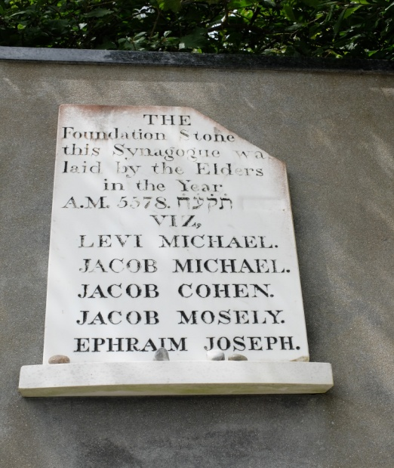
Fig.1 Photo from personal collection taken Sep 2020

One thing the Swansea congregation lacked was a Mikvah (ritual bath). Land had been leased or fifty years, in Wellington Street. Following pressure from the Chief Rabbi, It was built in 1837 and was in use until 1877 when one was later created in Christina Street.
The Waterloo Street Synagogue served the SHC for forty years, until the number of seats became insufficient for the growing number of families that was reported as being more than thirty. Freehold land in Goat Street was purchased in 1857, but it took two years to raise the funds to build it. An appeal to cover a £500 deficit needed to add to the £1200 raised by the community itself resulted in donations that included £50 from Baron Rothschild M.P. The new synagogue, finally opened in 1859, was designed by Henry J, Bayliss of Swansea and built by Mr Holtham of Bath and was large enough to accommodate 228 people. It was officially opened and consecrated, in a well attended service, by the congregations’ Reader Rev. J Tuchman and ceremonially opened and consecrated by the Rev. Hermann Adler, son of the Chief Rabbi. The SHC the Goat Street Synagogue was to serve the SHC until it’s destruction in the three nights’ blitz of 19-21 February 1941, when Swansea was bombed by the Luftwaffe during World War Two.
Photos of Synagogue
European Jews were expelled from Russia and Russian Poland on several occasions from 1870 onwards. This brought waves of refugees to Britain, some of which came to South Wales and to Swansea. While many refugees merely stopped of temporarily en route to Americas, some remained and settled in existing Jewish communities. The established Jews generally saw themselves as being Anglo-Jewish, English speaking and assimilated into a British culture, way of life and of a higher class status than the orthodox ‘foreign’ refugees who had begun arriving in large numbers from the 1890’s onwards. The influx of mainly poor Russian and East European Jewish refugees caused widespread tension in Jewish communities, where their arrival was seen as a threat to the generally harmonious, peaceful and comfortable existence they had fought hard to achieve. This was one factor that led to the Jewish community in Swansea splitting into two separate distinct groups. Conflict arose over various issues relating to newly arrived immigrants, who were not paid members of the SHC. These poor ‘foreign’ Jews needed access to various essential services and facilities, which were granted as privileges to paid members. Higher charges were being imposed on non-members, or those in arrears, for such things as the purchase of kosher meat (slaughtered according to Jewish law) and women who were non-members had allegedly been refused access to the Mikvah (ritual bath used by women). The conflict led to the formation of a separate congregation known as the Prince of Wales Minyan and the building in 1906, of a second synagogue, the Beth Hamderash, at Prince of Wales Rd.
The following ten year period has been considered by some as being the SHC ‘s ‘golden age, During this time it also had to deal with a Jewish population that was increasing dramatically in size and diversity and was spreading itself further afield in South West Wales. Small minyans were being created, which in the early 1900’s led to the setting up new synagogues in Aberavon, Ystradgynlais and Llanelli and in expanding the Hebrew schools (Cheder) that children could attend. The SHC was faced with requests for the shared use of not only its Cemetery and limited resources needed for services, and wedding ceremonies but also the sharing of its Minister and the school.
At a time when the Jewish population of Swansea was increasing dramatically, the SHC found itself dealing with its own internal conflict during a period of economic hardship that was affecting Swansea and the greater coal field areas of South Wales. The SHC had survived difficult economic periods in the 1840’s and in the late 1870’s Swansea was affected by such things as downturns in the copper trade. From the 1890’s onwards it was also affected by the various coal strikes that occurred throughout South Wales. From 1911 onwards, further coal and rail strikes led to various outbreaks of rioting, including the infamous riots during the coal strike at Tonypandy and the “Tredegar Jewish riots” which seemed to target the Jewish population of Tredegar. While Swansea seemed to have been largely unscathed by actual rioting, it was not immune to the economic hardships in the short period that preceded the outbreak of the First World War. Such events created a challenging time for the growth, development and identity of the SHC.
How the Jewish Community Developed & Changed Over Time
1730-1841
During the 250 years of its official existence, the size of Jewish community changed. It was subjected to many changes that affected society locally in Swansea and Britain as well as events that occurred in Europe. The population was estimated as having been three to four families in 1730. It was documented as having reached its peak in 1917, when it had grown to 1000, at approximately half the size of Cardiff’s Jewish congregation. The documented size of the population has historically been based solely on the numbers of seat holding members returned to the Jewish Board of Deputies and published in the Jewish Chronicle and Jewish Year Books. In reality the actual size of the population was greater, since not all Jews were paid members of the SHC and after 1906 many immigrants were member of a separate synagogue congregation, the Beth Hamedrash, of which no members’ lists seemed to exist. Many may not even have been members of either of congregations and numbers could in any case fluctuate.

The true size of the population is in fact difficult to determine. The SHC records that exist for Swansea consist mainly of annual accounts & membership lists and Minutes of the Management Committee that sate mainly from 1895 onwards. There are records details prior to 1895 and subsequent records give no detail about the lives and occupations etc; of its members or much in the way of detail relating to non-members. Likewise, records such as those of the decennial censuses give us a snapshot for one specific day only. Information recorded in a census has to be interpreted with caution. The mainly English speaking enumerators were attempting to record details of Polish, Russian, German and Yiddish speakers who may have been illiterate and be wary of providing details. This could lead to even more inaccuracies and ambiguities than are generally associated with the census. Following the Influx of Jewish refugees during the late 1900’s, an attempt to overcome this problem, when the Chief Rabbi instructed that Yiddish speaking interpreters be sent with the enumerators to explain the forms and assist with their accurate completion.
Some individuals were recorded very helpfully as being “Jewish” or “Hebrew” but otherwise identification of Jewish individuals was down to an interpretation of foreign names and places that were often transliterated. From 1891 onwards, schedules in Wales were also used as a means of determining the numbers of Welsh language speakers. Individuals aged over two were asked to identify the language they spoke as being Welsh or English or Both. Returns for foreign born Individuals who spoke a different language or combination of languages were usually completed to provide useful information that could help identify a Jewish individual. It was no guarantee however, since having a Jewish sounding name, traditional occupations, or even their language and country of origin, did not necessarily mean that they were Jewish. Researchers have fallen into the trap of and identified individuals from their names and occupations as being Jewish. The Swansea based Siedle brothers, photographers and Wearbart Kaltenbach (Lutheran clock maker from Bavaria), have been incorrectly identified from Trade directories, as being Jewish. Some Jewish individuals also changed their surnames completely or even had surnames such as Morris and Jones. Therefore when attempting to determine a more accurate estimate of the size and development of the Jewish community in Swansea, and avoid such problems, a combined approach was used, using as many available sources as possible, with details then cross-referenced with genealogical sources, Jewish databases, family trees and newspapers, to identify Jewish families.

Although no official records or the SHC exist pre 1870’s, in spite of their limitations, it is possible from the previously discussed Land Tax Redemption and Apprentice Indenture records and Trade Directories, to identify some of the first families that had arrived in Swansea, together with their occupations. Notwithstanding possible difficulties of identifying individuals from Jewish sounding names, some individuals may not even be listed and there were inaccuracies. Occupations could vary greatly from one year to another according to economic and other circumstances.

The Early Period

This first generation lived through a period in which much of Britain had been affected by the corn riots of 1793-1801. In 1801, when the cost of barley and oats doubled in price in six months, the wages of Swansea’s copper workers was no longer sufficient to provide staple food. The Michael family was one that in spite of such adversity managed to diversify, prosper and whose sons ultimately converted to Christianity. In 1780, Levi Michael, the first Jew born in Wales had an apprentice watchmaker named Barnet Levi. By 1811, Michael Levi was in business as Pawnbroker & silversmith with his brother as L & I (sic J.) Michael. In the same year, Jacob Cohen is listed as pawnbroker and salesman while at the Strand was Judith Michael Shopkeeper and M. Miers a silversmith and glassman; with Jacob Mosely a watchmaker and salesman at Castle street.

By 1830 it was estimated that there were 15 families in Swansea. As Swansea’s population grew, so too did the number and type of trade listed in trade directories. Amongst the Jewish traders were L & J Michael Phoenix Fire & Office Agents and Michael J Michael and Michael Lewin, Corn Factors at the Quay. The number of Jewish pawnbrokers had doubled, making up four of the six listed : Zaleg Cohen at Green Dragon Lane, Zipporah Levy at High street; Michael Marks at Castle Street and Michael Jacob at Wind Street. Dr. Douglas Cohen of Orange Street was one of four Physicians at the Infirmary. He was one of Jacob Cohen’s sons and his mother, who did not appear in any directory, had retired from pawnbroking after she was widowed in 1818. Jacob Jacob and Moses Moses were slop sellers, selling cheap, ready-made clothes at the Strand and Mosely & co; spirit dealers were at Castle Street. There were four individuals, who had multiple trades and who were described as clock & watchmaker, jeweller and silversmith: Michael Marks & Jacob Mosely of Castle Street, Michael Levi of Wind Street together with Moses Moses, who additionally was also an optician.

In 1837, there were 13 SHC seat holders, 11 of which were heads of households, with nine households resident in Swansea and an estimated total of 133 individuals. Cecil Roth places the estimated size of the community and numbers of seat holders in 1847, to be unchanged.

1841-1861

There were 148 Jews identifiable in 24 families in the 1841 census. Roth’s figures for 1847 roughly correspond with the reduction to 139 individuals by the 1851 census.

Of the 28 individual with named occupations, there were six each of watchmakers, jewellers, hawkers, and two pawnbrokers and an assistant. There were still a few surviving members of the original families, two female members of the Cohen family, who along with 3 other females together with the probably retired Michael Levi, were all living on their own independent means. Dr Cohen had by now moved to Liverpool, his widowed sister Rebecca Levy was a librarian and the only professional occupation listed being an accountant

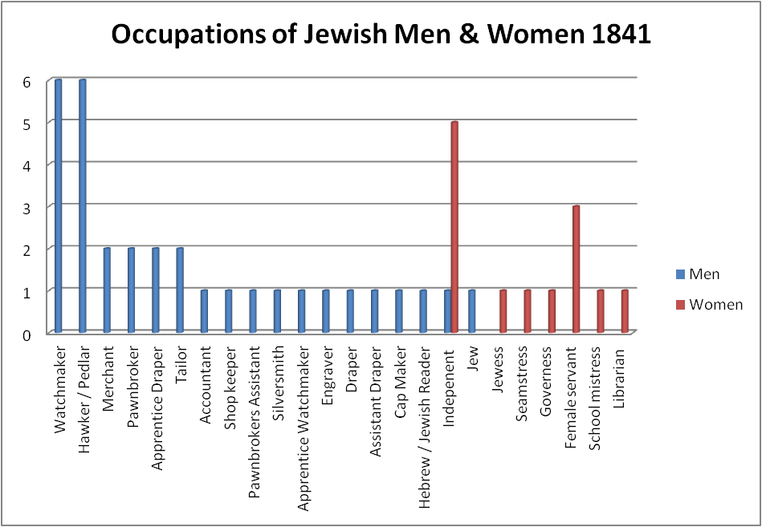
Fig. 2 Graph listing occupations of Jewish men and women,. Figures extracted from 1841 census returns

The 1840’s were a challenging time, not only for the Jewish community and the SHC, but Britain as a whole. as The ‘hungry forties’, as the 1840’s became known, also saw much of Britain in the grip of a severe depression that affected all members of society from tax-paying gentry down to poverty stricken labourers. Thousands of iron workers were laid off when the iron trade was affected, by amongst other things, tariffs and international competition. The agricultural producers that had been recovering from the effects of poor harvests in 1837-8 now found that their produce was worth half its value even if it could be sold. All were suffering a grinding poverty that made it difficult to pay rents, tithes, tolls and buy food. Increasing numbers were seeking poor relief. In 1842 alone, there was an 18.5 per cent increase in the number of poor receiving relief in Glamorgan. A downturn in the copper smelting in Swansea and subsequent threat of strike action due to reduced wages also threatened to put 150 coal workers out of work. In anticipation of being out of work, some had applied for poor relief, to which they were not entitled under the changes to the Poor Law. Funds were set up to provide alternative relief for the poor of Swansea. One fund, to which J.E. Mosely subscribed 10s, was the Swansea Loyal Fund, which had raised £300 in less than 2 months in December 1841. Funds were also raised for the Swansea Night Asylum, which provided temporary overnight accommodation and food for homeless poor who were looking for work. Most of the 696 admitted in nine months to September 1842, were labourers and coal miners, but there were also two watchmakers and two solicitors (although they were unlikely to be Jews).
The unrelenting depression and dissatisfaction with an increase in toll gates and to the changes that had been made to the Poor Law, led to resurgence in 1842-43, of The “Rebecca riots.” During the copper workers’ strike 1843, 150 men received indoor relief costing £913 while they paid £5669 to 1768 receiving outdoor relief.

In spite of such issues, trade must have been sufficient in 1844 to have kept the same numbers of Jewish watchmakers in business as were listed in the 1841 census. It brought an end however to the silversmith trade in Swansea, a trade for which the first settlers were renowned. The last silversmith, Moses Moses was a jeweller in 1844 seemingly no longer additionally an optician or silversmith and had in fact switched to pawnbroker by 1851. Isaac Jacob appears in 1844 as silversmith & jeweller and although he had an apprentice (his brother-in-law) the family had moved to London by 1861. Not all the jewellers may have been advertised in the 1844 directory, but of the six listed in the 1841 census, only two were named in the directory, two having died and two had moved away. By 1851 these four had been replaced by Swansea born sons of two families, along with Prussian born Solomon Brown, all of which were to become prominent officers of the SHC. In addition to three extra pawnbrokers in 1851, there were seven slop sellers and two dealing in hardware and china / glass. The appearance of so many slop sellers and the fact that 2 families moved away may be an indication that the state of the economy was unable to sustain the numbers and types of other trades, especially since in 1845, there seemed to be a charitable institution in existence, named Zedakah LaAniyimin. No records exist of how much relief it may have been providing at this point in this time, but it is likely to be the same, (but un-named) fund which in 1877-78 paid out £6 7s to ‘poor people.’

Those in poverty could pawn items for cash. The pawnbroker dealt with the poorer individuals of society and could be targets of thefts. During the early 1840’s there were two thefts of large quantities of items from Jewish shops in Swansea and at least eight court cases involving individuals attempting to pawn stolen items. Pawnbrokers themselves were the ones who often apprehended possible thieves and called the Police. They were also being accused of receiving stolen goods. Moses Moses, for example, was likely to have become a pawnbroker in 1844, which is when he first reported a suspicious attempt of passing off stolen goods at his shop in High street. His two sons, who were business partners, did not seem to be following their father’s example and were both subsequently jailed for six months after being convicted of fraud.

Jews made up 33 percent of pawnbrokers in Swansea in 1841 and there was also a Jewish assistant pawnbroker. The numbers of Jewish pawnbrokers increased during 1844-1851, suggesting there was a huge demand, and not just in Swansea. Jews in South Wales monopolised pawnbroking during the late eighteenth and early twentieth century. In Swansea it was the main occupation from 1851 to 1891, after which, pawnbroking went into decline, even when combining all variations of pawnbroker related occupations It could at times be a very insecure way of life, and some Pawnbrokers became bankrupt. The brother of Reverend Pisar moved to Pembroke Dock where he lost his stock in a shop fire and returned to Swansea bankrupt. Pawnbroking generally allowed most families to progress to relative comfort and affluence. Most of the SHC officials started their working lives as pawnbrokers. It allowed the possibility of combining trades, such as pawnbroking and jeweller and the selling of various types of goods such as second hand clothes, depending on economic need and personal circumstance. It also allowed other family members to assist with the business and so could provide members of the entire family with an occupation. When Jacob Cohen, one of the founding families died in 1818, his widow Catherine was able to continue the highly successful pawnbroking business. By the time she was selling up to retire in 1827, she had been involved with running it for 30 years. Pawnbroking had allowed her to become a property owner.It had also allowed their widowed daughter Rosetta Marks to earn a living when she was widowed in 1845.

There were seven pawnbrokers in 1851, slightly less occupied as jewellers and silversmiths, but it was the beginning of diversification to other occupations. Small numbers of dealers and clothing related occupations appeared, along with seven hawkers, and glaziers / painters, most of which were single foreign born Jews that were starting to arrive in Swansea in small numbers. There were by now several women who had achieved a higher class and status in the community as a teacher, schoolmistress, governess, librarian, who were living off proceeds of the family business and were fund holders and property owners.
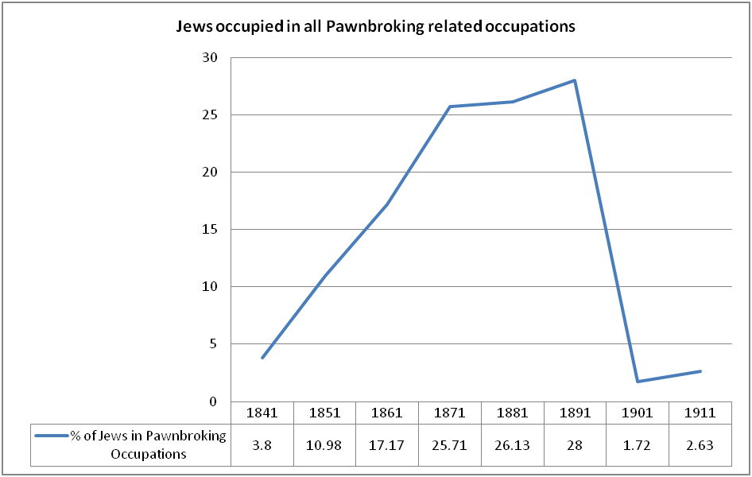Fig. 3 Change in Numbers of Total Jewish men and women employed Pawnbrokers 1841-1911. Data extracted from Censuses

Fig. 4 Change in Numbers of Jewish Pawnbroker associated Jobs 1841-1911. Data extracted from Censuses

Servants were to be found in almost forty per cent of households in 1841-1851. By 1861 sixty per cent of households now had servants of some sort and four households had two or more servants. The heads of two of those households were pawnbrokers (Simon Goldberg and Chapman Jacobs), the other two being a jeweller and a clothier and all four were prominent officials in the SHC in 1895.

While Swansea was rapidly expanding in 1851, the size of the Jewish population appeared to be stagnating. By 1851 it lost one family.

The Jewish population could never have expanded to the same extent anywhere in Britain. In 1845, the SHC was larger than some in small provincial congregations, such as Penzance and Cardiff was yet to establish a synagogue. None matched the size and variation of the largest population Jewish population of London. In 1845, the newly appointed Chief Rabbi attempted to ascertain details about the Jewish congregations across the British Empire by sending out questionnaires. It was impossible however to reach a conclusion as to the size of the population of many towns and cities, including London, since many Jews did not attend a synagogue and some synagogues had in fact been excluded. Estimated figures indicate that in comparison with the total populations of towns and cities, the size of the Jewish population was very small.

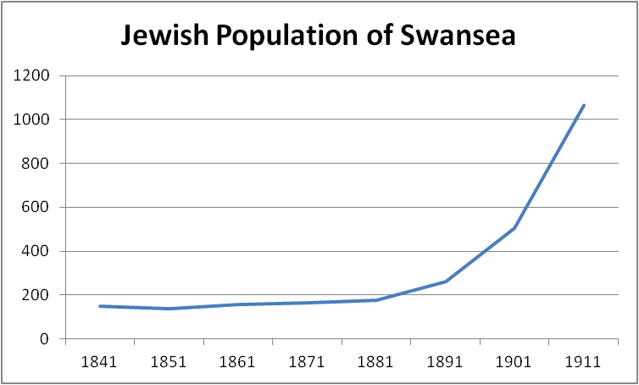
Fig. 5 Total Jewish Population over time. Data extracted from Censuses

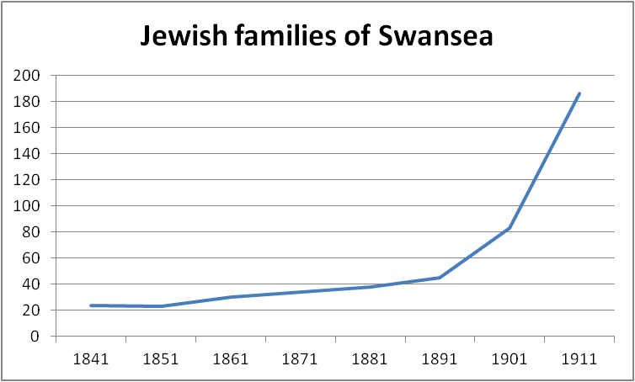
Fig. 6 Total Jewish families over time. Data extracted from Censuses

There appears to be no record of Synagogue attendance in the printed 1851 Religious census, probably due to the fact that the census was held on a Sunday, which is not the Jewish Sabbath. Figures submitted to the Board of Deputies for the Sabbath that year appear to indicate that there the attendance on the Sabbath had been 44 of the 133 members, 25 of which were seat holders. This largely corresponds with the 139 Jewish individuals, from 23 families, identifiable from the 1851 census. Seat holder numbers continued falling thereafter, dropping to 19 by 1854.. Crucially by 1857, numbers must have been rising to warrant the purchase of the land at Goat Street where the new Synagogue was opened in 1859.

From the late 1840’s, there the SHC was a turn-over of Ministers in relatively quick succession. It was a trend that continued into the 1900’s.
A congregation needed a circumciser (Mohel), a Cantor (Shochet) and a Reader (Baal Koreh), but one individual could fulfil more than role. It seemed likely from adverts that this was the case in the SHC. Little is known about them. Barnett Abrahams Reader of the Hebrew Congregation, had left by 1846, being replaced Ham Rosenthal, Minister by August 1849. Isaac Pisa arrived by 1852, but he died in 1857. In January 1858 his replacement the Rev. H.I. Spiro conducted a marriage in Swansea. He also conducted a marriage in Merthyr in the December. His stay was short, since The Rev. Joseph Tuchman had arrived by December 1859 and he remained with the SHC until at least 1871. All Ministers were likely to have been foreign born. The Rev. Abrahams was born in Plots, Russia. The Rev. Pisa and Lowenthall were both from Poland.

Poland or Prussia was identified as a birth place for around 25 per cent of the Jews of Swansea in 1841-1861. A further 25 per cent 22-27 per cent was born in England and Wales (counties other than Glamorgan). Half of the identified Jews in 1841-1861, were born in Swansea and similarly the county of Glamorgan.
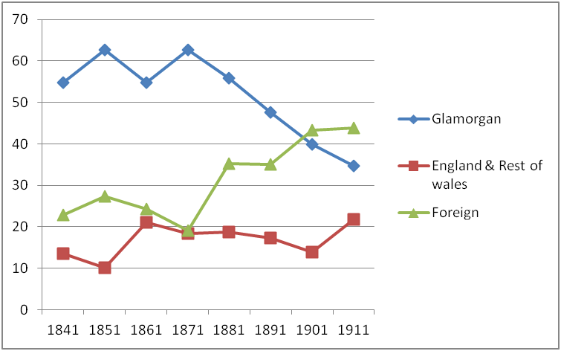
Fig. 7 Numbers of Jews in Swansea born in Glamorgan, England and rest of Wales and in foreign countries. Birthplaces of Jews Extracted from Censuses

There was only a slight increase in the percentage of foreign born Jews in 1851, with approximately a quarter of the Jewish population being born abroad, from Prussia or Russian Poland, with a handful from Germany and Moldova.

The Jewish families lived in the main streets near High Street. This allowed them to be able to walk to the Synagogue, and avoid taking a form of transport which would be considered a violation of one of the Jewish Sabbath laws. In 1841, the Synagogue was still in Waterloo Street. When the new Synagogue opened in Goat Street, it was little more than a street from the old away in a very central convenient place still for most households. By 1841, the Cohen family had moved to Oystermouth, which was around five miles away from the Synagogue. Over the next two decades, as Swansea itself expanded, Jewish households moved westwards into new commercial streets such as Oxford Street and to the more affluent residential areas such as Northampton Place and Singleton Street.

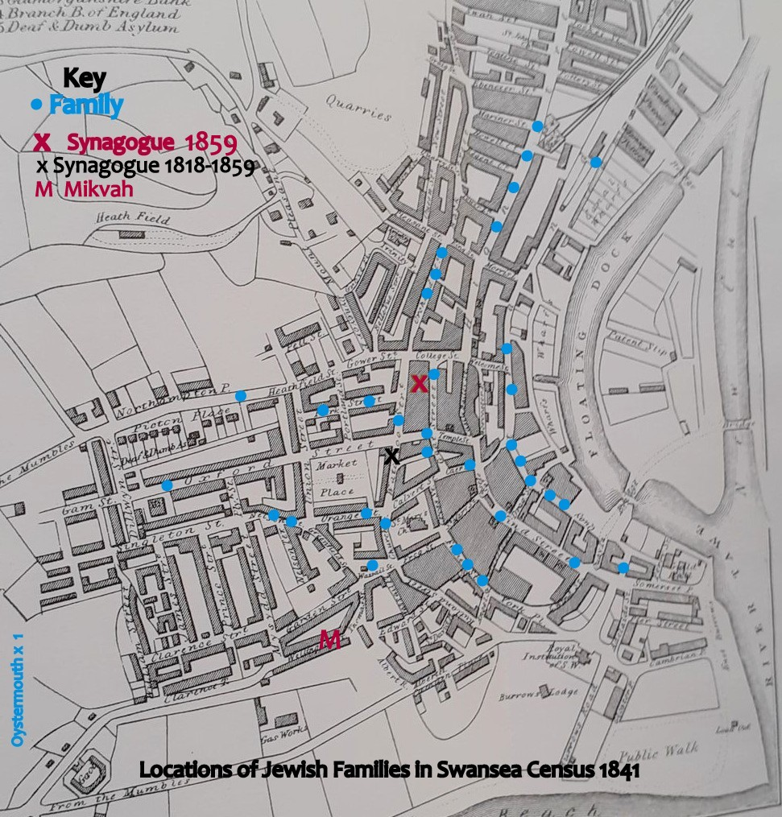
Fig. 8 Locations of Jewish families extracted from 1841 Census plotted on Map of Swansea in Lewis John, (1851)

1861 – 1881
There was a 10 percent increase in the 1861 census in the numbers of individuals born in England and counties other than Glamorgan. There were an extra seven families, which included that of surgeon dentist, Henry Micholl Jones. When he retired in 1881, Frederick D.B. Owen, another Jewish dentist arrived. He was born in Aleppo Syria, as David Betesh, the son of Shabtai Betesh. Dental surgery became a profession that was followed by the sons of a number of families from that period onwards.
In 1861, 24 per cent of those described as having an employment, were women, but by 1871 the percentage had dropped to 18, The teachers and librarian of 1861 were probably amongst a number of women no longer in work, described as annuitants and unemployed.
In addition to the dentist, in 1871 physician Dr. Douglas Cohen returned home from Liverpool to live with his un-married sister. With the repeal of the window tax in 1851, there was possibly more demand for glaziers, whose numbers had doubled. There were also signs of a move towards a shift of employment into clothing related trades. There were now two outfitters and an assistant, two clothiers and a clothier cum jeweller, as well as two shop assistants. Louis Jacobs was one outfitter who had seemingly switched by 1871 from being a jeweller in the previous census. Perhaps it was more profitable with more demand for ready-made cheap clothes of the latest fashion. When he died the following year, he was however described as a jeweller in his death notice. Money lending was one occupation that had been synonymous with Jews. It was not until 1871 when Samuel Samuel moved from Neath, that it first appeared as an occupation for any of Swansea’s Jews.

The number of SHC seat holders was reported to have been 30 in 1870. This was the same number of seat holders that were documented as being seat holders at Merthyr, which had a community of 238 people and 50 seat holders by 1874.
The numbers of foreign born Jews had fallen by 20 percent in the 1871 census and there was also a 14 per cent decrease in those born in England and Welsh counties other than Glamorgan. The number of Jews had only increased by six, from 157 in 1861 to 163 in 1871.

During the twenty year period over the three census years of 1861-1881 the Jewish community had grown by slightly more, from 108 in 1861 to 120 in 1881. It had increased, but by only four families in each census year. According to the censuses, it had gained only twenty individuals in total, with only four of adult age (13 or over) from 1861-1871, and a further eight from 1871-1881.

As Parry-Jones highlights, Jewish communities had survived in Wales against all odds with sometimes only double-digit numbers, compared to the critical mass of a 100 felt to be needed to maintain fully functioning communities in the United States. The only administrative records relating to this period are two balance sheets produced by the Treasurer in 1877-78 and 1878-79. During these years, the congregation lost five members overall, but 11 members were lost from Swansea. There was an increase in “country members” who were now moving to towns such as Llanelli, Neath and into the South Wales valleys which were yet to establish synagogues but offering more opportunities for trading.

What the figures do not tell us is whether the exodus of members was due to economic reasons, since there had been coal strikes in 1871 and 1873, culminating in a lock-out strike that was estimated to have affected 120,000 in South Wales, that would have impacted on the mines in the Swansea area and copper works that they supplied with coal.

Disputes also occurred however within the SHC itself. In the absence of SHC for this period, it is difficult to know whether the conflict that had developed in the group who managed the affairs of the SHC and Synagogue had any bearing on the fall in numbers. Daniel Levy moved to Swansea around 1859. He was born in North Shield, but had lived in Carmarthen, since 1835, where he had been a respected silversmith and jeweller. He had taken a prominent and active role in community matters there, rising to Provincial Grand Master of the Oddfellows leading it through a period when it was undergoing reform and legalisation. He had even been a special constable for the borough of Carmarthen on the 9th June 1843, when he apprehended some of the Rebecca Rioters who attacked the Carmarthen Workhouse. Following his move to Swansea, he became actively involved with the SHC and was for a time its Chairman and involved in giving out SHC alms to the poor. Unfortunately he seems to have fallen out with other committee members, perhaps sowing the seeds for the conflict and later rift that occurred in the congregation, which will be further discussed separately in one of the following sections.

1881- 1891

From 1881 onwards, large numbers of Jews began fleeing communities in the Ukraine and Bessarabia where organized anti-Jewish violent attacks and massacres (pogroms) were sweeping through the Russian empire in Eastern Europe. Russian Jews had up to this point been severely restricted by tsarist policies. Conscription into the Russian army was imposed from 1873 onwards and Jews were restricted to cities in the Pale region where it became increasingly difficult for them to support themselves. Initial waves of migrants came from areas that were untouched by pogroms in northern Pale and Habsburg, and as fear of pogroms spread, Jews came to Britain in ever increasing numbers at varying times up to the First World War. Some were en-route to America and temporarily increased numbers in port areas, but around 70 percent of those who stayed, settled in London. The pogroms that flared up following the death of Czar Alexander II in September 1881 and the subsequent re-enforcement of economic and other restrictions are likely to have been the catalysts for those Jews who came to Swansea from this region of Russia or Poland. Their numbers made up the bulk of the 25 per cent who in the 1881 were born in a foreign country.

There were now 34 families, living in streets that were now spreading further North, in Carmarthen and Llangyfelach roads and to the west of the centre surrounding Lower Oxford Street. Sixty percent of the families had at least one female servant. Five of the most affluent families had at least two servants and two also had a governess. These included the family of a ship owner and two pawnbrokers.

Of the of two money lenders Samuel Samuel had died and Michael L. Marks now also employed a clerk. Lazarus Jacob, who had previously been a jeweller, was now a ship owner, and Hyam Goldberg was a ship broker. Lazarus Jacob was still a ship owner in 1891 but had moved to moved to London but by then Hyam, Simon and Barnett Goldberg were ship owners themselves. Apart from a dentist, there was now a watchmaker & science teacher, teacher, medical student, optician and a watchmaker & optician and five glaziers. Of the 13 women employed, two were governesses, one employed by a Jewish household. The other occupations for women included a milliner’s apprentice, two servants, one had a fancy repository business and there were four female pawnbrokers and two pawnbroking assistants.

1891-1901
In 1894, Jews accounted for 84 of the 91 pawnbrokers listed in the valley towns of South Wales. In Swansea 1891, all were Jewish except one which was run by the non-Jewish Siedle brothers, often being mistaken as being Jewish because of their German surname. There several now also non-Jewish assistants, who may have worked for Jewish Pawnbrokers. Four combined pawnbroking with other trades, but it was the main employment for five families, including two influential Barnett families. Pearce Mendelsson was still at New Oxford Street where he had been since moving from Llanelli in the 1870’s and David Levy and Rosa Crawcour had opened shops north of Prince of Wales Rd, with some members of their families assisting with the business. There was also in 1899 a Jewish Physician working at Swansea Hospital.

There were now 259 Jews in 45 families. The number of those who were foreign born doubled from 1881 to 91, the majority having been born in Russia and Russian Poland. The numbers of Russians and Russian Poles had increased by 212 per cent overall in England and Wales and by 128 per cent in Swansea. With the increase of Jews born in Glamorgan, the percentage of foreign born Jews actually remained unchanged from 1881.

Amongst the new arrivals of foreign born Jews, were 13 picture frame carvers, nine glaziers and a group of 17 travellers / hawkers / commercial travellers were selling picture frames, jewellery and drapery goods. They were probably occupations that were followed before arrival and were the main occupations for Russians and Russian Poles in the 1891 census. New arrivals will undoubtedly have been financially supported by the SHC, but there are no records for this period that would give an indication of what relief was provided. The relief may have been for a limited period only until new arrivals could support themselves. One glazier who had been “subsisting off the charity of his brethren,” was cautioned by the judge when he appeared in court charged with begging.

There was also an un-married Russian photographer lodging in Sgyborfach street. He disappears after 1891, Swansea likely to have been only part of a step-migration to America. There was now a more recognisable pattern of single men, lodging or boarding with other Jewish families, some of whom were relatives or from the same town. There were three main areas in which Jewish households were concentrated. The centre, to the west towards St Helen’s Rd and the northern end above Prince of Wales Rd which became the epicentre of further immigrants over the next 20 years.

Isaac Seline, Treasurer of the SHC in 1877-79 and ex-Pawnbroker, was now a financier. His son David Seline later followed his father in his involvement with the SHC. He was a Solicitor in 1891, passing his final Solicitor’s exam in 1888, to become the first Jewish member of the legal profession to practise in Swansea, articled to solicitors J. Moy Evans. Swansea even had a flautist.

There was no change to the number of Jewish women were described as employed by 1891, but the type of employment offered women convenience, greater choice, independence and status. Four of the 13 were employers, working in pawnbroking or dealing and one a district post mistress, four were employed as an assistant book keeper and in various clothing related occupations. At home the numbers of households with servants fell to just under 50 per cent, with an increase of an extra family now able to afford two servants the same families had two ,one had three and four now had a nurse.

In 1895 there were 20, 000 men out on work, on strike at most of the tin-plate works including ones at Llanelli, Landore and Morriston areas of Swansea. Competition from American tin-plate producers meant Welsh plate was less profitable but men wanted the same rate of pay that had been agreed in 1874. The Rev, Philips Woolfers put out an appeal to the Mayor for help to support the community.

1901

Immigrants continued to arrive from Russia and Russian Poland, and by 1901 census they made up 33 per cent of the 247,758 foreign immigrants. Half of all foreign immigrants were found in London, 6517 in Glamorgan with the remainder in industrial centres and sea ports.

The total population of Swansea had increased by3.8 per cent to 94, 523. 504.
Jewish families increased by 91 per cent, to almost double in a decade, to 504 in 84 families. The number of foreign born Jews had increased by 87 per cent, coming almost entirely from Russia or Russian Poland. Newcomers were young single men who were lodging with other Jewish families or individuals, to the North of the Synagogue. Many were living in Burlais Crescent, where 60 individuals were living in eight houses. David Seline described this street as being “a place inhabited by the lower orders.” Seline was referring to a lower order of non-Jews, when perhaps non-Jews associated it with the Jewish community.

On the eve of a Swansea election in 1895, one complainant had asked what the prospective Conservative candidate would do about destitute pauper aliens competing unduly with local workmen. Numbers of foreign born Jews had increased by 87 per cent in 1901. They came almost entirely from Russia or Russian Poland. In reality, and in stark contrast with London, only 0.5 per cent of Swansea’s population were Jews and of those only 0.2 per cent foreign born.
Swansea was never going to turn into what some residents feared was happening to London. Growing numbers of London’s English residents feared their city was turning into a “little Jerusalem,” over-run with poor aliens who were causing a housing shortage, introduced the sweating system, caused low wages and competed with English workers for jobs. Much of this was already in place before any mass immigration of Jews, but the influx crystallised it all into a problem that could be associated with all Jews in general everywhere. By 1903, the Cambrian were claiming that changes for the worse were occurring in Swansea, with the Jewish Colony growing by the month, taking over businesses abandoned by Gentiles and streets being taken over by Hebrew speakers. A Royal Commission on Alien Immigration was set up by Arthur James Balfour in 1902. It was a response to a growing anti-alien campaign which wanted immigration stopped to protect the nation from invasion. The resulting1905 Aliens Act would in the end supposedly only exclude immigrants unable to support themselves unless they were claiming religious or political persecution and so immigrants.

As far as employment was concerned in Swansea, there was little threat in the 1900’s of Jews competing with local workers for jobs. Of the 170 employed, 31 per cent were hawkers or pedlars, particularly in drapery or travellers selling various types of other goods. Once a pedlar’s license had been obtained, goods could be sold in the rapidly expanding valley communities and areas further afield that could be easily reached daily by train. Numerous pedlars appeared in court for various reasons from 1891-1911, only four of which involved Jews in the Swansea area. Charges against one young Jew too young for a license were dropped when he broke down because he and no friends or family in Swansea and would have no means of make a living. Benjamin Brooks, described as a “Modern Autolycus,” allegedly on his way to obtain a license was fined or not hurrying to obtain one. The landlord of The Rising Sun pub, Pentrechwyth, was fined for assault against Hyman Rosen who was offering goods for sale at his bar. Isaac Shermin of Burlais Crescent was found guilty of stealing a gold ring on his travels at Cwmgiedd. Few are likely to have achieved the sort of wealth amassed by one peddler who bequeathed an entire £12, 000 to the Addenbrookes Hospital in Cambridge and the poor and needy Jews of the London Synagogue. One Swansea Jew who had lived in Swansea for five years must have found it a very hard life, since he tried to end his life in a suicide attempt.

There were other types of employment for men were in drapery, tailoring or in clothing trades, which employed 18 per cent, some of these likely to have working from home, for a contractor. There were ten glaziers, fifteen picture frame carvers and 18 dealers and shop keepers.

Fanny Freedman was the only pawnbroker left and she was one of only ten women in employment. Overall there was a drop of over 22 per cent in families that had servants, but there for the first time 4 families now had a cook, while three had more than 3 servants as well as a governess and a nurse. Women were moving away from employment into one of leisure. Employing a cook allowed responsibility of the complex Jewish laws relating to foods and associated festival days to be under the care of the cook.

The SHC struggled to maintain membership throughout the decade. From 110 members in total by the end of October 1901, numbers had increased to 132 by October 1903. It fluctuated in the following three years between 124 and 131, to peak at 135 in 1907. In 1907 membership dropped back to 121, increasing again to 135 by October1910.
Around 14 country members living in Aberavon and Llanelli were being lost annually from 1899 onwards and the only country members thereafter were from Neath. Those who had moved had no need to be members when they formed their own congregations and went on to build their own Synagogues, Llanelli building theirs, in 1909.

Of the 504 Jewish individuals in Swansea, only 35 per cent of the potential 313 on the 1901 census were actually members of the SHC in October 1901. Jews were not becoming members of the congregation because of a rift that was developing between the new Jewish immigrants and the SHC and between members of the SHC itself.

The Chief Rabbi visited in May 1909 as part of the congregation’s Jubilee celebration. By then there were only three members left of the congregation at which the Rabbi had himself addressed, giving his first ever speech, on opening the Synagogue back in 1859. He now took the opportunity to try and restore relationships and encourage Synagogue attendance. During the fifty years of the congregation, the Jewish community in England and Wales had been encouraged to assimilate, to anglicise and to refrain from drawing any unwanted attention to itself. Jews had become more lax in observing their religious customs and their use and knowledge of Hebrew. It was different culture to the newly arrived immigrants who were strictly Orthodox Ashkenazi Jews. They were also of a poorer class and had difficulty in paying even the cheapest weekly fees for seats. The Chief Rabbi only delayed in the end an inevitable break away community which set up its own congregation, which initially met in the Prince of Wales Rd.

1911

By the 1911 Census, Swansea’s Jewish population and number of families had more than doubled. There were now 1065 individuals in 186 households.
Foreign born Jewish immigrants were still arriving almost exclusively from Russia or Russian Poland / Prussia. They formed the largest percentage of the Jewish population at 43 per cent. Glamorgan born Jews were now less than 35 percent and less than 29 per cent had been born in Swansea. The numbers of Jews born in England and counties other than Glamorgan increased by 50 per cent and were now nearly a quarter of the population. Small numbers moved from Monmouthshire and Cardiff, but the English born Jews had increased by 257 per cent.

The English born Jews were mainly from the four main Jewish communities of London, Leeds, Manchester and Liverpool. These cities were centres of the tailoring trade and their arrival in Swansea completely changed the employment profile.
Almost all the servants employed in families were in fact not Jewish and mostly born in Wales. Jewish lodgers, prior to 1911 rarely lived with other Jewish families. It was only in the 1911 census that Jewish lodgers were increasingly living in Jewish households. The fact that Non-Jews being willing to both work for Jews and to also take them in as lodgers, can be seen as an indication of tolerance and acculturation.

In 1912 numbers plummeted to 115, regaining numbers throughout the First World War years to reach a post-War peak of 198 in October 1920. No less than 23 Swansea Jews had enlisted shortly after the outbreak of the First World War. In total around 50 Swansea based Jews and another nine from Swansea who had moved away, all played a part in the forces by the end of the War. Four families sent three sons, and the Freedman family had three sons in the army and one in the navy. Bertie Freedman ended up serving in the Labour corps. He had been arrested for failing to report for military service, despite having been twice to Cardiff to do so and being pronounced unfit. His youngest brother Percy Freedman enlisted when he was only 16 and survived a gunshot wound and also caught malaria. Sadly nine others were killed in action, including Joseph Seline, one of David Seline’s three serving sons. They mainly served in various army battalions, but three were in the RAF and three in the Royal Navy Air Service. One was also an Army Captain and Chaplain and several others attained non-commissioned officer roles. Three Jewish soldiers were to be awarded the Military Medal, including Sgt. Abe Levi. Corporal Nathan Kronenberg was another Military Medal recipient along with Lewis Sefton who received his medal from Alderman David Davies at the same time as being promoted to Corporal.

A Zion Mule corps had been set up in 1915 for those who were not naturalized and who were otherwise initially barred from Military service. As the War progressed, it was decided that non-naturalized Russian immigrants would be called up or be forced to return to Russia. Five battalions of Jewish volunteers were set up, the 38th to 42nd (Service) Battalions of the Royal Fusiliers in November 1917 (known as the Jewish Legion) and three served with the Jewish labour corps in 1918. It was estimated that there were 1000 Jewish Russian tailors, all eligible to be called up in Swansea in 1917. It was looking increasingly likely that the Reader from the Beth Hamderash Congregation would be called up for military service. A Reader was essential to be able to continue services, leaving the congregation no other option than to advertise for another Reader, when funds were under pressure. Meanwhile, many of the SHC contributed at least £110 17s to a fund to relieve poor suffering Jews in Russia and Poland in 1915

David Davies, the editor of the South Wales Daily Post and then ex-Mayor may have supported the Swansea Beth Hamdedrash and Swansea Jewish community, but he had a completely different point of view when it came to a Jew who had actually been born in England and who had been standing in opposition as a prospective Parliamentary candidate for Swansea. The Jewish Disability Act of 1858 removed all remaining disabilities that had prevented a Jew from taking a seat in Parliament. The oath that had to be sworn could now be modified. Alfred Mond, (who was knighted following the War) was able to stand as a candidate in opposition to David Davies or the Swansea West seat in 1918, for which he was elected. David Davies stated “the old town ought to be represented by someone of British blood” Libellous accusations were made about Mond’s allegiance and loyalty to Britain and the subsequent libel case was settled out of court. Alfred Mond was in fact Jewish and was head of his father’s Nickel refinery at Clydach, on the outskirts of Swansea (known locally as “The Mond”).

Swansea’s Jewish Community and their sense of identity.

Their involvement in the wider community

The historiography of Jews in Britain has understandably been Anglo-centric with the experiences of British Jews being seen as an entirely Anglo-Jewish one, because of the majority of Jews being based in London. Welsh Jews, like Scottish Jews are, as Parry-Jones points out, not ‘English’ in the strict sense and their experience is otherwise lost within the overall experience of Jews of Britain and England into which it is incorporated. Regardless of terms used by historians and a reluctance to view it any differently, Swansea’s Jewish community, as we have seen, has been shaped by things which may have been common to all Jewish communities, but also by things that were unique perhaps to Swansea and Wales. Historians such as Parry-Jones and Ursula Henrique sought to examine the experience of Welsh Jews, examining whether they identify as being Welsh and if they were accepted as being Welsh.

One of the ways the experiences of Jews in Wales differed to England was that daily life, worship, business and social activities was conducted by large sections of society whose first language would have been Welsh. Jewish settlers in Swansea would have been exposed to the Welsh language.
In 1801, 96 per cent of the population in Wales spoke Welsh. In 1811, Levi and Jacob Michael realised the value of the language to their business, even if we are unable to tell whether or not they themselves could speak Welsh themselves. Their advertisement for an apprentice in their tea and coffee warehouse included the requirement to speak Welsh.
By 1911, nearly 75 per cent of the population of Swansea spoke only English. There were criticisms that the results for Welsh speakers were inflated, but also that monoglot Welsh speakers were at a disadvantage from having to complete English forms. There were over four thousand returns had not included a response, suggesting an inability to understand the question asked. It probably also caused some to write “both” when they may have thought it meant Hebrew / Yiddish and another language rather than English and Welsh. Some even wrote that they spoke “Neither” and these were counted as monolingual speakers. It was even necessary to enlist a Yiddish interpreter in a court case. English speaking Russian Michael Koll was even working on his own account as an interpreter according to the 1911 census. The vast majority of Jews spoke English and none spoke only Welsh in any census year. None spoke English and Welsh in 1891. In 1901, Hyman Black a fancy dealer and Akser Deggots both supposedly spoke English and Welsh but had been speaking Hebrew and English in 1891. Joseph Cohen a hawker born in North Wales also spoke both. Widowed Henry Barnet who spoke English and Welsh in 1901 and 1911 (recorded as “both” on the census). Henry Barnett, who was a newly widowed pawnbroker, was English speaking in 1891, but had a Welsh and English speaking servant from St. Clears. The few individuals recorded as being both Welsh and English speakers in 1901 were discounted, since they were recently arrived Russians who spoke English only in 1911. There were eight individuals in 1891 who spoke of what was described as one of Jewish, Hebrew, Yiddish, Polish or Russian, or “neither”; 17 in 1901 and 73 in 1911. Bilingual foreign born Jews had generally already settled in Britain prior to 1891 and spoke a combination of English and Hebrew / Russian/ Polish / Yiddish or German. Genia Pomerantz a married wallpaper merchant was actually trilingual and spoke German, Hebrew and English. Dora Baddiel, a scholar, was a Welsh and English speaker in 1911.

The National Eisteddfod was another way to show patriotism, by attending, supporting or competing in one. There was little evidence that there was any Swansea Jewish participation in any way in any Eisteddfod. When a National Eisteddfod was held in Swansea in 1909, there seemed no financial or other support offered by the Jewish community. In contrast the Louis, S. Cohen the Jewish Mayor of Liverpool. He had financially supported and promoted the Liverpool Eisteddfod. His speech opening the Eisteddfod apparently drew parallels between the Jewish race and Welsh people although in spite of any commonalities, one writer felt that that Jews were not patriotic. The first National Eisteddfod was held in August 1861 in Aberdare. In the era prior to Eisteddfod competition, Miss E Jacobs, of Swansea was one Jewess who had been giving operatic concerts patronised by the Mayor and other elite.

Many of the prominent Jewish traders were members of the Swansea Indefatigable Lodge of Freemasons. Francis David Michael, silversmith, was perhaps the first enrolled as a member in 1814. Other pawnbrokers and traders followed, including house furnisher, Michael Jacobs in 1890 and jeweller Solomon Lyons in 1908. Prior to removal of the disabilities that prevented Jews from taking a seat in parliament in 1858, it was one of the ways they able to participate fully in society. They could ne members of Freemason’s lodges and other Friendly Societies and could also hold certain office such as Alderman or Mayor. These activities and roles would have brought them into contact with the upper classes of Swansea.

Women played an important part in the early community. In April 1854, Catherine Cohen was President of the Hebrew Ladies Philanthropic Society, Swansea. With daughter Matilda acting as Treasurer, she offered up a room in her house to elevate the minds of the humble classes and provide a Sabbath school.

Douglas Cohen was instrumental in memorialising Ann Hatton in recognition for her literary works, donating a painting of her to the Swansea Public Library.
And his sister Rosabelle Joseph wrote acrostic poems, some of which were included in a book sent to Soldiers in the Boer War. She was actively involved in several philanthropic organisations such as The Swansea Charity Society. Along with Hyam and Simon Goldberg, Rosabelle Joseph was also one of the Governors of the Swansea Hospital in the 1899.

A number of Jewish Friendly societies were founded in the late 1880’s, modelled on the Freemason pattern including, the Hyam Goldberg Lodge of the Grand Order of Israel and of the Ancient Order of Maccabeus (a Zionist order). In 1915, the Swansea Jewish Friendly Society Order of Achei Brith and Shield of Abraham I. Zangwill Lodge held its annual meeting with at least 12 official members attending.

One society that attracted Jewish member, including the Rev. J. Phillips, Jewish Minister, was the Royal Institution of South Wales. The Rev. Phillips himself also gave regular free talks open to all, in his capacity as Minister. He gave lectures on a variety of religious and non-religious topics, which fostered a better understanding of Judaism, good community and religious relations and earned him great respect from Christian groups. His example was followed by his predecessors the Reverends Sandheim and Fyne.

There was also a flourishing Jewish Literary Society that was set up in 1905, with around 60 Jews attending its inaugural lecture on the rather controversial topic of Christianity and Jesus.
Ministers and individuals also involved themselves in roles that brought benefit to the wider non-Jewish community. The Rev. Wolfers for example, was a member of the Swansea Hospital Committee, raising funds and generally overseeing the welfare of patients from a non-medical standpoint.

Jews of some trades became members of trades unions. The huge increase in the numbers working in the tailoring trade after 1911 gave rise in Swansea, to a branch of the Amalgamated Society of Tailors. This union had existed in Leeds since the 1880’s, in response to poor working conditions, long hours and low wages Elijah Max reedman, hairdresser, was praised by other members of the Swansea Hairdresser’s Union, for shutting his shop on a Sunday when the non-Jewish members were keeping their shop open on their Sabbath.

As entertainment became increasingly accessible, it was even used as a means of raising funds by the Jewish and wider community.

The Swansea Jewish Ladies, connected to the Daughters of Zion League held various balls which attracted members of the Jewish congregations from Cardiff and Merthyr, holding its first ball at the Cameron Hotel in 1910.

A drama was one thing staged to raise money to pay or the Burial Ground extension. The ground was purchased by the Beth Hamedrash congregation, (the Russian Orthodox Jewish Congregation, as the newspaper called them). They had considerable non-Jewish community support. the Mayor and Councillors donated money for their services and the Manager of the Elyseum Theatre who provided free use of equipment and the venue.

Jewish Identity

Jews had been scattered across the globe, united only by faith, spoke different languages, and had no country to call a homeland. A Zionist Society was established in 1906, although, like the Chief Rabbi and the Jewish Chronicle, not all Swansea’s Jews were in favour of Zionism (establishment of a Jewish homeland in Israel). Those who had settled in Britain were passionate about their adopted country and some felt that the creation of a homeland in Palestine would “prejudice Jews in the eyes of their fellow citizens in the British Empire.” Some of its exponents felt that it was “impossible to be a Jew and not a Zionist of some sort or another” While there were calls for a Jewish homeland, in Israel, the Richmond family on the 1911 census, had seemingly done the reverse and swapped Jerusalem for Swansea. Mendel Foner, one of the Russian immigrants, to Swansea, then re-located to Palestine. Immigrants left countries because they believed they could take fate in their own hands and change their life chances Sadly Mendel Foner died in 1924. He may have found the promised land was not a land of milk and honey. In 1934, his son complained of all the hard work and sacrifice needed in a waterless, neglected and impoverished wasteland.

Those that had settled prior to the influx of Russian Jews were socially integrated into a relatively tolerant society that allowed them to follow their faith to whatever extent they wished. In all their records and in reported events, Swansea’s Jews never once referred to themselves as being “Welsh.” They were “English” Jews. Welsh Jews were rarely described by the Chief Rabbi or the Ministers as being anything other than “English.” Reverend Sandheim the SHC Minister even gave a lecture to the Jewish community of Swansea on “Being a good Jewish Englishman.”

It was only in the Jubilee celebration in 1909 that Dr. Hermann Adler said that “there was a striking resemblance between Wales and the Holy Land that was once theirs.” He stressed that the one potent factor that preserved the nationality of the Welsh was the desire to preserve the Welsh language. Hebrew was one of the few remaining bonds that kept the Jewish people together and he impressed upon them that they should show as much regard to their the sacred tongue, since it was one of the few remaining bonds of union that linked Jews together. A number of the Russian Jews were Hebrew or Yiddish speakers, and this was one aspect that highlighted a difference between them and those who had been born in Britain who only spoke English. The hierarchical oligarchic structure and management of the Congregation headed by the Chief Rabbi, was an unfamiliar one to the “foreigners” as they became known. The “foreigners”, meanwhile considered those of the SHC as “English.” There was even a differentiation between Jews according to their different countries of origin. There were several examples of disputes between Jews themselves. On those occasions when offending Jews appeared in court, they were emphatic about being specifically identified as being a Jew of the country of their birth. In one case a Polish Jews with a German name, who was caricatured in a poem as a Russian Jew, but had lived in Llanelly 30 years and was a naturalised Englishman.

How Jews were treated by the press, courts and society
In the span time in which Jews had lived in Swansea, there seemed remarkably few issues of major conflict other than within their own congregation. The non-congregational denominations were generally supportive and complimentary of the generally good character and behaviour of Jewish residents. They also supported Jewish causes, as much as Jewish residents supported non-Jewish causes themselves. When the Synagogue needed funds several names of individuals who were not Jewish were amongst them, including three of The Cambrian staff.
The Cambrian newspaper gave factual reports in any reports relating to Jewish residents, unlike some Welsh newspapers which carried stereotypical and anti-Semitic descriptions. One paper even included supposedly humorous illustrations that exhibited some derogatory trait that would portray the Jew in a negative way. The portrayal of Daniel Levy in the Carmarthen Punch was at a time when he was the Provincial Grand Master of the Oddfellows in Carmarthen and must have been entirely tongue in cheek while in office and he does not seem to have felt the need to resort to taking anyone to court over it.
When David Seline’s name was submitted for the magistracy for Swansea and disapproved by the Lord Chancellor in 1908, a petition in his favour was signed by Lord Glantawe, Sir John Llewelyn. Sir Griffith Thomas, the Mayor and every member of the Jewish community.
Gwydderig’s englyn poem attributes the worst traits and features to Jews
Y Jew. The Jew
Du, dwyllodrus dad lladron- dyn a'i fryd Black, a cheat, a man with a mind
Yn fradwr o galon; a traitor at heart
A'r gwaelaf o'r gwehilion The worst of the rif-raff
Yw Jew a'i bac a'i jaw bone. Is the Jew and his jaw bone

There were many non-conformists who sympathised with Jews and Zionism, and forged a sense of co-operation perhaps because like Thomas Levi the Methodist Minister, they were in act descended from Jews.

Hyman Freedman, Swansea pawnbroker, was tried in Cardiff County Court in 1883. He had allegedly received stolen watches pawned by his employee. He was found guilty and by Lord Chief Justice Coleridge and sentenced to five years penal servitude. It was felt by several members of Parliament and the community of Swansea, that there had been a miscarriage of justice. Had he been tried at Swansea, perhaps there would have been a different outcome, since there was a general feeling among some judges and Police that Pawnbrokers were to blame for thefts and the magistrate found it quite humorous that Samuel Crawcour had made 544 court appearances in relation to Sunday trading laws, with the magistrate pointing out that he felt that Crawcour was “nearly one of ourselves.”

D. Lleufer Thomas in a lecture, said he naturally sympathised with, and cordially upheld the preservation of the small nationalities, which were like that of his own, Wales. He thought anti-Semitism was due to purely social and racial differences. Anti- Semitism had been thought to buy most historians to be a possible reason for the riots that occurred in Tredegar in 1911, when Jewish shops in particular were targeted and attacked. Brynmawr had also been affected and it seems that one Jewish pawnbroker in Brynmawr had been affected by a riot in 1910. His premises was generally overrun and plundered, windows were broken and the contents including jewellery valued at £350 were stolen. When the owner had instructed a solicitor to make a claim from the Monmouthshire County Council on the ground of insufficient police protection, he was advised it was too late to proceed with the case and subsequently went bankrupt.
There were riots related to the railway strike in Llanelli in 1911 where two men were in fact killed. No riots occurred in Swansea and little was reported in the specific Swansea press. Economic hardship created a rare newsworthy event in Swansea six months before the riots, when a widow sought poor relief in Swansea. She was not a member of either Jewish Congregation, but was told to ask the Jewish Congregation first, because it was said that Jews did not like to pay rates. As Parry-Jones argues, intolerance could surface during times of perceived threats such as during times of great change. The economic problems of that could have exacerbated underlying anti-Semitic feelings. Actions in response to perhaps issues relating to one or two individuals or problems could have become a means of venting anger and frustration against everything associated with them or with wider issues in general.
In Swansea Jews were more likely to have some disagreement or conflict with each other and often with relatives.

Lewis Guard for example allegedly assaulted his brother Simon Guard in the Synagogue in view of all.
Although the Chief Rabbi wanted the congregation to be portrayed as a harmonious homogenous English community of Jews, Jews themselves sometimes took matters into their own hands to obtain justice.

Conflict Within the Jewish Community

It was to Sir Alfred Mond that some of the Jewish congregation turned for financial help in April 1916, by this time there were two congregations and two synagogues, but the seeds had been sown back on 1869 when Daniel Levy fell out with the wardens of the committee of which he had been a Chairman at one point after moving from Carmarthen. A personality clash made him decide to stay away from the Synagogue and he let his membership lapse. When his wife died he attempted was reused access to erect a headstone on her grave and the membership rules dictated that arrears had to be paid up prior to being able to renew membership. Although he did this, he did not expect to lose his old Synagogue seat. Although he could have sat in another, he decided to take the SHC to court, in the event losing the case, since it was not felt he was not barred from attending at all and so could have availed himself of the services for which he had paid. The Chief Rabbi sent a strongly worded letter insisting the matter be kept out of court and out of the press. Daniel Levy aired his anger by doing both and somehow the Rabbis’ letter was published. In response SHC the newspaper and was named by the opposing SHC as an: “obnoxious element” much to his non-Jewish supporters’ disgust. Relationships did return to normality, but it was one that was closely followed by another conflict between Chapman Jacobs and Jacob Cohen Marks who spoke loudly and threateningly, the judge stating the case should not have proceeded and that the place to settle such a dispute was in the Synagogue, so case was withdrawn.
.
By 1895, further problems occurred when some of the newly arrived immigrants were having difficulty paying the minimum fees for a seat, which entitled them to the other privileges attached, such as purchasing kosher meat at a set rate. There were soon further accusations that a Jewess had been refused access to the mikvah, although the caretaker stated it was not used that day. It led to the disgruntled Russian immigrants complaining to the Chief Rabbi about their treatment and a threat to break away and form their own congregation. The SHC viewed and referred to the other Congregation as “The Foreigners” and the “Dissidents,” while the Beth Hamedrash referred to the SHC as “The English.”

The Chief Rabbi did not want a rift in the Congregation and for a while matters settled down, but it inevitably did occur and so the Beth Hamedrash Congregation was set up and by 1909 they had their own Synagogue in Prince of Wales Road, sharing the disgruntled Minister who felt increasingly over-worked. Terms of services and fees were negotiated and membership lists were meant to have been created and shared by the Beth Hamedrash, but none seemed to exist, much like the balance sheets which made it impossible to keep track of its income or deficits.
Several members both Congregations resigned, at various points. The secretary felt that the meetings were disorganised, lacked minutes and that things decided were often not carried out. At least two members had membership suspended from the Beth Hamedrash, when they became abusive in the Synagogue.

Meetings in both Congregations revolved around issues with each other, but mainly about money or the lack of it. The annual end of year balance sheets of the SHC indicate that every year they just broke even, never making a profit and only staying solvent because of donations and offerings at weddings, Holiday services and especially from top-up amounts given by the committee members themselves.

The congregations will most likely have put away their differences, temporarily at least, to attend one of the gatherings of Jews ever to come together or such an event in Swansea, when Kasriel Baddiel was buried in 1907. He had been the Beth Hamedrash President for 15 years, living with his family with at least 5 children, in two little rooms, his whole life a struggle for mere existence, yet ready to give his last crust.

While World War One began and progressed, the Congregation was fighting its own war. The Goat Street Synagogue caught fire in 1914. There followed on-going discussions relating to the Beth Hamedrash purchasing but sharing a plot of land adjacent to the existing SHC burial ground, which was almost full. The other main issue was that of establishing a Cheder in the Beth Hamedrash for their children. In 1917, for the first time, the Beth Hamedrash had a surplus of funds and was able to proceed with the purchase of the land for the cemetery with some being raised from a charity evening and a large donation from Sir Alfred Mond. At the end of 1920 the SHC had 198 members. The marriage register from 1914 onwards includes examples of Jewish grooms who had left the army and started working coal mines and picture halls. The numbers of women on the 1911 census showed an imbalance of 139 single men to 84 women which may have been higher by 1920.

Year | Welsh | English | Both | Mono Foreign | Bilingual  Foreign | Trilingual
1891 | 0 | 222 | 0 | 8 | 26 | 0
1901 | 0 | 417 | 2 | 17 | 37 | 0
1911 | 0 | 876 | 3 | 73 | 0 | 1
Fig. 8 Languages spoken of total Jewish population of Swansea
Language spoken by Monolingual speakers | Languages Spoken by Bilingual speakers | Languages spoken by trilingual speaker
Hebrew | English & Yiddish | English
Russian | English & Hebrew | Hebrew
Yiddish | English & Russian | German
Jewish | English & Polish
Polish | English & German

Fig. 9 Languages of Foreign Jews of Swansea

Conclusion

Swansea’s Jewish community had survived ups and downs and was growing, if not diverging.
It was forging yet another phase in its long history. It had lost some key members in the first and second generations through the influence of non-conformity and the Society or the Christian Mission to the Jew but had provided them with key members of their own. It had lost members through inter-marriage and because of disabilities that otherwise prevented entry to some Universities and professions. It had also lost key members through Jewish marriage that had moved away and join other Hewish Congregations. It had also lost many to War and the census figures for 1911 indicated a growing imbalance and shortage of Jewesses before account is taken of some of the factors above.
Assimilation and integration did not necessarily equate with acculturation, but many influential individuals and families had gained social mobility, gaining status and in some cases, wealth. Nevertheless they could retain their involvement with not just in the Jewish community but also in various roles and capacities in the Congregation and wider society.
There did seem to be a pattern however of people moving or retiring to Britain’s Jewish capitol – London. As Parry-Jones points out the experiences of the small Welsh Jewish communities can vary and can be similar in many ways. Swansea was no different from Cardiff or even Llanelli in the sense that their communities too suffered from conflict and rifts that caused breakaway Congregations to develop. But there were also differences and so a small community is, as Parry-Jones argues, more than just a microcosm of a larger Jewish community. It may be that the generation of Jews in Swansea that preceded the First World War identified as English Jews, but those that followed such as Myer Joseph were Jewish and Welsh, who grew to love Swansea. They were Jews, but above all they were citizens, good citizens.

As a council candidate in 1896, Braham Freedman (Abe reedman), faced opposition who stated
“it would be a reflection upon the intelligence of the Victoria Ward if the fact that Mr. Braham Freedman is a Jew influenced a single vote. He should be judged solely by what he is, an upright business man of considerable capacity, and a large ratepayer who con- tributes his share to the making of Swansea. We should be all the better for the presence of morn men of his type in the Council Chamber. This racial prejudice has even less right here to its head than in the other towns of Wales, for the chief credit of maintaining the old reputation of Swansea as a ship-owning port belongs to a gentleman of the Jewish race.”

APPENDIX

The Jewish Population of Swansea Identified From Censuses

Year Jewish Individuals No. of Families
1841 148 24
1851 139 23
1861 157 30
1871 163 34
1881 177 38
1891 259 45
1901 504 83
1911 1065 186
Fig. 10
Figures Extracted from the 1841-1911 Censuses of England & Wales accessed via Ancestry and Findmypast and cross-referenced with Databases 1851 & 1891. Retrieved Apr-Jul, 2021 from https://www.jewishgen.org, https://www.ancestry.com and https://www.findmypast.co.uk/,

Membership of the Swansea Hebrew Congregation 1877-1920
Year Swansea Member Country Member Total
1877-1878 48 5 53
1878-1879 37 11 48
1896-1897 86 1 87
1897-1898 78 9 87
1898-1899 76 12 88
1899-1900 96 14 110
1900-1901(Nov-Apr) 88 1 89
1901-1901(Apr-Oct) 96 14 110
1901-1902 113 15 128
1902-1903 118 14 132
1903-1904 115 9 124
1904-1905 122 9 131
1905-1906 117 9 126
1906-1907 127 8 135
1907-1908 113 8 121
1908-1909 118 7 125
1909-1910 124 11 135
1910-1911 125 7 132
1911-1912 (Oct 1912) 126 6 132
1912-1913 (Nov 12-Jun 13) 115 0* No differentiation made 115
1913-1914 (Jun 13 – Feb 14) 132 5 137
1914-1914 (Feb14 – Nov 14) 136 6 142
1914 – 1915 141 9 150
1915 – 1916 162 12 174
1916 – 1917 168 11 179
1917 – 1918 180 12 192
1918 – 1919 191 8 199
1919 -1920 192 6 198
FIg 11
Figures were extracted from the Swansea Hebrew Congregation Minute Book 1893-1909 WGA, D/D/SHC/1/1 and 1909-1932, WGA, D/D/SHC/1/2 and from the Swansea Hebrew Congregation Balance Sheets 1877-79 WGA, D/D/SHC 4/33-40

Swansea Hebrew Congregation Seat Members Seat Holders

Year | Swansea Hebrew Congregation Seat Holders | Heads of Family | Jewish Population | Attendees on Sabbath
1837^{i} | 13 | 9 Resident  2 Non-Resident | 133
1845 | 13 |  | 133
1851^{II} | 25 |  | 133 | 44
1852 | 21
1854 | 19
1857 | 29
1858 | 29
1859 | 32
1860 | 52
1861 | 43
1862 | 45
1863 | 46
1870 | 30
1896 |  |  | 300^{iii}
1901 |  |  | 200^{iii}
1906 |  |  | 400^{iii}
1917 |  |  | 1000^{iii}
Fig. 12
i. From Susser Archive https://www.jewishgen.org/jcr-uk/Newman_papers/Provincial_Jewry_Victorian/statistical_accounts_I_page_08.htm
ii. Figures from Provincial Jewry in Victorian Britain Papers prepared by Dr. (later Prof.) Aubrey Newman for a conference at University College, London, convened on 6 July 1975 by the Jewish Historical Society of England Accessed 2 Jun 2022 at https://www.jewishgen.org/jcr-uk/Community/swansea_articles/swansea-vic.htm
iii. From Parry-Jones, Cai, p. 167, Table of Population of Wales’s Jewish Communities in selected years from the Jewish Year Book.
All other statistics were extracted from the SHC Commemorative Booklet, which cited seat membership details from printed provincial congregations returns printed in the Jewish Chronicle.

FIg. 13 Occupations of Jewish Men and women extracted from the 1841 census

Fig 14 Occupations of Swansea Jewish residents extracted from the 1851 census

Fig, 15 Occupations of Jewish Men and women extracted from the 1851 census

Fig. 16 Occupations of Jewish Men and women extracted from the 1861 census

FIg. 17 Number of Jewish Pawnbrokers & assistants extracted from 1841-1911 censuses

Fig. 18 Occupations of Jewish Men and women extracted from the 1871 census

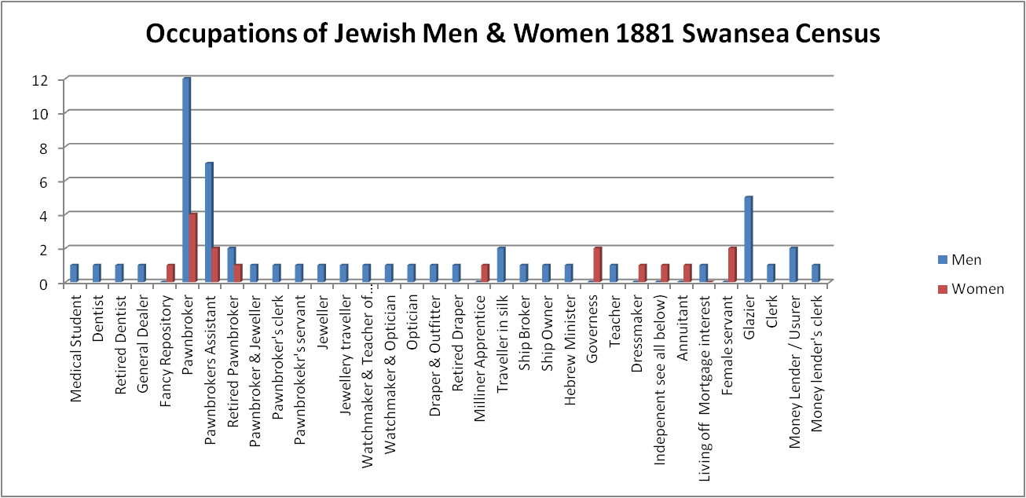
Fig. 18 Occupations of Jewish men and women in 1881. Occupations Data extracted from Census

Fig. 19 Occupations of Jewish Men and women extracted from the 1891 census

Fig. 20 Occupations of Jewish men and women extracted from 1901 Census

Fig. 21 Occupations of Jewish men 1911

FIg. 22 Occupations of Jewish Women extracted from the 1911 census

Fig. 23 Jewish Population plotted over time from data extracted from the 1841-1911 censuses

Fig. 24 The number of Jewish families plotted over time from data extracted from the 1841 -1911 censuses

Jewish Households Employing Servants
In the households which listed one servant, all those described in servant roles have been counted as ‘servant.’ In households with multiple servants, cooks, nurses and housekeepers, all such categories were classed as servants.
Four families employed a governess 1901-1911.

The classification and description of the occupation of servant varied across census years and servants could be described as general or female general or female domestic servants. There were also other categories of housekeepers, maids etc; There could be some ambiguity as to whether a member of the family was a paid ‘servant’ but the Jewish families virtually all included non-Jewish.
FIg.25 Number and types of servants in Jewish households extracted from the 1841-1911 censuses.
Census Year | Households with 1 Servant | Households with 2 Servants | Households with 3 Servants | Households a with Governess | Households with a Cook | Nurses | Total Households with servants of all types | Number of families | Percentage of families with servants
1841 | 8 | 1 |  |  |  |  | 9 | 24 | 37.5
1851 | 9 |  |  |  |  | 1 | 9 | 23 | 39
1861 | 14 | 4 |  |  | 1 | 5 | 18 | 30 | 60
1871 | 17 | 3 |  |  |  | 1 | 20 | 34 | 66
1881 | 18 | 5 |  | 2 |  | 1 | 23 | 38 | 60
1891 | 16 | 5 | 1 |  |  | 4 | 22 | 45 | 49
1901 | 24 | 5 | 3 | 3 | 4 | 3 | 32 | 83 | 38
1911 | 50 | 6 |  |  | 4 |  | 56 | 186 | 30

Fig. 26
Birthplaces of Jews in Swansea 1841. All Glamorgan born gave Swansea as a birthplace in 1851

Fig. 27 Birthplaces of Jews in Swansea 1851

Fig. 28 Birthplaces of Jews in Swansea 1861

Fig. 29 Birthplaces of Jews in Swansea 1871, data extracted from census

Fig. 30 Birthplaces of Jews in Swansea 1881, data extracted from census

Fig. 31 Birthplaces of Jews in Swansea 1891, data extracted from census

Fig. 32 Birthplaces of Jews in Swansea 1901, data extracted from census

FIg. 33 Birthplaces of Jews in Swansea 1911, data extracted from census

Map Showing Location of Jewish Families in 1841
FIg. 34 Locations of Jewish families extracted from 1841 Census plotted on 1851 Map of Swansea in Lewis John, (1851)

Map Showing Location of Jewish Families in 1851
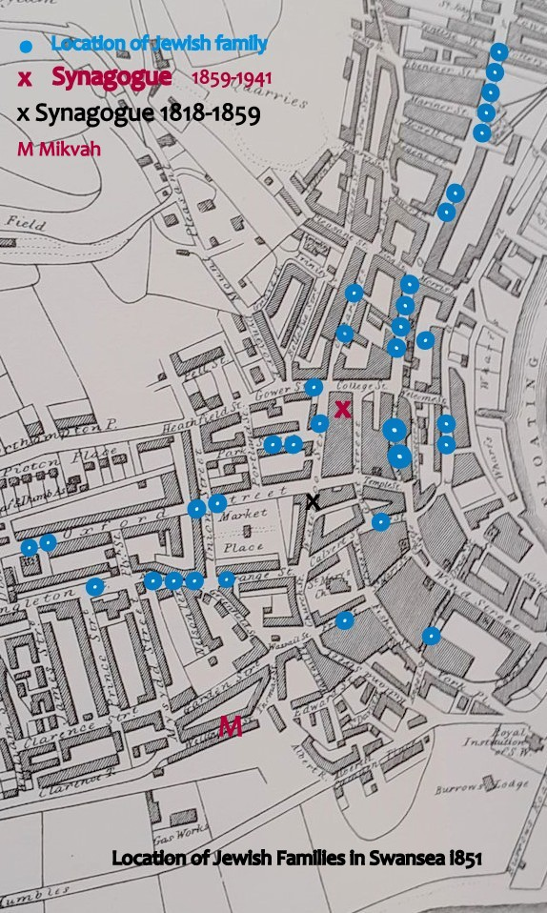
FIg. 35 Locations of Jewish families extracted from 1851 Census plotted on 1851 Map of Swansea in Lewis John, (1851)

Location of Jewish Families 1861
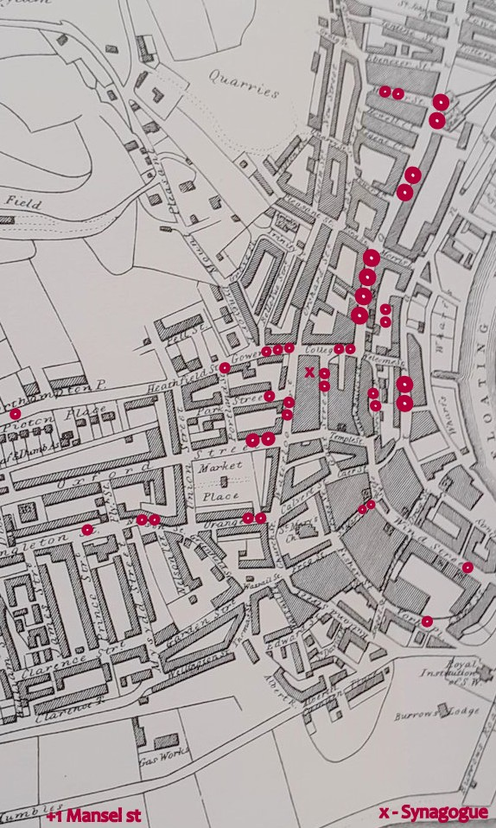
Fig. 36 Locations of Jewish families extracted from 1861 Census plotted on 1851 Map of Swansea in Lewis John, (1851)

Map Showing Location of Jewish Families in 1871
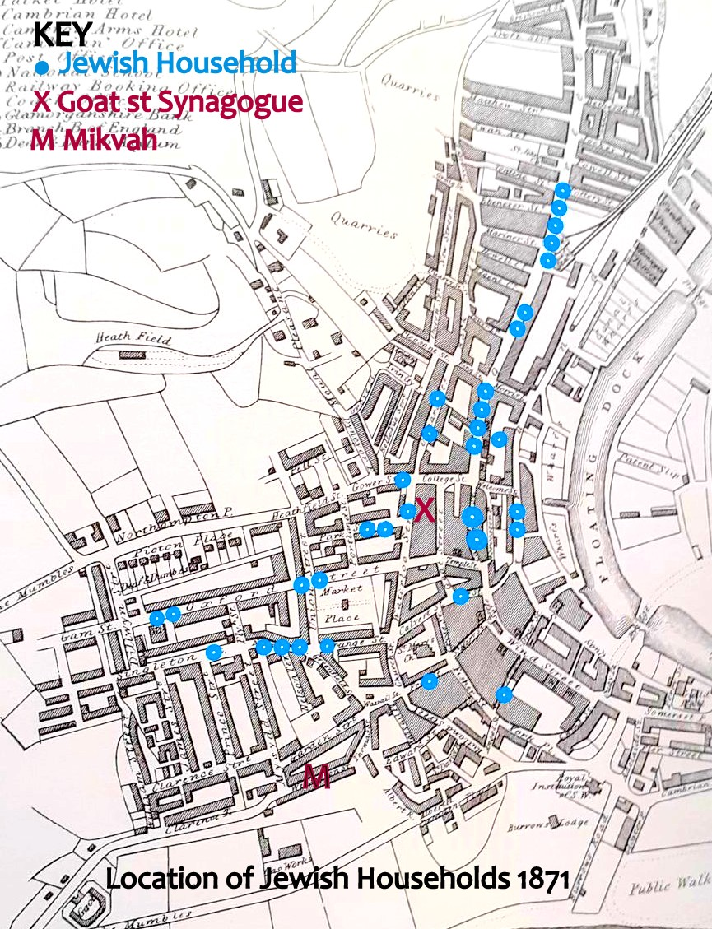
FIg. 37Locations of Jewish families extracted from 1871 Census and plotted on 1851 Map of Swansea in Lewis John, (1851)

Map Showing Location of Jewish Families in 1881
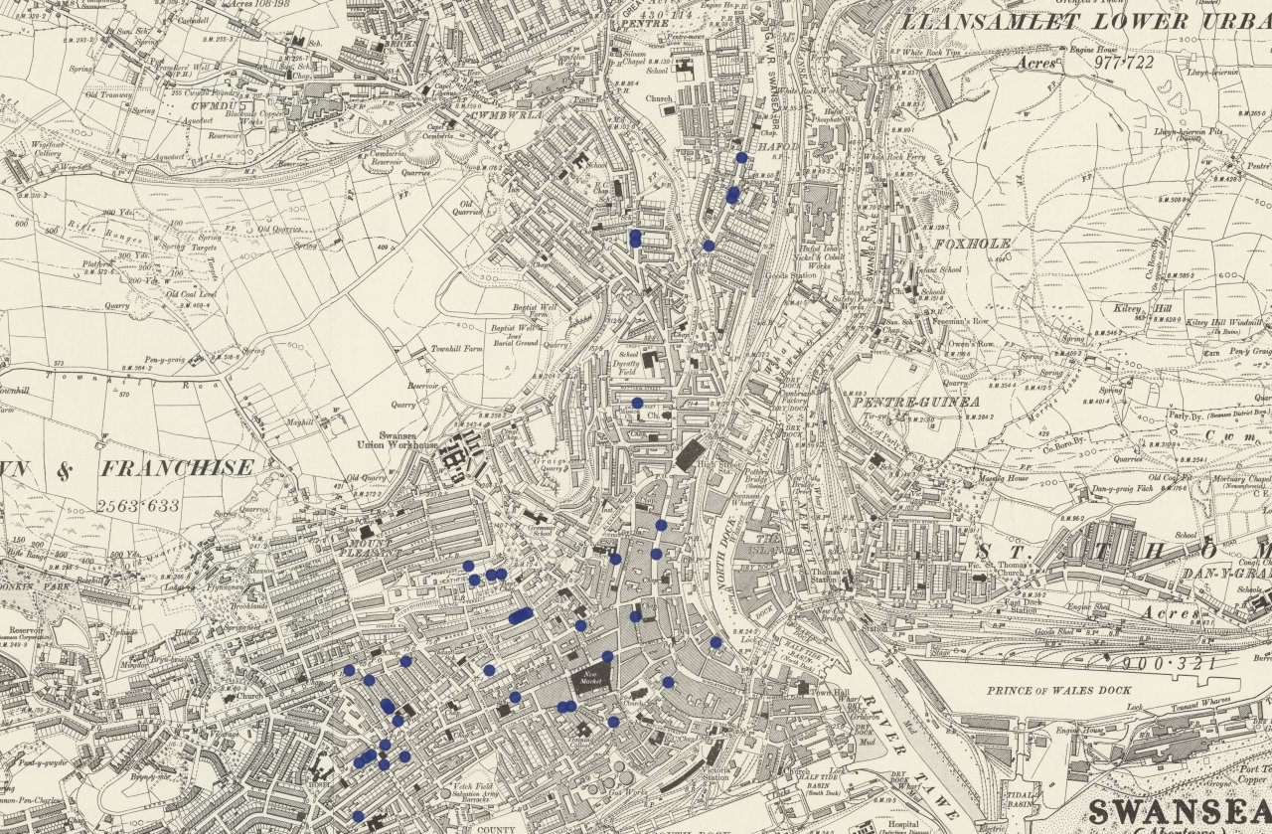
Fig. 38 Locations of Jewish families extracted from 1881 Census plotted on OS Map

Map Showing Location of Jewish Families in 1891
Locations of Jewish families extracted from 1891 Census plotted on OS Map
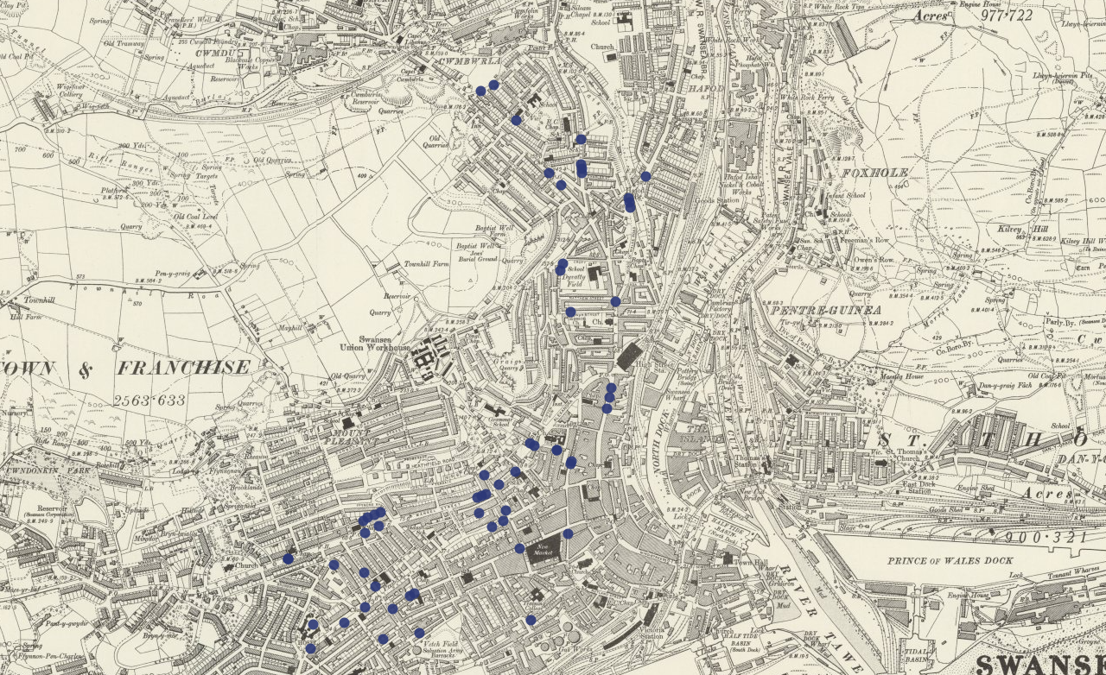
Fig. 39 Locations of Jewish families extracted from 1891 Census plotted on OS Map

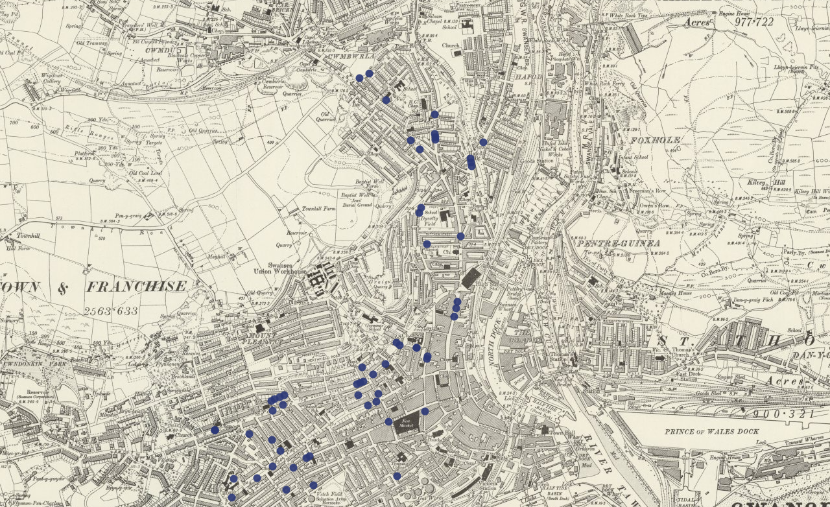
Fig. 40 Locations of Jewish families extracted from 1891 Census plotted on OS Map Zoom of Top Section

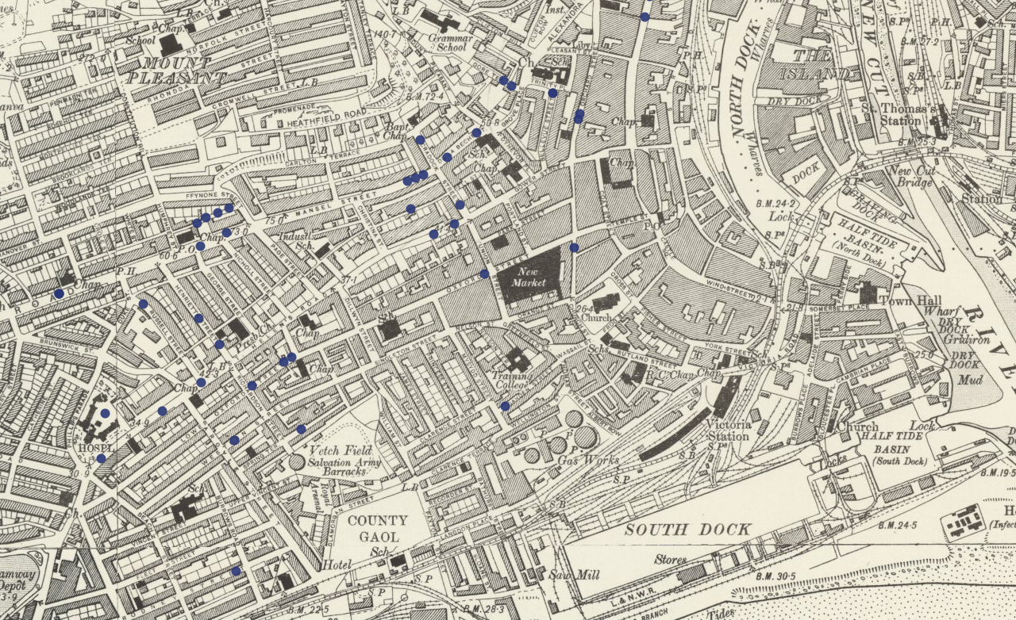
FIg. 41 Locations of Jewish families extracted from 1891 Census plotted on OS Map Zoom of Bottom Section
Map Showing Location of Jewish Families in 1901
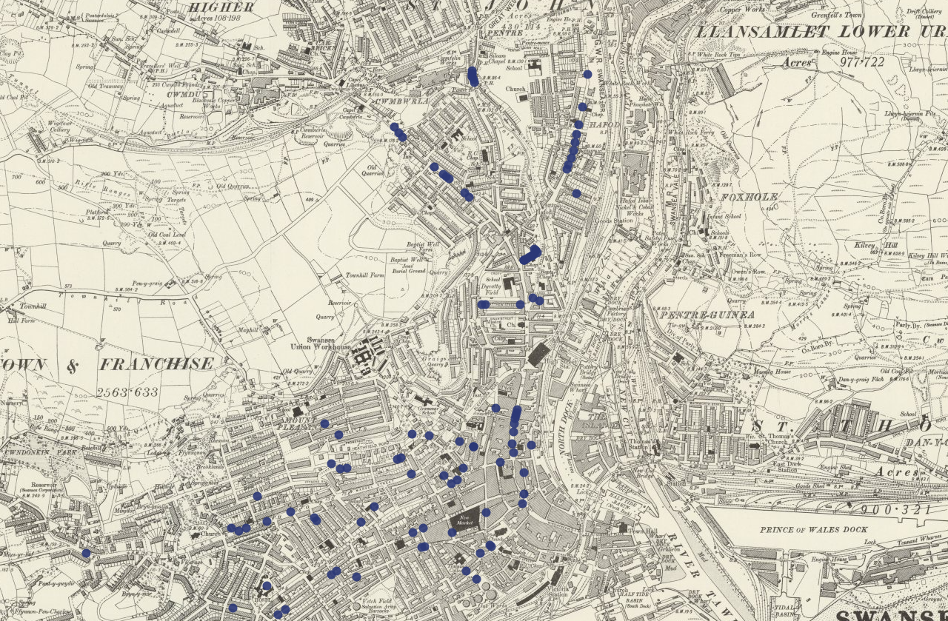
Fig. 42 Locations of Jewish families extracted from 1901 Census plotted on OS Map Zoom Mid-Top Section

1901 Map - area north of Prince of Wales Rd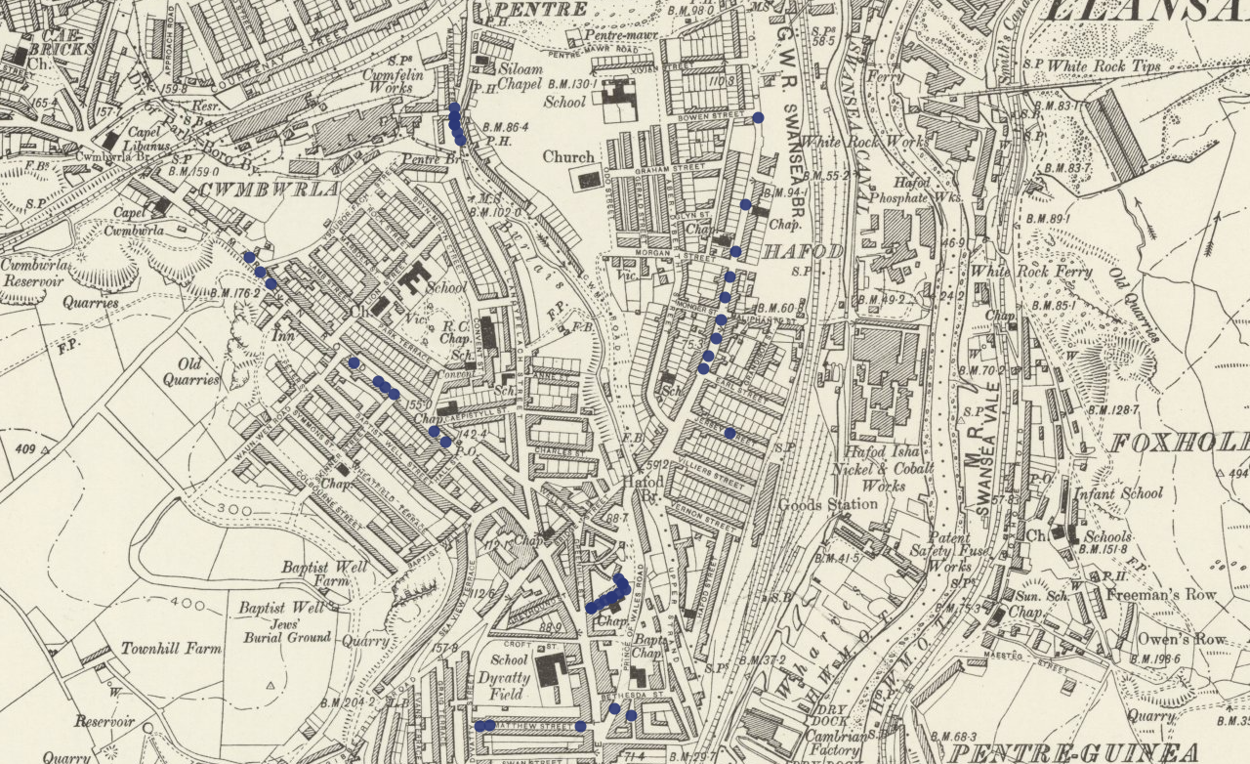
FIg 43 Locations of Jewish families extracted from 1901 Census plotted on OS Map
1901 Map - central area near Synagogue south of below Prince of Wales Rd
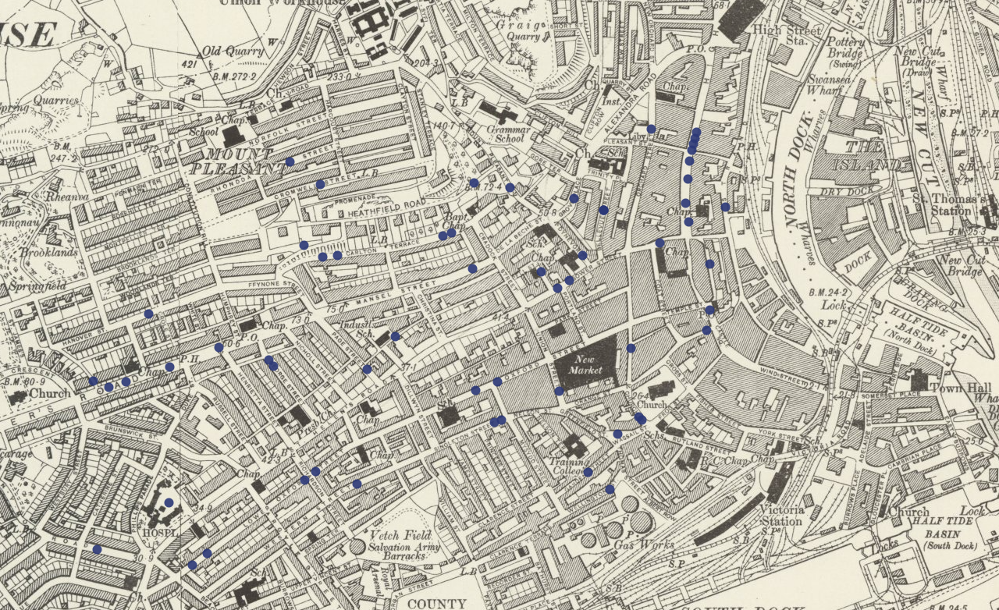Fig. 44 Locations of Jewish families extracted from 1901 Census plotted on OS Map
1901 Map Area - Spread of Households westwards towards Brynmill
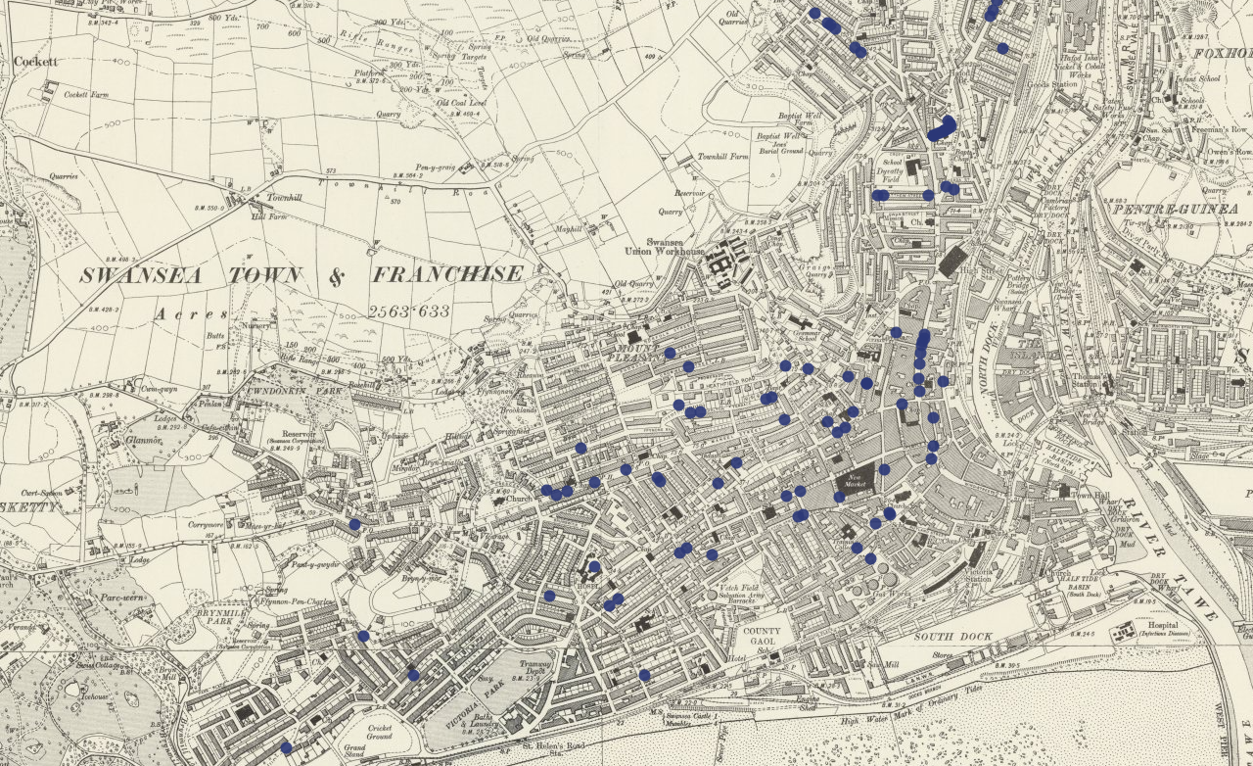
Fig. 45 Locations of Jewish families extracted from 1901 Census plotted on OS Map

Map of Locations of Jewish Families in 1911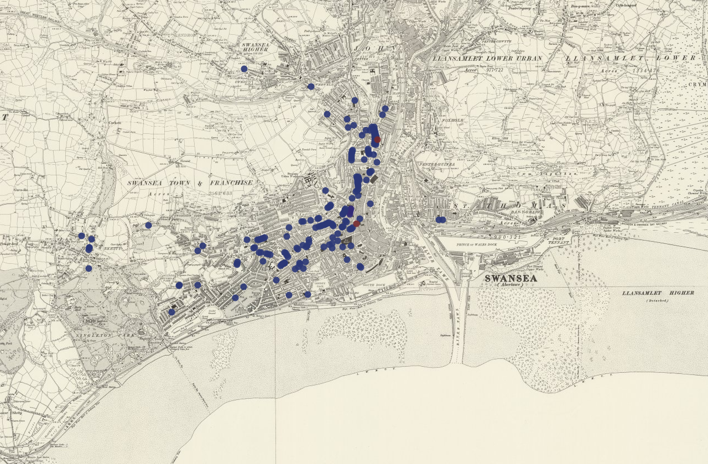 Fig. 46 Locations of Jewish families extracted from 1911 Census plotted on OS Map

FIg. 47Locations of Jewish families extracted from 1911 Census plotted on OS Map
Upper Red Circle represents the Beth Hamedrash Synagogue in Prince of Wales Rd
Lower Red Circle represents the Goat Street Synagogue

Fig. 48 Data extracted from 1891, 1901 & 1911 Censuses

* The country of birth used was that which appeared on the census. Difficulties with language and interpretation as well as changes to borders within Eastern Europe may have affected the accuracy of the information recorded.

* The small numbers from “Other Countries“ included:
1891 Other countries included Jam (1), Hungary (1), Turkey (1), Australia (2)
1901 Palestine (1), USA (1), Australia (2), Turkey (1), Rumania (3), Ireland (1), Lapland (1)
1911 Scotland (10), Palestine (5), USA (3), Australia (2), Turkey (1), Rumania (2)
* Not all Jews who had settled in Britain prior to each census had become naturalised.

FIg. 49 Data Extracted from Censuses 1851 -1911
The 1841 census has not been included since enumerators were only asked to identify the country of birth for those born in Scotland and Ireland. Individuals born abroad were recorded as being foreign, with no country identified.

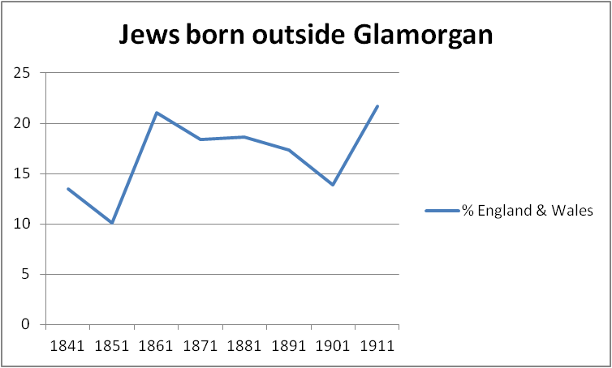
Fig. 50 % of Jews born in England and Welsh counties other than Glamorgan

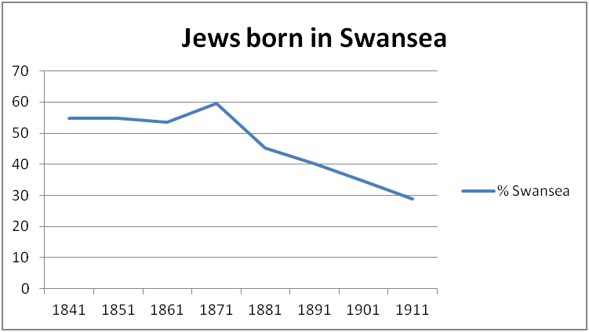
Fig. 51 % Of Jews born in Swansea extracted from 1841-1911 censuses
Although this census only recorded whether an individual was born in or outside of Glamorgan, the individuals were traced forward to 1851, and al had been born in Swansea.

Fig. 52% o Foreign Born Jews in Swansea. Data extracted from censuses

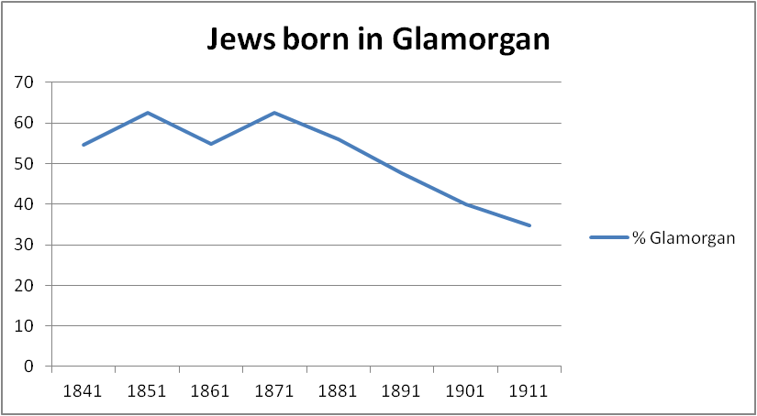
% of Jews born in Swansea extracted from 1841-1911 census.

BIBLIOGRAPHY

Primary sources

TNA Apprenticeship Books, Kew, The National Archives, Series IR 1 1710- 1811 Board of Stamps: Apprenticeship Books, Series IR 1; T

WGA Beth Hamedrash Minute Book Swansea, West Glamorgan Archive D/D/SHC/1/7

WGA SHC Graves Register Swansea, West Glamorgan Archive, DDSHC/ 8/ 1

WGA SHC Marriage Register (1840-1912) Swansea, West Glamorgan
Archive, DD SHC / 7 / 1

WGA SHC Marriage Register (1913-1936) Swansea, West Glamorgan Archive, D/D SHC 7/2

WGA Myer, Joseph, Oral History Recording Swansea, West Glamorgan Archive, GB 216 T 34/1

WGA SHC Notes & statistics Swansea, West Glamorgan Archive, D/D/SHC /8/11

WGA SHC Balance Sheets 1877-78 Swansea, West Glamorgan D/D/SHC 4/33
WGA SHC Balance Sheets 1878-9 Swansea, West Glamorgan, D/D/SHC 4/34
WGA SHC Balance Sheets 1903-4 Swansea, West Glamorgan D/D/SHC 4 /35

WGA SHC Balance Sheets 1904-5 Swansea, West Glamorgan D/D/SHC 4 /35a

WGA SHC Balance Sheets 1908-9 Swansea, West Glamorgan, D/D/SHC 4 /36

WGA SHC Balance Sheets 1909-10 Swansea. West Glamorgan, D/D/SHC 4 /37

WGA SHC Balance Sheets 1910-11 Swansea, West Glamorgan, D/D/SHC 4 /38

WGA SHC Balance Sheets 1914-15 Swansea, West Glamorgan, D/D/SHC 4 /39

WGA SHC Balance Sheets 1921-22 Swansea, West Glamorgan, D/D/SHC 4 /40

WGA SHC Burial Ground Conveyance Swansea, West Glamorgan, D/D SHC 27/4

WGA SHC Minute Book 1893-1909 Swansea, West Glamorgan, D/D SHC 1/1
WGA SHC Minute Book 1909-1932 Swansea, West Glamorgan, D/D/SHC/1/2
WGA SHC Rule Book 1892 Swansea, West Glamorgan, D/D SHC 3/1

WGA SHC Hebrew Grave Inscriptions. Swansea, West Glamorgan, D/D SHC 8/30

WGA SHC Con Book 1730-1980 Swansea, West Glamorgan, CHU 24
1851 Religious census Swansea, West Glamorgan

Parliamentary Archives Westminster HL/PO/PB/1/1804/44G3n191 Local and Personal Act (Not Printed), 44 George III, c. 54 An Act for naturalizing Samuel Levi Phillips.

Parliamentary Papers (P.P’s.), Commissioners & Other Annual Reports, House of Commons Debates (HC Deb)
Poor Law Commissioners Report, P.P. 1844, (10)
HC Deb 20 February 1838 vol. 40 cc. 1362-413
Poor Law Commissioners Report, P.P. 1834, (44)

Newspapers

Hebrew Observer
Jewish Chronicle
Llais Llafur
Llangollen Advertiser Denbighshire Merionethshire and North Wales Journal
Monmouthshire Merlin
South Wales Daily News
Swansea Journal and South Wales Liberal
The Cambrian
The Cardiff and Merthyr Guardian Glamorgan Monmouth and Brecon Gazette
The Cardiff Times
The Carmarthen Journal and South Wales Weekly Advertiser
The Glamorgan Monmouth and Brecon Gazette and Merthyr Guardian
The Welshman
Weekly Mail

Printed Books
Henriques, Ursula, R.Q. (ed.) The Jews of South Wales, (Cardiff: University Of Wales Press, 2013)
Lewis, John, The Swansea Guide 1851, (Bath: West Glamorgan County Council, 1989)

Other

Dictionary of Welsh Biography.
Cemetery Scribes Jewish Cemetery Database
Butcher’s South Wales Commercial Directory 1881-2
Kelly’s Post Office Director of Monmouthshire & South Wales 1871 & 1891
Holden’s Annual London and Country Directory of the United Kingdoms. and Wales, 1811, Vol 3
Land Tax Redemption Office: Quotas and Assessments.
Pigot’s Directory, South Wales, 1830

Ordnance Survey 1st edition 15.9 (1877), 15.10 , 15.13, 15.14 (all 1881)
Ordnance Survey 2nd edition 15.14 (1912)

Newman Papers https://www.jewishgen.org/jcr-uk/Community/swansea_articles/swansea-vic.htm Susser Archive https://www.jewishgen.org/jcr-uk/Newman_papers/Provincial_Jewry_Victorian/statistical_accounts_I_page_08.htm

The New Swansea Guide (1823) accessed via books.google.uk on 18 March 2014

UK Census of Population 1841, 1851, 1861, 1871, 1881, 1891, 1901, 1911, 1911 Census Summary, accessed via www.ancestry.co.uk
UK census reports 1841, 1851, 1861, 1871, 1881, 1891, 1901, 1911 accessed through www.histpop.org
https://www.visionofbritain.org.uk/census/EW1891GEN/8?show=ALL

Secondary sources
Books
Actual books used below:
Alban, J.R Swansea, 1184-1984, Swansea City Council, Pensord Press, (Blackwood, 1984)
Alderman, Geoffrey, The Jewish Community in British Politics, (Oxford:1983)
Davies, Grahame (ed.) The Chosen People, Wales & The Jews, (Bridgend: Seren, 2002)
Endelman, Todd, M. The Jews of Britain 1656-2000, (Berkley, Los Angeles: University of California Press, 2002)
Harris, E. Swansea It’s Port And Trade And Their Development, (Cardiff: Western Mail & Echo Limited, 1935)
Henriques, Usrula, R.Q. The Jews of South Wales, (Cardiff: University of Wales Press. 2013)

Hodges,T.M. The Peopling of the Hinterland and Port of Cardiff 1801-1914 in: Minchinton, W.E. Ed. Industrial South Wales 1750-1914: Essays in Welsh Economic History. London: Routledge, 2013, pp.3- 7

Hughes, S. Copperopolis: Landscapes of the Early Industrial Period in Swansea, (Aberystwyth: Royal Commission on the Ancient and Historical Monuments of Wales, 2008)

Hughes, S and Reynolds, P. A Guide to the Industrial Archaeology of the Swansea Region, (Aberystwyth: RCAHMW, 1992)
Parry-Jones, Cai, The Jews of Wales A History, (Cardiff: University of Wales Press, 2017)
Parry, Gwenfair & Williams, Mari.A. Miliwn o Gymry Cymraeg! Yr Iaith Gymraeg a Chyfrifiad 1891 (Caerdydd: Gwasg Prifysgol Cymru 1990)
Pearce, Keith, Lemon Hart of Penzance, (Penzance: Penlee House Museum and Gallery, 2018)
Mills, John, Rev. The British Jews, (London: Houlston and Stoneman, 1852)
Roth, Cecil, The Rise of the Provincial Jewry (London: Jewish Monthly,1950)

Rubinstein, W, Jolles Michael, A. and Rubenstein H.L. (eds.) The Palgrave Dictionary of Anglo-Jewish History,(Basingstoke: Palgrave Macmillan, 2011)

Williams, David, The Rebecca Riots A study in Agrarian Discontent, (Cardiff: University of Wales Press, 1955)
Articles
Alderman, Geoffrey, The Jew as Scapegoat? The Settlement and Reception of Jews in South Wales before 1914, Transactions & Miscellanies (Jewish Historical Society of England), Vol. 26 (1974-1978)
Anthony, Robert, 'A very thriving place': the peopling of Swansea in the eighteenth century, Urban History: Understanding Urban Wales, Special Edition, Vol. 32, No. 1 May 2005
Bowen, E.G. Cambria A Welsh Geographical Review p.5
Holmes, Colin, The Tredegar Riots of 1911: Anti Jewish Disturbances in South Wales. In: Welsh History Review
Konrad, Gyorgy, Aphorisms on the Durability of Jews, Partisan Review, 65/4 (1998), 548

Konrad, Gyorgy, Aphorisms on the Durability of Jews, Partisan Review, 65/4 (1998), 548

Levene, Alysa, Jewish Household and Religious Identity in Mid-nineteenth-century Britain, Journal of Family History, Vol. 43(3) (2018)

Neilson, Janet, M. The History And Influence Of Swansea’s Jewish Community, Minerva transactions of the Royal Institution of South Wales. Vol. 14, (2006), p.27
Rubenstein, W.D. The Anti-Jewish Riots of 1911 in South Wales: A Re-examination, Welsh History Review 18 (1997)

Neilson, Janet, M. The History And Influence Of Swansea’s Jewish Community, Minerva transactions of the Royal Institution of South Wales. Vol. 14, (2006), p.27

Vaughan, L & Penn, A. (2006). Jewish Immigrant Settlement Patterns in Manchester and Leeds 1881. Urban Studies, 43(3), 653-671

Theses/Dissertations
Anthony, C.R. ‘Seaport, society and smoke: Swansea as a place of resort and industry c. 1700 to c. 1840’, University of Leicester PhD, (2002).
Parry-Jones, Cai, The History of the Jewish Diaspora in Wales, PhD Bangor University (2014)
Websites
Dictionary of Welsh Biography https://biography.wales/
Haverfordwest Town Museum https://haverfordwest-town-museum.org.uk/blog/2020/08/25/the-rise-and-fall-of-the-haverfordwest-bank/
Histpop http://histpop.org
Jewishgen https://www.jewishgen.org

Thomas, B. B., (1959). ROBERTS, ROBERT DAVIES (1851 - 1911), pioneer in adult education and scientist. Dictionary of Welsh Biography. Retrieved 29 Jul 2022, from https://biography.wales/article/s-ROBE-DAV-1851

Vision of Britain: http://www.visionofbritain.org.uk

CHW 24, P. 29. (West Glamorgan Archives, Swansea. Swansea Hebrew Congregation 1730-1980 250th Anniversary Commemorative Booklet (hereafter SHC Commemorative Booklet))
DDSHC/ 8/ 1 Graves Register 1877-1959 Levy Michael’s Gravestone inscription 29 Nov 1841 burial entry p 64 Hebrew Translations at D/D SHC 8/30
http://www.visionofbritain.org.uk/unit/10039708/cube/TOT_POP
https://api.parliament.uk/historic-hansard/lords/1848/may/25/jewish-disabilities-bill accessed 21 Jan 2021
Henriques, Ursula R.Q. (ed.), The Jews of South Wales, (Cardiff: University of Wales Press 2013),p.11. Michael and Levi Marks had moved from Neath to Cardiff. Levi Marks’s son Mark Lyon Marks married Ann Michael, the grand-daughter of David Michael of Swansea.
Holmes, Colin, The Tredegar Riots of 1911: Anti Jewish Disturbances in South Wales. In: Welsh History Review Vol. 11, nos. 1-4, (1982-83), p.215
Parry-Jones, Cai, The Jews of Wales A History, (Cardiff: University of Wales Press, 2017), p.2
Roth, Cecil , The Rise of the Provincial Jewry, The Early History of the Jewish Community in the English Countryside, 1740-1840, (London: The Jewish Monthly, 1950), pp.102-104
Henriques, Ursula R.Q. (ed.), The Jews of South Wales, (Cardiff: University of Wales Press 2013), pp.131-176
Alderman, Geoffrey, The Jew as Scapegoat? The Settlement and Reception of Jews in South Wales before 1914, Transactions & Miscellanies (Jewish Historical Society of England), Vol. 26 (1974-1978), p.65
Rubenstein, W.D. The Anti-Jewish Riots of 1911 in South Wales: A Re-examination, Welsh History Review 18 (1997), p. 669
Glaser, Anthony, The Tredegar Riots of 1911, in Henriques, Ursula, R.Q. p.174
Henriques, Ursula, R.Q. pp. 85-108
Davies, Graham. (ed.), The Chosen People Wales & The Jews, (Glasgow: Seren, 2002), p.16
Parry-Jones, Cai, pp.112-136
Henriques, Ursula R.Q. p.38
Endelman, Todd, M. The Jews of Britain (1656-2000), (Berkley 2002), p.12
Parry-Jones, Cai, pp. 158-165
Konrad, Gyorgy, Aphorisms on the Durability of Jews, Partisan Review, 65/4 (1998), 548
Alderman, Geoffrey, The Jewish Community in British Politics, (Oxford:1983), p. vii
Parry-Jones, Cai, p.13
Swansea Hebrew Congregation 1730-1980 Commemorative Booklet (Swansea, 1980), p.1 (SHC Commemorative Booklet)
SHC Commemorative Booklet, p.2
Pearce, Keith, Lemon Hart of Penzance, (Penzance: Penlee House Museum and Gallery, 2018), p.1
SHC commemorative Booklet p.29
Wood, Col. William (ed.) The Storied Province of Quebec History- Past and Present. VOL I –II, Dominion Publishing Co; (Toronto, 1931), pp.694-5
HL/PO/PB/1/1804/44G3n191 Local and Personal Act (Not Printed), 44 George III, c. 54 An Act for naturalizing Samuel Levi Phillips
Haverfordwest Baptism Registers, Samuel Levi Phillips at St. Thomas’ Church on 28 October 1753, A Jew called Moses Phillips aged about two and twenty & a Jew named Benjamin Gabriel aged about nine and thirty years was baptised 23 Jun 1755 at St. Mary’s Haverfordwest. see https://haverfordwest-town-museum.org.uk/blog/2020/08/25/the-rise-and-fall-of-the-haverfordwest-bank/
Bowen, E.G. Geography in Wales: a retrospect, Cambria a Welsh geographical review, (1974), Vole 1, no.1, p.5
Thomas, B. B., (1959). ROBERTS, ROBERT DAVIES (1851 - 1911), pioneer in adult education and scientist. Dictionary of Welsh Biography. Retrieved 29 Jul 2022, from https://biography.wales/article/s-ROBE-DAV-1851
Alban, J.R Swansea, 1184-1984, Swansea City Council, Pensord Press, (Blackwood, 1984), pp.18-19
Op cit pp. 22-23
Harris. Edward, Swansea It’s Port And Trade And Their Development, (Cardiff: Western Mail & Echo Limited, 1935) p.115
Alban, J.R. pp.25-26
Harris, Edward, p115
Anthony, Robert, (May 2005) 'A very thriving place': the peopling of Swansea in the eighteenth century, Urban History : Understanding Urban Wales, Special Edition, Vol. 32, No. 1, p.74
Henriques, Ursula, R.Q. (ed.) The Jews of South Wales, (Cardiff: University Of Wales Press, 2013), pp. 11-12
Harris, Edward, P.30
Hodges, T.M. “The Peopling of the Hinterland and Port of Cardiff 1801-1914” in: Minchinton, W.E. Ed. Industrial South Wales 1750-1914: Essays in Welsh Economic History. London: Rutledge, 2013, pp.3 – 7
The total population of Swansea district from 1800-2020 available at: http://www.visionofbritain.org.uk/unit/10039708/cube/TOT_POP (accessed 29 October 2019)
Anthony, Robert, (May 2005) 'A very thriving place': the peopling of Swansea in the eighteenth century, Urban History : Understanding Urban Wales, Special Edition, Vol. 32, No. 1, p.85
Pearce, Keith, Lemon Hart of Penzance, (Penzance: Penlee House Museum and Gallery, 2018), pp.12-14
The Western Mail, 16 Apr 1873, p.4
Anthony, Robert, (May 2005) 'A very thriving place': the peopling of Swansea in the eighteenth century, Urban History : Understanding Urban Wales, Special Edition, Vol. 32, No. 1, p.71
Alban, J.R Swansea, 1184-1984, Swansea City Council, Pensord Press, (Blackwood, 1984), p.4
West Glamorgan Archive (WGA) Swansea Hebrew Congregation Burial Ground Conveyance D/D SHC 27/4. As part of the agreement a couple of pullets, or a shilling in lieu, were also payable annually to the Portreeve and an eight foot 20 inch thick wall with good lime mortar was required to be built around the perimeter of the cemetery.
Land Tax Redemption Office: Quotas and Assessments. IR23, pp.304-7 Accessed via Ancestry https://www.ancestry.com/imageviewer/collections/2319/images/33175_636897_0816-00305?pId=236969 The streets in Swansea Town & Franchise listed as being: Goat street, Market street, Cross street, St Mary street, High street, Strand, Castle Bailey street, Fisher street, & Frog street.
A formal Jewish service required a Minyan of ten adult males.
Commemorative Booklet p.31
The year A.M.5578 being the Hebrew year 1818.
Commemorative Booklet p.33
Commemorative booklet p.35
The Cardiff and Merthyr Guardian Glamorgan Monmouth and Brecon Gazette 16 Apr 1859, p.5. Lionel Nathan de Rothschild was the first Jewish Member of Parliament. He was first elected in 1847, but was barred from sitting in the chamber until 1858, because of the references and actions relating to Christianity in the oath needed to be sworn. It was only when the Jews Relief Act 1858 was passed that this problem was overcome and he was able to be sworn in using a Hebrew Bible with the wording “Christian” being substituted in the oath.
The Cardiff and Merthyr Guardian Glamorgan Monmouth and Brecon Gazette, 8 Oct 1859. p.8
Henriques, Usrula, R.Q. The Jews of South Wales, (Cardiff: University of Wales Press. 2013), pp.100-103
Commemorative Booklet p.49
Swansea Hebrew Congregation (SHC) Minute Book 1893-1909 D/D SHC 1/1
Parry-Jones p. 167
SHC Commemorative Booklet, pp.33-7 The SHC was first represented on The Jewish Board of Deputies from in 1854-5, in 1854-55 and following a lapse, from 1862 onwards. The Board of Deputies of British Jews as it was formally called, had established in London in 1760 and was made up of Deputies elected by affiliated individual synagogues, who dealt with all manner of issues relating to Jews in Britain.
Parry, Gwenfair & Williams, Mari.A. (eds.) Miliwn o Gymry Cymraeg! Yr Iaith Gymraeg a Chyfrifiad 1891 (Caerdydd: Gwasg Prifysgol Cymru 1990), P.1
Parry-Jones, Cai The Jews of Wales A History, (Cardiff: University of Wales Press, 2017)
Neilson, Janet, M. The History And Influence of Swansea’s Jewish Community, Minerva transactions of the Royal Institution of South Wales. Vol. 14, 2006, p.27 Ancestry and the various sources therein confirm that the Siedle brothers were born in Merthyr Tydfil to Eduard Siedle whose family were clockmakers, from Baden-Württemberg, Germany. Eduard’s occupation of Pawnbroker in Swansea may also have caused him to have been counted amongst Jewish Pawnbrokers. https://www.ancestry.com/family-tree/person/tree/179404164/person/122332064975/facts
WGA SHC Marriage Register. The marriages of Lilly Micholls Jones (1860) and Abraham Morris (1864), were conducted in the Goat Street Synagogue. The Chavenson family changed their surname to Lewis - as indicated on the Certificate of Naturalisation for Hayman Chavenson 3 Jan 1910 (UK, Naturalisation Certificates and Declarations, 1870-1916, (piece 048, no. 184325) for Hayman Chavenson Retrieved from Ancestry https://www.ancestry.com/discoveryui-content/view/53040:9156 May 2021.
Jones, David, J.V. Before Rebecca Popular Protest in Wales 1793-1835 (Bristol: Allen Lane, 1973), p.19
The National Archives (TNA) Board of Stamps: Apprenticeship Books, Series IR 1 1710-1811, Dec 1 1780
Holden’s Annual London and Country Directory of the United Kingdoms, and Wales, 1811, Vol.III (listed under Swansea). There was in fact no I. Michael. The entry is likely to have been Jacob Michael, brother of Levi Michael.
Suanders, N.H. in WGA, Notes & statistics Relating to Swansea Hebrew Congregation, DD SHC /8/11
Pigot’s Directory, South Wales, 1830, pp.863-865
SHC Commemorative Booklet, p.31
Roth, Cecil The Rise of the Provincial Jewry (London: Jewish Monthly, 1950), Appendix.
See Fig. 2 page 25 Graph of data extracted from the 1841-1911 censuses for Swansea. The accountant converted to Christianity in 1849, and has been counted as Jewish for the 1841 census only.
Williams, David, (1955) pp.115-6
The Cambrian 4 Nov 1843, p.3
The Cambrian 28 Aug 1843, p.4
The Cambrian 25 Dec 1841, p.3
The Cambrian 1 Oct 1842,p.3
Williams, David, The Rebecca Riots A study in Agrarian Discontent, (Cardiff: University of Wales Press, 1955), vii. “The Rebecca riots” first occurred in January 1839 in response to the erection of two of four new toll gates being built by the Whitland Turnpike Trust. The Efail Wen gate near Whitland was smashed by a group of rioters dressed as women proclaiming themselves as “daughters of Rebecca.” While they were the focus of the riots thereafter, as Williams outlined, there were also caused by other contributory economic and social factors.
Poor Law Commissioners Report, P.P. 1844, (10) Figures extracted from various tables in report.
Newman, Aubrey, Extract from papers on Provincial Jewry in Victorian Britain, JHSC Conference (1975), (Retrieved from https://www.jewishgen.org/jcr-uk/Newman_papers/Provincial_Jewry_Victorian/statistical_accounts_I_page_08.htm#Swansea Jan 2022)
WGA, SHC Balance Sheets 1877-78, D/D/SHC 4/33
The Cambrian 31 Oct 1840, p.4; 6 Jan 1844, p.3 ; 27 Apr 1844, p.3; 29 Jun 1844, p.3; 27 Jul 1844, p.3; 10 Aug 1844, p.3; 13 Aug 1844, p.3; 7 sep 1844, p3; 26 Oct 1844, p.3 ; 2 Jan 1846, p.3
The Cambrian 27 Apr 1944, p.3
The Cambrian 31 Aug 1844, p.3
Abstract of 1841 Census Report https://www.visionofbritain.org.uk/census/table_page.jsp?tab_id=GB1841OCC_M[1]&u_id=12782950&show=DB Retrieved March 2022. The abstract table shows 6 pawnbrokers and the actual census returns also listed a Jewish assistant pawbnroker (David Frankell)
Henriques, Ursula, R.Q. (2013), p.81
See the Jewish pawnbrokers 1841-1911 charta pp.30-31
The Western Mail, 4 May 1869, p.2
The Cambrian 16 Jun 1827, p.3
The Cambrian 9 Apr 1836, p.2
1851 Census Occupation table Appendix, page 73
West Glamorgan Archive, Swansea Hebrew Congregation Minute Book (1893-1909), WGA/SHC/D/D SHC 1/1 (Hereinafter SHC Minute Book 1893-1909)
Population and Chart Data extracted from Censuses
Newman, Aubrey, (1975)
Newman, Aubrey, Extract from Papers for a conference at University College, London, convened on 6 July 1975 by the Jewish Historical Society of England. Retrieved 5 May 2022, from https://www.jewishgen.org/jcr-uk/Community/swansea_articles/swansea-vic.htm
SHC Congregation Booklet, p.33
WGA SHC Marriage Register SHC/7/1 5 Aug 1849
The Cardiff Times 18 Dec 1858, p.2
SHC Marriage Register p.16
UK Naturalization certificate no. 6123 (6 May 1889) Rev. Abrahams son names Plotsk, Russia as his father’s birthplace.
1851 Census
UK Census of Population 1841, 1851, 1861, 1871, 1881, 1891, 1901, 1911, 1911 Census Summary, accessed via www.ancestry.co.uk UK census reports 1841, 1851, 1861, 1871, 1881, 1891, 1901, 1911 accessed through www.histpop.org The 1841 census only recorded whether individuals were born in or outside of the census county or whether they were born in Ireland, Scotland or foreign parts. Given the small numbers of Jews, It was possible to identify the same families in both 1841 and 1851 and subsequent censuses, to give a definite birthplace or them in 1841. There were also 13 whose birth place was not given or not known in 1841, 1 in 1901 and 3 in 1911.
Maps showing plotted locations of Jewish household s on 1841-1861 censuses. Appendix pp.90-93
The Cambrian, 30 Aug 1872, p.8
Appendix page 71 Susser Table of Seat Members
Newman Papers Extract from papers on Provincial Jewry in Victorian Britain Papers prepared by Dr. (later Prof.) Aubrey Newman for a conference at University College, London, convened on 6 July 1975 by the Jewish Historical Society of England (2016)
Appendix page 88
1861-1881 Censuses
Parry-Jones, Cai, The History of the Jewish Diaspora in Wales, PhD Bangor University (2014), p.31 Retrieved Sept 2019
Swansea Hebrew Congregation Balance Sheets, WGA, D/D/SHC 4/33-34
The Cambrian 5 Feb 1875, p.7
Welshman 10 December 1847, p.2
The Welshman 22 March 1844 March, p.4
Jewish Chronicle, 3 February 1865, page 1
Endelman, Todd,M. pp.127-129
Henriques, Ursula, R.Q. p. 2
Appendix x Birthplace chart 1881 – there were also two individuals who were “born abroad,” and another seven born in Germany, Australia and Turkey. The enumerator had attempted to record the names of towns or regions in Poland / Russia which were in the Northern Pale area and which were recorded as :Calvary, Memel, Posen and Courland (Modern day Kalwaria, Poznan, Klaipėda in Lithuania and Courland a government area in Lithuania, with a further two individuals arriving in 1911 from the area from the towns of Polanga and Telsai.
Appendix page 95, 1881 Map
Appendix page 78, Occupations Table 1881
Henriques, Ursula, R.Q. (2013) p.53
The South Wales Daily Post, 30 March 1899, p.3 (Listed as Dr. L Freeman Marks, but actually Urban Marks
Appendix page 100. Russia accounted for birthplace of 62 individuals, 11 Russian Poland, and 9 Poland. There were 77 classed as refugees or foreign subjects and 10 British subjects, although not all settled Jews may have become naturalised.
Birthplace Pie chart 1881, Appendix page 88
Table of Occupations, Appendix p. 79
1891 Census Report , Retrieved from https://www.visionofbritain.org.uk/census/EW1891GEN/8?show=ALL
Weekly Mail 19 Nov 1887, p.3
Maps, 1891 Appendix pp.95-96
South Wales Daily News 26 Nov 1888, p.3
The South Wales Daily Post, 16 February 1895, p.3
1901 Census Report Retrieved April 2022 The accuracy of census returns of Jewish families could be affected by fears of those fleeing persecution, conscription, as well as that the information problems with translation. https://www.visionofbritain.org.uk/census/EW1901GEN/9?show=ALL
Birthplace charts Appendix pp. 99-100
1901 Maps showing Distribution of residence, Appendix pp.95-97
Swansea Journal and South Wales Liberal 10 August 1895, p.3
South Wales Daily Post 17 Jul 1895, p.4
Countries of Birth graph, Appendix pp. 95-96
Birthplace graphs Appendix pp. 87 & 102
The Cambrian 14 Aug 1903, p,4
Endelman, Todd, M. pp. 156-160
South Wales Daily News 25 Jan 1900, p.6
The Cambrian 30 Sep 1892, p.6 Arrested Jewish hawker Claimed he an interpreter in court. He was fined when the arresting officer stated he’d understood English perfectly when summonsed and a license dated for the following day was found in his possession in spite of claiming he was on his way to Neath to obtain one.
The Cambrian 2 Sep 1898, p.6
Evening express 30 Sep 1905, p.3
The Cambrian 2 Oct 1908, p.4
The Cardiff Times 21 Dec1907, p.9
SHC Table of Seat Holder Members. Appendix p.70
Perry-Jones, Cai,(2017), p.41
1901Census. The 313 were those from the total of 504 who were considered adults aged 13 and over.
SHC Minutes
Pie chart showing Immigrants from outside Glamorgan England Wales. Appendix page 89
Levene, Alysa, Jewish Household and Religious Identity in Mid-nineteenth-century Britain, Journal of Family History 2018, Vol. 43(3), (2018),p.294
South Wales Weekly Post, 26 Sep 1914, p.6
UK, British Army World War I Service Records, 1914-1920, Retrieved via Ancestry.co.uk 2019-2020
The Cambria Daily Leader 8 March 1917, p.3
Commemorative Plaque now situated in Oyster mouth Hebrew Cemetery
The Cambria Daily Leader, 19th October 1918, p.3
South Wales Weekly Post, 25 August, 1917, p.1
UK, British Army World War I Service Records, 1914-1920, Retrieved via Ancestry.co.uk 2019-2020
South Wales Weekly Post 28 July 1917, p.2
Beth Hamedrash Congregation Minutes, 18 Nov 1917
The Cambria Daily Leader 19 July 1915, p.5
Birmingham Daily Gazette, 4 December, 1918, p.1
Aberdeen Press and Journal , 10 November 1919, p.5
Parry-Jones, Cai, (207), p.2
Parry, Gwenfair & Williams, Mari.A. Miliwn o Gymry Cymraeg! Yr Iaith Gymraeg a Chyfrifiad 1891 (Caerdydd: Gwasg Prifysgol Cymru 1990), p.16
The Carmarthen Journal and South Wales Weekly Advertiser 16th November 1811, p.4
Parry-Gwenfair & Williams, Mari, A. p.11
1911 Census Report http://www.histpop.org/ohpr/servlet/PageBrowser2?ResourceType=Census&ResourceType=Legislation&ResourceType=Essays&ResourceType=Registrar%20General&ResourceType=TNA&SearchTerms=swansea%20welsh%20language&simple=yes&path=Results&active=yes&treestate=expandnew&titlepos=0&mno=156&tocstate=expandnew&display=sections&display=tables&display=pagetitles&pageseq=57&zoom=5 Retrieved 2 April 2022
The Cambrian, 2 Nov 1906, p.6
Llangollen Advertiser Denbighshire Merionethshire and North Wales Journal , 21 September, 1900, p.4
The Cardiff and Merthyr Guardian Glamorgan Monmouth and Brecon Gazette, p.8
Hebrew Observer 5 May 1854, p.6
United Grand Lodge of England Freemason Membership Registers, 1751-1921, Indefatigable Lodge, Swansea, Lodge Number 427A, Folio 428B
United Grand Lodge of England Freemason Membership Registers, 1751-1921, Indefatigable Lodge, Swansea , Lodge Number 237, Folios 269
Hebrew Observer 7 April 1854, p.8
The Cambrian, 13th April 1888, p.5
The Cambrian, 5 October 1900, p.4
The Cambrian, 24 June 1898, p.6
The Cambrian, 25 August 1899, p.8
The Cambria Daily Leader, 11 May 1915, p.6
The Cambrian, 17th June 1892, p.8
South Wales Daily News, 17 November 1892, p.7
The Cambrian 10 April 1905, p.6
Swansea Journal and South Wales Liberal 06 July 1895, p.4
Endelman, Todd, (2002), p.136
Cambria Daily Leader 10 October 1910, p.4
Cambria Daily Leader 27 December 1910, p.2
South Wales Weekly Post 27 January 1917, p.3
Henriques, Ursula, R. Q. (2013). P.118
The Scotsman, 19 November, 1917, p.9
The Cambrian 9 November 1906, p.3
Endelman, Todd, (2002), p.143
Western Mail, 25 May 1934, p.11
The Cambrian 16 Jul, p.8 1909
The Cambrian, 21st May 1909, p.8
Evening Express 24th June 1896, p.3
The Cambrian 18 October 1872, p.1
Flintshire Observer Mining Journal and General Advertiser for the Counties of Flint and Denbigh, 19 Nov 1908 p.6
The Carmarthen Punch, Vol. I no.1 November 1846, p.1
Evening Express, 20 March 1908, p.2
Tarian Y Gweithiwr 28th October 1909, p.1
The Cambrian, 18 May 1906, p.6
The Western Mail, 24 May 1883, p.2
The Cambria Daily Leader, 5 March 1918, p.1
The Cambrian, 3rd February 1905, p.6
Evening Express, 2 Jun 1910, p.4
Glaser, Anthony The Tredegar Riots of 1911, in Henriques, Ursula, Q.A. (ed.) The Jews of South Wales (2013), p160
The Cambrian, 6th May 1910, p.4
Parry-Jones, Cai, p.112
The Cambria Daily Leader, 9th July 191
The Western Mail, 10 December 1869, p.4
Western Mail, 5 November 1869, p.4
The Western Mail 10 Dec 1869, p.4
The Western Mail 25 May 1871, p.3
Beth Hamedrash Minutes, 31 Jan 1915
SHC Balance sheets
The Cambrian, 4 October 1907, p,3
South Wales Weekly Post 12 Dec 1914, p.7
Sound Recording of Video interview of Myer Joseph and Unknown interviewer, 39:50
The South Wales Daily Post, 20 October 1896, p.2

