Introduction
Airbnb was founded in 2008 and is now one of many innovative businesses now operating within the shared economy, and is continuing to grow every day, Airbnb offers more than what you would expect from ant traditional hotel. This would then allow property owners to rent out any space, being apartment, a room, caravan or even a treehouse, and this also gives the owner the chance to be the host, guests would then go and look on the Airbnb website, find something the like and that will suit them, read the all reviews from both host and guest and then connect with the host that would offer affordable loggings that would be less conventional, one of the key factors to Airbnb being successful is to having established a good business framework model with the trust that both guest and hosts would be able to rely. Airbnb has developed a strong marketing strategy that would help support both host and guest throughout the hole rental experience. Building trust within the system does not just focus just on Airbnb but any company that is operating within the new sharing economy,
What is the sharing economy?
This is a new economic opportunity for customers to be able to access good, even if they may not be required, with the access surpassing ownership, as an example, if you use your van once a month, you could also rent a van from a sharing economy, such as Zipcar, this will save you paying a monthly rental for a car you hardly use. While using their economic resources. With more Americans being more socially conscious when expressing being greener. (Neilson).
In capitalism, the sharing economy is a socio-economic system built around the sharing of resources. And it often involves a different way of purchasing goods and services that would be different from the traditional business model with companies looking for employees that would produce the products to sell to the consumer. The sharing economy will enable organizations to make their money from underused resources. Within the shared economy anything unused like a spare bedroom can be let out while not in use. But more than just the economic benefits, compassion and community building is very important when driving the shared economy furthermore, consumer-to-consumer (c2c) business model will now allow individuals to examine their own resources to be able to add some additional income. Without having a high start-up fee and a long-term commitment for business sustainability.

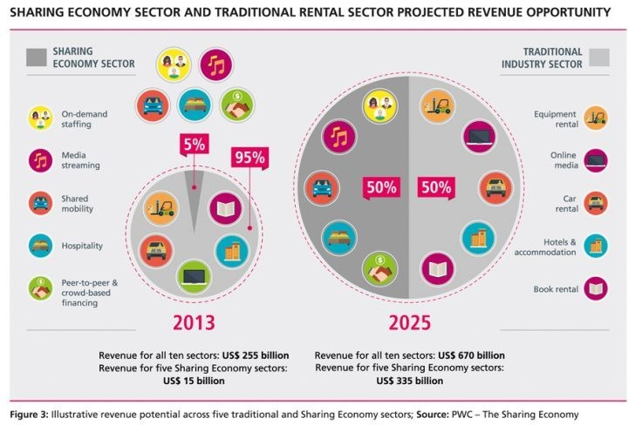
Figure 1.
Although the concept of sharing is not new, the opportunity to earn from it is, online commerce and social media having a big impact on the sharing economy. Media, peers can now communicate more easily thanks to online commerce. They can now trade goods and services with one another via the internet. Trusted financial services are available through websites like PayPal, social media has aided in the dissemination of economic and personal information, has benefited from the sharing economy’s advantages and has functioned as the crucial marketing tool for the expansion of innumerable businesses companies that promote collaborative consumption. Companies working largely in the sharing economy on a regular basis. Encourage their consumers to share their experiences on social media sites such as Facebook
Airbnb's business strategy is centred on trust-based consumer-to-consumer (C2C) transactions. Its premise is comparable to eBay's popular C2C marketplace, where buyers and sellers engage in transactions that are each assessed for risk by users based on extensive profiles, history, and other factors. product, cost, and other available resources on a per transaction basis, however, the proportionate degree of investment for visitors and hosts on Airbnb is substantially larger.
Travelers put their holiday experience, safety, and, in most circumstances, a bigger cash value on the line than a single product transaction. Hosts are giving up their houses, their personal privacy and safety, as well as their living experience, during the time that a guest is securing their space. In light of these personal commitments, Airbnb's ability to establish confidence, trust, and safety throughout its network was vital to the company's success.
Hosts are just as much Airbnb consumers as guests, so although they must persuade guests to stay in their homes, Airbnb must also persuade hosts to trust and believe in the Airbnb business. Airbnb's activities and interactions with hosts and potential hosts are intended to give the host a sense of control, confidence, and community, with an emphasis on doing so administratively, financially, and socially. Airbnb oversees the administrative functions of becoming a host, providing a support system and protection for the host and his or her property, in order to simplify and consolidate the hosting process. Instead of having hosts design a new website for their rental, the site is fully built (in several languages and currencies), and all he or she has to do is add content. Create a profile to get started. Airbnb offers a free customer service team to assist new hosts with the process. While Airbnb makes it clear on their website that it is the responsibility of the host to understand their tax and legal status, the company also provides reference papers and answers to frequently asked issues. Despite the fact that Airbnb manages the site's design, hosts have complete control over the rental price, amenities, and property restrictions. Airbnb may even provide complimentary professional photographs for host properties in some circumstances. The website includes a secure online payment system that ensures complete, on-time payment to the host ("Why Host"). Because hosts are effectively admitting a stranger inside their home (or boat, treehouse, etc.), a sense of control is vital for their trust in this arrangement. In order to do so, Airbnb develops mechanisms that protect hosts' persons and property. The host has complete control over who hires their space. A potential visitor submits an online reservation request, which the host has 24 hours to accept or decline. During this time, the host and possible visitor can contact using the website's communication system, referencing the "confirmed ID" mechanism discussed before.
The rental address is not given out until the owner accepts the guest, and hosts have access to the customer support hotline 24 hours a day, 7 days a week. Because the majority of hosts rent out their primary residences or rooms, preventing against potential damage is far more critical.

than if it were a hotel or a company. While the host is responsible for conventional renters' or homeowners' insurance, Airbnb debuted its "Host Guarantee" property protection service in 2011. The Host Guarantee was extended to up to $1 million in property damages in May 2012, thanks to insurance underwritten by Lloyd's of London. In 23 nations, this covers guest damages that go beyond "reasonable wear and tear." This protection ("Guarantee") requires no additional money or action on the part of the host.
People become hosts for a variety of reasons, one of which is the money incentive.
In November 2012, nearly 80% of Airbnb members in San Francisco responded to a poll. Because the majority of hosts rent out their primary residences or rooms, preventing against potential damage is far more critical. than if it were a hotel or a company. While regular renters' or homeowners' insurance is the duty of the host, Airbnb began renting out their personal properties to guests in 2011 and spent nearly half of the revenue on living expenses (Lawler). Airbnb focuses on making the financial side of renting easier to encourage more people to become hosts and to assist existing hosts. To begin, creating an Airbnb listing is completely free.

Business model canvas
This business model canvas will show how Airbnb will create value while doing there best to deliver products and services to all their customers, using these nine key components, this graph will show in detail what each component means.
.
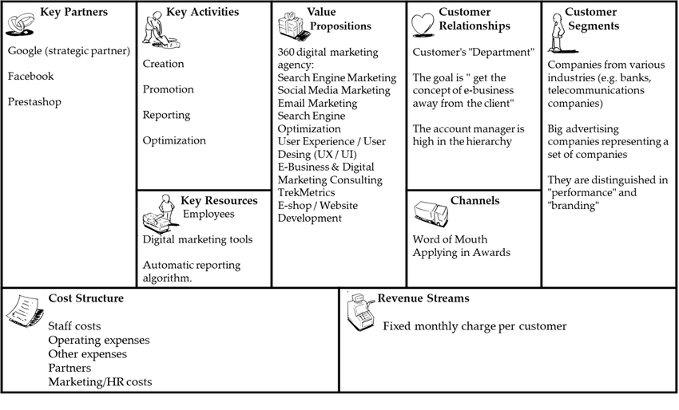
Figure 2, Business model canvas
1, Value propositions
- To make money out of unused rooms, spaces or properties
- In an easy and safe manner
- Stay somewhere unique
- New experiences
2, Customer segments
- Guests
- Hosts
3, Channels
- Website
- Airbnb App
- Word of mouth
4, Customer relationships
- Customer support
- Self-service
- Recommendations
5, Revenue streams
- Hosts fees from 3% to 5%
- Guest’s fees from 0% to 20%
6, Key resources
- Platform
- Accommodation
7, Key partners
- Google
- Facebook
8, Key activities
- Creation
- Reporting
- Promotion
9, Cost structure
- Operating expenses
- Partners
- Marketing
- Staff costs
This Generation are more prone to rent out their goods and services. As this Generation enjoys the extra income that comes with having more responsibilities. By funding their responsibilities, such as raising children and paying a mortgage. People are working together informally in their businesses. Communities arose because of necessity as much as a desire to live in them. The focus of a sharing economy company should be on branding. To assure its success, it will rely on networking and experience. Because sharing economy businesses want to stand out, branding is crucial. consumers to have faith in their company's brand. The exchange of information Because it is still relatively new, the economy has an edge. a market that is linked together by online commerce and the use of social media. A sense of community is formed as a result of distributing the work. A sharing economy business has emerged to focus on the customer experience and to make sure Customers are satisfied.
I'm searching for a good deal on a product. When these situations arise, when customers' needs are addressed, they will return to use the service. In addition to recommending it to others.
These are the characteristics of a corporation that uses the sharing economy. Airbnb, which has created a significant business in less than a decade, is one of these drivers. The hotel sector, which has been around for generations, now has a challenger.

Strategic formulation framework
One of the instruments used in the strategic formulation framework is the grand strategy matrix. The grand matrix is a tool for illustrating a product's or company's competitive position within a market. Four quadrants make up the grand matrix. Quadrant one - Businesses can take advantage of external opportunities and, if necessary, plan to take risks. Quadrant two – Companies must rethink their marketing strategies since, despite expansion, they are struggling to compete. Quadrant three – The corporation is at a disadvantage due to poor industrial expansion; as a result, new strategies must be implemented. Quadrant four – The company grew slowly at first but is now in a strong competitive position

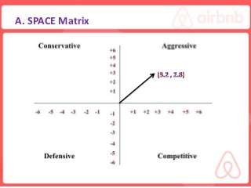
Figure 3, Strategic formulation framework
As shown in diagram 3, Airbnb has a strong competitive position and will continue to grow more within the industry, this will then give Airbnb the opportunity to increase their growth rate.

Tools and systems
Since its inception in 2008, Airbnb has been a dependable marketplace for renting or leasing lodgings, with a high reputation for being safe and user-friendly. Airbnb's technical stack is quite intriguing. All of the primary features would be impossible to achieve without advanced and dependable technology. This is followed by a list of nine technologies and systems used by Airbnb.
1. Hosting on the cloud
2. Database on the cloud
3. Storage in the cloud
4, Web server
5. Key-value
6. Framework
7. Framework for Java scripts
8, Programming languages
9. Big data applications
These technologies and methods have helped Airbnb achieve a competitive advantage over competitors that have attempted but failed to create a similar company.

Conclusion
The outcome of this report shows Airbnb's business model in greater detail, including the business model canvas, which states the 9 key components, the strategic formulation framework, and Airbnb's position on the grand strategy matrix, and finally, the tools and systems used by Airbnb to gain an advantage over their competitors.

