
9/7/2023
Lecturer: Suneth Fernando
Student: Stanimira Staneva (2023696)

Cloud Computing Architecture
ACCA5025

BSc Cloud Computing Level 5 Term 1
Assignment 1

  - Table of Contents
Introduction 2
Virtualisation 3
Virtual Machines 5

Introduction

In this report it is required to analyse the concept of virtualisation as well as the implementation of virtual machines in the context of Cloud Computing. Furthermore, the report explores the benefits and drawbacks of the Cloud and the different service models which are additionally discussed in the context of given case scenarios. Evaluation of available resources and evaluation of security are observed as well.

Virtualisation

Virtualisation is a technology that converts physical IT resources into virtual by creating simulated version of machine’s hardware and software components like servers, desktops, storage, operating system or networks. Virtualisation is also the force that makes cloud computing possible because it enables users easily to access a shared pool of online resources with the main idea that the user could run different operating systems and applications simultaneously on the same hardware and software. [2]
Virtualisation was developed on IBM mainframe in 1960s and is considered as a significant breakthrough in computer technology because it enabled users to work with a computer without actually owning one. Nowadays many big companies and data centres use virtualisation techniques to create abstraction of various IT resources and use these resources in the form of scalable and agile virtual machines that could run multiple independent operating systems at the same time. [1] Figure 01 below shows some different types of virtualization.

(Figure 01)

In cloud computing server virtualization is one of the most common types of virtualization where the physical server is divided into multiple virtual machines. Each of these virtual machines runs its own operating system and applications which enables multiple workloads on a single physical server. [3]
Considering the storage virtualization, physical storage devices are abstracted by storage virtualization and are presented as a single storage pool. As a result, cloud service providers can dynamically distribute storage capacity to users and applications. Additionally, it makes replication, backup and data movement easier. [4]
Desktop virtualization is also familiar as Virtual Desktop Infrastructure and provides to end-users virtualized desktop environments. It securely delivers through the network some resources like desktops, applications and data by allowing users to access them remotely from thin clients or other devices. [5]
Network virtualization allows the creation of virtual networks on top of a physical network infrastructure. It makes it possible for network traffic to be isolated and segmented which is critical for multi-tenant cloud environments. Virtual networks can be personalized to satisfy the unique needs of different users or applications. [6]
Operating system virtualization allows multiple isolated user-spaces to run on a single operating system kernel. It works on the OS layer and is often used for virtual hosting environments and lightweight but efficient isolation between applications and services. [7]
There are many reasons to use virtualisation in the context of cloud computing. It can significantly reduce operational costs as it provides savings on hardware, maintenance costs, electricity, etc. This can be achieved by using multiple virtual machines that share one particular physical resource. This method is economic and efficient, therefore many of today’s companies are working on cloud-based resources. Additionally, due to the multiple protocols and by adding firewalls and other security features, it is proved to offer excellent security. [2] Virtualization brings several benefits to cloud computing which are enlisted in Figure 02.

(Figure 02)

Virtual Machines

Virtual machines are fundamental component of virtualization. They are the software simulation of a physical computer within a virtualized environment. This software runs programs and applications without the need of an actual connection to the physical machine. A useful feature is that virtual machines are not dependent on one another because they all have their own operating system, therefore function on their own. Multiple virtual machines can run simultaneously on one physical server and these virtual machines can run many different operating systems supporting many different applications. [2]
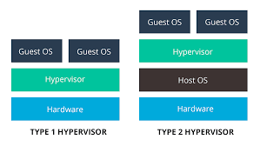
In order to work properly with the hardware of the host machine, the virtual machine uses hypervisor. Hypervisor is the transporter and the regulator of resources. It functions by fooling the guest operating system to believe that the hypervisor is the actual hardware. The hypervisor is responsible for managing both the physical hardware and the virtual machines. Hypervisors exist in two types: [2] [8]
(Figure 03)
Type 1 – Bare Metal Hypervisor | Type 2 – Hosted Hypervisor
Runs directly on the system | Installed on the operating system of the host
Guest operating system and application run on the hypervisor | Runs as an application on the host operating system
More secure | Less secure because any problem on the base OS affects the hypervisor too
Good scalability | Not so scalable because it relies on the underlying OS
Examples: VMware ESXi, Citrix XenServer, Hyper-V | Examples: VMware, Oracle VirtualBox, Microsoft Virtual PC

Cloud Services

Cloud computing provides a variety of services that are able to accommodate different computing needs and requirements. These services can be categorized into several types:
Infrastructure as a Service (IaaS) provides users with virtualized resources like virtual machines, storage, networking over the internet. A benefit of IaaS is that the users can manage those virtualized resources according to their needs and they have more control over the infrastructure when compared to other cloud service models. Examples of IaaS providers are Amazon Web Services, Microsoft Azure virtual machines, Google Cloud Compute Engine. [9]
On the other hand, Platform as a Service (PaaS) offers a platform which includes infrastructure as well as the services and tools needed to build, deploy and manage the applications. This model allows developers to focus mainly on writing the code because the platform handles the other operational tasks. Examples of PaaS providers are Microsoft Azure App Service, Google App Engine, Heroku, etc. [9]
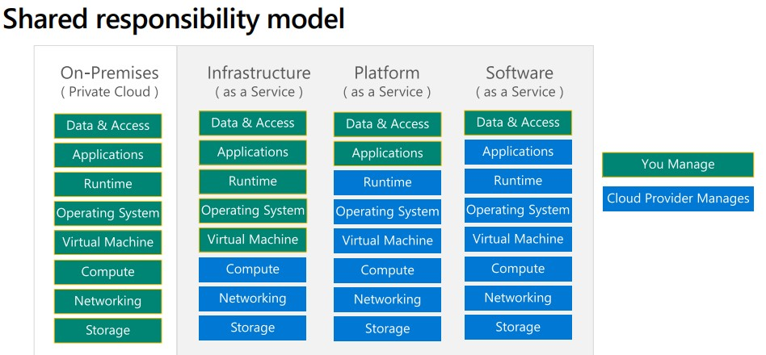
Software as a Service (SaaS) offers fully functional software applications over the internet and users are able to access and use the applications without being concerned about the infra, maintenance and updates. SaaS is a great option for users looking for ready to use software without installation or management. [9]
(Figure 04)

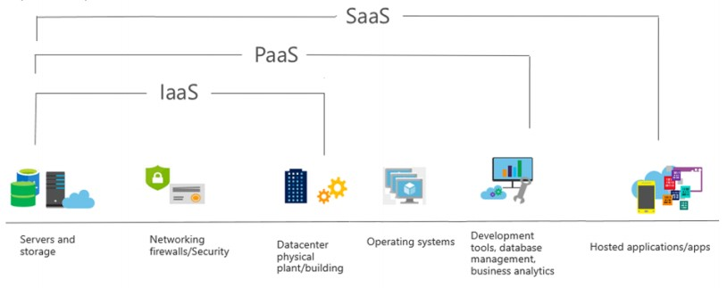
(Figure 05)

Security Considerations

Authorization and authentication are two fundamental security concepts which are used for protecting data and controlling access to resources. They are closely related; however they have key differences as well. [10]
Authentication is defined as the process of verifying user’s identity. Authentication confirms if the user is the one who claims to be. On the other hand, authorization is the process of granting or denying access to resources and is based on the user’s permissions or roles. [10]
Both of these are used to enforce stronger security. Authentication establishes verification of the identity of the user and then comes the authorization which determines what resources that user is allowed to access within the system. [10]
Authentication focuses on the user’s identity, therefore it answers the question “Who are you?”. Whereas authorization focuses on access control and permissions and answers the question “What are you allowed to do?”. [10]
Authentication involves validating usernames and passwords as well as biometrics, multi-factor authentication. Authorization involves checking the permissions, policies or roles of the user. [10]

References List

[1] BCS, The Chartered Institute for IT, Title: Cloud Computing : Moving IT Out of the Office, 1st edition. Swindon, England: British Informatics Society Limited, 2012, pp. 1–53. Accessed: Sep. 06, 2023. [Online]. Available: https://eu.alma.exlibrisgroup.com/leganto/readinglist/citation/9010672960002421?auth=SAML

[2] M. Portnoy, Virtualization: Essentials, 2nd ed. John Wiley & Sons, Incorporated, 2016, pp. 1–20. Accessed: Sep. 06, 2023. [Online]. Available: https://ebookcentral.proquest.com/lib/trinity/detail.action?docID=4644086

[3] J. Daniels, “Server virtualization architecture and implementation,” Crossroads, vol. 16, no. 1, pp. 8–12, Sep. 2009, doi: https://doi.org/10.1145/1618588.1618592.

[4] J. Ge, Y. Deng, and Y. Fang, “Research on Storage Virtualization Structure in Cloud Storage Environment,” 2010 International Conference on Multimedia Technology, Oct. 2010, doi: https://doi.org/10.1109/icmult.2010.5630956.

[5] S. M. Jang, W. H. Choi, and W. Y. Kim, “Client Rendering Method for Desktop Virtualization Services,” ETRI Journal, vol. 35, no. 2, pp. 348–351, Apr. 2013, doi: https://doi.org/10.4218/etrij.13.0212.0213.

[6] N. M. M. K. Chowdhury and R. Boutaba, “A survey of network virtualization,” Computer Networks, vol. 54, no. 5, pp. 862–876, Apr. 2010, doi: https://doi.org/10.1016/j.comnet.2009.10.017.

[7] M. Sharma, “Operating system based Virtualization,” GeeksforGeeks, Oct. 03, 2018. https://www.geeksforgeeks.org/operating-system-based-virtualization/ (accessed Sep. 06, 2023).

[8] Lalit Mohan Joshi and Dr. Rajendra Bharti, “A Survey of Hypervisor Forensic in Cloud Computing,” International Journal of Engineering Research and, vol. V4, no. 05, May 2015, doi: https://doi.org/10.17577/ijertv4is050822.

[9] S. Bouchenak, G. Chockler, H. Chockler, G. Gheorghe, N. Santos, and A. Shraer, “Verifying cloud services,” ACM SIGOPS Operating Systems Review, vol. 47, no. 2, pp. 6–19, Jul. 2013, doi: https://doi.org/10.1145/2506164.2506167.

[10] R. Santanam, M. Sethumadhavan, and M. Virendra, Cyber Security, Cyber Crime and Cyber Forensics: Applications and Perspectives. IGI Global, 2010. Accessed: Sep. 07, 2023. [Online]. Available: https://www-igi-global-com.ezproxy.uwtsd.ac.uk/gateway/book/46008

