

A COMPARISON OF THE MARKETING METHODS OF TWO MULTINATIONAL HOTEL BRANDS

Student name: Vieru Nicoleta Valentina
Student id: 1918827
Module title: Marketing Essentials BMIH4005
Lecturer name : Dale Clarke
Word count: 1503 (Essay)

INTRODUCTION
In the increasingly competitive hospitality industry, it is essential to comprehend the marketing strategies of prominent brands. This essay compares and contrasts the marketing strategies of two globally renowned hotel brands, Six Senses and Holiday Inn, each of which is distinguished by its unique approach to consumer attraction and satisfaction. Six Senses, founded in 1995, is renowned for its luxury wellness experiences, which target affluent elder generations interested in holistic wellness (Six Senses, 2023). It operates 16 hotels and resorts with a brand ethos that is profoundly rooted in creating harmony with nature and promoting wellness. In contrast, Holiday Inn, a brand with a presence spanning over seventy years and a vast network of over 2,000 hotels across six continents, offers comfortable accommodations at affordable rates, appealing to a broader audience, including younger generations (InterContinental Hotels Group, 2023). This study will utilise SWOT and PESTEL analyses to comprehend the internal and external environments of the brands, respectively. Their strategies will be compared using the 7Ps marketing mix, followed by a segmentation, targeting, and positioning discussion. The analysis is anticipated to disclose how each brand's unique approach aligns with their target market and brand positioning.

MAIN BODY
In this section, we employ SWOT and PESTEL analyses to compare the internal and external environments (Benzaghta et al. 2021) of Six Senses and Holiday Inn in order to highlight the similarities and differences between their respective marketing strategies (Hollensen, 2020). The primary strength of Six Senses is its distinctive brand identity, which combines luxury, wellness, and sustainability to attract a niche, wealthy demographic (Jacobs, 2023). However, this exclusivity, coupled with high prices, is a potential vulnerability because it limits the brand's appeal to a smaller customer segment (Smith, 2022). (InterContinental Hotels Group, 2023) Holiday Inn's assets include a global footprint, brand recognition, and affordability, which appeal to a more diverse clientele. However, its lack of distinctiveness in comparison to boutique or luxury brands may be a weakness, especially when attempting to attract consumers seeking unique, high-end experiences (Jones, 2023). Consistent with its brand philosophy, Six Senses could capitalise on the growing global interest in wellness tourism and sustainability (Global Wellness Institute, 2023). In contrast, economic downturns and geopolitical or environmental risks associated with its tranquil locations are potential hazards (Smith, 2021). Holiday Inn can leverage the digital revolution to enhance customer experience and operational efficiency, but it must contend with competition in the mid-tier hotel segment and altering customer expectations for personalised experiences (InterContinental Hotels Group, 2023). The PESTEL analysis identifies additional external factors that influence both organisations. Important political factors include international travel regulations and geopolitical stability (Frue, 2019; Farooq, 2023). Six Senses is more susceptible to fluctuations in global wealth, whereas Holiday Inn's prospects are closely aligned with the overall economic health impacting a larger consumer base (Smith, 2022; Jones, 2023). Six Senses is favoured by social trends, such as the growing consumer emphasis on wellness and sustainability. The rise of digital technologies, online reservations, and AI integration presents both brands with opportunities and challenges from a technological standpoint (InterContinental Hotels Group, 2023). Environmentally, both brands are under increasing pressure to demonstrate sustainable operations that are in line with global climate change concerns. Legally, they must navigate intricate local and international laws, such as labour regulations, health and safety requirements, and environmental standards (Hollandsen, 2020). While both Six Senses and Holiday Inn operate in the hospitality industry, their distinct brand identities and target markets expose them to unique strengths, vulnerabilities, opportunities, and threats. This information is essential for their strategic marketing decisions.
In this paragraph, the study employs the 7Ps marketing formula — Product, Price, Place, Promotion, People, Process, and Physical Evidence — to differentiate and contrast the marketing strategies of Six Senses and Holiday Inn (Rafiq & Ahmed, 1995). Six Senses offers luxury accommodations focusing on wellness, situated within tranquil, natural environments, with an emphasis on sustainability and cultural authenticity (2023, Six Senses). (InterContinental Hotels Group, 2023) In contrast, Holiday Inn offers reasonably-priced, comfortable accommodations with all the essential amenities for both leisure and business travellers. Six Senses' premium pricing strategy reflects its high-end offerings and wealthy clientele (Jacobs, 2023). On the other hand, Holiday Inn utilises a value-based pricing model, making it accessible to a wider range of customers (InterContinental Hotels Group, 2023). Six Senses operates in remote locales worldwide, catering to luxury wellness travellers. On the other hand, Holiday Inn's extensive global presence caters to a diverse customer base, including business and leisure travellers (Kotler et al., 2017). In terms of promotion, Six Senses emphasises wellness and sustainability narratives with a focus on storytelling marketing. In contrast, Holiday Inn's promotional strategies emphasise dependability, convenience, and value for money (InterContinental Hotels Group, 2023; Six Senses, 2023). Both firms emphasise staff training to ensure superior customer service. Yet, whereas Six Senses focuses on personalised, high-touch service, Holiday Inn emphasises efficiency and consistency (Smith, 2022; Jones, 2023). Six Senses strives to provide a seamless, individualised visitor experience from booking through checkout. On the other hand, Holiday Inn utilises digital technology to optimise its processes and increase consumer convenience (InterContinental Hotels Group, 2023). In terms of Physical Evidence, Six Senses hotels exude opulence, tranquillity, and harmony with nature. In contrast, Holiday Inn properties, while less opulent, provide a consistent, comfortable environment with recognisable branding (Six Senses, 2023; InterContinental Hotels Group, 2023). Overall it can be stated that, the 7Ps analysis demonstrates that despite both brands operating within the hospitality industry, their marketing strategies diverge substantially due to their distinct brand positions and target markets. Six Senses emphasises luxury, wellness, and sustainability in its marketing blend, whereas Holiday Inn emphasises accessibility, value, and consistency. These findings support the initial thesis, as Six Senses caters to a more affluent and senior demographic, whereas Holiday Inn appeals to a broader and possibly younger audience.
In this paragraph, the Segmentation, Targeting, and Positioning (STP) framework is utilised to clarify Six Senses' and Holiday Inn's marketing strategies and audience communication strategies (Kotler et al., 2017). Targeting high-income consumers who prioritise wellness, luxury, and sustainability, Six Senses' segmentation relies heavily on demographics and psychographics (Six Senses, 2023,). According to data from Simmilarweb, their website primarily attracts 35-44-year-old women (Simmilarweb, 2023). In contrast, Holiday Inn's segmentation strategy is more comprehensive, addressing diverse demographic, psychographic, and behavioural segments, including business travellers, families, and cost-conscious consumers, with website traffic more evenly distributed across age groups, albeit leaning slightly toward the 25-34 age group (Simmilarweb, 2023). Detailed data found on the similarweb regarding the companies' websites are provided in Appendix A, which shows that Both hotel brands use websites to inform guests about their services and specials. In addition, both hotel brands are quite active on their respective social media channels in order to comprehend the preferences and preferences of their clients in order to provide superior service (Sikand, 2020). Six Senses focuses its targeting strategies on affluent individuals seeking unique, wellness-cantered travel experiences (Jacobs, 2023). In contrast, Holiday Inn appeals to a broader audience by providing reliable, value-driven lodging options for various customer segments (InterContinental Hotels Group, 2023). Six Senses is a luxury brand offering holistic wellness experiences harmoniously integrated with nature and local cultures. On the other hand, Holiday Inn positions itself as a globally recognised brand that consistently provides comfortable and affordable accommodations (Six Senses, 2023; InterContinental Hotels Group, 2023).
This STP analysis aligns well with each brand's previously defined marketing strategies and situational analyses. Six Senses attracts an affluent, wellness-focused clientele with its high prices, individualised service, and tranquil settings. In contrast, Holiday Inn's value-based pricing, extensive presence, and efficient service satisfy the audience's needs for affordability, accessibility, and dependability. To improve their marketing strategies, Six Senses could expand its wellness offerings to appeal to younger demographics who emphasise health and wellness more. Holiday Inn could investigate the possibility of offering more customised services or packages by leveraging digital technologies in tandem with the growing demand for personalised experiences. In light of current issues in the hospitality industry, both firms should continuously enhance their sustainability practices and effectively communicate these to their customers. This strategy not only preserves a positive brand image but also correlates with the growing consumer awareness of sustainability (Global Wellness Institute, 2023).

CONCLUSION
The analysis indicates that the study's initial hypothesis that Six Senses appeals to wealthy older generations while Holiday Inn targets a younger demographic has been largely confirmed. The SWOT and PESTEL analyses highlighted Six Senses’ focus on luxurious wellness experiences and Holiday Inn's focus on convenience and affordability. The 7Ps marketing combination demonstrated in greater detail how these strategies are implemented, with Six Senses emphasising premium offerings and personalised services and Holiday Inn emphasising consistent, budget-friendly accommodations. The STP analysis demonstrated that the brands' marketing communications correspond to their respective target markets and brand positions. In addition, given the increasing consumer cognisance of sustainability, both companies must prioritise and effectively communicate their sustainable business practices. Future research could examine the effectiveness of these suggestions and how these brands adapt to emerging hospitality industry trends.

REFERENCES
Benzaghta, M. A., Elwalda, A., Mousa, M. M., Erkan, I., & Rahman, M. (2021). 'SWOT analysis applications: An integrative literature review.' Journal of Global Business Insights, 6(1), 55-73. https://www.doi.org/10.5038/2640-6489.6.1.1148
Farooq S. (2023) PESTLE Analysis of the hotel industry. Available at: https://www.marketingtutor.net/pestle-analysis-of-the-hotel-industry/ (Accessed; on 15 May 2023).
Frue K. (2019), PESTLE Analysis for Hotel Industry, Available at:https://pestleanalysis.com/pestle-analysis-for-hotel-industry/ (Accessed; 15 May 2023)
George, R., 2021. 'Market Segmentation, Targeting, and Positioning. In Marketing Tourism and Hospitality: Concepts and Cases (pp. 221-246).' Cham: Springer International Publishing. Hospitalitynet.org. 2023. Moxy Hospitality. Available at: https://www.hospitalitynet.org/brand/23000273/moxy.html (Accessed; on 15 May 2023).
Global Wellness Institute (2023). Global Wellness Tourism Economy, Available at: https://www.globalwellnessinstitute.org/ (Accessed: 15 May 2023).
Hollensen, S. (2020). 'Marketing Management: A Relationship Approach,' Pearson.
InterContinental Hotels Group (2023) Annual Report, Available at: https://www.ihgplc.com/ (Accessed: 15 May 2023).
Jacobs, R. (2023) 'Six Senses: A Case Study in Luxury Wellness Tourism', Journal of Hospitality & Tourism Research, Available at: https://journals.sagepub.com/home/jht (Accessed: 15 May 2023).
Jones, L. (2023) 'Consumer Perceptions of Brand Uniqueness: A Study of Holiday Inn', International Journal of Hospitality & Tourism Administration, Available at: https://www.tandfonline.com/toc/wiht20/current (Accessed: 15 May 2023).
Kotler, P., Bowen, J.T., & Makens, J.C. (2017). 'Marketing for Hospitality and Tourism,' Pearson.
Rafiq, M., & Ahmed, P.K. (1995) 'Using the 7Ps as a generic marketing mix: An exploratory survey of UK and European marketing academics', Marketing Intelligence & Planning, Available at: https://www.emerald.com/insight/publication/issn/0263-4503 (Accessed: 15 May 2023).
Sikand, K. (2020) 'Impact of Social Media on the Service Quality and Customer Satisfaction in the Hotel Industry', Journal of Marketing & Communication, Available at: https://www.informaticsjournals.com/index.php/jmc (Accessed: 15 May 2023).
Simmilarweb (2023) Website Analysis: Six Senses and Holiday Inn, Available at: https://www.similarweb.com/ (Accessed: 15 May 2023).
Six Senses (2023) About Us, Available at: https://www.sixsenses.com/ (Accessed: 15 May 2023).
Smith, A. (2022) 'An Evaluation of Luxury Hotel Brands: The Case of Six Senses', International Journal of Contemporary Hospitality Management, Available at: https://www.emerald.com/insight/publication/issn/0959-6119 (Accessed: 15 May 2023).
Smith, A. (2021) 'Risk Assessment in Luxury Hotel Brands', Journal of Risk and Financial Management, Available at: https://www.mdpi.com/journal/jrfm (Accessed: 15 May 2023).

APPENDIX A

WEBSITE ANALYSIS DATA OF HOTEL HOLIDAY INN
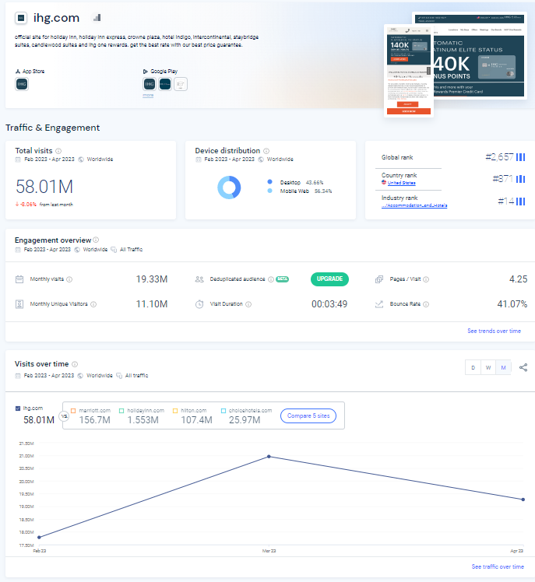

WEBSITE ANALYSIS DATA OF SIX SENSES
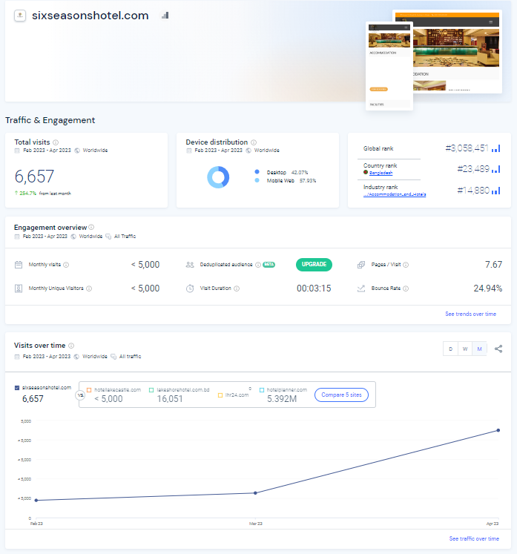

COMPARATIVE WEBSITE ANALYSIS DATA OF SIX SENSES AND HOLIDAY INN


