
Researching and Analysing Data
Kazi Tanzina Khatun
Student Number: 1605805
Lecturers name: Dr Mushfiqur Rahman
Date: 04/01/2018

Will Online shopping destroy the high street?
Contents .

- Introduction

1.1 Method of research

- Current condition

2.1 The Growth on Online Shopping

3.0 The Effect on High Street Retailers

3.1 The effect on Online-Only Retailers

4.0 The Future of High Street Retailers

5.0 Conclusion

6.0 References

1.0 Introduction
The trend in consumer shopping has rapidly changed over the past decade. As technology improves and new innovations are released, the way products are bought is constantly changing. With access to thousands of retailers at the fingertips of consumers on smartphones and tablets, going onto the high street is no longer a necessity.
In this report I will be examining the reason behind these changes, why consumers prefer online shopping to shopping on the high street and vice versa. I will review the effects the changing trend is having on traditional retailers and most importantly answer the question, is online shopping making high street stores redundant?

  - Methods of research

The methods used in this report is gathering various different sources of information from reputable media sources, mainly news articles. There will be focus to find a balance to both sides of the question and where possible, provide countering opinions, stats and reports.

2.0 Current condition

The current condition of high street retailers is looking bleak. With many retailers closing down stores and a number more reducing size and amount of products offered, we can see that high street retailers are struggling to keep up with online sales (Williams-Grut, 2017).
A number of High Street Brands has already permanently closed due to the growth of online shopping. Retailers such as BHS, Blockbusters and Austin Read have all felt the grunt of consumers moving away from the high street and onto online shopping (Wood & Allen, 2016). Across the UK, customer footflow dropped on average 0.9% in the first quarter of 2016 when compared to 2015 (Wood & Allen, 2016). This clearly shows evidence that customers are starting to lean more towards online shopping than the traditional high street.
As the sales decline, businesses find it more and more difficult to maintain overheads and to cover the cost of staying open (Harvey, 2013). Throughout 2016, there was an average of 15 stores closing per day (Ruddick, 2016). This rate of closure far outweighed the amount of new stores opening. There was only 87 new fashion store openings against 207 fashion store closures in the first six months of 2017.
As the figures above suggest, there is a massive shift happening in consumer spending. Less traffic is being directed at the high street and a lot of small to medium retailers are finding it difficult to break even. Even sales of large retailers are getting hit.

2.1 The Growth of Online Shopping

As internet access became more and more easier to attain, consumers sought other, more convenient ways to shop. The emergence of large online retailers like Amazon & Ebay brought a wide range of products with highly competitive prices to the online market.
Since the debut of online shopping in 1994, consumers have grown to love the many advantages it provides over the high street. In the beginning, there was already a market for consumers to shop from home. Customers were able to shop using television channels and catalogues. Either calling in to place their order or filling out a order slip from catalogues and sending them back. Online shopping was a completely new element to consumers (Turtle, 2014).
According to an article published by Time, consumers were hesitant to jump on the online shopping method as they just did not have enough knowledge on how it works. When this is combined with the fears of online viruses, scams and the cost of having internet and a computer at home, online shopping had a slow start.
But as we moved towards the information era of our society, there was a paradigm shift on how consumers viewed shopping online. Instead of seeing it as unknown, frightening and costly, consumers started seeing the many advantages it provided. More convenient for time restrained consumers, lower priced products, more of a selection and sizes near always being in stock was just some of the benefits consumers saw (Miller, 2012)
But the main reasons online shopping saw a growth was because of the growth of technology, internet and internet enabled devices. When this is coupled with peoples new understanding of the internet and how it connects people alongside their new found knowledge on accessing and using these devices, consumers saw the new channel of online shopping and how it could benefit them (Morley, 2016).

3.0 The Effect on High Street Retailers

We can see that many high street retailers have felt the effects of the change in consumer behaviour. Reports have suggested a drop in consumer shopping on the high street, even during peak seasons such as Christmas and Boxing day (Bradshaw, 2017). It was reported that there was a footfall drop of 6% two days before Christmas in 2016 vs 2015 and on boxing day a drop of 7%. This may not seem much, but when you consider this period to be the most important time for retailers to meet the annual sales targets, these percentage drops can have a huge detrimental effect.
Intu, a FTSE 100 company which owns various malls and shopping centres released figures stating over the same period, there was only a 3% increase in footfall in comparison to the rest of the year. When factoring in that this is the peak shopping season where most retailers make their sales, a 3% increase in miniscule (Bradshaw,2017)
Another major high street retailer, Debenhams, reported a drop of 44% in Pre-tax profits. Alongside this, they announced closure of two of their high street stores with a further eight planned to be closed (Wood, 2017).
But it is not just Debenhams that is trying to reduce their company costs. Many other retailers are trying to reduce their overheads by cutting back on expenditure and staff. Statistics reported by the British Retail Consortium stated there was a drop of 4.2% in the hours staff worked in retail.
Overall, 50% of all polled retailers stated a decline in sales in a survey carried out by “CBI” in October 2017 (Wood, 2017). We can see that the success of online retailers is contributing immensely to the troubles and difficulties the high street retailers are facing.

3.1 The Effect on Online only Retailers

On the other hand, we can see retailers who only operate online flourishing. Online fashion retailers such as Boohoo and ASOS have seen a rise as much as 40% in the last quarter of 2016 (Bradshaw,2017). Analysts from reputable financial intuitions such as HSBC are stating that online sales will be the main driver for like-for-like sales growth and that this growth confirms the future of retailers not having high cost fixed premises.
We can see on the graphs below what the projected growth for online only retailers are looking like;

Annual revenue of ASOS worldwide from financial year 2012 to 2017 (in million GBP)
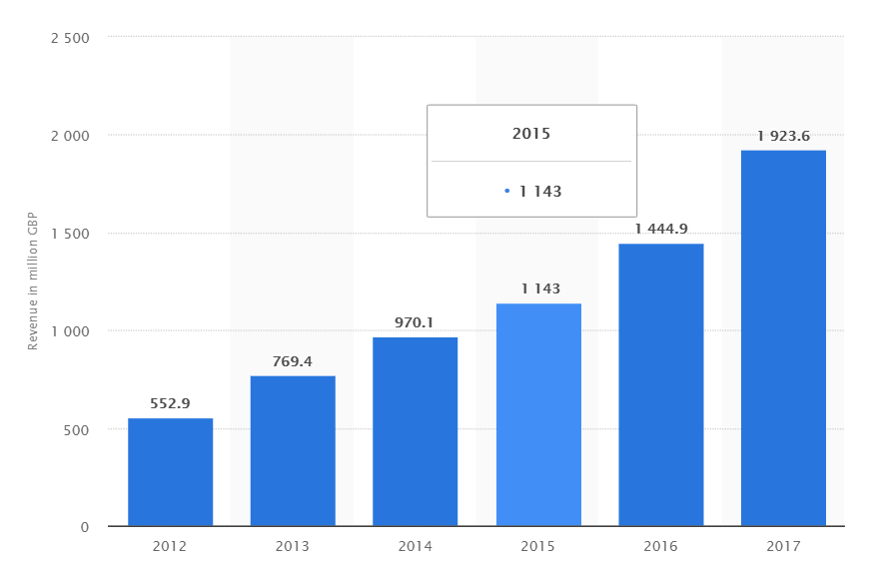
(Source: Statista, The Statistics Portal)

It can be seen that ASOS has more than tripled in sales in the past 5 years. It is noted that these growth have been specifically during the 5 years that mobile technology and other devices such as tablets have advanced majorly.

4.0 The Future of High Street Retailers

Even though the figures suggest that the high street stores are destined to be a thing of the past, there are retailers who are using the online shopping boom to their advantage. Although it was mentioned Debenhams is suffering a loss in profits, the high street giant, upon investing more resources in its online presence, is seeing an increase in sales through its website. Figures state that online sales grew by 9% in 2016 and equated to a total of 15% of the company’s total revenue (Bradshaw, 2017).
Next, another high street fashion retailer, has put much of its resources in streamlining its online directory. The company’s online sales rose by 13.6% in 2017 where as its store sales dropped by 6% (Butler, 2018). The figures reported in the company’s year-end report further adds to their growth online. As can be seen from the report below, a growth of online sales for their “Next Directory” was 7.7% for the year 2016 vs 2015. In contrast, it can be seen that retail sales growth was a mere 1.1%.

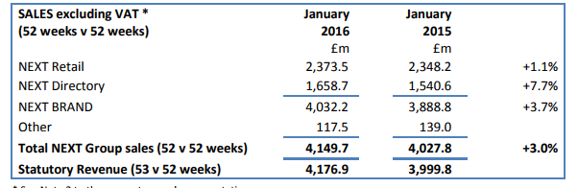

(Source: Next Plc Year End Report 2016)

These figures shows evidence that high street retailers can too, grow online and benefit from the advantages it provides. These companies hold a long standing reputation and moving their operations online means that customers know what to expect and are familiar with the company and its products. This in turn helps them to establish an online presence much more faster than other companies such as Boohoo and ASOS needed.

Despite the figures looking promising, experts in the field of retail are suggesting this may be a failed effort by the high street retailers to hold onto sales which are falling. Experts suggest that all that is happening is the retailer is moving its sales from the high street to online rather than competing with online retailers(Bradshaw, 2017). Experts say that with the high fixed costs of physical retail stores coupled with online operations costs, it is a double impact on the companies overheads which in turn, either make it less competitive in the prices it offers or less profitable as a business.

On the other hand, reports show figures that retailers who adopt a multi-channel sales technique can benefit from an increase in online sales as well as in-store sales. A survey of 8,000 customers conducted by YouGov, states that 24% of European customers whom used click and collect, made additional purchases in store when collecting their product (JDA,2017). The report conducted by YouGov goes on to suggest that although online sales figures may be on the rise, there are a large portion of these sales which are returned by the consumer. According to the report, 46% of customers in Europe have returned at least one product from an online purchase within 2017. The main reason behind this is due to the product not meeting expectations once being delivered.

Online only retailers may not see this sales channel as a threat, but it is growing in popularity. The report states that in Europe, over 49% of the surveyed customers had used click and collect in the past twelve months. This is a large growth from 2014 where the figures stated only 14% had used click and collect.
With all this in mind, it can be understood that the Click and Collect channel is a method high street retailers are trying to implement more effectively. It is, to an extent, how online shopping was in the early years and may take some time for consumers to adopt it.

5.0 Conclusion

From the findings of this report, it can be understood that high street retailers do have tools at their disposal to offer consumers an alternative to online shopping whilst still providing the same convenience. Only time can tell which method is more effective, but at this present moment, consumer behaviour is constantly changing and it is hard to determine which method is more successful.
Although Online retailers are enjoying the success attained from the tech boom and the advantages it provides for them, high street retailers are still prominent and present. The success of online retailers is taking its toll on many high street retailers, this can clearly be seen from the amount of store closures, but with some modernisation and adaption, high street retailers can offer a different service which is valuable in other convenient ways. The Click and Collect model is a clear way forward for high street retailers to offer their customers a different method of shopping whilst at the same time retaining their custom and footfall.
In summary, Online retailers are closing down high street retailers, but the ones which close, are also the ones that are unable to change and adapt to this new paradigm shift of consumer behaviour.

6.0 References
Wood, Z 2017, Last revised 26 October 2017, Alarm sounds over state of UK high street as sales crash, The Guardian, https://www.theguardian.com/business/2017/oct/26/alarm-sounds-over-state-of-uk-high-street-as-sales-crash
Bradshaw, J 2017, Last revised 8 January 2017, Online retail booms as high street struggles, The Telegraph, http://www.telegraph.co.uk/business/2017/01/08/online-retail-booms-high-street-struggles/

Morley, K 2016, Last revised 29 July 2016, The rise of online-only shops: customers lured by free returns and low prices, The Telegraph,
http://www.telegraph.co.uk/news/2016/07/29/the-rise-of-online-only-shops-customers-lured-by-free-returns-an/

Miller, G 2012, Last Revised 14 February 2012, Reasons why consumers like to shop online, Upstream Commerce,
http://upstreamcommerce.com/blog/2012/02/14/8-reasons-consumer-likes-shop-online

Williams-Grut, O 2017, Last revised 18 Aug 2017, How the internet is remaking the British High Street, Business insider UK, http://uk.businessinsider.com/future-british-high-street-internet-brexit-retail-2017-8 (Accesed:11/12/17)

Wood Z & Allen K, 2016, Last revised 23 April 2016, Where have all Britain’s shoppers gone?, The Guardian, https://www.theguardian.com/business/2016/apr/23/uk-high-street-spending-shoppers-slowdown

Harvey, F 2013, Last revised 25 October 2016, Kingfisher chief warns of store closure over online firms' tax advantage, The Guardian, https://www.theguardian.com/business/2013/mar/04/kingfisher-warns-of-store-closures

Ruddick, G 2016, Last revised 25 October 2016, Britain's high streets under strain as 15 shops close every day, The Guardian, https://www.theguardian.com/business/2016/oct/25/britains-high-streets-under-strain-as-15-shops-close-every-day

Tuttle, B 2014, Last revised 15 August 2014, Amazing things people said when online shopping was born, Time,
http://time.com/money/3108995/online-shopping-history-anniversary/

Butler, S 2018, Last Revised 03 January 2018, Next results signal a good Christmas for UK retailers, https://www.theguardian.com/business/2018/jan/03/next-results-signal-a-bumper-christmas-for-uk-retailers

JDA, 2017, Last revised 19 October 2017, Click and Collect helps drive extra in-store sales- report, http://www.netimperative.com/2017/10/click-collect-helps-drive-extra-store-sales-report/

YouGov Report, http://now.jda.com/European-Customer-Pulse-Report-EMEA.html?srcid=jda-pr

