

Emma Biggs
Student Number: 2308431

Principles of Systems Engineering (ACDA5021): Taguchi Experiment

School of Applied Computing

Ordinance Munitions and Explosives

BEng

Academic Year: 2025 - 2026

Abstract
This study applied the Taguchi design-of-experiments (DOE) method to identify the key control factors influencing projectile range in a mechanical catapult system. Five independent variables were tested using an L8 orthogonal array, with bolt tightness, elastic twist, firing rate, and projectile seating treated as noise factors. Analysis of the experimental results showed that arm-stop position and pull-back distance were the dominant contributors to performance. Optimisation using the Taguchi framework produced a predicted range of 142.9 cm, which closely matched the measured value of 142 cm. The findings demonstrate that the Taguchi method can deliver reliable optimisation outcomes even with limited experimental data and highlight the importance of designing for consistency rather than peak performance.

Table of Contents
Abstract 2
Table of Contents 3
Table of Figures 3
Table of Tables 3
1 Introduction 5
1.1 Experimental Objective 5
1.2 Overview of Taguchi Method 5
2 Method and Equipment 6
2.1 Equipment 6
2.2 Method 6
3 Results 8
4 Discussion 9
5 Conclusions and Reflections 11
6 References 12

Table of Figures
Figure 1 – Graphs demonstrating the differences between level averages of each parameter 7

Table of Tables
Table 1 – Table showing the value of each parameter level used in the experiment 5
Table 2 – Orthogonal Array used to structure experimental test runs 5
Table 3 – Experimental matrix showing the results of each trial 7
Table 4 – L4 orthogonal matrix displaying the experiments used to predict optimised range 7
Table 5 – Table showing the outcome of the final firing featuring the optimised factor positions 7

1 Introduction

1.1 Experimental Objective
To identify the key control factors affecting projectile range in a mechanical catapult, the Taguchi design-of-experiments (DOE) method was applied to a set of five independent variables. Using the supplied experimental matrix, the study aimed to determine the optimal configuration of controllable parameters while accounting for their interactions with noise factors. The Taguchi approach also enabled prediction of system performance following optimisation.

1.2 Overview of Taguchi Method
The Taguchi method is a structured DOE approach designed to improve product and process robustness by identifying control-factor settings that optimise performance while reducing sensitivity to uncontrollable noise factors [1]. It distinguishes clearly between controllable parameters defined by the researcher and noise factors that cannot be directly regulated but must be accounted for, prioritising consistent performance under realistic operating conditions rather than peak performance [2][3].
The use of orthogonal arrays enables simultaneous investigation of multiple parameters while substantially reducing the number of required experiments, making the method suitable when time or resources are limited [4].
By applying the signal-to-noise ratio (deviation from desired value) as a performance metric, the method allows researchers to rank factor importance, identify dominant contributors to variation, and predict the most reliable operating conditions [5][6].

2 Method and Equipment

2.1 Equipment
The experiment used a mechanical catapult with adjustable features that allowed systematic variation of operating parameters. Several of these features served as independent variables, including band-front position, band-anchor position, arm-stop position, pull-back distance, interaction terms, and the operator.
Each variable was assigned two levels (high and low), as shown in Table 1.
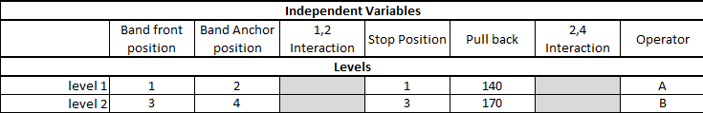
Table 1 – Table showing the value of each parameter level used in the experiment
The dependent variable was the horizontal range of the projectile, measured using a tape measure.
Noise factors identified prior to testing included bolt tightness, elastic-band twist, rate of fire, and consistency of projectile seating.

2.2 Method
The orthogonal array in Table 2 structured the eight experimental runs, each using a distinct combination of parameter levels to efficiently evaluate multiple variables. For each run, the band-front position, anchor position, and arm-stop position were set according to the matrix.
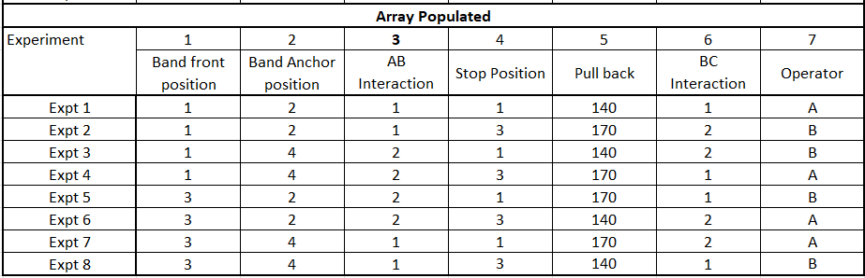
Table 2 – Orthogonal Array used to structure experimental test runs
A tape measure was placed along the firing path to record projectile range. The operator then seated the projectile, pulled the arm to the specified distance, and released it following a five-second countdown.
The results of these runs are shown in Table 3.
Data from the initial eight tests was used to identify the main performance-influencing factors and to predict the optimal catapult configuration. Four additional tests were then conducted focusing on the two most influential factors, with results presented in Table 5.
The data was subsequently used to calculate the predicted optimal range. A final test using the improved settings was performed to compare the predicted and measured outcomes.

3 Results
The results of the eight experiments are presented in the experimental matrix in Table 3, with projectile range (cm) highlighted in yellow. The mean range across all trials was calculated as 104.6 cm, providing a baseline for system performance prior to optimisation.
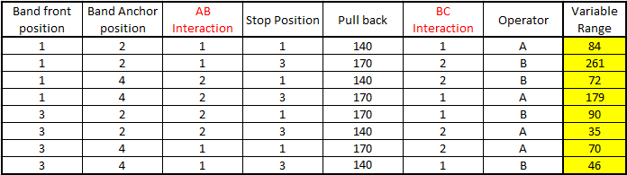
Table 3 – Experimental matrix showing the results of each trial
This data was used to calculate level averages for each parameter, enabling comparison of factor effects. As the L8 orthogonal array assigns each factor level an equal number of occurrences, level comparisons can be made without bias [7]. The resulting level-average plots are shown in Figure 1.
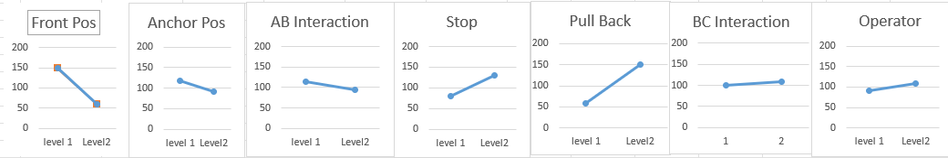
Figure 1 – Graphs demonstrating the differences between level averages of each parameter
The level averages formed the basis for predicting the system’s optimal configuration. Selecting the highest-performing level for each factor allowed construction of the L4 matrix in Table 4, used to estimate the optimised range.
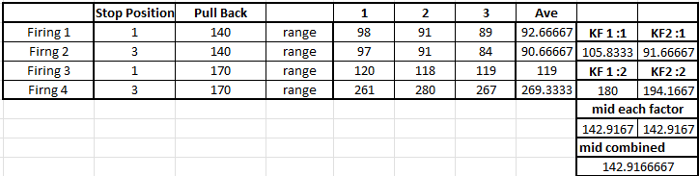
Table 4 – L4 orthogonal matrix displaying the experiments used to predict optimised range
The final firing using the predicted optimal settings is shown in Table 5.
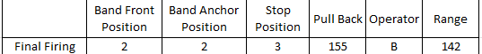
Table 5 – Table showing the outcome of the final firing featuring the optimised factor positions

4 Discussion
Analysis of the level averages presented in Figure 4 enabled the ranking of experimental factors according to their influence on system performance. Although factors displaying the greatest separation between level means initially appeared most influential on projectile range, optimisation of robust mean performance requires prioritising factors that yield consistent improvements under uncontrolled variation rather than those exhibiting the largest nominal contrasts.
For this reason, arm-stop position and pull-back distance were identified as the principal control factors, despite band-front position producing the largest difference in level means. The effect of band-front position was not deemed a key control factor because it primarily modifies the geometry of force application and is highly sensitive to alignment-related noise sources, including bolt tightness, elastic twist, and projectile seating. Its apparent influence is therefore magnified through interactions rather than reflecting a stable, independent mechanism of control.
Conversely, stop position governs the angular displacement prior to release, thereby affecting the magnitude of energy transferred to the projectile, while pull-back distance determines the elastic energy stored within the band. Adjustments to these parameters produced consistent and repeatable improvements in performance, confirming their status as the key control variables.
Experimental results further indicated that the shorter pull-back distance (140) outperformed the longer setting (170). This suggests that increased extension amplified noise effects such as elastic twisting and release inconsistency. At greater strain levels, the band was more susceptible to asymmetrical twisting, resulting in uneven force application, reduced energy-transfer efficiency, and increased shot-to-shot variability.
Projectile seating consistency constituted an additional significant noise factor. Minor variations in seating force or centring altered launch angle and release timing, contributing to variability between trials with otherwise identical control settings. Human-induced variation including differences in loading technique, release timing, and operator consistency further increased this variability.
Rate of fire and system-reset behaviour also influenced performance. Elastic components may not fully recover between rapid firings, particularly at higher pull-back distances, leading to reduced available force and increased variance in successive shots. To mitigate this effect, a timed interval between firings was introduced.
Other factors, including operator identity and interaction terms, produced comparatively small differences between level means and were therefore considered less influential than the previously described key control factors.
Application of the Taguchi design-of-experiments methodology identified an optimal factor combination yielding a predicted range of 142.9 cm, substantially exceeding the pre-tuning operational mean. A subsequent validation test achieved a range of 142 cm, demonstrating close agreement with the Taguchi prediction and confirming the effectiveness of the optimisation process.

5 Conclusions and Reflections
This experiment demonstrated the value of the Taguchi method in identifying the factors that most strongly influence the performance of a mechanical catapult system. Despite the limited number of trials, the method identified stop position and pull-back distance as the primary control factors affecting projectile range. Adjusting these parameters within the DOE framework produced a substantial improvement in range and yielded a prediction closely aligned with the final measured result.
The findings also showed that maximum input force does not necessarily produce optimal performance, as noise factors such as elastic twisting, firing rate, and projectile seating can offset potential increases in range. This emphasises the importance of designing for consistency rather than peak output, particularly in systems exposed to real-world variation.
The experiment further illustrated that meaningful optimisation is achievable even with restricted datasets when a structured Taguchi approach is applied. Future work could focus on developing a design that remains robust under varying operator techniques, reducing the influence of human-induced variability.

6 References
[1] G. J. M. Read, S. Shorrock, G. H. Walker and P. M. Salmon, "State of science: evolving perspectives on ‘human error’," Ergonomics. vol. 64, no. 9, 08/06 2021, doi: 10.1080/00140139.2021.1953615.
[2] N. Li, C. Shi, Z. Zhang, H. Wang and Y. Liu, "A review on mixture design methods for geopolymer concrete," vol. 178, pp.107490, 2019, doi: 10.1016/j.compositesb.2019.107490. Available at: https://www.sciencedirect.com/science/article/pii/S1359836819315070.
[3] J. A. Okolie, E. I. Epelle, S. Nanda, D. Castello, A. K. Dalai and J. A. Kozinski, "Modeling and process optimization of hydrothermal gasification for hydrogen production: A comprehensive review," vol. 173, pp.105199, 2021, doi: 10.1016/j.supflu.2021.105199. Available at: https://www.sciencedirect.com/science/article/pii/S0896844621000383.
[4] M. Akbari, P. Asadi, M. K. Besharati Givi and G. Khodabandehlouie, "13 - Artificial neural network and optimization," in Advances in Friction-Stir Welding and Processing, M. K. B. Givi and Parviz Asadi, Ed., Woodhead Publishing, 2014, pp. 543–599. doi: 10.1533/9780857094551.543Available: https://www.sciencedirect.com/science/article/pii/B9780857094544500136
[5] S. M. Karazi, M. Moradi and K. Y. Benyounis, "Statistical and Numerical Approaches for Modeling and Optimizing Laser Micromachining Process-Review," in Reference Module in Materials Science and Materials Engineering, Elsevier, 2019, doi: 10.1016/B978-0-12-803581-8.11650-9Available: https://www.sciencedirect.com/science/article/pii/B9780128035818116509
[6] N. Xiansheng, Z. Zhenggan, W. Xiongwei and L. Luming, "The use of Taguchi method to optimize the laser welding of sealing neuro-stimulator," vol. 49, no. 3, pp.297–304, 2011, doi: 10.1016/j.optlaseng.2010.11.005. Available at: https://www.sciencedirect.com/science/article/pii/S0143816610002496.
[7] A. Fanya, E. Haruman and M. S. Adenan, "Optimization of Multi-Objective Taguchi Method for Hybrid Thermochemical Treatment Applied to AISI 316LVM Biological Grade Stainless Steel," in Reference Module in Materials Science and Materials Engineering, Elsevier, 2019, doi: 10.1016/B978-0-12-803581-8.11165-8Available: https://www.sciencedirect.com/science/article/pii/B9780128035818111658

