Student Name: Oana Cristina Ilau
Student ID: 1817441

Module Code: BMSW5105
Module: Workplace Culture and its impact on Organizational Efficiency

Executive Summary
Culture determines how an organisation will run in a particular situation through its values and norms. The organisation has to adopt a cultural change to operate and run efficiently. Workplace culture can change due to political impact or environmental impact. The recent impact of COVID-19, regarded as sudden environmental change, negatively affects business performance and organisational efficiency. People are losing jobs, organisations are losing money by bearing administrative expenses with lower revenues. To reduce the impact of this change, the organisation should look for an alternative way of increasing performance. For this, they have to adopt a new culture through the analysis of Hofstede, Schein, GLOBE cultural model. These will give insight into the requirement of the natural change of an organisational environment. Again, different tools should be used for analyzing micro and macro environment that gives knowledge about economy, country, competitor buyer, and supplier. The organisation should maintain ethics in every aspect of its operation. After the pandemic, the organisation should introduce some corporate social works for enhancing customer satisfaction and increase the potentiality of gaining a competitive advantage that may increase profitability in the future.

Table of Contents
Introduction 3
Tesco & its history: 4
Products and Services of Tesco: 4
Goals and Objectives of Tesco: 4
Retail industry competitiveness in the UK: 5
Growth of Tesco: 5
Key Environment Scanning Tools: 6
Hofstede’s Cultural Dimensions Theory: 6
Porter’s five forces model: 7
Critical Evaluation of Broader Environment: 9
PESTEL analysis of Tesco: 9
Schein cultural model: 12
GLOBE Culture: 13
Organisational Personal and Ethical Standards in Tesco: 13
Ethical Standards in Tesco: 15
Corporate Social Responsibility in Tesco: 15
Recommendation 17
Conclusion 18
References 19

Introduction
The success of a business largely depends on the economic stability of the overall economy. Culture is another important aspect in this regard that defines organisations norms in dealing with a certain and uncertain situation. The recent COVID-19 pandemic broke out economic stability and leaders are facing difficulty to run operations successfully along with the global recession. Only the demand for daily necessity goods has seen in supermarkets to lead a life that affects the overall performance of the organisation. Organisational culture changes to adopt new ways of dealing with customers and satisfying employees. Tesco, a large retailer in the UK operated through 6,800 shops face difficulties by drastically fall in revenues and profitability in the first half of 2020. Every business organisation has to come out with new efforts and plans to satisfy customer demand for safe and healthy food. Organisational structure, culture, nature may require alteration to serve customers and to increase customer base and profitability. For that reason, the analysis of the external environment is very crucial. First of all, organisations own strengths and weaknesses should be analyzed critically to serve potential and expected new customers. To expand the business after the pandemic, the macro analysis should be conducted for seeing the political and economic stability of a country, environment, social, technological, and legal aspect of those nations. Again, porters five forces model may give insight into the customers, buyers, suppliers, and competitors. As culture is one of the main aspects of consideration in starting an operation in a new area, the Hofstede Model and Schein model would distinguish the effectiveness of a chosen country and society.

Tesco & its history:
Tesco, a British multinational public limited company, started its operation around 100 years ago in 1919 in London, UK. It operates in the grocery retailer industry and has now become the world’s third-largest retailer concerning revenue generation. Jac Cohen founder of Tesco began selling groceries in 1919 in the Wall Street market and it became a brand in 1924 after buying a tea shipment Thomas Edward Stockwell. Tesco opened its first shop back in 1931 and listed on London Stock Exchange in 1947. In between 1950 to 1960 Tesco expanded a lot by owning more than 800 shops and Jac gathered a lot of item in inventory and sold it at a cheaper rate and motivate employees to come out from comfort zone and figure out potential areas to serve customers (Tesco PLC, 2020). After the 1960’s Tesco started diversification and now moved to different regions in Europe and has a bank, mobile operation, and renowned Booker Group.

Products and Services of Tesco:
Tesco has a large number of products in its product lines and serves various customers in different states. Tesco has a major operation in the UK, India, Ireland, Hungary, etc. where there are more than 7000 shops owned by the organisation. And this large operation is supported by the key 450,000 employees. Its product line segmented into food, beverage, technology, bakery products, electronics, toys, gardening, etc. (Tesco PLC, 2020). Recently it introduces books and jewelry items also in their extended product line. All of the stores do not serve customers with all of these products and there is segmentation in product line and stores. This large business operation is supported by the Tesco Bank and recently food segment was reviewed and reduced the product line by 18% for diversifying in a new sector. Its product has growing demand due to the following cost leadership all of its operations.

Goals and Objectives of Tesco:
To become the champion for the customer was the simple mission of Tesco when it started business operation. Its objective is to ensure a better and healthy life for its customer by assisting in providing easier ways of dealing with life. Increasing customer satisfaction through serving in a better way. Tesco now wants to sell more than 1 billion organic products within the next six years and increasing the market share of nonfood businesses that is around 6.5 percent now (Tesco PLC, 2020). It's another important objective is to serve customers with a wide range of products at a minimal cost rather than competitors by ensuring a good environment and higher satisfaction. To become the world's largest retailer shop, its management team has now taken two approaches such as Proactive and Reactive approach. To achieve its goals and objectives, Tesco focusing on continuous development both in ethics and customer satisfaction level.

Retail industry competitiveness in the UK:
Tesco becomes the 4th top retailer in terms of revenue in the European market where Schwarz is in the top position. Tesco’s turnover was 64 billion last year but the overall retail industry faces a discontent situation due to pandemic for COVID-19. Around 85,000 loses jobs, millions of workers pay less at that time. Though it is in the top position in the European market, it faces enormous competition from big 4 giant retailers in the UK such as ASDA, Sainsbury, Waitrose. Recently Aldi has become the major competitor of Tesco. Tesco has a 27% market share in the UK where the other four major competitors have around 30% from the last five years (Tesco PLC, 2020). All of these competitors functioning as a cost leader in the market and always looking for new diversification product benefits.

Growth of Tesco:
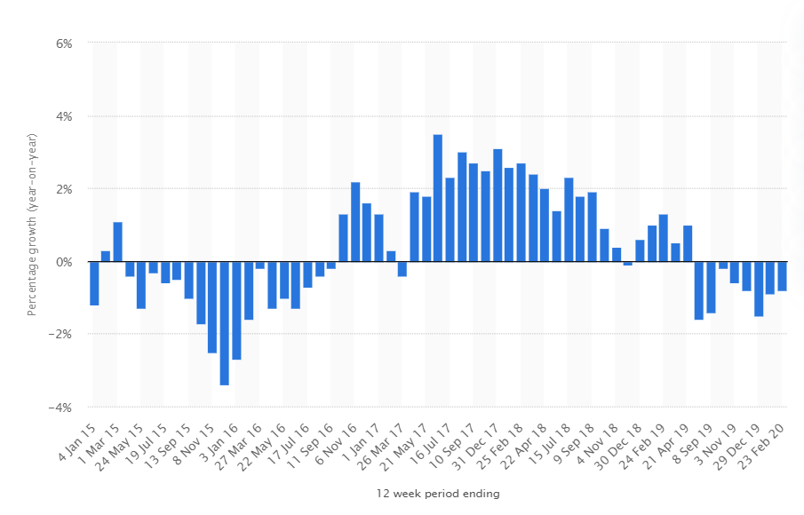
Figure 1 Growth rate of Tesco (Statista, 2020)
Tesco famous for its growing demand reduced the growth rate significantly due to the COVID pandemic. Its overall group sale decreased by .7% last year, Cash flow increased by 132% whereas EPS increased by 27%. Though subsidiaries' profit reduced by 18%, overall revenue increased by 2%. That measures in this COVID pandemic, operation, and management cost piles up that reduces profitability. If one considers the last 5 years growth of Tesco, it is seen that in the last 3 years it was doing considerably well compared to early 2015 where the growth rate becomes negative. The growth generated more in 2018 from the 3,784 stores of Tesco in the UK around 45 billion (Statista, 2020).

Key Environment Scanning Tools:

Hofstede’s Cultural Dimensions Theory:
Tesco serves customers of different countries and regions and for this, it has to cope up with different cultural issues because, without a proper understanding of the cultural background of different markets, no one can ripe benefits. Hofstede’s Cultural Dimensions Theory gives a framework for distinguishing different cultural and determines their role in a business establishment. Here in following this model is briefly described from the perspective of Tesco.
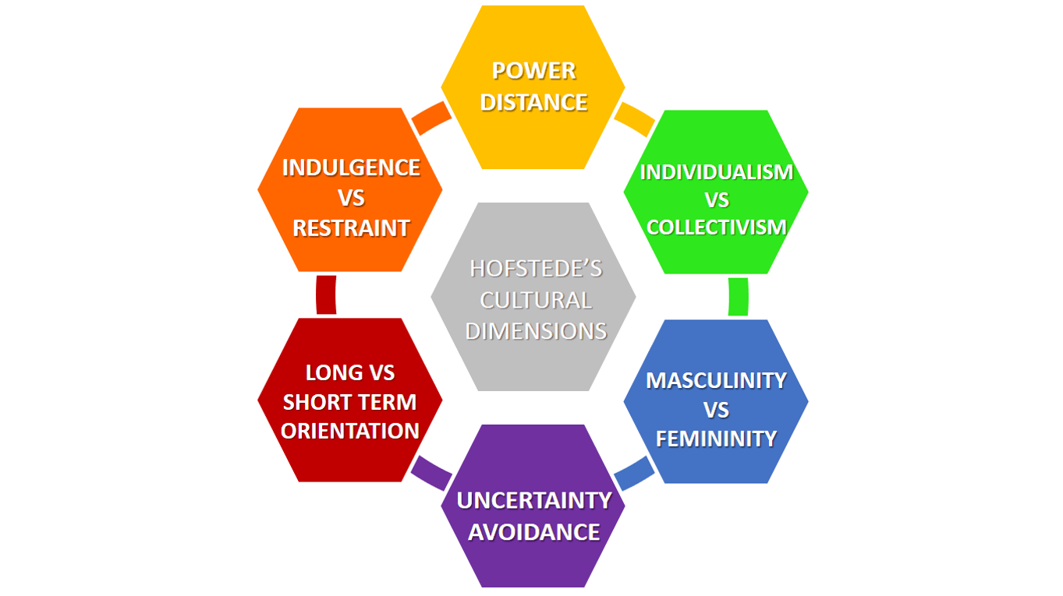
Figure 2 Hofstede Cultural Dimension in Tesco (Hofstede, 2011)
Power Distance: It measures the extent of encouraging inequality in society. A higher PD score refers to higher inequality that persists in the culture whereas a lower PD score indicates lower inequalities lies in an organisation (Favaretto et al., 2016). Tesco hires employees all over the world according to capability and does not discriminate against employees according to their gender and race. All of them are getting a salary according to their ability and knowledge and many are participating in decision-making also.
Individualism vs Collectivism: It determines the integration of different groups in society and their acceptance in the existing culture (De Mooij and Hofstede, 2010). Different cultural beliefs on a different perspective, some are willing to work individually and some have willingness collective work. Tesco focuses on the word “we” and they are making vertical integration with a supplier from different countries. They focus on a collective effort from employees and customers in every store.
Uncertainty Avoidance Index: It determines how the organisation can bear the uncertain events in a particular scenario. The higher the UAI lower the ability to meet the uncertain situation and lower the UAI, the higher the chances of meeting uncertainty (Hofstede, 2011). The growth rate of Tesco decline in 2015 but as they have the lower UAI, they recover the declining growth rate to a stable one before the pandemic.
Masculinity vs. Femininity: It measures the preference of society regarding secularism, equality, and sexuality (De Mooij and Hofstede, 2010). Femininity is in the core of Tesco as it behaves gently with customers and employees in different regions. There is equal treatment of all employees and in this pandemic, the employee is getting equal salary though it decreases in an amount no one dissatisfied.
Long-Term Orientation vs. Short-Term Orientation: It determines how society considers the longevity of an organisation (Favaretto et al., 2016). Tesco has a long-term dream of becoming the world’s largest retailer. That measures Tesco has a long-term orientation and it has some short-term orientation in focusing the niche market development.
Indulgence vs. Restraint: It measures how a society can control its desires and goals. Tesco wants to capture market where customers like to enjoy lives more, social norms are regulated, etc. (Hofstede, 2011) For that reason, Tesco is considering countries like India and Hungary where customers like to enjoy their lives and follow social norms and regulation to lead life.

Porter’s five forces model:
Michel Porter gave a framework to determine the organisation’s competitive environment in the market by analyzing its customers, suppliers, competitors, substitute products, etc. (Ansoff et al., 2018). For determining organisation structure, market competitiveness, and strategy porters five forces model is a very essential tool.
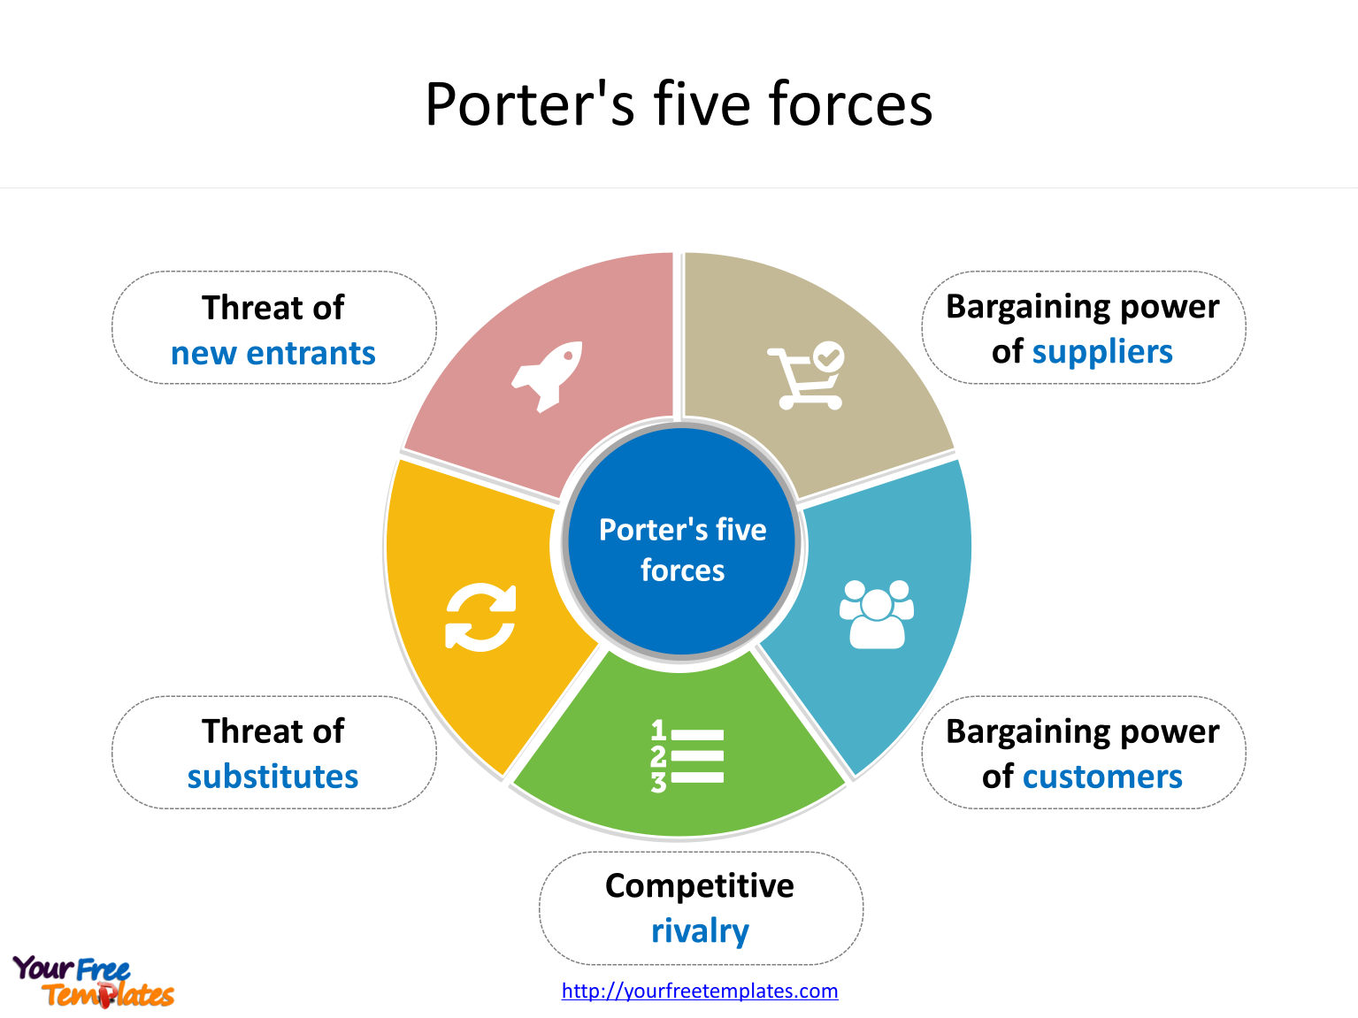
Figure 3 Porters Five Forces Model (Parnell, 2013)
Bargaining power of customers: Bargaining power depends on how many customers are engaged in an industry and their pattern of spending (Ansoff et al., 2018). Tesco, operating in the retail industry where the customer base is too high. Nut Tesco charges lower prices compare to others and continuously gaining more customer satisfaction. Here the bargaining power of the buyer is lower as the buyer may charge a higher price in other retail stores. But research says today's competitors like ASDA looking to grab the market by selling products at a similar rate to Tesco or sometimes even at a lower rate.
Bargaining power of supplier: The bargaining power of supplier increases when there is a shortage of supply of raw materials and when a particular supplier becomes the only source of those materials (Parnell, 2013). But Tesco has more than 2,500 suppliers in the UK and many more in other countries. Tesco negotiates very closely with each other and suppliers are facing challenges to meet Tesco’s demand as Tesco has a large pool of suppliers in hand and these suppliers have lees power in charging higher prices for the risk of switching.
The threat of new entrants: The power of an organisation may hamper due to the new entrance of potential competitors (Dess, 2013). Here in this retail industry, the threat of new entrants is very high. But in the case of Tesco, it is very low due to the capital requirements. Recently ASDA and Aldi enhance their operation but they are still now not the potential new threat to Tesco as Tesco’s operation is much more diversified and globalized than these organisations.
The threat of substitutes: Substitute products are alternative products to the customer that may give the same satisfaction (Dess, 2013). As Tesco is in the retail industry, its diverse product line has a large number of substitute products. Here Tesco bears potential threats but to reduce this threat Tesco offers wide ranges of choices to the customer at an affordable rate. A wide range of products reduces this threat over the years and for this Tesco has to make a more strategic alliance with different brands and suppliers.
Rivalry among existing customers: Higher the rivalry in the market, the higher the potential benefit to the customers (Parnell, 2013). Tesco has some powerful competitors both in the UK and outside the UK. Though Tesco becomes the market leader in this industry, a price war between Aldi and Tesco is so much intense. To reduce this competition Tesco introduced a discounted chain but its sales were disappointing. Though ASDA, Aldi is trying to capture market share from Tesco, higher capital requirement makes this process harder for them.

Critical Evaluation of Broader Environment:

PESTEL analysis of Tesco:
Business is being effected through both the internal and external factors in operating globally. Tesco is one of the world’s largest retailers operated in almost 12 countries around the world being affected through some external environmental factors such as political, environmental, social, economic, technological, and legal (Wheelen and Hunger, 2011). It is necessary to conduct situational analysis for successfully running a business by analyzing the macro environment and PESTEL gives insight into that analysis.
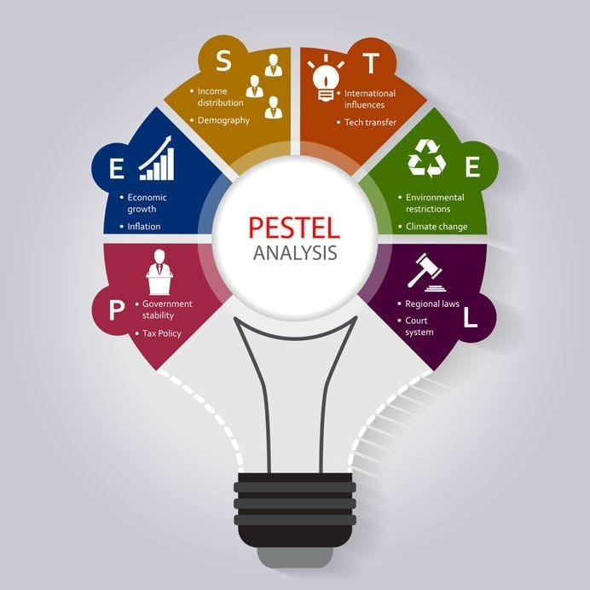
Figure 4 PESTEL analysis of Tesco (Yüksel, 2012)
Political: Stable and business-centric governments are the main source of economic development in many countries. Political factors determine how govt. rules and policies affect the performance of a business. It includes tax rate, vat, fiscal policies, etc. (Lasserre, 2017) that have a direct impact on the organisation's profitability and charter. Tesco operating in the UK has to provide 20% vat since 2011, is a stable one and they are not requiring to change policies frequently to go along with this rate. Free trading blocs by different governments and joint ventures with different European companies increase the profitability of Tesco and by this Tesco exploiting opportunities.
Economic: The success of a business largely depends on the economic stability of the world as it enhances the spending pattern of customers. The future is uncertain and this proved again by the recent COVID pandemic (Velikorossov et al., 2020). As Tesco operates globally and almost all of the country’s GDP goes down to negative, economic stability broke out. It is a global pandemic and this overall business environment lagging as consumers have less interest in premium and luxury products due to losing jobs or cutting wages by the employer. But as Tesco is a retailer and most of its product line is decorated with daily necessities its profitability slightly becomes negative, which is a good sign for the organisation. Recently the invention of the vaccine and people are now starting their work in the field, the world economy is slightly turning to the positive side which gives a positive indication in the business environment and reduces barriers.
Social: Social factors now largely affects business decision as it includes birth rate, spending pattern, cultural trends, level of education, and attitudes of customers (Amason and Ward, 2020). People are now investing less time in shopping and moves to the supermarket from where they can buy each of their necessities quickly and easily. As the rate of baby boomers increases, people are now becoming elder quickly, old people are reluctant to go super shop and require more health-conscious products than young. For this reason, Tesco introduces an electronic payment system in each of its shops, ensure the proper availability of non-food items and make a strategic alliance with pharmacies to make it their strength of operation.
Technology: Technological factors brings an innovative move for the organisation in today's competitive environment culture. It not only considers the technological development in the product but also development in the distribution channel and manufacturing process (Schilling and Shankar, 2019). Tesco introduces online stores as people are now more reluctant to spend time in physical visit in shopping centers, introduce a global payment system. Self-service check out point is the main technological development of Tesco that drives away a lot of customers from its peers and serves as the major strengths in this competitive environment.
Environmental: This factor becomes more important by the increasing nature of corporate social responsibility, waste disposal, and carbon footprint (Amason and Ward, 2020). Tesco investing much in reducing waste products in the factories, committed to reducing the level of carbon footprint by 50% within 2020. It also prohibited plastic packaging systems due to customer health consciousness and overcome weakness. As Tesco is concerned much with environmental issues related to the retail business, it has greater opportunity after the COVID pandemic as people are now more health-conscious than before.
Legal: An organisation should consider the legal aspects of a country when operating there. It may positively and negatively affect the performance of a business. Trade restrictions, consumer laws, and safety laws are the major factors in this macro environment analysis (Velikorossov et al., 2020). According to UK laws, Tesco cannot easily merge with similar companies and do alcohol business in retails. It cannot mislead customers and pay fewer wages to the employees. But get protection from heinous competition from ASDA, Aldi, etc. It is not regarded as a weakness or threat but as a potential way to improve performance by maintaining these laws.

Schein cultural model:
According to Schein, culture is a function of creating a community through employees and adopting organisational external surroundings. Culture is the way of explaining an organisation's characteristics, norms, and goals (Schöbel et al., 2017). There are three stages in culture according to Schein that defines an organisation’s shared beliefs and thoughts.

Figure 5 Schein's organisational Culture (Schein and Schein, 2019)
Artefacts: In upper-level Artifacts is visible that can be seen after visiting an organisation for the first time whether as an employee or visitors (Schein, 2012). Tesco’s building, super shops, internal design to attract customers, dress code of employees, etc. are seen when entering into the shops. It gives an understanding to the customers about its norms and ways of doing business. It is very easy to observe but very hard to interpret to others as the overall process requires subjective judgments.
Espoused Values: It is less visible and it is referred to the organisations stated norms and beliefs. Tesco’s formal rules of doing business are stipulated here by management and it includes management reports, annual reports, websites, etc. (Hogan and Coote, 2014). This gives a clear indication about Tesco, its performance, profitability, and management team. It helps to know the organisation as a whole and its overall culture that influences employee engagement and performance.
Basic Assumptions: It is invisible and they are basic rules of doing everyday activities in an organisation. The organisation has identical languages and norms that are difficult to change but easy to adopt for a newcomer (Hogan and Coote, 2014). Group norms of Tesco’s are largely focused such as the end of the operation at 5 p.m. and start operation at 8 a.m. Implicit rules of Tesco should be delegated to the new employees and helps to cope up with the new environment.

GLOBE Culture:
GLOBE represents Global Leadership and Organisational Behavior Effectiveness provides the employer with an extra sight through which he can better realize the international environment. It has nine dimensions of which seven are from Hofstede's cultural dimension as GLOBE is regarded as the updated theory of determining modern culture (Venaik and Brewer, 2010). Performance and humane orientation are the two new major dimension that describes how Tesco emphasis on individual and group performance along with national culture and how much emphasis Tesco give in building fairness in the organisation.
According to this model, Tesco identifies several cultural characteristics that are similar in different nations and categorizes them in a single group to serve them in the same manner that ensures equality in managing, efficiency in solving problems, and make the process of international work is easy. These clusters are characteristics, team-oriented, participative, self-perspective, humane oriented, autonomous, etc. (Venaik and Brewer, 2010). Tesco identifies that in the 12 countries that the organisation operates, there are similar characteristics such as trustworthiness, positivity, and dynamism. The culture of those countries brings unique opportunities to Tesco to flourish business activity and generate potential revenue. Tesco is more performance-oriented than represents in the business index. They ensure a training facility for an employee to enhance skills and ensures an effective reward system than before to motivate more. Another important aspect of maintaining a friendly culture in Tesco is that employees here are friendlier, generous, and show respect to each other when sharing values and thoughts.

Organisational Personal and Ethical Standards in Tesco:
The organisational structure determined by a certain person who belongs to the higher authority defines the goals and objectives of an organisation and how to accomplish those goals to run successfully the business (Maduenyi et al., 2015). Rules, regulations, responsibilities, and high ethical standards should be in the structure of an organisation. Tesco, the world’s fourth-largest retailer according to revenue has an effective hierarchy that maintains and develops organisational structure to accomplish the long-term goals of the organisation.
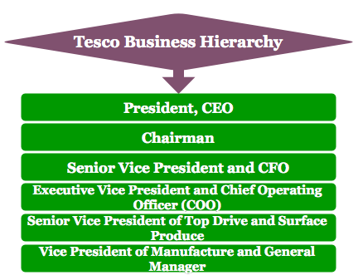
Figure 6 Organisational Personal of Tesco (Huhtala et al., 2013)
Tesco has a business pyramid that maintains power and responsibility through its organisational structure. Current CEO Julio also the president of Tesco, is regarded as the manager of managers who looks after the administrative tasks of Tesco operating in 12 nations. The chairman of Tesco is responsible for making a decision that is backed by ethics and employee satisfaction. Money is regarded as the blood of an organisation and it is maintained efficiently by the CFO of Tesco as he is responsible for financing every project through critical analysis and he also liable for making financing decisions through ethical judgments and makes some corporate social responsibility to enhance the reputation of Tesco. The executive vice president of Tesco has the responsibility of overlooking the daily operation of Tesco. It is more than 6,800 stores around the world so divisional sales volume and supplier information is separated and delegated to the designated authority certified by the vice president of Tesco. The senior vice president of Tesco is liable for surface produce that determines or identify the new potential opportunity for the organisational expansion and diversification. VP of manufacture and general manager has to maintain a good relationship with suppliers and vendors along with the building owner. The last but not the list is employees. They are regarded as the key people in the organisation who has the responsibility to satisfy customers by providing them fresh products in time and maintain good behaviour both in online and offline shops.

Ethical Standards in Tesco:
Ethical standards refer to the set of principles prepared by the higher authority of the organisation to work morally and it gives a framework that can be used as a reference tool for deciding what is right or wrong in a particular situation (Emerson and Mckinney, 2010). In the perspective of organisational culture and effective performance ethical standards are essential. It flows from a top-level to a low level by maintaining organisational structure. Tesco serves ethically all of its operated countries and becomes the founder member of the Ethical Trading Initiative. This ETI code of ethics is maintained by Tesco that includes employee freedom, collective bargaining power, good working environment, safe workplace activities, the prohibition of child labour, effective salary structure, training facility, employee medical treatment, a flexible working hour. Tesco operated through 6,800 shops with 450,000 employees who are highly trained to maintain ethics and accomplish fair business dealings with suppliers and customers. Tesco also ensures human ad workers right in the organisation, take steps on irresponsible marketing strategy and pricing strategy. In a competitive business environment, customers have more bargaining power and this entails organisations cutting prices and in some cases make dumping to grab the market share. Though the price of Tesco’s product is slightly cheaper than ASDA and other competitors, it maintains high ethical standards by not making any unethical strategy to influence a buyer. Tesco’s supply chain management got the best ratings in ethical rights rating and maintain the “Supplies code of conduct” throughout several years. Though it has a large number of branded items, it has non-conflicts of minerals in 2019. In 2020, it does not discharge any hazardous chemicals into the environment for maintaining ecological balance. But Tesco was frequently using Tax avoidance strategy in Hong Kong and Cyprus. Ethical consumers gave the worst ratings for that strategy back in 2015. But overall analysis determines that Tesco is maintaining higher ethical standards in employee selection, maintain a good working environment, reducing waste disposal, and combating carbon emission.

Corporate Social Responsibility in Tesco:
For being socially accountable, corporate social responsibility is the type of activity that a business does for society's betterment and increasing customer loyalty. It is a process of doing engaging more with customers and increases their level of satisfaction that makes them loyal to the organisation and this loyalty brings dependency and ultimate profitability in the future (Chain, 2011). Tesco performs CSR activities for its employees, community, environment, customers, and suppliers. For environment sustainability maintaining, Tesco ensures a training program to create awareness and increase operational effectiveness among workers. For crate a peaceful environment, Tesco runs some educational program especially for children in urban areas and give educational equipment through launching several scholarship programs. To become ethical with suppliers, Tesco maintains a long-term relationship with suppliers, followed transparent distributional channels, and competitive pricing. After the COVID-19 pandemic, people are now health conscious but Tesco was dealing with the health consciousness of customers before the pandemic and for this, they have a wide range of product variety in shops that includes both food and non-food items. Before Brexit, Tesco was following the instruction of the EU in doing CSR activities and for this, they introduce an embargo on sales in Zimbabwe. Employees in Tesco get chances for improving their qualities and expertise as Tesco arranges a lot of development programs for its employees to make them efficient enough to do tasks accordingly. Tesco launches different environmental sustainability programs and reduces the effect of carbon dioxide in the environment through proper utilization of recycling. As it relates to ethical standards, the organisation’s higher authority is responsible for the overall activities, CSR largely depends on these two elements.

Recommendation
COVID-19 changed the economic scenario of all over the world. It directly impacts every business and reduces employment and sources of income. Tesco serving in a retail industry that mainly deals with groceries also experienced a negative growth rate at the beginning of 2020. It changes the organisational culture as jobs are cutting down, employees are dissatisfied, and customer engagement reduces. In that context, Tesco should enhance their online service facility and increases staff level to serve the customer by reaching their home. They make a strategic alliance with different pharmacy dealers and they have to enhance this relationship and make available all type of medicine that gives relief in fever, cough, respiratory issues. After-sales service should be introduced by Tesco and they should diversify their product line by introducing more non-food and vegetable items in grocery shops. They should keep more substitute products for serving customer needs at a lower price and charge a minimum price for products to gain a competitive advantage. As in this pandemic, frozen food supply from the different nation is reduced due to the risk of spreading the virus, Tesco should find out alternative sources in the home country to manage those products and serve customers need. By doing these, changing workforce culture may bring organisational efficiency to Tesco.

Conclusion
Globalization has increased the level of business operation and enhance business opportunities around the globe. A recent uncertain recession broke out for COVID changes the business environment. Organisational structure and culture have been changed due to a sudden change in the work environment and economic condition that affects performance negatively. Tesco, a leading retailer in the UK now looking to expand the business as due to pandemic it substantially loses its revenue. It can conduct Hofstede's cultural dimension to distinguish between choices of different locations to operate efficiently. Schien's cultural dimension will give visible and invisible feedback about an organisation that serves currently in that location. This will give proper extensive beneficial information to the competitors. Again, the internal and external environment should be analyzed by the leaders in an organisation to look out for opportunities. For analyzing macro-environment, Tesco here analyzes the porters five forces model and PESTEL, that give insights about the political, economic, environmental, social and legal aspect of UK and demonstrate the market competitiveness along with supplier and buyers power to bargain with Tesco. Tesco maintains ethical standards from the beginning of its journey except in Hong Kong. It follows ETI and became the founding member of it and Tesco do some corporate social works that increase customer satisfaction and make them loyal to them. The different vocational training facilities, educational assistance in a rural area, equal employment opportunity, no gender discrimination, and prohibition of child labor are the main ethical and social concerns of Tesco over the years.

References
Amason, A.C., and Ward, A., 2020. Strategic management: From theory to practice. Routledge.
Ansoff, H.I., Kipley, D., Lewis, A.O., Helm-Stevens, R., and Ansoff, R., 2018. Implanting strategic management. Springer.
Chain, L.V., 2011. Corporate social responsibility.
De Mooij, M., and Hofstede, G., 2010. The Hofstede model: Applications to global branding and advertising strategy and research. International Journal of advertising, 29(1), pp.85-110.
Dess, G., 2013. Strategic management: Text and cases. McGraw-Hill Education.
Emerson, T.L., and Mckinney, J.A., 2010. Importance of religious beliefs to ethical attitudes in business. Journal of religion and business ethics, 1(2), p.5.
Favaretto, R.M., Dihl, L., Barreto, R. and Musse, S.R., 2016, September. Using group behaviors to detect Hofstede cultural dimensions. In 2016 IEEE International Conference on Image Processing (ICIP) (pp. 2936-2940). IEEE.
Hofstede, G., 2011. Dimensionalizing cultures: The Hofstede model in context. Online readings in psychology and culture, 2(1), pp.2307-0919.
Hogan, S.J., and Coote, L.V., 2014. Organisational culture, innovation, and performance: A test of Schein's model. Journal of business research, 67(8), pp.1609-1621.
Huhtala, M., Kangas, M., Lämsä, A.M., and Feldt, T., 2013. Ethical managers in ethical organisations? The leadership‐culture connection among Finnish managers. Leadership & Organisation Development Journal.
Lasserre, P., 2017. Global strategic management. Macmillan International Higher Education.
Maduenyi, S., Oke, A.O., Fadeyi, O. and Ajagbe, A.M., 2015. Impact of organisational structure on organisational performance.
Parnell, J.A., 2013. Strategic management. Sage.
Schein, E., 2012. Corporate culture. Handbook for Strategic HR: Best practices in organisation development from the odd network, 253.
Schein, E.H., and Schein, P.A., 2019. The corporate culture survival guide. John Wiley & Sons.
Schilling, M.A., and Shankar, R., 2019. Strategic management of technological innovation. McGraw-Hill Education.
Schöbel, M., Klostermann, A., Lassalle, R., Beck, J., and Manzey, D., 2017. Digging deeper! Insights from a multi-method assessment of safety culture in nuclear power plants based on Schein’s culture model. Safety Science, 95, pp.38-49.
Statista. 2020. Statista - The Statistics Portal. [Online] Available at: <https://www.statista.com/> [Accessed 8 December 2020].
Tesco PLC. 2020. Home. [Online] Available at: <https://www.tescoplc.com/> [Accessed 1 December 2020].
Velikorossov, V.V., Genkin, E.V., Balakhanova, D.K., Sidorov, M.N., Maksimov, M.I., Sulimova, E.A. and Loshkov, B.D., 2020. Strategic management.
Venaik, S., and Brewer, P., 2010. Avoiding uncertainty in Hofstede and GLOBE. Journal of international business studies, 41(8), pp.1294-1315.
Wheelen, T.L., and Hunger, J.D., 2011. Concepts in strategic management and business policy. Pearson Education India.
Yüksel, I., 2012. Developing a multi-criteria decision-making model for PESTEL analysis. International Journal of Business and Management, 7(24), p.52.

