NAME: KENNEDY NGANGA KAMAU
PROGRAMME: LEADERSHIP AND MANAGEMENT SKILLS FOR THE WORKPLACE
STUDENT NUMBER: 2018117
MODULE: DEVELOPING WORKPLACE CRITICAL THINKING
MODULE CODE: BMSW 5101
LECTURERS NAME: DR GREGORY COWAN
ASSIGNMENT TITLE: PART 1-INDIVIDUAL BUSSINESS REPORT
: PART 2-REFLECTIVE JOURNAL

EXECUTIVE SUMMARY.

OBJECTIVE:
To find out how organisational beliefs, attitudes, and value systems affect Barclays bank and how the tailoring of the institutions changes for the post-covid mindset will tackle the changes we face now, and create a more resilient business in the future.

BELIEFS, ATTITUDES, AND VALUE SYSTEMS
With a diversity of employees from different background and cultures, values, beliefs and attitudes have bonded over time to create harmony and cohesion in the institution. This have formed the moral principles that guide the institution and mostly during the pandemic period

BARCLAYS MANAGEMENT THEORY
This are the recommended management policies within Barclays mostly comprising of tool and frameworks that are put in place in running of the organisation.
This are the principles that help in the management of employees more effectively and involves a variety theories. they include human relation and contingency theories

CONCLUSION
The policies developed during the pandemic and the pre covid way of doing business combined have produced a more resilient organisation to deal with the new and future challenges.

PART 1.INDIVIDUAL BUSINESS REPORT

Critical thinking is part of the Barclays bank growth and one of the main factors it uses while making its strategic plan and its implementation. Founded in the 1690 from the origins of the goldsmith banking business established in the city of London. It has continued to grow while achieving valuable milestones like being the first bank to start the world’s first cash dispensing machine.
The bank has about 1600 branches in the United Kingdom with about 47686 employees as of 2021, this brings with it a rich diversity of beliefs, attitudes, and values withing the organisation. With an aim to be leading among the banking industry, critical thinking which involves mainly the objective analysis and evaluation of issues within the workplace is thus essential in making conclusions and judgements within the bank.
Considering the impact of covid 19 which has changed the way of doing business, Barclays understands the benefits of creating an understanding and all inclusive culture to cater for all people putting into consideration that much is achieved when people work as a team. Critical thinking then has become of great influence in pushing the organisation forward.
As the Chairman, Nigel Higgins put it. “We established some new ways of working during the pandemic that significantly increased our operational effectiveness and the roll-out of the Barclays Mindset is intended to help us retain these benefits in the post-pandemic world. We have made some early progress embedding the Mindset across our organisation, but there is more we can do to fully harness the power of Barclays for all our stakeholders. I therefore urge all of you to keep the Mindset principles – Empower, Challenge and Drive – front of mind in everything you do.” (The Barclays Way How we do business, 2021)
From the chairman’s statement we see that Barclays was forced to critically think beyond the normal way of doing things to a more accommodative way from the onset of the pandemic, through the pandemic and post pandemic. All aiming at satisfying all stakeholders, customers, and employees while retaining the business standards.
Putting in mind that critical thinking involves thinking that is impartial, compatible and non-arbitrary, Barclays bank acts in line with beliefs, attitudes, and values that support fairness and impartiality for their decisions and actions.
This was important especially during the lockdown where a high percentage of employees had to work from home while banking halls remained closed for customers. The top management had to come up with ways of facilitating the staff to work from home and they decided to buy computers and stationery needed for staff including desk and chairs to make sure they continued to run office work smoothly.
A working schedule was put in place to allow staff who had to get to the office as some things cannot be done virtually, they had to work at different time intervals with proper spacing to avoid congestion and observe the 2-meter rule of social distancing.
More call centres were put in place to cater for customers needs as that was the only means of contact, and more emphasis was put in making sure all ATMs were in good working condition. Customer were encouraged to use mobile banking, and this was made easy by introducing flexible and easy access to services that were previously only available from the bank hall.
The bank had to be responsive, purposeful, led by intellectual standards of thinking beyond the normal while maintaining its beliefs, attitudes and values as an institution.
The many employees come from different cultures and backgrounds and thus bring along with them different beliefs into the workplace, this is mainly feelings that what they believe is true to them even though it is not proven or irrational e.g., Christians believe in Jesus whom they have never seen and life after death.
Beliefs are also ideas that we hold as correct and that is to mean they are not only religious. We have philosophical, political, societal beliefs among others. E.g., some people believe that the world is round and that aliens exist in other planets.
We also have different values within the organisation, and this involves how much a person considers something as of importance and mostly is seen in the way people work and live. They are mostly a result of firm enduring beliefs. Examples of different values expressed at Barclays include honesty, selflessness, loyalty, and humility among many
Values are paramount to human success; this is mostly because they act as a guide and lead towards a meaningful career and life in general. This comes in handy while making personal decisions
Different attitudes are also expressed, and this mainly occurs when an individual expresses their value and beliefs. Mainly attitudes are expressed verbally and through behaviour, an individual’s way of approaching a situation. Examples may include aggression, ambitiousness, and being anxious.
Attitudes are normally viewed from three perspectives namely,
1.Cognitive which is based on acquired knowledge understanding.
2.Emotional attitude derived from emotional stimuli or the expression of passions e.g. anger
3.Behavioral mainly is attributed to the wat we react to circumstances or situations.
Barclays as a big financial institution with a lot of diversity has in its years of growth and expansion settled on its own beliefs, attitudes, and value systems to enhance harmony and cohesion among employees, customers, and all stakeholders.
This led to zeroing in on five core values which form who Barclays are and what they believe in. They are Respect, Integrity, Service, Excellence and Stewardship. This played a major role in maintaining the running of business especially during the pandemic
By embracing Respect which is basically recognition and acceptance of someone’s or somethings abilities, achievements, or quality. They have been able to integrate diversity and inclusion in the business. This has enhanced trust within the institution and utilising everyone’s contribution.
This played a vital role during the pandemic because the institution put up comprehensive measures to safeguard employees and customers in accordance to government guidelines, this mainly had to do with employees who were providing essential financial services and had to go to work physically as the rest worked from home. They created new technologies and ways of working to enable most of the staff to work from home.
For the millions of customers Barclays ensured transactions processes, finance access, and support was available to all without discrimination in any way. They also facilitated in processing the business interruption loan scheme by the government to various businesses the were affected by the covid.
Integrity plays a key role in operating with transparency, honesty, and decorum in all areas of the institution. It involves strong moral concepts in running affairs. The institution rolled out e-learning for managers to support each other and monitor their teams. An employee assistance programme was set up to offer professional assistance to needy colleagues.
Values such as good service delivery and excellence have also been vital for growth of the institution. It has always encouraged innovation and use of available resources and competence to make progress. This played out well during the pandemic especially with reduced customers due to lockdowns. The number of operating business hours was reduced while some branches were to open fewer days of the week to cover a larger geographical area of business while using minimal number of staff.
Security guard were put in place to ensure the covid guidelines were being observed in all the banks that were operating. Perspex screens were installed on counters and desks to shield the staff while doing their duty. Antibacterial wipes and sanitisers was provided while deep cleaning was carried out routinely in all the branches.

Barclays colleagues’ connection to company values.
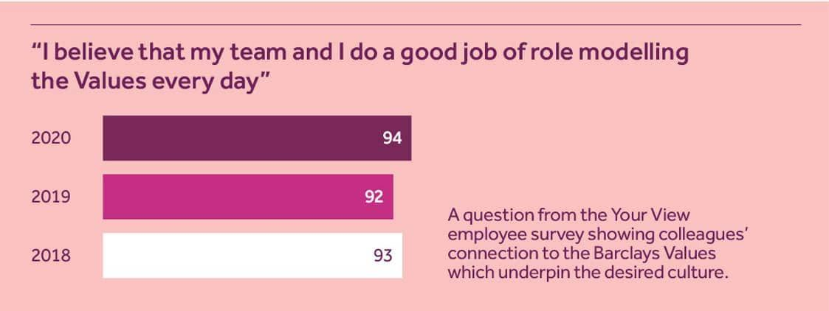
Image 1. (Home.barclays, 2017)
The diagram illustrates that the colleagues are fully connected in belief, attitudes, and values.

MANAGEMENT THEORIES.
Over the years Barclays bank has transitioned from the partnership business of Thomas Gould and John Freame to become one of the largest banks in the United Kingdom and the world in general. Management theories have changed over the 300 years it has existed as well as model of leadership.
Taylors scientific theory which involves approaching numerous views of the organisation in a scientific way using scientific tools like analysis and research and Weber’s bureaucracy which relies on two main principals of hierarchy and rule-based power were the main management theories the institution was using.
This failed over time because they ignored the fact that in modern day management style and organisational structure are defined and influenced more on several features of the environment, the contingency factors. Thus, embracing the Contingency theory of management which focus on specific variables linked to the environment to possibly decide on the favourable leadership for the situation.
With the outbreak of covid-19 and all the changes that come along with it, the lockdowns, new rules of engagement in doing business, people working from home, etc. Contingency theory came in handy and proved to be a success because it states that no leadership style is best for all circumstances and that success depends on various variables. Its asserts that there is no favourable way to organise a company, make decisions, or to lead a corporation.
Alternatively, the best and most favourable course of action is dependent (contingent) upon external and internal circumstances withing the institution. With diversity of people’s beliefs, attitudes, and values, there could be no one best way of leadership. Contingency theory seeks to formulate structures that are associated with the circumstance or fit the usage of specific technologies.
Barclays also uses the RED model of critical thinking in its decision making within the leadership. This creates the way in which critical thinking works on the various important expertise. Its main 3 components are:
1.Recognise assumptions
2.Evaluate arguments
3.Draw conclusions

Image showing the components of RED model.

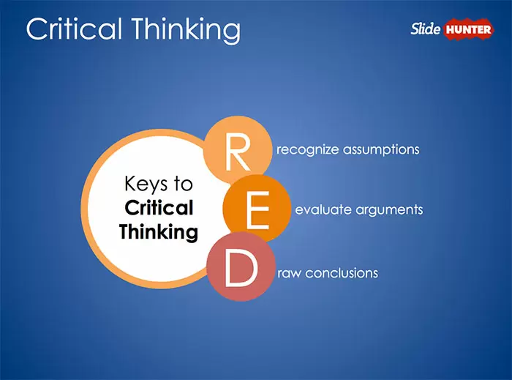
Image 2 (SlideHunter.com, 2015)

Those staff who recognize assumptions separate reality from opinions, those who evaluate arguments can scrutinise details objectively and precisely while those who draw conclusions brings various details together and get to conclusions with the evidence at hand.

RECOMMENDATIONS
The institution has shown to embrace change over the years with notable milestone achievements like being the first bank to offer a UK credit card in 1966, and the first to deploy a cash dispenser in 1967. It also become the first bank do TV advertising and the first UK bank to list shares in the New York and Tokyo stock exchange.
During the pandemic, the bank adapted to the change of working from home and online banking at a remarkable speed, proving facilities and tailor-made technologies and systems for colleagues to work efficiently during and after the pandemic.
This makes the institution a pace setter in the banking industry and these are attributes that should be emulated buy other banking institutions to stay on top of in the business.
With thousands of employees Barclays should put more efforts on empowering the diverse employees value systems to make them more energetic and improve confidence and skills, thus more commitment, and better services in return.

CONCLUSION.
Having adapted well to a successful work from home policy and an efficient mobile online banking system, this will be incorporated to the normal mode of doing business with the end of covid-19 rules and lockdown. This will lead to a more resilient way of doing business in the future and one that will be able to deal with the current challenges we face now.
Having the experience of working from the office and out of the office both achieving the institutions’ goal has created a dynamic way of dealing with change and challenges both external and internal. This has strengthened the organisational beliefs, attitude, and value systems to withstand current and future challenges in the business.

PART 2- REFLECTIVE JOURNAL
As I sit down to reflect on my nine weeks of learning developing workplace critical thinking at the University of wale trinity saint David level 5 at the London campus, I was feeling anxious and did not know exactly what to expect. It turned out to be a very intense learning experience where I learnt a lot of information. In my next level I would give myself more time for research in my schoolwork as it was so engaging yet I was not fully prepared.
I started in week one by introducing myself to the class and the lecturer introduced the outline of the module content. I filled a self-evaluation form (Cottrell 2017, p13). I went through a brief introduction to workplace context and change, management theories, logic and Harvard referencing. I was also able to learn about deductive and inductive reasoning something I had never come across in my previous studies. This gave me a view of what to expect in the following weeks, I decided to be attending both physical and online classes depending on my availability.
In week two I learnt about beliefs, values, attitudes, emotions, and critical thinking and its importance. Before this I did not think these topics are so vital in the business world and made me realise how much my personal life influence the way I relate to others in the workplace.
I took part in an exercise and discussion, and I learnt a lot about the role for reasoning in a dialogic approach to critical thinking. I normally would not think of something in a logical manner in most times. This made me start approaching dialogue in a more sensible way.
In week three I learnt about critical thinking in details and the importance of being a critical thinker. I now know the characteristics I need to have to think critically and the standards of good reasoning in my day-to-day life. i also learnt approach to human relations and now know the need for attention, social interaction and individual achievement to increase productivity in my activities.
I did the case study of critical thinking in JIT and Scanlon plan, I realised that some organisations only produce what they need when its needed. I found this to be very interesting as I had never thought of it that way despite knowing organisations that do it like Mac Donald’s.
During the fourth week class I learnt about the characteristics and changing business environment, I also studied on the characteristics I need possess to be a successful businessperson. This made me reflect on my personal capabilities and resorted in adapting to positive change where necessary.
I did the case study using the RED model of critical thinking, It helped me a lot to improve on the way I recognise assumptions, evaluate argument and draw conclusion from a variety of information or materials. I also learned to apply and develop new workplace skills. This has changed my approach to the way am doing things in my workplace in a positive way. I am able to recognise problems, identify alternatives, evaluate alternatives, and make proper decisions which was not the case before.
I also learnt about the scientific management and how it evolved with time, the difference between scientific and humanistic approach. I can conclude that there is no specific or best way to run an organisation (contingent). change is inevitable.
In week five I learnt the conceptual tools to enhance my critical thinking using the De Bono’s 6 thinking hats methods. This helped me in learning how to separate thinking into different functions and roles, unlike what I was doing before taking one whole concept and trying to think about it.
I also learnt about the bureaucratic managements origin and how it has evolved over time. This gave me a clear picture to see how it is reflected in so many areas of our life’s. I also realised that bureaucracy could build or destroy an organisation it all depends on the application method and support systems given to it.
I participated in an exercise to find out how business could face new bureaucratic burdens after leaving the European Union due to Brexit. I realise if given a chance to vote again I would choose to remain in the EU which was more advantageous than the exit.
Week six was more learning in decision making, decision criteria, and critical thinking and how they work together. I always thought its more of the same thing, but I now know the difference and the application of each. I participated in various examples where I applied topic to real life examples.
In week seven I refreshed my self with learning about beliefs, values, attitudes, emotions, and critical thinking. I was also interesting in the discussion about the hen and egg, asking myself what comes first between the two and listening to other students give their view illustrated how difficult it is sometimes to come to a conclusion on some issues.
I also got to learn about systems theory. I now know that I work within various systems in my daily life. Be it structural systems for roads or social system for work they all work together to achieve results. I came to hear of the term equifinality for the first time in my life and relate to how same inputs can result to same output by using different methods.
I studied about change and adaptability and the various structural changes a system goes through to give results.
Week eight was about creativity and innovation in the business environment. I watched several TED Talks on the same topic and concluded that we are in an era of open innovation. To adapt to a changing world innovation is essential in every way. I learned about strategy, planning, marketing, Technological processes, quality, logistics, organisation, and human resource, in all this innovation plays a major role if they have to effect change and achieve results.
Week nine was the last week of study and I learnt of the 5 transformational policies for a prosperous and sustainable world. We also summarised the whole semesters worked and looked at the requirements for the assessment.
It was a great learning experience that has transformed my way of thinking and approaching issues both personal and in the workplace.
References:
-Crispin Blunt MP. (2020). MESSAGE FROM BARCLAYS BANK RE CORONAVIRUS BUSINESS INTERRUPTION LOAN SCHEME. [online] Available at: https://www.blunt4reigate.com/news/message-barclays-bank-re-coronavirus-business-interruption-loan-scheme [Accessed 4 Apr. 2022].
-Wikipedia Contributors (2022). Barclays. [online] Wikipedia. Available at: https://en.wikipedia.org/wiki/Barclays [Accessed 4 Apr. 2022].
- Statista. (2021). Barclays: employment numbers by country 2021 | Statista. [online] Available at: https://www.statista.com/statistics/441855/barclays-group-employees-by-country-worldwide/ [Accessed 26 Apr. 2022].
- SlideHunter.com. (2015). Free Pearson’s Red Critical Thinking PowerPoint Diagram - Free PowerPoint Templates - SlideHunter.com. [online] Available at: https://slidehunter.com/powerpoint-templates/pearsons-red-critical-thinking-powerpoint-diagram/ [Accessed 28 Apr. 2022].

‌
- The Barclays Way How we do business. (2021). [online] Available at: https://home.barclays/content/dam/home-barclays/documents/citizenship/the-way-we-do-business/Barclays%20Way%20July%202021vf.pdf.
- Gurteen, D. (2022). What are beliefs? | Conversational Leadership. [online] Conversational Leadership. Available at: https://conversational-leadership.net/beliefs/ [Accessed 27 Apr. 2022].
- Statement from Barclays on supporting employees through the COVID-19 Crisis. (n.d.). [online] Available at: https://committees.parliament.uk/publications/682/documents/3232/default/.
-Home.barclays. (2017). Performance measures | Barclays. [online] Available at: https://home.barclays/who-we-are/our-strategy/performance-measures/ [Accessed 27 Apr. 2022].
- All Answers Ltd (2021). Analysis of Management and Leadership in Barclays Bank. [online] Ukessays.com. Available at: https://www.ukessays.com/essays/business/analysis-of-management-and-leadership-in-barclays-bank-business-essay.php [Accessed 28 Apr. 2022].
- (Cottrell 2017, p13)
- KUHN, D., 2018. A Role for Reasoning in a Dialogic Approach to Critical Thinking. Topoi, 37(1), pp. 121-128. available at: https://search-proquest-com.ezproxy.uwtsd.ac.uk/docview/2291274963?OpenUrlRefId=info:xri/sid:primo&accountid=130472

‌

‌

‌

‌

‌

‌

‌-

‌
‌

