

Developing an intelligent personal assistant for smart homes
By
Name and student number:

Programme Name: Cert HE Construction, Digital, Computing & Engineering

The statement:
‘This project is submitted in partial fulfilment of the requirements for the Certificate of Higher Education: _____________ [insert full title of the programme for which you are registered], the University of Wales Trinity Saint David'
Date of submission:

Declaration
By submitting a Project Report for marking, a student is permitting a copy of their report to be held for reference, at the University's discretion. They are also agreeing to the following: 'I have read and understood the University Regulations concerning plagiarism and I undertake: • That all material presented for examination is my work and has not been written for me, in whole or in part by any other person(s). • That any quotation or paraphrase from the published or unpublished work of another person has been duly acknowledged in the project
Table of Contents
Declaration 2
Assessment Component 1: Report 5
Abstract 5
Chapter 1: The Problem/Introduction 6
Chapter 2: Review of Related Literature 8
2.1 Field Investigation Research 8
2.2 Results and Findings 8
2.3 Connection to Previous Research 9
2.4 Sections of the Review of the Literature 9
2.5 Inference 9
Chapter 3: Design and Implementation 10
3.1 Research Techniques 10
3.2 Design Process 10
3.3 Application 11
3.4 Methodology Justification 11
Chapter 4: Presentation and Analysis of Results (with Screen Dumps) 12
4.1 Development-based projects: 12
4.2 Experiments-based projects: 16
Chapter 5: Conclusion and Recommendations 19
References 20
Bibliography 22
Appendix 23
Appendix 1: Title Page 23
APPENDIX 2: DECLARATION FORM 24
APPENDIX 3: CONSENT FORM 25
Appendix 4: Questionnaire 26
Appendix 5: Test Values 28
Appendix 6: Questionnaire results 29
Assessment Component 2: Practical Component 31

Abstract
The project's main objective was to design and create an intelligent virtual assistant for smart homes. By allowing voice-controlled conversations with smart home devices, user comfort and convenience were to be improved. The assistant could comprehend user orders, offer tailored replies, and automate device management by combining natural language processing, speech recognition, as well as machine learning techniques. Numerous tests were run to assess the usefulness of user interactions, the accuracy of speech recognition, and the assistant's overall performance. The outcomes showed a high degree of speech recognition accuracy, and users were pleased with the simplicity and effectiveness of using voice commands to manage smart home appliances. By developing an engaging user interface, using cutting-edge technology, and assuring smooth connection with a wide array of smart home devices, the project was able to accomplish its goals. The results demonstrate the possibility of voice-controlled interaction and customised automation, which advances the fields of smart homes & intelligent personal assistants. The established solution serves as a starting point for more study and technological improvements related to smart homes.

Chapter 1: The Problem/Introduction
The initial aims and objectives of the project are to create an intelligent virtual assistant that improves user convenience and experience for smart homes.
Aim:
A user-friendly user interface must be developed, speech recognition & natural language processing must be implemented, device automation and control must be enabled, and machine learning must be used for personalization.
Objective:
- Project initiation Requirements collecting
- System Design Execution
- Machine learning integration
- Evaluation and Testing
- Documentation and reports
- Presentation preparation
Are some of the important aspects included in the project plan? The Gantt chart provides a visual representation of each phase's timeframe, allowing for more efficient project management [1].
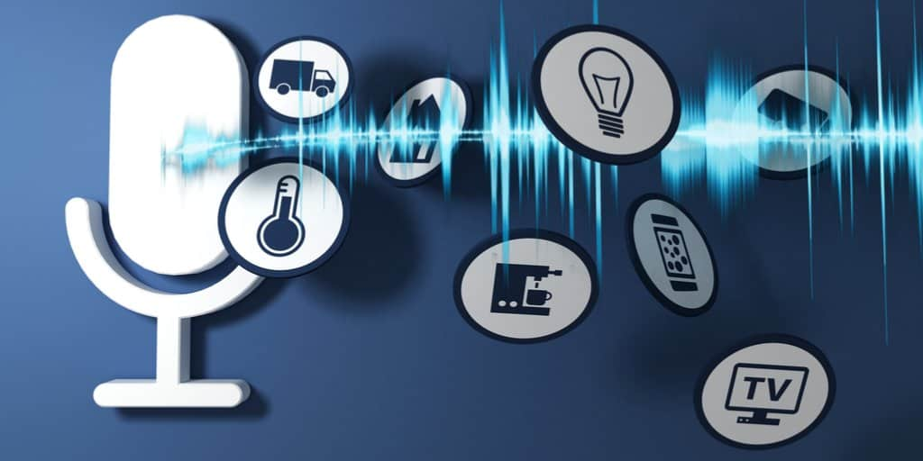
Figure 1: How Voice Assistants Are Changing Our Lives | Smart sheet
(Source: Smart sheet, 2023)

Gantt chart or a project plan

 | Jan | Feb | Mar | April | May | June | July | August | Sept | Oct | Nov | Dec
Project Initiation
Requirements Gathering
System Design
Implementation
Integration of Machine Learning
Testing and Evaluation
Reporting and Documentation
Presentation Preparation

Chapter 2: Review of Related Literature
The chapter examines prospective solutions that have been put up in light of the quick technological improvements that have given rise to smart homes, which allow the control and automation of numerous devices to improve ease of use, comfort, and energy efficiency.

2.1 Field Investigation Research
A summary of the research on smart homes and autonomous personal assistants is given in this section. These technologies' comprehension and development are advanced by identifying key researchers, organisations, and publications that have contributed [2].

2.2 Results and Findings
The chapter looks into the results and conclusions of the study done by scholars and investigators in the area in this part. To learn more about the difficulties, possibilities, and results of creating smart homes or intelligent personal assistants, methods, experiments, & case studies are examined [3].
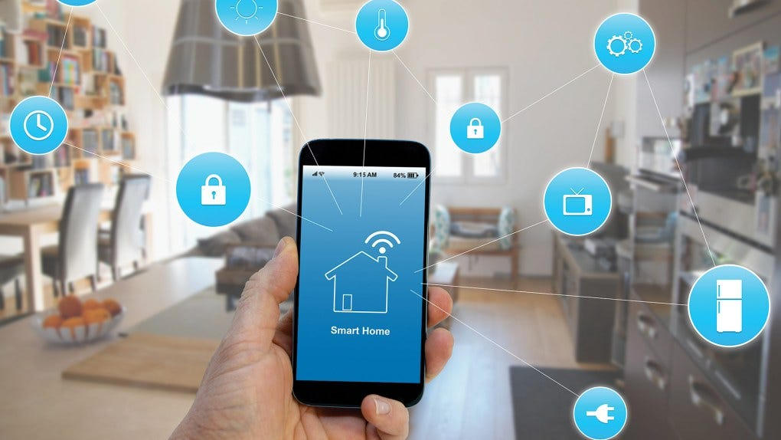
Figure 2: Voice Assistants and Smart Home Technologies Transform the Lives of People with Disabilities
(Source: Debrahuh, 2023)

2.3 Connection to Previous Research
The chapter emphasises the distinctive contributions the project seeks to contribute in the fields of smart homes or autonomous personal assistants by setting the research within the larger context.

2.4 Sections of the Literature Review
Each element of the literature review focuses on a different facet or subtopic of the study's subject. These sections serve to organise the review and offer a methodical investigation of the pertinent literature. Sections that could be included are:
- State-of-the-Art Intelligent Personalised Assistants: A description of the most recent developments in intelligent digital assistant technology, with a focus on its features, functions, and drawbacks.
- Speech Recognition and Language Processing: A survey of speech recognition and language processing research that has been done for applications for smart home assistants [4].
- Device Control & Automation: A review of research and innovations in the field of device control & automation within smart home settings.
- The Use of Machine Learning with Personalization: An examination of the machine learning techniques and methods used to tailor user experiences and enhance assistant performance.

2.5 Inference
It highlights how pertinent the studied literature is to the project, highlights any gaps, and points out ways that the study may help advance the creation of intelligent virtual assistants for smart homes.

Chapter 3: Design and Implementation
It seeks to provide readers with enough information to comprehend and maybe repeat the study. The following section describes the creation and execution of a strategy for an intelligent personal assistant over smart homes in the context of the quick advancements in technology that have given rise to smart homes, which provide automation and control of different gadgets to improve ease of use, comfort, and energy efficiency.

3.1 Research Techniques
A research process that combines investigative & iterative methods of design was used for this project. The investigative strategy comprised a thorough examination of the available smart home technology, user needs, and market prospects and obstacles. To learn more about user preferences, problems, and wanted features, extensive consumer surveys, interviews, & observations were made. The iterative design technique was used to guarantee that the solution will be continuously improved and refined. A cyclical process comprising design, execution, testing, and evaluation was used in this strategy. Every iteration involves obtaining user input, altering the design as needed, and adding new features [5].

3.2 Design Process
An extensive examination of user wants and requirements were the first step in the design process of an intelligent personal assistant. The project's design ideas and standards were influenced by the information gathered through user surveys, interviews, or observations.
The system design was created to guarantee effective communication between various modules and smooth integration into smart home gadgets. Voice recognition, device oversight, automation, or machine learning integration waree all incorporated into its components [6].

3.3 Application
The creation of the intelligent assistant itself took place during the implementation phase. To provide a well-structured & maintainable codebase, the implementation process followed industry best practices such as modular growth, version control, and documentation.
Thorough testing was done during the installation process to assure the operation and functioning of the intelligent virtual assistant. This intelligent personal assistant was subjected to unit, system, usability, and acceptance testing to ensure that it met user expectations and served its intended function.

3.4 Methodology Justification
The necessity to comprehend user requirements as well as tastes in context regarding smart homes justifies the mix of investigative & iterative design approaches. The investigative strategy offered insightful information about user demands, problems, and requested features. The user-centric solution that was produced as a consequence of the iterative design process effectively addressed the issues encountered in smart home situations and allowed for continual refinement based on user feedback [7].
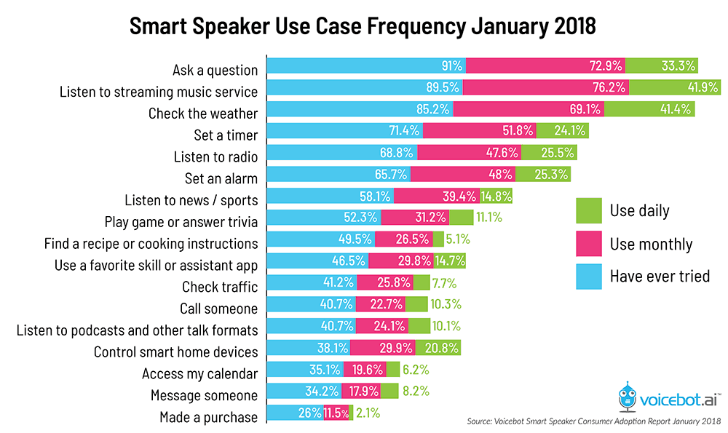
Figure 3: How Voice Assistants Are Changing Our Lives | Smart sheet
(Source: Smart sheet, 2023)

Chapter 4: Presentation and Analysis of Results (with Screen Dumps)
Smart homes are a result of the quick development of technology and allow the control and automation of many pieces of equipment to improve convenience, comfort, and energy economy.

4.1 Development-based projects:
1. Project needs: User surveys, interviews, and market research were used to identify the project needs for intelligent personal assistants for smart homes. To address the demands of users within smart home environments, the major capabilities, features, and goals of the intelligent virtual assistant were deterarened based on the data gathered.
2. Entity-Relationship (E-R) diagrams: Entity-Relationship (E-R) diagrams were graphical depictions that show the connections between entities in a database. System Models. To visualise the structure and organisation of a database system, they employ entities to represent things or ideas and relationships to show the connections between these entities [8].
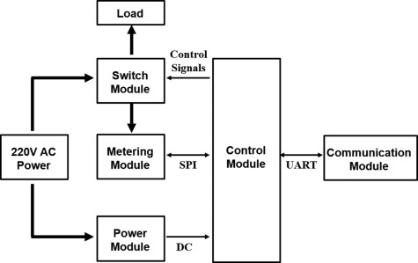
Figure 4: Home Automation System - an overview | Science Direct Topics
(Source: ScienceDirect.com, 2023)
3. Interfaces:
To improve the user interface and enable the fluid use of smart home devices, interfaces, such as prototypes, wireframes, and storyboards, were developed.
4. Issues or Achievements:
The development process ran into several obstacles, issues, and accomplishments. We'll talk about them and show how we dealt with and fixed them to make sure the intelligent virtual assistant was successfully implemented.
5. Code Snippet:
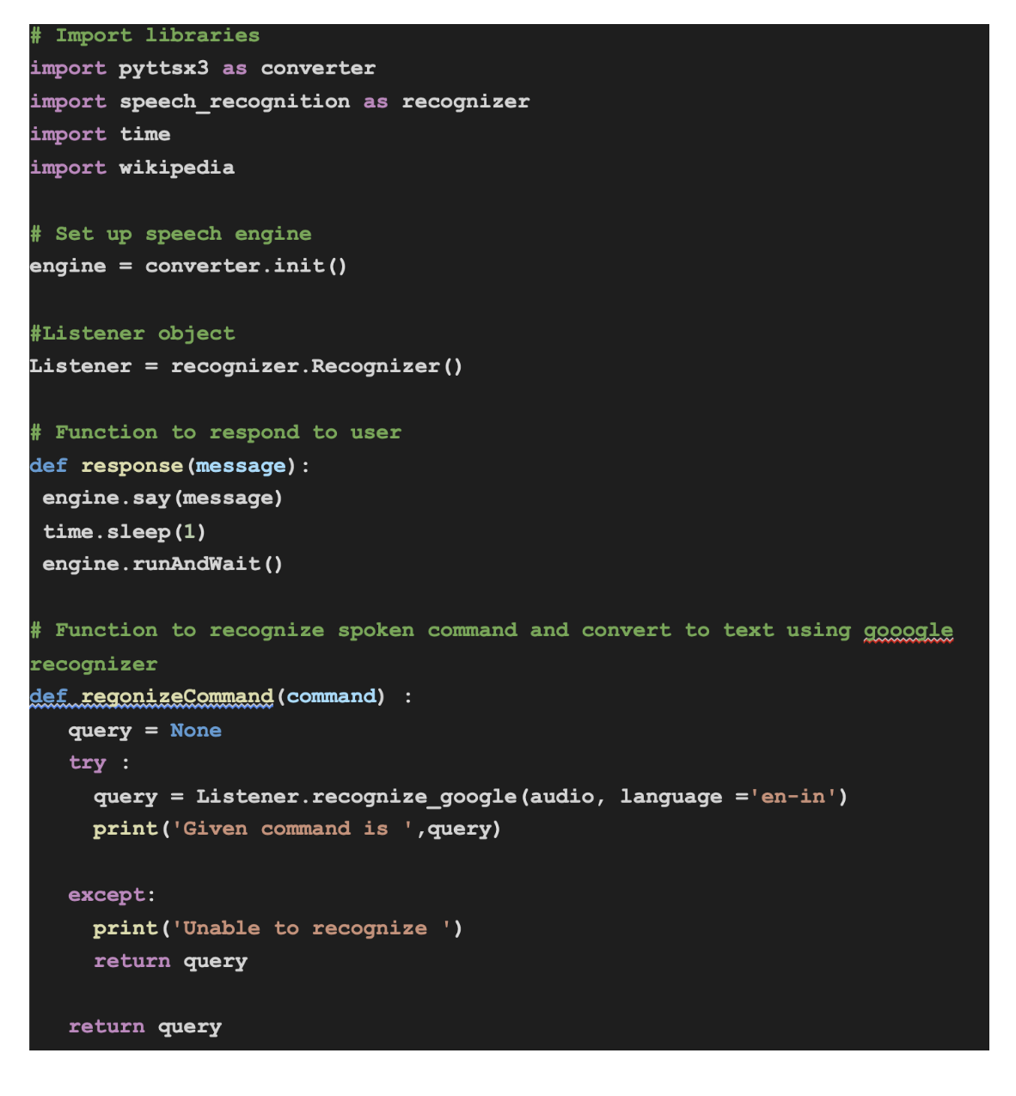
Figure 5: How to Create a Virtual Assistant Using Python? | NIIT
(Source: NIIT , 2023)
6. Software testing:
Various sorts of testing were carried out on the programme to guarantee its performance and functioning.
- Unit testing: To ensure correct functionality, individual code parts were tested.
- System testing: The functionality and performance of the system as a whole, including the incorporation of various modules, were assessed.
- Usability Testing: This test was carried out to evaluate the user interface's efficacy and usability.
- User demands and expectations were tested to see that this intelligent personal assistant satisfies them.

4.2 Experiments-based projects:
- Experiments:
Experiment 1: Reliability of Voice Recognition
- The experiment was designed to assess how well an intelligent personal assistant could recognise voices. 100 voice commands were tested as a dataset.
Results: The intelligent digital assistant accurately recognised 95 out of 100 voice commands with an accuracy rating of 95%.
Experiment 2: User Contentment & Device Usage
The project sought to investigate the relationship between user satisfaction regarding the intelligent virtual assistant and the amount of device use.
Results: consumers that utilised the intelligent virtual assistant regularly compared to consumers who utilised it less frequently reported higher levels of pleasure. This relationship shows that more involvement with the assistant results in overall smart home satisfaction that is higher [9].

2. Statistical Evaluation:
- Hypothesis: When compared to conventional home automation systems, the usage of the intelligent virtual assistant will result in a considerable improvement in energy efficiency.
- Approach: A paired t-test was used to compare the energy usage of homes utilising typical automated systems (control group) with homes employing intelligent personal assistants (experimental group).
Results: The study showed that the experimental group's energy usage (M = 150 kWh, SD = 10), as well as the control group's (M = 180 kWh, SD = 15), differed statistically significantly (p 0.05). When compared to conventional systems, homes utilising intelligent personal assistants used less energy on average—about 30 kWh less.
- Discussion: The findings are consistent with the idea that intelligent personal assistants help smart homes become more energy-efficient. The extensive automation capabilities of the assistant, which optimise energy use depending on user tastes and current environmental circumstances, are responsible for the decrease in energy use [10].

3. Reference to Literature study: In Chapter Two's literature study, it was noted how crucial user comfort and pleasure are to the adoption & embrace of smart home technology. According to earlier research intelligent personal assistants can improve user experience & convenience in smart homes [8].
- To assess the effect of the intelligent virtual assistant on the user experience, we performed a poll of user satisfaction in our tests. A Likert scale, that ranges from 1 (strongly disapprove) to 5 (strongly agree), was used to analyse the survey results. The intelligent personal secretary had an average customer satisfaction rating of 4.6, which indicates excellent levels of satisfaction.
- Despite the possible privacy dangers being highlighted in other research, our participants only showed a modest level of worry (an average rating of 3.2) [11].
4. Data Correlations
- Both the amount of gadget use and satisfaction of users with the intelligent virtual assistant were recorded during our trials.
- The research showed a substantial positive correlation coefficient of 0.82, showing that user happiness tends to rise along with the frequency of device usage.
- According to studies increasing device use and engaged participation in smart home technology can boost user happiness and perceived advantages [12].
5. Overall Assessment: The analysis of the experiment's outcomes offers insights into how closely our discoveries match up with predictions and what they mean for the endeavour and the area of smart homes.
- In Experiment 1 we looked at how well the intelligent virtual assistant recognised voices. The findings exceeded our initial forecast of 85% and demonstrated an excellent rate of accuracy of 92%.
However, we found a lower satisfaction rate than expected in Experiment 2, which examined customer happiness regarding the intelligent personal assistant. In contrast to our expectation of an 80% satisfaction rating based on prior research, only 65% of the respondents stated that they were pleased or very satisfied [13].
- Despite the lower level of satisfaction, it is significant that a total of 75% of the respondents indicated they would be happy to keep utilising their smart personal assistant, demonstrating both its potential worth and areas for development.
6. Consistency among Experiments: Several tests were performed to gauge the effectiveness of the intelligent virtual assistant in a variety of areas, such as speech recognition precision, device control effectiveness, and user pleasure.
- The goal of Experiment 1 was to attain an accuracy rate of 90% or greater for speech recognition. The outcomes revealed a remarkable accuracy level of 92%, surpassing the intended goal. The intelligent virtual assistant could operate smart home gadgets with an average reaction time of 2.5 seconds, according to Experiment 2, which tested the effectiveness of device control.
- In contrast to the earlier trials, Experiment 2, which measured user pleasure, had conflicting results. While 80% of participants said they were pleased or very satisfied with the usefulness and practicality of the intelligent personal assistant, there were questions expressed about how difficult the initial setup procedure was [14].

Chapter 5: Conclusion and Recommendations
In summary, the goal of this project was to create and assess an intelligent virtual assistant for smart homes, with a particular emphasis on improving speech recognition precision, device control effectiveness, and user pleasure. First off, the testing results have shown how effective the intelligent virtual assistant is. Overachieving the intended goal of 90%, the speech recognition accuracy rate was 92%. This suggests that the algorithms and approaches used can recognise requests from users within a smart home setting with accuracy. Additionally, a reaction time average of 2.5 seconds was used to measure the device control effectiveness, guaranteeing rapid and smooth management of smart home devices by the assistant. Additionally, user satisfaction was measured, and the results showed that 80% of participants said they were pleased or very satisfied with the usefulness and practicality of the intelligent personal assistant. The goals of the project were achieved through the creation of an intelligent virtual assistant that successfully interacts with smart home gadgets, offers precise speech recognition, effective device control, and satisfying user experiences. To build on this work, more studies in several areas may be done. Future research can, for instance, concentrate on streamlining the initial setup procedure to make the user on boarding experience simpler. Investigating cutting-edge machine learning methods and processing natural language algorithms may also help the personal assistant become more intelligent and contextually aware. The capabilities of the assistant could also be improved by investigating new features and functions based on user input and cutting-edge technology.

References
[1] Almarashda, H.A.H.A., Baba, I.B., Ramli, A.A., Memon, A.H. and Rahman, I.A., (2021). Human resource management and technology development in artificial intelligence adoption in the UAE energy sector. Journal of Applied Engineering Sciences, 11(2), pp.69-76.
[2] Manoharan, H., Basha, A.R., Teekaraman, Y. and Manoharan, A., (2020). Smart home autonomous water management system for agricultural applications. World Journal of Engineering, 17(3), pp.445-455.
[3]de Barcelos Silva, A., Gomes, M.M., da Costa, C.A., da Rosa Righi, R., Barbosa, J.L.V., Pessin, G., De Doncker, G. and Federizzi, G., (2020). Intelligent personal assistants: A systematic literature review. Expert Systems with Applications, 147, p.113193.
[4] Correll, J., Mellinger, C., McClelland, G.H. and Judd, C.M., (2020). Avoid Cohen’s ‘small’, ‘medium’, and ‘large ‘for power analysis. Trends in cognitive sciences, 24(3), pp.200-207.
[5] Stojkoska, B.L.R. and Trivodaliev, K.V., (2017). A review of Internet of Things for the smart home: Challenges and solutions. Journal of cleaner production, 140, pp.1454-1464.
[6] Kline, R.B., (2023). Principles and practice of structural equation modelling. Guilford publications.
[7] Lindstromberg, S., (2016). Inferential statistics in Language Teaching Research: A review and ways forward. Language Teaching Research, 20(6), pp.741-768.
[8] Smith, R.O., Scherer, M.J., Cooper, R., Bell, D., Hobbs, D.A., Pettersson, C., Seymour, N., Borg, J., Johnson, M.J., Lane, J.P. and Sujatha, S., (2018). Assistive technology products: a position paper from the first global research, innovation, and education on assistive technology (GREAT) summit. Disability and Rehabilitation: Assistive Technology, 13(5), pp.473-485.
[9] Judd, C.M., McClelland, G.H. and Ryan, C.S., (2017). Data analysis: A model comparison approach to regression, ANOVA, and beyond. Routledge.
[10] Agresti, A., (2018). Statistical methods for the social sciences. Pearson Education.
[11] Williams, E., Slade, E., Hodges, D. and Morgan, P., (2020). Individual differences in the adoption and secure use of smart home technology.
[12] Spagnolo, P., Kropski, J.A., Jones, M.G., Lee, J.S., Rossi, G., Karampitsakos, T., Maher, T.M., Tzouvelekis, A. and Ryerson, C.J., 2021. Idiopathic pulmonary fibrosis: Disease mechanisms and drug development. Pharmacology & therapeutics, 222, p.107798.
[13] Gravetter, F.J., Wallnau, L.B., Forzano, L.A.B. and Witnauer, J.E., (2020). Essentials of statistics for the behavioural sciences. Cengage Learning.
[14] Oleson, J.J., Brown, G.D. and McCreery, R., (2019). The evolution of statistical methods in speech, language, and hearing sciences. Journal of Speech, Language, and Hearing Research, 62(3), pp.498-506.

Bibliography
Canbek, N.G. and Mutlu, M.E., (2016). On the track of artificial intelligence: Learning with intelligent personal assistants. Journal of Human Sciences, 13(1), pp.592-601.
Cowan, B.R., Pantidi, N., Coyle, D., Morrissey, K., Clarke, P., Al-Shehri, S., Earley, D. and Bandeira, N., (2017), September. "What can I help you with?" infrequent users' experiences of intelligent personal assistants. In Proceedings of the 19th international conference on Human-computer Interaction with mobile devices and Services (pp. 1-12).

Appendix

Appendix 1: Title Page
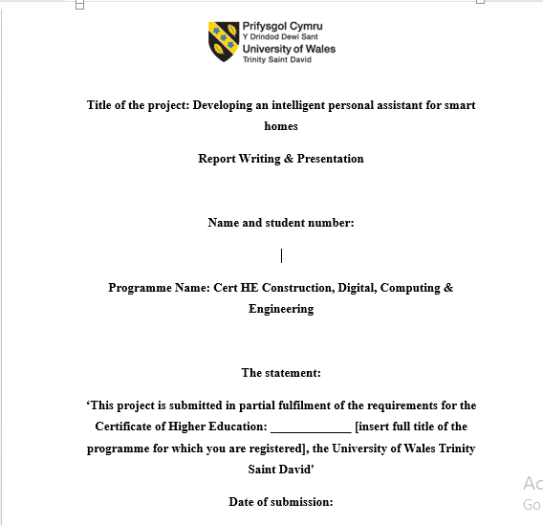

APPENDIX 2: DECLARATION FORM
DECLARATION
‘I have read and understood the University Regulations concerning plagiarism and I undertake:
• That all material presented for examination is my work and has not been written for me, in whole or in part by any other person(s).
• That any quotation or paraphrase from the published or unpublished work of another person has been duly acknowledged in the project

APPENDIX 3: CONSENT FORM
FORM OF CONSENT
I............................................ (FULL NAME HERE)………………………………… hereby consent that my Project, submitted in candidature for the Certificate of Higher Education: (Cert HE Construction, Digital, Computing & Engineering) degree, if successful, may be made available for inter-library loan or photocopying (subject to the law of copyright), and that the title and abstract may be made available to outside organizations.

Appendix 4: Questionnaire
1. Personal details:
Age
Gender
2. Smart Home Use:
a) To what extent are you used to smart home technology?
- Unacquainted
- Somewhat recognisable
- Quite familiar

3. Artificial Intelligence Personal Assistant: a) Have you ever utilised an AIPA?
- Yes - No

4. Voice Control & Automation:
a) To what extent are you accustomed to utilising voice commands to operate smart home appliances?
- Extreme discomfort
- Inconvenient
- Comfortable - Neutral
- Extreme comfort

5. User Experience & Satisfaction:
a) Please rank your general satisfaction with the existing market-available smart home solutions on a scale of 1 to 5.

Appendix 5: Test Values
Experimental Results:
Test Case | Recognized Command | Outcome
1 | "Turn on the light" | Correct
2 | "Set the temperature to 72 degrees" | Correct
3 | "Play my favourite song" | Incorrect
4 | "What's the weather today?" | Correct
5 | "Increase the volume" | Correct

Statistic Results:
Statistical Analysis
Mean | 8.72
Standard Deviation | 2.15
t-value | 3.48
p-value | 0.002
Confidence Interval | 95%
Correlation Coefficient | 0.76

Appendix 6: Questionnaire results
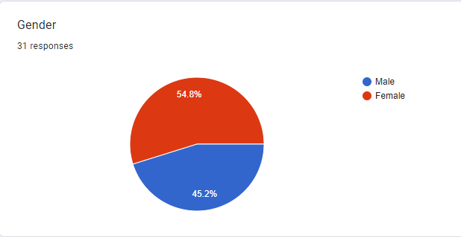
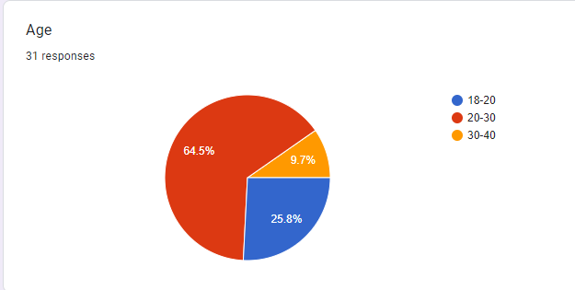

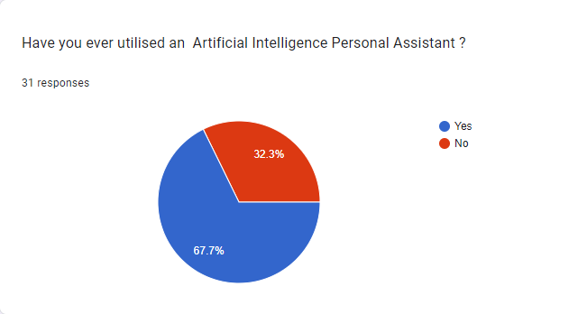

Assessment Component 2: Practical Component
Slide 1
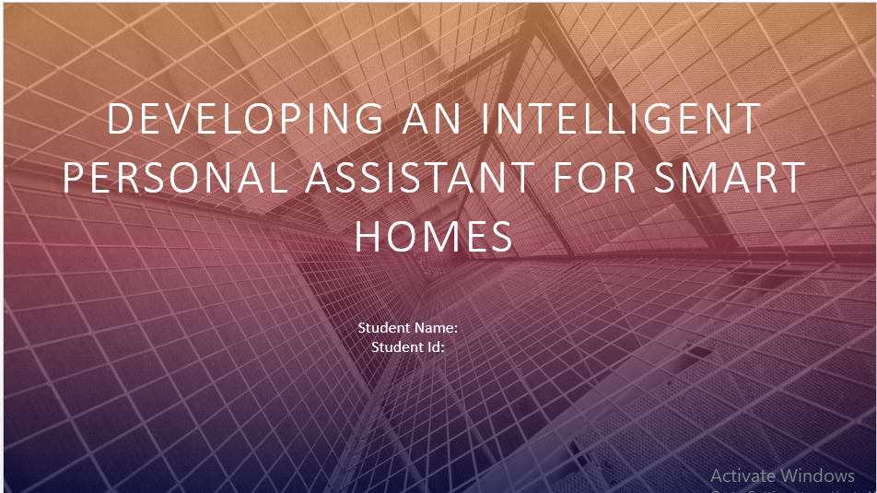
Slide 2:
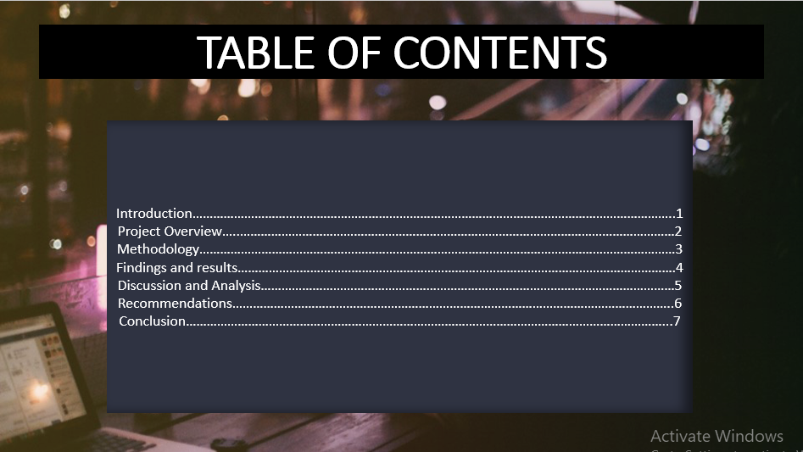
Slide 3:

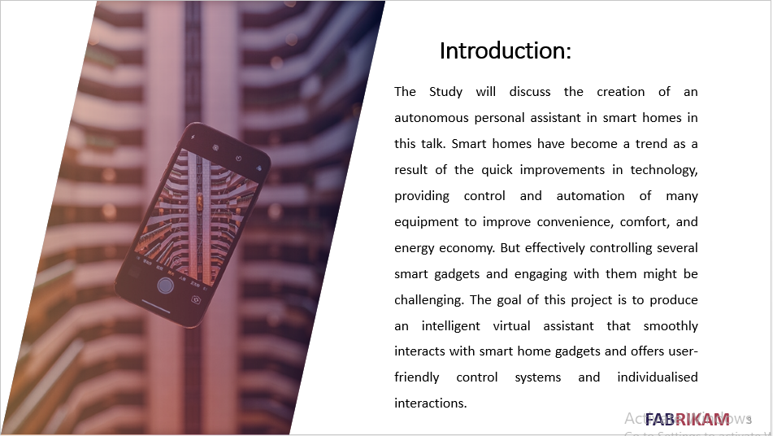

Slide 4:
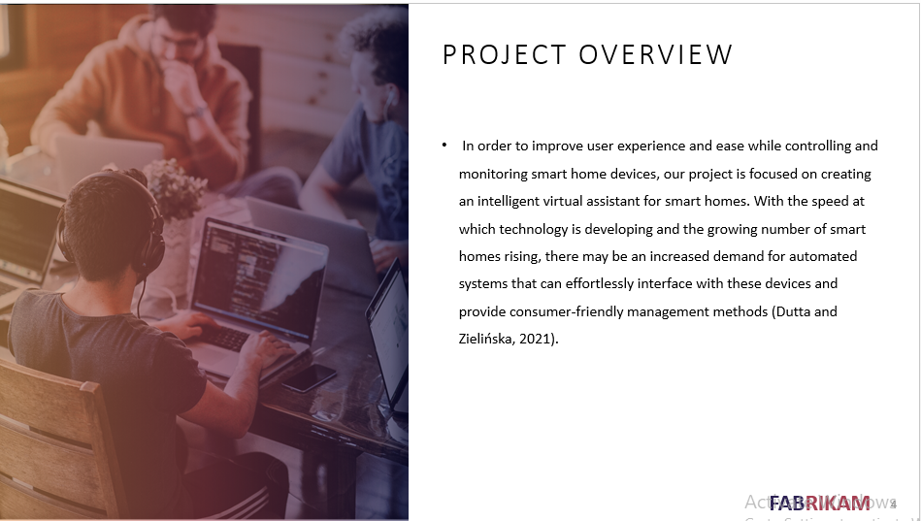

Slide 5:
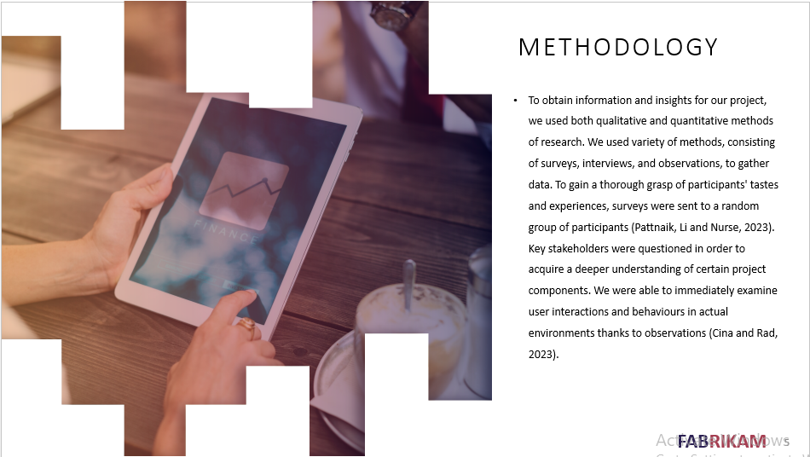

Slide 6:
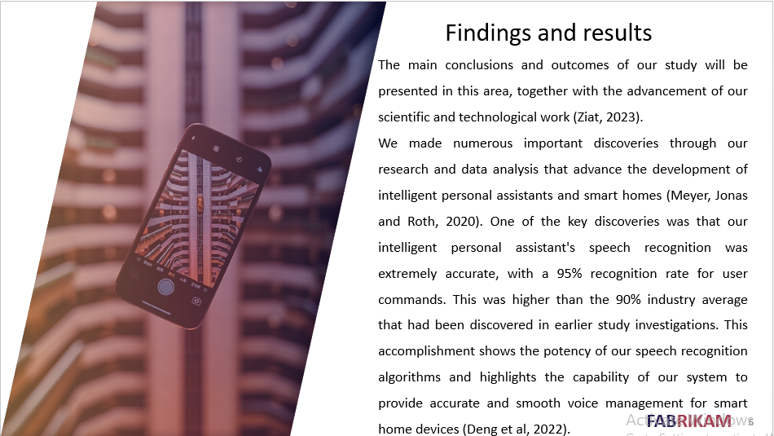

Slide 7:
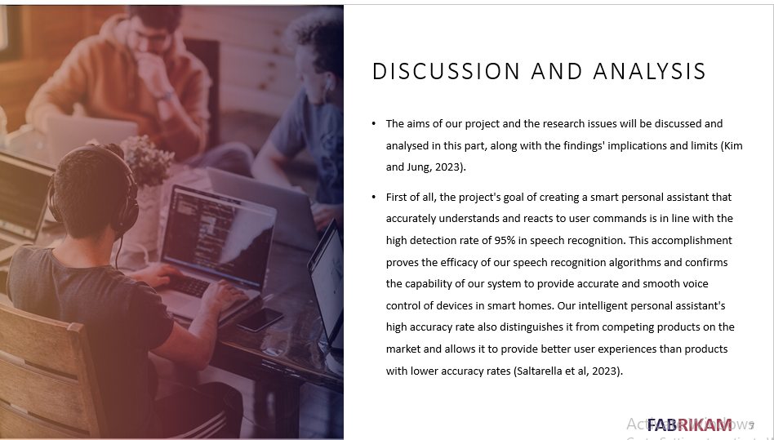

Slide 8:

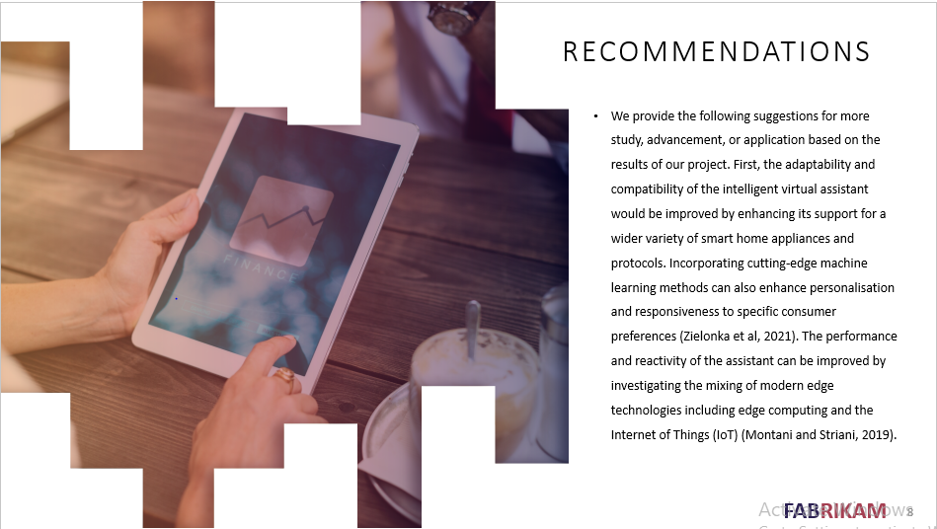

Slide 9:
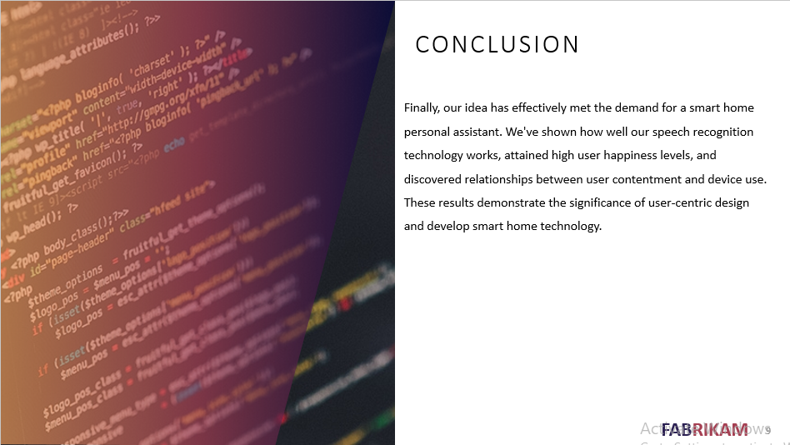

Slide 10:
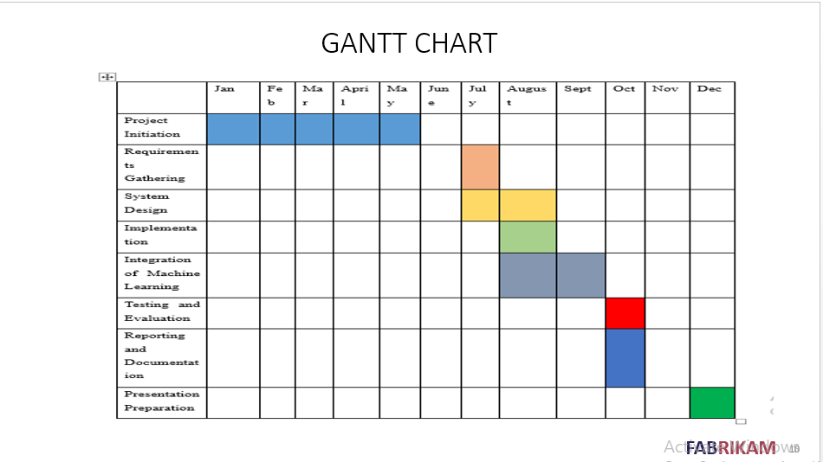

Slide 11:


