Student Name: Efrem Tekle
Student ID Number: [0952519]
Programme: BA (Hons) Business Management
Module: Learning in the Digital Era
Module Code: BMBM4008
Lecturer: Ffion Cumberpatch
Assignment Title: Video and Supporting Materials

Please find my submission for the Reflective VLOG assessment.
I am currently experiencing technical issues with the video file format and access
Recording-20260320_183154.webm

Reflective VLOG Supporting Notes: Learning in the Digital Era
1. Academic Skills
- When I started this module, I just Googled everything and picked the first thing I saw
- I never thought about whether a source was actually trustworthy
- Now I use the CRAAP test to check if something is good to use (see Appendix 1)
- It looks at Currency, Relevance, Authority, Accuracy, and Purpose
- I used it on two articles for my e-portfolio
  - Khalfallah and Keller (2025)
- De Araujo, Dhaigude, Kamath, Pai, Nayak and Ganesh (2025)
- I realised that just because something is published doesn't mean it's reliable
- Now I check who wrote it and why
- My arguments feel stronger because I'm using better sources

2. Referencing
- Harvard referencing was a nightmare for me at first
- I kept messing up the punctuation and italics
- I didn't get why it had to be so exact
- To fix this, I made my own template showing how to reference different sources
- I used colours to help me remember the format
- I also asked my lecturer to check my first few attempts
- Now I get it – referencing shows where my ideas come from
- It stops me from copying someone else's work
- I spend way less time fixing mistakes now
3. Four A's Framework
- I learned about the Four A's
  - Analyse, Agree, Argue, Arrive
- I used it to structure my essay on influencer marketing
- It helped me organise my thoughts properly
- Instead of just describing things, I was actually analysing them
- My essay flowed better and made more sense

4. Digital Skills
- I had to record a VLOG using Microsoft Stream
- At first, talking to a camera felt really weird
- I had to figure out lighting and sound and where to put the camera
- After practising a few times, I got more comfortable
- I also got better at using the university library website
- I learned how to search with keywords and filters
- This saved me loads of time finding good sources

5. Using AI
- At the start, I used AI to get quick answers without thinking
- Now I use it differently
- I use it to brainstorm ideas when I'm stuck
- I use it to find keywords for searching
- Sometimes I use it to summarise long articles so I know if they're worth reading
- But I learned that AI isn't always right
- I have to check everything myself
- My work still needs to be my own

6. My Biggest Challenge
- Harvard referencing was definitely my biggest struggle
- I kept getting small details wrong
- I had to go back and fix everything after finishing my essays
- I solved this by making a reference template
- I practised a lot
- I also asked my lecturer for help
- It got easier over time
- Now I feel confident with it

7. What I'm Proud Of
- I'm most proud of my influencer marketing essay
- I used the CRAAP test to pick good sources
- I used the Four A's to structure my argument
- I finally got my referencing right
- It felt good to hand in something I worked hard on

8. My Future Goal
- I want to become more independent with my studies
- I want to use the skills I learned in all my future modules
  - finding good sources
  - referencing properly
  - using digital tools
- I also need to get better at time management
- I want to stop leaving things to the last minute
- I want to produce good work consistently

9. Final Thoughts
- This module changed how I learn
- I went from just using Google without thinking to actually knowing how to research properly
- I've picked up skills that will help me through the rest of my degree
- These skills will probably help in my career too

References
CARS Checklist (CRAAP Test) (2010) Evaluating information: Applying the CRAAP test. California State University, Chico. Available at: https://library.csuchico.edu/help/source-or-information-evaluation (Accessed: 20 March 2026).
De Araujo, S.V.I., Dhaigude, A.S., Kamath, G.B., Pai, R.R., Nayak, S. and Ganesh, S. (2025) ‘Influencer credibility and consumer behaviour: the mediating role of self-brand congruity and moderating role of involvement’, Cogent Business & Management, 12(1), pp. 1–18.
Khalfallah, D. and Keller, V. (2025) ‘Authenticity, ethics, and transparency in virtual influencer marketing: a cross-cultural analysis of consumer trust and engagement: a systematic literature review’, Acta Psychological, 260, p. 105573.

Appendix 1
Appendix CRAAP Test Evaluation
Criteria and What I found
Source 1: De Araujo et al. (2025)
Currency- Published in 2025. Really recent, which matters because influencer marketing changes so fast.
Relevance- Talks about influencer credibility and how it affects consumers. This was exactly what my essay was about.
Authority- Written by a few university researchers. Published in Cogent Business & Management, which is a peer-reviewed journal.
Accuracy- Uses actual research and theories like self-brand congruity. Seems reliable and well put together
Purpose- Just trying to inform and analyse influencer marketing. Not trying to sell anything.

Source 2: Khalfallah and Keller (2025)
Currency- Published in 2025. Very up to date, which is important for digital marketing topics.
Relevance- Looks at authenticity, transparency, and trust in influencer marketing. These were key points in my essay.
Authority- Published in Acta Psychologica, which is a well-known academic journal. It's also a systematic literature review, so it brings together lots of research.
Accuracy- Uses evidence from multiple studies. The findings seem well supported.

Appendix 2
Appendix 2 – Presentation Slides (Task 3)

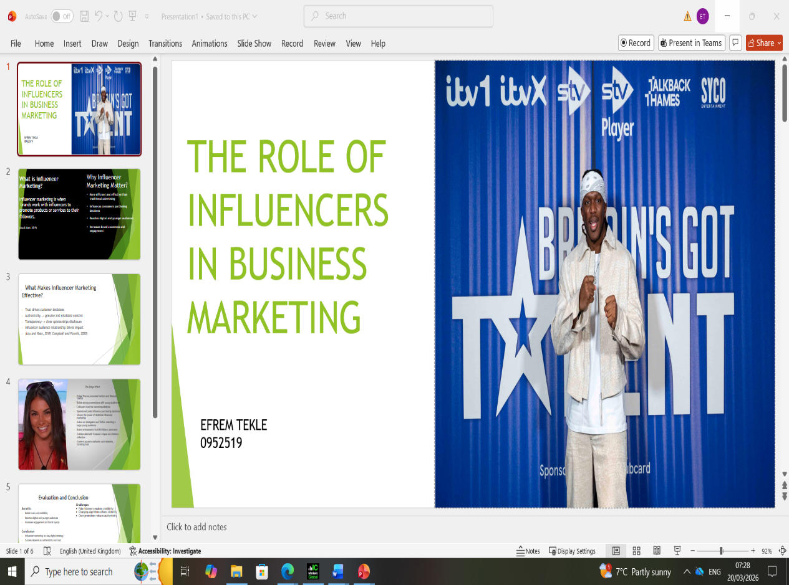

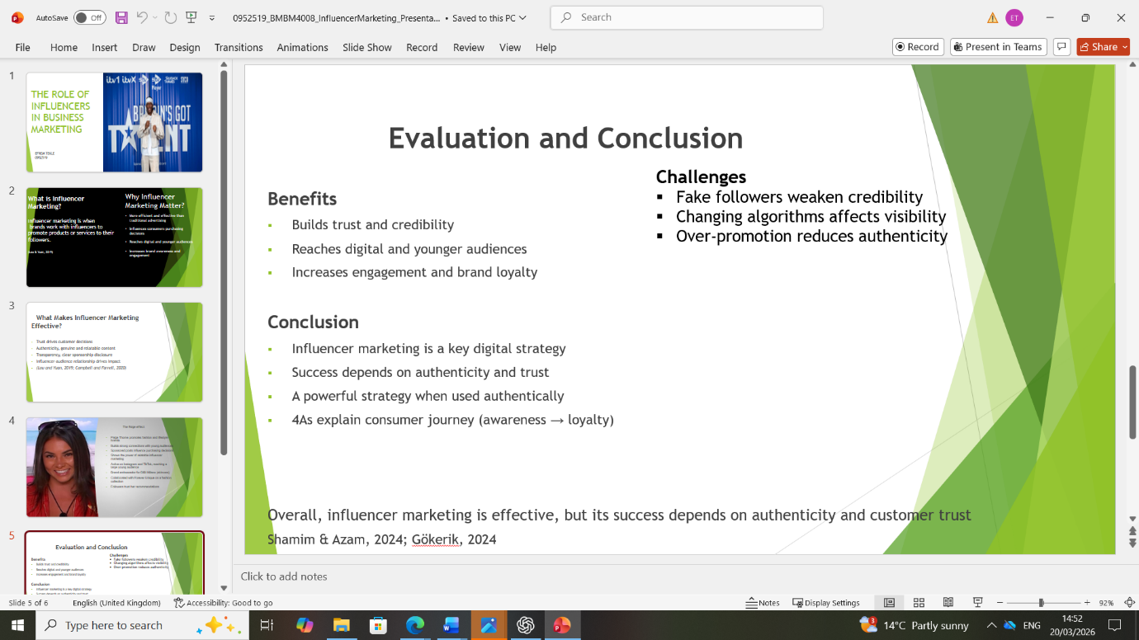
Appendix 3
Appendix 3 – Essay Referencing Evidence


