
Skills for the Workplace
Module Assignment Submission
Student Name: | Mandy Jones
Student Number: | 1911550
Module No: | BMSK4001
Module Title: | Academic and Employability Skills

Statement of Confirmation of Authenticity
By the act of making this submission, the student declares that this is the work of the student named above. The work has not, in whole or in part, been knowingly presented elsewhere for assessment, or where assessment has been built on a previous assessment, this has been identified. Where materials have been used from other sources it has been properly acknowledged. If this statement is untrue, the student acknowledges that an assessment offence has been committed.
Attention is drawn to the plagiarism and unfair practice policies of both the University and of ILM.

Table of Contents
Introduction 3
Part 1 Employability 3
1.0 Explore ‘Leadership Employability Skills’ in general 3
1.2 Evaluate own Leadership Employability skills 9
1.2.1 Current Employability skills 10
Gap Analysis to identify ‘gaps’ in knowledge/skills 10
1.2.2 Action Plan for Improvement 11
Part 2: Academic Skills 12
2.0 Reflection on Academic Skills required for University Level Study 12
2.1 Evaluate own Academic Skills 13
2.1.1 Current Academic Skills 13
Gap Analysis to identify ‘gaps’ in knowledge/skills 13
2.1.2 Action Plan for Improvement 14
Conclusion 14
References 15
Appendix 16

Introduction

I have been gainfully employed for nearly 40 years but felt that I needed to push myself further as I am stagnating and I enrolled for this course ‘Skills in the Workplace’ as I felt that it was such a good fit for me. I have never really thought about my Academic and Employability Skills and hopefully, within this Module I will examine and show what my skills sets are and how I can further develop them and also what new things I need to learn and reflect on how best to move forward.

Part 1 Employability

Rebecca Blaxell and Catherine Moore (2012) state that: “In a competitive, culturally diverse and increasingly internationalised workplace students can no longer assume that possession of a tertiary degree will naturally lead to employment.” Many employers are now seeking graduates with ‘employability’ skills and attributes as well as expertise within their chosen field.

1.0 Explore ‘Leadership Employability Skills’ in general

Someone who possesses Leadership Skills has the ability to take control of a situation and to lead whilst empowering other employees into being an effective team and to be a good leader you need to be able to motivate, inspire and make the most of other people’s strengths and abilities, also being able to understand people is a good leadership ability.

Some people do not possess the quality to lead or be in charge on a large scale and employers need a balance of both Leaders and equally valuable members of the team within their organisation however, employers do value people who have the potential for leadership who offer to lead in smaller everyday situations.

Having Leadership Skills means that you can manage people and take the initiative effectively and be able to see and plan ahead whilst acquiring knowledge and have other members of the asking you questions or help as they look to you and value your input.

One website I visited SkillsYouNeed.com states that ‘there is, in fact, no one right way to lead in all circumstances, and one of the main characteristics of good leaders is their flexibility and ability to adapt to changing circumstances. Leadership skills are highly sought after by employers as they involve dealing with people in such a way as to motivate, enthuse and build respect.’

I list below the qualities the Leadership and Employability Skills which I think are important:

Self-Management
This expertise demonstrates a preparation to acknowledge duty to improve one’s own presentation and learning, just as the will to be proactive and search out circumstances.

The three main skills in this area are:
- The ability to plan and manage time
- The ability to work using your initiative and without supervision
- Having the determination to succeed.

Communication
Good communication is substantially more than simply being comprehended and permits you to prop a discussion up, present your discoveries in a scope of various ways and tailor your way to deal with the crowd.

There are three main areas:
- Written communication: Structuring your ideas/results in a clear and logical manner with correct spelling and grammar
- Verbal communication: Presenting information verbally and tailoring your presentation style to the audience. Active listening is also important as communication is a two-way process
- Non-verbal communication: Non-verbal messages allow people to reinforce points with gestures, facial expressions and body language
The main skills in this area are:
- The ability to present information clearly and appropriately
- The ability to tailor messages to audience and purpose
- The ability to actively listen to and question others
Interpersonal Skills
These are the skills we use every day to communicate and interact with other people, both individually and in groups. They include a wide range of skills, but particularly communication skills such as listening and effective speaking and they also include the ability to control and manage our emotions.

They help to put you in situations where you can practice your skills and afterwards reflect on the outcomes which in turn help to develop your interpersonal skills.

The main skills in this area are:
- Communication skills: verbal, non-verbal and listening skills
- Emotional Intelligence: being able to understand and control your own and others’ emotions
- Team-working: being able to work formally and informally with groups of people
- Negotiation, persuasion and influencing skills: working with others to find a mutually agreeable solution
- Conflict resolution and mediation: working with others to resolve interpersonal conflict and disagreements in a positive way
- Problem solving and decision making: working with others to identify, define and solve problems.

Teamwork
Working in a team involves co-operation and negotiation with others while working towards a common aim. Being flexible is useful in a team when deciding team roles, and respecting other opinions and ideas is of vital importance.

The main skills involved in teamwork are:
- The ability to cooperate with others on a shared task
- The ability to lead and motivate others
- The ability to work in an interdisciplinary team.

Problem Solving
Problem solving involves analysing facts and situations and coming up with the appropriate solutions and this applies to all walks of life and not just to mathematical equations.
The main skills in this area are:
- Firstly, identifying that a problem exists and defining it
- The capacity for applying theory to practice
- The ability to retrieve, analyse and evaluate information from different sources

Project Management
The ability to plan, organise and support a project through its various development stages is a useful skill and it draws together several other skills such as teamwork and communication skills and adapting the project due to budget constraints or as other unexpected situations occur and it also shows an aptitude for problem solving.
The main skills in this area are:
- Having to coordinate work, from the planning stages to the final result and beyond
- Having to altering the project to adapt to a change in circumstances
- Having Good communication skills to keep relevant parties up-to-date with progress

Creativity and Innovation
Being creative and innovative is often linked to being entrepreneurial however, it is much more than just spotting opportunities and taking risks, it is also about considering new ways of doing things and using all of the information available to you to generate good ideas.

The main skills in this area are:
- The ability to generate ideas and think laterally
- The ability to identify and take opportunities
- The capacity to observe and evaluate trends and create appropriate opportunities

Commercial awareness
This skill shows a basic understanding of the key drivers behind a successful business or organisation and includes an awareness of the importance of customer satisfaction and competing with rival companies.

The main skills in this area are:
- The ability to demonstrate an insight into how organisations operate
- The ability to recognise external context and pressures on an organisation
- The capacity to understand the practical implications of turning an idea into a commercial reality

Social, Cultural and Global Awareness
An understanding that, in a global market, business practice and communication are no longer constrained by physical borders and the ability to relate with people from a range of different backgrounds is important in the commercial world, but also on a personal level with neighbours or team members.

The main skills in this area are:
- The ability to work in an international context
- The appreciation of diversity and ethical issues
- The understanding of cultures and customs in other countries

Application of Numeracy
Being able to manage simple mathematical calculations and the ability to budget are not only key requirements for many employers, they are valuable life skills.

The main skills in this area are:
- The ability to carry out arithmetic operations and understand data
- The ability to create, read and interpret graphs/tables
- The ability to manage a budget.

Application of IT
Basic IT skills such as word processing, spreadsheets and file management are key in most work environments and knowledge of website design or programming languages are also desirable in some sectors.

The main skills in this area are:
- The confidence in the use of information technologies
- The ability to identify the appropriate IT package or tool for a given task
- Word-processing and database skills
- The ability to use the internet and email effectively.

Resilience

Being resilient means having a positive approach, being able to deal with setbacks and bouncing back if things go wrong and includes being flexible and willing to rethink and adjust plans accordingly to ensure success.

The main skills involved in being resilient are:
- The ability to overcome potential setbacks
- A willingness to seek out challenge
- The ability to manage risks

Employer Engagement
Setting up, developing and maintaining links with employers and showing a willingness to look outside the immediate, academic context, having a profile on LinkedIn this will all help you to stand out from the crowd when it comes to looking for a new role.

The main skills involved in engaging with employers are:
- A willingness to talk to employers e.g. at presentations, skills sessions on campus
- Having to seek out opportunities to try different roles e.g. through work experience, part-time jobs or projects within Careers and Placements
- Ability to develop and maintain links with employers

Planning / Time Management
This skill is about being able to think ahead and understand what is required to achieve a specific goal, such as completing an assignment on time or getting the job you want, planning requires good organisation and flexibility.

The main skills involved in planning are:
- Being able to estimate how long tasks will take to complete
- Developing timetables with clear milestones and deadlines
- Being able to monitor and adjust timescales as necessary

1.2 Evaluate own Leadership Employability skills

I will try to evaluate my own Leadership Employability skills and state that I am an excellent communicator, I have a Facebook Account, I have a LinkedIn Page, I am on Twitter, also WhatsApp, Instagram and Snapchat. I also have four email accounts; two Outlook accounts, one personal, one for work; one Hotmail account and a Gmail Account which I use mostly. I am also an active Reviewer on TripAdviser and an active member of Avaaz and do many online surveys.

I have done an online Leadership Survey which I attach herewith – Appendix – Item 1.

I just read an article on the Balance Careers website and feel that I am very motivated and I want to do really well and improve my employability skills, I have vision and confidence in my beliefs and I am not afraid of looking at alternatives and going in a different direction to what I originally thought or believed. I am accountable for my decisions and take responsibility for both losses and I do not hog the limelight. I am a passionate person and hope to inspire my team through example and enthusiasm. I know there is strength in diversity, and I treat everyone the same. Communication is a skill and most Leaders are excellent speakers but also know when to listen and have excellent strategic skills which allows them to recognise problems before they become emergencies and see opportunities before their competitors. Also Leaders empower and feel comfortable delegating to other team members as are valued and ultimately know the people they lead determine their success.

1.2.1 Current Employability skills

Employability by definition is the capability of gaining and maintaining employment, so as I have worked for the same local authority for nearly 40 years I think my employability skills are really good, but definitely need polishing up and hopefully I can pass this course and go on to do the Degree which will enable me to either achieve promotion or a better opportunity with another organisation.

I can type at 80 wpm
I can take Shorthand at 80 wpm
I maintain a Website
I also maintain an office Facebook page
I work exclusively on Office 365 and I am pretty competent on all of the programs although I would like to be a more proficient user of Excel
I have studied English to an advanced level
I also have a Statistics O Level
I currently Manage 8 members of staff
I write all of the Minutes of meetings
I collate figures of attendance to meetings which I publish on our website
I am a good listener and go out of my way to help people
I currently do administrative work for our local hospice and I manage the Llanelli and District Talking Newspaper for the Blind

Gap Analysis to identify ‘gaps’ in knowledge/skills

Objective | Current Position | Deficiency | Action
What do I want to do? | What can I already do? | What am I lacking? | How do I fix this?
I want to be a better Minute writer. | Take Minutes down efficiently | The ability to sift through and get to the important points | Attend a course on Minute Taking
I want to manage my time more effectively | Do things at my own pace | Assertion | Self-awareness and motivation
I want to be more assertive and be able to say ‘no’ to people | I do typing for many people – most have nothing to do with work | Assertiveness | Become more self-assertive and aware
I want to excel at Excel | I use it and work on it but I do not understand the program fully | Knowledge | Look at an Online presentation and investigate further

1.2.2 Action Plan for Improvement

Objectives | Tasks | Success Criteria | Time Frame | Resources
List your Goals | What do you need to do to achieve these goals? | How will you identify your success? | When do they need to be done by? | Who or what do you need to help you?
To have more time and no leave things until last minute | Look at my time management skills | By not being so stressed | A-S-A-P | I need to be more self aware
To pass this course | By October 2020 | If I pass | October 2020 | My course teacher and my own dedication
To be more assertive | Learn to say ‘No’ to people | Lower stress levels | 3 months | Self-motivation
To go on to do a Degree | Self confidence | Going to class – passing this course and carrying on with my education – which has sorely been lacking for some time | 3 years | Tutor, class mates and myself

Part 2: Academic Skills

I left School with 6 O Levels and 5 CSE’s, I went to Secretarial college where I gained Shorthand and Typing skills – Advance Level English – Business Studies ‘O’ Level and Commerce ‘O’ Level. I have done various computer courses over the years.

Communication Skills – Use of Digital Technology.
Information Gathering Skills.
Analysing and Evaluation Information
Using Havard Referencing.

2.0 Reflection on Academic Skills required for University Level Study

I have used Gibbs (1988) Model of Reflection Model to determine that I need to communicate and present information more effectively whilst developing the ability to be more analytical and be able to form opinionated arguments. Using digital technology as well as the Online Library to search more effectively.

I feel that due to work commitments and family commitments I am not dedicating enough time or effort to my learning and need to sort it out effectively as I really do want to do on to do a Degree.
I need to read over and evaluate all of the aspects we have already covered and read more literature on what I want to achieve and how I can achieve my goal.

In conclusion I really feel that I am progressing well and I want to continue with my education and show everyone my true potential which will hopefully boost my self-esteem.

I have a lot of time, now that we are practically on lockdown – and I am really looking forward to reading whatever articles I can to help me achieve my goals.

2.1 Evaluate own Academic Skills

I feel I already have the necessary formal communication skills and I can communicate effectively and present information adequately. I can also effectively use my digital skills to support my learning and search effectively online for any information I need.

I can gather information effectively for basic research, data handling and statistics.

2.1.1 Current Academic Skills

Gap Analysis to identify ‘gaps’ in knowledge/skills

Objective | Current Position | Deficiency | Action
What do I want to do? | What can I already do? | What am I lacking? | How do I fix this?
Academic Writing | My Writing and Spelling skills are pretty basic | Preciseness | Go on a course
Completing reports to a high standard | Basic knowledge | Analytical ideas | Speak to my tutor and ask her advice
Great organisational skills | Basic | Time-management | Self-motivation

2.1.2 Action Plan for Improvement

Objectives | Tasks | Success Criteria | Time Frame | Resources
List your Goals | What do you need to do to achieve these goals? | How will you identify your success? | When do they need to be done by? | Who or what do you need to help you?
Complete this course to the best of my ability | Attend class conscientiously | By my marks | October 2020 | Tutor, class mates, myself
Go on to do the Degree | Attend class and pass the course | By passing the course | October 2020 | Myself, Tutor, family, class mates
To be more self-aware and assertive | Have belief in myself | Feel calmer | ASAP | Me, myself and I
To become a Lecturer | Hard work | Results | In the next 5 years | All the help I can get

Conclusion

In conclusion I know exactly what Academic and Employability Skills I possess, and I know what ones I lack, and I am determined to study hard and achieve the necessary skills I need to pass this course to the best of my ability.

References

Blaxell, R. & Moore, C. (2012). Connecting academic and employability skills and attributes. In Developing student skills for the next decade. Proceedings of the 21st Annual Teaching Learning Forum, 2-3 February 2012. Perth: Murdoch University. http://otl.curtin.edu.au/tlf/tlf2012/refereed/blaxell.html

Bornstein, A. and Bornstein J. (2019) 22 Qualities That Make a Great Leader, [online] available at https://www.entrepreneur.com/slideshow/299443 - Accessed – 14/03/20

Downard, B. (2017) 101 Best Leadership Skills, Traits & Qualities – The Complete List [online] available at http://briandownard.com/leadership-skills-list/ - Accessed – 20/03/20

Doyle, A. (2018) Leadership Skills List and Examples. [online] available at: https://www.thebalancecareers.com/leadership-skills-list-2063757 - Accessed – 20/03/20

Doyle, A. (2019) Top 10 Leadership Skills Employers Look For. [online] available at: https://www.thebalancecareers.com/top-leadership-skills-2063782 – Accessed - 20/03/20

Gibbs, G. (1988) ‘Learning by doing: A guide to teaching and learning methods’. London: FEU

Mindtools.com How good are your leadership skills? [online] available at https://www.mindtools.com/pages/article/newLDR_50.html - Accessed – 20/03/20

Swales, C. (2017) Develop leadership skills in any job, [online] available at https://www.monster.com/career-advice/article/develop-leadership-skills-in-any-job - Accessed - 20/03/20

The Balance Career – Leadership Skills https://www.thebalancecareers.com/search?q=leadership+skills - Accessed 24/03/20

Appendix

Item 1
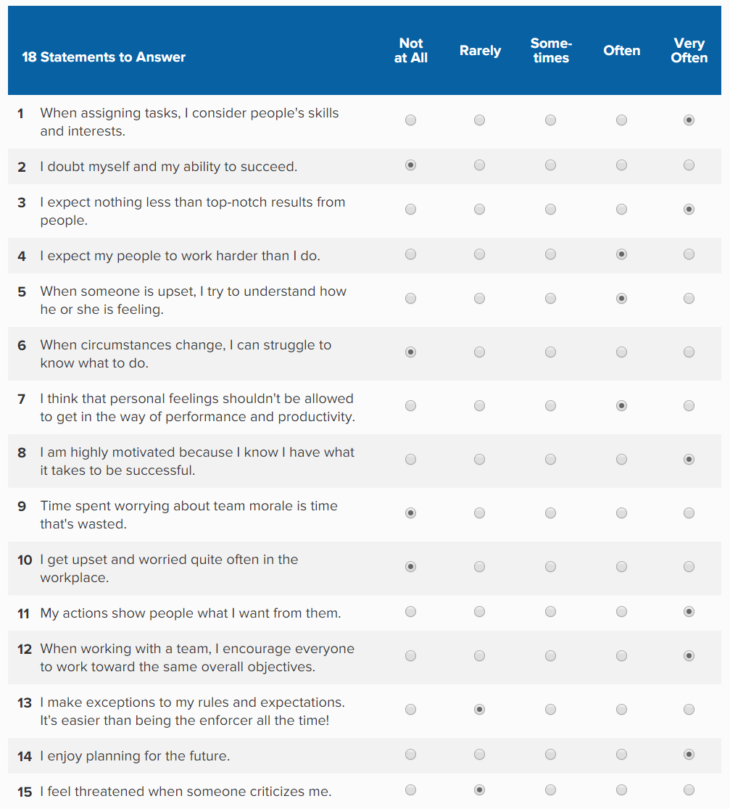
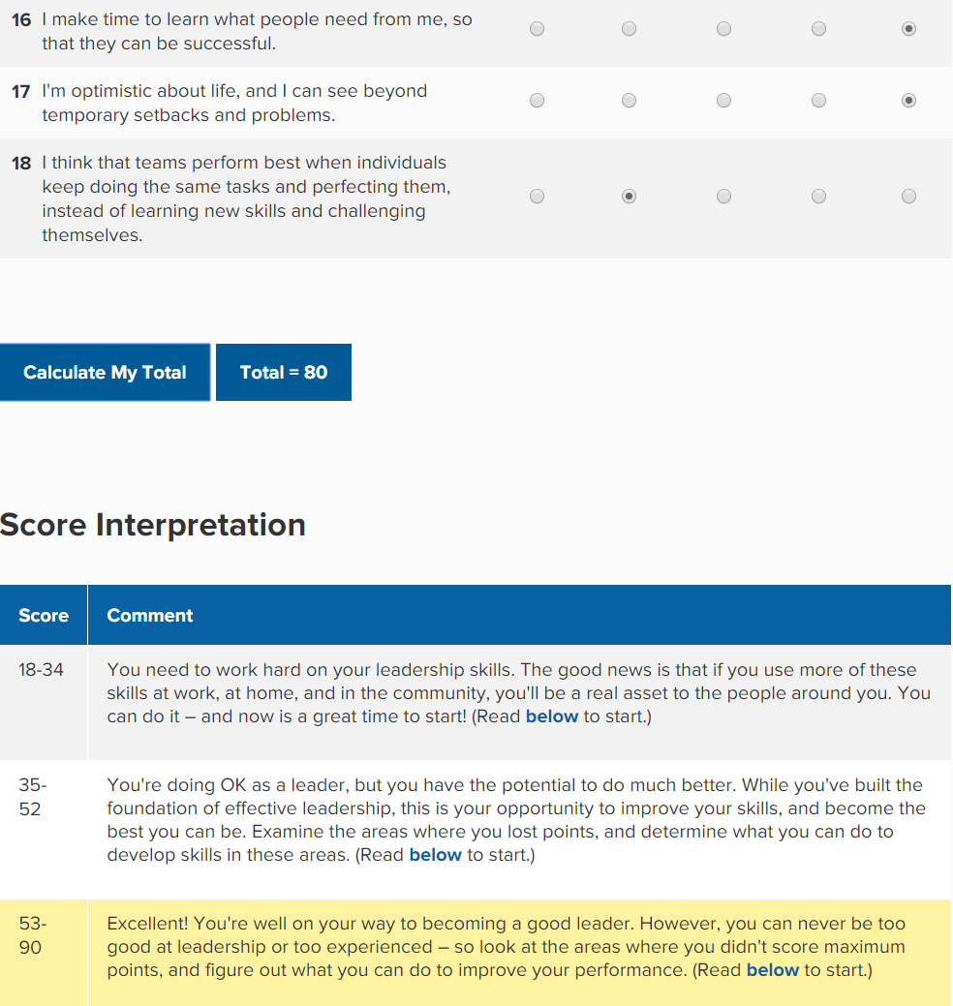

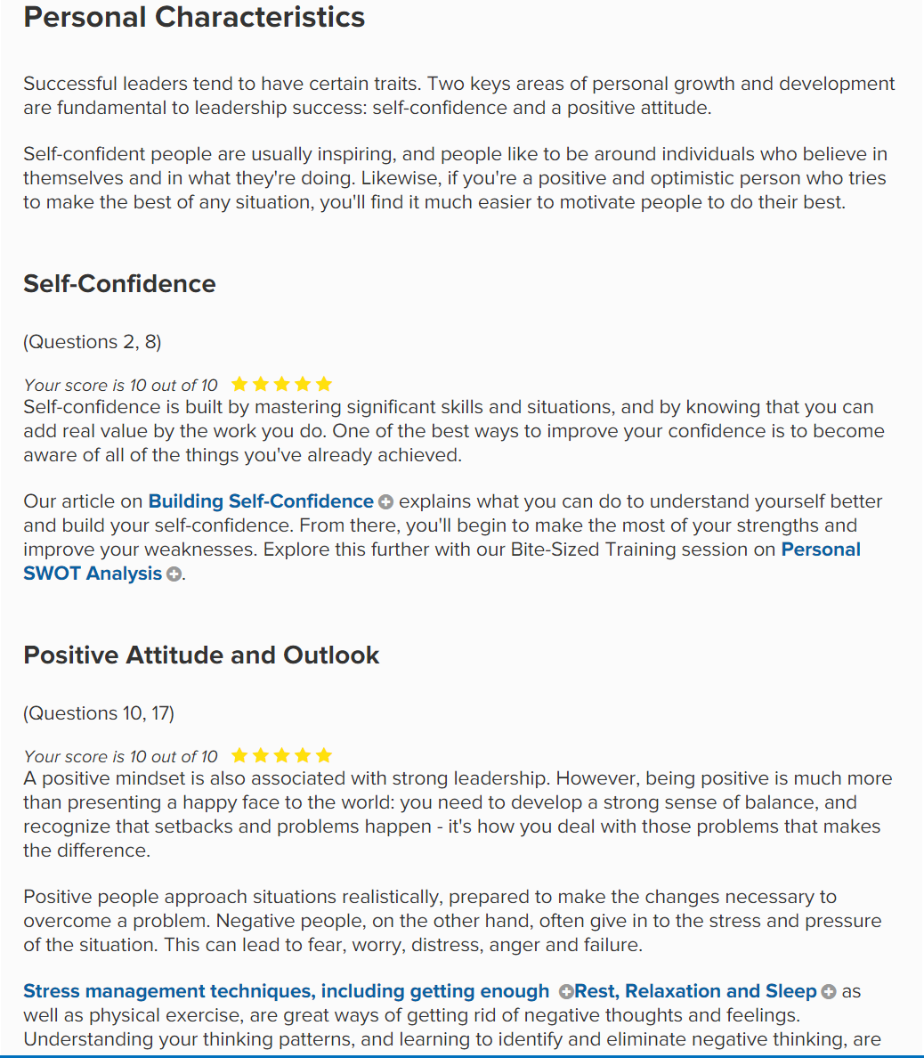
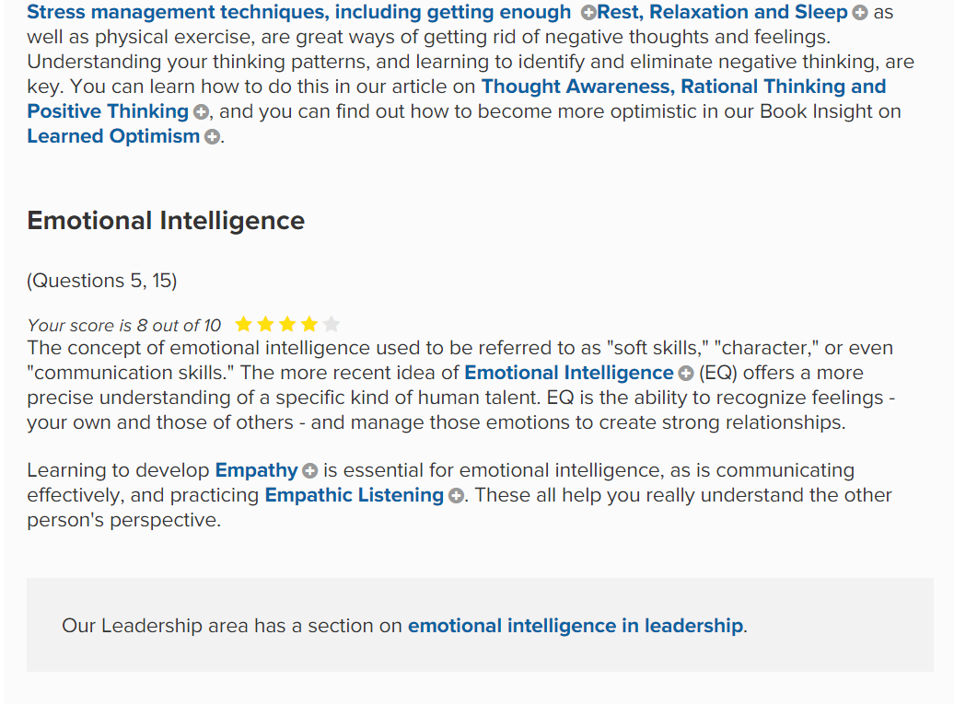

Item 2
Professor Graham Gibbs published his Reflective Cycle in his 1988 book "Learning by Doing." It's particularly useful for helping people learn from situations that they experience regularly, especially when these don't go well.
Gibbs' cycle is shown below:



