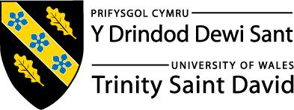
Skills for the Workplace
Module Assignment Submission
Student Name: | Becky Clark
Student Number: | 2112116
Module No: | BMSK4002
Module Title: | Effective Team Working and Communication  Part 2

Statement of Confirmation of Authenticity
By the act of making this submission, the student declares that this is the work of the student named above. The work has not, in whole or in part, been knowingly presented elsewhere for assessment, or where assessment has been built on a previous assessment, this has been identified. Where materials have been used from other sources it has been properly acknowledged. If this statement is untrue, the student acknowledges that an assessment offence has been committed.
Attention is drawn to the plagiarism and unfair practice policies of both the University and of ILM.

Table of Contents
Part 2 Communication 3
1.0 3
Communication Cycle 3
2.0 5
Assessing Own Communication Skills 5
Gap Analysis 6
PDP 6
References 7
Appendix A 7
Skills You Need Communication Quiz 7
Mind Tools Communication Quiz 9

Part 2 Communication

1.0

Communication Cycle
This module was first introduced by Claude Shannon and Warren weaver in 1949 in their book “The Mathematical Theory of Communication” and it shows the communication process as a transmission model- as seen in the diagram below.

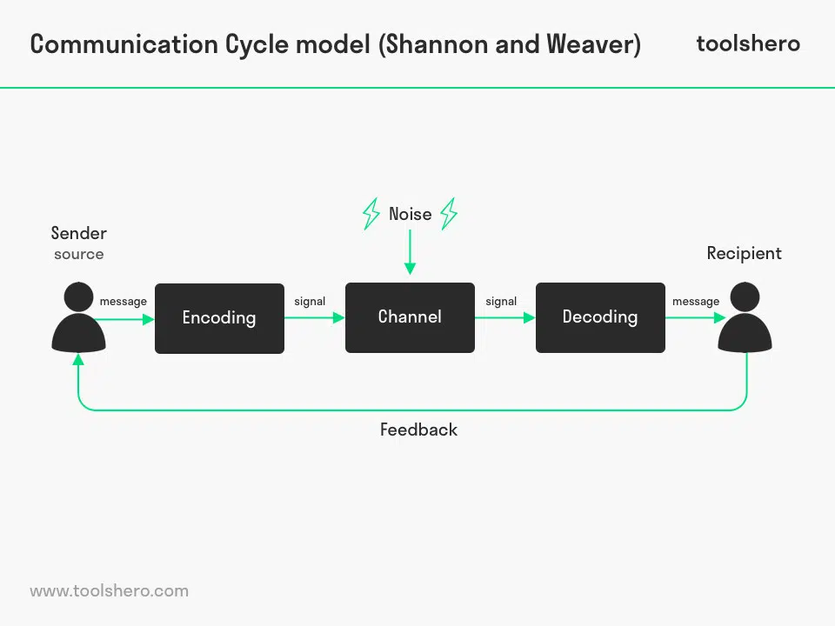
(How Good Are Your Communication Skills?: – Speaking, Listening, Writing, and Reading Effectively, 2022)
First there’s the sender. They have an expressive function. Through language and/or body language, they express something and send it to the recipient. It can be information, an emotion, song, dance, and so on.The thing they send is the message. This message is intended for the recipient(s). How the recipient handles it and interprets the message is called the appellative function.The sender then usually uses multiple media to get to the recipient. In addition to the voice for spoken words, the sender uses gestures, facial expression, posture and intonation as media. He can also use supporting media, such as a PowerPoint presentation, flip chart, music or a slide show. A message is communicated in different ways; spoken and written words, signs such as smoke, colours and symbols and body language (non-verbal communication). Nonverbal communication skills are cues that send various types of information or express certain attitudes and feelings without relying on written or spoken words
How the message is communicated and how it is understood are two different things. On the one hand we see coding and on the other decoding. A message has to be transmitted in such a way that it can be understood by both the sender and the recipient.
Coding translates what he has in his head to understandable language, with the intention that the recipient will understand what they mean. Therefore carefully chooses his words, tries to make clear what he means. That’s why it’s good that a sender focuses on a target group and tailors their message as much as possible to the group.
Decoding they interprets what he’s seeing and hearing and translates it into thoughts. Because everyone has their own and unique frame of reference, by background, education, how they were raised, experiences and so on, every individual will interpret a message differently.
The more clearly the sender has encoded the message, the more accurately the recipient can decode it, minimising the chance of misunderstandings. Misunderstanding occurs when there is no consistency to the message that is being delivered. The receiver should be able to easily understand the message and that happens when the message remains focused and does not go off-topic. (Effective Communication: How Not to Be Misunderstood, 2022)
What happens when it isn't received at all? Messages can travel in a variety of ways, as we already discussed, but the message may be immediately clear and understood, or murky and misleading, based on how well all of the components in the communication process have been considered and accommodated. In fact, the communication challenge is to make sure that the meaning that is intended by the sender is the same as the meaning of the receiver to give the message when it’s received.
Messages go both ways. In other words, the sender sends a message to the receiver, who then sends a message back to the sender. The messages that are sent back from the receiver to the sender are called feedback. There is always some kind of feedback. The receiver may be very passive and not initiate verbal feedback. The sender may not insist on it. In such cases, communication may or may not occur. Without meaningful feedback, you can’t even be sure that the message was received.(Communication: Sending and Receiving Messages, 2022)
There are a few communication modules you can look at and are all different and unique in they own ways another one is the original module it has been expanded and upon over the years beginning with the SMCR model which was introduced by David Berlo in 1960 and this model explored the different skills and attitudes used in a simple act of sending and receiving a message
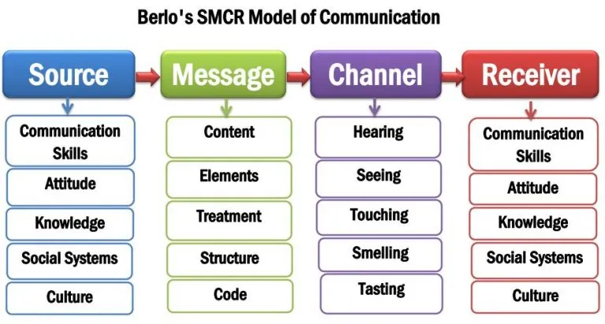
(2022)
The criticism for Berlo’s SMCR Model is that there lack of feedback, it does not mention the barriers of communication, there no room for noise, It is a rather complex model, it requires people on the same level for effective communication to happen.(BERLO’S SMCR MODEL OF COMMUNICATION, 2022)
The 5 key points for Effective Communication is
- Transparency
- Assertiveness
- Clarity
- Active Listening
- Precision
Active Listening is another communication skill that helps make information processing more transparent.But can be poorly understood and practised by most people. So what makes good active listening skills? pay attention to the other person, don't interrupt until the other person speaks, make good eye contact with the person who is speaking, ask questions especially if u dont understand what the other person is talking about, follow instructions and directions and visualise what is being said.
Their different types of listeners are Detached, Passive, Involved, Active. Detached like to avoid eye contact, they appear withdrawn and lack enthusiasm. Passives may or may not make eye contact with a person, they fakes attention, appears calm and laid back, and get little energy or effort. Involving these types of listeners like direct eye contact, gives the speaker attention. Active listeners give their full attention using direct eye contact and focus on what is said and participate fully.
How can we avoid ineffective communication barriers for the future? When people listen just to respond, they don't understand the point others are trying to make.Sometimes people can be too focussed on their own personal agenda during a discussion. You could spend too much time formulating your own response while others are speaking, without actually listening to them.
Communication through technology can cause misunderstandingsIn this day and age, many of us are using email, messaging and even social media to communicate. It can be so easy to misconstrue someone's tone or point if you can't see them or hear them in person.
Learn to listen As simple as it sounds, you'll be surprised how many people out there don't know how to listen well.Not understanding those who you are trying to communicate with will lead to misunderstandings.If you don't understand the point that someone is trying to make, don't be afraid to ask them to repeat it, or explain it further in a polite manner.

Lack of confidence or shyness can be the biggest barrier to effective communication.If you're not a naturally confident or assertive person, you may find yourself struggling to become a strong communicator.(5 Ways to Avoid Communication Barriers in any Environment, 2022)

2.0

Assessing Own Communication Skills
To assess my own communication skills I took a communication questionnaire and mind tools communication quiz which are both shown in Appendix A. My communication style score came back as an Assertive communicator.
Assertive Communication is a style in which individuals clearly state their opinions and feelings, and firmly advocate for their rights and needs without violating the rights of others. They value themselves, their time, and their emotional, spiritual, and physical needs and are strong supporters for themselves while being very respectful of the rights of others' opinions and feelings can firmly support their rights and needs without violating the rights of others. Assertive communicators,express feelings clearly, appropriately, and respectfully, listen well without interrupting, feel in control of self have good eye contact, speak in a calm and clear tone of voice have a relaxed body posture feel connected to others feel competent and in control not allow others to abuse or manipulate them stand up for their rights The impact of a pattern of assertive communication is that these individuals, feel connected to others and feel in control of their lives and are able to mature because they address issues and problems as they arise create a respectful environment for others to grow and mature .Assertiveness allows us to take care of ourselves, and is fundamental for good mental health and healthy relationships. (2022)
By taking this questionnaire and my results being Assertive Communicator really do describe me not just in the workplace but my personal life to as in my circle of friendship group im known as the “Mother hen” of the group everyone comes to me with they problems, i sit and listen and give my perspective on the situation and give my advice even though they might think it good or bad or even not what they want to hear, i won't sugarcoat they situation just for them to feel better especially if they in the wrong as the saying goes honesty is the best policy after all.
But Assertives do have their weaknesses too, some people don't know how to take me sometimes i can be very vocal and opinionated. I like to get my point across and can't keep my mouth shut in situations. I always like to have the last word (but I think that is most women). I always find it quite hard to say no in situations and always want to please everyone but assertives are misinterpreted as easy going and those sometimes who wish to take advantage of our easy going attitudes. we also find it difficult to master our behaviour, it's fine line between aggression which i can relate to as i do find myself flying off the handle my temper can go from 0 to 100 in 0.2 seconds for me this what i need to work on try keep calm and steady in a situation and just breath count to 10 then handle condition more calmly. At times ineffective assertive behaviour doest work in every circumstance. Some situations may call for different approaches that are not assertive by any means.
I also took a mind tool quiz to assess my Communication style which is also shown in Appendix A. My score was that I'm a capable communicator, but sometimes experience communication problems. I need Take the time to think about my approach to communication, but again like I have said previous people can take me the wrong way, and I need to focus on receiving messages effectively, as much as sending them. This will help to improve my ability to communicate.
After doing my presentation in front of my classmates which was way out of my comfort zone as I have a fear of public speaking and lack confidence in it too, but I did it with my classmates and tutors. I received feedback from them. having feedback is also a good source of communication have opinions from other how well i done and what i needed to improve on, some of the feedback back i received was that i good understanding what i was talking about, good body language i walked around give good eye contact, but what i needed to improve on was i need to slow down while speaking not rush through take my time at a slow and calm pace so this is what i will try work on for the future, practise more by either recording myself or speaking in front of family and friends to build my confidence that little bit more.
In the next few weeks im going to be starting a new job something i haven't done before and something that out of my comfort zone, i got myself Receptionist Job on the front desk of busy leisure centre where i'll be dealing with customers face to face and answering the phone on daily basis, not only do i have to have good customer service skills but i also need great communication skills to i think by taking this job can build my confidence and barriers and have successful career ahead of me, but without this course i don't think i would of had the confidence to even take this job because it giving me whole new learning curve and i learnt so much about the different types and styles of how to be great communicator, im looking forward to how this with better myself for the future.

Gap Analysis

Objective | Current Position | Deficiency | Action
What do I want to do? | What can I already do? | What am I lacking? | How do I fix this?
leadership and managing roll | I have good communication skills. I can work amongst a team or on my own. Good listening skills. | Confidence in public speaking need learn to slow down not rush what i'm saying.Some people don't know how to take me as i can come across very vocal and opinionated | Build my confidence in public speaking overcome my fear by practising videoing myself or speaking in front of small groups like family and friends. Try not to be so abrupt or vocal so others know how to me.

\PDP

Objectives | Tasks | Success Criteria | Time Frame | Resources
List your Goals | What do you need to do to achieve these goals? | How will you identify your success? | When do they need to be done by? | Who or what do you need to help you?
Gained confidence in public speaking and improved my communication skills. | By reconvening ongoing feedback from my peers | Building Long Term Relationships, Focus on the Key Variable, building confidence. | 6-12 months | Example surveys, feedback, training courses.
Leading and management job role | Leading and management qualification. | Having a leadership and manageable job role, learning others, having the confidence and the ability to do so. | 1-2 years | By making sure all my training courses are up to date, meet deadlines, feedback from tutors, work colleagues, friends family, passing my assignments,

References

Blenkinsop, P. (2010) The Communication Cycle. [online] Available at: http://manyana-education.blogspot.com/2010/10/communication-cycle.html Accessed: 15.05.19
Skills You Need (2019) Interpersonal Skills Self-Assessment. [online] Available at: https://www.skillsyouneed.com/ls/index.php/343479 Accessed: 15.05.19
Mindtools.com. 2022. How Good Are Your Communication Skills?: – Speaking, Listening, Writing, and Reading Effectively. [online] Available at: <https://www.mindtools.com/pages/article/newCS_99.htm> [Accessed 25 March 2022].
Uky.edu. 2022. [online] Available at: <https://www.uky.edu/hr/sites/www.uky.edu.hr/files/wellness/images/Conf14_FourCommStyles.pdf> [Accessed 25 March 2022].
toolshero. 2022. Communication Cycle model by Shannon and Weaver. [online] Available at: <https://www.toolshero.com/communication-skills/communication-cycle-shannon-weaver/> [Accessed
25 March 2022].
Newsmoor.com. 2022. [online] Available at: <https://newsmoor.com/smcr-model-of-communication-david-berlos-smcr-model-of-communication-example/> [Accessed 25 March 2022].
Lifehack. 2022. Effective Communication: How Not to Be Misunderstood. [online] Available at: <https://www.lifehack.org/588423/effective-communication-how-not-to-be-misunderstood#:~:text=Misunderstanding%20occurs%20when%20there%20is,sure%20you%20can%20help%20us.> [Accessed 25 March 2022]
Psych Central. 2022. Communication: Sending and Receiving Messages. [online] Available at: <https://psychcentral.com/blog/anger/2016/01/communication-sending-and-receiving-messages#1> [AccessCommunication Theory. 2022.
BERLO’S SMCR MODEL OF COMMUNICATION. [online] Available at: <https://www.communicationtheory.org/berlos-smcr-model-of-communication/> [Accessed 25 March 2022].ed 25 March 2022].
Zandax.com. 2022. 5 Ways to Avoid Communication Barriers in any Environment. [online] Available at: <https://www.zandax.com/blog/5-ways-to-avoid-communication-barriers-in-any-environment> [Accessed 25 March 2022].

Appendix A

Skills You Need Communication Quiz

Self-Assessment: Results

To assess your preferred communication style, transfer the scores you have given to each statement to the boxes below.
Then total each column downwards.
Look at the column where your score is the highest.
This is the communication style you use most of the time.

Q1  4 | Q3  4 | Q4  2 | Q2  4
Q5  4 | Q6  3 | Q7  3 | Q8  1
Q10  1 | Q11  3 | Q9  2 | Q12  3
Q14  4 | Q15  4 | Q16  2 | Q13  1
Q18  4 | Q17  2 | Q19  1 | Q20  1
Total  17 | Total  16 | Total  10 | Total  10
Assertive | Passive | Passive Aggressive | Aggressive

Mind Tools Communication Quiz

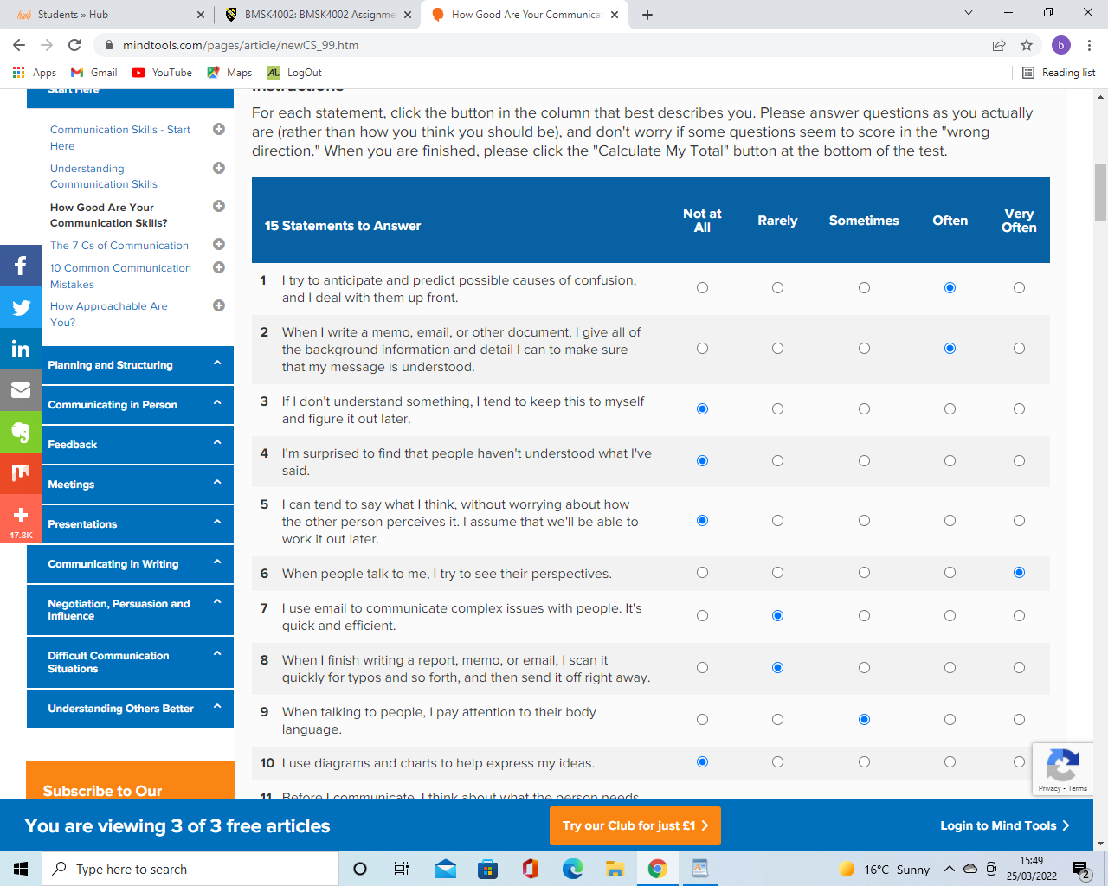
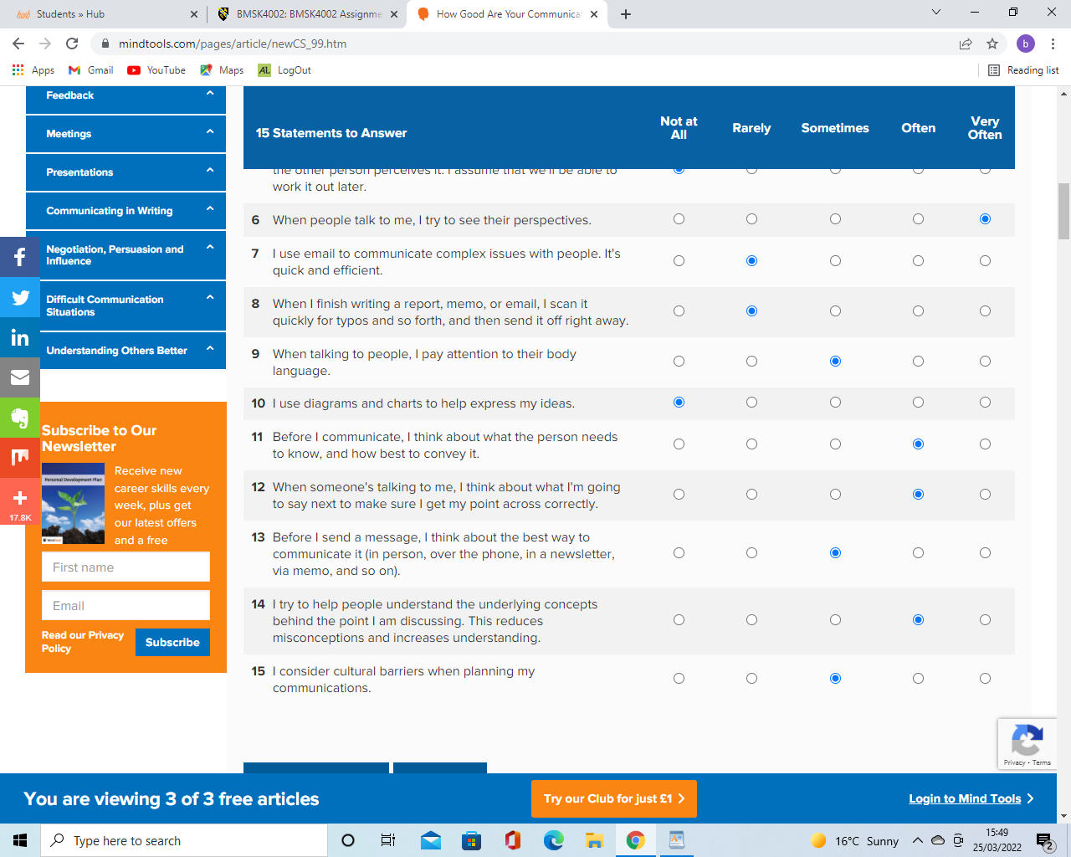
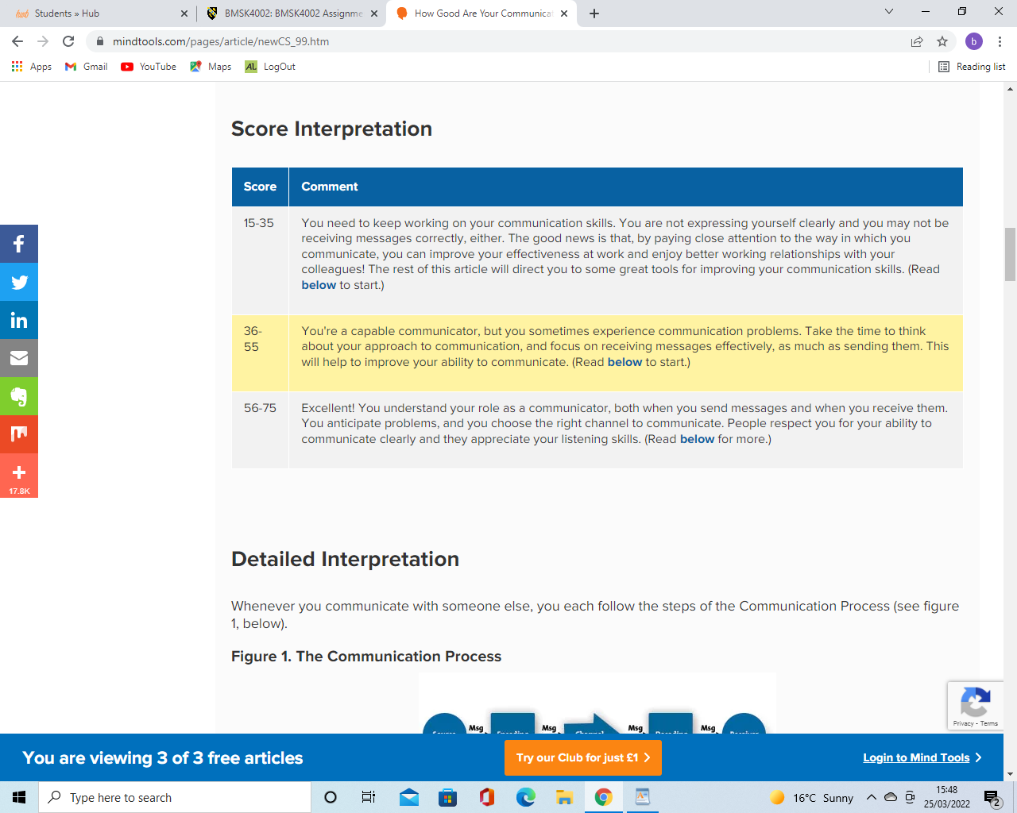
(How Good Are Your Communication Skills?: – Speaking, Listening, Writing, and Reading Effectively, 2022)

