

Subject name: Marketing Management
Student Name: Rimpalben Ajitsinh Yadav
Student id: 2132837
Assignment name: Marketing Management Assessment 1
Professor Name: Tushara Balendran

Table of Contents
Introduction 3
Background of the company 3
Innovative marketing strategies in Amazon for raising brand awareness 4
Brand identity 4
Brand meaning 5
Brand Response 6
Resonance 7
Management and evaluation of customer journeys across various communication channels 7
Impact of communication channels in ensuring current and future stakeholder’s expectations 10
Conclusion 15
Reference List 17
Appendix 21

Introduction
In different times it can be observed that most of the organisations emphasise on maximising customer satisfaction. but doing so often it can be observed that the organisations do not pay attention to one of the important issues which is the in journey of the customers. In the following report there will be a discussion on the ways an Organisation can create innovative marketing strategies to manage and evaluate the customer journey through a variety of communication channels (Liu et al., 2021). This is mainly for ensuring if the current as well as the future expectations of the stakeholders are met. The chosen organisation in this regard is Amazon

Background of the company
Amazon is a renowned multinational technology company of America which focuses on cloud computing, e-Commerce online advertising, Artificial Intelligence and digital streaming. Amazon is usually considered as the most influential cultural and economic force across the globe. It is also considered as one of the most valuable brands in the world. Company is founded by Jeff Bezos and it was established on July 5 1994. It was initially considered as an online marketplace specially for the books but during that time there has been an expansion and now it has multitude of various product categories. This strategy has been beneficial for the organisation. The mission statement of the company states that it wants to be one of the most customer centric companies (Masyhuri, 2022). One of the main objectives of Amazon is to provide the people with various things which they want to purchase online. Customer satisfaction is considered to be one of the main mottos of the company. Amazon provides retail online shopping services. The main objective of Amazon is to focus on customer obsession instead of focusing on the competitors. It thrives to achieve operational excellence and provide their customers with excellent services.

Innovative marketing strategies in Amazon for raising brand awareness
Here Amazon can use the following to strategy for building their brand awareness
Visitor Blog: Visitor publishing content to blogging permit you to construct brand mindfulness for your business and entrust with your main interest group by composing for the power source they trust. ...
Paid Promoting: A paid ad on a significant web index can assist you with acquiring openness for our image.

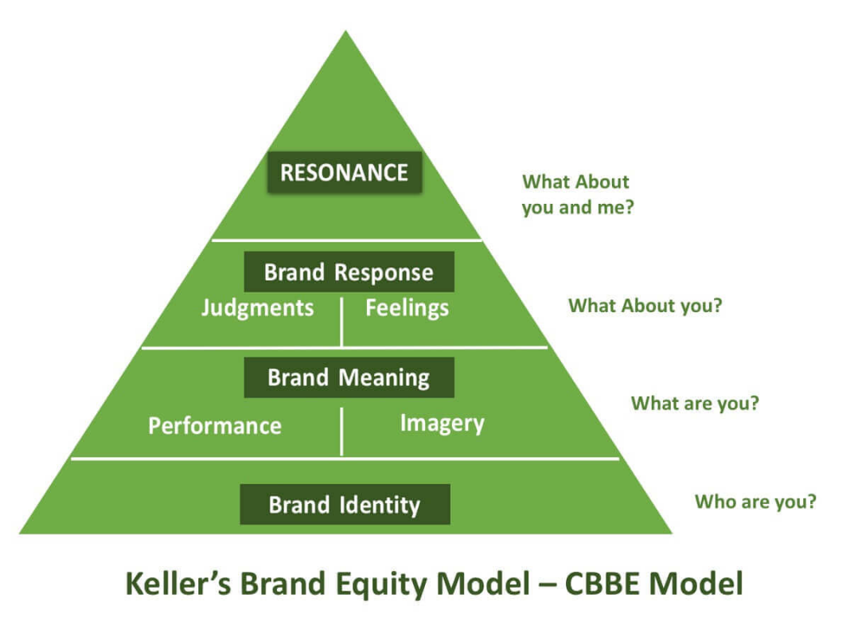
Figure 1: Keller’s Brand Equity Model
(Source: Lit, Kim and Sy, 2021)

Brand identity
Amazon follows which mainly is in two aspects this follows the depth of the end awareness and this follows the age of recognition and recall of the brand. Amazon always follows to manage strength and clarity in the category membership (Lit, Kim and Sy, 2021). the depth and awareness considered the purchase consideration from Amazon website which is amazon.com. This follows the consumption of the usage.com. The primary characteristics and supplementary features of the products from amazon.com can be categorised. This mainly and she was product durability, reliability and serviceability. with the Amazon products service effectiveness Embassy and efficiency can be recognised. These also follow the same style and designs and this is reputed and acceptable within the consumers. Amazon uses profiles on the basis of psychographic and demographic characteristics. the actual or aspirational profile of Amazon customers can be evaluated (Vollero, Sardanelli and Siano, 2021). Amazon uses a situation for partition antimaterial with the characters of location channel and context of usage. Amazon also values the personality, excitement and sophistication of the customer. The brand quality of Amazon focuses upon values and satisfaction level of the customers. The brand credibility of Amazon follows the expertise and trustworthiness and liability. They follow brand considerations which are relevant to the organisation. Amazon Follows several differentiation techniques from eBay and other retailers. Amazon behaves with their customers with warm excitement, fun and security which also needs social approval. This is the brand identity of Amazon.

Brand meaning
Performance
Maximising customer satisfaction, Amazon has maximised their customer satisfaction by focusing on the market research, customer care strategy, staff training and after sale services. The company has focused on building quality products and focusing upon the feedback of customers. They work on customer complaints for schedules to maximise the customer’s satisfaction. Amazon ensures the business to find out the needs and wants of the customer. They have followed techniques to tailor the needs at a greater level to achieve customer satisfaction (Warrier et al., 2021). The company follows staff training conditions within the organisation that make the business knowledgeable and the company delivered, high standard of customer care. The company followed several techniques for the after-sale services and they have followed customer care strategy. The customer complaints procedure in this company has been maintained successfully. Amazon has followed several programs to produce quality products. Amazon has developed programs to reduce low quality services and products. ensures the satisfaction of the customer. Customers are important for Amazon and if customers are not satisfied the business will go down. They have implemented several strategies to manage their customer services. By maintaining the strategy Amazon has made customer loyalty, improvement of reputation and employees’ satisfaction within the site.
Creating consistent brand experience for customers, for creating consistent brand experience Amazon boosted customer confidence and they later experienced memorable activities (Baboolal-Frank, 2021). They have made every interaction of the customers with the brand special. Amazon has developed the website consistently and they have evaluated the collaboration with social media channels. They have developed an Amazon Store and product pages to promote their products. Amazon has developed premium contents for their sailors and this belongs to the A + category. In this category the brain Tales the story about the product which helps the customer in making and managing their buying decisions. with the premium A + content Amazon has made various products eligible for the brand registered. Amazon has developed a Customised Store where they have used a Drag and drop editor tool. this becomes very popular among the customers. About 83% Shoppers use this technique and 32% properly have attributes on this.

Brand Response
Judgements
For their customer satisfaction Amazon mainly uses a cloud base system which is called Salesforce CRM management. This year management helps in managing customer relationships. The management with the software helps in tracking the business properly. This also analyses the customer data and the source of customer interaction and builds sales opportunities for Amazon. The CRM division of Amazon works on Amazon Web Services which allows the customers bringing engagement to the next table. This also helps in identifying the contact data of Amazon with one application. The sales and customer service team in Amazon feels that CRM is very important for Amazon. With the CRM techniques it is easy to talk with the customers in Amazon and getting the customer information and interaction in one Central place also can become possible. This also analyses the targets of Amazon consumers and this also helps in tracking the results properly (Junsawang, Chaiyasoonthorn and Chaveesuk, 2020). Some CRM features of Amazon are really helpful for the brand as this filter stack ships and returns every activity related to product. The CRM of Amazon manages the customer care operation from top to bottom of the organisation.
Feelings
Promoting the brand with customise ad and product bundling
Amazon creates several complementary products for their customers to increase and bundles they are a combination for purchasing together. They also sell items and they use recommendation techniques within the brand. ambassadors also use pair products smartly which keep bundles nice and simple. Amazon also follows several marketing techniques which combine the related items which are definitely related with a single item. and they also sell them separately (Shrestha and Nasoz, 2019). To promote their products Amazon offers the loyal customers free views and special introductory offers. Which makes the business stronger. Amazon also implemented several social media contests to attract more customers. Amazon has hosted several events to attract the customers more within the business. Amazon tracked the brand performance and gathered sales insights by organising referral programs.

Resonance
To increase customer satisfaction, Amazon built a bridge with them and the customers. They offer comparative pricing to the consumers which ensures product qualities. The shoppers of Amazon checked the product pricing before purchasing any item. Amazon used several collaborative filtering processes which they called Recommendation Technology. They had built a clear picture of profiles which had been purchased by them. Amazon also gathers data with the customers from their purchased profiles (Siby and George, 2022). The reprices of Amazon use artificial intelligence technology which helps them adjust and list the prices to a competitive level.

Management and evaluation of customer journeys across various communication channels
Customer Experience needs to be the foundation of any customer journey. Customer detention is considered as one of the vital aspects for any kind of business. It costs less to keep the existing ones rather than acquiring the new ones. It can be observed that one of the key factors which impacts customer loyalty is the consistency and the quality of communication across their various channels.
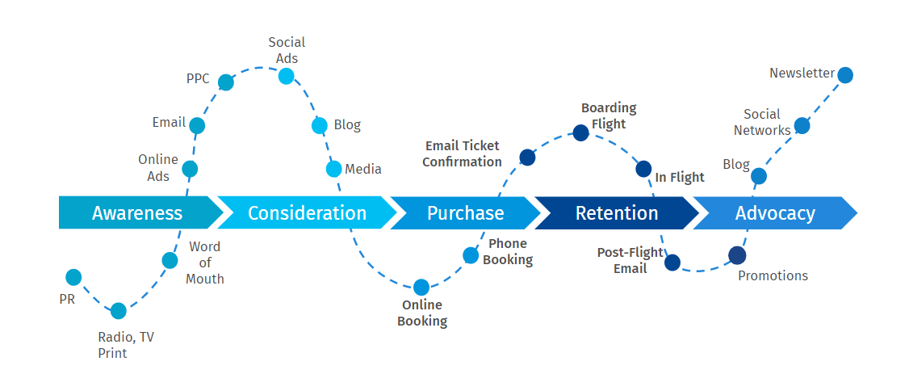
Figure 2: Stages of customer journey
(Source: Tou et al., 2019)
Awareness
Boosting the customer awareness usually relies on the understanding of the customers, who they actually are and to reach out to them on the right platform at the right moment. for the optimization of the strategy, it is essential to perform thorough research and it is very crucial. In this regard the communication channels include social media customer service and Analytics (Tou et al., 2019). It can be observed that the establishment of the analytics forms includes different information such as age, location, gender conversion rate, choice of divine and so on. It is essential to understand the customers and how the customers are able to discover and interact with the brand can be very informative for the development of strategies for increasing awareness. Is considered as one of the significant opportunities which is beneficial to boost awareness. There are different kinds of advertising which is being used by Amazon in this regard. These include social media marketing, search engine marketing and so on. The advantages of these communication channels catered to any budget and they are highly targeted.
Consideration
It can be observed that the customers do not have a lot of trust in the marketing communications and the advertising communications of the business. Instead of these, it can be seen that the consumer trusts the opinions of the peers as well as the words of mouth particularly from family friends while making any kind of purchase. Amazon can get their brand into consideration by specifically featuring the testimonials on their various channels (Prabhavathi et al., 2019). It is essential for them to add commentary on how the organisation has been beneficial for the customer and how they have helped in providing further insight into the business ethos. This is beneficial for the organisation as it will be helpful for the customers to consider and see the business as one of the authentic organisations which is run by all the real people. The customers usually prefer to have a conversation with those organisations which usually match their values and those organisations which have authentic purpose. Taken to the next step if the organisation can provide genuine content to the potential customers. With the help of this technique, it will be possible for Amazon to stay into consideration throughout the buying journey of the customers.
Purchase
This particular state is considered as the decision stage. In this stage it can be observed that the customers are usually finished with their decision making and that the customers have considered the brand against their competitors and are now ready to purchase. Therefore, in this stage it is essential for Amazon to be transparent with the possible costs. It is essential for the organisation to be transparent about the additional taxes as well as the hidden shipping cost and this may be the reason for cart abandonment (Daniel and Meena, 2021). Video Sadar factors which are responsible for the abandonment of the cart and this includes the requirement of account for making any kind of purchase and if the checkout process is too complex. Optimisation of the checkout experience for the customers is referred to as simplifying it. Therefore, it is necessary for Amazon to understand how much data it is essential together to facilitate the purchase of a customer.
Retention
After making any purchase the customers once the interaction process with the organisation to be easy if they require any kind of support or advice. It is essential for Amazon to make sure that they provide post purchase services and they are accessible to the customers through the company phone number as well as the company website for the convenience of the customers (Lindecrantz, Gi, and Zerbi, 2020). Therefore, it is essential for Amazon to offer social media cross platform digital telephone as well as in person interaction communication channel for ensuring that all the grounds are covered. It will also be beneficial for the organisation if the frontline staff are quick enough to make necessary decisions. It will be frustrating for the customers if the service team of the organisation do not have any kind of access to the necessary data which the customers need and if they fail to provide any kind of flexibility regarding their services. if the organisation is able to retain the customer successfully then it will result in repeat purchases. This will also lead to advocacy of the business.
Advocacy
It is essential for any kind of advocacy strategies to have proactive ways while dealing with the criticism as well as showcasing praise. If there is any kind of negative review which circulates on the social media platform then it is essential for the organisation to contact those customs as well as that situation accurately (Yang, 2019). It is also essential for Amazon to resolve the issues of the customers in a positive manner. Advocacy can also be maintained by seeking positive messages from the key influencer and rewarding the customers for the brand loyalty they show. The first state which Amazon can take is to find the comments about the brand. This can be done with the help of Google alert which is a free service. It can also be done with the help of tracking the social channels of the company as it helps to understand the frustrations of the customers regarding the company on their social accounts.
Therefore, by analysing all the steps it is possible for Amazon to manage and evaluate the customer journey across the various communication channels (Park et al., 2021). It will also be beneficial to understand if the current as well as future expectations of the stakeholders are met.
You need to provide examples of touchpoints utilised at the pre purchase, purchase and post purchase stages.
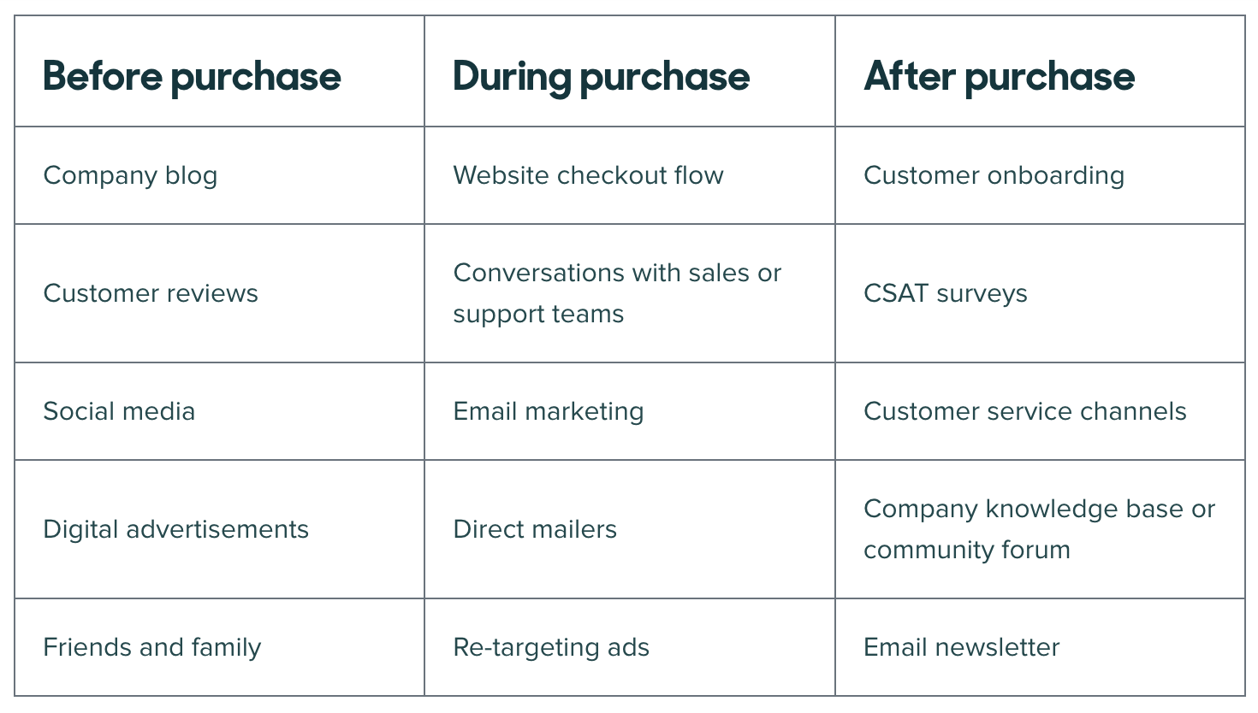


Customer Persona
Include a diagram of a customer journey map
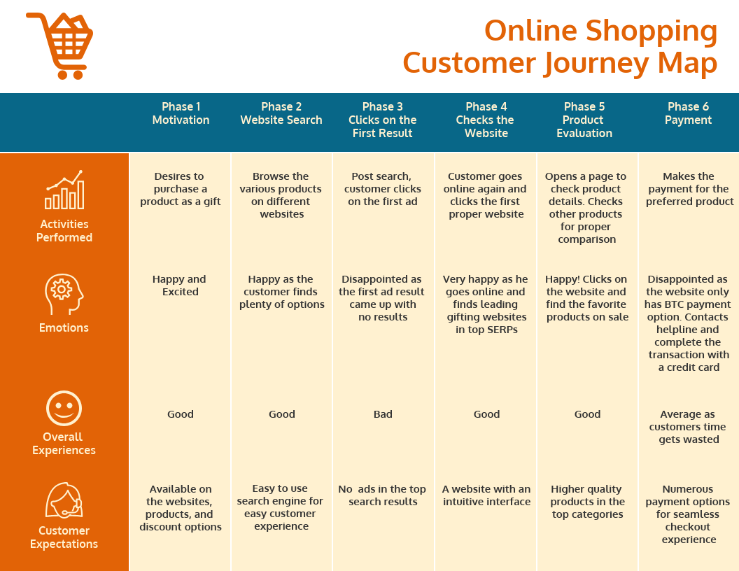

Impact of communication channels in ensuring current and future stakeholder’s expectations
Stakeholders | Power | Influence | Impact on project | Company initiatives
Employees | Low | Low | Low | Amazon mainly follows digital communication channels to manage the communication techniques with their employees. The digital communication channel is equally popular among the employees. It is managed in the workplace.
Managers | High | High | Strongly positive | With better communication techniques the managers can improve productivity within the organisation. better communication techniques help in getting betterment with the employees and this also comprehends their roles. the managers can assign their duty is better to the Employees.
Customers | Low | High | Moderate | With better communication skills the company can build a relationship more properly with their consumers. This is beneficial for the company in the professional and personable sectors also. This mainly tells the section of doing or not doing things within the company. Listening to the customers is always the best airport for the company.
Investors | High | High | Strongly positive | Using the analogy helps the company in getting betterment (Tou et al., 2019). by managing internal customer service policy communication Inconsistent way. Customer interaction is important for the business. It gives peace of mind.
Employees, employee communication can be maintained by email internal communication platforms, internet and the employee collaboration software’s. The role of communication among the employees is high. The communication techniques boost the morale of the employees and these also help in maintaining collaboration and engagement within the organisation. with the proper collaboration techniques and communication channels the productivity and satisfaction among the organisation can be developed. Communication was the key factor in cooperation and collaboration techniques. Effective work is communication that can help in getting better results among the team, individuals and the organisation. Communication can be considered as the key within the workplace. With better communication techniques, organisations can obtain better results. This also minimises the misunderstanding within the organisation with good communication skills. Short- and long-term benefits can be obtained within the organisation (AlQahtani, 2021). This mainly contributes to the company's success and this defines personal success as the leader. There can be common times types of communication in the workplace which are physical leadership communication presentations, update meeting customer communication and informal interactions. With proper communication techniques among the organisation better engagement of the employees can be obtained. These can perform as the key Metric for employee productivity and the potential retention within the organisation. The company can reinforce the people with contributors and the compounding also values the experience and unique skills within the organisation. the contribution inputs and makes a difference for getting betterment.
Managers, they can manage the resources and time which can save the techniques and the duties better (Awadhi, Obeidat and Alshurideh, 2021). The managers can also apply civil techniques for getting betterment within the organisation and with the work done, the managers can experience reduction of stress. These also reduce charge from the customer support presentative actions within the organisation the senior technical staffs also experience is of equal value to the customers and to the Amazon. by proper implementation of Management within Amazon the employee can get more satisfaction which is the key factor of the management. From the view of the manager, communication adds value to the organisation which reduces the turn off or off skills and these also season the staff members (Siby and George, 2022). greater loyalty techniques within the organisation keeps their employees for many years which is beneficial for the managers. This impacts the bottom line of the organisation as well as it impacts the top position also. why solving the management techniques, the managers can solve critical problems. The employees also feel too much about the company and they can be treated as values by the individual. With better communication techniques the managers can get better collaboration within the organisation with usage of various technologies. The manager can obtain several goes with the team members in the same building and in the same country. The managers also can present communication challenges which facilitate collaboration techniques and this help groups to communicate effectively with the latest technology. Better communication techniques, in managing conflict within the organisation. The managers can also get greater motivation techniques within the organisation by proper communication skills.
Customers
with the customer care services resolving the disputes can be managed quickly which is the innovative and vital thing of Customer Management policies. This is important for professional and personal development within the organisation (Ayoub et al., 2019). The organisation also can have strong consumer relationships within the business and implementing several strategies can make sure to deal with the discos within the organisation. with proper customer care activities in Amazon, using the best ways can get recognised. considering the customer demography in the organisation.
Communication channel has always been considered as one of the indispensable parts of any kind of business as it helps in delivery various messages to the customers as well as it is also beneficial in achieving the goals in the context of marketing sales as well as support. By using proper techniques, it is possible to boost the communication level and it also ensures value to the customers as well as the brand (Ashraf et al., 2020).
Investors
Proper communication techniques with the investors can make time to connect in any individual operations within the organisation. This can establish a proper rhythm within the organisation. with the proper activities of investors keeping the operations of the business concise becomes possible (Hassel and Sieker, 2022). Communication with the investors should be considered a first paced company like Amazon. the activities of investors should be managed within the company. The company should focus upon four types of investors: personal investors, venture capitalist Angel investors and peer to peer lending investors. Communication techniques are important with the investors as the clear communication helps in managing the operations within the company.
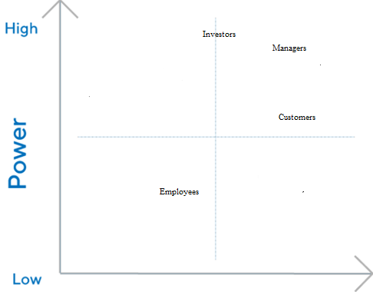
Figure 3: Stakeholder map
(Created by author)

Conclusion
This task has mainly focused upon the customer satisfaction techniques within Amazon and this has emphasised every touch point. There are descriptions of customers' needs and journey. This assignment has described the critical appreciation of the organisation and they have focused upon creating innovative marketing strategies that also raises business awareness for managing and evaluating the customer journey with the application of several communication channels. These also insure current and future stakeholder Expectations which need to be fulfilled. The brand awareness program of Amazon has been described with the help of Keller’s CBBE model. afterwards customer journey and stakeholder management has been addressed within the assessment.

Reference List
Ali, I. and Naushad, M., (2021). Determinants of customer satisfaction in online grocery shoppin. International Journal of Data and Network Science, 5(3), pp.383-390.http://m.growingscience.com/beta/ijds/4952-determinants-of-customer-satisfaction-in-online-grocery-shoppin.html
AlQahtani, A.S., (2021). Product sentiment analysis for amazon reviews. International Journal of Computer Science & Information Technology (IJCSIT) Vol, 13.https://papers.ssrn.com/sol3/papers.cfm?abstract_id=3886135
Ashraf, M., Ahmad, J., Hamyon, A.A., Sheikh, M.R. and Sharif, W., (2020). Effects of post-adoption beliefs on customers’ online product recommendation continuous usage: An extended expectation-confirmation model. Cogent Business & Management, 7(1), p.1735693.https://www.tandfonline.com/doi/abs/10.1080/23311975.2020.1735693
Awadhi, J., Obeidat, B. and Alshurideh, M., (2021). The impact of customer service digitalization on customer satisfaction: Evidence from telecommunication industry. International Journal of Data and Network Science, 5(4), pp.815-830.http://m.growingscience.com/beta/ijds/5335-the-impact-of-customer-service-digitalization-on-customer-satisfaction-evidence-from-telecommunication-industry.html
Ayoub, J., Zhou, F., Xu, Q. and Yang, J., (2019, August). Analyzing customer needs of product ecosystems using online product reviews. In International design engineering technical conferences and computers and information in engineering conference (Vol. 59186, p. V02AT03A002). American Society of Mechanical Engineers.https://asmedigitalcollection.asme.org/IDETC-CIE/proceedings-abstract/IDETC-CIE2019/59186/1069744
Baboolal-Frank, R. (2021). Analysis of amazon: Customer centric approach.https://repository.up.ac.za/handle/2263/86089
Daniel, D. A. J., and Meena, M. J. (2021). A novel sentiment analysis for amazon data with TSA based feature selection. Scalable Computing: Practice and Experience, 22(1), 53-66.https://scpe.org/index.php/scpe/article/view/1839
Hassel, A. and Sieker, F., (2022). The platform effect: How Amazon changed work in logistics in Germany, the United States and the United Kingdom. European Journal of Industrial Relations, 28(3), pp.363-382.https://journals.sagepub.com/doi/pdf/10.1177/09596801221082456
Junsawang, S., Chaiyasoonthorn, W., and Chaveesuk, S. (2020, April). Willingness to use self-service technologies similar to Amazon go at supermarkets in Thailand. In Proceedings of the 2020 2nd International Conference on Management Science and Industrial Engineering (pp. 135-139).https://dl.acm.org/doi/abs/10.1145/3396743.3396785
Lindecrantz, E., Gi, M.P. and Zerbi, S., (2020). Personalizing the customer experience: Driving differentiation in retail. Retrieved January, 9, p.2022.https://www.mckinsey.com/~/media/McKinsey/Industries/Retail/Our%20Insights/Personalizing%20the%20customer%20experience%20Driving%20differentiation%20in%20retail/Personalizing-the-customer-experience-Driving-differentiation-in-retail.pdf
Lit, Y., Kim, S. and Sy, E., (2021, January). A survey on amazon alexa attack surfaces. In 2021 IEEE 18th Annual Consumer Communications & Networking Conference (CCNC) (pp. 1-7). IEEE.https://ieeexplore.ieee.org/abstract/document/9369553/
Liu, Y., Wan, Y., Shen, X., Ye, Z., and Wen, J. (2021). Product customer satisfaction measurement based on multiple online consumer review features. Information, 12(6), 234.https://www.mdpi.com/2078-2489/12/6/234
Masyhuri, M. (2022). Key Drivers of Customer Satisfaction on the E-Commerce Business. East Asian Journal of Multidisciplinary Research, 1(4), 657-670.https://journal.formosapublisher.org/index.php/eajmr/article/view/405
Park, Y.J., Joo, J., Polpanumas, C. and Yoon, Y., (2021). “Worse Than What I Read?” The External Effect of Review Ratings on the Online Review Generation Process: An Empirical Analysis of Multiple Product Categories Using Amazon. com Review Data. Sustainability, 13(19), p.10912.https://www.mdpi.com/1295356
Prabhavathi, C., Vishali, N., Reddy, P. S., and Chandramouli, J. V. (2019). Machine Learning Model for Classifying L _ Text Using Nlp (Amazon Product Reviews). International Research Journal of Computer Science, 6(4), 161-178.https://www.academia.edu/download/59064530/11.APCS1008820190428-80775-otuu74.pdf
Shrestha, N. and Nasoz, F., (2019). Deep learning sentiment analysis of amazon. com reviews and ratings. arXiv preprint arXiv:1904.04096.https://arxiv.org/abs/1904.04096
Siby, A., and George, J. P. (2022). Influence of customer relationship management for the success of E-business. In Information and Communication Technology for Competitive Strategies (ICTCS 2020) ICT: Applications and Social Interfaces (pp. 473-481). Springer Singapore.https://link.springer.com/chapter/10.1007/978-981-16-0739-4_45
Tou, Y., Watanabe, C., Moriya, K., Naveed, N., Vurpillat, V., and Neittaanmäki, P. (2019). The transformation of R&D into neo open innovation-a new concept in R&D endeavor triggered by amazon. Technology in Society, 58, 101141.https://www.sciencedirect.com/science/article/pii/S0160791X19301022
Vollero, A., Sardanelli, D., and Siano, A. (2021). Exploring the role of the Amazon effect on customer expectations: An analysis of user‐generated content in consumer electronics retailing. Journal of Consumer Behaviour.https://onlinelibrary.wiley.com/doi/abs/10.1002/cb.1969
Warrier, U., Singh, P., Jien, C. W., Kee, D. M. H., Yi, G. Z., Jiann, T. W., ... and Ganatra, V. (2021). Factors that lead Amazon. com to a successful online shopping platform. International journal of Tourism and hospitality in Asia Pasific (IJTHAP), 4(1), 7-17.http://www.ejournal.aibpmjournals.com/index.php/IJTHAP/article/view/1017
Yang, S. (2019). The Study of Customer Experience Design and Optimization of Shopping Website: Case Analysis of Amazon in China. Asian Business Research, 4(2), 1.http://journal.julypress.com/index.php/abr/article/view/591

Appendix


