EMMA AMIRAT
STUDENT NO: 1818142
16th SEPTEMBER 2019
CREATING A STRATEGIC DIRECTION FOR SCHOOL IMPROVEMENT
MODULE NO: M6X01440

WHAT ARE THE KEY CONSIDERATIONS FOR SCHOOL LEADERSHIP TEAMS WHEN PLANNING FOR THE IMPLEMENTATION OF AN AREA OF LEARNING EXPERIENCE (AOLE) FROM THE DRAFT CURRICULUM FOR WALES 2022?
Introduction
The 2012 results of the Programme for International Student Assessment (PISA), a worldwide study by the Organisation for Economic Co-operation and Development (OECD) which evaluates standards of maths, science and reading skills of 15 year olds, triggered a serious evaluation of education in Wales by the Welsh Government owing to the PISA report highlighting that Welsh results were not only on the decline but had also fallen behind those of England, Scotland and Northern Ireland.

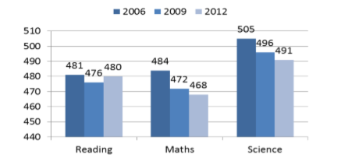
Figure 1: PISA results for Wales 2006 - 2012

This resulted in the Welsh Government appointing Professor Graham Donaldson to undertake a curriculum review. The subsequent report, Successful Futures: Independent Review of Curriculum and Assessment Arrangements in Wales, contained specific recommendations, all of which were accepted by the Welsh Government and which have been the catalyst for extensive education changes in Wales.
Based on the initial trigger for educational reform, some would agree that a curriculum review was necessary, however the extent of curriculum change that has subsequently been proposed or is being undertaken, can be seen by some schools as an incredibly daunting task to consider, plan for and apply in readiness for the statutory implementation of the new Curriculum for Wales in September 2022.

School leaders will need plan strategically to engage the whole school staff to work together in order to consider how to adapt the new curriculum to meet the needs of the pupils and the wider, individual school context. School development plans will need to consider challenges such as staff training needs, ongoing budget cuts, other educational reforms such as the new ALN reform as well as current trends for best practice such as United Nations Convention on the Rights of the Child (UNCRC), Siarter Iaith, etc.

Curriculum for Wales 2022
As outlined in the Draft document of the Curriculum for Wales 2022 (Welsh Government, 2019), the new curriculum will comprise of Six Areas of Learning and Experience (AoLEs):
Expressive Arts;
Health and Well-being;
Humanities;
Languages, Literacy and Communication;
Mathematics and Numeracy;
Science and Technology.
The Curriculum for Wales blog (Welsh Government, 2018), introduces an AoLE design model (Appendix 2), which clearly highlights how both the “What Matters” statements and “Progression Steps” offer the content for each AoLE, which comprises of knowledge, skills and experience, cross curriculum skills and wider skills, as well as Welsh dimensions and international context. When reading the draft document of The Curriculum for Wales, the content appears considerably less prescribed than previous curriculum models and the progression steps of 5 years, 8 years, 11 years, and 16 years, offers a gap of a few years for children to achieve the “I can” or “I have” statements.
This new way of working offers a welcome reprieve from data driven progress markers and acknowledges that children develop at different paces therefore allowing children more time to explore, consolidate and
practice skills. However, on the other hand, this is a radical change to what schools have previously been used to, where curriculum content, skills and range are neatly boxed up to be taught within a specific year group. Now, with the Curriculum for Wales 2022, schools have the autonomy to take complete ownership over how they develop their curriculum in order for pupils to learn skills across the progression steps towards achievement outcomes. Nevertheless, it also presents significant challenges in supporting teachers needing to adopt a new mind set of how they will be planning and teaching. In addition to this, the broadness of the new curriculum will be open to varied interpretation, therefore requiring a robust, collaborative approach, as a whole school staff, to develop the curriculum to suit the needs of the learners and context of the school community. But where do schools start when undertaking a task of these proportions?
As identified in Wales Strategic Plan, Welsh Government is driven by providing a curriculum where “learners will benefit from experiences at school that will support them in becoming young adults that are ambitious capable learners who are ready to learn throughout their lives, enterprising, creative contributors who are ready to play a full part in life and work, ethical, informed citizens who are ready to be citizens of Wales and around the world, and healthy confident individuals who are ready to lead fulfilling ,lives as valued members of society.”
The Four Purposes (appendix 3), as set out by Donaldson within Successful Futures, are at the heart of the new curriculum and each “What Matters” statement supports at least one of the Four Purposes. With this in mind, any discussion around adapting the new curriculum with your school team must start with how the Four Purposes are embedded within the school aims and ethos.
Considering the catchment area of our school where, according to the Wales Index of Multiple Deprivation (WIMD) (2014), we serve one of the most deprived areas in Wales, it will be vital that the Four purposes are embedded into any curriculum we develop because the majority of pupils quite possibly do not have the role models in their lives that can show them what it is like to be a healthy individual or an ethical citizen or even what it means to be ambitious. Therefore, for the majority or our pupils, the exemplar will need to come

from school staff throughout their daily interactions and teaching, as well as linking with organisations that will support our curriculum to provide the spark the children will need to ignite their motivation.
Expressive Arts AoLE
The publication, Primary Colours (Cooper, B, 2018), found that a narrowing curriculum, pressure on school budgets and the demands of national tests were all contributing to the decline in arts education in England, leaving schools with few resources and little time to introduce their pupils to drama, music and art galleries. In Wales, in could be argued that the introduction Literacy and Numeracy Framework and National Tests has impacted on subject areas such as art, music, drama and dance in a similar way and in some schools have slowly been pushed to the side line, with little time in the school week to explore these areas in any depth or in any meaningful way.
Upon release of the draft Curriculum for Wales 2022, the fact that Expressive Arts was a distinct AoLE with equal importance and significance placed on it as the other AoLEs, was a welcome inclusion.
Looking at how the Expressive Arts AoLE content is presented within the new curriculum, as with the other AoLE’s, it is giving teachers the go ahead to be more creative with their teaching and to use a more holistic approach to include the multi-disciplines of art in one project in order to provide as many cross curricular opportunities. It can be seen how it may become more manageable to plan for realistic, meaningful experiences for children to engage in the arts when it can be taught as a theme or topic based on the children’s interests.
The Expressive Arts AoLE centres on the five disciplines of art, dance, drama, film and digital media, and music, and it is explicit within the AoLE guidance that learning about expressive arts has a positive on children’s wellbeing, self-esteem and confidence. With our school being in an area of high deprivation, teachers place importance on the nurture aspect of their role, ensuring children are in the right frame of mind and ready to learn, before placing academic demands on them. Staff are all aware of Adverse Childhood Experiences (ACES) Appendix and how negative experiences that children may be exposed to within their family environment may have long lasting impact on their self-esteem, social skills and capacity to learn.

Considering this, developing the Expressive Arts AoLE within our school will give an opportunity to explore how the arts can support children, across a variety of curriculum subjects, to feel a sense of achievement and self-worth through enjoyable, holistic learning opportunities.
However, despite this positive advocacy for the impact that Expressive Arts can have children’s holistic learning and wellbeing, it still remains a concern as to how schools can provide high quality arts education with budget cuts and possibly limited staff expertise, and this will have to be considered when any strategic planning for implementing the Expressive Arts is carried out.
When considering how Expressive Arts can be taught, it is essential to review Donaldson’s 12 Pedagogical Principles within Successful Futures, (appendix). It is evident that the majority of the pedagogical principles will be pertinent when embedding Expressive Arts into the school curriculum, however efforts will need to be made by the school team to investigate which pedagogical principles will best suit the needs of the pupils in the cohort. Additionally, as a school leader, it would be foolish to assume that every member of staff is confident to teach within every pedagogical principle. Therefore, using a recognised toolkit with whole staff, such as The Teaching and Learning Toolkit (EEF, 2018), to explore teaching interventions and pedagogies that staff are confident with or that staff see as important to pupils, would provide a solid foundation for identifying what the school does well already and what the school needs to develop in order to see maximum impact with pupils’ progress.
When considering how to capture the progress of children’s learning within Expressive Arts, it is wise to bear in mind that it will be difficult to see progression of skills in a linear way like one would observe within maths progression for example. Just as we know that different learners progress in different ways, progress within the arts can be changeable depending on the range and depth of creative experiences that are presented to the child. As it states explicitly in the Draft Curriculum for Wales 2022,
“Learners may easily move backwards and forwards as they experience Expressive Arts activities and different learners are likely to progress in markedly different ways.” (Welsh Government 2019)

The challenge for staff will be to assess all the cross curricular skills that will be impacted on through the Expressive Arts. Not only the key skills that Expressive Arts projects will be rich in such as literacy, numeracy and digital competency, but personal and social skills, health and wellbeing skills, etc.
Furthermore, it will be a priority for schools to explore what the progression steps mean within their school. With no specific end of year expectancies placed on the curriculum, how do teachers ensure progression within each progression step? How do year groups ensure there is not a duplication of skills already achieved and not an omission of skills that haven’t even explored yet? With the Draft Curriculum for Wales focussing on curriculum content and implementation, there is very little published yet to explore the assessment arrangements in line with the new curriculum. There are still many unanswered questions over how the national tests fit in with the new curriculum and the accountability and reporting for each progression step. It is hoped that more detail will be given to school in Autumn 2019 so that these questions can be explored further.
In line with Donaldson’s recommendations, the way schools capture pupils’ learning, progress and achievements should be more creative and reflect the different ways in which children access their learning opportunities. This is even more pertinent for Expressive Arts because the nature of the AoLE will offer evidence of a much more practical nature and therefore the creation of digital learning portfolios on platforms such as HWB will provide a valuable source of assessment for both pupil and teacher. In addition to this, using the digital portfolios in the same way that staff teams may approach learning walks or book looks, will provide a platform for reflection on whether staff are using a range of teaching styles and creative, child led opportunities and provide opportunities to identify things to further build on.

Strategic Plan for the Implementation of Expressive Arts 2017 - 2022
Mission    Believe in yourself to aspire and achieve. |  | Vision  Our vision is to provide a nurturing learning environment where every child can be supported to experience the learning opportunities they deserve, no matter what their starting point. We will strive to teach children exciting, memorable and lifelong learning experiences through providing a curriculum that has the children at the heart of the learning.
Goal |  | Strategies
1 | To work collaboratively with artists to develop Expressive Arts and become leaders of practice to share with other schools. | - Make an application to the Lead Creative Schools Project.  - If successful, the 2-year project will support all the goals mentioned below.
2 | To celebrate and utilise individual strengths and expertise of teachers to support the implementation of Expressive Arts. | - Use personality tests with staff to identify personal attributes and recognise strengths. Create staff curriculum working groups based on findings.  - Use The Teaching & Learning Toolkit to explore pedagogical principles – What are we doing well? What do we need to develop?  - Identify CPD needs and create support networks both in school as well as linking with other schools in order to build staff skills and confidence.  - Use Ads sessions as small focussed sessions to share staff successes, learning and ideas linked to Expressive Arts pedagogies.  - Evaluate impact on pupil progress.
3 | To develop a unique curriculum, in line with Curriculum for Wales 2022, that meets the needs our learners in order to support their best opportunity for success. | - SLT use Schools as Learning Organisations case studies  - Staff teams to decide on a focus within the Expressive Arts AoLE for action research to inform curriculum development. Use Creative Habits of Mind wheel (appendix) and Hwb Wales Creative Learning Zone to support ideas planning.  - Link with pioneer schools or Lead Creative Schools  - Plan for immersion days/weeks as a focus to try ideas for providing Expressive Arts projects.  - Evaluate the impact using collaborative staff analysis.
4 | To provide an arts rich curriculum in order to improve pupil progress within the cross curricular skills of literacy, numeracy and digital competency. | - Review school data to identify key focus for targets.  - Use draft Curriculum for Wales to explore What Matters and Progression Steps for Expressive Arts  - Audit physical resources and current links with the wider creative community.  - Identify next steps in building links with wider organisations – Arts Council Wales, Swansea Dance Company, FourSite, Gower College, Nawr Arts Network, Into Film, etc.  - Audit trips provision – Do we go to enough theatres/museums/galleries? Funding for these?
5 | To celebrate the Culture of being Welsh and to recognise the variety of cultures in our community. | - Look at current provision for expressive arts – audit how much celebration of “Welshness” we do as a school – Welsh Music Day? Welsh artists? Welsh musicians? Source ideas to fill the gap.  - How can we use Expressive Arts to celebrate wider cultures within our school community?

Rationale for the Strategic Plan
When planning for curriculum change, experience and research suggests that it is the quality of what we provide rather than the quantity of staff or initiatives. So within this 5-year strategic plan for Expressive Arts, there is a focus of starting with current strengths, upskilling staff, working collaboratively to develop change, and evaluating the impact on the pupils’ learning.
The rationale behind goal one, applying for the Lead Creative School project, is that it is clear within the Expressive Arts AoLE that schools need the breadth of experiences working directly with creative people and organisations. This can be a huge task when considering the time it takes to find the right people and also imposes a financial implication which, due to budget cuts, schools simply cannot meet. However, being accepted as a Lead Creative School would mean direct support for developing Expressive Arts for two years, with only a 25% contribution to the funding. It would also allow us to celebrate the success and hard work of the pupils by sharing the project ideas with the wider community and other schools.
Goal 2 is all about inspiring and valuing staff in order to achieve real success with the long term plans. When thinking what a good teacher is you can generate a list that would include the following: good role models, good listeners, adaptable, resourceful, innovative, sensitive to others’ needs; so if that is what we expect of our teachers, then they should expect the same from the leaders guiding them. So this goal allows time to start with strengths, to listen to teachers’ ideas, to celebrate their innovativeness, and to work together to reach common aims.
Goal 3 is included in order to provide a collaborative approach to curriculum change and using staff meetings as professional dialogue to tease our what Curriculum for Wales means for us an individual school. Professor Mark Priestly (REFERENCE) talks about the challenges that schools in Wales face when approaching the implementation of the new curriculum but emphasises that these can be overcome with teachers being given time to fully understand the curriculum in order to develop it. These professional

dialogues around the new curriculum can happen in house as well as wider collaboration with similar school starting on their journey.
The rationale being goal 4 is an acknowledgement that funding the Expressive Arts could possibly be challenging in terms of funding. This goal will allow for exploration of many sources, both physical and financial, within Wales in order to provide a quality and varied approach to the Expressive Arts.
With the Siarter Iaith initiative in schools and the heavy emphasis in the new curriculum for each AoLE, not just Expressive Arts, to include welsh culture within its implementation, it was important to have goal 5 as part of the strategic plan. In addition to this, if as a school we value inclusiveness for all children, then other cultures that are important to the pupils need to be considered and celebrated within this goal.

Action Plan for Goal 4 of the Expressive Arts Strategic Plan
When looking at our school data at the end of the academic year 2018/19, (Appendix) , it was evident from the teacher assessments, that within the majority of year groups the percentages of pupils achieving their predicted targets has been lower in literacy than maths. This appears to be an historic trend within our school and is one that is predicted to continue based on the increase of children entering school in Flying Start or Nursery requiring Speech and Language interventions. We have a dedicated Teaching Assistant who facilitates the screening and intervention groups, which means children are withdrawn from class for additional invention, School Action plus, therefore resulting in our ALN percentage increasing to around 70%. This is considerably higher than both the Swansea and UK age range. For this reason, Literacy always appears as a strong focus on our school development plan. (Appendix)
Therefore, my focus for a detailed action plan will be goal 4 from the strategic plan, “To provide an arts rich curriculum in order to improve pupil progress within the cross curricular skills of literacy, numeracy and digital competency.”
Some children in our school struggle with the more formal aspects of education, and with research showing that an improvement in literacy and numeracy skills can be gained through quality Expressive Arts provision, it appeared to be a good aim to explore in more detail.
In 2017 The Cultural Learning Alliance published a document entitled “Imagination: The Case for Cultural Learning.” The CLA was keen to use evidence from cohort studies with large sample sizes of typically 12,000, as well as robust control groups in order to emphatically state that there are key skills delivered by cultural learning. Their report grouped these key skills into the following 10 Key Research Findings:

- Participation in structured arts activities can increase cognitive abilities by 17%.
- Learning through arts and culture can improve attainment in Maths and English.
- Learning through arts and culture develops skills and behaviour that lead children to do better in school.
- Students from low-income families who take part in arts activities at school are three times more likely to get a degree.
- Employability of students who study arts subjects is higher and they are more likely to stay in employment.
- Students from low-income families who engage in the arts at school are twice as likely to volunteer.
- Students from low-income families who engage in the arts at school are 20% more likely to vote as young adults.
- Young offenders who take part in arts activities are 18% less likely to re-offend.
- Children who take part in arts activities in the home during their early years are ahead in reading and Maths at age nine.
- People who take part in the arts are 38% more likely to report good health.
The evidence clearly provides a positive argument in relation to prioritising arts in education within our schools. As Lord Puttam, Chair of the Cultural Learning Alliance states with in the document:

‘Learning through culture and the arts leads to creative thinking, confidence and problem-solving – all skills which are prized by employers and which young people need. If we fail to offer our young people the opportunity to participate in the arts and culture, then we fail to support them in becoming the leading thinkers, innovators, creative business and community leaders of the future.’
The action plan will focus on how we can resource the Expressive Arts, how staff can be creative in developing pedagogies that are relevant to our children, focus the development of skills through developing action research projects in school, and then develop systems to track and monitor using formative assessment.
The challenges that could be envisaged with this area of the Expressive Arts is getting all staff on board with being creative in trying out a new way of teaching, as well as using action research as a tool within the classroom to evaluate whether a particular way of teaching is actually working.
Carol Dweck’s theory of Growth Mindset is promoted within the classroom quite readily, but do we use it within our staff teams to support those teachers who find it difficult to leave their comfort zone, as many will during this time of curriculum reform.
As senior leaders it would be appropriate during the different phases of the action plan to really know your staff, be mindful of who may clearly be struggling and for those who it may not be that obvious, have systems in place in school where people can come and express their fears, whether that by via a very approachable senior leader or via an anonymous staff worry box.
Other ways of supporting people to move from a fixed mindset to a growth mindset can be seen within the action plan. Having whole staff inset days enable staff to explore ideas and talk about the task in hand in a comfortable, relaxed atmosphere away from the stresses of a day teaching. Also, using ADS sessions with a specific focus gives teams to work together towards the same focus and use peer to peer support with any worries or misconceptions.

Finally, giving autonomy for each class to decide on their own research project will result in a more positive outcome than if they were told by senior management to do what was on their agenda. Ensuring that it links with what was identified in Action 2, and there are systems in place for capturing the evidence, then the “how” of the project is completely up to the teaching knowing their class and their interests in deciding what project to do.

When the staff are undertaking the planning stage of their action research, SLT will be encouraging then to link with other schools, use case studies on Estyn or HWB Wales Creative Learning Zone to give them inspiration and real life examples of innovative ways of delivering the Expressive Arts Curriculum. Collaborative learning communities should boost motivation and enthusiasm of staff.
When all research projects have been completed, it is the responsibility of senior leaders to value the commitment taken to undertake action research in the classroom, and even if the project didn’t have the impact on pupil progress that was imagined, then it is allowing time for that self-reflection to consider why and to inform future projects. Senior leaders who provide a safe and comfortable space to enable this discourse will relieve the pressure and fear of meeting targets and will have staff who focus on their professional learning journey and how that journey can impact positively on the progress of the pupils.

Overall Target – Goal 4
“To provide an arts rich curriculum in order to improve pupil progress within the cross curricular skills of literacy, numeracy and digital competency.”
Action | Who? | When? | Intended outcomes. | Monitoring and reporting. | Who? | When? | Costs.
1.To have a team building day, using personality questionnaires and teacher toolkit surveys to identify staff strengths and create curriculum teams. | All staff | First Inset Day in September | Curriculum teams will be created that have a balance of team players with different roles. | Record of curriculum teams and agendas set for ongoing work. | SLT | First week back | N/A
2.To review end of year teacher assessments in literacy and numeracy. | All Staff | Autumn term 2 x ADS sessions | Staff will identify specific areas within each subject that need improvement | Staff feedback to SLT | All Staff | Week 4 SLT meeting. | N/A
3.To audit physical resources, current links with the creative community, including trips. | Expressive Arts Curriculum Team | Autumn Term 2 x ADS sessions | Team will use Start/Stop/Continue exercise to produce a list of resources or links that are worth keeping and what we need to look into starting up. | Expressive Arts team to share with SLT. | Expressive Arts Team | Week 7 SLT meeting | N/A
4.To use Action Research to undertake an in class project using a literacy or numeracy skill identified in Action 2. | SLT to leads ADS on using action research in the classroom | Week 10 ADS | An improvement in pupils’ progress for the specific skills should be able to shown using the action research project. | Support with pupil progress during termly meetings with assessment lead.  Each class to feedback findings during INSET day in Summer term | Assessment lead  Class teams including support staff. | INSET day Summer term | N/A
 | Each class use ADS to plan a project to start in the Spring term and end in the Summer term | Remainder of ADS in Autumn term

Evaluation
Undertaking the module of “Creating a Strategic Direction” has challenged me in a positive way because it encouraged me to think outside of my current role as Foundation Phase Leader and made me consider what were important considerations if, in the future, I was to undertake the role of a Deputy or Head Teacher. It can be easy within my current role to guide, advocate and support for my specific area, but I am now more mindful of the wider perspective, not just looking further within school to KS2, but also looking around and actively sourcing avenues for collaborative working with other schools in order to support the implementation of the Curriculum for Wales 2022. In terms of the Professional Standards for Teaching and Leadership, I think the module has touched on all five of the standards of Leading Pedagogy, Leadership, Professional Learning, Innovation and Collaboration. It was useful to refer to the leadership standards in order to give some focus.
A key area which I feel I have progressed in, would be using strategic planning effectively to guide long term aspirations. A key starting point to this was understanding the initial vision of the school and ensuring that it was projected to all stakeholders, not only staff, but parents and pupils too, so all involved understand the wider goals, which fulfilled a leadership requirement of refining teaching through promoting pedagogic vision. Within the strategic plan it is evident that I considered the leadership standards of Leadership and Innovation by ensuring that it showed a commitment to working for educational change towards 2025, it endeavoured to include the development of new techniques and strategies, involved empowering others by delegating responsibility and was also mindful of opportunities for reflection in order to evaluate the impact the changes in practice were having.
The process of strategic planning has shown me how difficult it can be to consider some aspects of educational provision 5 years ahead of time, but while this may be true, producing a strategic plan that can be undertaken with flexibility in mind and which allows for opportunities, over the professional discourse, to adapt and mould to the individual needs of your school, really does allow for a tailor made curriculum designed specifically for the cohorts’ needs, which can be implemented by a staff team who truly have ownership over it.

Appendix…
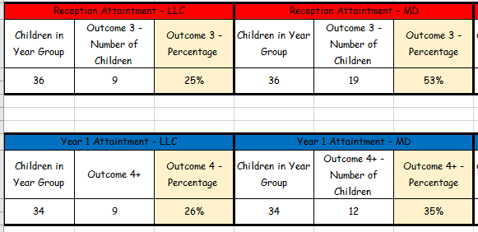

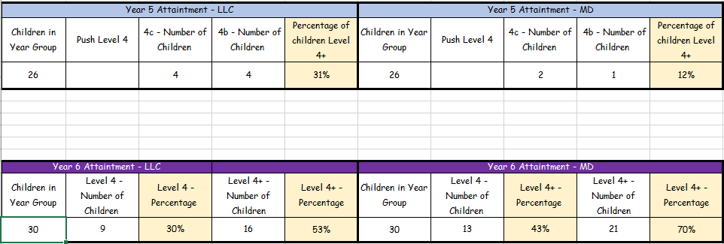
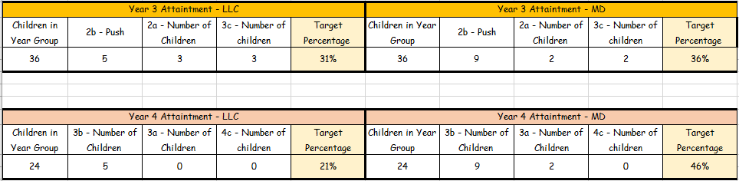
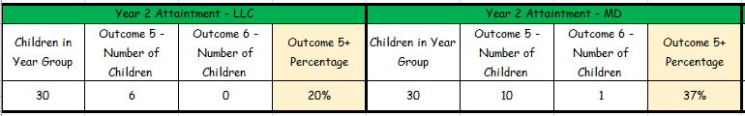

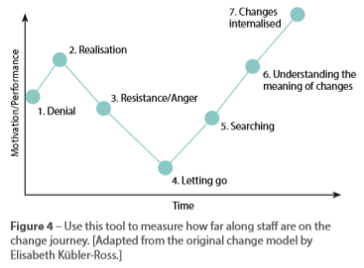

References
Donaldson, G. (2015) Successful Futures: Independent Review of Curriculum and Assessment Arrangements in Wales. Welsh Government

Welsh Government (2018) ‘How ‘Areas of Learning and Experience’ are being developed as a central element of the new curriculum’, Curriculum for Wales blog, 20 June. Available at: https://curriculumforwales.gov.wales/2018/06/20/how-areas-of-learning-and-experience-are-being-developed-as-a-central-element-of-the-new-curriculum/ (Accessed: 01 September 2019).

Education Endowment Foundation (2018), Sutton Trust-Education Endowment Foundation Teaching and Learning Toolkit (London: Education Endowment Foundation): https://educationendowmentfoundation.org.uk/evidence-summaries/teaching-learning-toolkit

Welsh Government (2019) Draft Curriculum for Wales 2022
https://hwb.gov.wales/draft-curriculum-for-wales-2022/

Culture and Poverty: Harnessing the power of the arts culture and heritage to promote social justice in Wales (2014) report by Baroness Kay Andrews.

Banerjee, A. and Watson, T.F. (2011) Pickard’s manual of operative dentistry. 9th edn. Oxford: Oxford University Press.
Davidson, A. (2013) ‘The Saudi Marathon Man’, The New Yorker, 16 April. Available at: http://www.newyorker.com/news/daily-comment/the-saudi-marathon-man (Accessed: 22 June 2015).
Guy, J. (2001) The view across the river: Harriette Colenso and the Zulu struggle against imperialism. Charlottesville, Virginia: University Press of Virginia.
Hislop, V. (2014) The sunrise. Available at http://www.amazon.co.uk/kindlestore (Downloaded: 17 June 2015).
Homer (1997) The Iliad. Translated by J. Davies. Introduction and notes by D. Wright. London: Dover Publications.
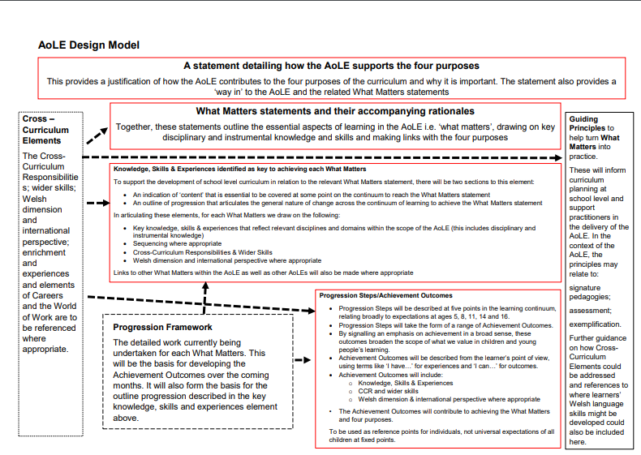
Appendix

