  Component One:  What are the key skills required when working in the housekeeping team? 750 words (+/- 10%)  Contribution to Overall Module Assessment: 25% | Student No: | 2209549
 | Module Title: | Hotel placement Operating Hotel Facilities
 | Module Code: | BMIH4006
 | Lecturer: | Kathryn Flynn
In the United Kingdom's hospitality industry, maintenance personnel play a crucial role in maintaining clean, comfortable, and welcoming facilities for visitors. Following is a discussion of several essential domestic skills, supported by relevant academic resources.

According to Baum (2007), the core of a housekeeper's responsibilities is the ability to efficiently manage and organise tasks. This level of organisation extends to maintaining an accurate inventory of cleaning supplies, creating and adhering to cleaning schedules, and communicating effectively with other team members. A housekeeper who excels at organisation can ensure that tasks are completed efficiently and to a high standard, which is essential for maintaining visitor satisfaction.

Due to the private nature of their position, housekeepers frequently interact with the personal belongings of visitors. This situation requires a high level of dependability and honesty from housekeepers (Jurowski & Gursoy, 2004). The guests must have faith that their accommodations will be meticulously cleansed and that their belongings will remain undisturbed. Employers in the United Kingdom place a high value on these characteristics when recruiting domestic personnel.

According to Lockyer (2007), the experience of a guest's stay can be significantly impacted by minute details. This involves not only ensuring that a room is immaculately spotless, but also being able to identify and replace any missing or broken items immediately. A meticulous housekeeper should have an acute eye for detail. This precision not only fulfils but also exceeds visitor expectations, contributing to positive reviews and repeat business. In addition to cleaning-related duties, attention to detail includes an awareness of the visitors' preferences and needs, from the arrangement of furniture and amenities to the prompt identification of maintenance requirements.

According to Tayauova (2012), the housekeeping profession is physically demanding, requiring extensive leaning, lifting, and extended periods of standing or strolling. This requires physical endurance and dexterity for a housekeeper to perform their duties effectively and avoid injury. Working in the hospitality industry, particularly as a housekeeper, requires physical stamina to efficiently complete daily tasks, such as cleansing restrooms, changing linens, and scouring large areas. In addition, dexterity facilitates the dexterous and effortless completion of tasks, whether they are delicate, such as wiping intricate decorative items, or strenuous, such as moving furniture during thorough cleaning processes.

According to Riley (2005), despite not being the most obvious requirement, possessing strong communication skills is a crucial aspect of maintenance positions. Housekeepers are frequently required to coordinate with other team members, report obstacles, and interact directly with visitors. Clear and effective communication can expedite operations and contribute to a more gratifying customer experience.

The United Kingdom's hospitality industry is characterised by its constant evolution, in which visitor needs and expectations can change rapidly. Therefore, housekeepers must be resilient and adaptable, able to respond effectively to changing conditions and unexpected obstacles (Baum, 2007). Their ability to acclimatise to change, maintain a positive attitude, and rapidly find solutions is crucial to providing high-quality service that keeps up with the industry's dynamic nature.

The hospitality industry, particularly in the United Kingdom, serves a wide variety of visitors from diverse cultural and socioeconomic backgrounds. This diversity necessitates that housekeepers demonstrate cultural sensitivity, comprehension, and reverence for visitors' diverse traditions, customs, and personal preferences (Reisinger & Turner, 2003). Such sensitivity may involve understanding the specific needs of each visitor, such as cleaning instructions, room arrangement preferences, and privacy-related customs. The demonstration of cultural sensitivity significantly contributes to the provision of a personalised, respectful, and comfortable stay for visitors of all cultural backgrounds.

Although housekeepers may not always interact directly with visitors, they play a crucial role in moulding the overall consumer experience. Possessing qualities such as civility, decorum, and a willingness to go above and beyond job requirements can leave guests with a favourable impression (Kusluvan, 2003). This could involve actions such as providing additional amenities upon request, responding quickly to visitor requirements, or even greeting guests with a pleasant greeting. Understanding the fundamentals of customer service and being able to implement them in daily tasks can substantially improve interactions with guests and lead to higher satisfaction ratings. Even though housekeepers work behind the scenes, their contribution to the overall visitor experience is priceless.

In conclusion, housekeeping positions require a combination of diverse abilities, spanning from tangible abilities such as administrative proficiency and physical stamina to gentler abilities such as effective communication and honesty. In the United Kingdom's highly competitive hospitality industry, housekeepers with this diverse skill set are essential to improving client satisfaction. In doing so, they considerably contribute to the overall success and reputation of their respective businesses.of its members to maintain a high level of service and guarantee complete customer satisfaction.

Word Count | 769

Component Two:
Contribution to Overall Module Assessment: 25%
In this scenario – You have just been promoted to team leader for a floor within the hotel. A guest complains that on their arrival, their room had not been properly cleaned. Create an action plan and answer the following questions.

Problem | Why did it happen? | What are you going to do? | How will you prevent this from happening in the future? | What measures would you introduce to improve team effectiveness?
The guest room was not thoroughly cleansed. | The housekeeping schedule was either disregarded or hurried. | Apologise to the guest and ensure that the room is immediately re-cleaned. | Review and reinforce with the team the cleaning schedules and standards. | Establish a distinct communication channel for problem reporting and solution discussion.
Essential items like hygiene were lacking. | The allotted domestic lacked the necessary training and experience. | Assign an experienced domestic to meticulously clean the room. | Provide regular training and refreshers on sanitation and customer service to the janitorial staff. | Encourage feedback and idea sharing to enhance processes continuously.
The chamber had a persistent foul odour. | The cleansing supplies or equipment were inadequate or ineffective. | Replace all used linens and quickly replenish any missing items. | Implement an improved communication and task management system. | Consistently recognise and reward team members' hard work to enhance morale.
The bed linens had not been changed and appeared dirty. | There was a misunderstanding or miscommunication regarding the guest's explicit requests. | Offer a free service or enhancement to make amends for the inconvenience caused. | Conduct routine inspections and quality reviews to maintain cleansing standards. | Facilitate cooperation and collaboration in order to distribute workload and increase productivity.
The specified amenities were not available. | The janitorial staff was understaffed or overburdened, causing details to be overlooked. | Review the incident with the janitorial staff to determine the oversight and to gain insight from the error. | Consider recruiting additional personnel or allocating tasks more effectively to prevent overwork and neglected duties. | Review and revise training modules frequently based on feedback from customers and industry standards.

Component Three:
Contribution to Overall Module Assessment: 50%
Your task is to create and prepare a presentation following the detailed scenario provided below.

As the floor housekeeping manager and given the recent guest complaints you need to put together a basic training presentation for your colleagues within the housekeeping team to get the best out of them, ensure that brand standard is being achieved and that Health and Safety procedures are also being followed.

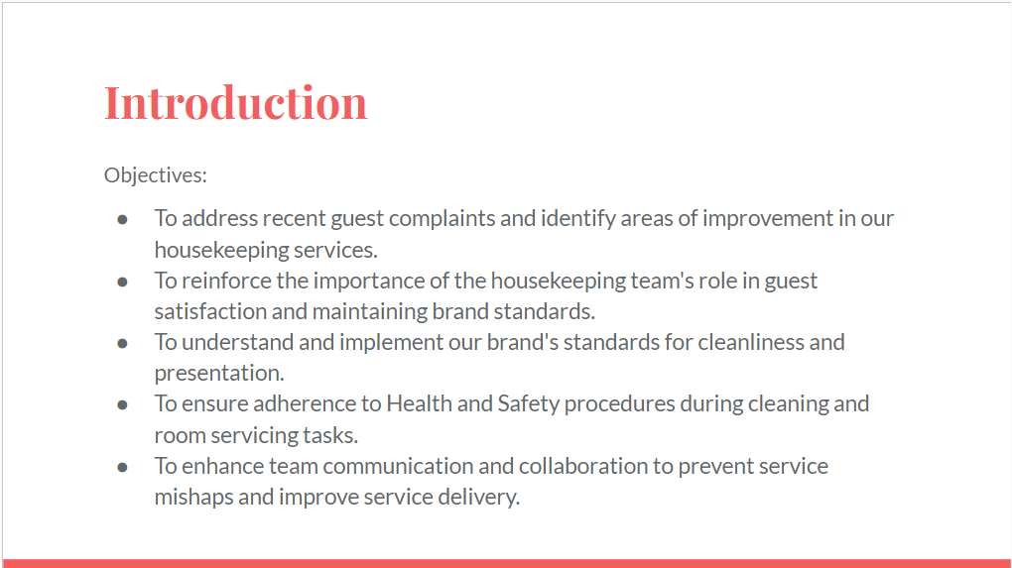

Training Notes:
Thank you for attending this crucial training session with me today. As you may be aware, we have recently received feedback from our visitors that requires our immediate attention and action.
We will focus on enhancing our skill set, learning better sanitation practises, and comprehending how to ensure consistent adherence to our brand standards and Health and Safety guidelines.
I expect that by the conclusion of this session, we will all have gained valuable insights and applicable strategies for our daily duties. This will not only help us enhance the guest experience, but it will also cultivate a better, more productive working environment for all of us.
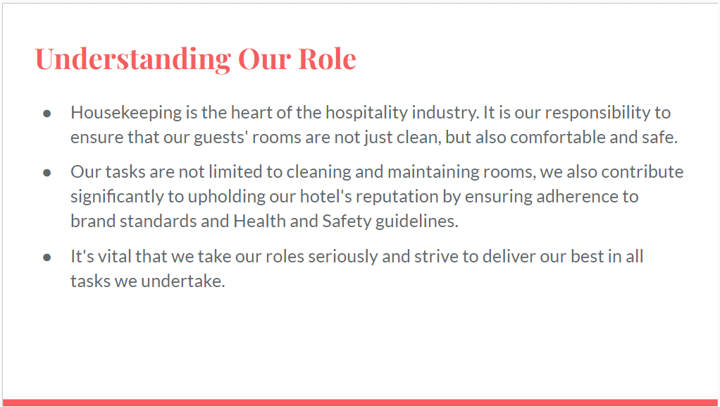

Training Notes:
- Highlight the broad range of tasks that fall under the housekeeping department.
- Discuss how these tasks contribute to the guest's experience and the hotel's reputation.
- Reinforce the importance of adhering to brand standards and Health and Safety regulations.
- Encourage pride in their work and the importance of representing the hotel and brand positively.
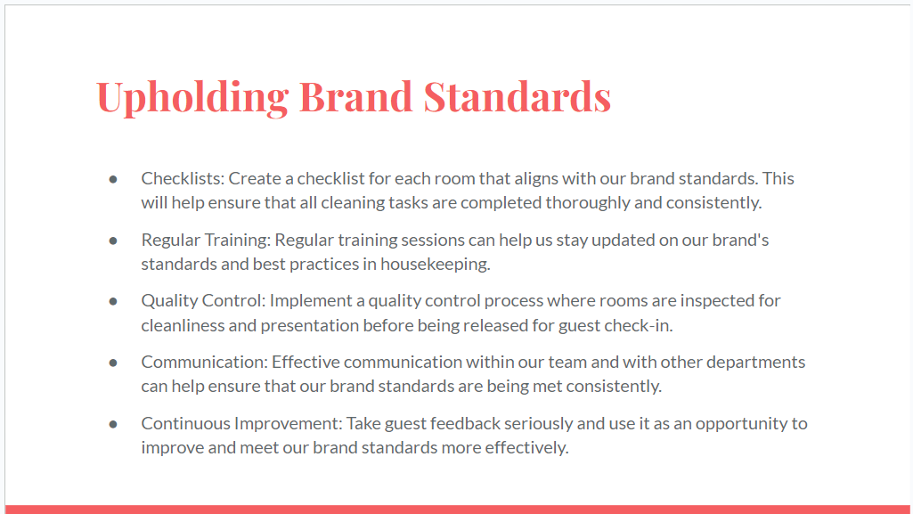

Training Notes:
- Discuss each method in detail, providing examples whenever possible.
- Encourage team members to share their thoughts and experiences regarding the maintenance of brand standards.
- Reinforce the significance of exceeding brand standards to create a memorable experience for guests.
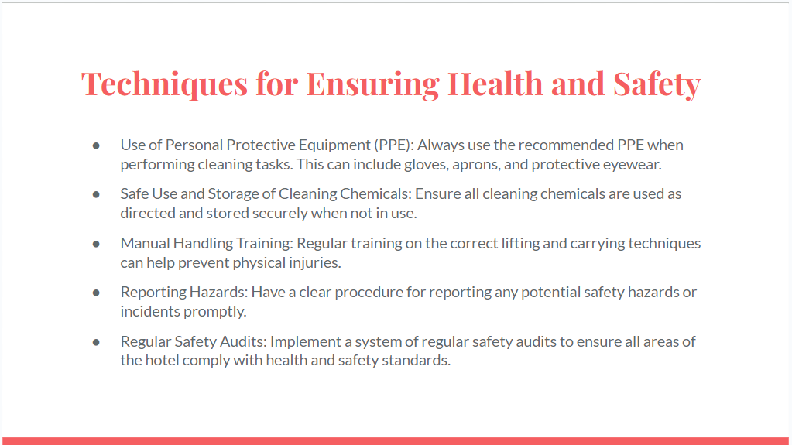

Training Notes:
- Discuss each technique in detail, providing specific examples from the team's daily tasks.
- Emphasize the importance of following these techniques consistently.
- Encourage team members to share any concerns or suggestions related to health and safety in their work areas.
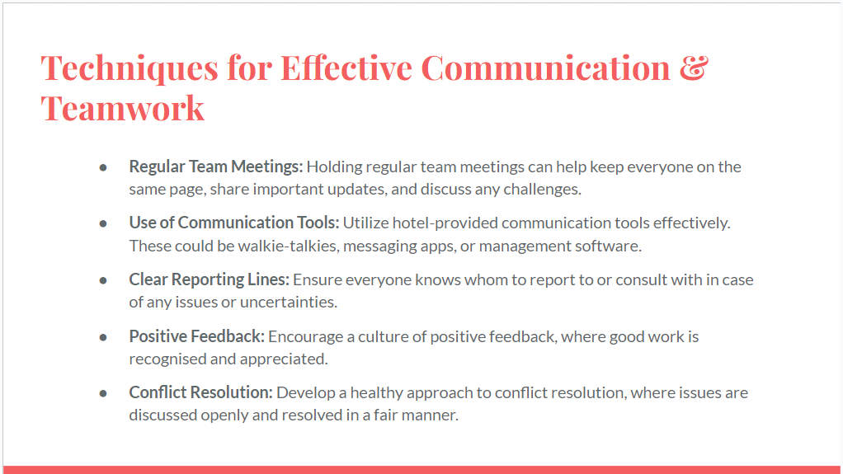

Training Notes:
- When practicable, provide real-world examples to illustrate each technique.
- Encourage team members to share their insights and suggestions for enhancing collaboration and communication.
- Reinforce the relationship between effective communication and collaboration, job satisfaction, and service quality.

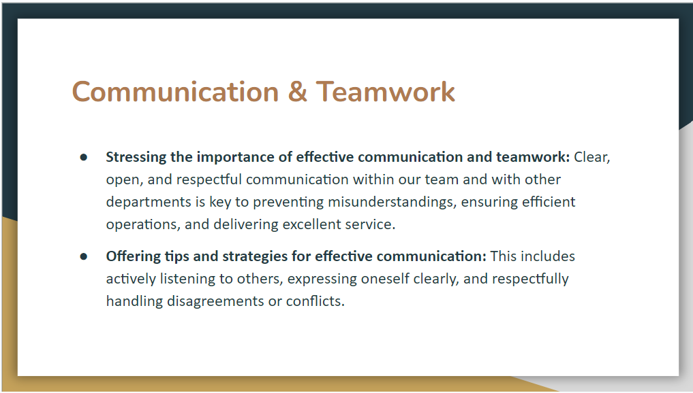

Training Notes:
- Highlight the significance of transparent and open communication.
- Remind team members that each member has an important role and that their contributions are valued.
- Teach effective communication techniques and plain expression
- Explain why respectful conflict resolution is essential.
- Discuss methods for handling disagreements constructively, emphasising the need to focus on the issue rather than the individual.
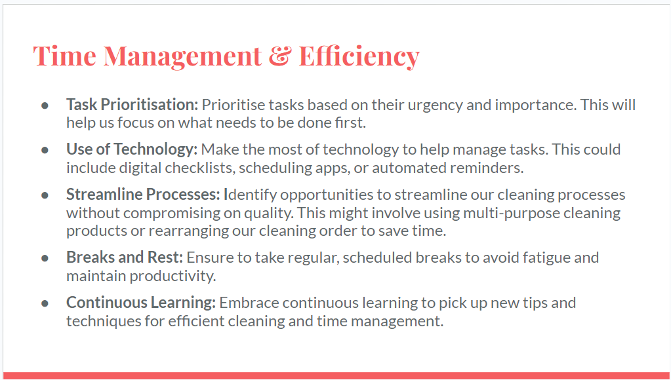

Training Notes:
- Whenever feasible, describe each technique in detail and provide practical examples.
- Encourage team members to discuss their time management strategies.
- Reinforce the connection between effective time management and enhanced visitor satisfaction.
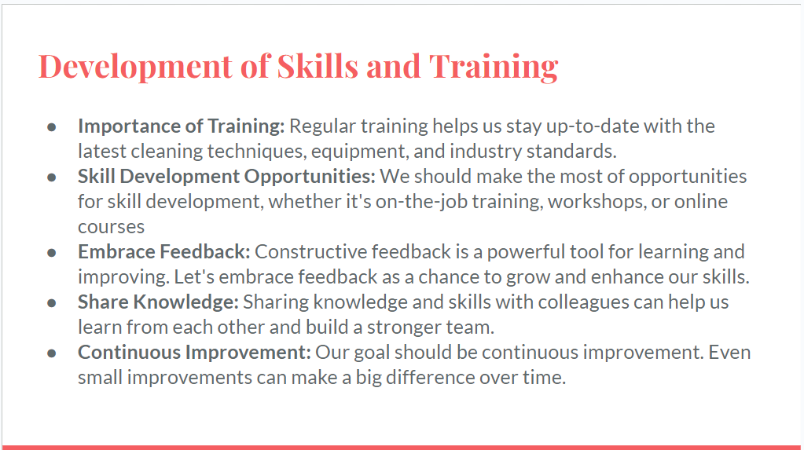

Training Notes:
- Discuss in depth the significance of regular training and skill improvement.
- Inform the team of any forthcoming training opportunities or resources available to them.
- Encourage team members to share their abilities and expertise.responsibilities.
- Discuss how the skills acquired through these training sessions can be utilised to improve service delivery, increase efficiency, and increase visitor satisfaction.
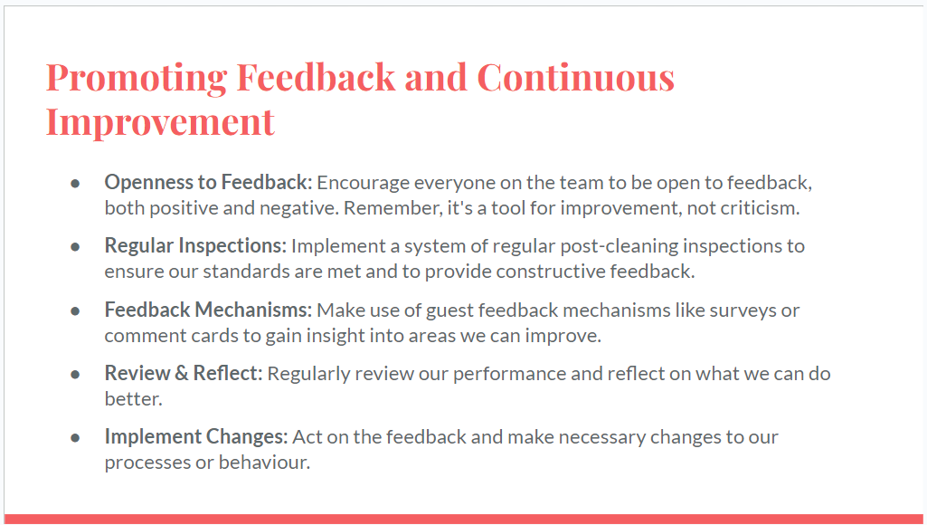

Training Notes:
- Discuss the significance of feedback in terms of enhancing our services.
- Explain the post-cleaning inspection procedure and how it will be utilised to provide constructive comments.
- Encourage open conversation and reflection on opportunities for development within the team.
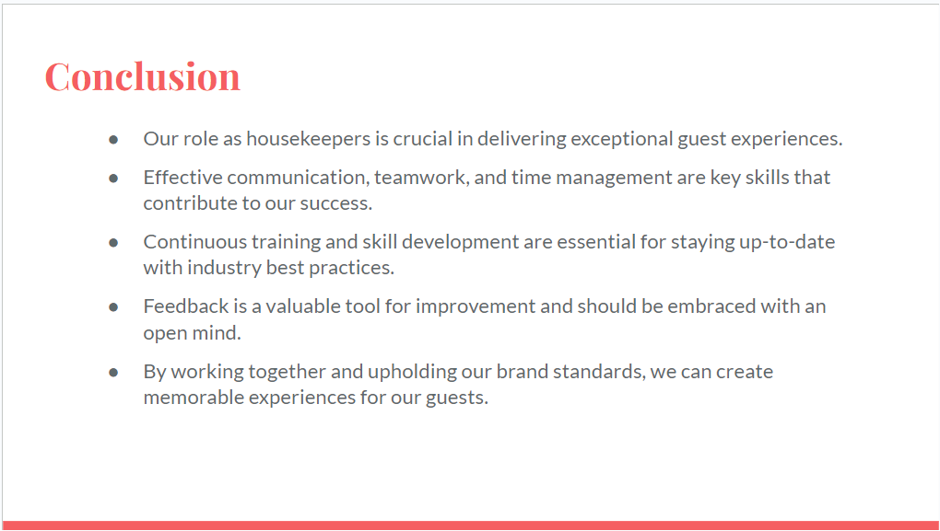

Training Notes:
- Summarise the presentation's important points and the next steps that need to be taken. Reiterate the importance of each area you've talked about and what it adds to the overall customer experience.
- Encourage your team members to use the ideas and plans you've talked about in their daily work.
- Thank the team for their hard work and commitment.

References

Baum, T. (2007). Human resources in tourism: Still waiting for change. Tourism Management, 28(6), 1383-1399.
Jurowski, C., & Gursoy, D. (2004). Distance effects on residents' attitudes toward tourism. Annals of Tourism Research, 31(2), 296-312.
Kusluvan, S. (2003). Managing employee attitudes and behaviors in the tourism and hospitality industry. Nova Science Publishers.
Lockyer, T. (2007). The international hotel industry: Sustainable management. New York: The Haworth Hospitality Press.
Reisinger, Y., & Turner, L. (2003). Cross-cultural behaviour in tourism: Concepts and analysis. Butterworth-Heinemann.
Riley, M. (2005). Food and beverage management. In Search of Experiences. Butterworth-Heinemann.
Riley, M. (2005). Human resource management in the hospitality and tourism industry. Oxford: Elsevier Butterworth-Heinemann.
Ross, G. F. (1995). Workplace stress in hospitality and tourism. Australian Journal of Hospitality Management, 2(1), 1-12.
Tayauova, G. (2012). Advantages and disadvantages of hospitality industry. Tourism and Hospitality Industry, 37, 39-47.

