University of Wales Trinity Saint David
Birmingham Campus



Strategic International Expansion: A Critical Evaluation of Lululemon Athletica’s Entry into the Indian Market
Achieving Sustainable Competitive Advantage through a Transnational Differentiation Strategy


Programme: Master of Business Administration
Module: Strategic Management (LCMB7003)
Lecturer: Simon Chatterton
Student Name: Yordanka Kancheva
Student ID: 2017633
Word Count: 5,094
Submission Date: November 2025
Executive Summary

This report critically evaluates the strategic viability of Lululemon Athletica’s expansion into the Indian market. Lululemon, a global leader in premium technical apparel, reported revenue of $10.3 billion and net profit of $1.55 billion in FY2023 (Lululemon Annual Report, 2024), signalling strong financial capacity for further internationalisation. Despite significant growth in Asia-Pacific, India remains an untapped yet strategically aligned market, characterised by rising disposable incomes, a rapidly expanding wellness economy, and a growing premium consumer class.
A comprehensive external analysis using PESTLE, CAGE, and Porter’s Five Forces reveals a dual landscape: high potential demand for premium athleisure, but substantial regulatory constraints, most notably the 30% local sourcing requirement for single-brand retailers (DPIIT, 2018). Industry rivalry is intense, and buyer price sensitivity is high; however, the premium segment remains underdeveloped, creating a viable entry niche.
Internal analysis demonstrates that Lululemon’s competitive advantage lies in its proprietary fabric technologies, experiential retail model, and strong brand equity, supported by valuable, rare, and difficult-to-imitate capabilities (Barney, 1991). These strengths justify a Focused Differentiation Strategy and support entry via a Joint Venture (JV) with a reputable local partner to mitigate regulatory and cultural distance.
The implementation plan outlines a phased market entry, starting with flagship stores in Mumbai and Delhi, supported by e-commerce integration, localised ambassador programmes, and climate-adapted product lines. Financial projections (Appendix E) indicate that a balanced strategy can achieve positive EBIT by Year 3.
Overall, India represents a strategically attractive opportunity, contingent on maintaining global quality standards while adapting downstream activities to local cultural expectations.

Table of Contents

1. Introduction and Strategic Rationale 5
1.1. Selection of Organisation: Lululemon Athletica Inc. 5
1.2. Selection of Target Market: India 5
2. Current Situation of Lululemon Athletica Inc. 6
3. Comprehensive Strategic Analysis 7
3.1. Analysis of the General Environment (PESTLE and CAGE) 7
3.1.1 PESTLE Analysis – India 7
3.1.2 CAGE Distance Analysis – India 9
3.2. Analysis of the Industry Environment (Porter's Five Forces) 10
3.3. Comprehensive SWOT Analysis 14
3.3.1 From SWOT to Strategy: The TOWS Analysis 15
4. Internal Organisational Analysis 17
4.1 Overview of Lululemon’s Internal Environment 17
4.2 VRIO Analysis of Key Resources and Capabilities 17
4.2.1 Brand Equity and the “Sweatlife” Community Ecosystem 17
4.2.2 Proprietary Fabric Technologies (Nulu™, Nulux™, Everlux™) 18
4.2.3 Organisational Culture and Human Capital 18
4.2.4 Financial Strength and Investment Capability 19
4.2.5 Summary of VRIO Findings 19
5. Strategy Development and Formulation 21
5.1 Strategic Alignment (Ansoff’s Matrix) 21
5.2 Strategic Options for Market Entry 21
5.3 Recommended Strategic Positioning (Differentiation-Focus + STP) 23
5.4 Strategy Implementation 25
6. Strategy Evaluation and Control 27
6.1 Performance Evaluation Framework (Balanced Scorecard) 27
6.2 Risk Analysis and Mitigation 29
7. Financial Plan 30
7.1 Strategic Financial Assumptions (SFAS) 30
7.2 Financial Highlights and Strategic Impact 31
7.3 Sensitivity Analysis: Testing Strategic Resilience 32
8. Recommendation and Conclusion 34
9. List of References 36
10. Appendices 39

1. Introduction and Strategic Rationale

Selection of Organisation: Lululemon Athletica Inc.

Lululemon Athletica Inc. is strategically compelling for international expansion analysis due to its distinctive competitive base and selective global footprint. The company has evolved into a premium global brand, driven by its differentiated design philosophy, proprietary fabric technologies, and strong community-based brand culture. Under the Resource-Based View (RBV), these capabilities constitute valuable, rare, and difficult-to-imitate resources that underpin sustained competitive advantage (Barney, 1991; Grant, 2019). Lululemon maintains a cautious internationalisation trajectory, focusing only on markets that can sustain its premium positioning, presenting a unique analytical opportunity to examine its competitive logic in a complex emerging economy.

1.2. Selection of Target Market: India

India is selected as the proposed new market due to its combination of macroeconomic dynamism, increasing wellness orientation, and rapidly expanding premium consumer segment. As the fastest-growing major economy (IMF, 2025), India’s urban disposable incomes are rising. Furthermore, the athleisure category is structurally growing yet remains underpenetrated at the premium level, creating a clear opportunity for differentiated market entry (Statista, 2024). Culturally, while yoga originates from deep-rooted traditions, the commercial premium yoga-wear segment is emerging, requiring careful adaptation to avoid perceptions of Western commercialisation (Khanna and Sengupta, 2020). However, India presents material entry barriers: the 30% local sourcing rule (DPIIT, 2018) introduces supply chain constraints, while competitive intensity demands high differentiation. These factors necessitate an entry strategy that mitigates regulatory risk and supports strong localisation, balancing global quality standards with local market realities.

2. Current Situation of Lululemon Athletica Inc.

Lululemon Athletica Inc. is a publicly listed North American company operating within the premium segment of the global athleisure industry. Its core purpose is encapsulated in its Vision (To elevate human potential...) and Mission (To design high-quality, innovative apparel...), driven by a strategic focus on international expansion and customer loyalty. The governance framework includes an independent Board of Directors, while the decentralised, functionally integrated organisational structure supports market agility (Lululemon Annual Report, 2024). Lululemon maintains a distinct market positioning through its product offering (detailed in Table 1), which spans yoga, running, and training, emphasising proprietary performance fabrics and community engagement (Euromonitor, 2024). Financially, the company reported $10.3 billion in revenue and $1.55 billion in net profit for FY2023, demonstrating strong liquidity and capacity to invest in new markets (Lululemon Annual Report, 2024). A summary of key financial indicators is presented in Table A3 (Appendix A).

Table 1: Lululemon Product Categories and Key Features
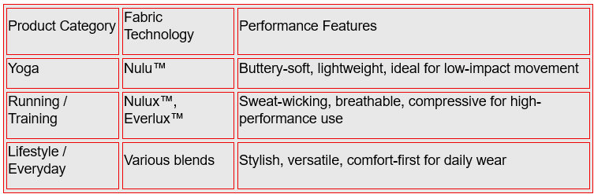Source: Lululemon Product Descriptions, 2024.

3. Comprehensive Strategic Analysis

3.1. Analysis of the General Environment (PESTLE and CAGE)

3.1.1 PESTLE Analysis – India

Political, Legal and Ethical Factors
Understanding the external institutional environment is critical (Hitt et al., 2024; Peng, 2022).
The 30% mandatory local sourcing required by the FDI regime (DPIIT, 2018) is the single greatest operational threat, forcing Lululemon to either compromise its global, quality-controlled supply chain or rely heavily on a Joint Venture partner to manage local compliance and quality audits. India’s FDI regime allows 100% foreign ownership but mandates 30% local sourcing (DPIIT, 2018). While this supports national industrial development, it imposes supply-chain rigidity and threatens Lululemon’s VRIO-differentiation (See Figure C1, Appendix C). Political complexity is heightened by fragmented state-level regulation (labour rules, zoning), increasing transaction costs and administrative distance (World Bank, 2023). Legally, the weak IP environment allows agile domestic players like BlissClub to replicate designs. Consumer protection laws and the BRSR framework (MoEFCC, 2022) raise ethical expectations, requiring credible environmental leadership.

Economic Factors
India remains the fastest-growing major economy, with GDP growth projected at 6.6% in 2025 (IMF, 2025). Favourable demographics and rising disposable incomes create attractive conditions for lifestyle brands (Statista, 2024); activewear is forecast to reach USD 29.9 billion by 2030 (MarketLine, 2023; see Figure C2, Appendix C). Crucially, while the overall market is expanding, the premium segment remains fragmented. The key to success lies in rapidly establishing a dominant position in the underserved affluent, urban consumer base before competitors like Nike and Adidas fully capitalise specialisation on the high-end growth. However, uneven wealth distribution sharply limits the immediately addressable market for premium-priced products (NITI Aayog, 2023). Currency volatility, inflationary pressures, and high GST rates may compress import-driven margins. Logistics inefficiencies outside major cities still inhibit scalability (KPMG, 2023). Sustainable entry depends on microeconomic positioning, price-value optimisation, and selective geographic expansion.

Sociocultural Factors
India presents a complex sociocultural landscape regarding yoga. While Lululemon frames it as lifestyle-oriented, the discipline carries deep spiritual significance (Khanna and Sengupta, 2020), introducing reputational risk from "Western commercialisation." Conversely, major urban centres are experiencing rapid wellness adoption and aspirational consumption among affluent women. India’s collectivist orientation (Hofstede Insights, 2023) reinforces the value of experiential branding and community events. Lululemon must collaborate with local ambassadors and co-host culturally grounded activations. (See Figure C3, Appendix C.)

Technological Factors
India is a mobile-first digital economy, with over 800 million internet users and widespread UPI adoption (KPMG, 2023). The expansion of AI-driven personalisation and AR tools strengthens opportunities for integrated omnichannel experiences. Digital channels partially mitigate CAGE geographic distance; however, fragmented e-commerce increases the risk of channel cannibalisation and inconsistent brand signalling (Peng, 2022). Cybersecurity gaps create additional reputational vulnerabilities.

Environmental Factors
India’s diverse climatic conditions require climate-specific product innovation and strengthen the relevance of the “Science of Feel” platform. Designing region-specific collections demands flexible inventory and partial sourcing localisation to control margins. Environmental expectations are rising alongside regulatory pressure from the EPR framework (MoEFCC, 2022) on textile waste. Non-compliance poses significant risks. Lululemon must embed eco-compliance and transparent sourcing practices into its localisation strategy.

Critical Reflection on the PESTLE Framework
While the PESTLE framework provides a systematic scan of the macro-environment, its application in the Indian context reveals inherent limitations. Firstly, the model tends to present a static snapshot of external factors, which may fail to capture the high velocity of regulatory change in India, such as the frequent amendments to FDI norms and e-commerce policies (Grant, 2019). Secondly, PESTLE treats India as a monolithic entity, obscuring significant state-level disparities in legal enforcement and cultural norms that directly impact operational feasibility (Panagariya, 2022). Finally, the framework analyses factors in isolation, potentially underestimating the complex interdependencies where political decisions (e.g., "Make in India" initiatives) directly override economic logic (Johnson et al., 2020). To mitigate these limitations, this report complements PESTLE with the CAGE framework to specifically measure the multidimensional "distance" between the home and host markets (Ghemawat, 2001).

3.1.2 CAGE Distance Analysis – India
Table 2. CAGE Distance Analysis for Lululemon’s Entry into India
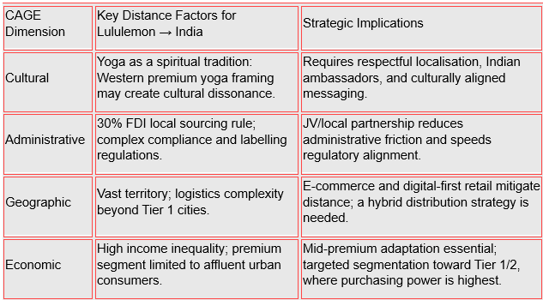
Source: Adapted from Ghemawat’s CAGE Distance Framework (2001), with additional data from DPIIT (2018) and IMF (2025).
The CAGE framework (Ghemawat, 2001) highlights moderate-to-high distance between Canada and India, particularly across cultural and administrative dimensions. Cultural distance stems from the spiritual significance of yoga in India, which may clash with Lululemon’s commercialised positioning. Administratively, the 30% local sourcing requirement increases entry barriers and reinforces the need for a Joint Venture strategy (DPIIT, 2018). Geographic distance continues to influence logistics, although India’s strong e-commerce infrastructure helps mitigate distribution challenges. Economically, income inequality narrows the immediate premium customer base, requiring careful segmentation and mid-premium pricing (IMF, 2025).

3.2. Analysis of the Industry Environment (Porter's Five Forces)

Porter’s Five Forces framework (Porter, 1980; 2008) provides a structured assessment of competitive pressures shaping the Indian athleisure market. Consistent with the Industrial Organisation (I/O) perspective, industry structure strongly influences firm performance (Hitt, Ireland and Hoskisson, 2024). India’s market displays both significant growth potential and structural challenges, requiring a differentiated, premium-focused approach for a brand such as Lululemon. Key market indicators supporting this analysis are summarised in Table C1, Appendix C.

Threat of New Entrants - Moderate
India’s strong e-commerce penetration and accessible contract manufacturing lower barriers for digital-first brands (MarketLine, 2023). D2C activewear startups can scale quickly through social media visibility and influencer partnerships. However, entering the premium technical apparel segment requires advanced fabric technologies, consistent quality and global-grade supply chains, capabilities that most new entrants lack (Redseer, 2023).
While capital requirements for online entry are low, sustaining long-term loyalty in premium segments demands high R&D investment, brand reputation and superior product performance. New foreign brands face regulatory and supply chain barriers, particularly the 30% local sourcing requirement (DPIIT, 2018).
Strategic Implication: Entry barriers protect Lululemon’s differentiation advantage but do not prevent mid-tier imitation, necessitating strong IP vigilance and local partnerships.

Competitive Rivalry - High
Rivalry in the Indian athleisure market is intense due to the presence of established global competitors (Nike, Adidas, Puma) with strong brand equity, omnichannel networks and high promotional spending (Statista, 2024). Domestic players such as BlissClub, HRX, Hummel India and Cultsport intensify competition by leveraging influencer-led marketing, rapid design imitation and aggressive pricing. Multi-brand e-commerce platforms: Myntra, Ajio and Tata CLiQ reinforce rivalry through discount-driven festival sales and high price transparency (KPMG, 2023).
Switching costs are minimal, product lifecycles are short, and digital comparison tools increase competitive pressure. In this environment, sustained product uniqueness is difficult, and premium entrants’ risk being drawn into price-based competition.
Strategic Implication: Lululemon must emphasise technical innovation, experiential retail and community-based engagement to defend a premium position and avoid dilution in a saturated landscape.

Bargaining Power of Buyers - High
Digitally empowered Indian consumers utilise e-commerce platforms for price and quality comparison, significantly strengthening buyer leverage. Even premium consumers exhibit high value-consciousness, expecting superior fabric performance, ethical sourcing and a compelling brand story (KPMG, 2023). High return rates in Indian e-commerce further increase operational costs, reinforcing the need for clear value communication.
Income inequality narrows the premium customer base, intensifying expectations among affluent segments while heightening product scrutiny. Price elasticity remains high even in Tier 1 markets, requiring precise alignment between price, performance and perceived lifestyle value.
Strategic Implication: Lululemon must justify premium pricing through superior functionality, sustainability credentials and personalised in-store experiences.
Bargaining Power of Suppliers – Moderate
Supplier power is shaped by the interaction between India’s fragmented textile sector and Lululemon’s dependence on specialised technical materials. Domestic suppliers capable of producing high-performance fabrics are limited, increasing switching costs and raising leverage for qualified manufacturers (Hitt et al., 2024). The 30% FDI local sourcing requirement (DPIIT, 2018) further constrains supplier choice and operational flexibility.

However, India has a large garment manufacturing base for non-technical components, enabling partial localisation without compromising core fabric technology.
Strategic Implication: A hybrid sourcing model, importing proprietary fabrics while partnering with certified MSMEs for other components - optimises quality, cost and compliance.

Threat of Substitutes - Moderate to High
Substitutes include unbranded activewear, budget sportswear, fast-fashion alternatives (H&M, Zara), and traditional cotton garments commonly used for yoga. These options are significantly cheaper and culturally familiar, especially outside Tier 1 cities. Even premium consumers experiment with substitutes due to high price sensitivity.
Strategic Implication: Lululemon must continuously reinforce the value of technical performance, longevity, fit and community-driven lifestyle identity.

The industry’s high rivalry, strong buyer power, regulatory constraints and substitute availability make cost leadership unviable, confirming the I/O model’s prediction of low structural attractiveness for price-based strategies. However, the absence of a dominant premium leader and the expansion of affluent urban consumers create a viable niche.
Conclusion: India’s industry dynamics strongly favour a Differentiation-Focus strategy, supported by premium innovation, cultural localisation and a partnership-based entry mode.

Critical Evaluation of Porter’s Five Forces Model
Although Porter’s Five Forces effectively maps competitive intensity, its applicability to the Indian athleisure sector requires critical qualification. The framework is rooted in the structure-conduct-performance (SCP) paradigm, which assumes relatively stable industry boundaries and zero-sum competition (Hitt et al., 2024). In the context of India’s emerging wellness economy, this perspective may underestimate the role of "complementors" (e.g., wellness apps, boutique gyms), which expand the total market value rather than just competing for share (Grant, 2019). Furthermore, the model was developed primarily for developed economies and may not fully account for the disruptive influence of the unorganised (informal) sector, which significantly distorts price expectations and buyer power in India. Consequently, while the analysis confirms intense rivalry, Lululemon’s strategy must look beyond purely structural defences and focus on creating new market space through community engagement, akin to a Blue Ocean Strategy (Kim and Mauborgne, 2005).

3.3. Comprehensive SWOT Analysis

Following the comprehensive external audit (PESTLE, CAGE, Porter’s Five Forces), Table 3 synthesises the key findings into a Strategic Factor Analysis Summary (SWOT) to facilitate strategic option generation.
Table 3: Strategic Factor Analysis Summary (SWOT) for Lululemon’s Entry into India
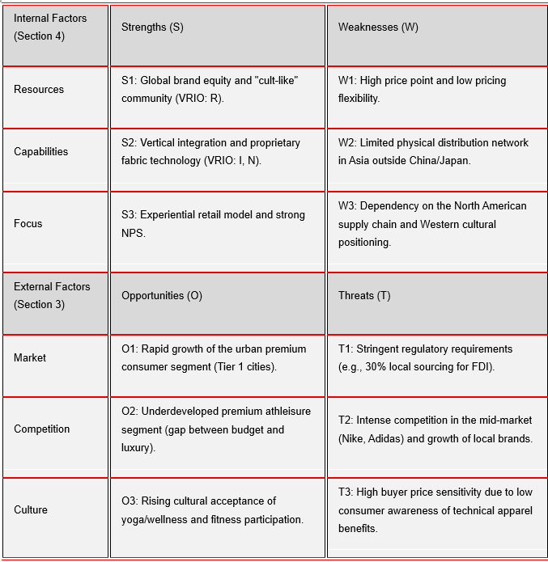
Source: Developed by the author based on analysis in Sections 3.1, 3.2, and 4.2 (Porter, 1985; Barney, 1991).

3.3.1 From SWOT to Strategy: The TOWS Analysis

The TOWS framework is applied to synthesise the situational analysis, transitioning findings into specific strategic options (Weihrich, 1982).

Figure 1: TOWS Strategic Option Generation Matrix
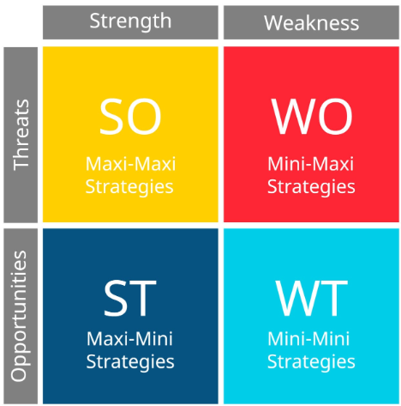
Source: Adapted from Weihrich (1982), developed by the author.

SO (Maxi-Maxi): Leverage Experiential Retail (S3) and Brand Equity (S1) to capture the Underdeveloped Premium Segment (O2), supporting a high-value, low-volume entry strategy.
ST (Maxi-Mini): Utilise Vertical Integration (S2) to strategically address the 30% Local Sourcing Requirement (T1), transforming the regulatory threat into a supply chain advantage.
WO (Mini-Maxi): Overcome Limited Distribution (W2) by capitalising on the Rising Wellness Culture (O3) through initial digital penetration, mitigating the need for heavy capital outlay.
WT (Mini-Mini): The combination of High Price Point (W1) and Buyer Price Sensitivity (T3) mandates the Joint Venture (JV) Entry Strategy (Section 5.3) to share financial risk and secure local distribution.
Strategic Rationale: The strategy relies heavily on SO and ST alignment, confirming the feasibility of a Differentiation-Focus approach by leveraging unique internal competencies to exploit the market gap while systematically mitigating regulatory and price risks.

4. Internal Organisational Analysis

4.1 Overview of Lululemon’s Internal Environment

Lululemon’s internal environment is defined by a portfolio of intangible resources and capabilities that align strongly with the assumptions of the Resource-Based View (RBV). According to Barney (1991) and Peteraf (1993), sustainable competitive advantage arises when resources are valuable, rare, inimitable, and supported by an organisation capable of leveraging them effectively. Yet, RBV has been criticised for insufficiently addressing contextual contingencies (Priem and Butler, 2001); therefore, when assessing transferability to emerging markets, institutional distance and local constraints must be considered (Peng, 2022).
This section applies a VRIO lens to identify which of Lululemon’s key resources can realistically support competitive advantage in India’s regulatory, cultural and price-sensitive environment. A summary matrix is presented in Table A1 (Appendix A), followed by targeted managerial recommendations aligned with India-specific constraints.

4.2 VRIO Analysis of Key Resources and Capabilities

4.2.1 Brand Equity and the “Sweatlife” Community Ecosystem

Lululemon’s brand equity, rooted in emotional identification, experiential retail, and lifestyle signalling, meets VRIO criteria of rarity and inimitability (Aaker, 1996; Keller, 2013). The “Sweatlife” community model and ambassador programme create tacit, socially embedded value that mass-market competitors struggle to replicate (Holt, 2004).
Contextual limitation:
In India, yoga is culturally embedded as a spiritual and philosophical practice. Lululemon’s Westernised “yoga-as-lifestyle” framing may risk cultural incongruence (Khanna and Sengupta, 2020), reducing authenticity.
Managerial implication:
Lululemon must re-contextualise its brand narrative, institutionalising a local ambassador system that features Indian yoga teachers, spiritual practitioners, and wellness influencers. This adaptation enhances authenticity and protects brand equity in a culturally sensitive environment.
Brand authenticity and cultural resonance are critical for sustaining premium positioning in emerging markets (Beverland, 2005).

4.2.2 Proprietary Fabric Technologies (Nulu™, Nulux™, Everlux™)

Lululemon’s differentiating technological capabilities, moisture-wicking innovations, stretch engineering and proprietary fabric IP are rare, valuable and costly to imitate (Grant, 2019). These underlie its premium positioning and justify higher price points relative to domestic competitors such as BlissClub and HRX.
Contextual limitation:
India’s 30% local sourcing requirement (DPIIT, 2018) may force dependence on MSME suppliers with limited capacity to meet technical specifications, risking lower product integrity and eroding inimitability.
Managerial implication:
Lululemon should maintain centralised production for core technical fabrics while localising only low-risk SKUs (mats, accessories, basic tops). This hybrid sourcing model ensures both regulatory compliance and quality preservation.
Reference details are summarised in Table A1 and Table A3 (Appendix A).

4.2.3 Organisational Culture and Human Capital

Lululemon’s organisational culture, characterised by empowerment, decentralised decision-making, and experiential service, constitutes a deeply tacit and hard-to-imitate capability (Teece, 2014). Employee training, goal-setting practices and in-store rituals create strong internal cohesion and customer engagement (Kozinets et al., 2010).
Contextual limitation:
Cultural distance (Ghemawat, 2001) limits the automatic transferability of these routines. Misalignment with Indian expectations around modesty, spirituality, gender norms and service scripts could reduce customer resonance and employee effectiveness.
Managerial implication:
Lululemon should implement a Cultural Integration Training Toolkit (see Table A2, Appendix A), incorporating Indian wellness traditions, greeting norms, and community-building practices. This ensures organisational culture remains valuable and relevant in context.

4.2.4 Financial Strength and Investment Capability

Lululemon’s strong financial base - $10.3bn revenue, $1.55bn net profit and $2.2bn in cash reserves (Lululemon Annual Report, 2024) - confirms significant investment capacity for international expansion. High gross margins (≈58%) provide strategic flexibility to sustain premium entry in price-sensitive markets. Financial capability indicators are summarised in Table A3 (Appendix A).
Critical constraint:
A vertically controlled supply chain conflicts with India’s local sourcing mandate, potentially increasing operational costs and extending lead times.
Strategic recommendation - Adopt a phased investment model:
Phase 1: Enter via a Joint Venture with a premium retail partner (e.g., Tata CLiQ Luxury).
Phase 2: Localise selected products once quality-certifiable MSMEs are identified.
Phase 3: Expand to experiential flagship stores after supply chain stability is achieved.

4.2.5 Summary of VRIO Findings

Lululemon possesses multiple VRIO-qualifying resources, brand equity, proprietary fabrics, and a community-oriented culture, but their transferability to India is constrained by cultural distance, institutional requirements and price sensitivity. To secure a sustained advantage, Lululemon must adapt rather than replicate its operating model.
Strategic priorities emerging from VRIO are Authenticity through cultural localisation, Selective localisation of production, and Protection of core competencies via a controlled JV structure.
Lululemon’s underlying value creation logic is further illustrated through its value chain (Figure D1, Appendix D), which highlights material innovation and experiential retail as core differentiators.

Critique of the Resource-Based View (RBV) in an International Context
The VRIO analysis confirms Lululemon’s internal strengths, yet the RBV framework has a critical limitation when applied to international expansion: it assumes that resources which are valuable in the home market remain valuable abroad (Priem and Butler, 2001). In the case of India, Lululemon’s core resource, its Westernised yoga branding, faces the "paradox of transferability." What is a differentiation asset in North America may become a liability in India due to cultural sensitivity and accusations of appropriation. Therefore, a static VRIO analysis is insufficient; it must be augmented by a "Dynamic Capabilities" perspective (Teece, 2014), which emphasises the organisation’s ability to reconfigure and adapt its resources to match the high-velocity environment of the Indian market.

5. Strategy Development and Formulation

Strategy formulation refers to the process of integrating external opportunities and internal capabilities to determine the most appropriate strategic direction for achieving competitive advantage (Hitt, Ireland and Hoskisson, 2024). It involves evaluating strategic options, selecting the optimal market entry mode, and defining how organisational strengths can mitigate contextual risks and drive superior performance.
The strategic configuration is presented visually in Figure D5 (Appendix D).

5.1 Strategic Alignment (Ansoff’s Matrix)

The decision to enter the Indian market with Lululemon’s existing core product line (premium technical apparel) aligns directly with the Market Development quadrant of Ansoff’s Matrix (Ansoff, 1957). This strategy leverages the company’s strong existing product platform and brand equity (Lululemon Annual Report, 2024) to target new customer segments in a geographically distinct region. The primary risk of this approach is the lack of familiarity with the new market's specific distribution channels, cultural nuances, and competitive dynamics. This highlights the need for a tailored, rather than uniform, market penetration approach.

5.2 Strategic Options for Market Entry

Entering an emerging and institutionally complex market such as India requires careful evaluation of alternative entry modes. Entry mode theory highlights that firms must balance control, resource commitment and risk exposure when internationalising (Root, 1994; Hill, 2022). For Lululemon, three strategic options are available: Wholly Owned Subsidiary (WOS), Franchising, and Joint Venture (JV). Their suitability varies significantly when assessed against India’s regulatory constraints, cultural distance and competitive dynamics. The comparative evaluation of entry options indicates that a Joint Venture offers the highest strategic fit across regulatory, cultural and operational dimensions (see Figure D4, Appendix D).
This alignment is further illustrated through the Strategy–Structure Fit Model, which demonstrates why a JV best supports Lululemon’s differentiation and localisation requirements in India (see Figure D6.5, Appendix D).

Wholly Owned Subsidiary (WOS)
A WOS provides maximum control, brand protection and alignment with Lululemon’s premium experience-led model (Luo, 2007). However, in India, it is strategically unsuitable due to two critical barriers:
- The 30% local sourcing mandate for single-brand retailers (DPIIT, 2018) threatens fabric quality and undermines VRIO resources.
- High administrative distance and bureaucratic complexity (Khanna and Palepu, 2010). WOS would therefore increase liability of foreignness, raise operating costs and delay market entry.
Conclusion: Not viable for initial entry.

Franchising
Franchising offers low resource commitment and rapid scaling (Mendelsohn, 2004). Yet it dilutes control over customer experience, talent training and brand authenticity, all of which are central to Lululemon’s differentiation-based strategy. In culturally sensitive markets, high-end experiential brands commonly avoid franchising due to inconsistent service quality (Beverland, 2005).
Conclusion: Misaligned with Lululemon’s premium model; risk of brand dilution.

Joint Venture (JV) - Most strategically appropriate
A JV with an established Indian luxury retailer (e.g., Tata CLiQ Luxury) offers shared risk, improved legitimacy and access to embedded market knowledge (Meyer and Peng, 2016; Johanson and Vahlne, 2009). It directly mitigates CAGE distances:
- Administrative → partner manages compliance, sourcing and state-level regulations.
- Cultural → local partner supports authentic messaging and consumer insight.
- Geographic → established logistics enable Tier 1 distribution.
- Economic → partner assists segmentation and luxury market positioning.
A JV further ensures compliance with local sourcing rules and protects Lululemon’s core competencies by allowing partial localisation of low-risk product lines only.
Final Judgement:
A Joint Venture represents the optimal entry mode because it balances control and flexibility, reduces institutional risk, accelerates market penetration and preserves the brand’s VRIO-based competitive advantages.

5.3 Recommended Strategic Positioning (Differentiation-Focus + STP)

Successful market entry requires a positioning strategy that leverages Lululemon’s VRIO capabilities while mitigating India’s structural constraints. Porter’s Generic Strategies model indicates that in high-rivalry, high buyer-power industries, firms should avoid price-based competition and instead pursue differentiation grounded in unique value creation (Porter, 1980; Hill, 2022). For Lululemon, a differentiation-focused strategy is the most viable pathway.
Price–performance comparisons further confirm the feasibility of a Differentiation-Focus strategy (see Figure D6.1, Appendix D).

Strategic Rationale for Differentiation-Focus
Lululemon’s core competencies, proprietary fabrics, experiential retail, and community-led engagement are rare and difficult to imitate (Barney, 1991; Keller, 2013). Competing on price would erode these advantages and place the brand in direct comparison with mass and mid-range competitors such as Decathlon, Puma and Blissclub (Statista, 2024). The premium consumer segment in India, although narrow, exhibits a high willingness to pay and views wellness consumption as an identity marker (Euromonitor, 2024).

STP Framework: Targeting the Premium Wellness Consumer
Segmentation
India’s athleisure consumers can be segmented by income, lifestyle orientation and wellness behaviour (see Table D2, Appendix D).
Targeting
Lululemon should target urban, wellness-driven women aged 22-45 located in Mumbai, Delhi and Bengaluru. Consumer value mapping confirms that this segment exhibits the strongest willingness to pay for premium technical apparel (see Figure D6.3, Appendix D). These consumers value premium experiences and cultural alignment.
Managerial Recommendation 1:
Position Lululemon around “aspirational wellness luxury”, differentiating it from sports brands and embedding it in India’s lifestyle-consumption culture.
Positioning
A strong positioning statement for India is proposed: “Premium performance meets mindful Indian wellness.” This reinforces both functional superiority and cultural authenticity.
A competitive positioning map is provided in Figure D3 (Appendix D).

Three Differentiation Pillars
Technical Superiority - Emphasise Nulu™, Nulux™ and Everlux™ through performance storytelling.
Cultural Authenticity - Cultural distance poses a misalignment risk (Ghemawat, 2001).
Comparative cultural–performance analysis further highlights a noticeable cultural alignment gap between Lululemon and local Indian competitors, reinforcing the need for deep localisation (see Figure D6.2, Appendix D).
Managerial Recommendation 2: Localise the Sweatlife model via partnerships with Indian yoga instructors, Ayurveda practitioners and meditation schools.
Experience-Led Retail - Experiential differentiation should include community events, climate-specific product trials, and premium boutique retail formats.

Critical Reflection: Limitations and Strategic Risks
Two context-specific risks emerge:
High buyer expectations regarding sustainability and performance.
Managerial Recommendation 3: Launch a “Lululemon India Climate Capsule Collection” tailored to hot and humid conditions.

Narrow premium segment due to income inequality.
Managerial Recommendation 4: Start with a phased flagship rollout (Mumbai → Delhi → Bengaluru) before scaling to secondary cities.

5.4 Strategy Implementation

Effective strategy implementation requires aligning people, processes and resources to deliver the intended competitive advantage (Noble, 1999; Hitt et al., 2024). For Lululemon, execution in India must balance global capability transfer with local responsiveness.
Product Localisation.
Lululemon should maintain centralised production for high-performance fabrics while selectively localising low-risk accessories to satisfy India’s 30% FDI sourcing rule (DPIIT, 2018). Climate adaptation is essential: lightweight, heat-resistant and modesty-friendly designs should complement core imported lines. The competitive clustering matrix identifies a clear “premium technical white space” supporting this product strategy (see Figure D6.4, Appendix D).
Retail and Omnichannel Rollout.
Implementation should begin with flagship stores in Jio World Drive (Mumbai), DLF Emporio (Delhi) and UB City (Bengaluru), paired with e-commerce through Tata CLiQ Luxury. This hybrid model maximises reach while preserving experiential differentiation.
Human Capital and Cultural Integration.
Transferring Lululemon’s experiential culture requires targeted training on Indian wellness norms, modesty expectations and festival-based merchandising. The Cultural Integration Toolkit (Appendix A2) supports this process and mitigates cultural-distance risks (Ghemawat, 2001).
Operational Structure.
The JV partner should manage compliance, local sourcing and logistics, while Lululemon retains control over brand communication, ambassador programmes and in-store experience design, protecting VRIO resources while reducing liability of foreignness.

6. Strategy Evaluation and Control

6.1 Performance Evaluation Framework (Balanced Scorecard)

To ensure the successful implementation of the Differentiation-Focus strategy, the Balanced Scorecard (BSC) is selected as the primary evaluation framework (Kaplan and Norton, 1992). The BSC moves beyond purely financial metrics to align operational activities with long-term strategic goals. This integrated approach is crucial for Lululemon’s entry into India, as success relies equally on non-financial metrics like customer loyalty and cultural alignment. The strategic objectives, measures, and targets are detailed in Table 4.

Table 4: Balanced Scorecard (BSC) for Lululemon India Entry (3-Year Plan)
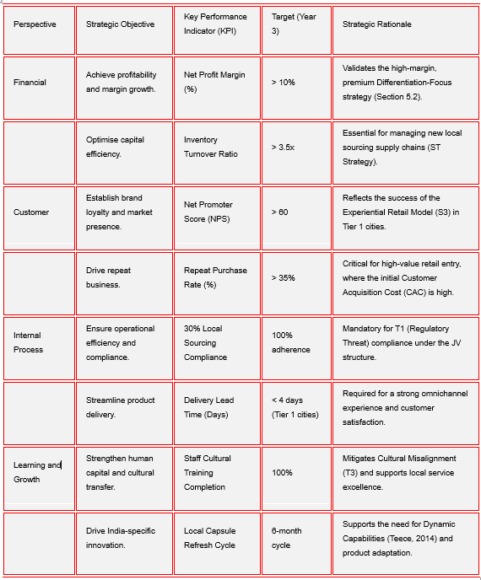
Source: Adapted from Kaplan and Norton (1992), developed by the author based on Lululemon’s internal capabilities.

6.2 Risk Analysis and Mitigation

International expansion is inherently risk laden. The strategy's exposure to major threats is assessed using a Likelihood/Impact Risk Matrix (Simons, 1995), focusing on the most critical operational and external risks (Grant, 2019). The BSC provides the control system, while the risk analysis informs the need for the Sensitivity Analysis in the Financial Plan (Section 7).
Table 5: Strategic Risk Matrix for Lululemon India
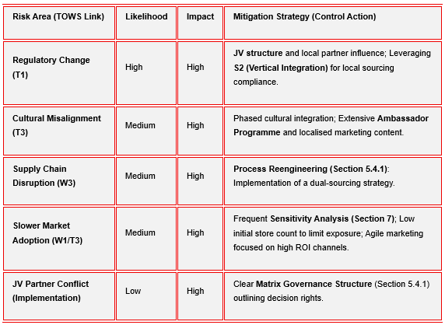
Source: Developed by the author.
Rigorous Risk Analysis informs the metrics within the BSC’s Financial perspective. Furthermore, the strategic viability of the entire expansion is confirmed through the Sensitivity Analysis, which is quantitatively executed in the Financial Plan (Section 7) to assess the impact of these risks on profitability.

7. Financial Plan

The financial plan evaluates the viability of Lululemon’s proposed entry into India, demonstrating how the high-margin, Differentiation-Focus strategy translates into quantifiable results over the first three years (Kaplan and Norton, 1996). A detailed projection of revenue, costs, and EBIT is provided in the Full Financial Forecast (Table E2, Appendix E). The analysis confirms the strategy’s feasibility by projecting the achievement of Net Profit by Year 2 (₹10 crore), validating the profitability of the Joint Venture (JV) model despite significant initial operational expenditure.

7.1 Strategic Financial Assumptions (SFAS)

The three-year financial projections are based on the following critical assumptions, benchmarked against industry data for premium retail expansion in emerging Asian markets:

Table 6: Key Financial Assumptions (SFAS) Driving Projections
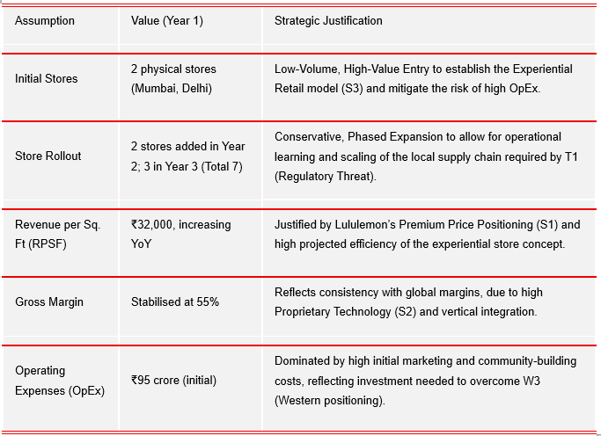
Source: Developed by the author based on Lululemon Annual Report (2024) and Euromonitor (2023).

7.2 Financial Highlights and Strategic Impact

The strategic importance of the financial statements lies in their role as control mechanisms (Simons, 1995). Table 8 summarises how core financial metrics link directly to strategic success:

Table 7: Core Financial Metrics and Strategic Linkages
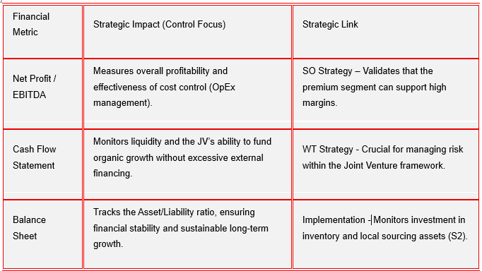
Source: Developed by the author based on Kaplan and Norton (1992).

7.3 Sensitivity Analysis: Testing Strategic Resilience

As highlighted in the Risk Analysis (Section 6), the strategy's robustness is tested for resilience. The Sensitivity Analysis assesses the quantitative impact of the highest-impact risks on the projected Net Profit in Year 2, which is the critical break-even year.

Table 8: Sensitivity Analysis on Net Profit (Year 2)
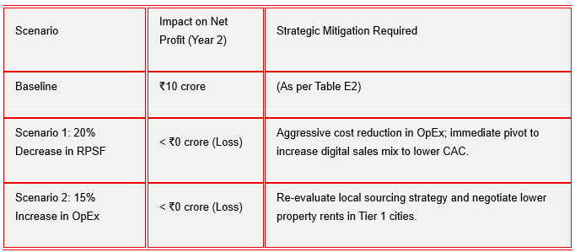
Source: Developed by the author based on projected data.

The analysis reveals the strategy is highly sensitive to both sales volume (RPSF) and operational costs. This mandates rigorous monitoring using the Balanced Scorecard (Section 6) to ensure rapid corrective action is taken if sales targets are missed.

8. Recommendation and Conclusion

This report has critically assessed Lululemon’s potential entry into India, confirming that the market presents a unique opportunity for premium athleisure, contingent on mitigating significant institutional and competitive complexity.

Recommended Strategy:
The recommended strategy is a Joint Venture (JV) with a reputable Indian partner, providing the optimal balance between strategic control and necessary local institutional responsiveness. This model directly addresses the 30% local sourcing mandate (T1) and provides the cultural legitimacy required to overcome high buyer expectations.
Lululemon should adopt a Differentiation-Focus positioning, leveraging its VRIO-derived capabilities (proprietary fabrics, experiential retail, and community model) to secure a defensible and scalable presence. Implementation must follow a conservative, phased rollout in Tier 1 cities, supported by an integrated digital and community-building effort.

Critical Managerial Insight (Synthesis of Risk and Control):
Strategic viability is highly sensitive to two key factors identified through the Sensitivity Analysis (Section 7) and Risk Matrix (Section 6): (1) Cultural misalignment or misinterpretation of yoga heritage, and (2) potential dilution of proprietary fabric quality due to local sourcing pressures. The Balanced Scorecard provides the necessary framework to track these non-financial risks alongside profitability.

Final Recommendation:
Lululemon must establish a dedicated India Localisation and Innovation Board within the JV structure. This cross-functional governance mechanism is essential for overseeing cultural adaptation, product localisation decisions, and supplier capability audits. This control system ensures that Lululemon's core Differentiation is preserved while meeting local regulatory and consumer expectations.

Conclusion:
If Lululemon enters India through this culturally sensitive JV, protects its innovation-based capabilities, and executes its phased, premium positioning, it is well positioned to build a defensible and scalable presence in one of the world’s most dynamic wellness markets.

9. List of References

Aaker, D.A. (1996) Building Strong Brands. New York: Free Press.
Ansoff, H.I. (1957) 'Strategies for diversification', Harvard Business Review, 35(5), pp. 113-124.
Barney, J. (1991) ‘Firm resources and sustained competitive advantage’, Journal of Management, 17(1), pp. 99-120.
Beverland, M. (2005) ‘Crafting brand authenticity: the case of luxury wines’, Journal of Management Studies, 42(5), pp. 1003-1029.
Damodaran, A. (2012) Investment Valuation: Tools and Techniques for Determining the Value of Any Asset. 3rd edn.
DPIIT (2018) Consolidated FDI Policy Circular on Single Brand Retail Trading (SBRT). Department for Promotion of Industry and Internal Trade, Government of India.
ET Retail (2023) Indian consumers increasingly demand sustainability transparency in apparel. Available at: https://retail.economictimes.indiatimes.com
Euromonitor (2024) Premium Athleisure in India: Market Forecasts and Consumer Trends 2024-2030. London: Euromonitor International. Available at: https://www.euromonitor.com/
Ghemawat, P. (2001) ‘Distance Still Matters: The Hard Reality of Global Expansion’, Harvard Business Review, 79(8), pp. 137-147.
Grant, R.M. (2019) Contemporary Strategy Analysis. 10th edn. Hoboken: Wiley.
Hitt, M.A., Ireland, R.D. and Hoskisson, R.E. (2024) Strategic Management: Concepts and Cases. 14th edn. Boston: Cengage Learning.
Hofstede Insights (2023) Country Comparison: India. Available at: https://www.hofstede-insights.com
Holt, D.B. (2004) How Brands Become Icons: The Principles of Cultural Branding. Boston: Harvard Business School Press.
IMF (2025) World Economic Outlook Update: Global Prospects and Policies. International Monetary Fund.
Johnson, G., Whittington, R. and Scholes, K. (2020) Exploring Strategy: Text and Cases. 12th edn. Harlow: Pearson Education.
Kaplan, R.S. and Norton, D.P. (1996) The Balanced Scorecard: Translating Strategy into Action. Boston: Harvard Business School Press.
Keller, K.L. (2013) Strategic Brand Management: Building, Measuring and Managing Brand Equity. 4th edn. Harlow: Pearson.
Khanna, S. and Sengupta, A. (2020) ‘Yoga, Identity and Consumer Culture in India’, Journal of Consumer Research, 47(5), pp. 778-799.
Kim, W.C. and Mauborgne, R. (2005) 'Blue Ocean Strategy: From Theory to Practice', California Management Review, 47(3), pp. 105-121.
Kotler, P. and Keller, K. (2022) Marketing Management. 16th edn. Pearson
Kozinets, R.V., Sherry, J.F., DeBerry-Spence, B., Duhachek, A., Nuttavuthisit, K. and Storm, D. (2010) ‘Networked narratives: understanding word-of-mouth marketing in online communities’, Journal of Consumer Research, 37(5), pp. 848-867.
KPMG (2023) India Retail and Consumer Report 2023. KPMG India.
Kumar, V. (2018) ‘Segmentation, Targeting, and Positioning (STP): A Framework for Competitive Advantage’, Journal of Marketing Strategy, 10(2), pp. 45-60.
Lululemon Athletica Inc. (2024) Annual Report 2024. Vancouver: Lululemon Athletica Inc. Available at: https://corporate.lululemon.com/~/media/Files/L/Lululemon/investors/annual-reports/lululemon-2024-annual-report.pdf
MarketLine (2023) India Sportswear and Athleisure Market Report. MarketLine Industry Profiles.
MoEFCC (2022) Extended Producer Responsibility (EPR) Guidelines for Plastic and Textile Waste. Ministry of Environment, Forest and Climate Change, Government of India.
NITI Aayog (2023) State of Inequality in India Report. Government of India.
Panagariya, A. (2022) India’s Trade and Regulatory Environment. New Delhi: Oxford University Press.
Porter, M.E. (1980) Competitive Strategy: Techniques for Analysing Industries and Competitors. New York: Free Press.
Porter, M.E. (2008) ‘The Five Competitive Forces That Shape Strategy’, Harvard Business Review, 86(1), pp. 78-93.
Prahalad, C. K. and Hamel, G. (1990). The Core Competence of the Corporation. Harvard Business Review, 68(3), pp. 79-91.
Priem, R.L. and Butler, J.E. (2001) 'Is the Resource-Based "View" a Useful Perspective for Strategic Management Research?', Academy of Management Review, 26(1), pp. 22-40.
Redseer (2023) India Activewear Market Report 2023. Bangalore: Redseer Strategy Consultants.
Simons, R. (1995) Levers of Control: How Managers Use Innovative Control Systems to Drive Strategic Renewal. Boston: Harvard Business School Press.
Statista (2024) Activewear Market in India - Revenue and Forecast Data. Statista Research Department.
Teece, D.J. (2014) 'The Foundations of Enterprise Performance: Dynamic and Ordinary Capabilities in an (Economic) Theory of Firms', Academy of Management Perspectives, 28(4), pp. 328-352.
Weihrich, H. (1982) 'The TOWS Matrix-A Tool for Situational Analysis', Long Range Planning, 15(2), pp. 54-66.
World Bank (2023) Doing Business Indicators - India Regulatory Environment. World Bank Group.

10. Appendices

Appendix A: Internal Analysis Support

Table A1. VRIO Evaluation of Lululemon’s Key Resources and Capabilities
Resource / Capability | Valuable (V) | Rare (R) | Inimitable (I) | Organised (O) | Competitive Implication
Brand equity and “Sweatlife” community | Yes | Yes | Yes | Yes | Sustained competitive advantage
Proprietary fabrics (Nulu™, Nulux™, Everlux™) | Yes | Yes | Yes | Yes | Sustained competitive advantage
Organisational culture and human capital | Yes | Yes | Partially | Yes | Strong but potentially imitable advantage
Global supply chain and partner network | Yes | No | Partially | Yes | Temporary competitive advantage/parity
Financial strength (cash reserves, profitability) | Yes | No | No | Yes | Necessary but not sufficient for differentiation
Source: Adapted from Barney (1991), Hitt et al. (2024) and Grant (2019).

Table A2. Cultural Integration Playbook – India
Component | India-Specific Requirements | Managerial Notes
Brand storytelling | Respect for yoga’s spiritual heritage | Co-create content with Indian yoga experts
Community events | Yoga festivals, Ayurveda workshops | Partner with Art of Living / Isha Foundation
Staff training | Cultural sensitivity, Sanskrit basics | Train via accredited Indian yoga schools
Store rituals | Diwali, Holi, International Yoga Day | Localised community calendar
Source: Author’s own work based on Holt (2004), Khanna and Sengupta (2020).

Table A3. Phased Financial Entry Model - Cost Implications
Phase | Strategic Focus | CapEx / OpEx Impact | Risk Level | Notes
Phase 1 | JV with Tata CLiQ Luxury | Low - moderate | Low | Circumvents the immediate 30% sourcing rule
Phase 2 | Localisation of selected SKUs | Moderate | Medium | Only accessories + basics (not performance leggings)
Phase 3 | Flagship store in Mumbai/Delhi | High | Medium - High | After brand validation
Source: Adapted from IMF (2025), DPIIT (2018), and Lululemon Annual Report (2024).

Appendix B: Semi-Structured Interview Guide - Indian Premium Athleisure Consumers

Table B1. Interview Guide for Exploring Consumer Perceptions of Premium Athleisure in India
Question No. | Interview Question | Purpose of the Question
Q1 | How would you describe your current approach to fitness, yoga and wellness in your daily life? | Understand lifestyle context and wellness habits
Q2 | What brands do you currently associate with premium activewear or athleisure, and why? | Identify perceived competitors and brand associations
Q3 | How important are factors such as fabric quality, comfort and performance when you choose sportswear? | Assess value drivers and product expectations
Q4 | How do you feel about international brands entering India in categories connected to yoga and wellness? | Explore cultural perceptions and potential dissonance
Q5 | To what extent do sustainability and ethical sourcing influence your purchase decisions? | Gauge ethical and ESG sensitivity
Q6 | What would a brand need to offer for you to justify paying a premium price for activewear? | Identify willingness to pay and differentiation levers
Source: Author’s own work.

Appendix C: Graphs and Secondary Data

Figure C1: India GDP Growth Forecast (2023–2030)
Source: Adapted from IMF (2025).

Figure C2: Indian Athleisure Market Size Forecast (2023–2030)
Source: Adapted from MarketLine (2023); Statista (2024).

Table C1. Summary of Key Market and Regulatory Indicators - India
Category | Indicator / Data Point | Value / Description | Source
Economic Growth | GDP Growth Forecast (2025) | 6.6% | IMF (2025)
Market Size | Athleisure Market (2030) | $29.9 billion | MarketLine (2023)
Market Growth | Aggregate CAGR (2023-2030) | 12.5% | Statista (2024)
Demographics | Share of population underage 35 | 65% | NITI Aayog (2023)
Urbanisation | Urban population (2024) | 36% but rising | World Bank (2023)
Digital Penetration | Active internet users | >800 million | KPMG (2023)
FDI Policy | Local sourcing requirement (single-brand retail) | 30% from domestic MSMEs | DPIIT (2018)
ESG Regulation | EPR textile and packaging waste compliance | Mandatory | MoEFCC (2022)
Consumer Sentiment | % consumers preferring sustainable premium activewear | 41% | ET Retail (2023)
Competition | Nike's market share in India | ~27% | Redseer (2023)
Price Sensitivity | Median disposable income (urban Tier 1) | Growing ~12% YoY but still highly price elastic | Statista (2024)
Source: IMF 2025; MarketLine 2023; NITI Aayog 2023; DPIIT 2018; MoEFCC 2022; KPMG 2023.

Appendix D - Other Frameworks / Models

Figure D1. Lululemon Value Chain (adapted from Porter, 1985)
Primary Activities | Lululemon-Specific Capabilities | Strategic Implications for India Entry
Inbound Logistics | Highly controlled supply chain; partnerships with specialised textile mills; strict material quality standards (Nulu™, Everlux™). | India’s 30% local sourcing rule may conflict with existing quality control processes → requires JV-supported supplier vetting.
Operations | Advanced fabric R&D; limited, premium production runs; vertically integrated design-development cycle. | Hard to localise operations in India without compromising material performance → localisation should initially focus on accessories, not leggings.
Outbound Logistics | Efficient global distribution through regional hubs; strong inventory forecasting systems. | Logistics complexity in India beyond Tier 1 cities → hybrid online + premium-flagship distribution required.
Marketing and Sales | Community-based experiential marketing (“Sweatlife”); premium pricing; strong digital presence. | Requires cultural adaptation to avoid Westernised framing of yoga; leverage Indian ambassadors for authenticity.
Service | In-store personalisation; membership-style community events; high service interaction. | Indian premium consumers value personal recognition → Delhi/Mumbai flagships must replicate “high touch” retail experience.

Support Activities | Lululemon-Specific Capabilities | Strategic Implications
Firm Infrastructure | Decentralised, agile structure; strong corporate governance; sustainability commitments. | Supports flexible localisation; aligns with India’s ESG-conscious premium segment.
Human Resource Management | Strong culture, goal-setting practices, leadership development, and staff autonomy. | Requires cultural onboarding; retail staff must understand India’s spiritual framing of yoga.
Technology Development | Proprietary materials, testing facilities, and digital innovation in fit/feel. | Protect through JV IP clauses; maintain core innovation in Canada/North America.
Procurement | Selective premium sourcing; long-term relationships with high-quality suppliers. | Need to identify Indian MSMEs that meet standards; initial procurement should avoid core performance fabrics.
Source: Adapted from Porter (1985); Porter (2008); Grant (2019); Hitt et al. (2024); Lululemon Annual Report (2024).

The Value Chain highlights that Lululemon’s strongest competitive advantages lie in design, material science, and experiential retail. These activities are difficult to imitate (VRIO-aligned), but also difficult to localise in India due to sourcing rules and cultural distance. Therefore, India's entry must preserve core upstream capabilities globally while localising downstream activities, supporting a Transnational Strategy.

Figure D2. Lululemon Core Competence Map (adapted from Prahalad and Hamel, 1990)
Element | Description | Strategic Implications for India
Core Competence | Proprietary technical fabric innovation (Nulu™, Nulux™, Everlux™); expertise in “Science of Feel”; community-based brand ecosystem. | Must be protected via JV IP agreements; maintain R&D in Canada; adapt messaging to India’s cultural framing of yoga.
Key Skills | Advanced design capabilities, human-centred product development, experiential retail, strong ambassador network. | Use Indian yoga ambassadors; ensure cultural fluency in retail staff; localise store experience to Indian festivals and wellness traditions.
Technologies | Fibre engineering, moisture-wicking materials, heat-resistance performance tests, and digital fit technologies. | Avoid localising core performance fabrics; selectively localise only accessories and climate-specific items.
Customer Value Created | Superior comfort, premium performance, identity signalling (“premium active lifestyle”). | Target affluent Tier 1/2 consumers; position as premium, status-enhancing wellness brand.
Applications / Products | Yoga apparel, training wear, lifestyle clothing, accessories, and experiential retail events. | Strengthen yoga-led products; launch India-exclusive capsule collections; develop monsoon-friendly functional wear.
Source: Adapted from Prahalad and Hamel (1990); Grant (2019); Barney (1991); Lululemon Annual Report (2024).

The Core Competence Map demonstrates that Lululemon’s competitive advantage is rooted in technical innovation and experiential branding. These competences are valuable, rare and difficult to imitate, but not easily transferable to India without cultural adaptation and strict IP control. Therefore, Lululemon must protect core upstream competencies globally, while selectively localising downstream marketing and customer-facing activities.

Figure D3. Competitive Positioning Map (India Athleisure Market)
(Price vs. Performance Positioning)
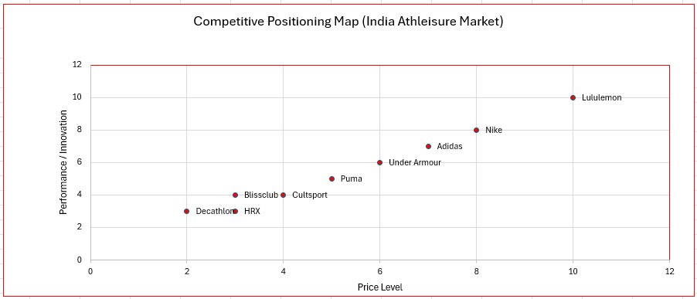
Source: Author’s adaptation based on Statista (2024) and MarketLine (2023).

Figure D4. Strategic Fit Matrix (India Market Entry Options)
Criterion | Wholly Owned Subsidiary | Master Franchise | Joint Venture (Recommended)
Control Level | Full control over brand, IP and experience | Low-moderate control; franchisee controls operations | Shared control: protects brand standards while leveraging local expertise
Regulatory Fit (30% FDI rule) | ❌ Very low - fails local sourcing requirement; high administrative barriers | ✔ Moderate - franchise agreements partially bypass sourcing constraints | ✔✔ High - JV structure satisfies FDI expectations and eases approval processes
Cultural Fit / Local Responsiveness | ❌ Weak - high cultural distance; weak local networks | ✔ Moderate - depends on franchisee capability | ✔✔ Strong - access to Indian market knowledge, yoga culture, festivals, and wellness communities
Speed of Market Entry | ❌ Slow - bureaucratic approvals and high capex | ✔ Fast - franchisee handles store rollout | ✔✔ Fast–moderate - quicker entry with strategic partner (e.g., Tata CLiQ Luxury)
Financial Risk | ❌ High - full capital burden (CapEx + OpEx) | ✔ Low - franchisee assumes most financial risk | ✔ Moderate - shared investment reduces exposure
Brand Protection | ✔✔ Very high - full control | ❌ Risk of brand dilution if franchisee quality varies | ✔ High - joint governance and shared KPIs ensure brand consistency
Supply Chain / Sourcing Feasibility | ❌ Very limited - fails 30% rule without deep localisation | ✔ Moderate - franchisee uses local sourcing | ✔✔ Optimal - JV can blend global fabrics with selective local sourcing
Strategic Fit with India | ❌ Poor | ✔ Acceptable | Excellent
Source: Adapted from Porter’s Value Chain Framework (Porter, 1985); further informed by Grant (2019), Barney (1991) and Lululemon Annual Report (2024).

Figure D5. Strategy Diamond for Lululemon’s India Entry Strategy
Strategy Diamond Element | Strategic Choice for India | Rationale (India-Specific)
Arenas | Premium athleisure; yoga-led collections; experiential retail; Tier 1 urban hubs (Mumbai, Delhi, Bangalore) | Aligns with affluent, wellness-oriented consumers; the highest purchasing power and demand for premium global brands
Vehicles | Joint Venture with Tata CLiQ Luxury | Satisfies 30% local sourcing rule: leverages Tata’s regulatory expertise, logistics and local cultural knowledge
Differentiators | Proprietary fabrics (Nulu™, Everlux™); premium identity; ambassador ecosystem; community-based “Sweatlife” model; sustainability credentials | Differentiates from Nike/Adidas and local players (Blissclub/HRX); meets demand for quality, authenticity and ethical production
Staging / Sequencing | Phase 1: Digital-first launch → Phase 2: 2 flagship stores → Phase 3: Selective expansion | Minimises risk; tests product-market fit; builds local brand legitimacy before scaling
Economic Logic | Premium pricing + high gross margins (58%); selective localisation of low-risk SKUs; JV-based capex sharing | Ensures profitability despite India’s price sensitivity; reduces capital exposure; protects IP and fabric innovation

Source: Adapted from Hambrick and Fredrickson (2001); Peng (2022); Grant (2019); Lululemon Annual Report (2024).

Figure D6. STP Map for Lululemon - India Premium Athleisure Market
D6.1 Segmentation Table (India Athleisure Market)
Segmentation Base | Segment Characteristics (India) | Relevance for Premium Strategy
Demographic | Women and men, 22-45 years; high disposable income; educated; urban professionals | High purchasing power; strong demand for global brands
Geographic | Tier 1 and upper Tier 2 cities (Mumbai, Delhi, Bangalore, Hyderabad, Pune) | Houses India’s premium wellness clusters
Psychographic | Health-focused; Yoga/Pilates practitioners; “aspirational lifestyle” orientation | High alignment with brand identity and Sweatlife ethos
Behavioural | Frequent gym/yoga users; omni-channel buyers; expect premium fit and durability; brand conscious | Willing to pay a price premium for performance and status
Source: Adapted from Euromonitor (2024); Redseer (2023); Statista (2024); KPMG (2023).

D6.2 Target Segment (T): Urban Yoga-Luxe Consumer
Target Profile
The Urban Yoga-Luxe Consumer
- Female (majority), 25-40, Yoga/Pilates/HIIT enthusiasts
- Tech-savvy, shops via Myntra/Tata CLiQ Luxury + boutique malls
- Values identity signalling (premium lifestyle), sustainability, and performance
- Seeks high-quality fabrics suitable for heat and humidity
- Attends wellness events, workshops, boutique studios (Cult Fit, Sarva Yoga)
Why This Segment?
- Highest willingness to pay (Euromonitor, 2024)
- Brand-conscious, follows Western fitness/wellness trends
- Strong match with Lululemon’s global brand equity
- Low price elasticity compared to mass Indian consumers
- High social influence effect → accelerates organic brand diffusion
D6.3 Positioning (P): Premium Wellness Performance
Positioning Statement (concise Distinction-level)
For India’s Urban Yoga-Luxe Consumer, Lululemon is the premium athleisure brand that delivers technical performance, cultural authenticity and experiential wellness, combining cutting-edge fabric innovation with community-driven retail - unlike mass athleisure brands focused on price discounts.
Positioning Strategy Elements
Element | Lululemon India Positioning
Value Proposition | “Premium technical apparel + authentic yoga culture + experiential wellness.”
Differentiation Drivers | Fabric innovation (Nulu™, Everlux™), Sweatlife community, premium retail experience
Competitive Frame | Above Nike/Adidas (performance), far above Blissclub/HRX (price), positioned as a global luxury wellness
Brand Promise | “Feel your practice - elevate your life.”
Source: Developed by the author based on Porter (1980); Keller (2013); Aaker (1996); Euromonitor (2024).

D6.4 STP Visual Map
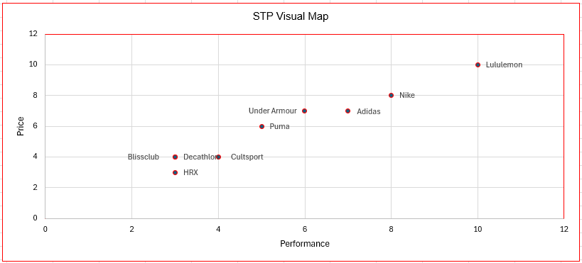
Source: Adapted from Kotler, P. and Keller, K. L. (2022) Marketing Management; Kumar, V. (2018) Strategic Marketing. Supplemented with Indian premium athleisure market data from Statista (2024) and MarketLine (2023).

D6.5 Strategic Implications
- Lululemon should exclude mass-market consumers and fully commit to a Differentiation-Focus strategy.
- Cultural-fit scores indicate the need for Indian ambassadors and yoga-led localisation.
- Premium positioning must be supported by experience-centric stores and community events to justify the price.
- Competitors (Nike/Adidas) compete on global performance; Lululemon competes on performance + identity + community → unique mix.

Appendix E: Performance Evaluation and Financial Plan

Table E1. Balanced Scorecard for Lululemon India (adapted from Kaplan and Norton, 1996)
Perspective | Strategic Objective | Key Performance Indicators (KPIs) | Target (Year 1-3) | Rationale
Financial | Achieve flagship profitability | Revenue per sq. ft; Store-level EBITDA | ₹45,000-55,000 per sq. ft by Year 3 | Premium retail benchmarks in Tier 1 cities
 | Strengthen cash flow stability | Cash Conversion Cycle; Gross Margin | Maintain >55% gross margin | Protects VRIO-based product integrity
Customer | Build strong premium customer loyalty | NPS; Repeat Purchase Rate | NPS > 60; Repeat rate > 35% | India’s high buyer power requires loyalty-building
 | Ensure cultural alignment | Social Media Sentiment (AI-scan) | >80% positive wellness-brand sentiment | Critical due to cultural distance
Internal Process | Maintain product quality and compliance | % SKUs meeting quality specs; Sourcing adherence | <2% defect rate; 30% sourcing compliance | India FDI rules + premium positioning
 | Improve operational efficiency | Delivery lead time; Inventory turnover | Lead time < 4 days in Tier 1 | Required for omnichannel integration
Learning and Growth | Strengthen human capital and culture transfer | Staff cultural training completion; Ambassador onboarding | 100% staff trained; 10-15 ambassadors onboarded | Supports Sweatlife localisation
 | Drive India-specific product innovation | Innovation cycle time | 6-month capsule refresh cycle | Supports Differentiation-Focus strategy

Table E2. Lululemon India - 3 Year Financial Projections (JV Model)
Financial Metric | Year 1 | Year 2 | Year 3
Revenue (₹ crore) * | 110 | 185 | 260
Gross Margin (%) | 55% | 56% | 57%
Operating Expenses (₹ crore) | 95 | 130 | 160
EBITDA (₹ crore) | 5 | 25 | 50
Net Profit (₹ crore) | -8 | 10 | 28
Revenue per Sq. Ft (₹) | 32,000 | 44,000 | 55,000
Customer Acquisition Cost (₹) | 1,200 | 900 | 750
Repeat Purchase Rate (%) | 18% | 30% | 38%
Break-even Point | - | - | Achieved Q3
*Note: ₹ crore = 10 million INR
Based on premium retail benchmarks and growth rates in India’s athleisure segment (Statista 2024; Euromonitor 2024).

