Microsoft Office User
[Email address]
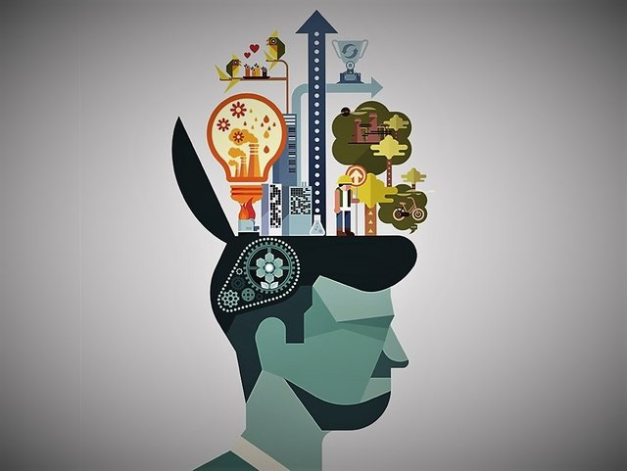
What makes a criminal? Does it come from the Psychology of how their brain works, the environment they were brought up in and conform to, or is there something else that is in play, that is causing people to act in this way? Whether they intend to break the law on purpose or not, the psychology of these people define what decisions they’ll make, and what kind of life they will choose to live, what tendencies they’ll have, and whether they will conform to a certain group or belief, whether that be good, conforming to the needs of modern society or for the worse down a more anti-social and dangerous path in life. There are various psychological theories of human behaviour that are used to deduce what different people’s mental states are, and how it can affect the way they live in their current lifestyle, how it has an effect on the people around them, and impact they are having on themselves. In this assignment, I will be discussing Certain theories that help us analyse a person’s behaviour and mental state, how we can define Human behaviour based on neuroscience and parts of the brain, and how certain influences such as conformity, mental illness, as well as other things can affect someone’s behaviour, and can lead to anti-social behaviour, and a rise in crime

What makes a criminal? Does it come from the Psychology of how their brain works, the environment they were brought up in and are forced to conform to, or is there something else that is causing people to act in this way?
Theories of Human Behaviour
Assignment 1

Humanistic Perspective

The Humanistic approach to human behaviour was supposedly created by Abraham Maslow, an American Psychologist known for being ‘the founder of humanistic psychology’ who is who “developed a hierarchy of needs to explain human motivation”. This means that he created a hierarchal system, to help understand the process of human motivation for greed and want for basic human needs.
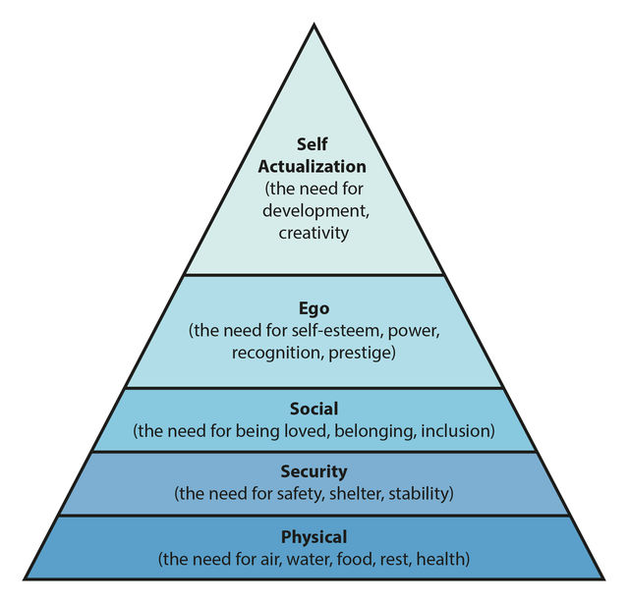

(The Hierarchy of needs created by Abraham Maslow)

The Hierarchy portrays the needs from most essential, ‘deficiency needs’ as he referred to them, which referred to the bottom 4, Ego social, Security and Physical. to more greed orientated and not as essential to maintaining life, Self-Actualisation. For example, as you can see form the hierarchy, ‘Physical’ needs are more essential, as needs such as water, and food are more important to the human body, than ‘Security’ needs such as safety. The higher the need, the more anxious we as humans feel about not having it. Maslow also referred to Self-Actualisation as the ‘growth need’. This is because, the need obliges us as humans to reach our full potential, to develop both our creativity and development to its max capacity. The properties of this development include: being content with who they are, and having a good understanding of the world around them, having a need for privacy and a small group of close relationships, being independent, and being an expert in their line of work, and finally, having a lot of experience in life, and having a lot of insight of the role they have in their line of work, and line life in general. They are able to use their experience to complete any task they have completed before, as fully as they can. These certain needs relate to events that the Police need to deal with as part of their job upholding the law, in the sense that certain needs can lead to people resorting to criminal methods to get what they want or need to survive. “Hunger makes a thief of any man” as stated by Kostadis J. Papaioannou in the European Review of Economic History. This shows that if someone is desperate enough, they would resort to stealing, or any criminal needs to provide for themselves and their family, if there was no other choice.

Behavioural Perspective

Behavioural Psychology, can be defined as “the study of the connection between our minds and our behaviour”. The study can also be known as ‘behaviourism’. The study involves finding out why certain stimuluses, can provoke a reaction, such as a reflex, an emotion, or a need. Ivan Pavlov, a Physiologist, created the theory of Classical Conditioning, which proved that certain stimuli, such as the ‘sight, smell, taste or body sensation’ would cause reactions from both humans and animals. Pavlov was able to prove this through his experiment with dogs. The experiment included Pavlov measuring the amount of saliva the dogs developed, after using different stimuli to provoke reactions. This included using the sight, taste and smell of meat powder, which caused the dogs to salivate considerably. This was an unconditioned response, as the dogs had not been taught to do this, and happened naturally, as it was an automatic reaction, and was not learned. Pavlov continued to use the meat powder, but began pairing it with a neutral stimulus such as noise or tone, to provoke a reaction. The thinking behind this was, the dogs would begin to learn to pair the tone, or sound of a ‘tuning fork, a light, and a touch on the leg’. This meant that even though the dog could not see or smell the meat, they would still have learned to associate the unconditioned stimulus (the meat powder) to the now conditioned stimulus.

(This image shows how the dog associates the unconditioned stimulus, the food, to the conditioned stimulus, the bell.)

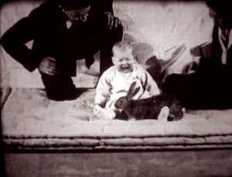
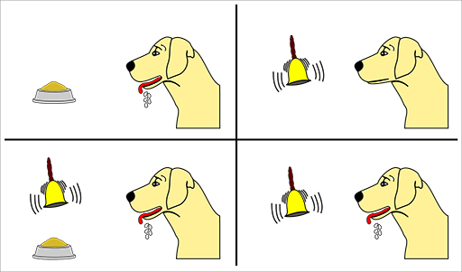
John Broadus Watson, an American Psychologist, inspired by Pavlov’s work, wanted to test of certain emotions such as fear, could be provoked in humans. This led to the Little Albert study. The experiment featured a young boy, Albert who was ‘almost 13 months old’. The test included using a white rat as a neutral stimulus. At first, before the conditioning, Albert was not afraid of the rat and “he moved toward it and touched it”. Watson then snuck behind Albert and made an unexpected clanging sound that frightened Albert and caused him to cry. Because of this, Albert later associated the unconditioned stimulus, the white rat, with the conditioned stimulus, the clanging sound, and when they brought out the rat again, Albert instantly started crying.

(An image of the Little Albert study)

Behavioural Psychology can play a big part in the public services, maybe not to the extent of the Little Albert study, but can be used to stop first time offenders, from getting extended prison time, through not wanting to go back for example in the prison service, and the police.

Social Cognitive Perspective

Social-Cognitive Psychology is “the scientific study of the mind as an information processor”. This means that it studies the way that we think under many different situations, and circumstances in the moment. It has been agreed that “learning through environmental conditioning contributes to personality development”. But before we discuss this, we must first understand Nature vs Nurture. Nature can be defined as “what we think of as pre-wiring and is influenced by genetic inheritance”. Nurture can be defined as “ the influence of external factors”. Albert Bandura came up with the concept of ‘self system’. Albert Bandura was renowned social cognitive psychologist who was a ‘professor of social science in psychology’. This self system he had come up with shows the influence if Nurturing, and shows the process that a human goes through, when reacting to a situational change, and influences that have been nurtured, through parental, and inspirational figures in their life. This is called ‘Observational learning’. This is most common in young children, who at a time may try and imitate the behaviour and actions of their parents, even if not reinforced. If these behaviours are reinforced “children may then incorporate them into their personality”. This is not only common in children, as in social situations, everyone today will conform to the ‘normal’ behaviour they are used to, due to the area they have been brought up in, and the social norm of the area. This can be an example of Nurture. You are complying to the norm of everyone else, copying to not stand out, among everyone else. This relates to the police because, this helps understand why poorer living areas, will have an increased crime rate, drug usage, and conception rate, than other areas, and therefore a need for extra observation to crack down on crime.
Myers type indicator

Biological Perspective

The Biological Perspective is an outlook on human psychology through the study of ‘the physical basis’ of parts of our anatomy, such as the human ‘brain, immune system, nervous system, and genetics’.

Psychodynamic Perspective

Conclusion

Bibliography

(Cherry, 2020)
(M.D., 2012)
(Papaioannou, 2017)

(Psychologist World, 2021)
(Griggs, 2005)
(Schweitzer, 2019)
(Mcleod, 2021)
(Cherry, 2019)
(Local Government, 2021)
(Clear, n.d.)

(Griggs, 2005)
(Mcleod, 2020)
(Maccormick, 2021)
(Mcleod, 2018)
(Luttrell, 2016)

(Coppens, 2018)
(Cherry, 2021)
(Satel & Lilienfeld, 2013)

