Introduction

This paper introduces the background and development history of CSR. The impact of stakeholder theory and other mainstream CSR theories on different organizations is analyzed. This paper mainly introduces the development and current situation of CSR in China. The CSR situation of state-owned enterprises, private enterprises and NGOs in different periods is analyzed.

Section 1

Corporate Social Responsibility (CSR) is a management concept whereby companies integrate social and environmental concerns in their business operations and interactions with their stakeholders. It has become an important concept in the last few decades and attracted attention from a range of academics and businesses. In recent decades, the academic circles have different understandings and interpretations of this western term (Barnett, Henriques and Husted, 2020 and Griffiths,2013), which have reflected the different interests and perspectives regardless of whether they have a financial interest or non-financial interest in a business entity (Harrison and Freeman, 1999). Early interpretations focused on the economic and legal obligations of enterprises (Friedman, 1970), while later scholars added corporate social responsibility, such as moral or charitable obligations to society (Davis & Blomstrom, 1975). The version of the CSR definition considered most comprehensive in earlier studies comes from Carroll (1979) and focuses on "economics, law, ethics, organization", while corporate social responsibility, economic responsibility and environmental responsibility have been gradually added into the definition (Belaland Momin, 2009). Despite the long history of CSR research in business literature, there is no universally agreed definition or boundary for the concept (Sendlhofer, 2019 and Tang, Gallagher and Bie, 2014). Most research on CSR focuses on the concept, motivation, types of activities and performance effects of CSR (Porter, Kramer, 2006).

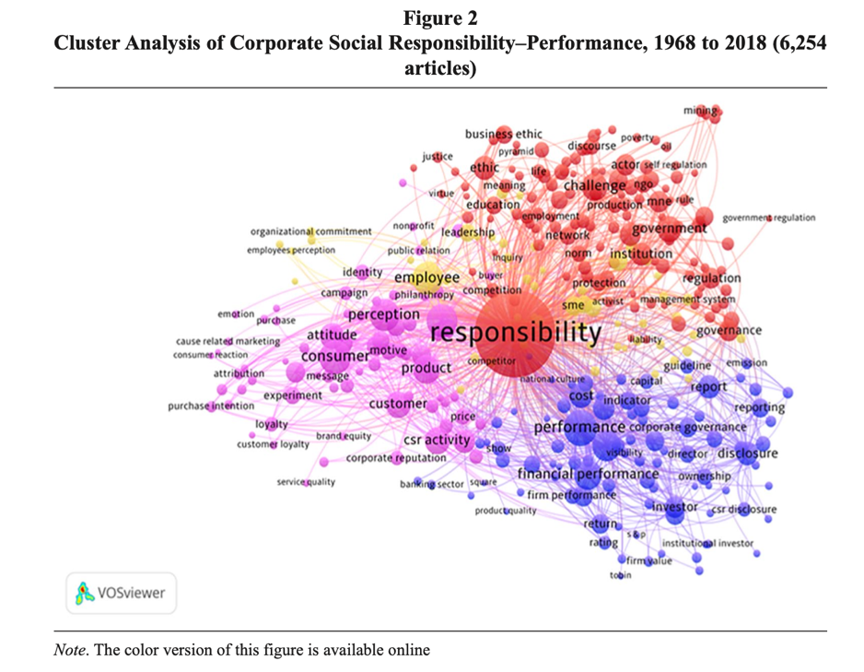
Figure 1 from Barnett, Henriques and Husted, 2020
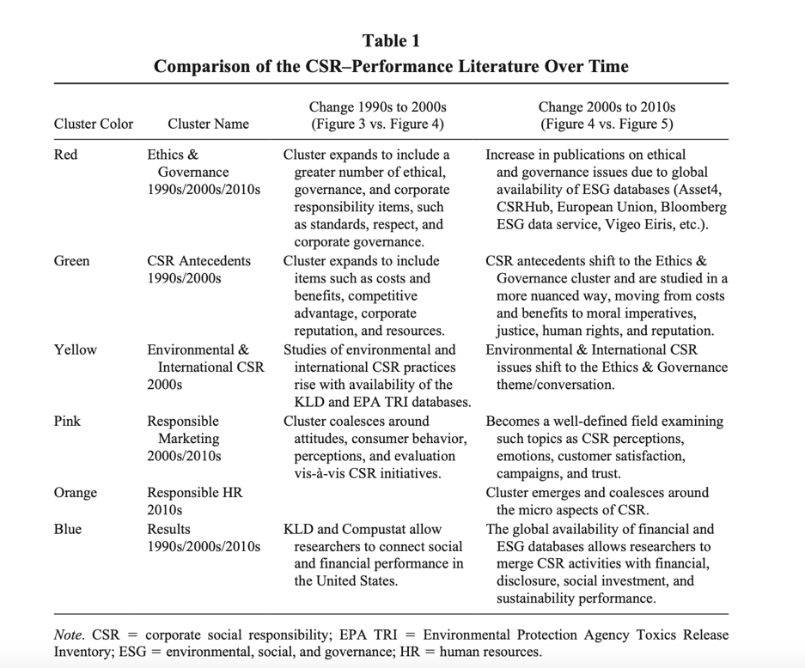
Figure 2 from Barnett, Henriques and Husted, 2020

Today, corporate social responsibility (CSR) is still a widely discussed issue, with many new theories and definitions proposed (Kim, Milliman and Lucas, 2021). Although most of the early researches on CSR continue to focus on America and Europe, the researches on CSR in China have increased significantly in recent years (Ervits, 2021 and Zhu et al., 2020). As a discipline, corporate social responsibility (CSR) and public relations (PR) have much in common (Noronha, Tou, Cynthia and Guan, 2012). For business organizations, both PR and social responsibility theories emphasize the importance of paying attention to their business organizations to their stakeholders or the public. (Li, Cheng and Xu, 2021 and Lu et al.,2015). The management perspective of CSR strategy recognizes that CSR is part of a complete business strategy, which is closely related to the competitiveness of enterprises (We and Choi, 2008). McWilliams and Siegel (2006) believe that CSR needs to be established based on cost-benefit analysis of CSR. Scholars of strategic theory believe that both strategic CSR and CSR go beyond the Resource-based view (McWilliams and Siegel,2001 and Rhee, Park and Petersen, 2018). They believe that CSR activities should address social problems while companies continue to grow. For example, environmental protection, solving social problems such as employment and continuing education (Yang et al., 2021; Kim, 2018 and Rhee, Park and Petersen, 2018). On the other hand, strategic CSR is based on close-knit community and stakeholder relationships, as well as collaboration between all parties (Abdurakhmonov et al., 2021). Finally, strategic CSR can contribute to society through aggressive long-term resource investment. Strategic CSR views CSR activities as a source of opportunity, innovation and competitive advantage. In conclusion, they believe that CSR activities are aimed at fulfilling the obligations of corporate citizenship, while CSR activities are aimed at promoting corporate growth and actively improving society as a whole (Tang, Gallagher and Bie, 2014 and Abdurakhmonov et al., 2021).

Theoretical Underpinnings

In line with the evolution of CSR, Stakeholder Theory has emerged as the dominant paradigm in CSR discussion. It believes that firms have relationships with many constituent groups which have an interest in the activities and outcomes of a firm (Donaldson and Preston, 1995; Margolis and Walsh, 2003). These stakeholders both influence and are influenced by the behavior of the firm, and it is crucial to balance the needs of multiple stakeholders in the firm's activities and outcomes. The stakeholder theory's view of CSR implies that managers should recognize and serve the interests of a broader group (Jones et al., 2007; Aguinis, 2011). According to the "stakeholder view", some researchers believe that corporate social responsibility is an integral part of social rights, and enterprises have many responsibilities and obligations for the society they operate (Carroll, 1979; Silberhorn and Warren, 2007). Others argue that CSR may simply be a voluntary action to serve society and the environment (Matthews, 1993; Graafland and Van der Duijn Schouten, 2012). A third school of thought sees it as a form of legitimacy and survival (Van Marrewijk, 2003; Guo et al., 2012). In addition, within the scope of common interests of stakeholder groups, CSR is known as the social contract between enterprises and their stakeholders (Gray et al., 1995a). Freeman believes that in addition to shareholders, other external stakeholder groups are also important, which lays a foundation for the concept of CSR (Belal, 1999). This conceptual shift in general provides a new perspective for rethinking how to identify different stakeholder groups and organize company activities according to their interests (Carroll and Shabana, 2010).

Stakeholder theory is the most important theoretical basis of corporate social responsibility research. Scholars believe that prominent internal and external stakeholders affect direct corporate social responsibility. For example, the relationship between CSR and performance (Kim, Kim and Qian, 2015), the relationship between CSR and human resources (Shen and Benson, 2016), The relationship between CSR and politics (Griffiths,2013 and Cialdini et al.,202), and the relationship between CSR and competition (Porter, Kramer,2006). In short, all stakeholders are closely related to CSR (Kim, Kim and Qian, 2015 and Zhu et al.,2020). Yang and Rivers(2009) divided stakeholders into two different groups: the first group is organizational stakeholders and the second group is social stakeholders. The first group (e.g., employees, consumers, shareholders) requires stakeholder groups to have a direct relationship (consumers, employees, and suppliers) with goods and services that affect the bottom line and achieve the organization's mission (Rhee, Park and Petersen, 2018; Kim, 2018 and Wong and Dhanesh, 2016). These stakeholders will worry about the company's reputation, profit and other core indicators, and even more about the company's loss or bankruptcy (Noronha, Tou, Cynthia and Guan, 2012). On the other hand, social stakeholders are more concerned about corporate social responsibility (Li, Cheng and Xu, 2021 and Lu et al.,2015). Strictly speaking, the realization of corporate social responsibility is a voluntary corporate behavior aimed at creating benefits for different stakeholders including shareholders (Ervits, 2021). It is obvious that the first group is more concerned and sensitive to performance profit than the second group (Sendlhofer, 2019). CSR programs need to be integrated into a firm's strategy so that they are fundamentally a source of competitive advantage rather than viewed as a nuisance or cost to the firm (Rhee, Park and Petersen, 2018).

Previous literature has also taken resource-based theory as a mainstream of CSR. Resource-based theory refers to the concept of gaining a competitive advantage by deploying specific enterprise resources. This theory was later further refined by Jay Barney (1991), who argued that "the sources of sustained competitive advantage are valuable, rare, inimitable and irreplaceable firm resources" (Barney 1991, p. 116). Similarly, Peteraf(1993) discussed a kind of heterogeneity, which reflects the existence of superior resources that enable an organization to gain a competitive advantage. A basic assumption in resource-based theory is that firms have heterogeneous resource endowments and can therefore use their resources to identify and use those assets, capabilities, organizational processes and capabilities to improve their efficiency and effectiveness and thus provide a superior competitive advantage. Some studies attempt to identify CSR behavior and ascribe it to resource-based theory as firm resources. Litz (1996) studied the integration of resource-based theory in corporate social responsibility from social and ethical perspectives. The conclusion is that social and ethical competencies have the potential to promote the development of necessary firm competencies that lead to competitive advantage. Branco and Rodrigues (2006) also discussed the usefulness of resource-based theory in understanding why firms engage in social responsibility. They stressed the importance of investing in CSR to create intangible resources such as enhanced reputation, improved relationships with external stakeholders, improved retention and attractiveness of the business to potential employees, and increased employee motivation in role performance, commitment and loyalty. This theory positions CSR as a dynamic intangible resource that focuses on creating and maintaining competitive advantages for enterprises.

Other scholars choose Institutional Theory as the theoretical basis (Davis and Moosmayer, 2014 and Yin, 2015). Institutional theory focuses on the influence of firms in a wide range of political, economic and different social systems (Situ, Tilt and Seet, 2018 and Campbell, 2007). It believes that enterprises are within a certain range of political, economic and social systems (Wu and Fan, 2021). Additional pressure is exerted by the government or society on companies or organizations through laws, policies, norms and ethics, which result in additional social responsibilities of companies (Wu and Fan, 2021 and Combs et al., 2022). Different countries and environments will bring different social pressures on enterprises or organizations, which leads to different CSR performance of the same company in different regions. For example, in many cases of multinational enterprises, the goals and behaviors of enterprises in backward countries and developed countries are completely different (Shao and Janssens, 2021; McMurrian and Matulich, 2016 and Yang & Rivers, 2009). In the study of CSR in China, the central government factor is particularly important, and the influence of political CSR in Chinese society is far greater than that in the West (Ervits, 2021 and Fam, 2017).

Besides, some other theories have also been used when regarding specific topics towards CSR. For example, social exchange theory is applicable to the current relationship between social responsibility and employees. It explains the relationship between human resource practices, management trust, and employee commitment (Eisenberg et al., 1990; Setton et al., 1996; Wayne et al., 1997). In an organization that focuses on employee welfare, the practice of CSR will create employee trust in the organization and, in turn, generate high employee commitment. While the relationship could also be explored under Social Identity Theory. According to Social Identity Theory, individuals derive part of the identity from the group(s) to which they belong to Tajfel and Turner (1985). Lindgreen and Swaen (2010) added on, when organisations invest strong relationships with their stakeholders, both parties are more likely to work towards the achievement of common goals.

In short, the different theories mentioned above are the mainstream theories of CSR research at present, and new theories are still emerging today (Sendlhofer, 2019 and Rhee, Park and Petersen, 2018).

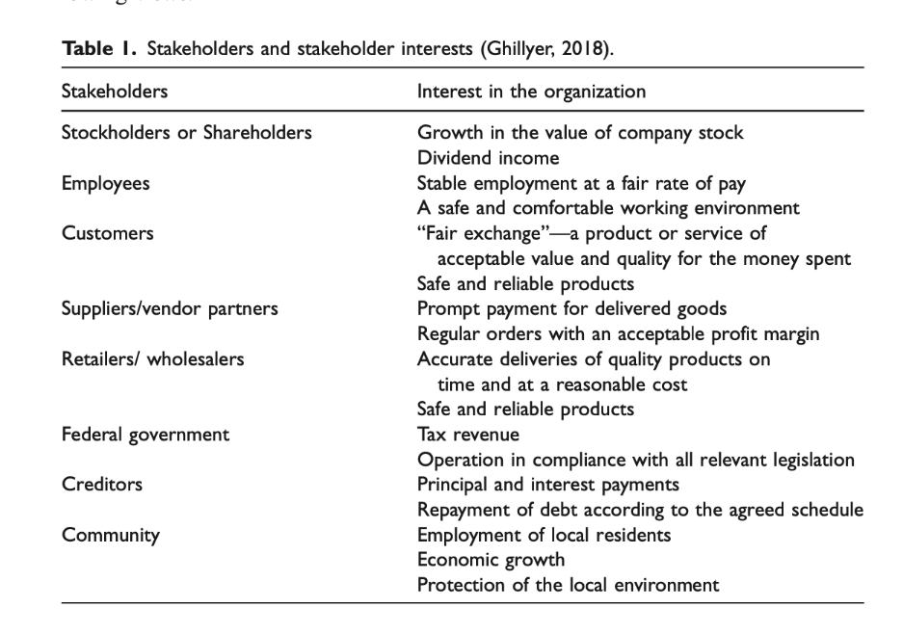
Figure 3 is from Zhu et al.,2020

Drivers of CSR

The drivers for implementing CSR in an organizational strategy vary by organization, industry, and even geography. Responsible business practices come from both inside the organization (internal stakeholders, such as employees) and outside the organization (external stakeholders, such as customers, suppliers, and local communities). In the following part the internal and external drivers of CSR would be discussed.

In terms of internal influencing factors, more and more studies on CSR focus on the organizational level of labor market (Griffiths,2013). As a representative of the driving force of the labor market, employees are putting pressure on employers to engage in CSR. As the labor market becomes more competitive, employers are becoming aware of the work preferences of their potential employees, especially those with higher skills. Corporate social responsibility is important if a company wants to attract and retain top talent. Employees want to work for a company that cares about how the company impacts and contributes to society. "Visionary procrastination" refers to a disengagement context that is considered particularly relevant when individuals perceive the moral responsibility of corporate social responsibility. The micro basis of CSR is defined as the core driver of responsible business activities (Bartusevičius, Bor, Jørgensen and Petersen, 2021). The inherent purpose of CSR is to improve the well-being and well-being of employees, including those aimed at improving working conditions, health and safety, and continuing education (De Roeck & Maon, 2018). Employee responsibility for CSR is very important. If employees consider themselves as internal stakeholders of corporate social responsibility and participate in the formulation and implementation of responsibility, their work attitude and efficiency will be significantly improved (Yang et al., 2021). For example, studies on the power of corporate CEOS (Sajko, Boone and Buyl, 2020 Novel Coronavirus (Kim, Milliman and Lucas, 2021) all prove this point of view. There have been some changes in internal and external factors during the COVID-19 pandemic. According to a review of corporate social responsibility business cases in the hospitality industry (Rhou & Singal, 2020), empirical research results support that focusing on employee feelings, especially social responsibility activities, can help organizations better attract, motivate and retain employees (Uyar et al., 2021). This behavior can effectively improve work efficiency and reduce the loss caused by understaffing (Kim, Milliman and Lucas, 2021).

On the other hand, external interest factors of an organization have a great impact on CSR (Rhee, Park and Petersen, 2018). Kim, Milliman and Lucas (2021) believe that external CSR activities are oriented to external stakeholders, such as the government, society and vulnerable groups. In the CSR study of multinational corporations, researchers find that local major stakeholders have a positive impact on CSR activities, but no impact on strategic CSR activities (Wu and Fan, 2021). In fact, it is often pressure from external stakeholders that forces boards to take action on poor practices associated with the business. Because organizations and enterprises have different objectives and stakeholders, they carry out activities in different regions and environments. As a result, different organizations or companies in the same region have different CSR practices in different regions. Multinational corporation stakeholder analysis has always been a hot topic in this field. Researchers hope that multinational corporations can assume more responsibilities and make greater contributions to social responsibility while ensuring sustained growth (Wu and Fan, 2021). For foreign companies doing business in new countries, CSR practices in the host country are a priority (Yang & Rivers, 2009). Suppliers, employees and investors of mines may come from different countries, and these stakeholders have different needs and CSR expectations (Ervits, 2021). 75% of the 100 largest companies in the world issued CSR reports in 2017. Yang et al. (2021) studies show that corporate social responsibility (CSR) has become a key issue for many companies as the public becomes more and more aware of the impact of corporate activities on the environment and society. This is related to CSR related investments having a significant impact on the financial performance of enterprises (Akbar et al.,2021). Corporate social responsibility reports reflect the efforts of companies to provide sustainable solutions to social and environmental challenges. However, such efforts may be affected by regulation, as governments also need to be responsible for the promotion of CSR in order to be seen as legitimate and modern (Clapp & Utting, 2008). Therefore, CSR is not only a commercial phenomenon, but also a new impression jointly formulated and recognized by various institutional participants (Belaland Momin, 2009; McMurrian and Matulich, 2016 and Jia et al., 2020). Because the norms and values of practice in different regions are presented in different ways, when companies intend to implement CSR in their national context, they may do so in different ways with sustainable development in mind.

What needs to be specially pointed out here is the government behavior that cannot be ignored in the research of Corporate social responsibility in China. This political CSR has a huge impact on both state-owned and private enterprises (Situ, Tilt and Seet, 2018). Although CSR has traditionally been defined as voluntary actions taken by businesses to create a better society and a cleaner environment, in recent years many governments have adopted policy measures to encourage and promote CSR (Ward, 2004; Albareda et al., 2008; Steurer, 2010). As a result, CSR is evolving into a new political relationship between government, business and civil society to promote responsible and sustainable business practices (Albareda et al., 2008). CSR needs to be understood as part and parcel of a wider system of national societal governance incorporating government institutions, business organisations and non-governmental organisations (Moon, 2004).

Section 2

The concept of Corporate Social Responsibility was introduced into China by western transnational enterprises in the 1990s (Lin, 2019 and Li, Cheng and Xu, 2021). Before the concept was introduced, the corporate social responsibility in China had has experienced a long process of development. While the whole process can be divided into different periods from ancient times to modern times, they shared the same idea of maintaining competitiveness through word of mouth and reputation (Lu et al.,2015). For example, the goal of ancient Chinese merchants was to become "Confucian Merchants", which meant merchants with good Confucian qualities (Ervits, 202). The first period of CSR in China is from 1949 to 1983 when the People's Republic of China was established. Scholars called this period "misplaced corporate social responsibility" (Ip,2009). During this period, the traditional "Confucian businessmen" completely disappeared, and Confucianism was no longer worshipped by society and businessmen (Whitehead, 2014). The second period of CSR in China, from the early 1990s to 2001, is the golden 20 years of China's reform and opening up. Society had completed the transition from a planned economy to a socialist market economy (Davis and Moosmayer, 2014 and Situ, Tilt and Seet, 2018). The third period is from 2002 to 2019, when the government and society began to attach importance to social enterprise responsibility (Xu, 2013; Yin, 2015). Large enterprises, especially state-owned enterprises, began to pay attention to environmental protection, unemployment, continuing education and other social responsibilities (Lee and Lee, 2015 and Wang and Gao,2018). The fourth period, 2019 to the present, is what the author calls as “COVID-19 era”. At this period, due to the impact of COVID-19, the social focus shifted from economic construction to epidemic prevention and control due to the comprehensive lockdown (Li, Cheng and Xu, 2021).

Ethics is an important carrier of culture, and culture is realized through beliefs and values (Murillo and Lozano, 2006 and Simpson and Aprim, 2018). Therefore, it is important to understand the influence of the main ideologies of Traditional Chinese culture and ethics, especially Confucianism and Taoism in different periods (Lu et al.,2015 and Ervits, 2021). Political changes shape the main ideologies of Chinese ethical culture, as well as the ethical dilemmas caused by the beliefs, values and attributes under these ideologies (Ke and Wang, 2014). The underlying ethical dilemmas are rooted in Confucianism. There are negative aspects of Confucian values, such as the Mianzi, respect for authority, egoism, etc. Taoism emphasizes balance and harmony like Confucianism. However, different from Confucianism, Taoism advocates harmony with nature and lives in harmony with nature (Ke and Wang, 2014). This is very consistent with the environmental protection advocated by CSR (Uyar et al., 2021 and Davis and Moosmayer, 2014). In general, Chinese political leaders in the new era gradually introduce ideas of traditional culture into Chinese ideology, forming socialist market economy and values with Chinese characteristics (Yang et al., 2021 and Ke and Wang, 2014).
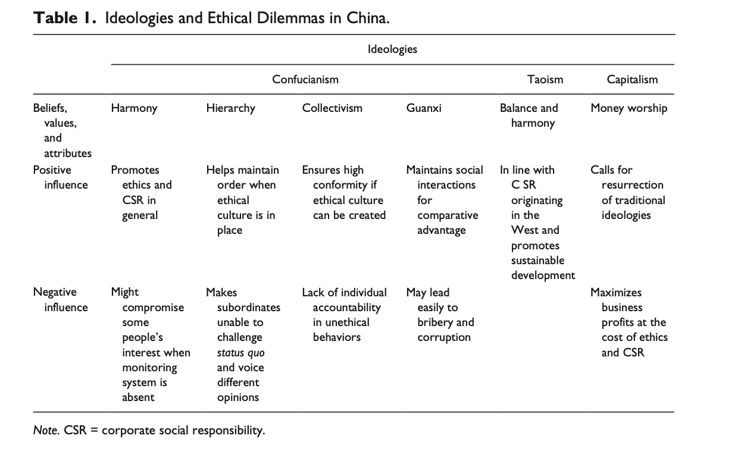
Figure 4 from Ke and Wang, 2014

Considering the practical business and political issues, in this paper we focus on CSR after 1980. Corporate social responsibility has completely different manifestations in the three periods mentioned above. In the first period, CSR mainly focused on the economic responsibility of multinational corporations (Chinese subsidiaries) and local large and medium-sized enterprises (Lu et al.,2015). The slogan of this period was always to focus on economic construction (Wu and Fan, 2021). Corporate profits and job creation were the primary goals of the government and enterprises (Ip,2009). In the second period, a large number of private enterprises rapidly developed into listed companies or even transnational enterprises. The maximization of shareholder financial value became the key issue of corporate social responsibility. At this period, legal problems becme prominent social problems, such as the illegal procedures of real estate and construction engineering companies, environmental damage, financial fraud and other common problems (Ke and Wang, 2014). The ethical charity began to attract attention after China joined WTO (Noronha, Tou, Cynthia and Guan, 2012). Whether an enterprise had a large amount of social donations had become a new standard to measure CSR (Lee and Lee, 2015). Environmental protection, employee rights and the contribution of local governments were new targets for CSR (Noronha, Tou, Cynthia and Guan, 2012). In the third period, many Chinese enterprises began to actively participate in the formulation of social responsibility issues and lead social changes according to social responsibility issues (Simpson and Aprim, 2018). For example, a large number of entrepreneurs became NPC deputies and CPPCC members, actively participated in social activities and shouldered more social responsibilities (Lin, 2015 and Hu and Xu, 2021).

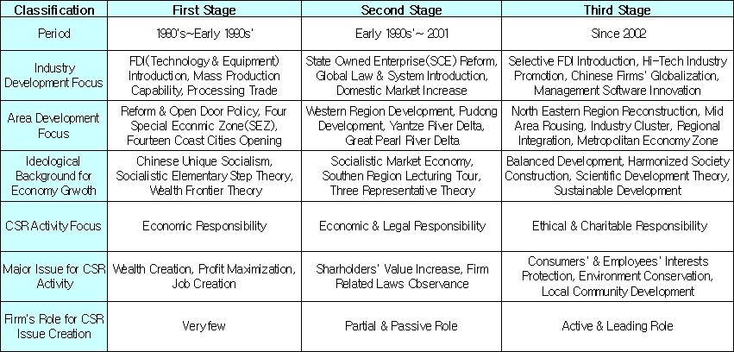
Figure 5 from Simpson and Aprim, 2018

The author selects three representative organizations in China's education industry, namely, the New Supply Education Group, a private enterprise; Peking University, a public university (including affiliated and state-owned enterprises); and the 21st Century Education Research Institute, a non-profit organization. Data were collected from the official websites of the three enterprises, Baidu, and annual reports.
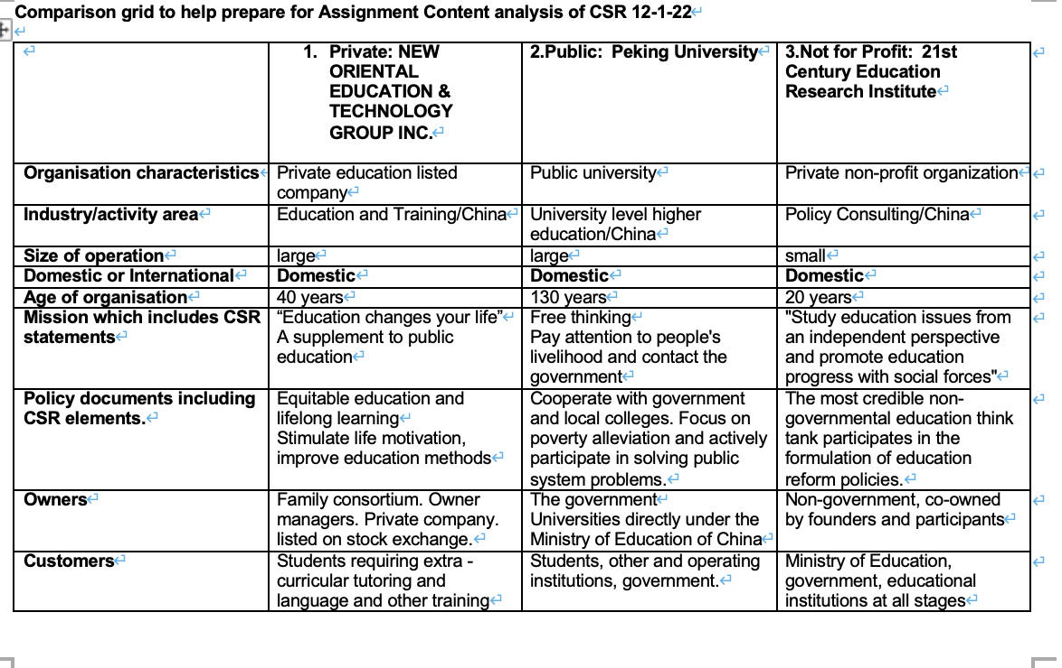
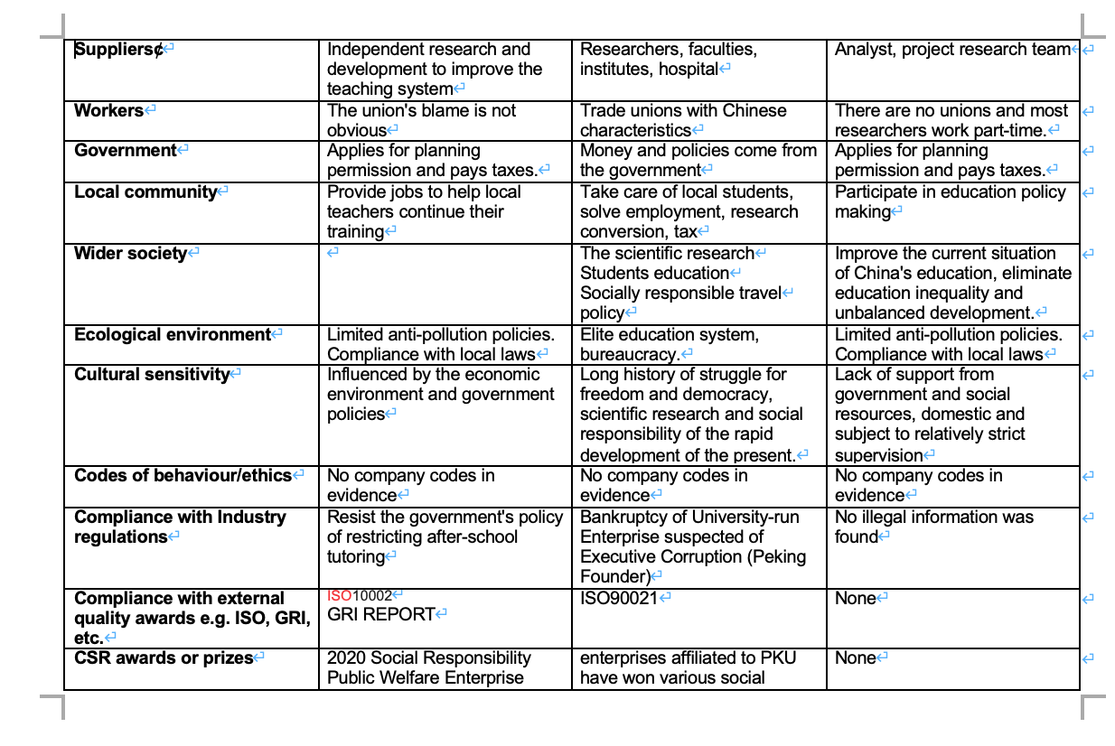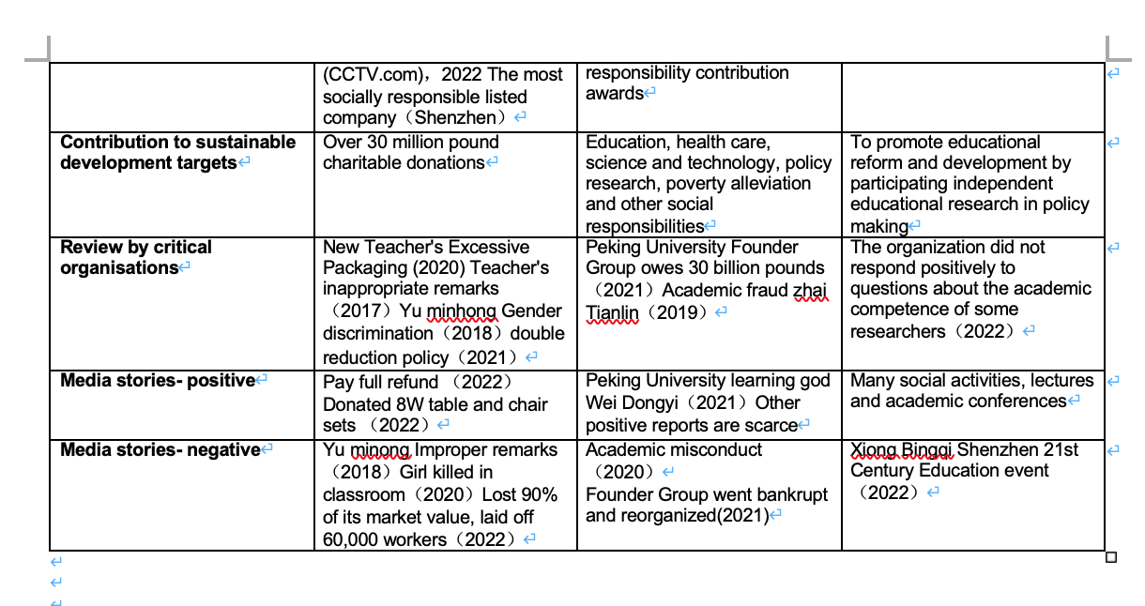

Organizational income and distribution imbalance

Through the comparison in the figure, we can obviously see that there are huge differences in the channels and quantities of funds obtained by organizations of different nature. New Oriental Education, as the most successful listed education group, derives its funds from business income and needs to pay a huge amount of taxes when it is affected by policies (NOG REOPRT, 2018). In CSR reports, only 15% of enterprises are classified as leaders (Noronha, Tou, Cynthia and Guan, 2012). As a leader in the field of private education, New Oriental not only maintains the sustainable operation of the organization, but also spends a lot of money and experiences in social charity, such as educational donation in poor areas and online education promotion (Baidu, 2022). Compared with small and medium-sized private education enterprises, New Oriental has the financial and management ability to shoulder more social responsibilities (Sendlhofer, 2019 and Wong and Dhanesh, 2016). Studies show that consumers prefer to choose products from socially responsible companies, and good brand image building is an important factor for the success of private enterprises (Rhee, Park and Petersen, 2018). This can also explain why many private SMEs do not have many social responsibility behaviors. In 2015, the New Oriental Education Group established the new Oriental Public Welfare Foundation, which was rated as a 4A social organization in 2019 (Baidu, 2022). Public institutions can be supported by the State compared to the private sector (Zheng, and Kapoor,2020). Peking University receives more than 1 billion pounds of government grants and large donations from alumni associations every year (Peking University, 2015). In addition, PKU FOUNDER Group is a state-owned enterprise with assets of over 100 billion pounds, which provides various support and convenience for Peking University (FOUNDER, 2022). With the support of a large number of funds, the scientific research of Peking University has developed by leaps and bounds, and a large number of excellent researchers have joined the university. This enables the school to help other local governments and schools carry out collaborative research and participate in more social responsibility fulfillment (Ye,2017). The CASS study was widely criticized in the media as irrelevant because most of the sampled companies, or 80 percent, were from state-owned enterprises. Last but not least, the 21st Century Education Research Institute does not receive a fixed amount of government funding every year, and most of its funding is raised by itself. According to the registration information of the Industrial and Commercial Bureau, it belongs to a private consulting company and needs to pay taxes according to regulations (Xu, 2013). That is to say, there is no obvious preferential tax policy for non-profit organizations at present, and they still need to pay taxes like profit-making companies (Davis and Moosmayer, 2014). As the organization is funded by donations from foundations at home and abroad, it receives financial support from cooperative schools and research institutions (Whitehead, 2014). The lack of funds led to the limited development of the organization for a long time, the development remained stagnant. Only to research existing projects and areas, there is no more energy to expand into new areas. In short, there are huge differences in income and rejection among different types of Educational organizations in China (Situ, Tilt and Seet, 2018 and Shao and Janssens, 2021). In many cases, these organizations show "silent or implicit forms of social responsibility", which further hinders the spread of CSR in China (Whitehead, 2014). This empirical result is consistent with the results of Fortune magazine's 2008 China Corporate social responsibility survey. Respondents cited a lack of awareness and awareness of CSR as the biggest obstacle to the spread of responsible business practices in China. This can only happen when the practice of CSR is fully institutionalized within an organization (Lin, 2019).

The impact of government policies on different organizations in the education industry

As mentioned above, government policies have had a huge impact on China's economy at different times. The development of Chinese education has kept pace with the development of Chinese business and society as a whole, so we focus on the situation of Chinese education after 1977. (1977-2002) Neoliberal Globalization and Opening to the Outside world: Return to the international arena, and the government begins to send overseas students to study (Zheng and Kapoor,2020). New Oriental's initial main business is TF, IELTS overseas training test. According to statistics, the domestic market of overseas study in China is over 50 billion pounds (Bai and Wang, 2020). This is also a major factor in the development of a large number of private education and training companies. China has introduced a series of new rules and regulations to motivate listed companies to improve their CSR behavior and promote the standardization of information of listed companies in China (Noronha, Tou, Cynthia and Guan, 2012). Listed education companies donate a considerable amount of money to charities and donations every year in line with government policies. What should be emphasized here is the "double reduction policy" (Lin,2021) mentioned above. Part of the "double reduction policy": "Training institutions are not allowed to teach outside the syllabus of public schools. In addition, the price of after-school training institutions has been changed to follow the government's guiding price. "The supervision of funds for after-school training institutions has been changed, and each school is required to set up a fund supervision account in the bank." A similar policy banning private tutoring has been introduced in the past, but its impact is far smaller than the double reduction policy. It caused New Oriental to lose 90% of its market value, lay off 60,000 workers and close 200 teaching centers. According to incomplete statistics, more than 80% of small and medium-sized training institutions are facing refund or bankruptcy (QQNews, 2022). Private education companies are looking for new business opportunities and are looking for transformation. This is the huge impact of the policy on private sector CRS. It's a lot better than the private sector and the public sector. The Government not only links education with the rejuvenation of the Chinese nation, but also launches the Higher Education, Science and Technology Innovation Program and Revitalization Program of Higher Education (Zhen and Kapoor,2020). Chinese government's requirements for universities: It proposes to build world-class universities with Chinese characteristics, requires Chinese higher education to fully accept the leadership of the Communist Party of China, and consolidate the leadership of Marxism in the international political economy (Zheng and Kapoor,2020). This can explain that Chinese universities are more public institutions, and their daily management follows the operating mechanism of the Chinese government. In recent years, the government has begun to change its policies to advocate enterprises to take more social responsibilities. For a long time, universities were not keen on social responsibility (Al-Shammari and Masri,2016 and Simpson and Aprim, 2018). According to KPMG's survey on G250 enterprises' social responsibility report in 2013, the score of Chinese enterprises' social responsibility report was only 39%, 20% lower than the global average (KPMG, 2013). KPMG's 2015 survey further showed that Chinese companies scored very low on the quality of carbon disclosure in CSR reporting (KPMG, 2015). In terms of the impact of CRS policies on NGOs, the impact of Chinese government policies on non-profit organizations mentioned above is reflected in registration, taxation, donation acceptance, announcement and many other mitigating factors (Whitehead, 2014). The trend towards more market-driven capitalism suggests that CSR performance in China may indeed be more complex. Cooperation between Chinese enterprises and NGOs reflects this complexity (Li & Zhang, 2007). Finally, it should be mentioned that corporate Law of 2006 is widely regarded as the first year. This study also found that political embeddedness and normative social pressure are partially supportive in explaining market-related CSR behaviors in the context of China (Zuo, Schwartz and Wu, 2015). However, the relationship between political embeddedness and employee responsibility and community responsibility is not significant. Similarly, the isomorphic forces of norms, such as positive norms, values, and beliefs about "doing what the government thinks is right", exacerbate the impact of policies on corporate CRS (Kim, Milliman and Lucas, 2021and Shen and Benson, 2016).

Media coverage of different corporate social responsibility

From the report content and the amount of analysis of the media for private enterprises in half praise a lot; The number of negative information in public universities is mainly once; Nonprofits are mostly positive and rarely reported. In addition to the influence of income and government attitude discussed above, which is necessary to consider the attitude of different organizations towards media (Li, Cheng and Xu, 2021). The private sector's emphasis on branding increases the chances of media exposure and positive coverage. Public universities, especially well-known ones, have an innate superiority for media publicity. As power government departments, they will not focus on their publicity (Ye,2017). At the early stage of CSR development and communication, Chinese enterprises have their unique way of CSR communication, namely, CSR communication through corporate websites (Tang, Gallagher and Bie, 2014). It is a pity that even today, most of our official websites are filled with political news and propaganda information of good times (Bartusevičius, Bor, Jørgensen and Petersen, 2021 and Ke and Wang, 2014). As Chinese companies continue to integrate into the global market and follow the western rules of the game. NGOs and non-profit organizations are friendly to the media, and they hope to gain greater attention and influence by more positive publicity (Xu, 2011 and Whitehead, 2014). Another important factor affecting media is public preference (Ke and Wang, 2014 and Yang et al., 2021). According to the Internet information survey, more netizens like to read negative information, especially scandals of well-known public figures and institutions (Zhu et al.,2020 and Tang, Gallagher and Bie, 2014). For example, the gender incident of Yu Minhong in the table. The incident began when he publicly said that women should get married and have children to take responsibility for family and childbirth. This view has been opposed by feminists and led by the media and the public to form a huge online storm (Baidu 2018). Mr. Yu eventually apologized publicly. In a similar case, the president of Peking University was criticized by the public and media for mispronouncing a word in his opening speech. The nonprofit 21st Century Education Research Institute has also had public questions about the academic ability of its associate dean. Although the public is often biased towards negative emotions. However, in many cases, this year's evaluation is also given to the behavior of corporate leaders (Lu et al., 2015). For example, after the double reduction policy, many education enterprises went bankrupt and could not compensate teachers' salaries. Yu minhong has paid out more than £2bn in compensation and compensation to sacked employees. The public, media and even the government all appreciate this behavior, which has largely recovered the negative information brought by the previous stock price crash (Lin,2021). In a word, the belief in moral responsibility and charitable responsibility in the mind of the media and the public has a huge impact on the corporate image. In other words, when organizational behavior is consistent with public and media cognition, the media and the public will give positive feedback and reports (Rios-Manriquez, Ferrer-Rios and Sanchez-Fernandez,2021). The opposite would invite media outrage and public disgust. A positive attitude towards the media will bring more positive reports to the organization, which is beneficial to improving the brand image and establishing a responsible media impression (Jia et al., 2020 and Wang and Gao,2018).

In conclusion, under the special political system and economic environment in China, all organizations are greatly influenced by the attitude and policies of the government (Lin, 2021 and Kuo, Yeh and Yu, 2011). Corporate development and concern for social responsibility have changed in different periods due to the adjustment of government policies. The government, law, economic environment, media, the public, all have obvious interference in the organizational behavior and corporate social responsibility of education industry(Lee and Lee, 2015；Situ, Tilt and Seet, 2018 and Rhee, Park and Petersen, 2018). Given the new quarantine and lockdown policies during COVID-19, this will have a huge impact on education and other industries(Collings et al., 2021). In addition, through qualitative analysis, we find that the media and the public have different expectations and attitudes towards different organizations, which can be further analyzed in the future.

Section3

Review and analysis according to sections 1 and 2. The following conclusions and suggestions are put forward for the three institutions.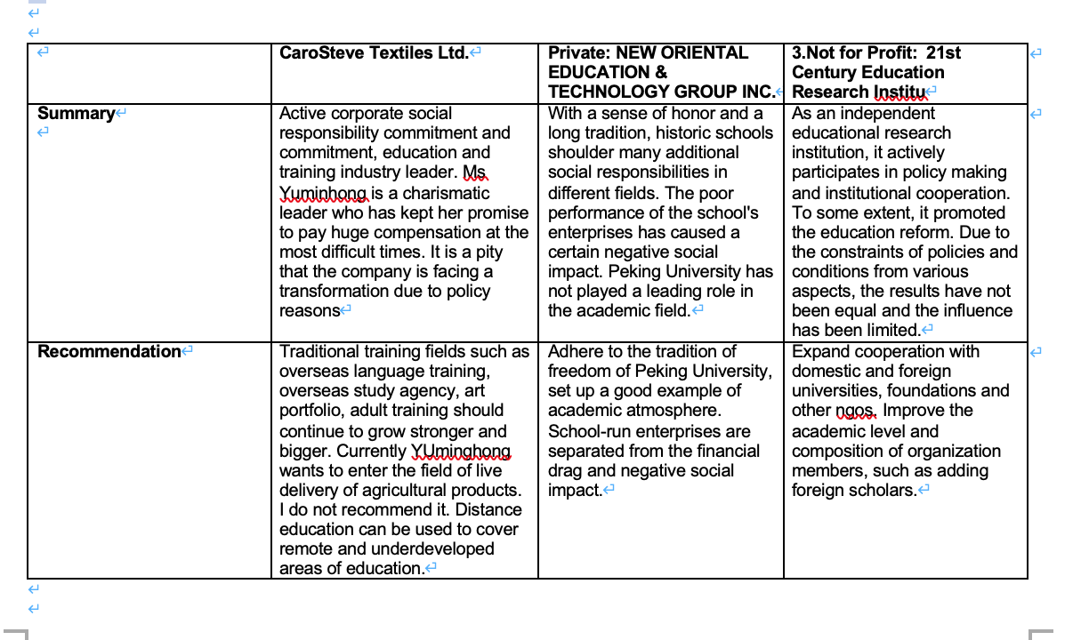
question is to reduce the impact of government administrative intervention on different organizations

Public education improves teaching quality and reduces the impact of the administrative intervention on school teaching and scientific research (Zheng and Kapoor,2020). The tendency of administrative management has two aspects, one is the tendency of government to administrative school management, the other is the tendency of internal school management (Song, Jin and Tang, 2022). We are now emphasizing the transformation of government functions, clarifying the authority and responsibility of government management, and clarifying the rights and responsibilities of schools at all levels and of various types, which are from different modes of running schools and avoid one-sides-all schools (Cyranoski, 2010). For example, almost all universities offer popular subjects such as business, computer and media, which is a waste of public resources and not conducive to the healthy development of universities. At present, the university management mode is single mode. In the 21st century, although the university president is advocating to take responsibility for the system, the understanding and financial rights of many schools are in the hands of secretaries (Song, Jin and Tang, 2022). This leads to school leadership that is not focused on the students or the faculty, and it creates all sorts of problems because of bureaucracy. Reduce unnecessary administrative intervention. For schools, administration is necessary, but unnecessary intervention is unnecessary. For example, if the enterprises affiliated with the university have nothing to do with the transformation of scientific research, but are simply real estate companies or energy enterprises, it is suggested to restructure and divest them. Only by changing the focus of school leaders from "doing what is happy for the government" to "doing what is beneficial to the society" or "doing what is beneficial to the school" can we fundamentally solve the problem of lack of social responsibility in Chinese universities(Song, Jin and Tang, 2022). This helps Chinese college students develop a positive outlook on life and values, so that they can actively participate in social responsibility activities in their future social and business life (Simpson and Aprim, 2018 and Zuo, 2015). The current situation is worrying. More college students do not care about CSR and lack a serious sense of responsibility (Ren and Wang, 2021).

As for private companies, simple executive orders and legislation cannot make them care more about CSR (Murillo and Lozano, 2006). Before solving the financial, development and legal problems of enterprises, it is difficult for small and medium-sized private business owners to focus on the CSR direction (Yin, 2015). For example, private companies are often forced to solicit donations in the event of natural disasters or accidents. In fact, many companies donate to avoid taxes or curry favor with the government (Noronha, Tou; Cynthia and Guan, 2012 and Zuo, Schwartz and Wu, 2015). Only enterprises voluntarily undertake more social responsibilities, actively solve problems such as unemployment, pay attention to vulnerable groups, and pay attention to remote areas (Rhee, Park and Petersen, 2018 and Lin, 2019). Spontaneous CSR behaviors of enterprises will bring better results and public responses (Barnett, Henriques and Husted, 2020). Slogans and postings purely for publicity and brand can hardly really improve enterprises' social responsibility (Sendlhofer, 2019 and Zhu et al., 2020). Another important aspect is the process by which the government formulates industrial laws and regulations. For example, the "double reduction policy" was formulated without the consultation and participation of education and training institutions. Influential policies should be widely consulted, not just made by experts and officials. There e was no time to prepare for the policy, and within a week of its introduction in July all relevant education and training companies were dealt a devastating blow that will have a negative impact on the whole industry for years to come.

It is more important for NGOs to reduce administrative intervention. Currently, there are strict and complex administrative regulations on NGO registration, taxation, gathering, publishing and many other aspects (Whitehead, 2014 and Davis and Moosmayer, 2014). Many NGOs also get help from the government to conduct policy research, which causes the public to have doubts about the NGO's position. For example, China's food safety reports submitted by Chinese NGOs in the past few years did not involve sensitive issues. It was not until overseas research institutions publicly released information and the Chinese government was forced to admit the truth that NGOs took substantive action on sensitive issues. NGOs in the education sector have not been excessively suppressed by the government due to their low sensitivity. Labor, environmental, and human rights NGOs have long been subject to stricter regulation (Davis and Moosmayer, 2014 and Situ, Tilt and Seet, 2018). It has become very difficult to investigate information and publish reports, and CRS practice has been greatly hampered. We found that most domestic NGO members were government officials or university professors, while it was difficult for foreign researchers to enter the system.

Industry supervision of media publicity needs to be strengthened

The regulation of the media industry mentioned here does not mean the introduction of laws and regulations, but the need for the media to change the way of publicity aimed at attracting attention (Flora Hung-Baesecke, Chen and Boyd, 2016). As mentioned above, consumers and internal employees may be more interested in an organization's external image and ethical standards than in social innovation (Khanal, Akhtaruzzaman and Kularatne, 2021). Consumers' awareness of the enterprise's contribution to the local community has a more positive impact on consumers' purchase intention than the enterprise's contribution to the environment (Campbell, 2007). For example, the research shows that "shadow education" in China is a huge market (Zhang and Bray, 2020). Parents have been promoted and led to believe that after-school tutoring is necessary, and this situation has become more and more serious in the last two decades. In a sense, parents are "kidnapped" by tutoring agencies and voluntarily or forced to send their children to training institutions (Bai and Wang, 2020 and Ren and Wang, 2021). This situation has changed dramatically with the introduction of the "double reduction policy" in 2021. More than 80 percent of small and medium-sized training institutions went bankrupt. Large training institutions have also adjusted their business and reduced their staff. At present, excessive remedial courses have been restrained (Lin,2021). The media still put enormous pressure on parents. The media's propaganda of elite schools and low enrollment ratio give families a huge psychological hint that they will suffer poor results if they do not try to improve their grades (Du et al., 2021). A similar pattern is more pronounced on the Internet. With the popularity of web media, the Internet celebrity economy becomes a hot spot (Khan and Bohnsack, 2020). The Internet is full of information about flaunting wealth, luxury life, violence and pornography, which is not beneficial for the public to establish good values. Zhu et al.,2020. Studies show that positive videos and texts are far less attractive than negative, violent and pornographic texts, and people spend much less time on positive information pages than negative ones. Zhu et al.,2020. Finally, the issue of CRS related to media publicity is moral kidnapping (Zhou, 2020). State-owned or listed companies mentioned above are required to make donations. For example, Internet companies that did not donate immediately during the COVID-19 outbreak were collectively condemned by the public (你妈叫你捐款, 2021). For example, Erke, a Chinese sports brand on the verge of bankruptcy, donated 500W pounds of supplies for COVID-19 (Hsiao and Chen, 2021). More than 10 million Chinese netizens voluntarily bought shoes and clothes from the brand, either offline or online. A year later, attention to the brand plummeted, and no one was buying his products. Similar media-led events that highlight patriotism will not be of real significance to China's CSR (Flora Hung-Baesecke, Chen and Boyd, 2016).

The final piece of advice comes from the organization itself. Whether state-owned or private, the corporate responsibility and moral integrity of CEOs and employees have a significant impact on the development of enterprises and CSR (Hu and Xu, 2021). Many times CEOS need to balance CSR and performance. For example, investment in environmental protection, employee welfare, charitable and industry donations will all have an impact on corporate performance (Yin, 2015). Studies have shown that reasonable CSR behavior can improve employee happiness index and consumer satisfaction. But too often it is hard for our policymakers to choose between interests and responsibilities(Tang, Gallagher and Bie, 2014). The employee should prevent and condemn the behavior that the enterprise damages the social responsibility. In fact, many industry scandals are caused by the exposure of people in the industry. For example, China's gutter oil, tainted milk and other food safety and exaggerated propaganda cases of teachers' background mentioned above(Kim, 2018 and Zuo, Schwartz and Wu, 2015).

References

Al-Shammari, M. and Masri, H. (2016) ‘Universities as Drivers and Models of Corporate Social Responsibility: An Empirical Evidence of University in Developing Country’, in Ethical and Social Perspectives on Global Business Interaction in Emerging Markets. IGI Global, pp. 116–132. doi:10.4018/978-1-4666-9864-2.ch007.

Abdurakhmonov, M., Ridge, J., Hill, A. and Loncarich, H., 2021. Strategic Risk and Lobbying: Investigating Lobbying Breadth as Risk Management. Journal of Management, p.014920632110117.

Aguinis, H. and Glavas, A., 2017. On Corporate Social Responsibility, Sensemaking, and the Search for Meaningfulness Through Work. Journal of Management, 45(3), pp.1057-1086.

Bai, L. and Wang, Y., 2020. Pre-departure English language preparation of students on joint 2+2 programs. System, 90, p.102219.

Baijiahao.baidu.com. 2018. 俞敏洪道歉. [online] Available at: <https://baijiahao.baidu.com/s?id=1617659469070866090&wfr=spider&for=pc> [Accessed 28 January 2022].

Baidu, 2022. 北京新东方公益基金会_百度百科. [online] 百度百科. Available at: <https://baike.baidu.com/item/北京新东方公益基金会/24258830?fr=aladdin> [Accessed 28 January 2022].

Baijiahao.baidu.com. 202. 你妈喊你捐款. [online] Available at: <https://baijiahao.baidu.com/s?id=1713765390891744842&wfr=spider&for=pc> [Accessed 28 January 2022].

Barnett, M., Henriques, I. and Husted, B., 2020. Beyond Good Intentions: Designing CSR Initiatives for Greater Social Impact. Journal of Management, 46(6), pp.937-964.

Bartusevičius, H., Bor, A., Jørgensen, F. and Petersen, M., 2021. The Psychological Burden of the COVID-19 Pandemic Is Associated With Antisystemic Attitudes and Political Violence. Psychological Science, 32(9), pp.1391-1403.

Belal AR, Momin M. 2009. Corporate social responsibility (CSR) reporting in emerging economies: a review and future direction. Research in Accounting in Emerging Economies 9: 119–143.

Campbell, J. L. (2007). Why would corporations behave in socially responsible ways? An institutional theory of corporate social responsibility. Academy of Management Review, 32, 946-967.

Cialdini, R. B. et al. (2021) Poison Parasite Counter: Turning Duplicitous Mass Communications Into Self-Negating Memory-Retrieval Cues. Psychological science. [Online] 95679762110151–.
COPY THE CITATION TO CLIPBOARD

Chapple, W. and Moon, J., 2005. Corporate Social Responsibility (CSR) in Asia. Business & Society, 44(4), pp.415-441.

Cheng, Q., 2021. Demand and Value of After-School Service in Primary Schools Under the Background of “Double Reduction” Policy. Journal of Contemporary Educational Research, 5(11), pp.188-191.

Chen, S., Chen, C. and Wen, P., 2021. Parental anxiety, endorsement of literacy learning, and home literacy practices among Chinese parents of young children. Reading and Writing.

Chen, X., Shen, X., Huang, X. and Li, Y., 2021. Research on Social Media Content Marketing: An Empirical Analysis Based on China’s 10 Metropolis for Korean Brands. SAGE Open, 11(4), p.215824402110529.

Collings, D. G. et al. (2021) Leading through paradox in a COVID‐19 world: Human resources comes of age. Human resource management journal. [Online]

Combs, J., Jaskiewicz, P., Ravi, R. and Walls, J., 2022. More Bang for Their Buck: Why (and When) Family Firms Better Leverage Corporate Social Responsibility. Journal of Management, p.014920632110660.

Cyranoski, D., 2010. China debates university reform. Nature, 464(7287), pp.336-337.

Davis, S. and Moosmayer, D., 2014. Greening the Field? How NGOs Are Shaping Corporate Social Responsibility in China. Journal of Current Chinese Affairs, 43(4), pp.75-110.

Davis K., Blomstrom R. L. Business and society: Environment and responsibility (3rd ed.). New York: McGraw-Hill, 1975. Google Scholar
Du, J., Ye, Z., Peng, F., Wang, Z., Diao, Z., Huang, Z. and Xiang, M., 2021. Enlightenment of China’s University Teachers’ Entrepreneurial Awareness for Entrepreneurship Education. Education and Urban Society, 53(8), pp.938-959.

FOUNDER, 2022. Founder. [online] Founder.com. Available at: <http://www.founder.com> [Accessed 28 January 2022].

Flora Hung-Baesecke, C., Chen, Y. and Boyd, B., 2016. Corporate social responsibility, media source preference, trust, and public engagement: The informed public’s perspective. Public Relations Review, 42(4), pp.591-599.

Education, C., 2022. CORPORATE SOCIAL RESPONSIBILITY (CSR) AND EDUCATION IN CHINA. [online] ImmerQi. Available at: <https://immerqi.com/blog/csr-china-and-education/> [Accessed 23 January 2022].

Ervits, I. (2021) CSR reporting by Chinese and Western MNEs: patterns combining formal homogenization and substantive differences. International journal of corporate social responsibility. [Online] 6 (1), 1–24.

Fam, S., 2017. China Came, China Built, China Left?: The Sarawakian Experience with Chinese Dam Building. Journal of Current Chinese Affairs, 46(3), pp.119-158.

Friedman, M. 1970. The social responsibility of business is to increase its profits. New York Times Magazine. September, 13.

Global Journal of Commerce & Management Perspective, 2018. DO COMPANIES IN INDIA FOLLOW THE STANDARD EXPECTED EXPENDITURE (2%) CSR NORMS OF COMPANIES ACT 2013 - A STUDY. 7(2), pp.97-103.

Griffiths, S.L. (2013) Integrating current challenges to CSR into business strategy, Responsible Business Management Symposium, Federation of Universities of Applied Science, Lahti, April.

Globalreporting.org. 2022. GRI - Sector Program. [online] Available at: <https://www.globalreporting.org/standards/sector-program/> [Accessed 27 January 2022].

Google Books. 2022. Public Education Reform and Network Governance. [online] Available at: <https://books.google.co.uk/books?hl=en&lr=&id=vNmMDwAAQBAJ&oi=fnd&pg=PP1&dq=chinese+public+education&ots=O3ou38SbOh&sig=e-p97SppErK61Ehr8t8Jm5F3Nv8&redir_esc=y#v=onepage&q=chinese%20public%20education&f=false> [Accessed 27 January 2022].

Hsiao, C. and Chen, H., 2021. Application of Corporate Social Responsibility -- Taking Chinese Listed Companies in the COVID-19 as an Example. Journal of Business and Management Sciences, 9(4), pp.145-155.

Hu, H. and Xu, D., 2021. Manager or Politician? Effects of CEO Pay on the Performance of State-Controlled Chinese Listed Firms. Journal of Management, p.014920632110153.

Ip, P. K. (2009). The challenge of developing a business ethics in China. Journal of Business Ethics, 88, 211-224.

Jia, Y., Gao, X., & Julian, S. 2020. Do firms use corporate social responsibility to insure against stock price risk? Evidence from a natural experiment. Strategic Management Journal, 41: 290-307.

Ke, J. and Wang, G., 2014. China’s Ethical Dilemmas Under Globalization and Uncertainty. Advances in Developing Human Resources, 16(1), pp.74-91.

Khanal, A., Akhtaruzzaman, M. and Kularatne, I., 2021. The influence of social media on stakeholder engagement and the corporate social responsibility of small businesses. Corporate Social Responsibility and Environmental Management, 28(6), pp.1921-1929.

Khan, S. and Bohnsack, R., 2020. Influencing the disruptive potential of sustainable technologies through value proposition design: The case of vehicle-to-grid technology. Journal of Cleaner Production, 254, p.120018.

Kim, K., Kim, M. and Qian, C., 2015. Effects of Corporate Social Responsibility on Corporate Financial Performance: A Competitive-Action Perspective. Journal of Management, 44(3), pp.1097-1118.

Kim, J., 2018. Animosity and Switching Intention: Moderating Factors in the Decision Making of Chinese Ethnic Diners. Cornell Hospitality Quarterly, 60(2), pp.174-188.

Kim, J., Milliman, J. and Lucas, A., 2021. Effects of Internal and External CSR on Supportive and Harmful Employee Attitudes. Cornell Hospitality Quarterly, p.193896552110631.

Kuo L, Yeh CC, Yu HC. 2011. Disclosure of corporate social responsibility and environmental management: evidence from China. Corporate
Social Responsibility and Environmental Management. DOI: 10.1002/csr274

Lee, J. and Lee, Y., 2015. The Interactions of CSR, Self-Congruity and Purchase Intention among Chinese Consumers. Australasian Marketing Journal, 23(1), pp.19-26.
Li, X., Cheng, B. and Xu, H., 2021. Time-Based Corporate-Social-Responsibility Evaluation Model Taking Chinese Listed Forestry Companies as an Example. Sustainability, 13(14), p.7971.

Lin X,2021 4th Analysis of the Influence and Countermeasures of China’s New Educational Policy “Double Reduction” —Take an After School English Training Institution as an Example International Conference on Humanities, 2021 - atlantis-press.com

Li, H., & Zhang, Y. (2007). The role of managers’ political networking and func- tional experience in new venture performance: Evidence from China’s transition economy. Strategic Management Journal, 28, 791-804.

Lin, Y., 2019. Communicating bad news in corporate social responsibility reporting: A genre-based analysis of Chinese companies. Discourse & Communication, 14(1), pp.22-43.

Lu, Y. et al. (2015) Corporate social responsibility reporting quality, board characteristics and corporate social reputation: Evidence from China. Pacific accounting review. [Online] 27 (1), 95–118.

McMurrian, R. and Matulich, E., 2016. Building Customer Value And Profitability With Business Ethics. Journal of Business & Economics Research (JBER), 14(3), pp.83-90.

McWilliams, A., & Siegel, D. (2001). Corporate social responsibility: A theory of the
firm perspective. Academy of Management Review, 26, 117-127.

McWilliams, A., Siegel, D., & Wright, P. (2006). Corporate social responsibility:
Strategic implications. Journal of Management Studies, 43, 1-18.

Mitra, A. and Panda, S., 2015. Should India Follow the Global CSR Trend of Financing Tertiary Education?. SEDME (Small Enterprises Development, Management & Extension Journal): A worldwide window on MSME Studies, 42(4), pp.29-36.

Miller, P. and Shotte, G., 2010. Franchising Education: Challenges and Opportunities for Coping with the Economic Recession and the Provision of Higher Education in the United Kingdom. Policy Futures in Education, 8(6), pp.644-652.

Mirfazli E. 2008. Evaluate corporate social responsibility disclosure at annual report companies in multifarious group of industry members of
Jakarta Stock Exchange, Indonesia. Social Responsibility Journal 4: 388–406.

Minor, D., & Morgan, J. 2011. CSR as reputation insurance: Primum non nocere. California Management Review,
53: 40-59.

Murillo, D. and Lozano, J., 2006. SMEs and CSR: An Approach to CSR in their Own Words. Journal of Business Ethics, 67(3), pp.227-240.

NEW ORIENTAL EDUCATION & TECHNOLOGY
GROUP INC，2018

Noronha, C., Tou, S., Cynthia, M. and Guan, J., 2012. Corporate Social Responsibility Reporting in China: An Overview and Comparison with Major Trends. Corporate Social Responsibility and Environmental Management, 20(1), pp.29-42.

Nwajiuba, C., Igwe, P., Akinsola-Obatolu, A., Ituma, A. and Binuomote, M., 2020. What can be done to improve higher education quality and graduate employability in Nigeria? A stakeholder approach. Industry and Higher Education, 34(5), pp.358-367.

Porter ME, Kramer MR. Strategy and society: the link between competitive advantage and corporate social responsibility. Harv Bus Rev. 2006;84(12):78-163.

Poulsen, S. and Ipsen, C., 2017. In times of change: How distance managers can ensure employees’ wellbeing and organizational performance. Safety Science, 100, pp.37-45.
(Ren and Wang, 2021)

Ríos-Manríquez, M., Ferrer-Ríos, M.G. and Sánchez-Fernández, M.D. (2021) ‘Structural model of corporate social responsibility. An empirical study on Mexican SMEs’, PloS one, 16(2), pp. e0246384–e0246384. doi:10.1371/journal.pone.0246384.

Rhee, Y., Park, C. and Petersen, B., 2018. The Effect of Local Stakeholder Pressures on Responsive and Strategic CSR Activities. Business & Society, 60(3), pp.582-613.

Sendlhofer, T., 2019. Decoupling from Moral Responsibility for CSR: Employees' Visionary Procrastination at a SME. Journal of Business Ethics, 167(2), pp.361-378.

Shao, K. and Janssens, M., 2021. Who is the Responsible Corporation? A multimodal analysis of power in CSR videos of multinational companies. Organization Studies, p.017084062110448.

Shen, J. and Benson, J., 2016. When CSR Is a Social Norm. Journal of Management, 42(6), pp.1723-1746.
Song, P., Jin, C. and Tang, W., 2022. New medical education reform in China: Towards healthy China 2030.

Ren, Z. and Wang, F., 2021. Socialization Towards Internationalization. Journal of International Students, 12(3).

Rhee, Y., Park, C. and Petersen, B., 2018. The Effect of Local Stakeholder Pressures on Responsive and Strategic CSR Activities. Business & Society, 60(3), pp.582-613.

Sajko, M., Boone, C. and Buyl, T., 2020. CEO Greed, Corporate Social Responsibility, and Organizational Resilience to Systemic Shocks. Journal of Management, 47(4), pp.957-992.

Simpson, S. and Aprim, E., 2018. Do corporate social responsibility practices of firms attract prospective employees? Perception of university students from a developing country. International Journal of Corporate Social Responsibility, 3(1).

Situ, H., Tilt, C. and Seet, P., 2018. The Influence of the Government on Corporate Environmental Reporting in China: An Authoritarian Capitalism Perspective. Business & Society, 59(8), pp.1589-1629.

Tang, L., Gallagher, C. and Bie, B., 2014. Corporate Social Responsibility Communication Through Corporate Websites. International Journal of Business Communication, 52(2), pp.205-227.

Uyar, A., Kuzey, C., Kilic, M. and Karaman, A., 2021. Does firms’ CSR engagement support tourism sector development? Moderation effect of CSR committee and CEO duality. Tourism Economics, p.135481662110245.

Walsh, G., & Beatty, S. E. (2007). Customer-based corporate reputation: Scale devel- opment, validation & application. Journal of Academy of Marketing Science 35(1), 127–143.

We, O. and Choi, B., 2008. A Study on the Corporate Social Responsibility (CSR) Reinforcement in China; Focusing on Chinese Automobile Industry. International Area Review, 11(2), pp.33-54.

Whitehead, D., 2014. Chinese NGO-Firm Partnerships and CSR from an Institutional Perspective. Journal of Current Chinese Affairs, 43(4), pp.41-74.

Wang, X., Cao, F., & Ye, K. 2018. Mandatory corporate social responsibility (CSR) reporting and financial reporting quality: Evidence from a quasi-natural experiment. Journal of Business Ethics, 152: 253-274.

Wong, J. and Dhanesh, G., 2016. Communicating Corporate Social Responsibility (CSR) in the Luxury Industry. Management Communication Quarterly, 31(1), pp.88-112.

Wu, S. and Fan, D., 2021. Taking social responsibilities overseas? The learning paths and performance consequences of Chinese multinationals. Journal of General Management, 46(4), pp.284-301.

Xu, Y., 2013. Labor non-governmental organizations in China: Mobilizing rural migrant workers. Journal of Industrial Relations, 55(2), pp.243-259.

Xw.qq.com. 2022. 新东方裁员6万，股票大跌90％，俞敏洪断腕谋转型，能否东山再起？. [online] Available at: <https://xw.qq.com/amphtml/20220111A05ZZ700> [Accessed 28 January 2022].

Yang, X., & Rivers, C. (2009). Antecedents of CSR practices in MNCs subsidiaries: A stakeholder and institutional perspective. Journal of Business Ethics, 86, 155- 169.

Yang, M., Maresova, P., Akbar, A., Bento, P. and Liu, W., 2021. Convergence or Disparity? A Cross-Country Analysis of Corporate Social Responsibility Reporting for Banking Industry in Nordic Countries and China. SAGE Open, 11(3), p.215824402110299.

Ye Jingyi,2017 Reflections on and Practices of Peking University Fulfilling Social Responsibility. University Social Responsibility and Quality of Life pp 205-221.https://link.springer.com/chapter/10.1007/978-981-10-3877-8_13

Yin, J., 2015. Institutional Drivers for Corporate Social Responsibility in an Emerging Economy: A Mixed-Method Study of Chinese Business Executives. Business & Society, 56(5), pp.672-704.

Zheng, J. and Kapoor, D. (2020) 'State formation and higher education (HE) policy: An analytical review of policy shifts and the internationalization of higher education (IHE) in China between 1949 and 2019’, Higher education, 81(2), pp. 179–195. doi:10.1007/s10734-020-00517-2.

Zhou, L., 2020. Moral stance taking as a device of covert aggression in Chinese political language use. Discourse, Context & Media, 36, p.100415.

Zhu, W., Shang, Y., He, S. and Pan, W., 2020. Corporate social responsibility of Internet enterprises based on data mining. The International Journal of Electrical Engineering & Education, p.002072092094058.

Zuo, J. (2015). Improve social services capability and create world-class universities—Peking University’s practice experience. China Leadership Science, 1, 50–53.

Zuo, W., Schwartz, M. and Wu, Y., 2015. Institutional Forces Affecting Corporate Social Responsibility Behavior of the Chinese Food Industry. Business & Society, 56(5), pp.705-737.

2022. [online] Available at: <https://www.europeanbusinessreview.com/saying-no-to-plastics-an-asian-perspective/> [Accessed 23 January 2022].

Appendix
- Private: NEW ORIENTAL EDUCATION & TECHNOLOGY GROUP INC.
Investor.neworiental.org. 2022. [online] Available at: https://investor.neworiental.org/system/files-encrypted/nasdaq_kms/assets/2021/05/09/23-02-12/新东方教育科技集团2020财年ESG报告.pdf [Accessed 28 January 2022].

新东方教育科技（集团）有限公司. 2019. 2018年度报告 | 新东方教育科技（集团）有限公司. [online] Available at: https://investor.neworiental.org/zh-hans/financial-information/annual-reports [Accessed 28 January 2019].

Baidu, 2022. 北京新东方公益基金会_百度百科. [online] 百度百科. Available at: https://baike.baidu.com/item/北京新东方公益基金会/24258830?fr=aladdin [Accessed 28 January 2022].

Xw.qq.com. 2022. 新东方裁员6万，股票大跌90％，俞敏洪断腕谋转型，能否东山再起？. [online] Available at: https://xw.qq.com/amphtml/20220111A05ZZ700 [Accessed 28 January 2022].

Baijiahao.baidu.com. 2018. 俞敏洪道歉. [online] Available at: https://baijiahao.baidu.com/s?id=1617659469070866090&wfr=spider&for=pc [Accessed 28 January 2022].

- Public: Peking University
FOUNDER, 2022. Founder. [online] Founder.com. Available at: http://www.founder.com [Accessed 28 January 2022].

Peking University. (2015, April 28). News. Peking University. Retrieved from http://pkunews.pku.edu.cn/2015zt/2015-04/28/content_288465.htm.

Ye Jingyi,2017 Reflections on and Practices of Peking University Fulfilling Social Responsibilit.University Social Responsibility and Quality of Life pp 205-221.https://link.springer.com/chapter/10.1007/978-981-10-3877-8_13

3．Not for Profit: 21st Century Education Research Institute
21世纪教育研究院. 2022. 教育蓝皮书 - 21世纪教育研究院. [online] Available at: http://www.21cedu.cn/9 [Accessed 28 January 2022].

Baidu.com. 2022. [online] Available at: https://www.baidu.com/link?url=_x1Goy-sftGXkEyzADibp8yqtbQSCp76KvYTbhBodGc0_n7t2XgmpKH2EhKVqsw2dhwfX1YTnO1hSOYQe4meK_&wd=&eqid=c53c26ba00177e110000000661f4367c [Accessed 28 January 2022].

