Professional behaviours and valuing people
(AC.1.1)
To become a people professional, it is important to ensure you are up to date with the ever-changing rules and regulations that you are confronted with. It is essential to embrace change, learn from it, and try to better understand its impact on the business and its employees. By staying informed, people professionals can provide better advice and a more efficient service (LearnDirect). This is particularly critical when ensuring that information remains relevant, accurate, and legally compliant. Keeping up to date with regulations places responsibility on-line management to ensure that these rules are being followed and effectively implemented. People services members must maintain honesty while demonstrating empathy for individuals' personal beliefs and circumstances, always safeguarding personal data and ensuring it is stored securely and confidentially (Marchington et al.).
People practitioners need to make sure the information they share is based on facts and free from bias. It's important for them to listen to employees experiences and work on creating strong connections, a positive culture, and good workplace behaviours (CIPD, 2023). They also need to push for equality, diversity, and inclusion, while helping people to learn, grow, and progress in their careers. Offering rewards and incentives to staff is another important part of the role, as it keeps everyone motivated and engaged. By doing all of this, HR professionals can stay aligned with the key values of the profession, as shown in the CIPD Profession Map. This means developing specialist knowledge, core behaviours, and essential knowledge, which leads to an approach to HR that's based on principles, evidence, and results (Profession map, CIPD, 2023).
People professionals also need to keep up with new technology, making sure data is created and shared correctly as part of people analytics. This helps in planning development programmes and improving processes. HR plays an important part in recruitment, employee growth, and career progression. They have the knowledge to manage and support people well. When it comes to hiring, HR needs to make sure job descriptions are current and accurately describe the role, while interview scores are recorded in a fair and consistent way. It’s also important to do timely probation reviews to check how new hires are doing and whether they’re the right fit for the job (Gartner, 2023).
A key aspect of the people profession is supporting employee welfare, ensuring that employees have access to the appropriate resources and are signposted to the most relevant support. HR professionals act as a voice for employees, advocating on their behalf with senior management. This responsibility ensures that discrimination is prevented, and diversity is embraced across the organization, creating a supportive, inclusive, and respectful workplace for all employees. (EasyHRWorld).
Being a people professional, according to the CIPD profession map, is about staying up to date, doing the right thing, and having the skills to support both the business and its people. It’s about making sure things are fair, inclusive, and legal. While also looking out for employee well-being. People professionals play a big part in creating a positive workplace where everyone can thrive. (CIPD, 2023).
(AC.1.2)
I believe one of my strongest personal values is my impact on working lives. In my role, I do not currently work in the people services department; however, in my operational department, I am considered the people services expert. Staff and employees often seek me out for advice and guidance, and I possess a basic to intermediate level of knowledge. If I am unsure about how to offer guidance, I do not hesitate to contact the people services department for further support. One of my strongest motivators is the wellbeing of the employees, and I take great pride in ensuring they feel supported and cared for. I regularly conduct 1-2-1s, signpost resources, engage with other personnel for advice, and ensure any necessary interventions are carried out. (CIPD, 2018)
If I am unable to fully assist the employees, I explore reasonable adjustments that could be made, and, if necessary, initiate employee assistance programs to assess if there’s more we can do to help. I also carry out occupational health referrals when appropriate, taking this on as my responsibility.
Ethically, I prioritize my honesty and confidentiality in the workplace, especially when dealing with sensitive matters. Occasionally, staff may request adjustments that unfortunately aren’t feasible for our department, such as working with computers in a role based at an outdoor activity centre. In such cases, I am upfront and honest with them about the limitations. If such a request arises, I would ask for formal documentation, such as a doctor's note, to support the adjustment. Should the situation warrant, I would explore the possibility of redeployment, temporarily moving the staff member to another department, like sales or guest services, to show my commitment to supporting them and helping them stay in work.
Regarding confidentiality, I understand its importance to both the business and the employee. On occasion, staff may share sensitive information or face upsetting circumstances, such as extensions to probation periods. In such cases, while I strive to maintain confidentiality, there may be situations where I need to break it for the safety of the employee or for operational needs, such as adjusting rotas. I am always cautious with how much information is shared and ensure I seek guidance from our people services department before taking any action. This careful balance helps maintain trust and integrity while ensuring the wellbeing of employees and the smooth operation of the business. (Avado Learning, 2023).
(AC 1.3)
People professionals play a key role in shaping how an organisation runs. Being able to contribute to discussions confidently, with clear and informed input. It is important that people professionals keep up to date with the ever-changing laws and regulations and ensure these are implemented through policies and procedures as soon as possible. This helps ensure the business stays compliant and avoids legal complications. It is essential that these new changes are communicated to employees clearly and effectively, and that management fully understands the new changes to implement them within their own teams. If the people practice employees have had a history of untrustworthy or false information, it can create a negative effect, causing staff to become more reluctant to follow what is being asked of them. This lack of trust can lead to disengagement, making it harder to implement changes. The impact of this could be detrimental, as it may result in poor employee morale and decreased productivity. (CIPD, 2023).
Being able to influence is essential for good decision making. People professionals often provide advice on things like recruitment, employee engagement, and recruitment, all of which directly impact the businesses goals. If they can’t express their insights clearly, decisions might be made without proper up to date knowledge, which can hurt the business in the long run. The same goes for implementing changes within the company. Whether it’s introducing new policies or addressing organisational culture, people professionals need to guide others through those processes. Without the ability to influence, these changes can face resistance. If the people services department is honest in their approach, constantly learning and developing their knowledge, and taking accountability for past mistakes, they will be seen in a more favourable light. Employees will be more willing to follow their guidance, knowing that the people services team is transparent and reliable. Employees will view staff members in people services as leaders and be influenced by their knowledge, which will foster a culture of trust and respect. (CIPD, 2023).
When people professionals communicate confidently, they build trust. People, whether it's senior leadership or employees, are more likely to listen to someone who is clear and knowledgeable. If someone isn’t able to express their ideas well, it can make them seem less credible, which can affect their ability to influence decisions or actions. Additionally, it is important for people services employees to be proactive in staying informed of new laws, delving deeper into the specific problems faced by the business, and altering or changing practices based on regular feedback. By actively gathering this feedback, people services will gain a more comprehensive understanding of the business situation, enabling them to make well-informed decisions. Once confident in their knowledge and approach, they will come across as more knowledgeable, which will be apparent to the staff. Being well-prepared with accurate information and having done the necessary research beforehand will ensure the HR representative is seen as an expert and a reliable resource. Any questions staff have will be addressed promptly and effectively, further reinforcing trust and confidence in the people services team. (Workology, 2023).
When people professionals are not confident in their ability to influence, it can lead to a lack of trust and respect. Ultimately, if they aren’t actively shaping decisions or advocating for change, the organisation may suffer from poor morale or missed opportunities for growth.
(AC 1.4)
If I were to witness something I believed to be non-ethical, such as favouritism for promotion. I would first have a private conversation with the manager. I’d ask them to explain how they’re making their promotion decisions and if they’ve considered a fair process for all employees. If the behaviour continues or there’s no reasonable explanation, I’d raise the issue with senior management. I would also do my research to find a policy on progression and maybe even look to see if our academy can offer any training for managers to ensure they’re making fair, unbiased decisions.
If the matter were illegal, such as discrimination, harassment, or racism, I would act accordingly and immediately. Separating the individuals involved and taking statements would be my first step. If the issue warrants it, I will also gather CCTV footage to ensure accuracy. After collecting all relevant documentation, I would escalate the matter to my head of department and our HR team for further review. Once all facts were gathered, we would need to arrange a meeting, potentially involving suspension to protect the business and the individuals involved. I would explain that this is a necessary procedure for both protection and fairness.
I would investigate all relevant data, such as risk assessments, standard operating procedures, and training records. Additionally, I would check if any medical conditions had been declared during the recruitment process, such as Tourette’s syndrome or other conditions that might influence the situation. CCTV footage could also be saved if needed. I would carefully review the separate statements from all parties involved to ensure both sides of the story were heard. Following the investigation, I would bring the staff member in for a meeting to ask questions and ensure a fair and thorough process. If needed, I would escalate the matter to a disciplinary hearing.
If the situation was severe, I would escalate more quickly due to the severity of the issue. In such cases, the matter could potentially result in gross misconduct, which may lead to immediate dismissal, such as in cases of drug use or assault. It is important to follow these protocols to maintain a safe and ethical work environment for all employees. (Neurolaunch)
(AC 2.1)
When employees feel like they belong and are respected, they’re more likely to be motivated, happy, and committed to their work. This doesn’t just make for a better working environment but also drives better results for the company. If an employee feels included in the business and involved with the decision-making process and strategies, they will feel a sense of place and feel valued in the organisation. An employee feeling valued will naturally feel engaged and appreciated. The morale of the employee will be higher, and they will feel the need to want to do more and potentially progress in the organisation, having a desire to stay long term with the business. Employees feeling fairly treated will feel respected, they will feel listened to, and enthusiastic to come to work. This will help with retention of staff. When people feel valued, it boosts their confidence. They’re more likely to feel satisfied with their job. A workplace that’s inclusive also means employees can connect with each other better, building stronger relationships and improving teamwork. If people are treated fairly, it builds trust, trust is essential for good mental health, motivation, and overall happiness at work. (BCG, 2024)
If a business implements up-to-date policies to ensure diversity and inclusion is celebrated, this will make the employees feel included from the start. A business that has an open-door policy will allow staff to feel included and welcomed in the workplace. A business that offers staff incentives is also a very good way to increase motivation to work there. For example, in my organisation, we have staff discounts for discounted stays, free access to our swimming pool, employee of the month recognition, and access to discounted swimming lessons and childcare. Additionally, ensuring staff members' ideas are heard, valued, and implemented into the company's plans can increase a sense of ownership and pride. This sense of involvement helps foster a positive, inclusive work environment where employees feel they can contribute to the business’s success. All of this will boost morale but also encourage a deeper connection to the company's goals and mission. A diverse workforce brings different ideas which can help the company stand out and stay competitive. People who feel recognised and fairly treated are also more likely to stay loyal, which saves the business money on recruitment and training. This leads to a more engaged and productive team, meaning better performance for the company. (CIPD, 2023)
HR professionals can also use the Maslow’s method when looking deeper into the needs of an employee. This method helps to categorise and make simple the approach when dealing with staffing. These include basic needs such as food, water, warmth and rest as well as safety needs such as security and safety. There is the addition of psychological needs such as the need for belongness and love from friends or relationships to esteem needs and accomplishments and then finally self-actualisation to help achieve the persons full potential. (Simply Psychology) By having HR professionals using this method it will aid when improving morale, motivation and structure.
(AC 2.2)
When designing people practice initiatives to be inclusive, it’s important to make sure that everything is accessible and fair to everyone, no matter their background or situation. Within my organisation, I noticed that our onboarding and recruitment process was not always inclusive. New recruits would be given a form with questions and health questionnaires to fill out. However, I challenged this and believed that this approach was not inclusive to all. What I suggested was instead of questions straight away, to implement buttons on the form which would ask more regarding writing, hearing, and speech of the new potential employee. For instance, if someone clicked that they struggled to write, we would then arrange a phone call to allow them ample chance, like everyone else. There could be different ways of learning we could offer like online courses, in-person sessions, or even hybrid options – so everyone has a chance to access the content. This has made me more conscious with accessibility, like making sure training materials are easy to read, and offering support for those who may need it. (Canditech)
I noticed some people with dyslexia could struggle with the forms or not fill them out in much detail or attentiveness, which may look negative towards them and shine a bad light from the get-go. With the above approach, it allows these recruits a better chance to explain things. Additionally, this creates a fairer, more inclusive process, ensuring that every candidate is judged equally on their abilities rather than potential barriers, which can also improve the company’s reputation and attract more diverse talent to the organisation. (HRM Handbook)
By applying the principles of appreciate inquiry, I focused on identifying strengths and opportunities for improvement rather than just addressing the problem. This approach aligns with AI’s discovery and dream phases by recognising the need for a more inclusive process and envisioning a recruitment system where all candidates can fully supported. The design and destiny phases were realised by implementing tailored accessibility measures, fostering inclusivity. (Ackerman, C. E. 2023).
(AC 2.3)
When it comes to working inclusively and building good relationships with others, I always try to make sure everyone feels respected and valued. From my own experience, I’ve found that being open and empathetic really helps create a positive environment. Through discussion with my peers, I am confident that I always try to do my best to ensure everything is done equally and fairly, treating everyone as equal in line with their job description or job expectancy’s. For example, the entry-level staff, supervisors, and relief managers would be expected to achieve different things, and as such, would be pulled up on this. I am a very open and honest person and treat people how I would like to be treated. I try to listen to what people have to say, respect different opinions, and encourage everyone to get involved. Everyone’s got their own background and perspective, and I think it’s important to embrace those differences rather than letting them get in the way.
Through doing this and my length of service at my organisation, this has won me recognition, and I have received rewards for my leadership. I have a knack for wanting to help others and if I see staff struggling or needing support, I will drop immediately what I am doing to try and help that staff member or see what’s bothering them. I would then signpost, assist, or provide solutions best to my knowledge to improve their well-being. In a recent team meeting I made sure everyone had a chance to share their thoughts, especially those who might be quieter or less confident. This helped build a positive atmosphere where everyone felt included in the decisions being made.
(AC 3.1)
The role of a people practitioner has changed a lot recently, and it’s still changing. Previously, the job was mainly about doing the admin side of things like recruitment, handling employee issues, and making sure the company followed the law. But now, the role is more focused on the bigger picture, like making sure employees are happy, helping the company meet its goals, and keeping up with changes in how people work. Ongoing learning is essential to keep up to date with industry standards. HR professionals should keep up to date with CIPD standards. Getting a better understanding of technology and understanding data. Understanding a better knowledge of strategies is vital for growth. One of the biggest changes is how people practitioners use data. Now they need to look at things like employee performance, turnover rates, and other data to make better decisions. Knowing how to use data helps us make smarter choices about hiring, keeping staff, and improving company culture. (Human in Progress)
Another big shift is making workplaces more inclusive and flexible. People practitioners now need to make sure that policies promote diversity and inclusion and offer flexible working options for different people. With more people working from home or in hybrid setups, managing teams who aren’t all in the same office has become important. (CIPD, 2023)
To keep up with all these changes, I know I need to keep learning and developing my skills. It’s important to stay up to date with new technology, workplace trends, and ways to help employees feel supported and included. (CIPD)
(AC 3.2)
I believe one of my strongest assets is my ability to deal with staff welfare. Employees feel comfortable coming to me with their frustrations or personal issues, and I always make sure to listen and offer support. I'm well-researched on where to direct them for further help, such as counselling services or other resources, which helps them feel more supported. I’ve worked hard to build trust with staff, and being approachable and non-judgemental is key to this. It’s something I’m proud of, as it contributes to a positive work environment.
However, when reflecting on my weaknesses, I’ve noticed an area where I can improve. One of them is my time management. Because I focus so much on supporting individuals, I sometimes end up spending too much time on specific cases. This means I can fall behind on other tasks, which can be a bit overwhelming.
To get a more well-rounded view, I asked John – my line manager for feedback. He agreed with me about my strength in supporting staff. He mentioned that I’m approachable, and employees feel they can come to me with personal matters, knowing I’ll help them find the right resources. John also pointed out that I do a good job of researching where to signpost employees for additional support. However, he highlighted that I sometimes take on too much myself, especially when supporting staff. This can make it hard to keep on top of other tasks and responsibilities. He also mentioned that I could be more vocal when it comes to giving feedback to senior managers. John feels I have valuable ideas, but I tend to hold back at times.
Looking at the CIPD Profession Map, two core behaviour areas stand out for me. The first is employee relations, which is one of my strengths. Both my self-reflection and John’s feedback show that I’m good at building strong relationships with staff and creating a supportive environment. The second is professional courage and influence, which is an area I need to improve. While I’m confident talking to staff, I struggle to be as assertive with senior managers. I need to work on being more vocal and confident when sharing my thoughts, particularly in meetings.
(AC 3.3)
To help with my development, I have picked a few things to work on. I’m going to attend a communication skills workshop to build my confidence in giving feedback, especially to senior managers. I also plan to have regular check-ins with a mentor to practice speaking up and get advice. On top of that, I’ll read books and articles about leadership and communication to continue learning. These activities should help me communicate more confidently and develop my overall skills. I have chosen to do the above as I believe a more confident manager, who has done the research and is informative on their approach will not only benefit myself but benefit the whole organisation when it comes down to laws and regulations. I have noticed with more confidence when dealing with senior management this will showcase my own worth and my accountability plus expertise to become someone the business feels reliant on and trustworthy when dealing with certain matters.
(AC 3.4)
I’ve done a few development activities recently that have made a real difference to how I work. First, I took part in difficult conversation training, which has helped me deal with tricky situations more confidently. I’m much better at handling sensitive chats now, whether it's with staff or senior management. Then, I did Acuity law training, which gave me a better understanding of the legal side of HR. It’s made me more confident when making decisions and giving advice. Lastly, I did the Future Leader programme, which helped me think more strategically and gave me the tools to step up as a leader. All of these have helped me improve in my role and grow professionally.

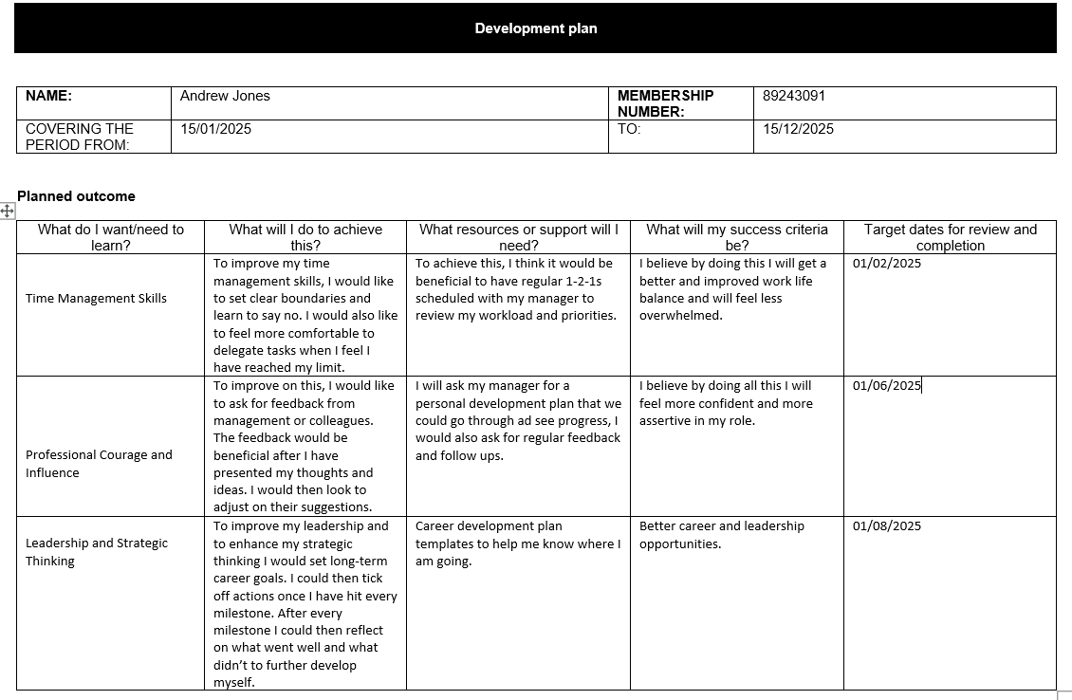

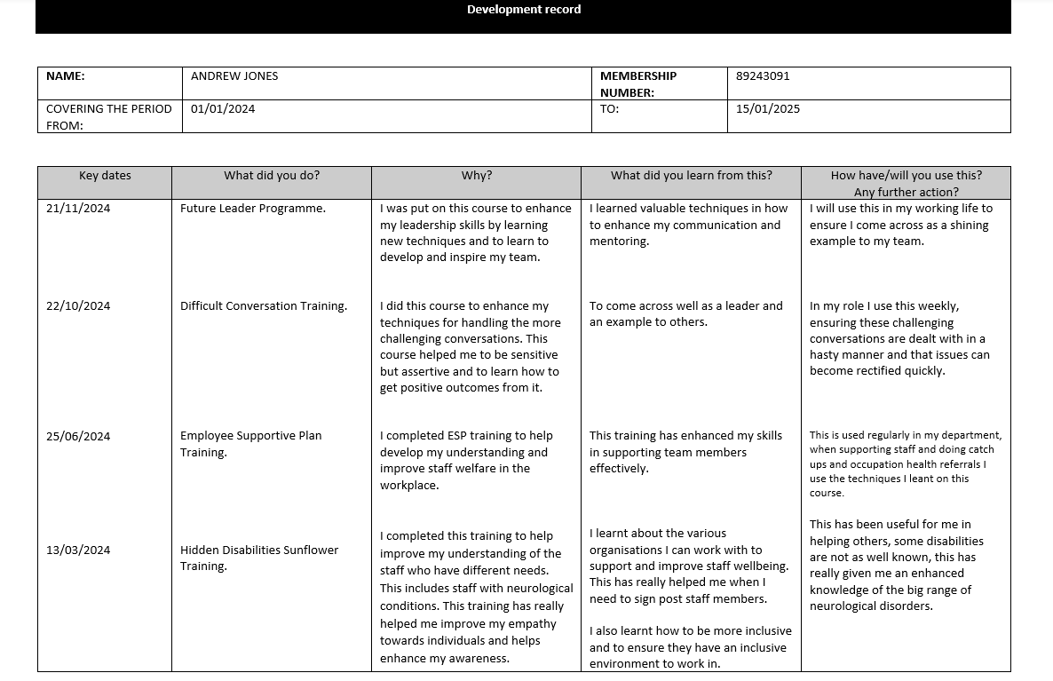

Bibliography: Reference list
Avado Learning, 2023. Understanding HR ethics. Available at: https://www.avadolearning.com/blog/understanding-hr-ethics/#:~:text=In%20HR%2C%20ethics%20go%20beyond%20compliance%2C%20fostering%20a,promoting%20diversity%2C%20and%20integrating%20AI%20responsibly%20are%20essential [Accessed 30 December 2024].
BCG, 2024. Joy at work: Matters more than you realize. Available at: https://www.bcg.com/publications/2024/joy-at-work-matters-more-than-you-realize [Accessed 3 January 2025].
Canditech, Available at: https://www.canditech.io/glossary/bias/?kw=canditech.io%2Fglossary&cpn=486202746&utm_term=canditech.io%2Fglossary&utm_campaign=BNG-US_UK_ISR-TCPA-DSA-All-DT&utm_source=bing&utm_medium=ppc&hsa_acc=6403002882&hsa_cam=21388528940&hsa_grp=1234752638461257&hsa_ad=&hsa_src=o&hsa_tgt=dat-2328971786895445:loc-188&hsa_kw=canditech.io%2Fglossary&hsa_mt=b&hsa_net=adwords&hsa_ver=3&msclkid=a126226985f6177a01d645ed72d4c8ab [Accessed 5 January 2025].
CIPD, 2023. HR professionals pivotal in implementing change. Available at: https://www.cipd.org/uk/about/news/hr-professionals-pivotal-implementing-change [Accessed 2 January 2025].
CIPD, 2023. Reputation and impact: The rise of the people profession. Available at: https://community.cipd.co.uk/cipd-blogs/b/the_people_profession_now_and_for_the_future/posts/reputation-and-impact-the-rise-of-the-people-profession [Accessed 7 January 2025].
CIPD, 2023. Explore the Profession Map. Available at: https://www.cipd.org/en/the-people-profession/the-profession-map/explore-the-profession-map/ [Accessed 8 January 2025].
CIPD, 2023. The Profession Map. Available at: https://www.cipd.org/uk/the-people-profession/the-profession-map/ [Accessed 11 January 2025].
CIPD, 2023. Evidence-based profession. Available at: https://www.cipd.org/uk/knowledge/guides/evidence-based-profession/ [Accessed 4 January 2025].
CIPD, 2023. HR policies factsheet. Available at: https://www.cipd.org/uk/knowledge/factsheets/hr-policies-factsheet/ [Accessed 6 January 2025].
CIPD, 2023. How HR can increase its influence and impact in the new world of work. Available at: https://pminsight.cipd.co.uk/how-hr-can-increase-its-influence-and-impact-in-the-new-world-of-work [Accessed 9 January 2025].
EasyHRWorld, Employee welfare. Available at: https://www.easyhrworld.com/hr-glossary/employee-welfare [Accessed 30 December 2024].
Gartner, 2023. HR technology: a new approach to talent management and workforce development. Available at: https://www.gartner.com/en/human-resources/topics/hr-technology-strategy [Accessed 3 January 2025].
Human in Progress, The future role of HR. Available at: https://humaninprogress.com/the-future-role-ofhr/#:~:text=The%20role%20of%20HR%20will%20undergo%20significant%20transformation%2C,streamline%20tasks%20like%20recruitment%2C%20training%2C%20and%20performance%20management [Accessed 5 January 2025].
HRM Handbook, Positive environment. Available at: https://hrmhandbook.com/general/positive-environment/#:~:text=By%20creating%20a%20positive%20environment%2C%20Human%20Resources%20departments,to%20increased%20respect%20for%20the%20HR%20Professionals%E2%80%99%20abilities [Accessed 27 December 2024].
LearnDirect, Why Human Resources Became the People Profession. Available at: https://www.learndirect.com/pillar/why-human-resources-became-the-people-profession#:~:text=Human%20resources%20is%20the%20division%20of%20a%20business,role%20with%20supposed%20power%2C%20lacking%20any%20actual%20influence [Accessed 8 January 2025].
Neurolaunch, Reporting unethical behaviour in the workplace. Available at: https://neurolaunch.com/reporting-unethical-behavior-in-the-workplace/ [Accessed 9 January 2025].
Simply Psychology. Maslow’s hierarchy of needs. Simply psychology. Available at https://www.simplypsychology.org/maslow.html
What is Appreciative Inquiry? A brief history & real-life examples. PositivePsychology.com. Available at: https://positivepsychology.com/appreciative-inquiry/ (Accessed: 25 February 2025).
Workology, 2023. Confidence: The most important HR competency for the future. Available at: https://workology.com/confidence-the-most-important-hr-competency-for-the-future/ [Accessed 11 January 2025].

3571

