Psychology in Health and Social Care
BMHP4003_BIRM

Lecturers: Rebecca Kavanagh
Dr Muhammad Hossain

Student Name: Sharon Strachan
Student No:1911689

Contents Page
Introduction Page 3

Trauma Recovery Model (TRM) Page 3 - 4

Figure 1: Trauma Recovery Model Page 4

Maslow’s hierarchy of needs Page 5

Theories of aggression Page 5 & 6

Social Identity Theory Page 6

Theory of planned behaviour Page 6 & 7

Conclusion Page 7

Bibliography Page 8 & 9

Introduction
This report is based on a case study that will seek to address the social and biological factors which influence human behaviour. Theoretical knowledge including psychological theories will be made applicable to this report in order to provide clarity as to how theories of lifespan development can be applied to Health and Social Care practice. Hypothetical links will be made to various scholars to demonstrate understanding relating to the case study emphasising how best to manage the situation presented within the case study whereby a young person who had previously received a 18 month custodial sentence for the offence of possessing drugs with intent to supply. It is apparent that this young person is demonstrating some problematic behaviours whereby focus will be laid upon understanding these behaviours and the approach necessary to be able to manage this young offender. In finding the resolution to the problem, recommendations will be made in the latter part of the report as to how the Youth Offending Team could offer support in an attempt to move forward in managing such challenging behaviours of those young people that are engaged in the service. Ultimately, what will transpire from this report is ways to shape their approach and expand their knowledge around challenging situations they were to occur once more.

Trauma Recovery Model (TRM)
It is understood within the case study that the young person namely Mason Kabee appeared to be displaying aggressive behaviours when confronted by the team. First and foremost, it is imperative to identify any traumas that Mason may have experienced which may well be contributing to the challenging behaviours he is presenting. The Trauma Recovery Model (TRM) is a model allows practitioners to understand the psychological needs of those young people and offers clarification as to why they behave the way in which they do. In order for practitioners to be able to address ones needs it is imperative that they understand these behaviours in order to be able to offer and identify the necessary interventions to best address those individual needs. The TRM is designed to lay focus upon presentation and behaviour. On one hand there are underlying issues that need to be considered when addressing one’s behaviour and on the other have, the layers of intervention that needs to take place in order to allow individuals to improve on various aspects in their life pertaining to their behaviour.
The TRM discusses that in the initial stages one can find themselves at the instability/chaotic stage whereby they present the behaviours that Mason is showing such as, challenging behaviour, aggression also the fact that he is hanging around with other peers who are known to the police, this could be considered as inappropriate relationships. It is apparent that when Mason was in custody, he would have maintained positive relationships with staff within the establishment which encouraged Mason to become more motivated. Then, when Mason was released from custody and was required to engage with the Youth Offending Service that trust he build with previous staff would be fragmented with the need for new relationships to form. This refers to the second phase within the TRM model. According to the TRM model once Mason begins to build some trust with those professional people within the Youth Offending Team his willingness to comply with routines will be ostensible. As Mason progressed through the stages, he will then be in a place to attempt to deal with the trauma that he has experienced which of course will be difficult for him. The next point in the process would be that Mason will have more insight and awareness and will be able to manage his behaviours more effectively demonstrating more calmness. Lastly, once Mason has moved through the stages, he will be able to start achieving his goals. The chief belief in relation to the TRM is based solely upon assumption that those young people who are involved in the criminal justice system are what practitioners believe to be redeemable with the view of them being reintegrated back into the community and in turn maintaining their desistance (Skuse & Matthew, 2015).
Figure 1: 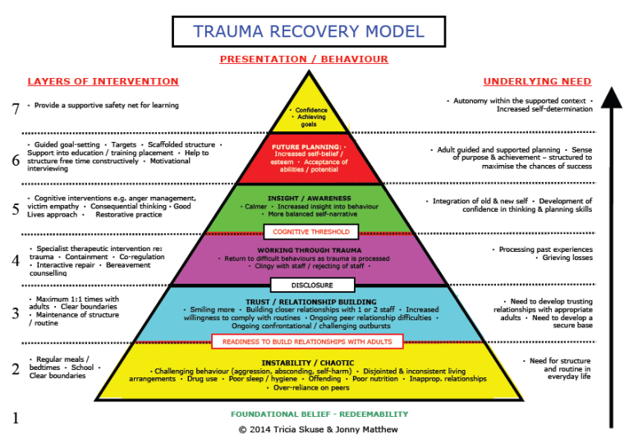

Maslow’s hierarchy of needs
It is worth noting here that the lower phase of the TRM model draws upon Maslow’s (1943) hierarchy of needs. Within Maslow’s (1943) it mentions that an individual’s rudimentary needs’ such as food, water and warmth need to be met before psychological growth can occur. Just like the TRM model you move through the phases in the Maslow’s hierarchy of needs model in order to improve and achieve self-actualisation. When individuals are going through the different layers of interventions It is fair to say that one’s behaviour in more unsettled until they become attuned to the living environment which then allows them to develop an emotional readiness for relationships with adult (Golding & Hughes, 2012). As proposed by Golding & Hughes (2012) once relationships and trust are formed, an individual will undoubtedly be able to regulate their emotions better and fine a way to manage.

Theories of aggression
In addition to the above, it has been high lighted in the case study that since being released from custody Mason has not been attending his college course which the Youth Offending Team have attempted to address. However, Mason responded negatively displaying verbally aggressive behaviour. Let us begin to understand Mason’s response laying immediate focus upon theories of aggression. Dollard, Doob, Miller, Mowrer and Sears (1939) who were a group of psychologists came together to form the Yale Researchers who were considered to be behaviourists. Their stance and hypothesis were that ‘when people get frustrated (i.e., when their goals are thwarted), they respond aggressively’ (Dollard, Doob, Miller, Mowrer and Sears, 1939). But the question is this, how does this supposition relate to Mason’s aggression? It was said in the case study that prior to Mason being released from custody he entered a joinery apprenticeship and appeared positive regarding this new opportunity. Within the establishment it offered structure to Mason allowing him to feel supported however, when Mason was reintegrated back into the community, he may have felt very anxious and scared about the new life he was about to experience with it all becoming reality. It appears that Mason was of the view that when he left custody he would engage in this college course, nevertheless, the fact that he is now in the community and his plans haven’t worked out this is coming out in belligerence as Mason may well be unfulfilled that he has been unable to follow through with the initial plan.
Neal Miller (1941) explained that frustration produces promptings which can evoke a number of different responses one of which can be instigating some sort of aggressive response. In some way it could be agreed that Mason’s act of aggression could align with the views of Dollard, Doob, Miller, Mowrer and Sears (1939, p11) who described aggression to be ‘an act whose goal response is injury to an organism (or organism-surrogate).’ In the opinion of Dollard, Doob, Miller, Mowrer, and Sears (1939) their views were that they consider this to be intent to injure. With that being said, in the case study it suggests that Mason is still associating with people who are known to the local police. This indicates that Mason has no intentions to change and is continuing to associate with negative peers which is creating damage to himself and his future goals.

Social Identity Theory
Additionally, it is imperative to recognise that Mason may have his own belief that he belongs to a particular social category or group according to Hogg & Abrams (1988). In this instance, Mason has been involved in criminality and also associates with peers who are too entrenched in crime therefore may well familiarise himself with this social group due to the similarities. It is right in suggesting that those individuals who are considered to be similar to the self can be referred to as being the in-group whereas on the other hand, those individuals who differ from the self are considered to be the out-group (Stets & Burke, 2000). It is worth noting here that ‘the core of an identity is the categorization of self’ (Burke & Tully 1977; Thoits 1986). When being part of a social identity group it is fair to say that with that group comes a set of expectations which in turn ‘forms a set of standards that guide one’s behaviour’ (Burke 1991; Burke and Reitzes 1981). This again refers to the earlier point of the group in which Mason identifies with share comparable behaviours.

Theory of planned behaviour
Furthermore, the theory of planned behaviour is recognised as a cognitive theory which recommends that if an individual participates in a certain type of behaviour i.e. in Mason’s case offending, this can be foretold by their intention to maintain the offending behaviour (Ajzen, 1985). Ajzen (1991 p. 181) advises that

'Intentions are assumed to capture the motivational factors that influence a behaviour; they are indications of how hard people are willing to try, of how much of an effort they are planning to exert, in order to perform the behaviour. As a general rule, the stronger the intention to engage in a behaviour, the more likely should be its performance'

The theory of planned behaviour is broken up into three categories personal categories which relates to one’s persona attitude towards a particular behaviour. Secondly, subjective norms which refers to how one views other people’s opinions regarding a particular behaviour and lastly, perceived behavioural control which discusses an individual understanding their behaviour and understanding how this can be controlled. One may feel as though they have the ability to regulate their behaviour meanwhile others may look at external factors of support. In relation to the case study if Mason wanted to receive support, he could look to the Youth Offending Team who have been put in place to support Mason whilst reintegrating into the community.

Conclusion
In conclusion the main purpose of this report was to identify the reasons behind Mason’s behaviour in order for the Youth Offending Team to be able to put a plan of action in place to support Mason in moving forward. The report has explored and drawn upon a number of theoretical notions to explain and understand Masons verbally aggressive behaviour. Though this report has explored Mason’s behaviour nevertheless, it is important to note that
‘In practice, readiness to engage in the treatment process has not always been recognised as important; however, readiness to change is now considered to be a prerequisite of successful outcomes for the offender’ (Skuse & Matthew,2015).

Bibliography
Aspiring psychologist. (2017). Trauma Recovery Model. [online] Available at: https://psychologymindpalace.wordpress.com/2017/12/07/trauma-recovery-model/.
Ajzen, I. (1985). From intentions to actions: A theory of planned behaviour. In J. Kuhi & J. Beckmann (Eds.), Action-control: From cognition to behaviour (pp. 11ó39). Heidelberg: Springer.
Ajzen, I. (1991). The theory of planned behaviour. Organizational behaviour and human decision processes, 50(2), 179-211.
Brookes, E. (2021, Sept 20). The theory of planned behaviour. Simply Psychology. www.simplypsychology.org/theory-of-planned-behavior.html
Burke, Peter J. and Judy Tully. 1977. "The Measurement of Role/Identity." Social Forces 55:881-97

Burke, Peter J. and Donald C. Reitzes. 1981. "The Link Between Identity and Role Performance." Social Psychology Quarterly 44:83-92

Burke, Peter J. 1991."Identity Processes and Social Stress." American Sociological Review 56:836-49
Dollard, J., Doob, L. W., Miller, N. E., Mowrer, O. H., and Sears, R. R. (1939). Frustration and aggression. New Haven, CT: Yale University Press.

Golding, K. & Hughes, D. (2012) Creating Loving Attachments. London. Jessica Kingsley.
Hogg, Michael A. and Dominic Abrams. 1988. Social Identifications: A Social Psychology of Intergroup Relations and Group Processes. London: Routledge

Maslow, A.H. (1943) A Theory of Human Motivation. Psychological Review, 50, 370-396.
Miller, N. E. (1941). The frustration-aggression hypothesis. Psychological Review, 48, 337–342.
Skuse, T. and Matthew, J. (2015). The Trauma Recovery Model: Sequencing Youth Justice Interventions for Young People with Complex Needs. [online] Available at: <https://jonnymatthew.com/wp-content/uploads/2018/08/3.-TRM-published-paper-July-2015.pdf> [Accessed 6 April 2022].
Stets, J. and Burke, P., 2000. Identity Theory and Social Identity Theory. Social Psychology Quarterly, 63(3), p.224.
Thoits, Peggy A.1986. "Multiple Identities: Examining Gender and Marital Status Differences in Distress." American Sociological Review 51:259-72.
Trauma Recovery Model (TRM) Available [online] at: Trauma Recovery Model – aspiring psychologist (wordpress.com) Accessed on: Wednesday 6th April 2022

