Policing by consent
2200579

Policing by consent has become a very important part of professional policing in the recent years. This is reinforced by Jackson et al (2012) who stated that there has been a massive interest in insuring that the public have a trustworthy and respectful concept of the police. This development in insuring that the police and public are one community has given the opportunity for the public to give consent to be policed (Williams and Harris 2008). This review will examine the understanding of the public’s view upon the police also how it affects the modern-day police service.

During the 1980’s, there were regular confrontations that happened between the police and the public that were violent, this also led to public criticism of the police being dishonest, brutal and racist (Alaine 1990). There were many confrontations and events that happened in the 1980’s, not only were they racially targeted but they were caused by many other factors. It’s important to state that the police in the UK are a relatively modern mystery, there has been a frequent number of occasions where they have been questioned on their existence, but one key date in modern-day policing is 1829 where Sir Robert Peel and the Home Secretary introduce a bill in parliament for the beginning of the Metropolitan Police Force for London (Wood 2021). In-light of this being implemented in 1829, the Metropolitan had already recruited 30,000 officers by 2003, these officers had the role of being more visible and responsive and positively engaged in the local communities (Punch 2003). We now know the Metropolitan Police as one of the most powerful and well-known organisations to the modern day. They are key to ensure that the public are safe and to also tackle any problems and/or crime. Comparing 1980’s – 2003, we can already see an increase in demand for accountability within the police force. This shows how much the publics perspective has changed over the years. Not only were the 1980’s racially fuelled, but even in the modern times of the 2000’s we still see racially fuelled altercations within the public-police relationships.

However, the trust in police is still an issue within the UK after the events of George Floyd in America which had a very powerful effect on all police services across the world. Not only did this spark controversy but during the summer of 2020 a vast amount of people gathered in more than 260 places within Great Britain to protest police brutality and anti-black racism, there was a key accusation that the UK is not innocent (Monkova 2021). These protests were not to cause chaos but to raise awareness. Following the incident regarding George Floyd, the number of stop and search’s that were conducted by the metropolitan Police increased drastically during the months of January 2020 – July 2020 with April and May showing increased stop and searches regarding black ethnicity (Desai 2020).
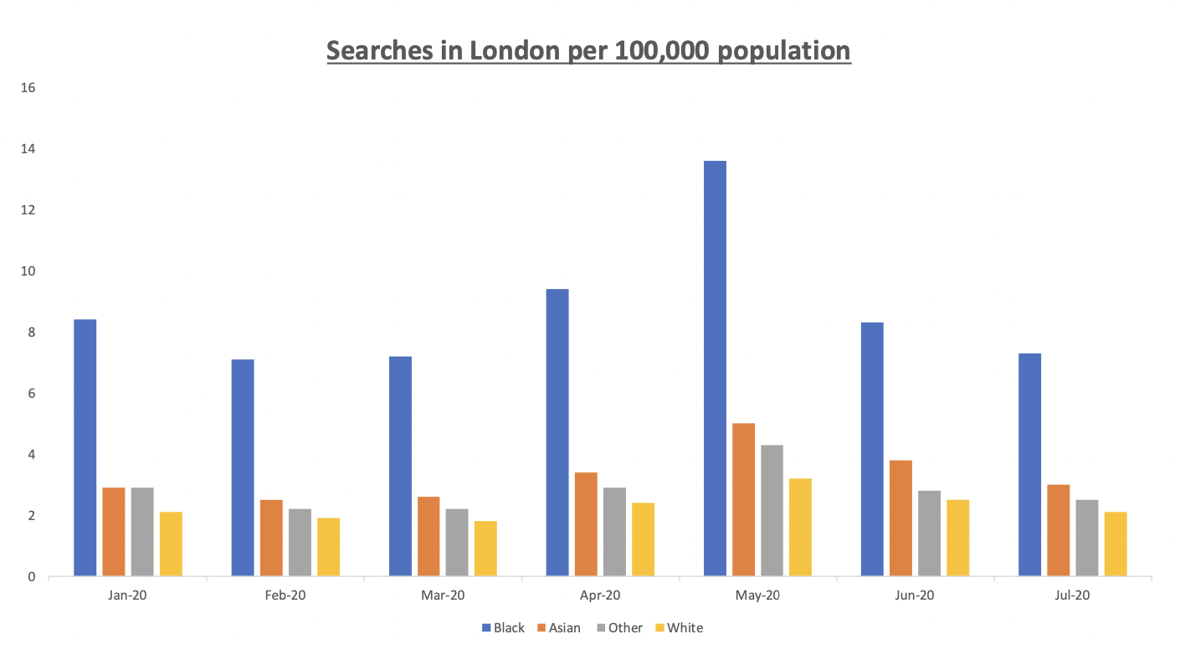

This chart clearly shows that even modern-day policing still targets black ethnicity. This is a number that is seen raising slightly from January to July, Not only do we see the black ethnicity being targeted but we can also see a rise in the Asian ethnicity. The incident that included George Floyd caused what we now know today as Black Lives Matter. This became a world-wide protest against the police forces. The nature of the event was to alert the world of the brutality that the black culture was facing and how they were being targeted even in modern society. We can relate this protest to the events in 1981 which were the same racial uprising. In 1981, policing in the area of Brixton, which was racially mixed, sparked severe rioting, in the lord Scarman report in 1981, he debated for a stronger emphasis on the term ‘consent’ regarding the public and the involvement in the community (Punch 2003). The rebellions in Brixton 1981 were not intended to cause rebellion but more of an uprising against the lawful government, as it was an outburst of anger and resentment against the police during times of social and economic deprivation (Taylor 1984). There were also young black males affected by the riots as they were mostly involved with the attempt to overthrow the police. Following on the Scarman report, there were also tensions rising with the young black males as there were more stop and searches being committed and a lot of racial discrimination. Comparing these past events to modern day events are similar, this is because the meaning of policing by consent is by having the public approve of policing, but this isn’t achievable if the racial targeting doesn’t stop. This is backed up by the Black Lives Matter protest, the riots in 1981 were targeted by young black males and then in 2020 with the uprising of Black Lives Matter which targets the black community. Both of these events allow us to understand that the modern-day society is for some reason not very fair towards other ethnicity’s.
The police and public relationship is key for the police to police our streets as this would not be achievable without the publics cooperation. (Wood 2021) states that the police are required to work in partnership and engage with communities as this is a defining feature for them to create neighbourhood policing. The public trust is massive on the impact of effectiveness and the legitimacy of the police force, there are many studies that have collectively shown that the trust in the police can lead to public’s voluntary cooperation and voluntary compliance with the laws (Boateng 2013). Despite these events, there is also positives to take away. Recent analysis of the Metropolitan Police’s public attitude survey has shown a small but a very significant increase in the positive opinions about police fairness and some cases of the level of engagement with the community (Bradford 2009). The police are no less important to the community than any other public service, whilst Peel’s nine principles still provide great context, public engagement is deemed as the great importance to the success of the service (Bain 2014). As stated previously, not only does public trusting in the police enhance police effectiveness, but it is linked to the amount of security the police can provide, therefore we can view this as the public only placing trust in the police if they feel safe (Goldsmith 2005). The beginning of neighbourhood policing began in the first decade of the twenty first century, is was to address local crime and disorder issues, reassure the public and reconnect the police with communities, this was done by a number of small teams including police officer and community officers, they had 3 functions where were to provide a visible presence, engage with communities and to tackle their problems, although this was the case, there wasn’t a huge amount of success when rolled out between 2005 and 2008 (Higgins 2018).
It has taken the police many decades to get where they are today in terms of public trust and appreciation, without the riots and events that have gone on through the years it is clear that the development of policing by consent wouldn’t be as strong as it is now. Considering the riots in 1981 Brixton were because the police racially targeting the black ethnicity and the increase of stop searches in modern times, there are principles now in place to change this. There has been an increase of diversity and ethnicity variation in the police force and this continues to grow. After the recent events of covid, we have also seen an increase of appreciation of the public services including policing due to the forces risking their own lives to preserve life. The police force does not claim to be perfect as they are always learning from previous events to ensure they do not repeat.
We have learned that the public are at the heart of the police service. The police provide a service that allows law and order to be placed but this can only be done under the partnership built by trust and honesty from both. The police service is still continuing to progress their understanding and changing many things to promote diversity. This will allow us to unite as one and become a better people, because the colour of your skin doesn’t change who you are and who you should be viewed or portrayed as. Ensuring these communities to unite would mean consent would increase from the public as there is more acceptance.

Word count: 1414 words.

Reference List:

Jackson, J., Bradford, B., Hough, M. and Murray, K., 2012. Compliance with the law and policing by consent: notes on police and legal legitimacy. In Legitimacy and compliance in criminal justice (pp. 38-58). Routledge.

Williams, E. and Harris, J., 2008. Scotland Yard. Beginnings and principles of British thought.

Guyomarch, A., 1990. Policing by consent in the 1980s: National initiatives and local adaptation in Sussex. University of London, London School of Economics (United Kingdom).

Wood, D. (2021) Blackstone’s handbook for policing students. Sixteenth edition. Edited by D. Wood. Oxford: Oxford University Press.

Punch, M., 2003. Policing for London and “honest policing”. Polizei-Newsletter. http://www. polizei-newsletter. de.

Monkova, T., 2021. Policing in Britain and America: Between Consent and Force (Doctoral dissertation, McGill University (Canada)).
Desai, E. (2020) Policing with consent - london.gov.uk, Policing with Consent. Available at: https://www.london.gov.uk/sites/default/files/policing_with_consent.pdf (Accessed: November 5, 2022).
Punch, M., 2003. Policing for London and “honest policing”. Polizei-Newsletter. http://www. polizei-newsletter. de.
Taylor, S., 1984. The Scarman Report and explanations of riots. In Scarman and after (pp. 20-34). Pergamon.
Wood, D. (2021) Blackstone’s handbook for policing students. Sixteenth edition. Edited by D. Wood. Oxford: Oxford University Press.
Boateng, F.D., 2013. Restoring the lost hope: A multidimensional approach for building public trust in the police. JIJIS, 13, p.33.
Bradford, B., Jackson, J. and Stanko, E.A., 2009. Contact and confidence: Revisiting the impact of public encounters with the police. Policing & society, 19(1), pp.20-46.
Bain, A., Robinson, B.K. and Conser, J., 2014. Perceptions of policing: Improving communication in local communities. International Journal of Police Science & Management, 16(4), pp.267-276.
Goldsmith, A., 2005. Police reform and the problem of trust. Theoretical criminology, 9(4), pp.443-470.
Higgins, A. (2018) The Future of Neighbourhood Policing - The Police Foundation. Available at: https://www.police-foundation.org.uk/2017/wp-content/uploads/2010/10/TPFJ6112-Neighbourhood-Policing-Report-WEB_2.pdf (Accessed: November 8, 2022).

