Context Diagram

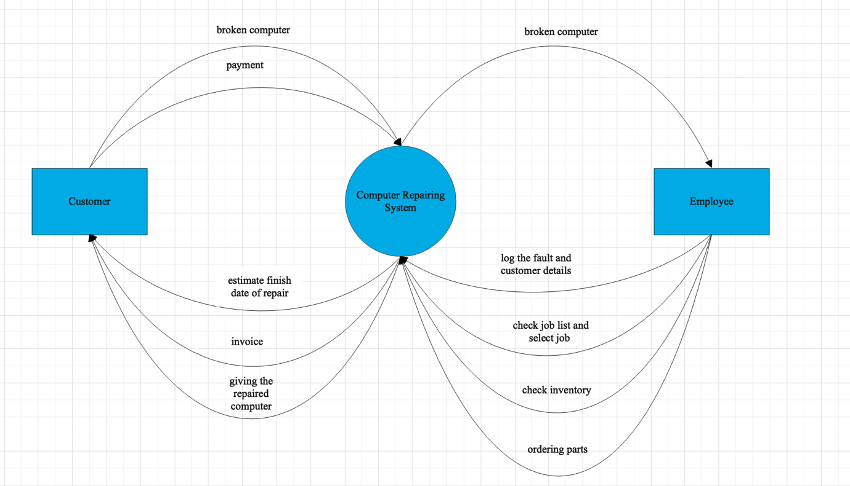

- Whit this diagram I am showing you, the main processes in the system. Besides, how are main entities using the system.

Data Flow Diagram – level 0

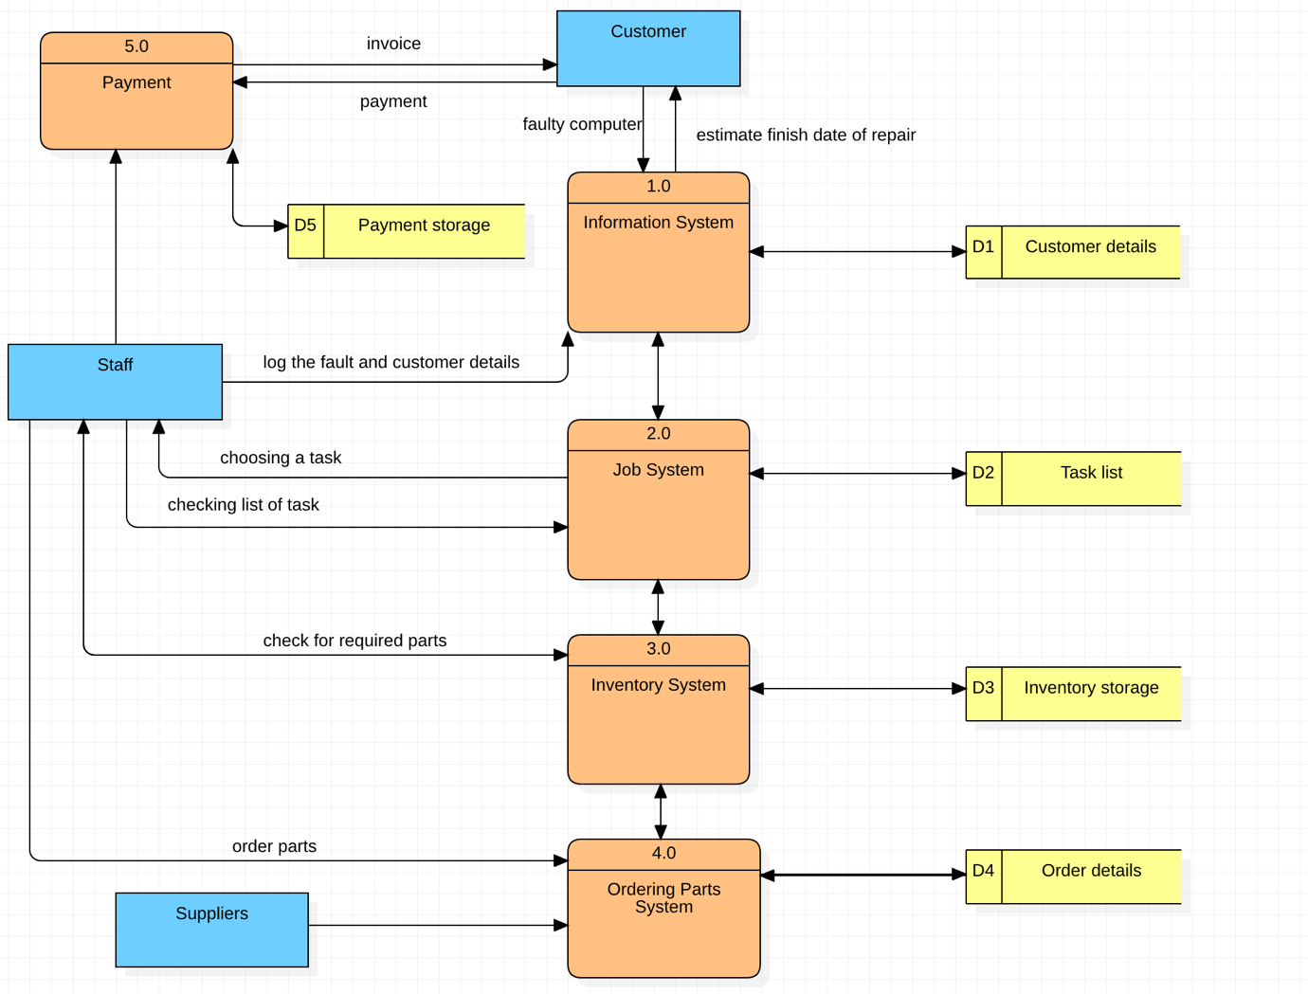

- I read from the case study that the owner of the company needs an information system, where he can store the whole information about the clients and their computers, because of that I created one for his convenience. After that there is need of Job system, because the future staff need to see, what are the task for the day, also for their convenience, I created inventory system, where they can see what parts they have, and what parts they need to order, also this system is connected to the ordering system, which I created, because when they are connected to each other, it will be easier and faster to order. Finally, when computer is repaired, there is a payment system, which helps the company to send invoices and receive money from the client.

ER- Diagram

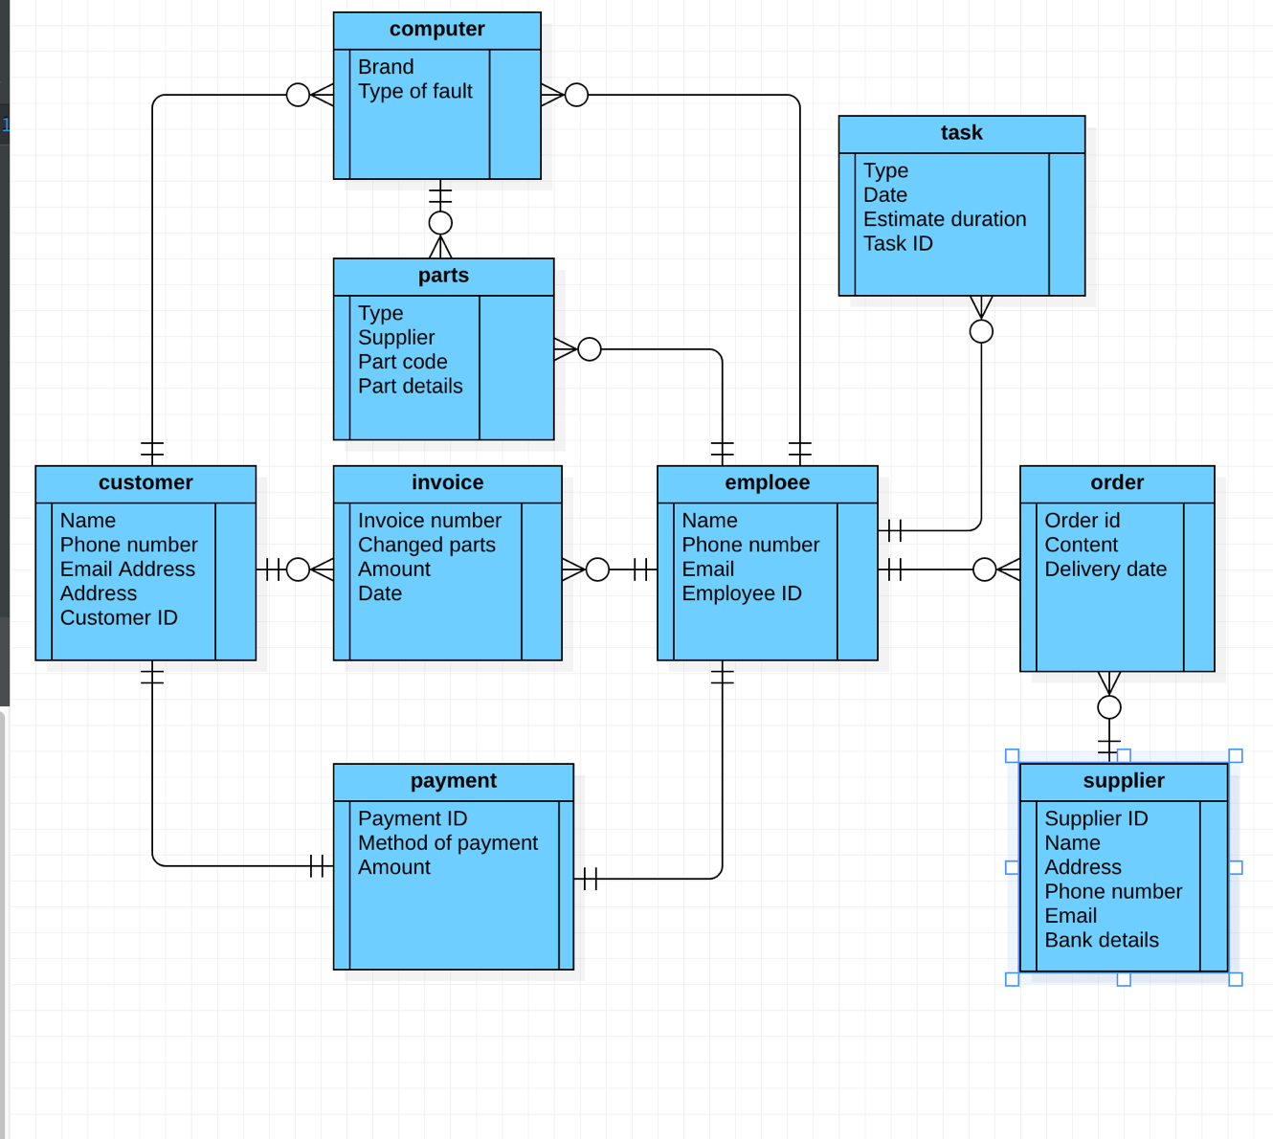

- A customer can bring many computers for repair, so the connection between customer is one to many. An employee can repair many computers, therefore the connection is again one to many. One employee can have many tasks, the connection there is one to many. When an employee sees, that there is missing part and he can’t repair the computer without it, he needs to order this particular part and the connection between them is one to many, because one employee can order many parts. The connection between supplier and order is one to many, because one supplier can produce many orders. When the computer is repaired, the customer has to pay and the connection between customer, and payment is one to one, because one customer can do one payment, also one payment can be done by one customer. Employee can do many invoices, and the customer can receive many invoices, so the connection between them is one to many.
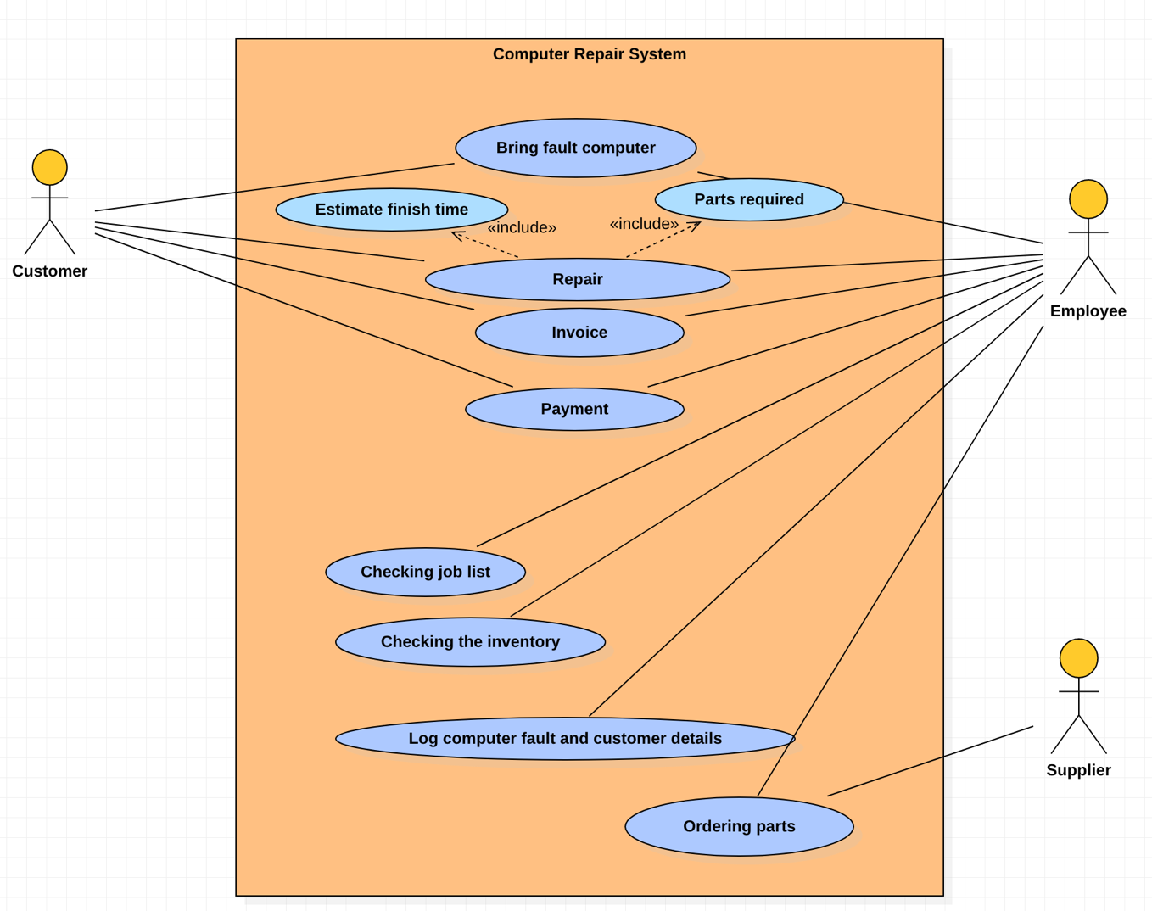

- Using this diagram, I am showing you how customer communicate with the employee, what is employee doing. Likewise, what is employee doing and how is he connected with the supplier.

