Report on Ransomware & CryptoWall Trojan

Table of Contents

- Malware

- Ransomware
- Overview
- What does ransomware do?
- Who is the target for ransomware?

- CryptoWall
- What is it?
- CryptoWall versions
- Infection
- Paying?

- Restoring data

- Protecting against ransomware

- Conclusion

- References

- Malware
1.1 Overview
This report looks at outlining what malware is, specifically CryptoWall ransomware and strategies to prevent and handle ransomware attacks on computer systems. Particularly looking into ways to back up and restore data after a ransomware attack.

Malware refers to any intrusive software developed by cybercriminals [1]. It is where a program infects a computer or network with malicious intent to compromise data.

See image for examples of Malware:

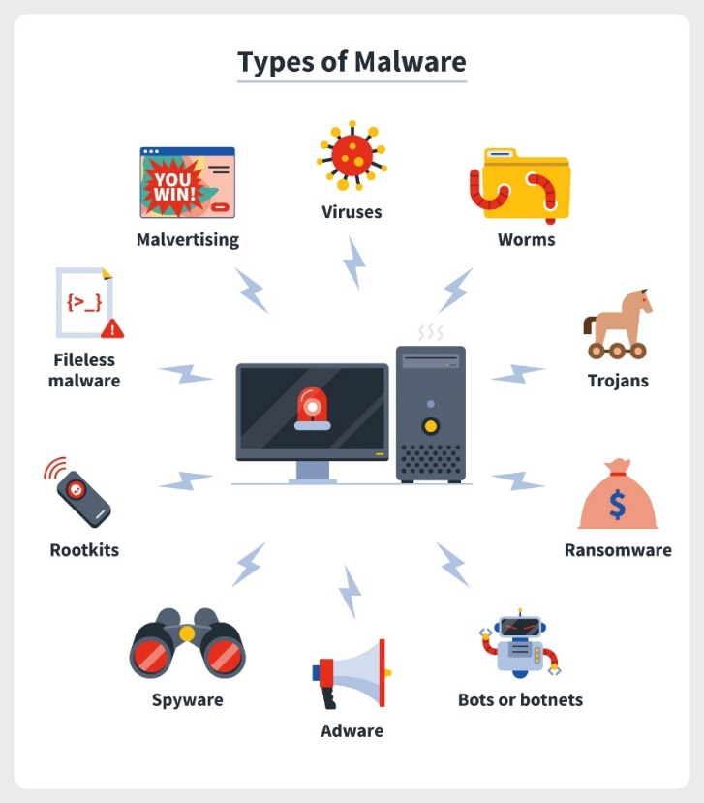

[2]

- Ransomware
2.1 Overview
Ransomware is a file-encrypting malware, where the victims' files are locked and the victim is then asked to pay a ransom for the safe return of their files. The user cannot access their encrypted files without a decryption code from the attacker, which is in the form of a mathematical key which only the attacker knows. [3]

2.2 What does ransomware do?
There are three steps to infection:
Access: The attacker places the ransomware software on the victim’s computer.
Activation: The malware then infects the system and its files.
Ransom demand: The attacker then sends an on-screen ransom demand to unlock the victim’s data. [4]
Ransomware commonly uses the phishing scam to trick users into access to their computer systems. This is where the victim receives an email with a fake file to infect their device. Once access is gained, the attacker can access and encrypt any files on the system or network. The ransom is then commonly presented to the user by demanding an untraceable bitcoin payment in return for the decryption code. [3]

2.3 Who is the target for ransomware?
As Fruhlinger [3] points out, nobody should feel like they are safe from ransomware attacks as ransomware can spread automatically across the internet. Attackers look for an opportunity or flaw in an organisation’s security.
Fruhlinger cites that ransomware caused $5 billion in losses through ransoms paid and through loss of time recovering from attacks. [3] This is why it’s important for businesses to have a good practice in place ready for potential attacks.
Sectors where data is particularly important such as the healthcare sector seem to be heavy targets. With an estimated 45% of attacks targeting healthcare. [3]
Given the nature of how ransomware works, a lot of damage can be done with just one infected computer [5]. This can be dangerous for a company with a shared network as ransomware can access and encrypt files across the entire network. If the company has no back up measures in place the loss of data could be crippling.

- CryptoWall
3.1 What is CryptoWall
CryptoWall is a type of ransomware virus. It is ever changing now on version 4.0. It uses a Trojan horse to encrypt files on a computer. A Trojan disguises itself as other programs or files inside a computer system. [6] In the case of CryptoWall the Trojan is the application clicked on to download the malware onto the computer system. Once the computer system has been successfully infected CryptoWall will encrypt the user’s files and the user will be unable to access their files. When CryptoWall performs an encryption it does so by copying the file and encrypting the copy. It then deletes the original file making it harder for the user to restore it. [7] After the encryption is complete the malware then leaves instructions on how to pay for a decryption key and deletes itself from the user’s system. The ransom is usually required to be paid in bitcoin via a payment link unique to the victim. [7]
Using a cryptocurrency such as bitcoin means that the destination the ransom is being paid to is unknown therefore no personal information is needed. This makes it harder to trace the attacker. [8]

3.2 Infection
Like most ransomware, CryptoWall is known to be spread through phishing links or fake email attachments. Upon the user clicking on the link or attachment a downloader is launched and once downloaded the ransomware infects the computer and begins encryption on the user’s files. The user is then presented instructions on how to pay the ransom in return for a decryption key. Once infected, even if the ransom is paid, it’s not certain the user will be able to recover all their data. [9]

3.3 Paying
Paying isn’t always a direct solution. In some cases users may find that even after paying the ransom for the decryption key the encryption isn’t undone. The victim is then left out of pocket and without access to their files. Mathews cites a CyberEdge report which states only 19% of victims of ransomware that pay will regain access to their files. [10] From this we can infer that 81% of victims that pay do not get their files back.

- Restoring Data
The top priority after a ransomware attack is to regain access to the user’s data and control of the computer itself. It is not recommended to pay the ransom fee, as previously stated it is not guaranteed that the hacker will issue the decryption key after the victim has made the payment. The first option to try is restoring data from a previous backup, preferably a recent one so that the most data can be recovered [7].
Fruhlinger cites a video from Steve Ragan that demonstrates how to recover a system from a ransomware attack [3]. This will help the user to regain access, but decrypting user files can only be done with the decryption key. After removing the ransomware from the computer system the user should then begin to restore their available back up solutions.

- Protecting against Ransomware
There are several ways to prevent ransomware attacks. These steps can be applied to protect data from other threats. A good practice to start with is installing an antivirus software. Antivirus will detect malware as it enters the computer and prevent unknown applications from accessing the user’s computer [3]. The user should not install software or give administrative access to applications without knowing exactly what each of them are.
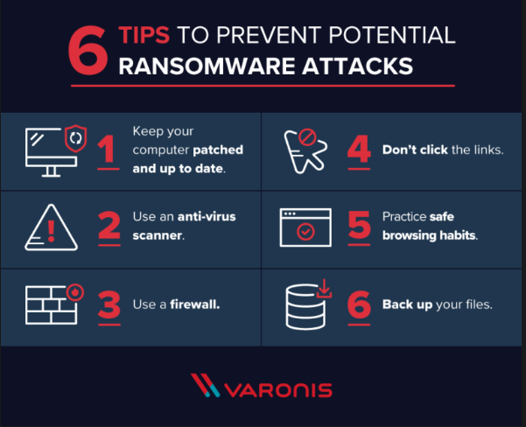

[11]

After a CryptoWall attack the victim may find themselves with all their important documents encrypted and unusable. If the user does not have any backup copies available, then their data may be permanently lost. Therefore, it is important to have a strategy in place to keep data safe.
There are many options to consider when choosing a strategy against potential attacks. The first important measure to consider is backing up important data.
The ‘3-2-1’ backup rule is a robust and common practice used to safeguard important data against ransomware attacks [12].
The ‘3-2-1’ rule not only protects against malware attacks, but also accounts for human error or hardware error. The ‘3-2-1’ rule refers to having your original copy and then two backup copies in different storage locations. Recommended storage locations include, but are not limited to, remote copies in the cloud, hard copies such as an external hard drive or Network Attached Storage (NAS) [12]. Having data stored in multiple locations can increase the chances of the user safely recovering their data after a ransomware attack.
Ransomware will find user backups which are connected to the network and encrypt or delete them too [3] This can be to prevent a system restore. It is good practice to have off network back up copies of data so that they can not be infected too. If the data is stored in the cloud, using software such as OneDrive, the ransomware may also be able to access and encrypt the backup as it is linked to the computer and updated regularly. In the event of this happening the user has the off network back up solution to fall back on. This method only works if the off-network copies are updated regularly so that the user loses the least amount of data. Having a weekly or monthly back up of user data reduces the risk of large data loss. However, cloud back up strategies could prove useful for hardware failure as the data can be accessed remotely from other devices.
In a business setting, it is important for all employees to also be aware of the dangers of malware [5]. Ensuring employees learn how to identify threats when receiving emails for example could save an entire network attack. According to a FBI complaint centre, CryptoWall ransomware has cost at least $18 million in damages to businesses and its customers between 2014 and 2015 [13]

- Conclusion
Lessons that can be learned from the findings are to always be vigilant when clicking on any links or files. Always be sure what you are downloading, even if it seems safe. Having an antivirus will help to detect malicious intent. Having a strong back up strategy in place such as the ‘3-2-1’ backup rule will help to reduce the risk of loosing all user data after a ransomware attack. Having these practices in place will help to ensure user safety, reduce the loss of time and data and prevent a loss of income.

- References

[1] | unknown, “Cisco,” [Online]. Available: https://www.cisco.com/c/en/us/products/security/advanced-malware-protection/what-is-malware.html. [Accessed 31 October 2022].
[2] | C. Stouffer, “Norton,” 27 August 2021. [Online]. Available: https://us.norton.com/blog/malware/types-of-malware. [Accessed 31 October 2022].
[3] | J. Fruhlinger, “CSO Online,” 19th June 2022. [Online]. Available: https://www.csoonline.com/article/3236183/what-is-ransomware-how-it-works-and-how-to-remove-it.html. [Accessed 3rd November 2022].
[4] | T. N. C. S. Centre, “A guide to ransomware,” [Online]. Available: https://www.ncsc.gov.uk/ransomware/home#section_2. [Accessed 8th November 2022].
[5] | O. Systems, “CryptoWall Ransomware Virus,” [Online]. Available: https://ontech.com/cryptowall-ransomware/. [Accessed 8th November 2022].
[6] | McAfee, “Understanding Trojan Viruses and How to Get Rid of Them,” 30th July 2020. [Online]. Available: https://www.mcafee.com/blogs/internet-security/understanding-trojan-viruses-and-how-to-get-rid-of-them/. [Accessed 8th November 2022].
[7] | B. Computer, “CryptoWall and HELP_DECRYPT,” 10 July 2014. [Online]. Available: https://www.bleepingcomputer.com/virus-removal/cryptowall-ransomware-information#CryptoWall. [Accessed 8th November 2022].
[8] | F. Daily, “The Wild World of Crypto Ransomware Payments,” 25th October 2021. [Online]. Available: https://www.financialexecutives.org/FEI-Daily/October-2021/The-Wild-World-of-Crypto-Ransomware-Payments.aspx. [Accessed 8th November 2022].
[9] | A. Zaharia, “Everything You Need To Know About CryptoWall,” 8 February 2022. [Online]. Available: https://heimdalsecurity.com/blog/cryptowall-ransomware/. [Accessed 8 November 2022].
[10] | L. Mathews, “Why you should never pay a ransomware ransom,” 9th March 2018. [Online]. Available: https://www.forbes.com/sites/leemathews/2018/03/09/why-you-should-never-pay-a-ransomware-ransom/?sh=6ba802891753. [Accessed 8th November 2022].
[11] | M. Buckbee, “The State of CryptoWall in 2018,” 1st June 2018. [Online]. Available: https://www.varonis.com/blog/cryptowall. [Accessed 8th November 2022].
[12] | J. Reed, “3-2-1 Backup Rule,” 28 June 2022. [Online]. Available: https://www.nakivo.com/blog/3-2-1-backup-rule-efficient-data-protection-strategy/#:~:text=The%203%2D2%2D1%20backup%20rule%20has%20been%20the%20most,losing%20all%20of%20your%20data.. [Accessed 8th November 2022].
[13] | Sophos, “Naked Security,” 25th June 2015. [Online]. Available: https://nakedsecurity.sophos.com/2015/06/25/cryptowall-ransomware-cost-us-victims-at-least-18-million-fbi-says/. [Accessed 8th November 2022].

