

Student name: Adriana Rodrigues Bissoli
Student ID: 2337158
Module name: Introduction to Physiology
Module code: (BMHP5023)
Lecturer name: Shaila Hussain
Assessment: Case Study Report

Table Content

Contents
Table Content 2
Introduction 3
Diagrams of Treatment and management of type 2 Diabetes. 7
Cellular Metabolism in T2DM. 8
Recording and tracking blood sugar levels for T2DM. 9
Recommendations 11
Conclusion 13
References 14

Introduction
This case study report explores the key considerations for managing patients with type 2 diabetes who attend a general practice clinic. It outlines the role of the practice nurse in supporting ongoing care, monitoring health status, and guiding patients through personalised management plans. The report explains what type 2 diabetes is and describes how the body normally regulates blood glucose levels, highlighting what happens when this process becomes impaired. It also emphasises the importance of lifestyle-based interventions such as balanced nutrition, increased physical activity, weight management, and smoking cessation in improving blood sugar control and reducing long-term risks. Recommendations are provided to help healthcare professionals deliver effective education, encourage patient engagement, and ensure regular review of treatment goals. Overall, the report underscores that well-structured care plans, supported by a collaborative approach, are essential for improving outcomes for people living with type 2 diabetes.
What is diabetes T2DM, and the types? Risk factors associated with it.
More than 3.2 million people in the UK are at risk of developing Type 2 diabetes (T2DM) which is a long-term condition where the body becomes resistant to insulin or cannot use it effectively, causing elevated blood glucose levels. The main forms of diabetes include type 1, type 2, gestational diabetes, and several less common secondary types. Type 2 is the most widespread and often develops gradually in adulthood. Several factors increase the likelihood of developing it, including being overweight, limited physical activity, poor diet, family history, older age, high blood pressure, and certain ethnic backgrounds. Lifestyle habits such as smoking and chronic stress can also contribute to insulin resistance and raise overall risk. (Diabetes UK, 2023).

Diagrams of Pathophysiology T2DM.
The diagram shows T2DM pathophysiology, where the pancreas produces insulin, but the body’s cells become resistant to it. This reduces glucose uptake, causing blood sugar to rise. Over time, the pancreas becomes overworked and insulin production declines, illustrating how insulin dysfunction and pancreatic fatigue contribute to ongoing hyperglycaemia

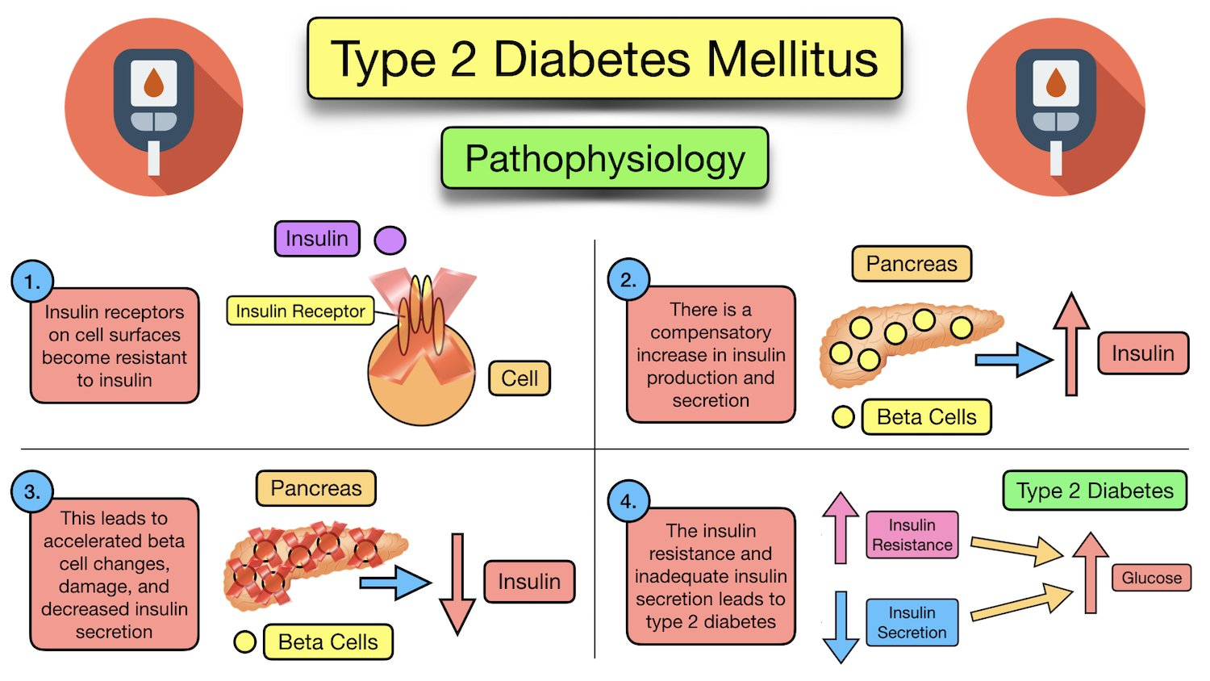(Galicia-Garcia et al., 2020)

Relate it to the endocrine system
The condition known as Type 2 Diabetes Mellitus is fundamentally an endocrine disorder because it involves dysfunction in the hormone-regulating system of the body specifically the hormone Insulin, which is released by the Pancreas. In this condition, either insufficient insulin is produced or the body’s cells become resistant to insulin’s effects, preventing glucose from entering cells and causing elevated blood sugar.
The endocrine system’s disruption of insulin regulation leads to long-term complications affecting organs and tissues. Managing the condition often requires lifestyle modification, oral medications, and sometimes insulin therapy, all addressing the underlying hormonal and metabolic imbalance.
When a person has Type 2 Diabetes, maintaining safe and effective blood sugar levels becomes more complex because the body’s usual mechanisms are disrupted. Under normal conditions, the hormone Insulin is released from the pancreas in response to rising glucose after a meal it signals cells in tissues like muscle and fat to take up this glucose for energy, while the liver stores or releases glucose to keep levels steady (CDC, 2024).
In type 2 diabetes, two major problems emerge first, the body’s cells become less responsive to insulin resistance, so glucose remains in the bloodstream instead of being taken up efficiently.
Second, over time the pancreas cannot sustain the increased insulin production needed to overcome this resistance, so overall insulin levels may fall or be insufficient for demand.
To manage blood sugar in this context, strategies focus on both improving insulin sensitivity and reducing glucose load. Lifestyle changes such as regular physical activity, maintaining a healthy weight, and choosing complex carbohydrates help cells respond better to insulin and reduce glucose spikes. Simultaneously, medications may be used to decrease liver glucose output, increase insulin action, or support remaining pancreatic function. By combining these approaches, blood sugar levels are brought closer to the safe range, reducing the risk of complications associated with chronic high glucose (Care Learning, 2025).

Diagrams of Treatment and management of type 2 Diabetes.

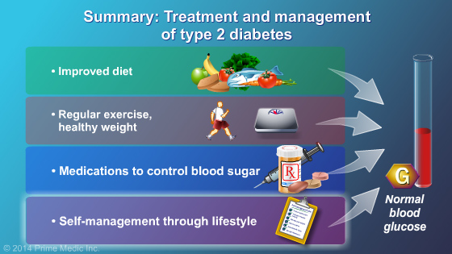
(Kanaley et al., 2022)
Essentially, controlling a dysregulated endocrine system is an active process in Type 2 Diabetes that involves maintaining healthy blood sugar levels. It is possible to maintain blood sugar within a safe and effective range by externally doing the tasks that the body's internal hormonal system can no longer do on its own through food, exercise, medication, and regular monitoring.
In type 2 diabetes, the body struggles to regulate blood sugar because cells become resistant to insulin, the hormone that helps glucose enter cells for energy. Normally, insulin acts like a key, unlocking cells so sugar from the bloodstream can be used or stored. When resistance develops, glucose builds up in the blood instead of being absorbed efficiently. To keep levels safe, the body relies on several strategies. The pancreas may produce extra insulin at first, but over time this response weakens. Lifestyle changes such as balanced eating, regular physical activity, and maintaining a healthy weight help improve how cells respond to insulin. Exercise, for example, makes muscles more sensitive to glucose uptake, lowering blood sugar naturally. Medications can also support regulation by either boosting insulin production, reducing liver glucose release, or improving insulin sensitivity. Monitoring blood sugar levels is essential, as it allows adjustments in diet, activity, or medication to prevent dangerous highs or lows. The overall goal is to maintain glucose within a range that provides energy for daily needs without causing damage to organs and blood vessels. This careful balance helps protect long-term health and reduces complications linked to diabetes.

Cellular Metabolism in T2DM.
Physical health in individuals with T2DM is heavily influenced by lifestyle factors, including activity, social interaction, nutrition, alcohol use, smoking, sleep, and co-morbid conditions.
Activity levels, regular physical activity is beneficial for glucose regulation and insulin sensitivity. Individuals with low activity or prolonged sedentary behaviour have higher risk of developing T2DM and worsening outcomes (Yadav, 2022).
For example, one large Chinese study found people with light physical activity were substantially more likely to have T2DM than those engaging in vigorous activity.
Therefore, encouraging moderate to vigorous activity, and breaking up long sitting periods, is essential for physical health in T2DM.
There are several aspect to T2DM these are 1 Social interaction: Although less studied than other factors, social connection is recognised in broader healthy-lifestyle indices, including in one UK Biobank cohort as one of the low‐risk behaviours that reduce mortality in people with T2DM. Good social interaction supports mental health, encourages adherence to lifestyle changes, and may indirectly improve physical health outcomes.
2 Nutrition: A high-quality diet abundant in vegetables, whole grains, lean protein and low in processed meats and sugar-sweetened beverages helps in managing weight, insulin resistance and glycaemic control (Diabetes UK, 2022).
Other lifestyle factors that contribute to T2DM are poor diet.

Alcohol consumption: Moderate alcohol intake may in some populations correlate with lower risk, but heavy or binge drinking is harmful, especially given its impact on weight, liver and metabolic health. For someone with T2DM, limiting alcohol is prudent to avoid interference with glucose control and additional metabolic burden.
Smoking: is clearly associated with increased risk of T2DM and worse outcomes among those already diagnosed. Smoking exacerbates cardiovascular risk, vascular damage and insulin resistance, thereby compounding the physical health burden.
Sleep patterns: Both poor sleep quality and abnormal sleep duration, too short or too long, are linked to higher T2DM risk and poorer control. Regular, adequate sleep is part of the lifestyle bundle that seems to protect against progression and complications of T2DM.
Existing health conditions, many people with T2DM have or develop co‐morbidities such as hypertension, dyslipidaemia, cardiovascular disease, or obesity, which compound physical health risks. Studies show that even those with similar diabetes severity had markedly better mortality outcomes when following a healthy lifestyle. In summary, for someone living with type 2 diabetes the physical health outlook is significantly shaped by how active they are, how well they eat, whether they smoke or drink excess, how well they sleep, how socially connected they are, and whether other conditions are present. Addressing these modifiable factors offers meaningful scope to improve health outcomes, rather than focusing solely on medication.
(Ahmed, Tsiami and Khan, 2023).

Recording and tracking blood sugar levels for T2DM.
Examine how recording and tracking blood sugar levels help individuals with Type 2 diabetes to safely manage their condition.
Recording and tracking blood-sugar levels plays a key role in helping patients with T2DM manage their condition safely and proactively. By regularly logging measurements whether through finger-pricks, a continuous glucose monitor (CGM) or a connected app an individual can observe how meals, physical activity, sleep, stress and medications influence their glucose. This insight makes self-care far more informed rather than just relying on routine lab tests. For example, recent meta-analysis shows that using digital self-monitoring and remote support in T2DM resulted in a significant reduction in HbA1c, average blood-sugar control over roughly three months, and improvements in fasting and post-meal glucose levels, compared to less frequent or no structured monitoring (Uhl et al., 2023).
Meanwhile, studies comparing CGM to standard self-monitoring found modest but meaningful improvements in HbA1c (0.3 %) and increased time in range periods when blood sugar is in target, which is linked to fewer highs and lows.
In practical terms, tracking gives the person feedback loops: they might see that a certain food causes a spike, or that going for a 20-minute walk lowers their level the next morning. They also gain early warning of patterns, e.g., nocturnal rises or frequent lows, which can prompt timely discussions with their healthcare provider about needing adjustments in medication or lifestyle. Moreover, with connected tools, data can be shared remotely with clinicians, improving responsiveness and reducing the risk of dangerous hypoglycaemia or hyperglycaemia.
In short, regular tracking turns a passive chronic condition into an actively managed one empowering the individual, improving safety, and helping maintain or restore better glucose control over time (Morris-Murray and Frazzitta, 2024)
The importance of tracking and recording.
Tracking and recording are vital for managing Type 2 Diabetes Mellitus because consistent self-monitoring of glucose, diet, physical activity and medication helps identify trends, informs treatment adjustments, and fosters day-to-day awareness of how lifestyle affects blood sugar. For example, technology-assisted monitoring helped participants visualise how their actions influenced glucose and motivated healthier choices.
Without such tracking, subtle deteriorations in glycaemic control may go unnoticed, delaying therapy adjustment and increasing the risk of long-term complications such as cardiovascular, renal or retinal damage. In short not recording means reduced insight, delayed responses and greater harm. (Kerr et al., 2024).

Recommendations
Include relevant recommendations of proposed evidence-based strategies in terms of health and social care, including health promotion, to improve their overall health and well-being of the person of a person with diabetes and how lifestyle changes could improve their condition.
As a GP Practice nurse, the recommendations for patients with T2DM would be to improve overall health and wellbeing particularly via lifestyle change.
People should be supported through structured programmes that combine nutritional modification, physical activity, and behaviour-change components for example, guided self-monitoring, regular feedback and peer support. Research shows such integrated interventions can reduce HbA1c, improve weight and quality of life.
Dietary advice should emphasise patterns such as the Mediterranean diet or a low-glycaemic-index/low-carbohydrate approach, increasing fibre, whole grains, legumes, vegetables and healthy fats, while reducing saturated fat, refined carbohydrates and excess energy intake. These dietary changes have been shown to improve glycaemic control and body composition. (Williams, Jones and Stephens, 2022).

Physical activity should be promoted including a combination of moderate aerobic exercise, resistance training, and daily movement and supported by health professionals or social care networks. Exercise enhances insulin sensitivity, helps manage weight and supports cardiovascular health.
Health promotion efforts in social care should integrate social support, education, and self-management skills, addressing barriers e.g., motivation, access, literacy, and leveraging peer or family networks to reinforce change. Studies emphasise that bolstering autonomy, competence and relatedness empowers people to make sustained changes.
By adopting these strategies, individuals may achieve better glycaemic control, reduce medication needs, lower risk of complications and enhance quality of life (Colagiuri and Ceriello, 2025).
Interventions and or lifestyle changes that an individual to manage their diabetes.
Individual with T2DM can adopt a diet rich in vegetables, whole grains, legumes, and healthy fats (e.g., a Mediterranean-style diet) and reduce refined carbohydrates and saturated fats; this dietary approach has been shown to significantly improve glycaemic control.
Engage in regular physical activity aiming for 30–60 minutes per session, at least three times per week, including both aerobic and resistance exercises which supports improved HbA1c, fasting glucose and reduced cardiovascular risk.
Combine diet + exercise interventions (rather than one alone) for maximal benefit studies show larger reductions in HbA1c, and weight when both are applied together.
Incorporate self-management support and family involvement: exercise programmes that include self- or family-management lead to better glucose control and reduced complications.
By making these changes consistently, the individual can improve glucose levels, reduce reliance on medications, and lower the risk of complications associated with type 2 diabetes (NICE, 2022).

Conclusion
To conclude, T2DM is a long-term condition caused by insulin resistance and impaired glucose regulation. Its management relies on a balance of medication, healthy eating, regular physical activity, and ongoing self-monitoring. Evidence from recent studies (2020–2025) highlights that lifestyle interventions such as adopting a Mediterranean-style diet, maintaining a healthy weight, and engaging in regular exercise can effectively control blood sugar and reduce complications. Empowering individuals through education, digital self-management tools, and social support further improves long-term outcomes. Overall, early intervention, consistent self-care, and collaboration between health and social care professionals are key to improving wellbeing and preventing disease progression.

References

1. Dey, R.K. (2023) ‘Diabetes mellitus: a comprehensive review of pathophysiology, management, and emerging therapeutic approaches’, Journal of Diabetes Medication & Care, 6(4), pp. 96-100. (Accessed 20th November 2025).
2. Diabetes UK (2020). Diabetes Risk Factors. [online] Diabetes UK. Available at: https://www.diabetes.org.uk/about-diabetes/type-2-diabetes/diabetes-risk-factors. (Accessed 20th November 2025).
3.CDC (2024). About Insulin Resistance and Type 2 Diabetes. [online] Diabetes. Available at: https://www.cdc.gov/diabetes/about/insulin-resistance-type-2-diabetes.html. (Accessed 20th November 2025).
‌4. Care Learning (2025). 4.1. Explain the regulation of blood sugar – Care Learning. [online] Care Learning. Available at: https://carelearning.org.uk/qualifications/level-3-extended-hsc/hsccmo2-biochemistry/4-1-explain-the-regulation-of-blood-sugar/. (Accessed 20th November 2025).
5. Yadav, M. (2022). Diet, sleep and exercise: The keystones of healthy lifestyle for medical students. Journal of Nepal Medical Association, [online] 60(253), pp.841–843. doi:https://doi.org/10.31729/jnma.7355. (Accessed 21st November 2025).
6. Ahmed, A., Tsiami, A. and Khan, H.T.A. (2023). Effects of dietary and lifestyle management on type 2 diabetes development among ethnic minority adults living in the UK: A generational shift. International Journal of Gastronomy and Food Science, 31, p.100634. doi:https://doi.org/10.1016/j.ijgfs.2022.100634. (Accessed 21st November 2025).
7. Uhl, S., Choure, A., Rouse, B., Loblack, A. and Reaven, P. (2023). Effectiveness of continuous glucose monitoring on metrics of glycemic control in type 2 diabetes mellitus: A systematic review and meta-analysis of randomized controlled trials. The Journal of Clinical Endocrinology and Metabolism, [online] 109(4), p.dgad652. doi:https://doi.org/10.1210/clinem/dgad652. (Accessed 23rd November 2025).
8. Morris-Murray, M. and Frazzitta, M. (2024). Using continuous glucose monitoring to measure and improve quality metrics: Updates on the Healthcare Effectiveness Data and Information Set 2024 Glucose Management Indicator measure. Journal of Managed Care & Specialty Pharmacy, 30(10-b Suppl), pp.S30–S39. doi:https://doi.org/10.18553/jmcp.2024.30.10-b.s30. (Accessed 23rd November 2025).
9. Kerr, D., Ahn, D., Waki, K., Wang, J., Breznen, B. and Klonoff, D.C. (2024). Digital Interventions for Self-Management of Type 2 Diabetes Mellitus: Systematic Literature Review and Meta-Analysis. Journal of Medical Internet Research, [online] 26, p.e55757. doi:https://doi.org/10.2196/55757. (Accessed 24th November 2025).
‌10. Colagiuri, S. and Ceriello, A. (2025). 2. GLYCAEMIC CONTROL ASSESSMENT AND TARGETS IN TYPE 2 DIABETES. Diabetes Research and Clinical Practice, p.112146. doi:https://doi.org/10.1016/j.diabres.2025.112146. (Accessed 24th November 2025).
‌11. NICE (2022). Type 2 Diabetes in adults: Management. [online] Nice.org.uk. Available at: https://www.nice.org.uk/guidance/ng28. (Accessed 25th November 2025).
12. Diabetes UK (2023). Type 2 diabetes. [online] Diabetes UK. Available at: https://www.diabetes.org.uk/about-diabetes/type-2-diabetes. (Accessed 25th November 2025).
13. Williams, D.M., Jones, H. and Stephens, J.W. (2022). Personalized Type 2 Diabetes Management: An Update on Recent Advances and Recommendations. Diabetes, Metabolic Syndrome and Obesity: Targets and Therapy, [online] Volume 15(1), pp.281–295. doi:https://doi.org/10.2147/dmso.s331654. ( Accessed 25th November 2025).
14. Galicia-Garcia, U., Benito-Vicente, A., Jebari, S., Larrea-Sebal, A., Siddiqi, H., Uribe, K.B., Ostolaza, H. and Martin, C. (2020). Pathophysiology of type 2 diabetes mellitus. International Journal of Molecular Sciences, [online] 21(17), pp.1–34. Available at: https://pmc.ncbi.nlm.nih.gov/articles/PMC7503727/.(Accessed 3rd November 2025).
15. Kanaley, J.A., Colberg, S.R., Corcoran, M.H., Malin, S.K., Rodriguez, N.R., Crespo, C.J., Kirwan, J.P. and Zierath, J.R. (2022). Exercise/physical activity in individuals with type 2 diabetes: A consensus statement from the American College of Sports Medicine. Medicine & Science in Sports & Exercise, [online] 54(2), pp.353–368. doi:https://doi.org/10.1249/mss.0000000000002800. (Accessed 3rd November 2025).
‌

‌

‌

‌

‌

‌

‌

‌

‌

‌

‌

‌

‌

‌

‌

