BMSW5102 Developing Relationships and Workplace Achievement

Lecturer: Sujeewa Herath

Student Name: Abdul Samad
Student Number: 1918548

Contents
Executive Summary 3
Introduction 3
Tamera’s Kitchen’s Mission 3
What is Human Resources Management? 4
Critically discuss the different motivation factors that organisations should use to develop employees for the future and evaluate the role and the importance of employee motivation in performance enhancement using your chosen organisation. 4
Herzberg’s Two Factor Model 7
Maslow’s Hierarchy of Needs 7
Critically evaluate the role and importance of Employee Engagement in your chosen organisation 8
Critically evaluate how reward makes an impact on organizational performance using your chosen organization. 10
Total Reward Model – Towers Perrin 13
Conclusion 14
SWOT Analysis 14
Personal Development Plan: PDP 15
References 17

Executive Summary

Relationships play a vital role in workplace achievement, whether to advance, improve and nurture the organisation and the employees’ career path. The organisation maintains a low turnaround of high-performance quality employees with a strong skillset, capable of multitasking and achieving the best results, where management engage with everyone in achieving the organisation’s goals.
The report will further discuss the three questions, motivational workplace engagement and reward performance. The managers play a critical role in implementing different types of motivational theories and rewards into their establishment to receive a positive performance output.
This report will critically assess the viewpoint of an individual who currently works within Tamera’s Kitchen and has worked for the organisation for the last 18 years.

Introduction
In each business relationships between employer and employees are important as they potentially elevate opportunities for workplace achievement. There are numerous influences that showcase whether a business has an operational rapport between employers and employees. These features are confidence in the workforce, mutual respect welcoming cultural diversity between employers and employees.

Tamera’s Kitchen’s Mission
The team at Tamera’s Kitchen “believe in consistently superb service to every guest that walks through their door.” (Tamera's Kitchen, 2018) All their dishes are made with fresh ingredients and contain an authentic Eastern flavour. With a fully licensed bar and a takeaway/delivery service available, Tamera’s Kitchen is determined to make your evening a pleasant one.

Opposite Tamera’s Kitchen stands Wetherspoon, a pub and eatery that is recognised for having exemplary rewards practises and processes that enables the company to hire, support and train staff for optimum performance. Motivating their employees through intrinsic and extrinsic rewards proves how Wetherspoon inspires a positive win-win culture. Wetherspoon encourages independent and autonomous learning and rewards hard work. Their accomplishments are testament to their success and all hard working employees are rewarded for their loyalty to the business by providing greater financial opportunities.

What is Human Resources Management?
Human resources management is a section of an organisation that specifically caters to information management, learning, development, performance and reward management. The goal of HRM is to ensure that the best skilled, and talented candidates are employed with the belief they are likely to accomplish and fulfil all the goals of the organisation.
In addition, HRM governs the creation and sustainment of policies that govern Human Resources. There are two known versions of HR that are frequently practised. Hard and soft. Hard is implemented to achieve business goals, while soft HR is implemented to confirm the commitment and access flexibility of the candidates chosen for the business.

Critically discuss the different motivation factors that organisations should use to develop employees for the future and evaluate the role and the importance of employee motivation in performance enhancement using your chosen organisation.

Armstrong defines organisations as ‘frameworks for getting things done’. (Armstrong, 2014, p.117-119) and Koltko-Rivera (2006) defines motivation as, “an internally generated drive to achieve a goal or follow a particular course of action. Highly motivated employees focus their efforts on achieving specific goals. It’s the manager’s job, therefore, to motivate employees—to get them to try to do the best job they can.” (Koltko-Rivera, 2006)
Armstrong (2014) interprets the term motivation as ‘a force, or a practise of goal orientated behaviour’ where an individual/group can reach a desired reward. Generating money, supporting job satisfaction, and improving the quality of life is always a key motivator for any business. Increasing pay may improve productivity, but what is most crucial is maintaining and supporting those whose work output meets the needs of the organisation. ‘Tamera’s Kitchen' is an example of an organisation that relies on implementing motivational strategies to inspire high performance in their workforce. Maintaining the high performance of such individuals means assisting their needs and the source of their motivation. Both Abraham Maslow and Herzberg have performed extended studies on motivational needs. Maslow’s Hierarchy of needs as cited by Gawel illustrates how the physiological, safety, social, esteem and self-fulfilment motivates an individual when their lower needs are met. (Gawel, 1996) Herzberg expands on Maslow’s theory suggesting how there are jobs that create satisfaction and jobs that prevent dissatisfaction. This fact in itself is what motivates employees to work hard and well.

Motivation is the key in making employees work effectively for any business.
While money and improving quality of life is always a main motivator for business, the factors that motivate an individual to work is dependent on their needs. Herzberg introduced the concept that all individuals have two sets of needs. One basic need is the hygiene factor model where happy employees are generated meeting their basic needs. There are many motivators in this world who have developed models and programs that can be used to increase the productive flow of any chosen organisation. “The goal of the program is to create conditions encouraging motivation of all employees in the enterprise. Motivational programs affect employees in psychologically and economically ways, whereby the importance of both ways is equal. A motivational program is used especially as part of an adaptation programs.” (Silvia Lorincová, 2019)

Extrinsic motivation is all about control, an external force that manipulates an individual to join the masses. Studies in adults and children reveal that extrinsic motivation is not a model to produce better work but a system of behaviour control, through fear, shaming and training.
According to Gawel, individuals can find it problematic to communicate their wants and needs from a job. (Gawel, 1996) Consequently, employers are likely to ignore what individual work colleagues say and want, and instead offer them resources that are not what they need, but based on the assumption of what they could desire using Maslow’s Hierarchy of needs. Tamera’s kitchen tries to overcome this problem, by providing opportunities to motivate his team to speak up about issues in the business, such as replacing broken/worn out tools and communicating to his work colleagues on a 1-1 basis and not just as a group basis.

In Tamera’s Kitchen, there are two managers with seven front staff, and two chefs with five kitchen staff. All roles in the restaurant require certain responsibilities to be fulfilled. To obtain the best performance of all his staff, the Main Director uses different motivational tactics to inspire and influence both work teams. Once a month, all members of staff are given the opportunity to speak up about issues in the business, such as broken and or damaged items that need replacing. The significance of giving employees’ the opportunity to vocalise their opinions motivates them to carry an active role in the business and encourages them to do their best. The result of permitting such feedback is that the workforce feels prouder, motivated, and engaged with the business. ‘The feedback the customers give about our food is that they have never tasted food like this before, it is brilliant. This honest feedback produces a chain reaction which straight away motivates the staff to stay with the restaurant.’ Ben Sadler – Head Chef.

Motivation is used to get an individual or group to be highly productive and effective in any work environment. Here we can evaluate the significance of motivational input that leads to performance output. Binary tactics and applying punishment and reward systems are manipulative strategies while intrinsic motivation is all about freedom. While work environments are not set up for freedom it can be considered that extrinsically motivated working environments stifles expressiveness, as it rewards obedience and submission. Tamera’s kitchen tries to include opportunities of optional weekly competition, pre-tasting menu items, and free lunch as a way to reward employees who fulfil the needs of the business.

To conclude, there are multiple ways to motivate different groups in an organisation dependent on their intrinsic and extrinsic needs. Whether they are motivated to work for an incentive of reward, by an old-fashioned reward punishment practise, or through a more modernistic intrinsic model, everyone at Tamera’s Kitchen, are all motivated to excel better in an environment that nurtures their individual needs. Living in a culturally eclectic society, different individuals require different needs, and therefore different methods of motivation. It reinforces how the management team need to create goals that support team building motivation for both individuals and a group conscious.

Herzberg’s Two Factor Model
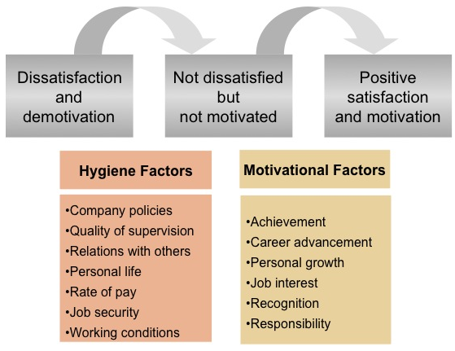

Maslow’s Hierarchy of Needs

Maslow presents a model that illustrates the basic needs of an individual and that only when all the basic needs are met, then higher needs can be addressed as well. The needs are illustrated as follows…
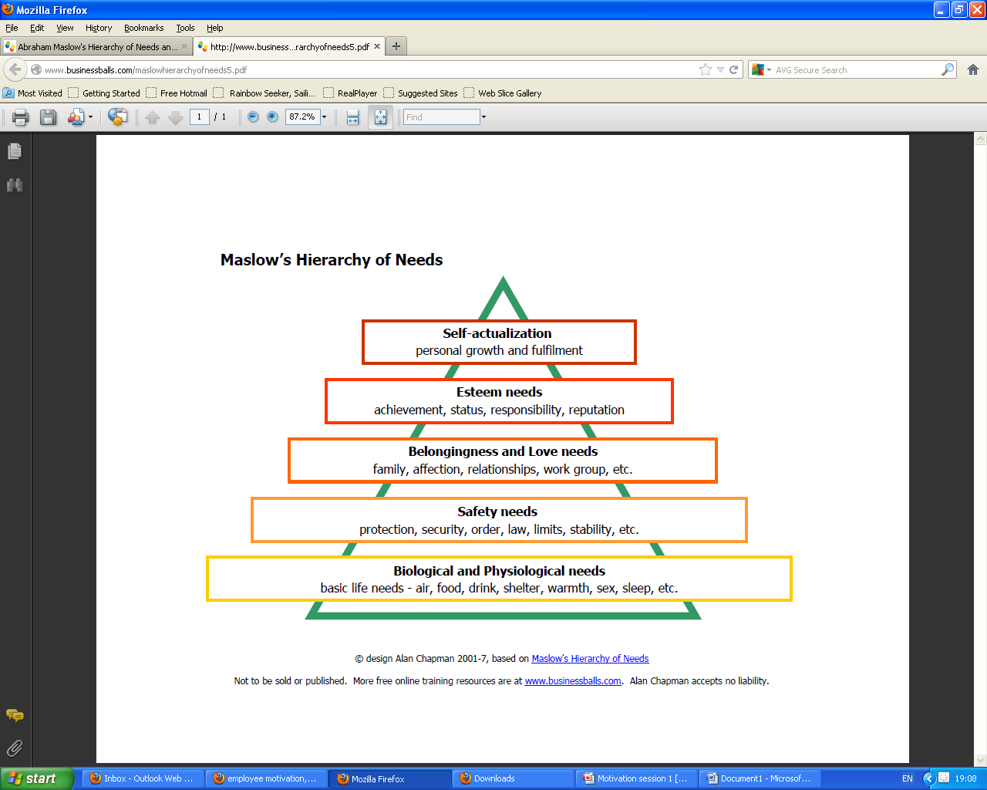

Critically evaluate the role and importance of Employee Engagement in your chosen organisation
Kahn first coined the term ‘employee engagement’ 26 years ago. (Kahn, 1990, p.702) Kahn’s studies recognise how there are three psychological situations associated with engagement or disengagement at work. These are areas of meaningfulness, safety, and availability. He raised three fundamental questions that stem from the questions: (i) How meaningful is it for me to include myself into employment role? (ii) How safe is it? and (iii) How available am I to commit to this role? Kahn identified how workers who were more engaged in work situations provided more seriousness, safety, and availability within their job role. Kahn’s studies are important as it is the framework of psychological comprehension of employees who work in all businesses, not just Tamera’s Kitchen.
Herzberg quoted the notion that ‘If you want someone to do a good job give them a good job to do.’ (Wilkinson, 2015) Herzberg illustrates ththat to engage your employees, it is necessary to give them a job that they consider as ‘good’. In order to find out what ‘good’ is to your employees, you need to engage the employees in your organisation. As all employees have their own story about the company they work for. Listening to their life stories, their hopes and aspirations, such communication offers the opportunity of distinguishing where personal and company goals overlap and where their integrated values converge. In Tamera’s Kitchen, the Director values direct and effective communication amongst all levels of his staff. Employee engagement pertains to the relationship between employer and employee that supports focus, concentration and becoming engrossed in one’s work. ‘Going the extra mile’, setting the example that others must follow, creating the illusion of being the winner in the race.
Carter, (2013) cited, “with employees viewed as one of the greatest assets for organizations, maintaining loyal, productive employees while balancing profits becomes a challenge for leaders, and drives the need to understand employee engagement drivers.” Tamera’s Kitchen agrees with Carter’s theory and it is evidenced how fully engaged employees work harder, and commit with the business for years and not just for a few months. Tamera’s Kitchen has had a low turnaround of employees, which is seen by the kitchen’s statistics since 2004, as the chef, manager and director have all remained the same. Tamera’s Kitchen is aware that their employees wish to work in an environment that is both meaningful and financially rewarding. This element of deep-seated commitment means that fewer leave, sick absence is significantly reduced, there is less conflict and need for disciplinary action, and therefore productivity increases. Here it clearly conveys how employee engagement is more about driving the organisation’s values of commitment and rewarding those who do perform for the loyalty of the business.
The role and importance of employee engagement is apparent in Tamera’s Kitchen as all are acknowledged and respected for their role and function in the business. Nationwide CEO Steve Rasmussen also believes in workplace engagement and his executive team put those beliefs into practise, defining his employees as either ‘Patriots’ or ‘Mercenaries’. (Robinson, 2013) Those who are hired to work for Tamera’s Kitchen are ‘Patriots’ for the business. Having such ‘Patriots’ in your business are a necessity, as they absorb and benefit the culture of the business, as opposed to a more ‘Mercenary’ mind sets, who do not think the rules apply to them, and they do not necessarily care nor respect the history and culture of the business, and are genuinely more apathetic and work primarily for monetary gain. To find out whether your employees are ‘Mercenaries’ or ‘Patriots’, employee engagement is necessary to assess the strengths and weaknesses of your employees in the workforce.
There are all kinds of managers in a business. Some managers spend so much time staring at figures. Some managers specialise in communication, and yet they forget about managing the business. It is evidenced by organisations where managers listen to their people, tend to succeed, and grow faster than their rival competition. However, studies in 2017 by Wote Street people (2018) cited have shown that 87% of worldwide businesses do not engage with their staff. This is a huge percent. It suggests that the implementation of employee engagement is not an important priority, and that interaction is therefore not essential to any business. Tamera’s Kitchen would highly disagree as they understand and recognise that employee engagement is a basic requisite. For without engagement, there would be no opportunity to access and acquire the underlying motivations, commitments, and organisational citizenship of their group.
Here, Armstrong creates a clear illustration on the different forces that influence engagement. Tamera’s Kitchen encourages a strong working ethic, and those who go above and beyond for their customer, ‘going an extra mile’ are a part of the organizational citizenship who are celebrated for their positive influence, from customer tips to additional monetary gifts. This inevitably produces a chain reaction that inspires employees to commit and be inspired whether through intrinsic or extrinsic motivational tactics.
To conclude, the role and importance of employee engagement in Tamera’s Kitchen, is used more as a competitive advantage, as something that says something about the employment brand and the culture of their business. They are a family business and they treat their employees like family. Everyone has a voice and they are respected. Having an active, authentic employment brand starts with having a pleasing work environment where people have their performance celebrated and recognised by experienced individuals who actively support and celebrate employee engagement.

Critically evaluate how reward makes an impact on organizational performance using your chosen organization.
Armstrong defines ‘organizational performance’ as ‘how well something is done’ and ‘reward…how people should be recognised for doing it’. (Armstrong, 2014, p.331). The definition of reward and performance can be further evaluated through analysing and assessing the connection between rewards and how ‘intrinsic’ and ‘extrinsic’ have different impact on organizational employee performance. Examples of rewards through recognising the improvement of their performance according to his or her innate preferences is defined as an intrinsic reward, while extrinsic rewards are based in financial capital, cash bonus, etc. It is evidently clear that extrinsic rewards can aid in attracting employees, but does not necessarily mean they will stay, leading to high turnover rates. Tamera’s kitchen attempts to offer a combination of intrinsic and extrinsic rewards in an attempt to positively impact the business. Tamera’s Kitchen’s current reward strategy is discussed and appraised. It is argued whether the rewards system, both intrinsic and extrinsic can lead to positive impacts on employee’s performance. As different rewards motivate different employees to enhance business competency, reward systems are therefore mandatory tactics used by business managers to achieve company goals and raise company’s profits.
Tamera’s Kitchen reveals how their non-financial rewards are a powerful instrument in improving employee’s confidence and performance. It is encouraged for managers to provide and recognise exemplary, and hardworking employees, as this can boost the employee’s ego and performance. Recognition and praise for a job well done, then becomes an additional reward to encourage employees to improve their innately motivated talents. For example, when an innovative chef creates a new item on the menu into a top selling dish, the employee receives a letter from the director himself. As a result, this may inspire other chefs to follow suit. However, rewards are always administered fairly and appropriately for the output of each employee, for if done incorrectly, jealousy may arise amongst working peers, or perhaps make employees feel mediocre or humiliated, therefore bombing the purpose of the initial reward. Armstrong’s reward system model frames a strategy to underpin the process of rewarding performance through financial and non-financial rewards.
Tamera’s Kitchen follows Armstrong’s reward system strategy, where strategies, polices and processes are implemented to ensure management reward their employees fairly, and that they are recognised for the performance they deliver. The director at Tamera’s Kitchen has a structured reward policy that defines important levels of pay, contingency pay, the use of job evaluation and market surveys and flexing benefits. Armstrong clearly illustrates the process that the output performance of employees is congruent with their perceived value in the organisation. For organisations to make an impact on their organisational performance, their reward scheme must be established to reassure that the role people make to accomplishing organisational or team objectives are valued, acknowledged and therefore compensated (Armstrong 2014).

Business reward strategies relates to setting up incentives, for example rewards like cash. These takings can be extrinsic, supposing a tangible monetary or non-monetary arrangement provided by the employer. They can also be intrinsic, such a generating personal esteem and fulﬁlment resulting from working a meaningful role and nurturing positive relationships with co-workers. It has been tested, implanted and assessed that employees respond very considerably to non-monetary incentives as recognition, career advancement, and learning opportunities, as well as monetary incentives including pay, bonuses, and benefits.
Tamera’s Kitchen works to a time-based pay system where all employees are rewarded for the period of attendance they offer in an organisation. In addition, they all have offered them the opportunity to have their skills recognised, offering all employees the benefit of being managed within a fair, predictable and transparent framework. Nevertheless, time-based pay has no motivational impact on managing staff performance.
As all employees of all levels respond to different kinds of incentives: consequently, such rewards act as an incentive to inspire employees to adjust and or improve their current performance to reach specific rewards. Rewards are typically divided between tangible and intangible natures from an intrinsic or extrinsic source. Intrinsic rewards are those that come from the inside of an individual, enabling him or her to gain pleasure from doing and completing the activity, while extrinsic rewards, come from external sources, including motivational influences such as financial pay-outs and compliments.
Tamera’s Kitchen chooses to reward the performance of employees who provide a ‘job well done’. From monetary and non-monetary rewards. Additional rewards are distributed throughout the year from gift cards for a job well done to UK Holidays, where the director allows his staff to choose a location in the UK to celebrate their yearly performance as a group. It is clear that Tamera’s Kitchen reward strategy mirrors much of the Towers Perrin matrix model. The intangible non-financial rewards indicated in the lower half of the model relay how human capital and human process advantage are necessary factors in enhancing value into the upper two quadrants of the model.

Total Reward Model – Towers Perrin
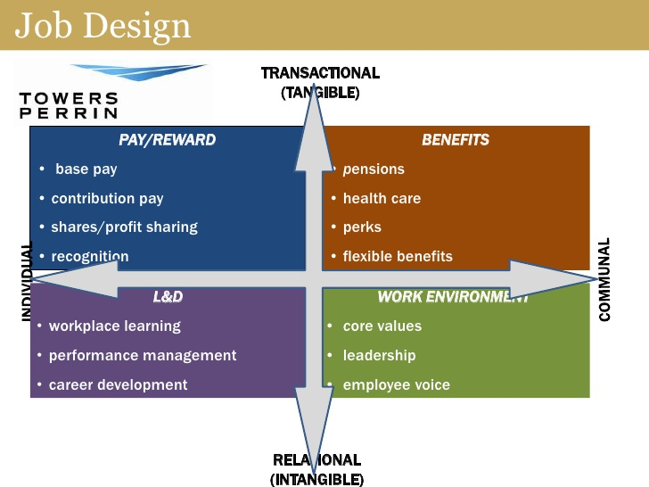
(National HRD Network, 2012)
Tower Perrin’s model contains a matrix with four sections. The top half of the model convey transactional or tangible rewards. These are monetary and are critical in recruiting and retaining staff. Armstrong enforces the importance of using Tower Perrin’s model, illustrating the notion that “…the first thing, to get total remuneration right. In one sense, that is the easiest because it’s clear cut,” says Armstrong. (Wilkinson, 2015)
To conclude, there is great evidence in Tamera’s Kitchen how reward makes a positive impact on organisational performance when it is implemented properly and effectively. Armstrong’s financial and non-financial reward systems means there is evidence of satisfied employees who are more likely to stay and contribute to the company for future years to come. (Armstrong, 2014) Reminding employees of effective reward systems put in place for their access, for example, strategic reward systems such as a pension scheme, where 3% of wages are added to the pension employee to add reassurance and therefore raise company’s profits. Tamera’s Kitchen offers suitable rewards and performance incentives to improve the quality of its organisation and therefore improve the quality of employee’s incentives to work inside the organisation. As employees today seek to something more than the base salary, motivational reward packages can contribute to creating an impact on organisational achievement.

Conclusion
Relationships play an integral role in the workplace environment, as it provides opportunities for executives to bond, unite, create, and celebrate the success of their workforce using intrinsic and extrinsic rewards. The role and importance of rewarding the achievement of their employees as it motivates and influences employees to advance their skills, and fully commit to the organisation. Motivation is therefore central to delivering a business that has goals to succeed. Living in a culturally eclectic society, different individuals require different needs, and therefore different methods of motivation. It reinforces how the management team need to create goals that support team building motivation for both individuals and a group conscious. Tamera’s Kitchen offers suitable rewards and performance motivations to improve the quality of employee’s incentives to work inside the organisation.

Tamera’s Kitchen SWOT Analysis
A SWOT analysis is a tool to identify the four categories in your business. (Strengths, the Weaknesses, Opportunities and Threats)
STRENGTHS  Competent hard workers  Multi taskers  18 years of experience working at the same company/opening other branches.  Confident customer service skills  Strong organisational/Time Management skills  Able to administer a strong framing network. | WEAKNESSES  Marketing Skills  Technology Used  Rent for restaurant (when managing through a pandemic)  Stress and Anxiety  Lack of motivation
OPPORTUNITIES  Promotion and career development  Open new branches  Train and development plan | THREATS  Rival restaurants  Pandemic  Fear of losing job- furlough.  Unstable economy

Personal Development Plan: PDP
Component 2:

Development objective | Specific Actions to be Completed | Evidence of completion | Time scale for completion of task
Performance skills assessed and Time Management Skills | Turn up to work on time and have correct break times.  Allowing myself to complete all my tasks.  Be organised and understand what is required of me. | When employee attends each work session on time and there is a long term, encouraging pattern of skills developing. | 3 months beginning from date pdp is administered Ongoing.
Multi-tasking Engagement on at least two departments. Teaching and improving spoken/unspoken communication | Put employee on a 3 month programme where they can work at front of store as a waitress/ bar attendant and work as a chef. | When employee can work in different environments unaided with senior staff. | 3 months
Motivation and Drive Factors | Watch motivational video. | Motivation Booklet is signed and up to date | Within the first week
Cashier Training  And Customer Service skills | Read written booklet  Complete the training booklet/health, Customer Service and safety training  Observation Practise for 1 week  Using till with supportive staff on standby  Using Till unaided | Using till unaided  Training and health and safety training booklets are up to date | 3 months programme
Chef Training | Read written booklet  Complete the training booklet.  Health and Safety training  Observation Practice for 2 weeks supporting assistant chef  Applying Tamera’s Chef training in the Kitchen with supportive staff on standby  Applying Tamera’s Chef training in the Kitchen unaided | Working in the kitchen unaided | Up to 3 years programme.

References:

Armstrong, M. and Taylor, S. (2014) Armstrong's Handbook of Human Resource Management Practice. 13th Ed London: Kogan Page Limited.
Carter, D. and Baghurst, T. (2013) The Influence of Servant Leadership on Restaurant Employee Engagement Journal of Business Ethics, 1(124), pp. 453-464.
Cumming, E. (2017) 'How Britain fell for Wetherspoons', The Guardian, [online]
Available at: https://www.theguardian.com/lifeandstyle/2017/aug/06/how-britain-fell-for-wetherspoons
[Accessed 28th July 2021].
Evance, T. (2017) Alternative Resources Directory. [online]
Available at: https://alternativeresourcesdirectory.com/news/maslows-hierarchy-of-needs
[Accessed 16th July 2021].
Gawel, E, J. (1996) Herzberg's Theory of Motivation and Maslow's Hierarchy of Needs, Practical Assessment, Research, and Evaluation, 5(11), pp. 1-3.
JD Wetherspoon. (2021) 2021jdwetherspoon. [online]
Available at: www.jdwetherspoon.com
[Accessed 01st July 2021].
Kahn, W. (1990) Psychological Conditions Of Personal Engagement And Disengagement At Work, Academy of Management Journal, 33(4), pp. 692–724.
Koltko-Rivera, M. (2006) Press Books. [online]
Available at: https://pressbooks.lib.vt.edu/fundamentalsofbusiness3e/chapter/chapter-11-motivating-employees/#return-footnote-108-1
[Accessed 1st July 2021].
Maslow, H, A. (1943) A Theory of Human Motivation, Psychological Review, 50(4), 370–396.
National HRD Network, (2012) Going beyond Compensation and Benefits Total Rewards. [online]
Available at: https://www.slideshare.net/hrtalksblog/going-beyond-compensation-and-benefits-total-rewards
[Accessed 16th July 2021].
Robinson, J. (2013) Insider. [online]
Available at: https://www.businessinsider.com/employees-are-either-patriots-or-mercenaries-2013-3?r=US&IR=T
[Accessed 28th June 2021].
Lorincová, S., Štarchoň, P., Weberová, D., Hitka, M. and Lipoldová, M. (2019) Employee Motivation as a Tool to Achieve Sustainability of Business Processes, Sustainability 11(13 pp 3509.
Sullivan, N. (2014) Employee Benefits. [online]
Available at: https://employeebenefits.co.uk/issues/motivation-supplement-2014/motivation-can-drive-productivity/
[Accessed 19th June 2021].
Teaching Adults. (2018) Teaching Adults. [online]
Available at: https://www.teachingadults.co.uk/communication-relationships-emotional-intelligence/
[Accessed 28th June 2021].
Verywell Mind. (2021) How Maslow’s Famous Hierarchy of Needs Explains Human Motivation. [online]
Available at: http://www.verywellmind.com/what-is-maslows-hierarchy-of-needs-4136760
[Accessed 18th June 2021].
Wilkinson, A. (2015) Employee Benefits. [online]
Available at: https://employeebenefits.co.uk/issues/july-2007/total-reward-is-helping-to-define-a-new-era-of-benefits/
[Accessed 1st July 2021].
Wote Street People. (2018) Employee Engagement. [online]
Available at: http://wotestreetpeople.co.uk/employee-engagement/
[Accessed 1st July 2021].

