

The cost-of-Living crisis and Warm Spaces

Level 6 BA Business and Management
BMSP6002
Word Count 10480
Student Id - 2011226

DECLARATION
- This work has not previously been accepted in substance for any degree and is not being concurrently submitted in candidature for any degree.
- This Dissertation is being submitted in partial fulfilment of the requirements for the degree of BA Business Management.
- This Dissertation is the result of my own independent work/investigation, except where otherwise stated. Other sources are acknowledged by footnotes giving explicit references. A Bibliography is appended.
- I hereby give consent for my Dissertation, if accepted, to be deposited in the School Dissertation Library.
Name: Anne-Marie Thomas 2011226
Date of Submission: 29th March 2023
Signature: A Thomas

Acknowledgements.

I would like to thank my supervisor Navdeep Randawa, for her advice and encouragement through the writing of my dissertation, The project would not have been completed especially with myself being unwell through the whole process awaiting an operation, she has been very patient with me.
Also, I would like to thank my lectures for their guidance over the past three years, and advice in developing this project.
My fellow classmates Kirsty and Nia-mai who have kept me sane and given me encouragement throughout.
Finally, I would like to thank my family and friends for their encouragement and support during my journey, especially my children and my very tolerant husband.

List Of Figures

Figures | Name and reference | Page number
Figure 1 | (Communities urged to provide Warm Welcome Spaces. Riley, 2022) | 13
Figure 2 | Ammanford Library In my area In My Area, 2022) | 17
Figure 3 | Welsh map of warm spaces | 18
Figure 4 | Research onion (Saunders,2012) | 21
Figure 5 | Respondents Gender | 27
Figure 6 | Respondents Age | 28
Figure 7 | Respondents Age | 28
Figure 8 | Area respondents’ lives | 29
Figure 9 | Have you heard of a warm space | 30
Figure 10 | Age Crossed with Have you heard | 31
Figure 11 | Who can use? | 32
Figure 12 | Stigma and age chart | 33
Figure 13 | Is there a hub in your area | 34
Figure 14 | How likely are you to sue a space | 35
Figure 15 | Age crossed with how likely chart | 36
Figure 16 | Know anybody that has used a warm space | 38
Figure 17 | Know anybody that will benefit a warm space | 38
Figure 18 | Maslow’s hierarchy triangle (Mcleod 2023) | 47
Figure 19 | Lasswell’s model of communication (communication theory- meanings and examples, n.d) | 49

Abstract

This study is intended to look at the ‘Warm Spaces’ the initiative was launched by the government, the Welsh assembly and local council in October 2022 through the winter months up to March 31st, 2023. Using academic literature
The aim of the research is to attain weather warm spaces are being used, do people know about them and is it worth the government funding. To achieve this both qualitative interviews took place with three space leaders and quantitative research with 102 participants on social media platforms.
Contents
1 Introduction ……………………………………………………………………… Page 8
1.1Purpose of Research ………………………………………………………… Page 10
1.2 Objectives of Research……………………………………………………… Page 10
1.3 Research Questions ………………………………………………………… Page 11
1.4 Dissertation Structure …………………………………………………………Page 11
2 Literature review …………………………………………………………………Page 12
2.1 Warm Spaces ……………………………………………………. …………. Page 14
2.2 Warm spaces – A quiet Revolution…………………………………………. Page 15
2.3 Warm Hubs and the Welsh Assembly ………………………………………Page 16
2.4 Carmarthenshire Council……………………………………………………. Page 17
2.5 How to find warm spaces……………………………………………………. Page 18
2.6 Examples of Warm Spaces in Carmarthenshire……………………………Page 19
3 Methodology………………………………………………………………………Page 21
3.1 Introduction ………………………………………………………………… . Page 21
3.2 Research Aim…………………………………………………………………. Page 21
3.3 Research Approach ………………………………………………………… Page 21
3.4 Methods Used ……………………………………………………………….Page 22
3.5 Data Protection and Ethics…………………………………………………. Page 24
3.6 Data Analysis and Presentation of Data ………………………………… Page 24
3.7 Limitations of Research and Study ………………………………………. Page 25
3.8 Time Management and Budget …………………………………………… Page 26
4 Results
Quantitative Questions and Results ……………………….………………... Page 27
4 .1Quantative Findings Overview………………….………….……………. Page 41
5 Qualitative Data …………………………………………………………… Page 42
6 Themes………………………………………………………………………. Page 49
7 Findings ………………………………………………………………………. Page 53
8 Conclusion……………………………………………………………………. Page 54
9 Recommendations ……………………………………………………………Page 55
10 Further Study Recommendations …………………………………………Page 56
11 References …………………………………………………………………. Page 57
12 Appendix ……………………………………………………………………. Page 63

Introduction
The ‘cost of living Crisis' what does this mean, what are the government, local councils and communities doing to help the situation. Is what they are doing enough to helping communities?
The ‘cost of living Crisis' refers to the fall in ‘real’ income that the United Kingdom (UK) has and is experiencing since the latter end of 2021. (Hourston, 2022). Wage growth is not sufficient to keep up the pace with inflation.
The fall in disposable income is predominantly being caused by soaring inflation which is not in line with benefit and wage increase and has been made increasing worse by the tax increases.
Since 2021 the cost of living has been rising, this has been since many countries have opened their economies from the Coronavirus Pandemic. Gas price increase is also a major issue, this has been from several factors, a depletion in gas storage supplies in Europe, and the war between Ukraine and Russia are but a few.
According to Darren Dodd who writes for the Financial Times the war between Russia and Ukraine has also had a devastating impact on the world’s economy, as well as the Ukrainian people, as is well documented across the FT website. (Dodd, 2023)
Gas prices have increased drastically with over 80percent of households in England and Wales are heated by mains gas, and a third of electricity is gas power stations. The rise in fuel costs has also had a considerable effect on transport across the UK with many families unable to afford fuel for their vehicles. (Energy Efficiency of Housing, England and Wales, Country, and Region - Office for National Statistics, 2022)
An article in the Guardian by Jack Monroe states that the poor are being ‘priced out of food ‘within the UK, In December 2022 it was reported that the consumer price index inflation rose to 5.4percent, this is the highest level in nearly 30 years. (Monroe, 2022)

92percent of UK families said that their cost of living has increased from a year earlier as of January 2023. When compared to a peak of 91percent in the summer of 2022, 67percent of households reported monthly rises in their cost of living in the same month (Clarke, 2023). The crisis is particularly worse for the poorest of households in the UK because they often spend a larger percentage of their income on housing and food. According to projections from the 2022 Autumn Budget, real house disposable income in the UK will decline by 4.3 percent in the fiscal year 2022-2023, the largest decline in living standards since the middle of the 1950’s when this kind of data was first published. (Clarke, 2023)

1.1 Purpose of research
The purpose of this research is to research the role of ‘Warm Spaces ‘in the community. Many local councils across the UK have had funding from a government initiative, this research will be focusing on Carmarthen Council. Carmarthen Council who has 57 Warm Spaces currently advertised on their webpage.
The Question is, are designated warm spaces being utilised and at what cost to the local councils, would local residents like to see something else in its place and if so what, and do communities know about the Warm Space initiative, are they being used?
A warm space is designed to allow anybody from your local community whether they are unemployed, working, young or old to have a warm and welcoming space a couple of times a week over the winter months during this crisis. Assigned warm places have been set up in Ammanford, Carmarthen, and Llanelli libraries along with many other village community centres, places of worship and cafes. Newspapers, books, computers, and iPads have all been made available to attendees along with comfortable seating and warm refreshments all at no cost to those who choose to attend. (Warm Places and Warm Welcome Spaces, n.d.)

1.2 Objectives
The objectives of this dissertation are to critically analyse literature and data collected, to understand warm spaces, if they are commonly known about within the community and are they being used. Whilst looking at the data, recommendations will also be made to support the initiative and working collaboratively with the community and the local councils to make any improvements for any further initiatives such as warm spaces. Collaborative working is working with somebody not on your own, Bruce Tuckmas theory states that collaborate working has four main stages Forming, Storming, Norming and Performing, this theory is commonly referred to as the origin for a success of team building. (2019)

1.3 Research questions
1. Review currents warm space provisions.
2. To research the uptake of warm spaces
3. Consider barriers for attendees of warm spaces.
To answer the questions each will be investigated and answered by gathering evidence from a literature review, and a questionnaire which will be given to 102 participants, whilst also interviewing three volunteers from local warm space initiatives, using Quantitative and qualitative data to gather the information.

1.4 Dissertation structure
Firstly, a literature review will be undertaken to understand the fundamental nature of the research subject, this will include primarily looking at warm spaces in Carmarthenshire Council (CCC) area, CCC will be use for the purpose of this investigation to abbreviate Carmarthen County Council, analysing the usage and community perspective of the initiative, examining the advantages and disadvantages of the initiative, all of which whilst looking at community views. This will be achieved by liaising closely with the community, gathering evidence via feedback platforms such a survey on social media and interviewing three volunteers for warm spaces asking open ended questions aiming to have a flowing conversation, this will enable the interviewer to gain the information required for the research without directing the interviewee to their answers. The data collected will then be analysed to conclude the research questions.

2 Literature Review
Reviewing the available information on the cost of living and more specifically ‘Warm Places ‘or similar initiatives will not only provide a background knowledge of their purpose and design, but baseline how effective they are against intent. The review will consider journals, newspaper articles, press release and government reports (national and local) to assess the impact warm places are having within communities. The research will examine elements of Warm Hubs/ Warm spaces/Warm places, across the United Kingdom and in Wales.
The cost-of-living crisis has caused extreme hardship to many households, the need of warm spaces across the UK is to help with these dark times that people are experiencing, being cold and worrying about putting their lights and heating on, or even just boiling the kettle for a warm drink. Warm spaces are enabling individuals and families who are unemployed and working to have a friendly haven to chat, have a warm cuppa and sit in comfort and warmth instead of freezing in their own homes and help with their self-worth which is being slowly taken away from many due to the cost-of-living crisis.
Carl Rogers Cherry (2022) is recognised by many as one of psychology’s greatest philosophers. According to Rogers, developing a positive self-concept is a continuous process influenced by ones’ experiences in life. Individuals who have a solid sense of self tend to be more self-assured and capable of handling life’s difficulties.
Established from the research the evidence shows that the Maslow’s Hierarchy of Needs Macleod (2023) has been identified, this is a psychological theory of motivation that includes a five-tier model of human needs that is frequently represented as levels within a pyramid.
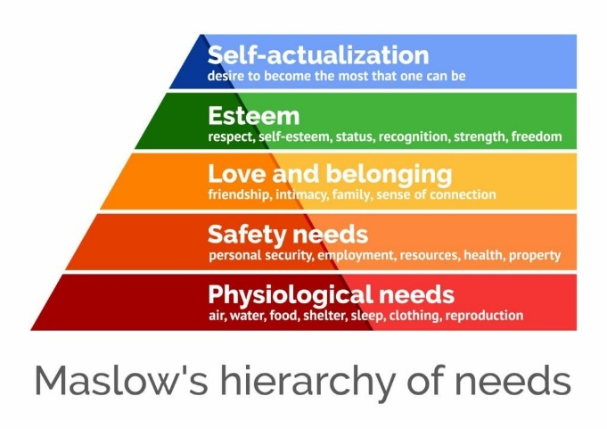
Mcleod (2023) Figure 1
The need for food and clothes which is a basic need of the human race which unfortunate due to the cost of living crisis many people are lacking, safety this could be at work or the security of having a home, love and belonging this can include friendships this is where the warm spaces can help for interaction with other people, self-esteem this can be made lower or non-existent from not having money, or the confidence of leaving the home or admitting you are in the need of some help.
Maslow states that Prior to addressing higher wants, people must attend to lower needs to the hierarchy, Mcleod (2023).

2.1 Warm Spaces
According to the website’ Warm Spaces ‘there are over 4320 registered organisations across the United Kingdom that have opened in the winter of 22/23. Welcoming the public to a warm welcoming, and safe space. (Find a Warm Welcome Space Today, 2022). From homework clubs in church and community halls to libraries and clubs with organised events.
On the 27^{th of} September 2022 the ITV News released a story on the new initiative the government had just announced, Suzanne Elliott states that anybody can set up a warm space as long as they go through their local council and fill in an application form. Hairdressers and pubs were among various places offering a warm space this winter. ITV News and Elliott (2022)
The new website ‘Warm Spaces’ (Warm Spaces, 2022) is a one stop shop., where people can be directed to their nearest warm space. Community centres, Cafes and church halls are some other locations that have joined up. Figure two shows an interactive map that is on the ITV website, where readers can find their nearest warm space across the UK.
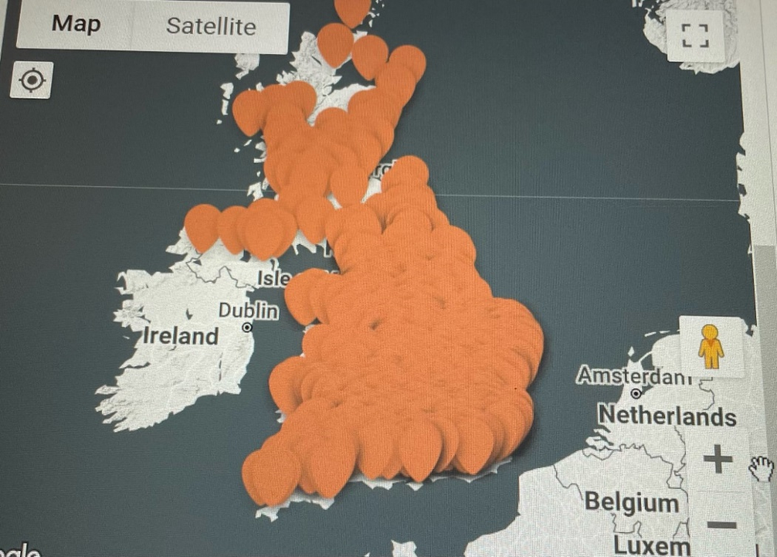
(Warm Spaces, 2022)
Figure 2
After being unable to locate a place to share their own warm bank, the founders Flint the organisation behind Warm Spaces made the decision to launch the site. Some warm spaces offer a warm drink and a biscuit while other offer warm food.
Jason Baldry co-founder states that “every place will offer something different and may have different stipulations and the website is really just a go to flag for that location” (Warm Spaces, 2022)

2.2 Warm Spaces – A Quiet Revolution
A blog by David Barclay on March 3rd, 2023, looks at the warm spaces and the effects they have had on local communities. David calls the initiative a ‘quintessentially British kind of movement’ Barclay (2023) this movement is powered by an army of volunteers, providing countless hot drinks and conversation.
Several religious leaders and the former prime minister Gordon Brown met in the summer of last year to discuss the growing ‘Cost of living crises and the increasing bleak future for low-income households, which lead to the launch of the Warm Welcome Campaign also known as the Warm Hub or Warm spaces.
According to David Barclay, Barclay (2023) Gordon brown remarked that he had heard of a proposal for “heated areas designed to resemble train stations waiting rooms” this area would be for people who were unable to pay their energy bills, this was said to be a throw away remark. As the effect of that mental image set in, the room became silent and everyone who attended left the meeting with the conviction that’ better’ for people needed to be made.
Over the next few weeks, a ‘Warm Space ‘made an appearance it was an initiative that would be free, safe, warm, and welcoming.
The government decided to trust local council and groups to set these initiatives up, local people would know more what their community need. Centres, Groups, and libraries arranged a variety of events from a warm space with a hot drink, papers to read and computers to use to homework clubs and film nights.
One lady intervened by the BBC said, “before she found her local warm hub, she would stay in bed all day to keep warm”, David states in his blog. Warm spaces are described by many as a lifeline, a way to keep going in this cost-of-living crisis.
2.3 Warm Hubs and The Welsh Assembly
On 20th September 2022, the Welsh assembly’s Jane Hutt MS for social justice announced the Welsh assembly were releasing £1 million pounds to support warm Hubs Hutt (2022). Stating that many people would be struggling to keep their homes at a healthy temperature this winter. The Welsh assembly wanted organisations like community councils, faith groups, sport and community clubs would set up Warm Hubs within local communities a safe warm place for the public, by using these hubs it is hope that peoples heating cost would reduce in their own homes and to help those facing extreme fuel poverty. Hutt (2022)
It was suggested that Warm hubs would possibly include:
-Refreshments and snacks (as a minimum) but could extend to more substantial meals where needed and if possible.
-Advice and support would be available to those who attend, these could include health and wellbeing and financial matters.
-Make available the internet and devices attendees could use to source any information or apply for various grants or help online.
-Activities such as light exercise, arts and crafts and cultural activities could be made available, (Hutt, 2022)
Funding would be distributed via local authorities within Wales,

2.4 Carmarthenshire County Council
2.4.1. Collaborating with the local Community.
October 17th, 2022, CC announced the ‘Warm Place’ initiative available to residents within CC, with the story being released on Carmarthenshire news online. Announcing libraries at Llanelli, Ammanford and Carmarthen where opening public warm spaces. Explaining that with the cost-of-living crisis and specifically the rise of energy costs people poverty is very real.
Carmarthen County council describe warm places as a ‘Warm and welcoming space where residence can spend time to keep warm over the winter months’ (Warm Places and Warm Welcome Spaces, 2022).
Initiatives that are pre-existing such as food banks and community luncheons and sports groups could also apply for the new funding that had become available along with cafes, public houses, and such like other businesses. A total of £180.000 became available via the CC Poverty Fund which has been funded by the Welsh government. Discretionary fund and other Welsh funding government schemes. (Evans, 2022)
Business within the CC area were sent out a newsletter emails on the 28th of October asking if they would like to be part of the initiative and apply for funding, funding applications could be made up until November 18th, 2022, and used by March 2023. Email attached in appendix. Appendices one
The funding was allowing groups or businesses that would be interested in setting up a warm space the sum of up to £10,000, however there was a clause that funding was to be claimed back after the money had been spent, unfortunately many business could not do this, after investigating this further there was an option of claiming back the money that was spent every 6 weeks, however this still was not feasible for some that wanted to help.
Many libraries in Carmarthenshire have also enrolled in the warm space initiative, Ammanford, Carmarthen and Llanelli libraries all have a generic welcoming statement, offering a warm friendly space and a welcoming environment. With hot drinks and a biscuit daily, the use of their computers and internet or just to sit with a hot drink and read a book, paper, or magazine. The libraries also offer advice on the cost of living and how to access potential support if needed.
Deputy Leader and Cabinet lead Cllr. Linda Evans quoted in the south Wales guardian’ We all know that heating our homes will be considerably, more expensive this winter, which is a worry that plays on everybody’s mind’, Linda later goes on to say in the article that the council would be opening libraries as warm spaces to help with the ongoing crisis, stating that CC need to try and provide warm spaces in other towns and rural areas of CC.

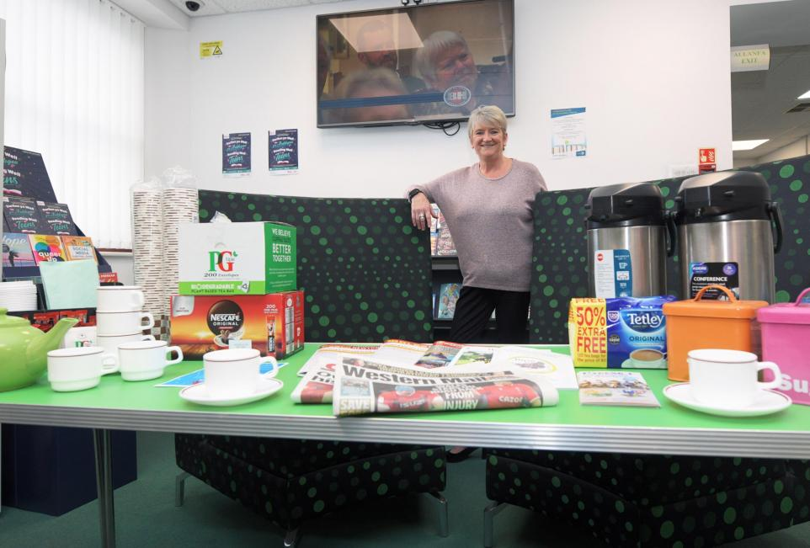 Figure 3 (Riley, 2022)
Cllr Lind Evans at one of the first warm spaces to open in Ammanford library.

2.5 How to find Warm spaces within the CC area.
According to towns and counties postcodes in Carmarthenshire there are 321 Towns and villages, out of these only 57 have set up and registered recognised established council warm spaces on the Carmarthen Council website.
The CC website describes the warm spaces as areas people can go and read paper, magazines and books, use iPad’s and computers and some also have televisions to watch, whilst being able to have a warm drink available free of charge.CC also encourage to think creatively about the type of events that they could hold within the warm spaces that suits their community’s needs, from setting up money advice to pointing people in the right direction for help and advice on most subjects.
As well as a description of their warm spaces CC also have an area on their website where you can add your warm space to their official directory and find your nearest warm space, by typing in your postcode it will bring up the closest spaces to you, all spaces are shown on an ordnance survey map on the CC website.
This is an example off the CC website displaying where warm spaces are within CC area.
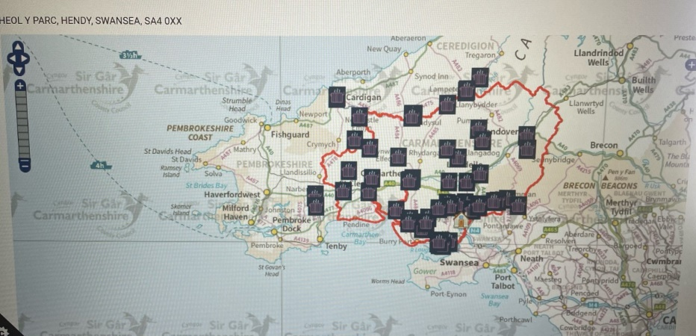(In My Area, 2022)
Figure 4

2.6 Examples of Warm space initiatives in CCC
In this area there are five samples of warm spaces advertise out of the fifty-seven on the Carmarthen council website.
Trallwn Area Community Hall- Coffi, Clecs a Croeso Cynnes which translates to Warm welcome, coffee, and tales(chats). Trallwn community hall is the closest nearest warm space to Hendy at 5 miles away. Offering a warm space with a hot drink and a snack daily between 9.30am-4pm although their advert does state these times could change. Whilst offering computer use, game sessions and other events. (Trallwm Area Community Hall - Coffi, Clecs a Croeso Cynnes, 2022)
YCwtch Tymbl which is another one warm hub in the Hendy area is seven miles away, they have a bold statement attached to their warm space “No child should go hungry, no parent should go hungry to feed their child, and no one person should be struggling or left out in the cold this winter” (Y cwtsh, Tymbl,2022). Cwtch state they are at the heart of their community and a welcoming safe place for all, they have incorporated a ‘Social Supermarket’ within their warm space. Offering free coffee, tea, and a warm bowl of soup to all between 12-1pm, in return the volunteers will ask you to fill in a membership form and pay a donation of £1, this enables all members of your household to become a member for a year. The majority of warm spaces will run from October 2022-March 31st. Whist using the space you get the opportunity to take up to 12 items of food, personal hygiene items and essential household items for a donation of £3 although this donation is not a compulsory donation.
Dr Mz warm space boasts a warm and welcoming space and drop-in centre for young people aged 11-25. In addition to a café, cosy lounging area with a big screen Tv, a digital suit with laptops and iPads, a gaming area, and a silent room. Supported by youth workers. Offering opportunities and events for the participants to advance their culinary skills on a budget, agricultural, technological, artistic, and other talents. Open Monday for LGBTQ+ young people and Wednesday to Friday 3.30pm- 7.30pm. (Carmarthen Youth Project - Dr Mz, 2022)
The Art House -warm spaces for people living with dementia, are open Monday2-4pm, providing simple arts and crafts and refreshments for those with dementia and their careers, A place to chat and make friends to laugh together in challenging times. (The Art House - Warm Space for People Living with Dementia, n.d.)

3 Methodology
3.1 Introduction
The methodological chapter defines and provides an overview of processes used within this paper to gain the required information needed for the primary research, whilst explaining the methods that were used to collate the data.
3.2 Research Aim
The aim of this paper is to research ‘Warm Spaces’ within the community, are the warm places widely known about and are they being used, do the communities know who can use the spaces, and is there a stigma attached to such places? Various sources and approaches were used to gain the relevant information. The methodological chapter will explain what methods and approaches were used to collate the information for this research.
3.3 Research Approach
In order to comprehend the who, what and why of a study issue and desired outcome, a variety of research methodologies can be used. In order to comprehend the phenomenon being seen by way of acquiring insight based on humanistic and interpretive behaviours, this research will be undertaken using a qualitative and quantitative technique.
To provide a more thorough examination of the study, strategy and approach the Saunders research onion has been looked at, the metaphor of the onion made famous in the research field by Saunders and others like Shrek. Onions contain layers and to grasp the phenomenon that is being investigated, the researcher must peel the study onion back to its core. Sinha, Clarke, S., & Farquharson, L. (2018)

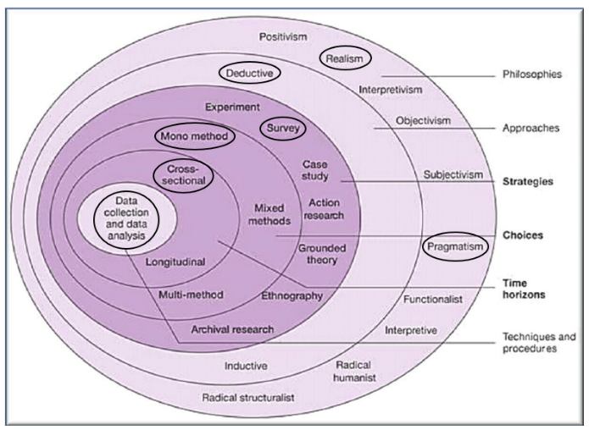

Figure 5 Saunders Research Onion (Saunders,2012)

3.4 Methods Used
Firstly, Preparation of an effective questionnaire is undertaken, (appendices two), designed on Google Forms, the software Google Forms offers several different formats of questions, which include multiple choice and text (Google,2021) and shared to social media platforms. Social media platforms are used daily by most people according to The Digital 2022 April Global Statshot Report there were 4.65 billion social media users globally, this equates to 58.7percent of the world’s population, many of whom use social media as a primary source of information. (Walsh (2022). Facebook and WhatsApp have been the chosen platforms for this study since they both fall in the top three rated social media platforms, Facebook has over 2.9 billion active users monthly, and WhatsApp have 2 billion,
Setting a target number and a time limit, in this case the target number would be 100. Secondly write the questions that are needed for the three interviews, ensuring the questions support the expressed objective and show no bias.
The goal of methodology Is to include a variety of research methods within a piece of work, helping to establish a stronger research strategy for conducting, analysing, and making conclusion and to provide a clear structure to data collection. (Igwenagu, 2016). While writing the literature review it has revealed the factors of the study, this section will show how all the data was gathered and why. There will be no financial reward or incentive for participants.
To gather information for this report, both qualitative and quantitative methods will be used. The qualitative method will use semi-structured interviews to gather information about people's experiences rather than just their opinions. At the beginning, qualitative research was intended to reveal patterns and themes in social and cultural phenomena (Ernst, a2003).
With the help of predefined questions in the form of a questionnaire, 102 participants were interviewed using quantitative research (this was originally 100 however the excels forms did not stop at 100), which assists in looking for trends and patterns in the data by using close ended questions. A quantitative study collects numerical information like age and opinion, as well as the possibility of collecting subjective information through surveying using a scale marking method. (Grbich, 2007)
With the intensive gathering and analysis of narrative data, qualitative research is thought to be a type of study that gives participants' opinions greater weight and attention while also gaining clarity and insight into phenomena (Ahmad & Sumaiya,2019).
Interviewing three participants with open ended questions, allowing a free-flowing conversation, rather than answering from a list of answers.
There are benefits to using both qualitative and quantitative methods. While quantitative methods allow the researcher to ask many participants with just one specially designed questionnaire, qualitative methods allow the researcher to collect more descriptive data to analyse the subject with a small group of participants.
The questionnaires will seek to gain the understanding that the public have on the research subject, the questions will be phrased with as much neutrality as possible.

3.5 Data Protection Procedure and ethics
In compliance with Trinity St David’s data protection policy, the dissertations academic supervisor will be briefed on the assignment and methods planning to be used to collect data, drafting an ethics form is the first part of the of the research before surveys and interviews can be conducted, secondly finalising the ethics form ready to be signed off by the dissertation supervisor. Gaining consent form all Qualitative participants, whilst also making the quantitative participants aware that the information they provide is being used for research and analysis. (Uwtsd, n.d.) Minimising the risk of harm and stress, by obtaining informed consent prior to the interview or questionnaire this would either be by form or writing a brief section at the start of the questionnaires.
Another compliance that is needed to be met for data protection is the using of Pseudonyms (nick names) this is to protect the identity of the Qualitative participants, also arranging a private venue for their face-to-face interviews, assuring the participants that their identity will not be revealed. Interviews will be recorded to allow a more accurate collection of information, then transcribed to allow data collection.

3.6 Data analysis and Presentation.
After collecting the responses, it is time to condense the results, analyse the specifics and look for any recurring trends and lay the format of new theories. Create categories for the data encryption and divide the data into manageable parts.
Virginia Braun and Victoria Clarke created the thematic process initially for psychological study. Thematic analysis is a versatile tool and can be used to a wide range of research types. (Braun & Clarke 2006 - Using Thematic Analysis, n.d.)
Following the completion of the interview’s transcription will take place, further allowing relevant information to be extracted from the dialogue in accordance with the dissertation. Allowing the identification of any patterns and themes within the information. Using Thematic analysis allowing a way of seeing information as well as processing data.
A theme is a ‘patterned response or meaning’ derived from the data that informs the research question (King & Varpio, 2020) (Braun and Clarke.2012)
The process of thematic analysis can be approached in a variety of ways, the most popular comprises of six steps: familiarisation, coding, generating themes, reviewing themes, defining, and labelling themes and writing. By using this process, you can prevent bias from creeping into your analysis. (Jones,2022)
The quantitative research findings will then be exported to excel and loaded into SPSS (Statistical Program for the Social Sciences); this is used for research analysis. The SPSS application offers a wide range of fundamental features that will be employed for this research, including cross tabulation and bivariate statistics. (Jordan,2021)

3.7 Limitations of study
Bias according to Merriam Websters inline directory is the deviation of the expected value of a statistical estimate or encouraging one answer or outcome over others. (“Definition of Bias,” 2023c). Consideration needs to be taken that bias does not affect the data collection process when doing the face-to-face interviews.
There are strengths and weakness for both surveys and questionnaires, strengths could be questionnaires are cheap or free to conduct, quantitative data collection compared to qualitative data collection methods like interviews is simpler and easier to gather data from a bigger audience such as social media platforms.
Weakness could be, the number of responses to a questionnaire can be too low to yield quantifiable information, and the use of open-ended questions in an interview type survey could leave questions unanswered or answered incorrectly if the interviewee goes off on to a different subject.
Questionnaires will be made available on Facebook, Instagram, and WhatsApp for participants to complete, this is a random sampling method, sharing on social media could potentially attract people who will just answer for fun and not for the desired reason. One of the most common and straight forward data collection technique in the study domain random sampling, this consists of probability, statistics, and mathematics. Enabling the collection of objective data, which then enables studies to draw objective conclusions. (Taylor, 2023)
The face-to-face questionnaire will be asked to three warm space leaders, however sourcing these could become problematic since most people have busy lives and cannot simply find the time to take part.

3.8 Time Horizon and Budget
Without the correct planning and preparation, you will not receive the quality of work that is needed for a dissertation, this takes time, a four-week allowance has been given for this. This includes investigating whether there is a gap in the existing or recent research and if there is any research available on the subject, does the question merit investigation? Will statistical analysation take place and if so what kind of analysis? Will there be any computers or tools used to assist with the research and reduce the time scale.
The cost of books that cannot be obtained from the library or online will be kept to minimum, there will be a small cost in fuel travelling to interview the three qualitative participants. Participation will be voluntary, but since this may discourage the participants from taking part, interview limits will be set at 30 minutes each, this is not to use up too much of other people’s valuable time.
Additionally important is to consider a note pad, pens, and highlighters as not all the information will be recorded directly onto a laptop.
For research and data management, creating questionnaires and posting onto social media a laptop or a form of computer will be needed, however if the researcher does not have one the university can loan one or allow the use of one on campus, to record the interviews a mobile phone will be used.

4 Quantitative Questions and Research Results
The key research findings are presented in the section that follows, presenting the primary research from the findings. A total of 102 responses were collected from the questionnaire distribution on social media platforms which provide the information for data analysis, the three semi structured interviews provided in depth information that could be analysed using humanistic and interpretivist behaviours in terms of experiences that the participants were familiar with regarding the research issue as all three participants ran their own warm hub.

4.1 Questions

Question 1 What is your Gender?
Out of the 102 participants figure 1 shows 89 which is 86percent were women, 13 percent where men and 1percent preferred not to say their gender.

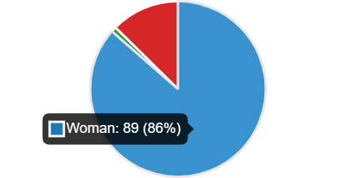
Figure 6

Question 2 What is your age ?
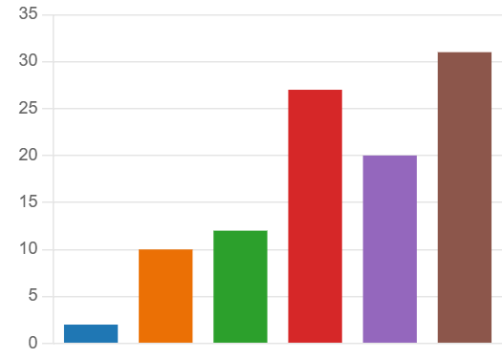
Figure 7

Figure 7 determines that the age group with highest number of participants was 55+ this is 31.62percentage of the participants.
Under 18 | 2
18-24 | 10
25-34 | 12
35-44 | 27
45-54 | 20
55+ | 31
Figure 8 Age chart


Figure 9

Question 3 What council Area do you live?

In figure three it shows that the blue area is 58percentage of participants live in Carmarthenshire, the orange area 31percentagelive in Swansea and green area 12 percentage live in neither.

Question 4 Have you heard of warm spaces?

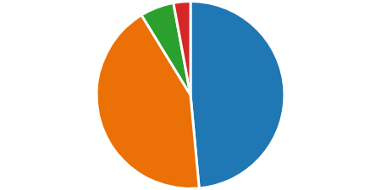
Figure 10

Figure ten shows in the blue quadrant that 49 percentage of participants had heard of a warm space where a high rate of 44percentage had not. Figure four has been cross tabulated with age to see if this had a bearing on the results as you can see in figure five from the age of 25-44 is the highest rate of participants not knowing what a warm space was.

What is your age? * Have you heard of 'Warm Spaces' Crosstabulation
Count
 |  | Have you heard of 'Warm Spaces' |  |  |  | Total
 |  | No | Not sure | On the news, social media etc | Yes | Total
What is your age? |  | 1 | 0 | 0 | 0 | 1
What is your age? | 18-24 | 7 | 1 | 0 | 2 | 10
What is your age? | 25-34 | 11 | 1 | 0 | 0 | 12
What is your age? | 35-44 | 11 | 1 | 2 | 12 | 26
What is your age? | 45-54 | 7 | 1 | 0 | 12 | 20
What is your age? | 55 + | 5 | 1 | 1 | 24 | 31
What is your age? | Under 18 | 2 | 0 | 0 | 0 | 2
Total |  | 44 | 5 | 3 | 50 | 102
Figure 11

Question 5
Who do you think can use a warm space?

Figure 12

In figure twelve it shows that 79 percent of participants knew that a warm space is open to anybody to use, this is a very strange answer as according to the survey data 44%perecnt of participants did not know what a warm space was.

Question 6 Do you think there is a stigma attached to initiatives such as warm spaces?

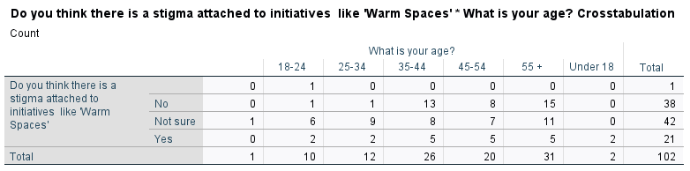
Figure 13

The question, do you think a stigma is attached to initiatives such as warm spaces was asked, 21 said yes, 39 said no and 42 participants said they were unsure. Figure thirteen shows that the higher age categories that has said yes, they do think there is a stigma attached.

Question 7 Is there a warm space in your area?

Yes | 33 | 32%
No | 6 | 6%
Unsure | 64 | 64%
Figure 14

Figure fourteen shows that 64percent of participants did not know if there was a warm space in their area, where 33percent knew there was and only 6percent said no there was not one in their area.

. 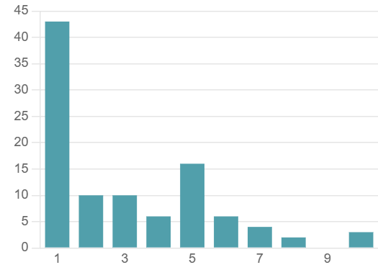
Figure 15
Question 8 How likely are you to use a warm space?

An average rating of only 3.07percent of participants are likely to use a warm space, this question was analysed with the age of the participant to see if there was a pattern. Figure fifteen shows that the older the participants were the more likely they would use the initiative. Other responses were that they are managing well now and having other commitments for example work so unable to attend.

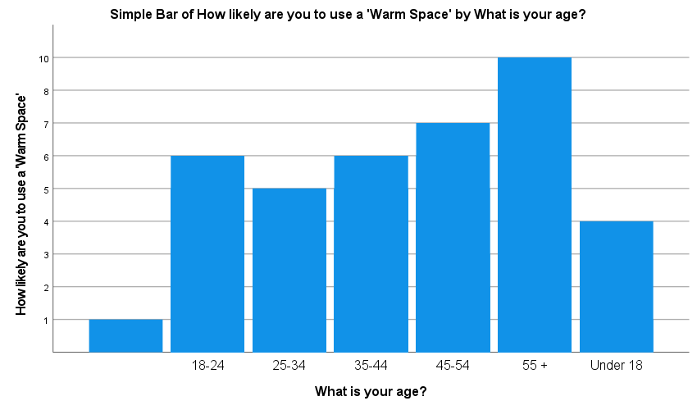
Figure 16

Question 9 Do you think Warm Space money could be spent on other things in the community? If yes what.

The data from this question showed that thirty-seven people answered this question, yes, they think the money could be spent better elsewhere. Below are some of the replies that were found.
-Helping others who are on low income who work, not just people on benefits who receive more help than those who are on a low working income. This can be done by helping local houses draught proof homes etc.
-Pavements that are unfinished, filling potholes in roads.
-Unsure what it is so can’t comment on what the service provides.
-I am not sure what a warm space is although assuming it is for homeless people then I would recommend money being spent elsewhere due to there not being many homeless people in the Carmarthenshire area
-The other answers were generic in the fact that people answered they were unsure what a warm space was so couldn’t comment

Question 10 Do you know anybody that has used a Warm Space?


Figure 17

There is a very high percentage of 81percent people that do not know anybody that has used a warm space, with only seven people 7percent saying yes, they do know somebody that has used a space. Is this because there is not one local to them or they are unaware of warm spaces?


Figure 18

Question 11 Do you know anybody that would benefit from a Warm Space?

The orange quadrant shows that 44percent of people are of the opinion they do not know anybody that would benefit from a warm hub, with 37percent as a maybe with only 20percent showing that they do not know anybody that would benefit.

4.1Quantitative Findings overview

After analysing the data from the 102 questionnaires, it was found:
-87.25percent of women participated with just 12.74percent of men, and 76.47percent where of the older three brackets 35-55 years old.
-58.82percent lived in Carmarthenshire, which is the focus of this ‘Warm spaces’ research. 49.01percent had heard of the warm space initiative with 43.13percent that said -they had not.
-80.58percent of participants said that anybody can use a warm space with 14.28percent though it was a homeless initiative.33.35percent answered that there was a warm space in their area with 62percent that didn’t know.
-20.58percent said there was a stigma attached to warm spaces, 38.23 percent said there was not and 41.17percent were usure.
- 32.32 percent participants said there was a warm space in their area, while only 5.8 percent said no however 62.74 percent said they were unsure.
- 3.07percent participants said they would use a warm space.
- 36.27percent responded to the question do you think the warm space money can be used elsewhere, some of the comments are in the findings.
- 19.60percent said they do know somebody that could benefit from a warm space, 43.13 said they do not know anybody with 36.27 unsure.

5 Qualitative Data
Three participants took part in the qualitative section of this research, they are each fundamental to running the warm space initiatives in their communities.
Semi structured questions were asked to gain the information required for this research. The participants will be given the pseudo name of participants A, B and C for the purpose of this assignment. In this section are the selected sections of the interviews relevant to the research.
Question 1 Are the levels of attendees to your warm space as you expected, if not have you had to implement anything to improve your attendance figures.?
Participant A – At the start the numbers were quite low, but they increased as word spread about what we were doing.
Participant B- We were unsure what to expect to be honest, we hoped we would have around 20-30 as we are a small village, however after introducing a homework club and a mother and baby coffee morning, we now see around 100 participants a week.
Participant C – When we applied for the funding, we approximately said we would hope to help100 plus people a week, at the start we only had four or five a day this was worrying. We decided to do a leaflet drop and asked the local school to send out a text message to all parents to explain about the warm space and a list of times days etc as the school holiday were coming up (this was October half term) we decided to open more in the day. The school half term was busy, and this then continued right up to now, we asked the community what times they think we should open rather than us choosing the times.
Result 1 - As the responses show all three warm spaces are successful, maybe with a slow start that have increased to helping substantial numbers from their communities.

Questions 2 How many roughly attend your warm initiative every week.
Participant A – we get around 60 individual a week these include of families as well, during the school holidays and over Christmas we had a lot more, adding homework clubs etc has also helped.
Participant B- Currently we get around 100 plus per week, we are hoping we can continue to help these numbers after this is supposed to finish on the 31st march.
Participant C- To be honest it depends on things like the weather and what we have on, and the time of day. In the morning sessions we get a lot of mother and baby’s as we have started a session for them and also some elderly, whilst the teatime section we see more children and young families.
Participant C- do you know rough numbers for a week, they said it was hard to judge but around 120 on a busy week and maybe only 40-50 on a quiet one.
Result 2 – attendance varies on all three participants; this could be down to the size of their community or lack of knowledge from the communities about the initiative.

Question 3 – How many days a week do you run the warm spaces?
Participant A – Our space runs 5 days a week at different times to suit different people, we try to make sure that there is a time to suit all types of people.
Participant B – At the moment we open 3 days a week 1 morning and 2 teatime / evening sessions, this is due to the lack of volunteers as two of our initial volunteers are unable to commit anymore due to their own ill health.
Participant C – We open on a Monday morning 9-11 and teatime 4-7 and a Wednesday the same a Saturday we open 10 am -2pm. This seems to work for the people that come here.
Results 3 – The amount of time the space are run vary between the three however two are very similar four and five days a week, the third struggles with volunteers so could possibly open more if this was not the case.

Question4 – What percentage of attendees would you say are over 55 years old?
Participant A – ok that’s a good question is this in general over the week?
Interviewer - yes just in general not to each session.
Participant A – We have a high number of elderlies that attend but I would say they are over 65 not 55, we do get some in that age bracket, if we are talking the older age, I’d say at least 60% of the people come are that age.
Participant B – Over 55 in the morning session, we get mainly the older generation, but we do have a mother and baby and that is attended by about 10 mothers.
Interviewer – Do the older generation sit in the same room as the mother and baby,
Participant B – no we have a separate room for that, the older ones like to sit and chat quietly not with baby’s running about if you know what I mean.
Results 4 – There is definitely a pattern in question four, all space are used Widley by the elderly, however due to the fact that the three of them run a mother and baby group and homework club means that they all have a good amount of the younger generation as well.

Question 5 - do you have organised events for your warm space?
Participant A – yes, we have all kinds of stuff going on, games, bingo, quiz, afterschool clubs and book and board game swopping.
Interviewer- book and game swopping how does that work.?
Participant A – people can bring their old books, board games and jigsaws along to the centre as long as they are not damage or bits missing. They can then swop to another one this is good with young families we recently had a large donation of children’s books in to add to the swapping station.
Participant B – We have a mother and baby session and a mature person hot drink and chat sessions we did try quiz sessions etc but due to lack of volunteer we are struggling to stay open as much as we would like to. We do try and have children’s things going on to help parents keep the occupied in the cold winter nights.
Interviewer – have you advertised for more help?
Participant B – yes, we put it on social media and asked people we know, people are buys doing their own thing unfortunately a lot of wont help for nothing.
Participant C- We stick to our rota and do mother and baby, homework club, board games and a Saturday morning open one. We do get the elderly in, but they just like to sit and chat or read. You would be surprised how many children have not played board games before.
Results 5 – All three spaces have organised events.

Question 6 – Is there a donation or a fee requested for your warm space?
Participant A – No we don’t charge the money comes from Carmarthen Council; we are thinking of working with our local food bank to help people more as well.
Participant B – What do you mean a fee?
Interviewer- A charge to be able to attend your warm space sessions, like a membership.
Participant B- gosh not the whole point of this is that people can save money by coming here have a hot drink and keep warm, save on their bills. Why would we charge them?
interviewer – some warm spaces charge a membership fee although they say it is a donation fee and not compulsory.
Participant B – that is wrong they should not be allowed to charge.
Participant C- We ask for a £1 a week donation but this allows the people to also have something to eat not just a warm drink and a biscuit, we also only charge a further £1 if people want to take an extra meal home with them.
Interviewer what type on food do you supply for £1.
Participant C unfortunate due to being short of volunteers its basic but warm and filling, stews, soups, and a roll and sometimes something like cottage pie. We get donations from our local shop and community to help with this it’s great. Last week they had a pasta bake as we were given a load of pasta and tuna for free from somebody that was moving house so cleaned out their cupboards.
Interviewer -Are you able to accept food off just anybody?
Participant C -yes as long as it is in date and has not been opened, we will accept it, we do not accept food from a fridge or a freezer thou just in case.
Results 6 – Only one third of the participants charge or ask for a donation, this is not for attending the space this is payment towards a free meal they can receive if required.

Question 7- What benefits do you think warm spaces have on people?
Participant A -Isn’t that obvious? Not having to put their heating on and keeping warm, being safe.
Interview – At this point I quickly moved on to the last question as I could sense that Participant A -was getting bored of the questions, which was surprising as was enthusiastic all the way through.
Participant B-It was set up to be a warm place for people that, so they did not have to sit in a freezing house possibly on their own, having company a lot that attend live on their own and have nobody to talk to.
Participant C- I started to come to the warm space for company as I live on my own and retired, I think having a warm cuppa and a natter means so much to so many people, having social interaction keeps a lot of people sane sitting on your own all the time is not good for mental health. After a few weeks I decided to volunteer to help others like me. I do hope we can continue as I will be lost as well without coming here to help.
Results 7 -All three participants stated that the benefits were a warm place and a hot drink rather than sit in a cold house, one participant stated that it also helps with mental health being able to chat to people and not be on their own at home. Maslow’s Hierarchy of Needs theory has been identified in this question.

Question 8 - Lastly would you consider keeping your warm space running after the funding stops on the 31^{st of} March this year?
Participant A - We have already investigated this and have enquired with the local councillor to see if there is any funding available otherwise it will be hard to cover the cost of it all.
Participant B -Yes as I said earlier, we would like to carry on, it depends on the money though as horrible as that sounds, we do it for nothing, but we need to pay the bills and the cost of products we supply like tea coffee and biscuits.
Participants C- Possibly but I can’t carry on after end of march as I am starting a new job, so I need to find volunteers to take over which unfortunately are few and far between at the moment. I know my friend and her mother are still happy to carry on, but we need more than two people to help.
Results 8 -All the warm spaces would consider staying open.
The interviews were concluded after 30 minutes, the participants were thanked for their time and help.

The need for food and clothes which is a basic need of the human race which unfortunately due to the cost-of-living crisis many people are lacking they are also lacking safety.
Participant A, B and C all expressed that many attendees had very low esteem and lack of confidence and their motivation was either non-existent or low. Participants voiced that this was due to lack of money, and the lack of basic needs and the worry of no security, what will happen next, will food, petrol and bills increase more. When will it stop?
Participant A “The young parents tend to be the worst, not knowing how to interact with other people worried about finances, clothing and do they have enough money to top up their meters, but also the elderly has a proud thing about them as well”.
This shows the basic need for clothes and food, is very high on attended minds worrying where they are going to find the money just to clothes and feed themselves and or their families.
Participant C “There are so many people now that just feel they are sinking, can’t cope anymore and just need that somebody to talk to, this place it’s like a medicine a chat and a cuppa and some advice helps so much with many people”.
Having the worry of no or very little money and how you are going to pay the bills is a pattern and people that attend the warm spaces, according to Public Health Wales over the last year there has been a 69percent rise in the number of people experiencing food insecurity in Wales, and a rise of 50 percent in the number of people getting into debt and falling behind on their bills. (Cost of Living Crisis: A Public Health Emergency, 2022)

Question Two To research the uptake of warm space provisions, found that at the start of the warm spaces there were not many attendees, was this down to stigma or people needing motivation to go. Mullins (2013) provides a traditional textbook definition of motivation, stating that it is a “driving force” that propels people to pursue their objectives, meet needs, or preserve moral principles”. (Motivation and Factors Affecting Motivation, n.d.). Needs, values, and objectives is the key phrases here since they serve as the foundation for motivation and drive behaviour. Warm spaces aim is to enable attendees to aid meeting their needs.
Participant B stated that the numbers were low to start with but after introducing homework clubs and mother and baby coffee mornings their numbers increased. The addition to these sessions was meeting the needs of the participants and in turn driving their motivation to attend.
Participant B- We were unsure what to expect to be honest, we hoped we would have around 20-30 as we are a small village, however after introducing a homework club and a mother and baby coffee morning, we now see around 100 participants a week.

Question three Considering barriers for attendees of warm space, found that Communication was one of the biggest barriers to many people.
According to the social perspective, communication occurs when the sender and the receiver interact. It states that speech content directly affects how people communicate. "How one communicates" is the basis of the social viewpoint. (Communication Theory - Meaning and Examples, n.d.)
Harold Lasswell, an American sociologist, and psychologist is best known for his 1948 linear model of communication. The Laswell model of communication Mulder (2022) identifies the speaker, the channel via which the message is delivered and the recipient of the message, it also identifies the effect of the message. The Lasswell’s communication model expresses that verbal communication has five components, who says what, in which channel, to whom, and with what effect?
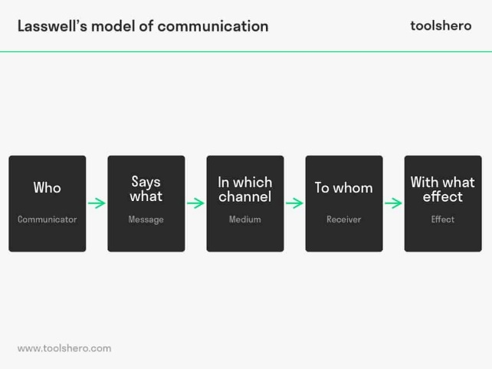
(Communication Theory - Meaning and Examples, n.d.)
Figure 20

Laswell’s linear communications model can also be used to understand communication. By referring to all five questions, the model can significantly assist when offering communication advice to organisations such as warm spaces.
Participant C “The thing is most people sit at home on their phones and do not know how to speak to people, warm spaces are about communication with others just as much as a warm space and a hot drink”.
Participant A “Conversation, having a natter is a big help to people it helps them find out they are not on their own, but people don’t know how to do it or are embarrassed to talk about their issues whether it be cost of living or mental health.
Communication is something that so many take for granted, many find this one of the hardest things to do in their lives, being able to speak to somebody about their basic needs and asking for help is not often easy.

6 Themes
Theme 1: To help with low self-esteem and confidence.
Participant A, B and C all expressed that most attendees had very low esteem and lack of confidence and their motivation was either no existent or low. Participants voiced that this was due to lack of money, and the lack basic needs and the worry of no security, what will happen next, will food petrol and bills co up more. When will it stop?
Participant A “The young parents tend to be the worst, not knowing how to interact with other people worried about finances, clothing and do they have enough money to top up their meters, but also the elderly have a proud thing about them as well”.
This shows the basic need for clothes and food, is very high on attended minds worrying where they are going to find the money just to clothes and feed themselves and or their families, knowing they cannot provide this gives low self-esteem.
Participant B “people just feel low bless, having a chat does help a lot of people but some find it hard to chat especially at the start”
This interprets as, again chatting to people helps with confidence which in turn can help with low self-esteem.
Participant C “There are so many people now that just feel they are sinking, can’t cope anymore and just need that somebody to talk to, this place it’s like a medicine a chat and a cuppa and some advice helps so much with many people”.
This interprets as, the cost-of-living crisis has affected many people’s confidence and by talking to others helps with a person self-esteem and confidence grows,
Theme 2: To help with Motivation.
Participant A “adding homework clubs etc has also helped.”
This interprets as, a coffee and a chat are not enough for some people, by adding clubs such as homework club increased people’s motivation to attend in turn this increased numbers.
Participant B “numbers were low to start with but after introducing homework clubs and mother and baby coffee mornings our numbers increased”.
This interprets as, the addition of the extra sessions was meeting the needs of the participants and in turn driving their motivation to attend.
Participants C. “In the morning sessions we get a lot of mother and baby’s as we have started a session for them”.
This interprets as, again having some sort of club increases the numbers of attended.
Theme Three: To help people communicate.
Participant A “Conversation, having a natter is a big help to people it helps them find out they are not on their own, but people don’t know how to do it anymore especially the youngsters always on their phones or are embarrassed to talk about their issues whether it be cost of living or mental health. I think covid hasn’t helped mind”.
This interprets as, Communication is something that so many take for granted, many find this one of the hardest things to do in their lives, being able to speak to somebody about their basic needs and asking for help is not often easy.
Participant C “The thing is most people sit at home on their phones and do not know how to speak to people, warm spaces are about communication with others just as much as a warm space and a hot drink”?
This interprets as, again that communication currently does not often flow due to technology and unfortunately the isolation of the Covid-19 pandemic.
Theme 4: To assist with the rising cost of living.
Participant A “This is all about people saving money”.
This interprets as, the warm spaces are to help people save money not spend it.
Participant B “The whole point of this is that people can save money by coming here having a hot drink and keep warm, save on their bills”.
This interprets as, the heated warm paces can be used by those who are having financial difficulties, and not have to pay for anything while there.
Participant C “We only charge £1 voluntary donation for a meal, this saves their bills at home both on food shopping and heating, electric etc.”
This interprets as, again the warm spaces are set up to help with everyday bills to reduce food and heating costs, along with electricity.
During the literature review warm spaces were examined their intended use and the extent of use, from the themes and the literature review it is clear to see that they have worked as expected although in some area a few changes had to take place to make them work, it hasn’t just been the case of opening up for people having a natter this simply did not work as first expected from the councils. Having to open a variety of clubs like homework club or mother and baby was needed.
There have been a variety of results when comparing the three warm spaces that were investigated, Overall, it has been made easier to understand the comparative findings between each warm space participated in this study by comparing the results and the study data in the literature review. Future study might expand on the ground works established in by this research to examine the communication that local councils and communities have regarding the cost-of-living crisis referred to in the literature review and warm spaces.

7 Findings
It is clear from the dialogue and themes that warm spaces are working and helping many people, relying solely on volunteers which can sometimes be problematic. There is a clear pattern from all three regards to what sessions they run, mother and baby and homework sessions are the main core of all three groups. There is a mixed opinion about asking for a donation however if participant C was interview before the other two it could have been mentioned what the other spaces charge a donation for, and that it’s not just for attending the space the attendees get a warm meal in return for a donation.
All three participants would like to carry on with the initiative; however, this is dependant across the board on funding, how would they fund the space to allow it to continue, and volunteers as the spaces cannot run without them.
The three participants mentioned that the warm spaces were for people to be able to keep warm and not sit in a cold house, to connect with people and motivate people to leave their homes and not sit alone. To aid with the burden of increasing household bills and the cost-of-living crisis.

8 Conclusion
The Mental Health Foundation states that “Our basic human needs of staying warm, safe and having enough to eat is being challenged” (Cost-of-living and Mental Health, 2023). Finding the time to care for oneself might be challenging especially when added daily concerns like worrying about bills, food an keeping warm. Even with so much going on its crucial to make time to look after your physical and emotional health.
Almost everyone in the UK is impacted by the cost-of-living challenges, The price of heating our homes, running water to wash the dishes or do the laundry, and the price of food. Most households plan every meal to a budget which hasn’t been done in such a scale in this country in years. With all the stress of the increase of bills, and of course the stress from our everyday lives like health, family, friend, and work, it can make you feel you lack the mental capacity to handle anymore.
Warm spaces have been a haven to many people that we just do not know about and possibly saved lives, maybe after completion of this winter hubs on the 31st march there will be data released on hubs, and on how they have actually helped the communities. The total cost of the hubs across the UK and especially in Carmarthenshire where the focus of this research was based on is currently unknown, this leaves plenty of scope for future research on the warm spaces.

9 Recommendations
Whilst warm spaces appear to be working according to this research study, there are a few areas that lack clarity. 44.13% of participants in the study had not hear of a warm space, maybe schools could send notifications to families informing them of the warm space in their village and what they are all about, explain that they are not just for low-income families and that all are welcome.
Secondly with over 321 towns and villages within Carmarthenshire and only 57 registered warm spaces, do the council need to approach communities to participate in the initiative, possibly give a subsidy to those groups, business or volunteers that take part. This in turn could and will help more people.
Warm hubs should be in the centre of communities, so they are accessible to all, possibly on a main public transport route. Residence may benefit from the provision of refreshment’s, resources to offset the rising cost of living, social events, information sessions etc, making a clear offer to residents not just provision of a warm space.

10 Further study Recommendations

As there was no other research found regarding the dissertation subject ‘Warm Spaces’, apart from newspaper articles and government press release on warm spaces, the following recommendations would benefit from additional study after the end date of the ‘Warm Spaces ‘which is 31st March 2023.After this date there should be information available from all the participating council, that would derive from the warm spaces themselves.
Recommendation one
How much has ‘the Warm spaces’ initiative cost the government, and could the money be spent to help the more vulnerable in a more cost affecting and positive way?
Recommendation Two
How many people has the initiative helped over the 6 month it has been running for and, is the number of people using the spaces what the government and councils were expecting.
Recommendation Three
What age groups has the initiative helped and could the homework clubs and hot drink be held within the schools to allow the spaces to make more room for adults and families in an evening?
Recommendation Four
Is there funding available to carry on with the initiative past the end date? And would this benefit the communities.

References (45)

Ahmad, S., & Sumaiya, I. (2019). Qualitative v/s Quantitative Research. Journal of Evidence Based Medicine and Healthcare, 2828-2835.

Aspers, P., & Corte, U. (2019b). What is Qualitative in Qualitative Research. Qualitative Sociology, 42(2), 139–160. https://doi.org/10.1007/s11133-019-9413-7

B. (2019, December 8). The Bruce Tuckman Theory. Teamwork Definition Information. Retrieved March 17, 2023, from https://teamworkdefinition.com/brucetuckmantheory/

Barclay, D. (2023, March 3). Warm Spaces - A Quiet Revolution. Warm Spaces.

Braun & Clarke 2006 - Using Thematic Analysis. (n.d.). Scribd. Retrieved March 15, 2023, from https://www.scribd.com/doc/151684840/Braun-Clarke-2006-Using-Thematic-Analysis#

Braun, V., & Clarke, V. (2012). Thematic analysis. In H. Cooper, P. M. Camic, D. L.
Long, A. T. Panter, D. Rindskopf, & K. J. Sher (Eds.), APA handbook of research methods in psychology, Vol. 2. Research designs: Quantitative, qualitative, neuropsychological, and biological (pp. 57–71). American Psychological Association

Bryn and Trallwm Club - Hub at The Club. (n.d.). Retrieved January 17, 2023, from https://www.carmarthenshire.gov.wales/home/council-services/benefits/warm-places-and-warm-welcome-spaces/warm-banks-directory/bryn-and-trallwm-club-hub-at-the-club/

Cherry, K. (2022, December 2). Carl Rogers Psychologist Biography. Verywell Mind. Retrieved March 22, 2023, from https://www.verywellmind.com/carl-rogers-biography-1902-1987-2795542

Clarke, D. (2023, March 8). Topic: Cost of living crisis UK. Statista. Retrieved March 17, 2023, from https://www.statista.com/topics/9121/cost-of-living-crisis-uk/#topicOverview

Communication Theory - Meaning and Examples. (n.d.). Retrieved March 22, 2023, from https://www.managementstudyguide.com/communication-theory.htm

Cost of living crisis: a public health emergency. (2022, November 15). Public Health Wales. Retrieved March 22, 2023, from https://phw.nhs.wales/news/cost-of-living-crisis-a-public-health-emergency/

Cost-of-living and mental health. (2023). Mental Health Foundation. Retrieved March 17, 2023, from https://www.mentalhealth.org.uk/explore-mental-health/cost-of-living

Definition of bias. (2023c). In Merriam-Webster Dictionary. Retrieved March 15, 2023, from https://www.merriam-webster.com/dictionary/bias

Dodd, D. (2023, February 24). One year on: Ukraine and the world economy. Financial Times. Retrieved March 17, 2023, from https://www.ft.com/content/69a35338-d82f-488a-a099-17e13450bace

Energy efficiency of Housing, England and Wales, country, and region - Office for National Statistics. (2022, October 25).

Evans, A. (2022, October 17). Warm places will be available for Carmarthenshire residents this winter. Carmarthenshire News Online. Retrieved March 13, 2023, from https://www.carmarthenshirenewsonline.com/news/warm-places-

Find a Warm Welcome Space Today. (2022). Warm Welcome. Retrieved March 15, 2023, from https://www.warmwelcome.uk/#:~:text=We%20have%20over%204000%20registered%20organisations%20that%20have,Campaign%20is%20the%20community%20response%20to%20the%20crisis.

Google. (2021). Google Forms: Free Online Surveys for Personal Use. Retrieved from http://www.google.co.uk/forms/about/

Grbich, C. (2007). Qualitative Data Analysis: An Introduction. Sage Publications (CA).

Hourston, P. (2022, February 7). Cost of living crisis. Institute for Government. Retrieved January 17, 2023, from https://www.instituteforgovernment.org.uk/explainer/cost-living-crisis
https://www.ons.gov.uk/peoplepopulationandcommunity/housing/datasets/energyefficiencyofhousingenglandandwalescountryandregion

Hutt, J. (2022, October 12). Written Statement: Funding for Warm Hubs | GOV.WALES. GOV.WALES. Retrieved March 13, 2023, from https://www.gov.wales/written-statement-funding-warm-hubs

Igwenagu, C. (2016). Fundamental of Research Methodology and Statistics (1st ed.). lap lambert academic publishing.

In my area. (2022, season-04). Carmarthens County Council. Retrieved March 13, 2023, from https://www.carmarthenshire.gov.wales/home/council-services/in-my-area/?searched=true&Easting=257574.13&Northing=204185.59&Language=en-GB&Address=93%20HEOL%20Y%20PARC%2C%20HENDY%2C%20SWANSEA%2C%20SA4%200XX&Catchment=Warm_Hubs
ITV News, & Elliott, S. (2022, September 27). How to find a “Warm Space” near you amid rising energy bills. ITV News. Retrieved March 17, 2023, from https://www.itv.com/news/2022-09-27/how-to-find-a-warm-space-near-you-amid-rising-energy-bills

Jones, S. (2022, November 18). Interpreting themes from qualitative data: thematic analysis — Eval Academy. Eval Academy. Retrieved March 15, 2023, from https://www.evalacademy.com/articles/interpreting-themes-from-qualitative-data-thematic-analysis

Jones, S. (2022, November 18). Interpreting themes from qualitative data: thematic analysis — Eval Academy. Eval Academy. Retrieved March 15, 2023, from https://www.evalacademy.com/articles/interpreting-themes-from-qualitative-data-thematic-analysis

Jordan, M. (2021, May 21). What is SPSS and How Does it Benefit Survey Data Analysis? Alchemer. Retrieved March 16, 2023, from https://www.alchemer.com/resources/blog/what-is-spss/?msclkid=df66f8f6cf9d11ec88b7121fd2da25a6

Mcleod, S., PhD. (2023, March 21). Maslow's Hierarchy of Needs - Simply Psychology. Simply Psychology. Retrieved March 22, 2023, from https://simplypsychology.org/maslow.html

Mcleod, S., PhD. (2023b, March 21). Maslow's Hierarchy of Needs - Simply Psychology. Simply Psychology. Retrieved March 22, 2023, from https://simplypsychology.org/maslow.html

Monroe, J. (2022, January 23). We’re pricing the poor out of food in the UK – that’s why I’m launching my own price index. The Guardian. Retrieved January 17, 2023, from https://www.theguardian.com/society/2022/jan/22/were-pricing-the-poor-out-of-food-in-the-uk-thats-why-im-launching-my-own-price-index

Motivation and factors affecting motivation. (n.d.). Motivation and Factors Affecting Motivation. Retrieved March 22, 2023, from https://www.open.edu/openlearn/health-sports-psychology/motivation-and-factors-affecting-motivation/content-section-3

Mulder, P. (2022, May 19). Lasswell Communication Model. Toolshero. Retrieved March 22, 2023, from https://www.toolshero.com/communication-methods/lasswell-communication-model/

Mullins, L. (2013). Management & Organisational Behaviour. (10th ed.) Pearson Education Ltd, p. 13, 243, 252.

Riley, J. (2022, October 20). Communities urged to provide Warm Welcome Spaces. South Wales Guardian. Retrieved March 13, 2023, from https://www.southwalesguardian.co.uk/news/23060546.communities-urged-become-warm-welcome-spaces/

Sinha, Clarke, S., & Farquharson, L. (2018). Shrek, Saunders, and the Onion Myth: Using Myths, Metaphors and Storytelling. European Conference on Research Methodology for Business and Management Studies, 366–XV.
Taylor, S. (2023, March 6). Random Sampling. Corporate Finance Institute. Retrieved March 15, 2023, from https://corporatefinanceinstitute.com/resources/data-science/random-sampling/

Towns in Carmarthenshire, Wales | Town Information, UK. (2023). Towns and Counties Postcodes. Retrieved March 13, 2023, from https://www.townscountiespostcodes.co.uk/towns-in-wales/carmarthenshire/#:~:text=Our%20database%20currently%20has%20a%20total,of%20321%20Towns%2FVillages%20in%20Carmarthenshire%2C%20Wales%20.

Uwtsd, T. D. W.-. (n.d.). Research ethics | UWTSD. Uwtsd. Retrieved 9 May 2022, from https://www.uwtsd.ac.uk/research/research-ethics/?msclkid=36bac0c7cf9a11ec8e7863546e7aabfe

Walsh, S. (2022, August 12). The Top 10 Social Media Sites & Platforms 2022. Search Engine Journal. Retrieved March 16, 2023, from https://www.searchenginejournal.com/social-media/biggest-social-media-sites/#close

Warm places and Warm welcome spaces. (2022, November). Carmarthen County Council. Retrieved March 13, 2023, from https://www.carmarthenshire.gov.wales/home/council-services/benefits/warm-places-and-warm-welcome-spaces/#.ZA8TeZHP02w

Warm places and Warm welcome spaces. (n.d.). https://www.carmarthenshire.gov.wales/home/council-services/benefits/warm-places-and-warm-welcome-spaces/
Warm Spaces. (2022). Warm Spaces. Retrieved March 17, 2023, from https://warmspaces.org/

Wheelhouse café. (n.d.). Retrieved January 17, 2023, from https://www.carmarthenshire.gov.wales/home/council-services/benefits/warm-places-and-warm-welcome-spaces/warm-banks-directory/wheelhouse-caf%C3%A9/

will-be-available-for-carmarthenshire-residents-this-winter/
Y Cwtsh, Tymbl. (2022, November). Retrieved March 13, 2023, from https://www.carmarthenshire.gov.wales/home/council-services/benefits/warm-places-and-warm-welcome-spaces/warm-banks-directory/y-cwtsh-tymbl/

Y Cwtsh, Tymbl. (n.d.). https://www.carmarthenshire.gov.wales/home/council-services/benefits/warm-places-and-warm-welcome-spaces/warm-banks-directory/y-cwtsh-tymbl/

Appendices
1 Quantitative Questionnaire
https://forms.office.com/Pages/ShareFormPage.aspx?id=-REPTm4EBUWcuNshUjEeIZe5696bAfFBof3vEcDfUptUMkkxWE1RWVM1MkNXTTA5UE9GTkRCTTk0SS4u&sharetoken=3L83xRiilhaAzj7pEFzV
2 Lanedi Community Council Warm Space Email Application invite.
Carmarthenshire County Council, with support from Welsh Government, have made available funding of up to £10,000 to enhance and/or increase provision to people facing poverty in Carmarthenshire. The fund is to support initiatives that provide practical support including facilitating and enabling communities to reduce poverty.

Communities local to ours have successfully integrated “Warm Hubs” into community buildings which give people facing poverty issues somewhere to keep warm with a welcoming, accessible, non-judgemental & safe environment. Allowing members of the community, particularly those with low incomes, to reduce the cost of heating their own homes and provide welcomed socialisation to those living in isolation.

The fund is open to Community Groups and Organisations and so I have attached the details of the application for your information as you are eligible to make an application. If you would like to apply but are struggling with the application form then please get in touch, I will be more than willing to help you.
3 Carmarthenshire County Council Poverty Fund Guidance

Purpose

The objective of the fund is to support an increased number of people facing poverty by enhancing and increasing appropriate provision within Carmarthenshire. The fund is supported by Welsh Government.

We welcome applications to support initiatives that provide practical support to those on low incomes, and those living in poverty. Playing a role in facilitating and enabling communities and citizens to reduce poverty across Carmarthenshire.
Priorities would include:
- Preventing people falling into poverty, providing support before they hit crisis – early intervention
- Overcoming barriers to escaping poverty
- Improving Financial Wellbeing
- Support food initiatives, increase volunteering opportunities, learn new skills, and access wider community-based activities and support.
Project examples
The following provides an indicative list of eligible activities (this is not an exhaustive list):
Warm hubs/spaces – support for communities to establish warm hubs where individuals are provided with a welcoming, accessible, safe, and warm environment to help reduce the cost of heating their own homes and to help people facing extreme fuel poverty this winter.

Development of community cafes – providing local residents of all ages an opportunity to meet and socialise, reducing social isolation.

Growing projects – Developing and strengthening food partnerships, providing skills for individuals to grow nutritious produce on a budget, eat healthily, save money, and improve Well-being.
Social supermarkets/ community shops - reducing food waste by selling residual stock.

Fuel clubs – Creation of fuel syndicates to empower communities to buy oil in bulk and share the savings.

Mobile cooking schools – Providing training and advice, improving peoples cooking skills in preparing nutritious meals on a budget.

How much can organisations apply for?

Organisations can apply for a maximum of £10,000 and a minimum of £1,000.

Application Process

- Applicants must contact the Bureau on 01269 590216 or alternatively via e-mail bureau@carmarthenshire.gov.uk to register your project and apply for an application form.
- Bureau Officer support is available via the Bureau to develop your project and to complete an application form.
- Applications can be submitted electronically via e-mail at bureau@carmarthenshire.gov.uk accompanied by an electronic signature from an approved signatory.
- Applications MUST be submitted with any relevant organisational policies such as Health & Safety (e.g., food health certificates), financial statement (subject to status of the entity), Constitution or set of rules signed. Please refer to the checklist at the end of the application form for further information.
- If you are successful, an Offer Letter with the grant Terms and Conditions will be sent to you.
- Once the grant offer Terms and Conditions have been returned, projects can proceed.
- Payment of grant awards will be made in arrears on submission of evidence of procurement, expenditure, and project outcomes in the form of original paid invoices and relevant bank statement evidencing project expenditure. Any expenditure incurred prior to the grant offer letter will be deemed ineligible, this also includes where contracts have been signed or orders placed.
- All grant awards will be monitored, and applicants will be required to provide evidence of all outputs achieved as a result of the funding.
- Claims must be submitted by 3rd March 2023. Claims can be submitted electronically via e-mail at bureau@carmarthenshire.gov.uk

Deadline for Submission of Applications

Applications for support must be submitted by 18th November 2022.

Assessment Process

Your application will be assessed by a panel and their decision is final.

Applications will be assessed against the following criteria:

- Demonstration of need for the funding.
- How the initiative will be sustained following funding
- How the project will improve Communities Well-being by tackling and reducing poverty
- How the project contributes towards reducing social isolation and loneliness.
- Must be services or activities which equip communities or individuals to support themselves, their families, and their communities.
- Should build on community assets, local resources and mobilise volunteers to contribute to healthy and confident communities.
- Priority will be given to projects where there is no similar provision available locally.

All applications submitted for the Poverty Grant must support the aim of tackling poverty. The project must benefit the residents of Carmarthenshire.

All approved projects will be advertised on the Carmarthenshire County Council’s website and via relevant partner websites.

Who can apply?

To be eligible for this funding, groups or organisations must:

- Be based in, and/or represent, serve, and support people in Carmarthenshire.
- Demonstrate that the proposal is clearly to the direct benefit of the residents and communities of Carmarthenshire.
- Be a constituted community group or a registered Charity or CIO based in Wales.
- Other entities would be considered where there is no other community facility providing relevant support within the locality.

To be able to access this grant, it will be required that you will deliver a high-quality support service, aimed at reducing the effect of poverty across Carmarthenshire.

Eligible costs

Capital costs.
- Equipment

Revenue costs – examples include:
- Staffing
- Marketing and promotional costs
- Volunteer costs
- Travel costs
- Activities
- Warms hubs – additional costs relating to the provision of warm hubs e.g., provision of refreshments, additional expenses associated with extending the opening hours of existing facilities, enrichment items / activities.

Procurement Process
Applicants must adhere to the procurement guidelines attached at Annex 1.

Contact
Poverty Fund, Bureau, County Hall, Carmarthen, Carmarthenshire. SA31 1JP
Tel: 01269 590216 / Email: bureau@carmarthenshire.gov.uk

 |  | Third Party Grant Procurement Rules
Requirement | Value | Procurement Process
All | up to £4,999 | A minimum of 1 written Quotation must be obtained and retained.  Best value for money must be obtained and reasonable care must be taken to obtain goods, works or services of adequate quality at a competitive price. A documented record to support the decision must be retained for audit purposes.  Applicants are requested to ‘Think Carmarthenshire First’ when seeking quotations for the purchase of Goods/Services. Please therefore, explore the marketplace to establish if there are any businesses within Carmarthenshire that can provide the goods / service that you are seeking to purchase. Applicants may be required to demonstrate such quotations have been sought.
All | £5,000 and £24,999 | A minimum of 3 written Quotations must be sought from competitive sources*. The quotes must be based on the same specification and evaluated on a like for like basis.  A documented record of the quotes sought the evaluation process and the decision to award must be recorded.  Applicants are requested to ‘Think Carmarthenshire First’ when seeking quotations for the purchase of Goods/Services. Please therefore, explore the marketplace to establish if there are any businesses within Carmarthenshire that can provide the goods / service that you are seeking to purchase. Applicants may be required to demonstrate such quotations have been sought.
All | £25,000 and £74,999 | A minimum of 3 written Quotations must be sought from competitive sources*. The quotes must be based on:  - the same specification,  - the same evaluation criteria and evaluated on a like for like basis. It is best practice to establish an evaluation panel.  - the same closing dates.  A documented record of the quotes sought the evaluation process and the decision to award must be recorded for audit purposes.  **In the event that only one quotation is received, you must contact the Project Manager from Carmarthenshire County Council (CCC) to provide details and justification of the procurement process you have undertaken. The decision to proceed to purchase must be approved by CCC on a case-by-case basis. In circumstances where it is evident that more than one quotation could be sought, there may be a requirement to advertise via Sell2Wales -  https://www.sell2wales.gov.wales
NB - spend thresholds of £75K and under are exclusive of VAT
Important Guidance
Advertising via Sell2Wales
* It is possible for you to advertise on the National Procurement website, https://www.sell2wales.gov.wales if you are in a situation where you have difficulty in identifying the minimum number of suppliers required and/or would like to vary or attract new suppliers to quote or tender. Advertising via Sell2Wales is best practice, however you may feel that you are better able to identify potential suppliers who could provide the best overall offer.
This facility is available to you free of charge, please visit the Sell2Wales website: https://www.sell2wales.gov.wales and contact the website helpline on 0800 222 9004 for further information.

Seeking Quotations/Tenders
For spend above £5,000 it is essential that the quotes/tenders are sought from appropriate suppliers for the goods, works or services required. In circumstances where it is evident that unsuitable quotes/tenders have been sought, there may be a requirement to advertise via Sell2Wales.

Other Funders
If a project involves any other or additional funding streams, these Third-Party Grant Procurement Rules must be followed as a minimum for the total estimated spend of the requirement.

Avoiding conflicts of interest
We recognise that it is possible that applicants / developers or persons connected with them (such as relatives, business partners or friends) may wish to tender for a contract being offered by the applicant / developer. This is acceptable, but applicants will need to ensure that the tendering process is undertaken in an open, transparent, and fair manner, as outlined above, which does not give one person or company tendering any advantage over another, which arises from the process. Appropriate measures to prevent identify and remedy any conflicts of interest must be carried out.
If an applicant / developer or any person connected with them directly or indirectly, has a financial, economic, political, or other personal interest which might be perceived to compromise their impartiality and independence in the context of the procurement procedure:
- that applicant / developer, or any other person or party with an interest must declare that interest in writing to the Project officer who will offer advice accordingly.
- specifications and evaluation criteria must not be biased or tailored to favour one solution or any one party over another.
- that person or party with an interest should take no part whatsoever in any of the tender evaluation procedures to ensure that the process is fair to all. It is acknowledged that the grant applicant may be required to provide the final approval.
- every stage of the procedure must be recorded formally.
- If the contract would normally be subject to a single tender procedure, it is recommended that the sponsor should seek written quotes from at least two other suppliers (i.e., following the procedure set out above for contracts between £5000 and £25,000)

The purpose of these guidelines is to ensure that there is fairness in the spending of public money and that the integrity of the applicant is not compromised.

Changes to the specification or contract
If any changes are required to the specification after seeking quotes/tenders which affects the original scope of the requirement, a new procurement exercise may need to be undertaken to ensure that best value for money has been achieved. This may occur where there are unforeseen additions to the original requirement, where tenders are received in excess of the available budget, where funding levels change etc. The grant applicant must inform the Project officer who will offer advice accordingly.

N.B
- Failure to observe the relevant procedures outlined above will be considered non-compliant and may lead to a withdrawal of the grant offer and potential claw-back of funding.
- In cases where you are unable to satisfy the requirements of these procedures you must always inform the project manager.
- If you have any queries as to how these procedures should be applied, you should contact the project manager for clarification and further guidance.

Dos and Don’ts of Tendering
Do’s | Don’ts
- ensure that any potential conflicts of interest are declared at the earliest opportunity. | - Don’t skew the specification to eliminate or to discriminate against suppliers i.e. limit the specification to a specific brand.
- comply with the appropriate rules | - Don’t change the scope of the specification once distributed.
- ensure that the specification is precise and not in excess of the requirements. | - Don’t change the evaluation criteria during the process.
- ensure that the Evaluation Criteria is directly relevant to the subject of the contract | - Don’t give companies too short notice to quote.
- complete and retain full records for future reference and audit purposes | - Don’t enter too much detail verbally with suppliers regarding specific questions. The same information must be provided to all suppliers to ensure the process is fair
- ensure that quotes/tenders are evaluated on a ‘like for like’ basis. | - Don’t reveal prices to potential suppliers.
- ensure that you treat suppliers in an open, transparent, and non-discriminatory manner. | - Don’t breach confidentiality.
- allow sufficient time for companies to quote | - Don’t open quotes/tenders in advance of the deadline.
- ensure the value of the Goods/Works or Service is estimated accurately at the start of the process to apply the correct procurement process. The aggregated value must be used where applicable. | - Don’t consider submissions received after the deadline.

Procurement Definitions
Title | Description
Aggregation | Adding together the value of separate contracts for the same supply, service or works.
Contract | A Contract for the purposes of these Rules shall be any agreement (whether in writing) between the grant applicant and one or more other parties for: -  - the sale of goods or materials.  - the supply of goods or materials.  - the execution of works  - the provision of services (including accommodation and facilities).
Competitive Source | an independent provider bidding against another independent provider
Goods | are material items i.e. equipment, food, vehicles etc
Public Contracts Regulations 2015 | are rules and regulations that Public Sector organisations must adhere to when procuring Goods, Works and Services over a certain value threshold whereby an official Tender Exercise in accordance with the Public Contracts Regulations 2015 should be undertaken.
Evaluation | a method of determining which offer provides the best value for money in accordance with the pre-determined evaluation criteria
Evaluation Criteria | A list of key requirements taken from the specification that will enable suppliers to explain how they intend to deliver the requirement which will be evaluated. The criteria by which the most economically advantageous tender will be determined is based on a combination of price/cost and quality criteria.
Evaluation Panel | It is best practice to establish an evaluation panel to undertake the evaluation exercise. It may be appropriate to have a cross functional team as a panel. Panel should agree specification and evaluation criteria. Panel should be consistent throughout each stage of procurement exercise
Sell2Wales | is a National Procurement Website where all public sector contracts are advertised. Third Party Grant Recipients can also advertise via the website free of charge, please visit the Sell2Wales website https://www.sell2wales.gov.wales and contact the website helpline on 0800 222 9004 for further information.
Services | tasks undertaken by people i.e. consultancy services, translation services etc
Specification | this is a written statement that defines the requirements. The specification will vary according to the work, product or service concerned. For a simple product the specification may be a brief description, while in the case of a complex requirement it will be a comprehensive document. The description of the goods, works or services required must not refer to a specific make, brand, or source.
Tender/Quote | is the document compiled by a potential supplier in response to an invitation to quote/tender. It sets out general information demonstrating the capability and eligibility of the supplier - including detailed information about how they propose to fulfil the specifications of the requirement.
Works | include landscaping, construction, building works etc

‘Mae croeso i chi gysylltu gyda’r cyngor trwy gyfrwng y Gymraeg neu’r Saesneg.
You are welcome to contact the council through the medium of Welsh or English’

4 List of Carmarthe Councils Warm Spaces
Warm places and Warm welcome spaces (gov.wales)
5 Participants authority sheet
Participant Information Sheet
** Provide Programme Title **

** Provide Title of Project **

Dear Participant:

My name is ********** and I am a **********. Currently, I am studying towards an ********** and I would like to invite you to participate in my Independent Project.

The aim of my report is to **********. Attached to this letter is a ********** developed by me that will assess your view on the **********. I do believe your opinions will be extremely helpful to me.

All questionnaires will be kept strictly confidential and at NO time will individual questionnaires be released to the general public. This gives you a chance to express your views in a confidential and anonymous forum and still be able to make a difference. Your participation in this study is completely voluntary so you can withdraw from the questionnaire at any stage. The questionnaire should take about 5 minutes to complete, but there is no time constraint. There are also no right or wrong answers.

After careful and precise analysis of the data obtained from this questionnaire, I will be happy to provide you with a copy of the findings at your request.

I thank you in advance for your time and participation. If any questions do arise, feel free to contact me at your convenience.

**********

**********

6 Ethics Form
APPLICATION FOR ETHICAL APPROVAL

In order for research to result in benefit and minimise risk of harm, it must be conducted ethically.

The University follows the OECD Frascati manual definition of research activity: “creative work undertaken on a systematic basis in order to increase the stock of knowledge, including knowledge of man, culture and society, and the use of this stock of knowledge to devise new applications”. As such this covers activities undertaken by members of staff, postgraduate research students, and both taught postgraduate and undergraduate students working on dissertations/projects.

The individual undertaking the research activity is known as the “principal researcher”.

This form must be completed and approved prior to undertaking any research activity.

SECTION A: About You (Principal Researcher)
1 | Full Name: | Anne-marie Thomas
2 | Student Number: | 2011226
3 | Email address: | 2011226@student.uwtsd.ac.uk
4 | Programme of Study: | BA Business Management
5 | Supervisor: | Navdeep Randhawa

SECTION B: Internal and External Ethical Guidance Materials
 | Please list the core ethical guidance documents that have been referred to during the completion of this form (including any discipline-specific codes of research ethics, location-specific dodes of research ethics, and also any specific ethical guidance relating to the proposed methodology). Please tick to confirm that your research proposal adheres to these codes and guidelines. You may add rows to this table if needed.
1 | UWTSD Research Ethics & Integrity Code of Practice | ☒
2 | UWTSD Research Data Management Policy | ☒

SECTION C: Details of Research Activity
1 | Indicative title: | Warm hubs within Carmarthenshire
2 | Proposed start date: | 1 October 2022 | Proposed end date: | 31st march 2023
Introduction to the Research (maximum 300 words in each section)
Ensure that you write for a Non-Specialist Audience when outlining your response to the three points below:
- Purpose of Research Activity
- Proposed Research Question
- Aims of Research Activity
- Objectives of Research Activity
Demonstrate, briefly, how Existing Research has informed the proposed activity and explain
- What the research activity will add to the body of knowledge
- How it addresses an area of importance.
3 | Purpose of Research Activity  Produce a small-scale qualitative research study and produce a report.  Produce a small-scale quantitative research study and produce a report.
4 | Research Question  Are warm hubs in the Carmarthenshire area working, are the numbers predicted using the service.
5 | Aims of Research Activity  By using a semi structured interview style, the aim Is to see weather Warm Hubs are successful, if so why and if not why.
6 | Objectives of Research Activity  Carry out research and interview method to capture data
7 | Part 1 Collect qualitative data through 4 20-minute interviews with participants using a semi structured interview.  Part 2 I will create a survey and collect data from10- 99 respondents

SECTION D: Scope of Research Activity
 | Will the research activity include: | YES | NO
1 | Use of a questionnaire or similar research instrument? | ☒ | ☐
2 | Use of interviews? | ☒ | ☐
3 | Use of focus groups? | ☐ | ☒
4 | Use of participant diaries? | ☐ | ☒
5 | Use of video or audio recording? | ☒ | ☐
6 | Use of computer-generated log files? | ☐ | ☒
7 | Participant observation with their knowledge? | ☐ | ☒
8 | Participant observation without their knowledge? | ☐ | ☒
9 | Access to personal or confidential information without the participants’ specific consent? | ☐ | ☒
10 | Administration of any questions, test stimuli, presentation that may be experienced as physically, mentally, or emotionally harmful / offensive? | ☐ | ☒
11 | Performance of any acts which may cause embarrassment or affect self-esteem? | ☐ | ☒
12 | Investigation of participants involved in illegal activities? | ☐ | ☒
13 | Use of procedures that involve deception? | ☐ | ☒
14 | Administration of any substance, agent or placebo? | ☐ | ☒
15 | Working with live vertebrate animals? | ☐ | ☒
16 | Procedures that may have a negative impact on the environment? | ☐ | ☒
17 | Other primary data collection methods. Please indicate the type of data collection method(s) below. | ☐ | ☒
 | Details of any other primary data collection method:  (this box should expand as you type) | ☐ | ☒

If you have ticked NO to every question then the research activity is (ethically) low risk and you may skip section E and continue to section F.

If YES to any question, then no research activity should be undertaken until full ethical approval has been obtained.

SECTION E: Intended Participants
 | Who are the intended participants: | YES | NO
1 | Students or staff at the University? | ☐ | ☒
2 | Adults (over the age of 18 and competent to give consent)? | ☒ | ☐
3 | Vulnerable adults? | ☐ | ☒
4 | Children and Young People under the age of 18? (Consent from Parent, Carer or Guardian will be required) | ☐ | ☒
5 | Prisoners? | ☐ | ☒
6 | Young offenders? | ☐ | ☒
7 | Those who could be considered to have a particularly dependent relationship with the investigator or a gatekeeper? | ☐ | ☒
8 | People engaged in illegal activities? | ☐ | ☒
9 | Others. Please indicate the participants below, and specifically any group who may be unable to give consent. | ☐ | ☒
 | Details of any other participant groups:  Complete this only if your participants cannot give consent. This includes animals. If students choose individuals under the age of 18 and or vulnerable individuals, a DBS (Disclosure and Barring Service) check is essential.  (this box should expand as you type) | ☐ | ☒

Participant numbers and source
Provide an estimate of the expected number of participants. How will you identify participants and how will they be recruited?
10 | How many participants are expected? | Part 1 4  Part 2 up to 99
11 | Who will the participants be? | Part 1 Volunteers from 4 different warm hubs  Part 2 attendees from the 4 different hubs  (this box should expand as you type)
12 | How will you identify the participants? | Participant A, B, C & D

 | Information for participants: | YES | NO | N/A
13 | Will you describe the main research procedures to participants in advance, so that they are informed about what to expect? | ☒ | ☐ | ☐
14 | Will you tell participants that their participation is voluntary? | ☒ | ☐ | ☐
15 | Will you obtain written consent for participation? | ☒ | ☐ | ☐
16 | Will you explain to participants that refusal to participate in the research will not affect their treatment or education (if relevant)? | ☒ | ☐ | ☐
17 | If the research is observational, will you ask participants for their consent to being observed? | ☐ | ☐ | ☒
18 | Will you tell participants that they may withdraw from the research at any time and for any reason? | ☒ | ☐ | ☐
19 | With questionnaires, will you give participants the option of omitting questions they do not want to answer? | ☒ | ☐ | ☐
20 | Will you tell participants that their data will be treated with full confidentiality and that, if published, it will not be identifiable as theirs? | ☒ | ☐ | ☐
21 | Will you debrief participants at the end of their participation, in a way appropriate to the type of research undertaken? | ☒ | ☐ | ☐
22 | If NO to any of above questions, please give an explanation
You should be able to tick YES for all of these questions. If not, then explain why not in this box.

(this box should expand as you type)

 | Information for participants: | YES | NO | N/A
24 | Will participants be paid? | ☐ | ☒ | ☐
25 | Is specialist electrical or other equipment to be used with participants? | ☐ | ☒ | ☐
26 | Are there any financial or other interests to the investigator or University arising from this study? | ☐ | ☒ | ☐
27 | Will the research activity involve deliberately misleading participants in any way, or the partial or full concealment of the specific study aims? | ☐ | ☒ | ☐
28 | If YES to any question, please provide full details
You should be able to tick NO for most of these questions. For any cases that you have ticked YES then provide details in this box. If you are using cameras/voice recorders to record interviews then please state that in this box.

(this box should expand as you type)

SECTION F: Anticipated Risks

 | Outline any anticipated risks that may adversely affect any of the participants, the researchers and/or the University, and the steps that will be taken to address them.
1 | Risks to participants  For example: sector-specific health & safety, emotional distress, financial disclosure, physical harm, transfer of personal data, sensitive organisational information. If you have identified in section D that there are no participants then enter N/A and go skip to question 3.
 | Risk to participants: possibly get upset. | How you will mitigate the risk to participants: ask non personal questions  (this box should expand as you type)
2 | If research activity may include sensitive, embarrassing or upsetting topics (e.g. sexual activity, drug use) or issues likely to disclose information requiring further action (e.g. criminal activity), give details of the procedures to deal with these issues, including any support/advice (e.g. helpline numbers) to be offered to participants. Note that where applicable, consent procedures should make it clear that if something potentially or actually illegal is discovered in the course of a project, it may need to be disclosed to the proper authorities
 | (this box should expand as you type)
3 | Risks to the investigator  For example: personal health & safety, physical harm, emotional distress, risk of accusation of harm/impropriety, conflict of interest
 | Risk to the investigator:  Participants become hostile when questions are asked | How you will mitigate the risk to the investigator:  Change the style of question asked remind the participant that this is voluntary.
4 | University/institutional risks  For example: adverse publicity, financial loss, data protection
 | Risk to the University:  - Risk of legal action is student improperly protects participants personal information and it enters public domain. | How you will mitigate the risk to the University:  Store participant data on a password protected device during the study and then delete after the study is completed.
5 | Environmental risks  For example: accidental spillage of pollutants, damage to local ecosystems
 | Risk to the environment:  N/A | How you will mitigate the risk to environment:

SECTION G: Feedback, Consent and Confidentiality

If you have identified in section D that there are no participants then enter skip this section and continue to section H.

1 | Feedback  What de-briefing and feedback will be provided to participants, how will this be done and when?
 | I would thank the participants for their cooperation and willingness to help in my data collection.
2 | Informed consent  Describe the arrangements to inform potential participants, before providing consent, of what is involved in participating. Describe the arrangements for participants to provide full consent before data collection begins. If gaining consent in this way is inappropriate, explain how consent will be obtained and recorded in accordance with prevailing data protection legislation.
 | I will tell the participants that I am conducting a qualitative study into Warm hubs in Carmarthenshire . In addition to this I would inform them of my intention to record our conversation before asking them to sign a participant agreement/consent form.
3 | I will use pseudonyms for my participants and other nonidentifying information such as but not limited to age and profession to discuss the findings.

SECTION H: Data Protection and Storage

 | Does the research activity involve personal data (as defined by the General Data Protection Regulation 2016 “GDPR” and the Data Protection Act 2018 “DPA”)? | YES | NO
1 | “Personal data” means any information relating to an identified or identifiable natural person (‘data subject’). An identifiable natural person is one who can be identified, directly or indirectly, in particular by reference to an identifier such as a name, an identification number, location data, an online identifier or to one or more factors specific to the physical, physiological, genetic, mental, economic, cultural, or social identity of that natural person. Any video or audio recordings of participants is considered to be personal data. | ☐
 | If YES, provide a description of the data and explain why this data needs to be collected:
2 | This includes audio/video data of participants, but can also include IP addresses and usernames. Names, addresses and emails also count, as do consent forms.  (this box should expand as you type)
 | Does it involve special category data (as defined by the GDPR)? | YES | NO
3 | “Special category data” means sensitive personal data consisting of information as to the data subjects’ –  (a) racial or ethnic origin,  (b) political opinions,  (c ) religious beliefs or other beliefs of a similar nature,  (d) membership of a trade union (within the meaning of the Trade Union and Labour Relations (Consolidation) Act 1992),  (e) physical or mental health or condition,  (f) sexual life,  (g) genetics,  (h) biometric data (as used for ID purposes), |  | ☐
 | If YES, provide a description of the special category data and explain why this data needs to be collected:
4 | What counts as ‘sensitive’ will differ between cultures. Any information on behaviour that is not in accordance with cultural norms would count as sensitive personal data.  (this box should expand as you type)

 | Will data from the research activity (collected data, drafts of the thesis, or materials for publication) be stored in any of the following ways? | YES | NO
5 | Manual files (i.e. in paper form)? | ☐ | ☒
6 | University computers? | ☐ | ☒
7 | Private company computers? | ☒ | ☐
8 | Home or other personal computers? | ☒ | ☐
9 | Laptop computers/ CDs/ Portable disk-drives/ memory sticks? | ☐ | ☐
10 | “Cloud” storage or websites? | ☒ | ☐
11 | Other – specify: | ☐ | ☒
12 | For all stored data, explain the measures in place to ensure the security of the data collected, data confidentiality, including details of backup procedures, password protection, encryption, anonymisation and pseudonymisation:
If possible, save your data on computers that are secure and regularly backed up. Many cloud services only provide GDPR-compliant storage for business customers. An example of suitable text is given below.

All data will be kept in password protected cloud storage on the University Office 365 system which
will not be shared. Audio/visual data will be transcribed and would be shown to participants to
check accuracy of reporting. Any USB sticks used to store or transfer data will be password protected. All participants will be given a unique identifier to ensure confidentiality and this list will be kept securely in the password protected folder.

 | Data Protection
 | Will the research activity involve any of the following activities: | YES | NO
13 | Electronic transfer of data in any form? | ☒ | ☐
14 | Sharing of data with others at the University outside of the immediate research team? | ☐ | ☒
15 | Sharing of data with other organisations? | ☐ | ☒
16 | Export of data outside the UK or importing of data from outside the UK? | ☐ | ☒
17 | Use of personal addresses, postcodes, faxes, emails, or telephone numbers? | ☐ | ☒
18 | Publication of data that might allow identification of individuals? | ☐ | ☒
19 | If YES to any question, please provide full details, explaining how this will be conducted in accordance with the GDPR and Data Protection Act (2018) (and/or any international equivalent):
This includes data such as drafts of your thesis as well as experimental or survey data. An example of suitable text is given below.

All data will be encrypted and kept in password protected cloud storage on the University Office 365 system which will not be shared. Any USB sticks used to store or transfer data will be password protected. All data transfers will be encrypted and password protected. All participants will be given a unique identifier to ensure confidentiality and this list will be kept securely in the password protected folder. The data will be stored until the completion of the project and then deleted. In accordance with the DPA2018, participants will have the right to ask to see what data is held relating to them, and this data will be deleted immediately if the participant requests this, in which case the data will not be used in the project.

20 | List all who will have access to the data generated by the research activity:
 | Normally the principal researcher, possibly also the supervisor and, if the project has an industrial partner, a representative of that partner. Possibly also external examiner or second marker?
21 | List who will have control of, and act as custodian(s) for, data generated by the research activity:
 | Usually the principal researcher.
22 | Give details of data storage arrangements, including security measures in place to protect the data, where data will be stored, how long for, and in what form.
All data will be encrypted and kept in password protected cloud storage on the University Office 365 system which will not be shared. Any USB sticks used to store or transfer data will be password protected, and will be reformatted at the end of the project in order to destroy the data. The data will be stored until the completion of the project and then deleted.

(this box should expand as you type)
22 | Confirm that you have read the UWTSD guidance on data management (see https://www.uwtsd.ac.uk/library/research-data-management/) | ☒
23 | Confirm that you are aware that you need to keep all data until after your research has completed or the end of your funding | ☒

SECTION I: Declaration
The information which I have provided is correct and complete to the best of my knowledge. I have attempted to identify any risks and issues related to the research activity and acknowledge my obligations and the rights of the participants.

In submitting this application I hereby confirm that I undertake to ensure that the above named research activity will meet the University’s Research Ethics and Integrity Code of Practice which is published on the website: https://www.uwtsd.ac.uk/research/research-ethics/
 | 1 | Signature of applicant: | Anne-marie Thomas | Date:23-01-2023
2 |  | Director of Studies/Supervisor: |  |  | Date:
3 |  | Signature: |  |  | Date:

FOR INTERNAL USE ONLY:
 | Ethical approval given
1 | Signature of assessor: | Navdeep Randhawa | Date:07/02/23
2 | Name: | Navdeep Randhawa
3 | Role: | Lecturer/ Tutor

