Module Name: Digital Skills
Module Code: LCLM4002

Task 2 – Informative Poster: How to Create a Chart in a Word Document – A Step-by-Step Guide
Table of Contents
Introduction 1
Main Body: Step-by-Step Guide 2
Conclusion 3
References 3

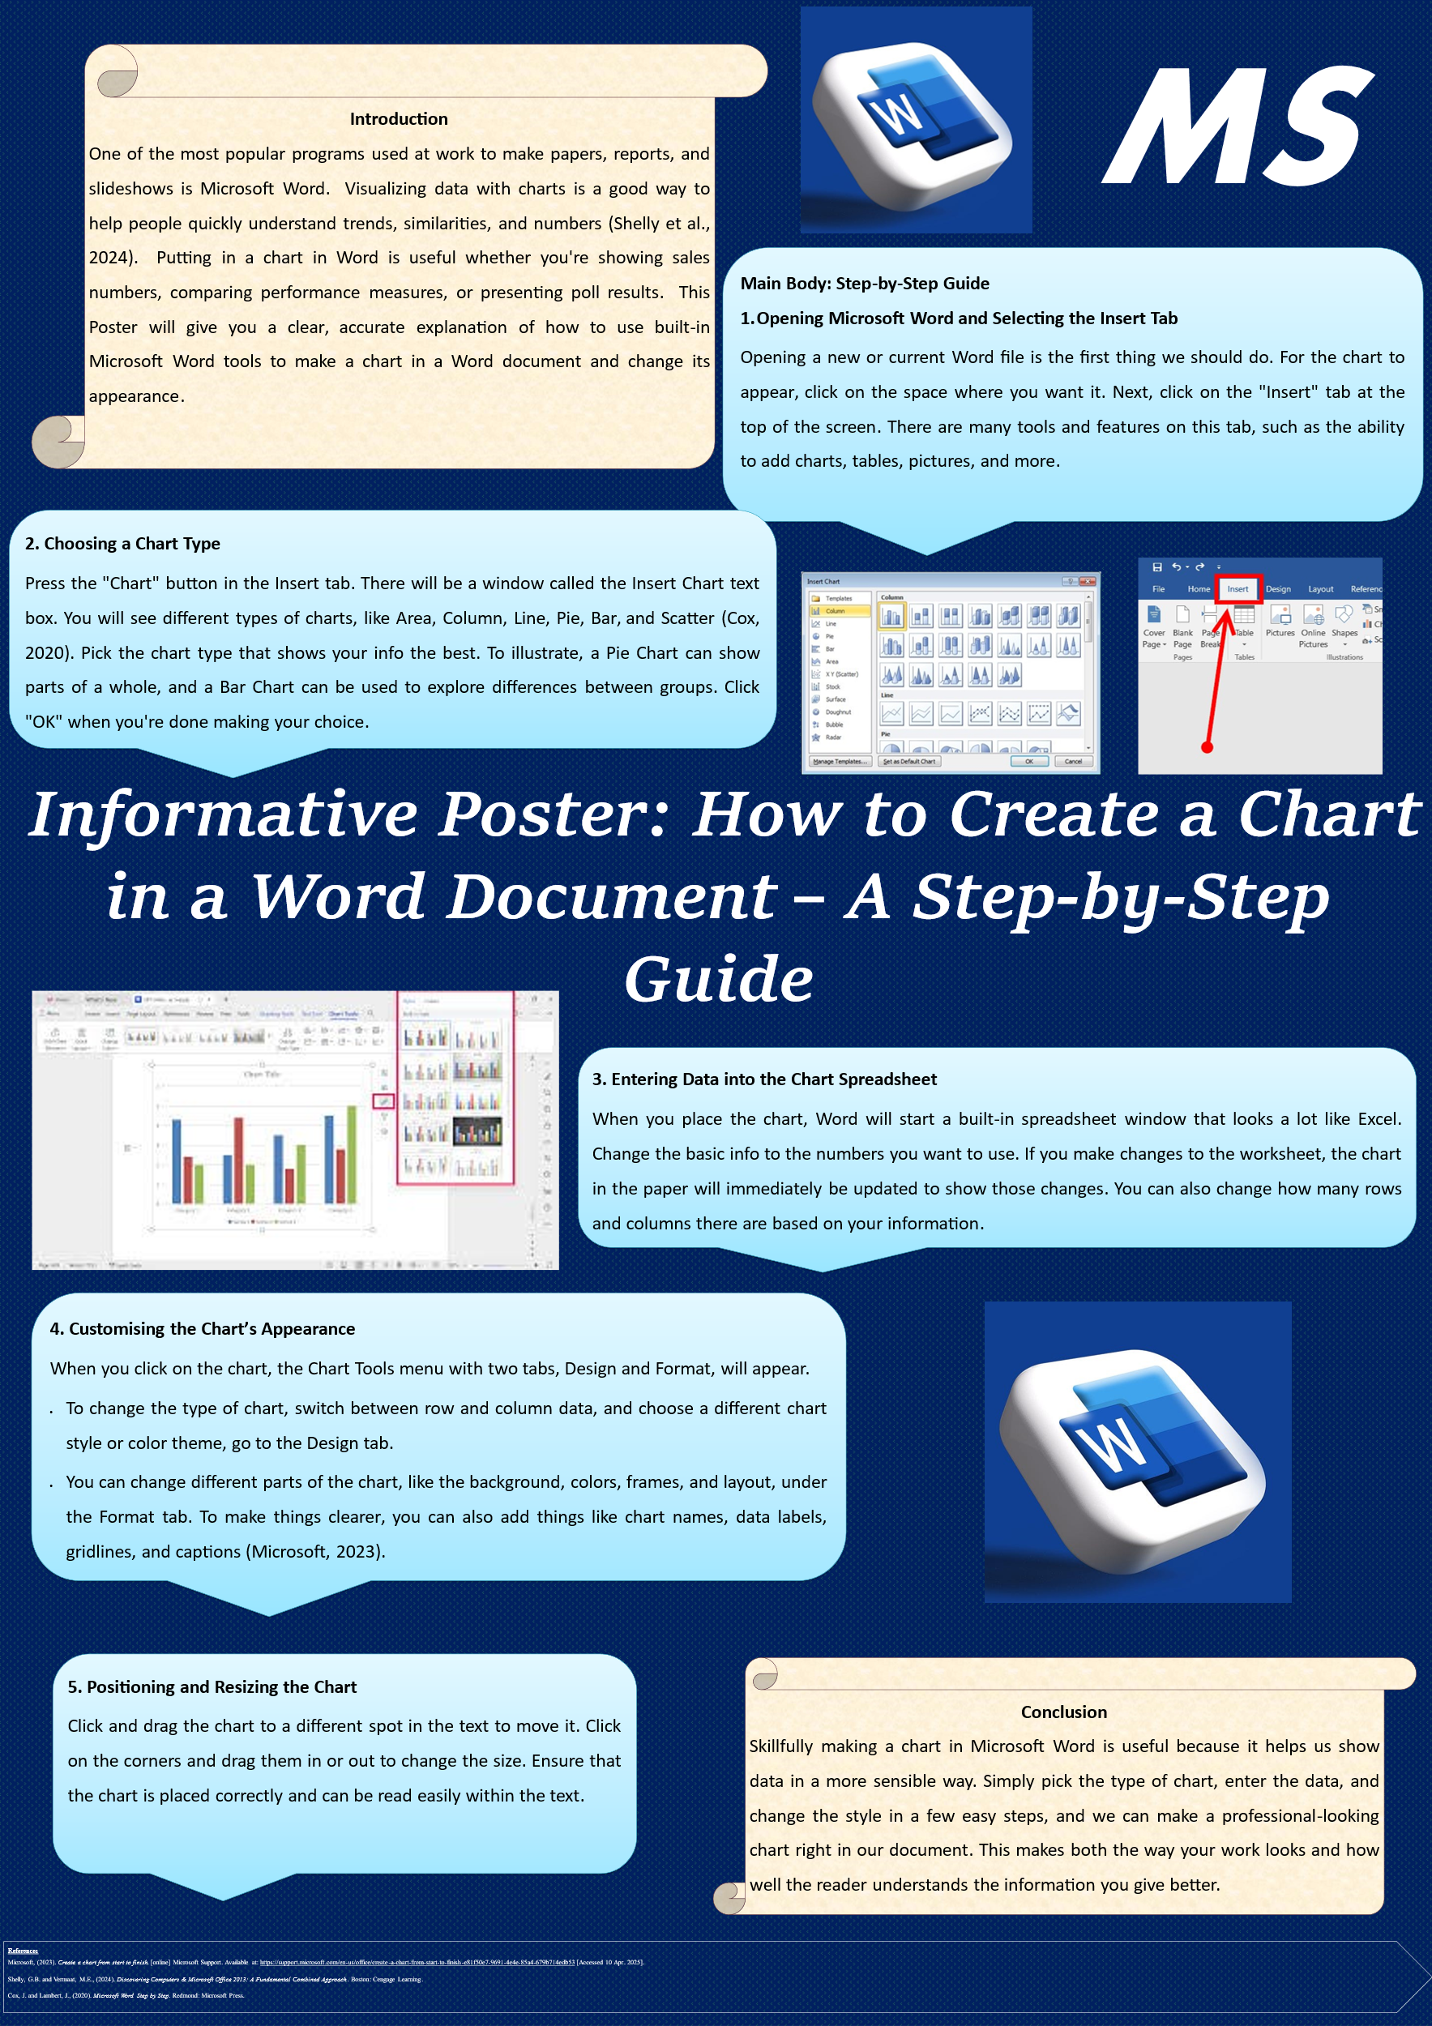
Introduction
One of the most popular programs used at work to make papers, reports, and slideshows is Microsoft Word. Visualizing data with charts is a good way to help people quickly understand trends, similarities, and numbers (Shelly et al., 2024). Putting in a chart in Word is useful whether you're showing sales numbers, comparing performance measures, or presenting poll results. This Poster will give you a clear, accurate explanation of how to use built-in Microsoft Word tools to make a chart in a Word document and change its appearance.

Main Body: Step-by-Step Guide
- Opening Microsoft Word and Selecting the Insert Tab
Opening a new or current Word file is the first thing we should do. For the chart to appear, click on the space where you want it. Next, click on the "Insert" tab at the top of the screen. There are many tools and features on this tab, such as the ability to add charts, tables, pictures, and more.
- Choosing a Chart Type
Press the "Chart" button in the Insert tab. There will be a window called the Insert Chart text box. You will see different types of charts, like Area, Column, Line, Pie, Bar, and Scatter (Cox, 2020). Pick the chart type that shows your info the best. To illustrate, a Pie Chart can show parts of a whole, and a Bar Chart can be used to explore differences between groups. Click "OK" when you're done making your choice.
- Entering Data into the Chart Spreadsheet
When you place the chart, Word will start a built-in spreadsheet window that looks a lot like Excel. Change the basic info to the numbers you want to use. If you make changes to the worksheet, the chart in the paper will immediately be updated to show those changes. You can also change how many rows and columns there are based on your information.
- Customising the Chart’s Appearance
When you click on the chart, the Chart Tools menu with two tabs, Design and Format, will appear.
- To change the type of chart, switch between row and column data, and choose a different chart style or color theme, go to the Design tab.
- You can change different parts of the chart, like the background, colors, frames, and layout, under the Format tab. To make things clearer, you can also add things like chart names, data labels, gridlines, and captions (Microsoft, 2023).
- Positioning and Resizing the Chart
Click and drag the chart to a different spot in the text to move it. Click on the corners and drag them in or out to change the size. Ensure that the chart is placed correctly and can be read easily within the text.
Conclusion
Skillfully making a chart in Microsoft Word is useful because it helps us show data in a more sensible way. Simply pick the type of chart, enter the data, and change the style in a few easy steps, and we can make a professional-looking chart right in our document. This makes both the way your work looks and how well the reader understands the information you give better.

References
Microsoft, (2023). Create a chart from start to finish. [online] Microsoft Support. Available at: https://support.microsoft.com/en-us/office/create-a-chart-from-start-to-finish-e81f50e7-9691-4e4e-85a4-679b714edb53 [Accessed 10 Apr. 2025].
Shelly, G.B. and Vermaat, M.E., (2024). Discovering Computers & Microsoft Office 2013: A Fundamental Combined Approach. Boston: Cengage Learning.
Cox, J. and Lambert, J., (2020). Microsoft Word Step by Step. Redmond: Microsoft Press.

