Control & Instrumentation
George Goddard

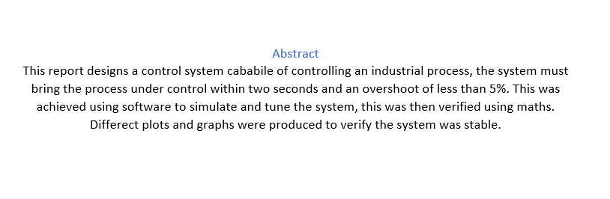
Contents
Introduction 3
Types of controller 3
History of PID controller 4
PID theory 4
Lag 4
Nyquist diagrams 5
Root locus 5
Pole zero diagrams 5
Bode plots 5
Method 6
Equipment 6
Task 1 6
Task 2 10
Mathematical calculation 10
Task 2 Simulink 15
Results 17
Pole zero 17
Nyquist plot 19
Bode plot 21
Discussion 21
Conclusion 22
Bibliography 23

Table of Figues

Figure 1 7
Figure 2 8
Figure 3 8
Figure 4 9
Figure 5 9
Figure 6 10
Figure 7 16
Figure 8 17
Figure 9 18
Figure 10 18
Figure 11 20
Figure 12 22
Figure 13 22
Figure 14 23

Introduction

Proportional integral derivative or PID controllers are widely used in industrial and commercial operations. They are used to control different industrial applications such as temperature, pressure, flow, speed and other processes. They work by using a feedback control loop to adjust process variables to regulate the process. A requirement for an industrial process has been specified as per the brief. This detailed that the process must come under control within two seconds and have an overshoot of less than 5%.

Types of controller

There are several different control systems available for use in different applications some of these are:
- Discrete controller - This controller receives an error signal from the plant and will either turn the system on or off. This type of control system is cheap, simple and easy to maintain however as the system is either on or off the system never settles at the set point and this continuous switching can cause wear and fatigue on components.

- Three state control – Similar in design to a discrete controller but this controller has three states, on, off and half on. As with a discrete controller it is cheap, simple and easy to maintain, it also suffers from wear and fatigue on the components due to the continuous switching.

- P controller - A proportional controller uses a proportion of the error signal to control the process. This is a simple feedback controller with a long settling time and the process will never reach the set point.

- PI controller - Proportional integral controllers only takes into account the current error which leads to a large steady state error. This controller has a narrow range of stability.

- PD controller – A proportional derivative controller control the overshoot by using the rate of change of the error signal, a PD controller improves the stability of the system without affecting the steady state error. As with other controllers the process never reaches the set point.

- PID controller - Proportional integral derivative controllers use the derivative of the error, the absolute error value and the integral of the error to control the process. The integral control takes into account previous errors, the derivative control takes into account possible future errors due to overshoot, and the proportional control looks after the current error. PID controllers can be complex and difficult to tune but can be tuned to settle quickly and have no steady state error. [1]

History of PID controller
‘The first evolution of the PID controller was developed in 1911 by Elmer Sperry. However, it wasn't until 1933 that the Taylor Instrumental Company (TIC) introduced the first pneumatic controller with a fully tuneable proportional controller. A few years later, control engineers went eliminate the steady state error found in proportional controllers by resetting the point to some artificial value as long as the error wasn’t zero. This resetting “integrated” the error and became known as the proportional-Integral controller. Then, in 1940, TIC developed the first PID pneumatic controller with a derivative action, which reduced overshooting issues. However, it wasn’t until 1942, when Ziegler and Nichols tuning rules were introduced that engineers were able to find and set the appropriate parameters of PID controllers. By the mid-1950’s, automatic PID controllers were widely adopted for industrial use.’ [2]

PID theory

Having a stable control system is key to the system operating within its parameters. ‘The stability of a control system is defined as the ability of any system to provide a bounded output when a bounded input is applied to it.’ [3] There are a number of tools that can be used to predict the stability of a system, these are:

Nyquist diagrams
Root locus
Bode plots
Pole zero diagrams

These can be calculated and drawn mathematically or computer software packages such as MatLab can be used to generate the diagrams.

Lag

Lag within a control system can cause the system to underperform or fail if time sensitive adjustments are delayed due to lag. The addition of lag to a system changes the phase relationship between the controller and the plant. This change in phase can compound the issue making the lag worse. This gives the system positive feedback making the system unstable. Predicting the system stability is important as failure of the system could affect the process it is controlling.

Nyquist diagrams

Nyquist diagrams are used to visually represent the stability of a system. This is done by showing the phase response and frequency response on a one graph, it plots all the real values of the transfer function frequency. This type of diagram can be used to determine gain margin and the phase margin.

Root locus

A root locus is a visual representation that shows the poles of a closed loop system, it can be used to analyse system stability and transient response. It can also be used to design the damping ratio and natural frequency of a closed loop system.

Pole zero diagrams

A pole zero diagram can only be drawn if you know the transfer function of the system. Poles and zeros can be calculated manually using different formula one being the quadratic formula. They can also be created using software simulations. With a continuous time transfer function, the poles and zeros appear in the s plane of the Laplace transform. If poles are located in the negative range of the real axis this will indicate a stable system, poles located in the positive area on the real axis indicate instability. A conjugate pair in the negative real axis produce a decaying sinusoidal and in the positive region a produce an exponentially growing sinusoidal. [1]

Bode plots

A bode plot is a graph of the frequency response of a system, bode plots generally are a combination of a magnitude plot and a phase plot. On a bode plot the x axis represents angular frequency on a logarithmic scale, with the y axis representing magnitude on a linear scale. ‘The frequency response of a system is presented as two graphs: one showing magnitude and one showing phase. The phasor representation of the transfer function can then be easily determined at any frequency. The magnitude of the output is the magnitude of the phasor representation of the transfer function (at a given frequency) multiplied by the magnitude of the input. The phase of the output is the phase of the transfer function added to the phase of the input.’ [4]

Method

Equipment

The equipment used for task one was:
Laptop
MatLab
Simulink

Task two required:
Pen
Paper
Calculator

Task 1

The first task in completing this report was to simulate the industrial process. To do this a software package from MatLab was used. Simulink was used from within MatLab to do the simulation. Once Simulink had loaded the components are selected from the parts library. The first component selected was the step input, this was dragged from the library onto the page. The second component was the add function, the inputs on this were changed from ++ to +- the PID controller was then added to the system followed by a transfer function. The final component added was a scope which had four inputs.

Once all the components were in the system they were connected by dragging wires between them The layout of the system is shown in Figure 1 The transfer function block was edited to the values that had been assigned to me these were 2,2,1.

Now all the components were in place the system could be simulated to show how the PID controller performed. The scope showed the four channels which where:
- Step input
- After the add block
- After the PID controller
- The system output
Figure 2 & Figure 3 show the untuned system with a settling time of 7.5s and an overshoot of 5.91%. Figure 4 shows the initial output and response on the four graphs, with the system response on the fourth graph. By using the response time and transient behaviour slider I was able to tune the system to give a settling time of 0.864 seconds and an overshoot of 2.27%.

Figure 5 & Figure 6 show the tuned system with the process coming under control within the specified parameters. The P, I, D & N values from the system were:
P = 20.9635
I = 7.4034
D = 14.826
N = 856.0509
Figure 1

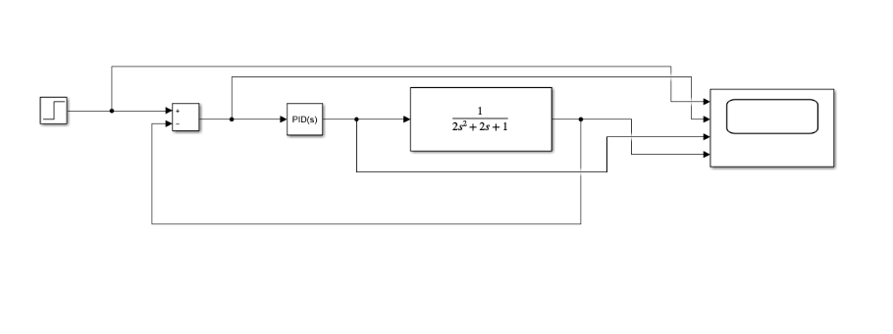

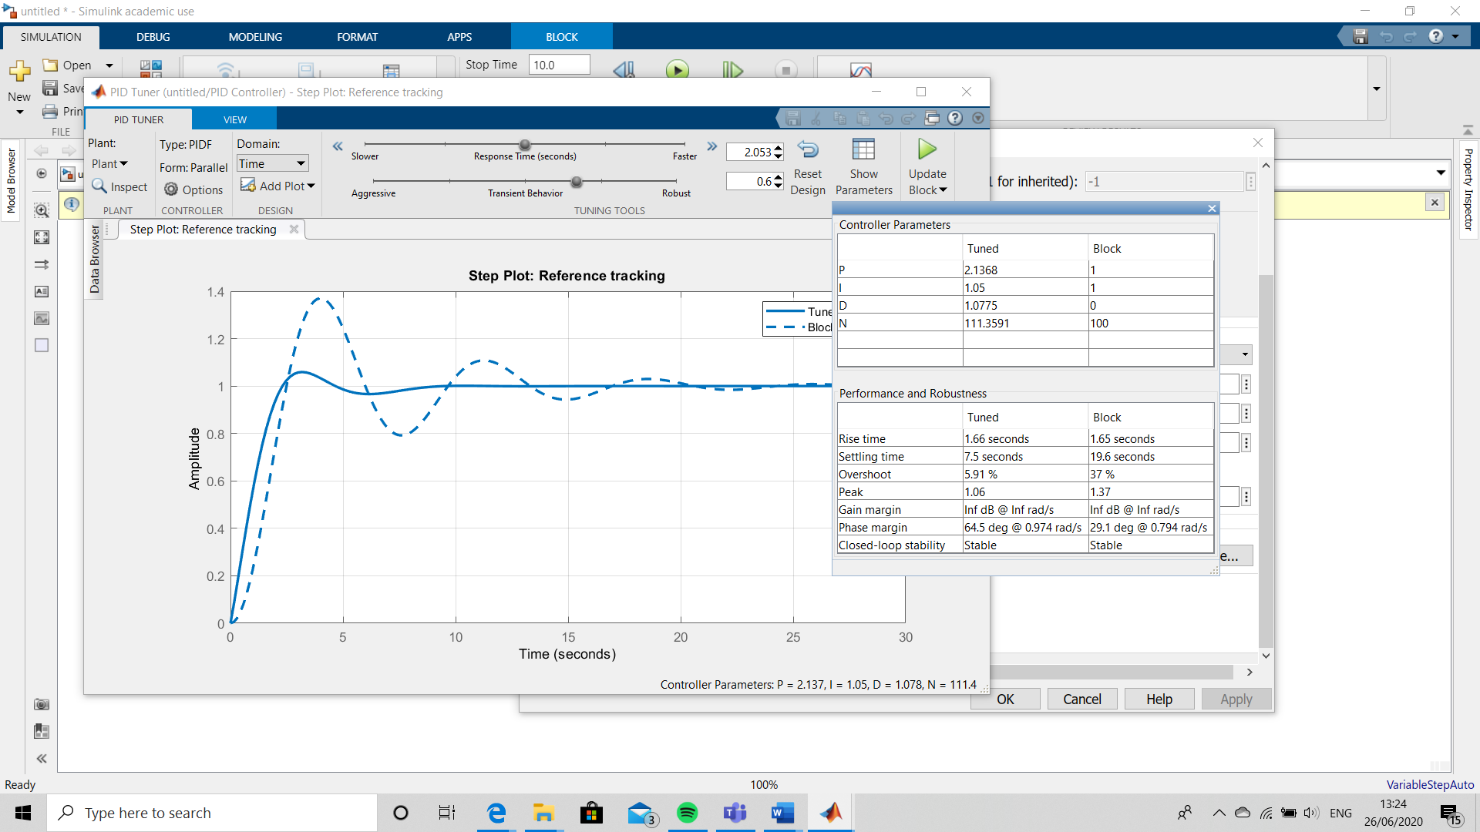

Figure 2

Figure 3

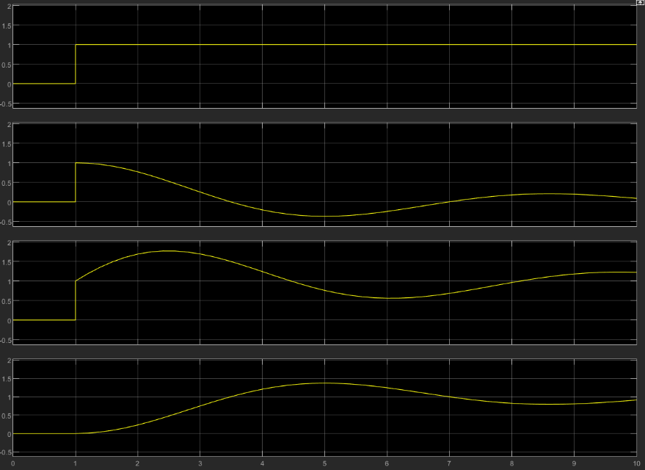
Figure 4

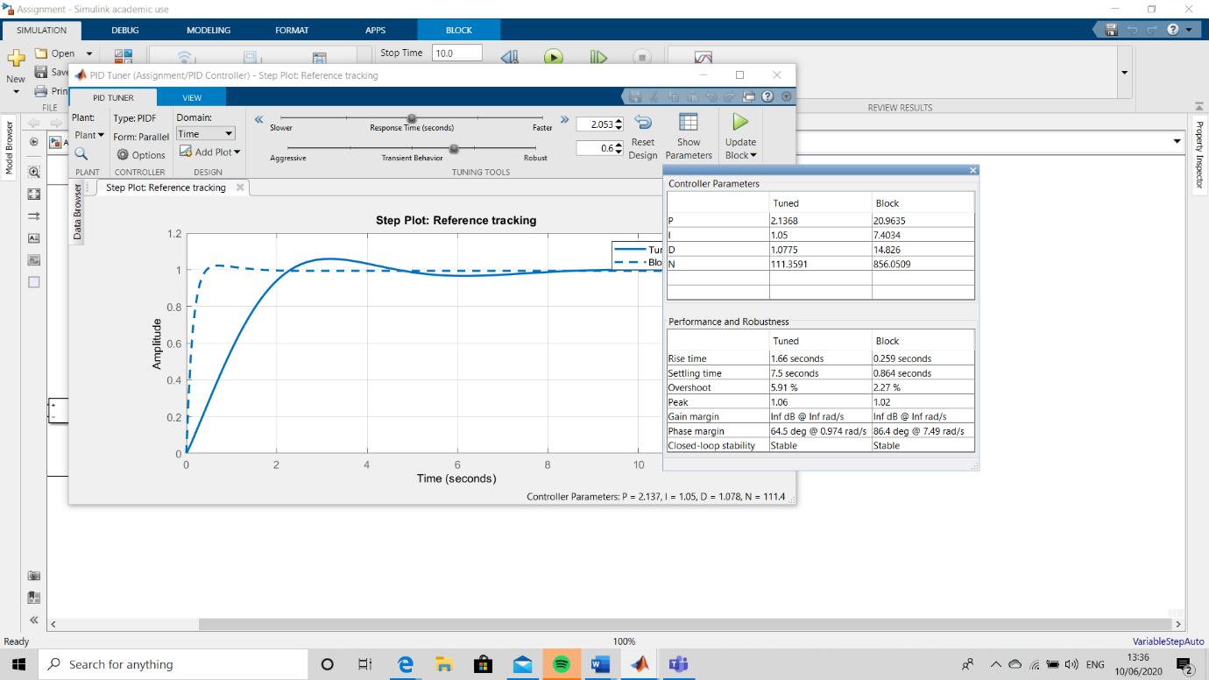

Figure 5

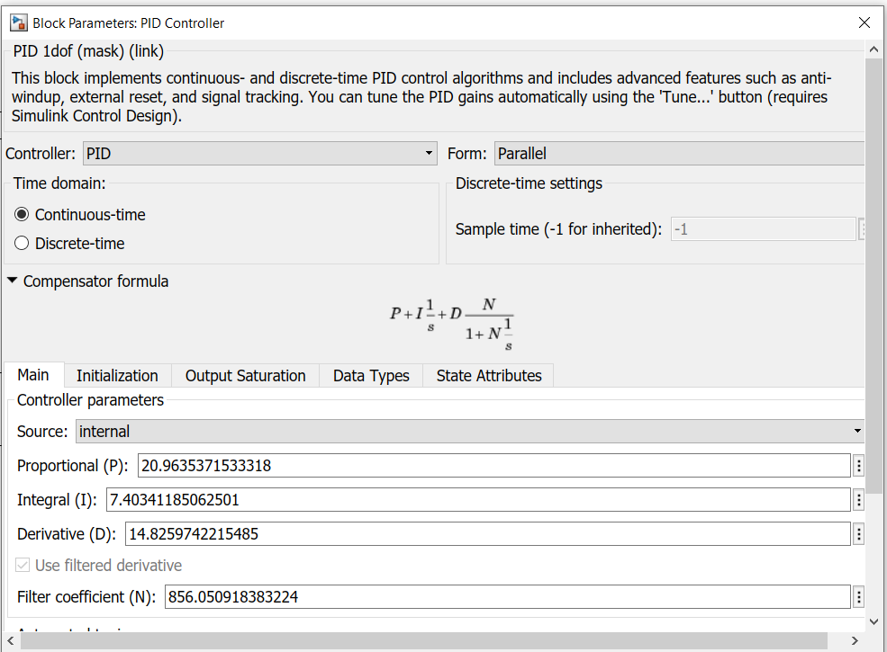

Figure 6

Task 2

Mathematical calculation

Using the results from MatLab the following equations find the closed loop transfer function. This is achieved by taking the PID function from MatLab and inputting the tuned system values, Equation 4. The forward path of the transfer function is calculated by multiplying the controllers transfer function (Equation 4) by the process transfer function (Equation 2).
Equation 17 is used to calculate the transfer function as a whole, it does this by removing the feedback loop and building it into the system. G is the forward path transfer function and H is the transfer function of the feedback loop. For this system H = 1.

Equation 1
$$G\left(s\right)=\frac{1}{as^{2}+bs+c}$$

Where
A = 2
B = 2
C = 1
Equation 2
$$G\left(s\right)=\frac{1}{2s^{2}+2s+1}$$

Where:
Kp = 20.9635
Ki = 7.4034
Kd = 14.826
N = 856.0509

Equation 3
$$K_{p}+K_{i}\frac{1}{s}+K_{d}\frac{s}{\frac{1}{N}s+1}$$

Equation 4
$$20.9635+\frac{7.4034}{s}+14.826\frac{s}{\frac{1}{856.0509}s+1}$$

Equation 5
$$\left(20.9635+\frac{7.4034}{s}+14.826\frac{s}{\frac{s}{856.0509}+1}\right)×\left(\frac{1}{2s^{2}+2s+1}\right)$$

Equation 6
$$\left(20.9635+\frac{7.4034}{s}+14.826\frac{s}{\frac{s+856.0509}{856.0509}}\right)×\left(\frac{1}{2s^{2}+2s+1}\right)$$
Equation 7
$$\left(20.9635+\frac{7.4034}{s}+14.826\left(s÷\frac{s+856.0509}{856.0509}\right)\right)×\left(\frac{1}{2s^{2}+2s+1}\right)$$

Equation 8
$$\left(20.9635+\frac{7.4034}{s}+14.826\left(s\left(\frac{856.0509}{s+856.0509}\right)\right)\right)×\left(\frac{1}{2s^{2}+2s+1}\right)$$

Equation 9
$$\left(20.9635+\frac{7.4034}{s}+14.826\left(\left(\frac{856.0509s}{s+856.0509}\right)\right)\right)×\left(\frac{1}{2s^{2}+2s+1}\right)$$

Equation 10
$$\left(20.9635+\frac{7.4034}{s}+\left(\frac{12691.8106s}{s+856.0509}\right)\right)×\left(\frac{1}{2s^{2}+2s+1}\right)$$

Equation 11
$$\left(\frac{\left((s\left(s+856.0509\right))×20.9635\right)+\left(s+856.0509\right)7.4034+s\left(12691.8106s\right)}{s\left(s+856.0509\right)}\right)×\left(\frac{1}{2s^{2}+2s+1}\right)$$

Equation 12
$$\left(\frac{20.9635s^{2}+17945.8230s+7.4034s+6337.6872+12691.8106s^{2}}{s^{2}+856.0509s}\right)×\left(\frac{1}{2s^{2}+2s+1}\right)$$

Equation 13
$$\left(\frac{12712.7741s^{2}+17953.2264s+6337.6872}{s^{2}+856.0509s}\right)×\left(\frac{1}{2s^{2}+2s+1}\right)$$

Equation 14
$$\frac{12712.7741s^{2}+17953.2264s+6337.6872}{\left(s^{2}+856.0509s\right)\left(2s^{2}+2s+1\right)}$$

Equation 15
$$\frac{12712.7741s^{2}+17953.2264s+6337.6872}{2s^{4}+2s^{3}+s^{2}+1712.1018s^{3}+1712.1018s^{2}+856.0509s}$$

Equation 16
$$\frac{12712.7741s^{2}+17953.2264s+6337.6872}{2s^{4}+1714.1018s^{3}+1713.1018s^{2}+856.0509s}$$

Equation 17
$$TF=\frac{G}{1+GH}$$

Equation 18
$$TF=\frac{\frac{12712.7741s^{2}+17953.2264s+6337.6872}{2s^{4}+1714.1018s^{3}+1713.1018s^{2}+856.0509s}}{1+\left(\frac{12712.7741s^{2}+17953.2264s+6337.6872}{2s^{4}+1714.1018s^{3}+1713.1018s^{2}+856.0509s}\right)×1}$$

Equation 19
$$TF=\frac{\frac{12712.7741s^{2}+17953.2264s+6337.6872}{2s^{4}+1714.1018s^{3}+1713.1018s^{2}+856.0509s}}{\frac{2s^{4}+1714.1018s^{3}+1713.1018s^{2}+856.0509s}{2s^{4}+1714.1018s^{3}+1713.1018s^{2}+856.0509s}+\frac{12712.7741s^{2}+17953.2264s+6337.6872}{2s^{4}+1714.1018s^{3}+1713.1018s^{2}+856.0509s}}$$

Equation 20
$$TF=\frac{\frac{12712.7741s^{2}+17953.2264s+6337.6872}{2s^{4}+1714.1018s^{3}+1713.1018s^{2}+856.0509s}}{\frac{2s^{4}+1714.1018s^{3}+1713.1018s^{2}+856.0509s+12712.7741s^{2}+17953.2264s+6337.6872}{2s^{4}+1714.1018s^{3}+1713.1018s^{2}+856.0509s}}$$

Equation 21
$$TF=\frac{\frac{12712.7741s^{2}+17953.2264s+6337.6872}{2s^{4}+1714.1018s^{3}+1713.1018s^{2}+856.0509s}}{\frac{2s^{4}+1714.1018s^{3}+14425.8759s^{2}+18809.2773s+6337.6872}{2s^{4}+1714.1018s^{3}+1713.1018s^{2}+856.0509s}}$$

Equation 22
$$TF=\frac{12712.7741s^{2}+17953.2264s+6337.6872}{2s^{4}+1714.1018s^{3}+1713.1018s^{2}+856.0509s}×\frac{2s^{4}+1714.1018s^{3}+1713.1018s^{2}+856.0509s}{2s^{4}+1714.1018s^{3}+14425.8759s^{2}+18809.2773s+6337.6872}$$

Equation 23
$$TF=\frac{\left(12712.7741s^{2}+17953.2264s+6337.6872\right)\left(2s^{4}+1714.1018s^{3}+1713.1018s^{2}+856.0509s\right)}{\left(2s^{4}+1714.1018s^{3}+1713.1018s^{2}+856.0509s\right)\left(2s^{4}+1714.1018s^{3}+14425.8759s^{2}+18809.2773s+6337.6872\right)}$$

Equation 24
$$TF=\frac{25425.5482s^{6}+{21790988.97s}^{5}+{21778276.19s}^{4}+{10882781.71s}^{3}+{35906.4528s}^{5}+{30773657.69s}^{4}+}{4s^{8}+3428.2036s^{7}+{28851.7518s}^{6}+{37618.5546s}^{5}+{12675.3744s}^{4}+{3428.2036s}^{7}+2938144.981s^{6}+24727419.85s^{5}+{32241016.08s}^{4}+}$$

$$\frac{+30755704.46s^{3}+{15368875.62s}^{2}+{12675.3744s}^{4}+{10863441.04s}^{3}+}{10863441.0{4s}^{3}+ 3426.2036s^{6}+{2936430.879s}^{5}+{24712993.97s}^{4}+{32222206.8s}^{3}+{10857103.35s}^{2}+{1712.1018s}^{5}+{1467358.389s}^{4}+}$$

$$\frac{{10857103.35s}^{2}+5425382.831s}{{12349284.05s}^{3}+{16101698.76s}^{2}+5425382.831s}$$
Equation 25
$$TF=\frac{25425.5482s^{6}+21826895.42s^{5}+52564609.25s^{4}+52501927.21s^{3}+{26225978.97s}^{2}+5425382.831s}{4s^{8}+6856.4072s^{7}+2970422.936s^{6}+{27703181.39s}^{5}+{58434043.81s}^{4}+{5543931.89s}^{3}+{26958802.11s}^{2}+5425382.831s}$$

Task 2 Simulink

Having calculated the closed loop transfer function of the system this function was then put into Simulink to verify the maths. To do this a system was designed that had the original system with an additional transfer function block into which the calculated transfer function was input. A scope was connected to the original system and to the output of the transfer function. The simulation was run, and the scope showed two plots both following the same path. This verified that the maths had been calculated correctly. Figure 7 shows how the simulation was set up.

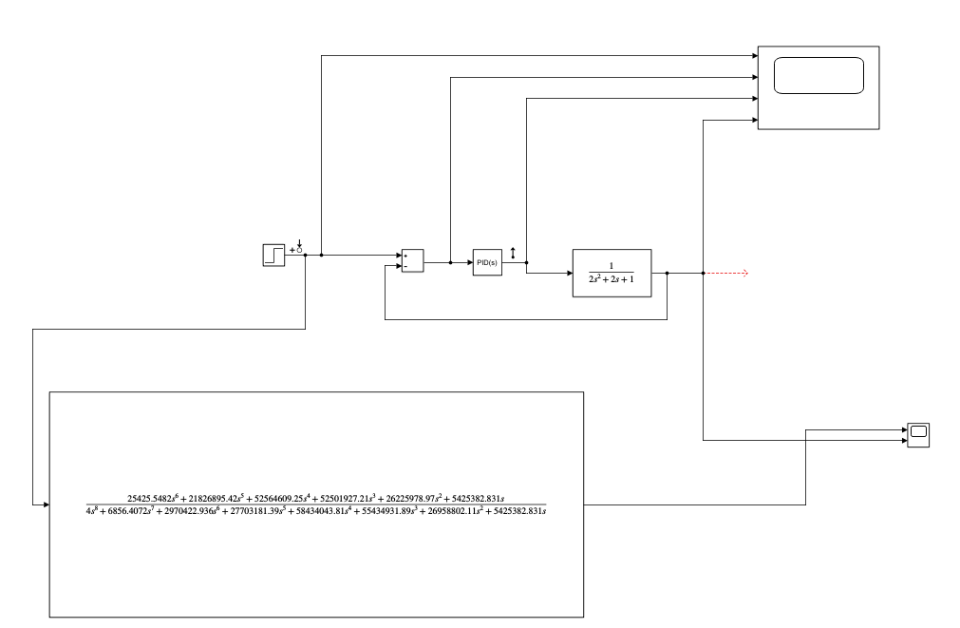
Figure 7

.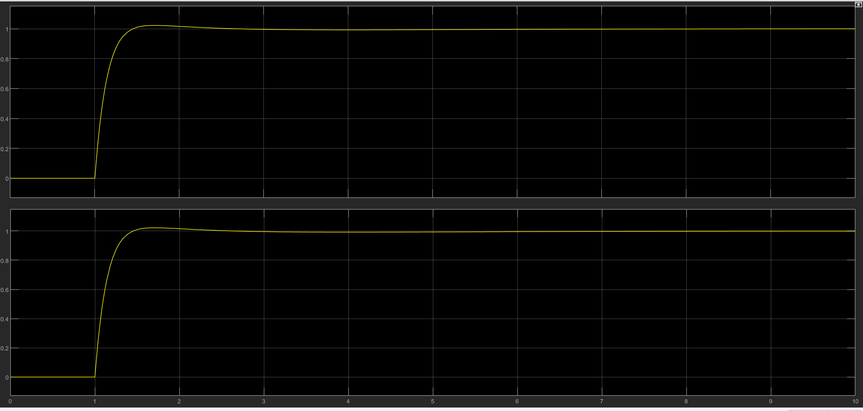
Figure 8

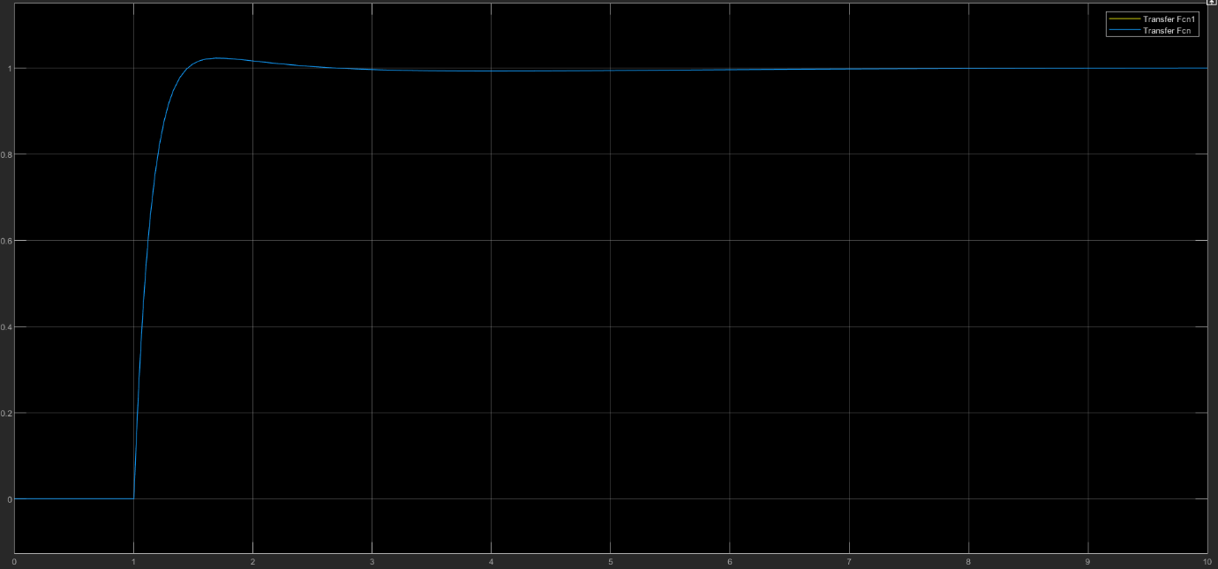
Figure 9

Results

The following graphs and plots show the results of the simulated system

Pole zero

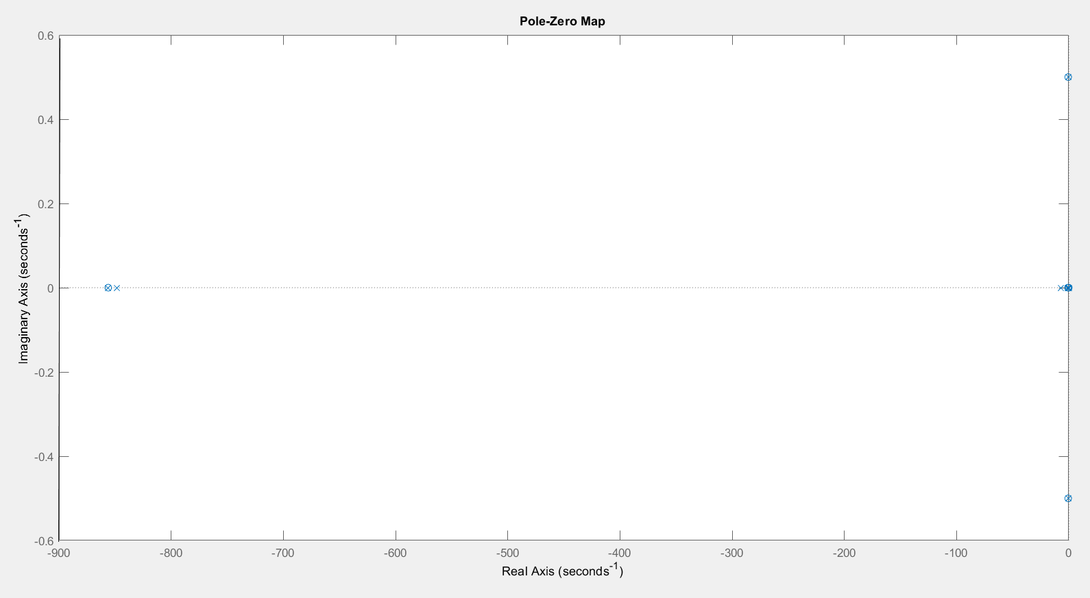
Figure 10

This graph shows the poles and zeros of the closed loop system. The poles closest to the imaginary axis are the dominant ones showing stability. There is a pole and zero at the origin and poles at -0.75, -1.1 and -6.9. The graph also shows a conjugate pole zero pair inside the negative imaginary axis meaning they will have some decay to them and are not continiuos oscilators. As the poles are in the negative area on the real axis this indicates the system is stable. As the conjugate pair are just inside the negative real axis this indicated a decaying sinusidal, again showing a stable system.

The poles and zeros of the initial transfer function were calculated mathamatically and replicated on MatLab to verify the results.

Equation 26
$$\frac{-b±\sqrt{b^{2}-4ac}}{2a}$$

A = 2
B = 2
C = 1
Equation 27
$$\frac{-2±\sqrt{2^{2}-4×2 ×1}}{2×2}$$
Equation 28
$$\frac{-2±\sqrt{4-8}}{4}$$

Equation 29
$$\frac{-2±\sqrt{-4}}{4}$$

Equation 30
$$\frac{-2}{4} ± \frac{\sqrt{-4}}{4}$$

Equation 31
$${\frac{-2}{4} ± \frac{j}{4}}^{2}$$

Equation 32
$$-0.5 ± j0.5$$

The initial transfer function had no zeros but a complex conjugate pair at - 0.5 $±$ j0.5. Figure 11 shows the poles at -0.5 on the real axis and at 0.5 and – 0.5 on the imaginary axis. As the poles are in the negative real axis it shows a stable transfer function.

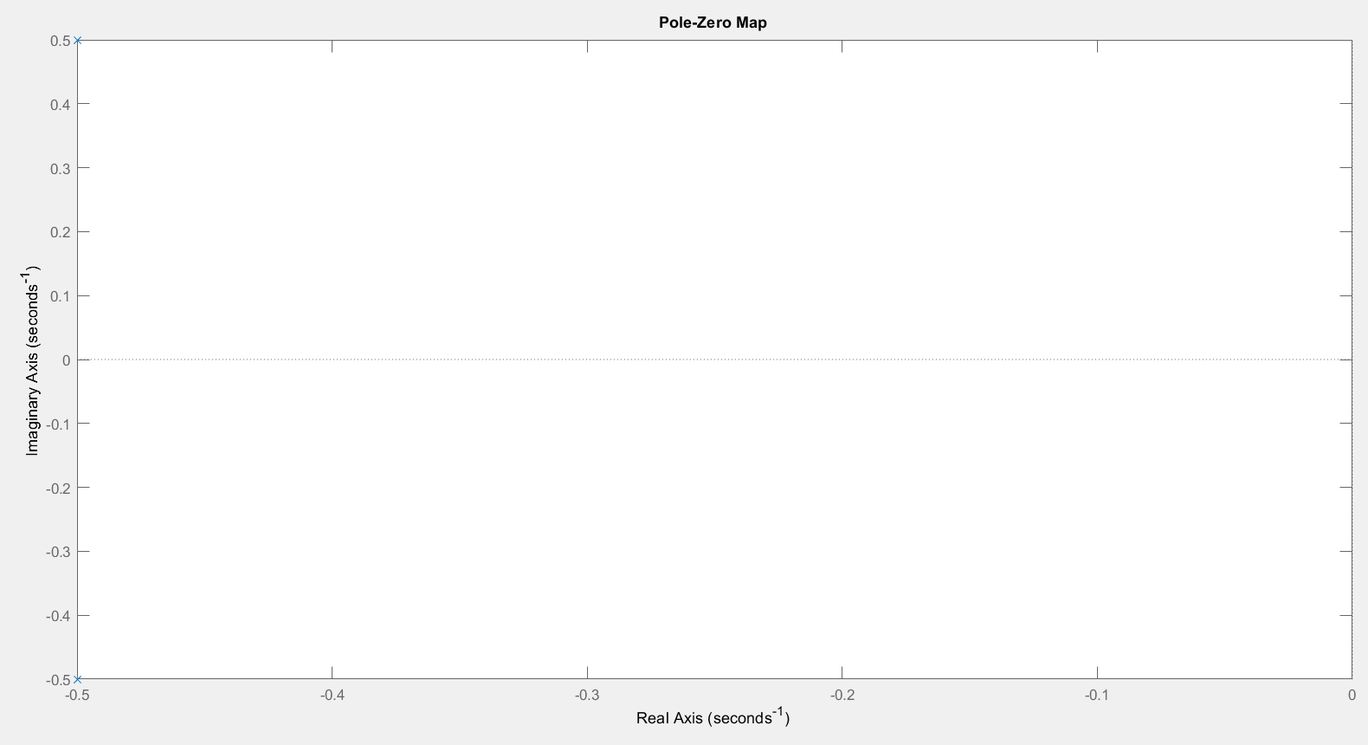
Figure 11

Nyquist plot

Gain margin is read from a nyquist plot by drawing a unit circle and measuring the distance between the unit circle and the plot. A unit circle has a radius of one, as can be seen from Figure 12 the nyquist diagram originates at zero and doe not cross the unit circle in the negative real axis. It is therefore measured in the positive axis and has a gain margin of 0.13 (dB). Figure 13 shows the plot originating at zero and quickly crossing into the positive real axis.

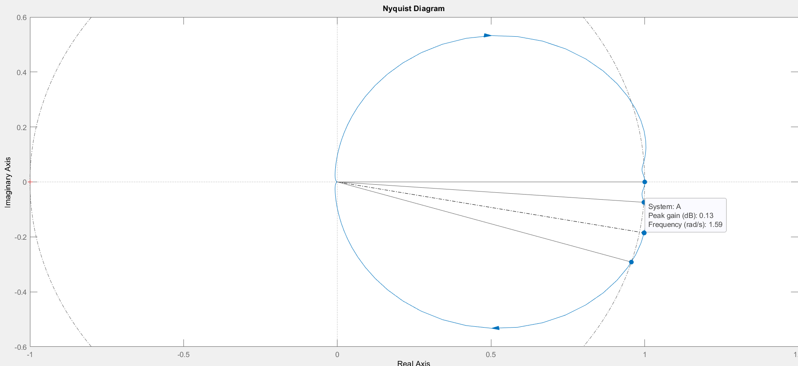
Figure 12

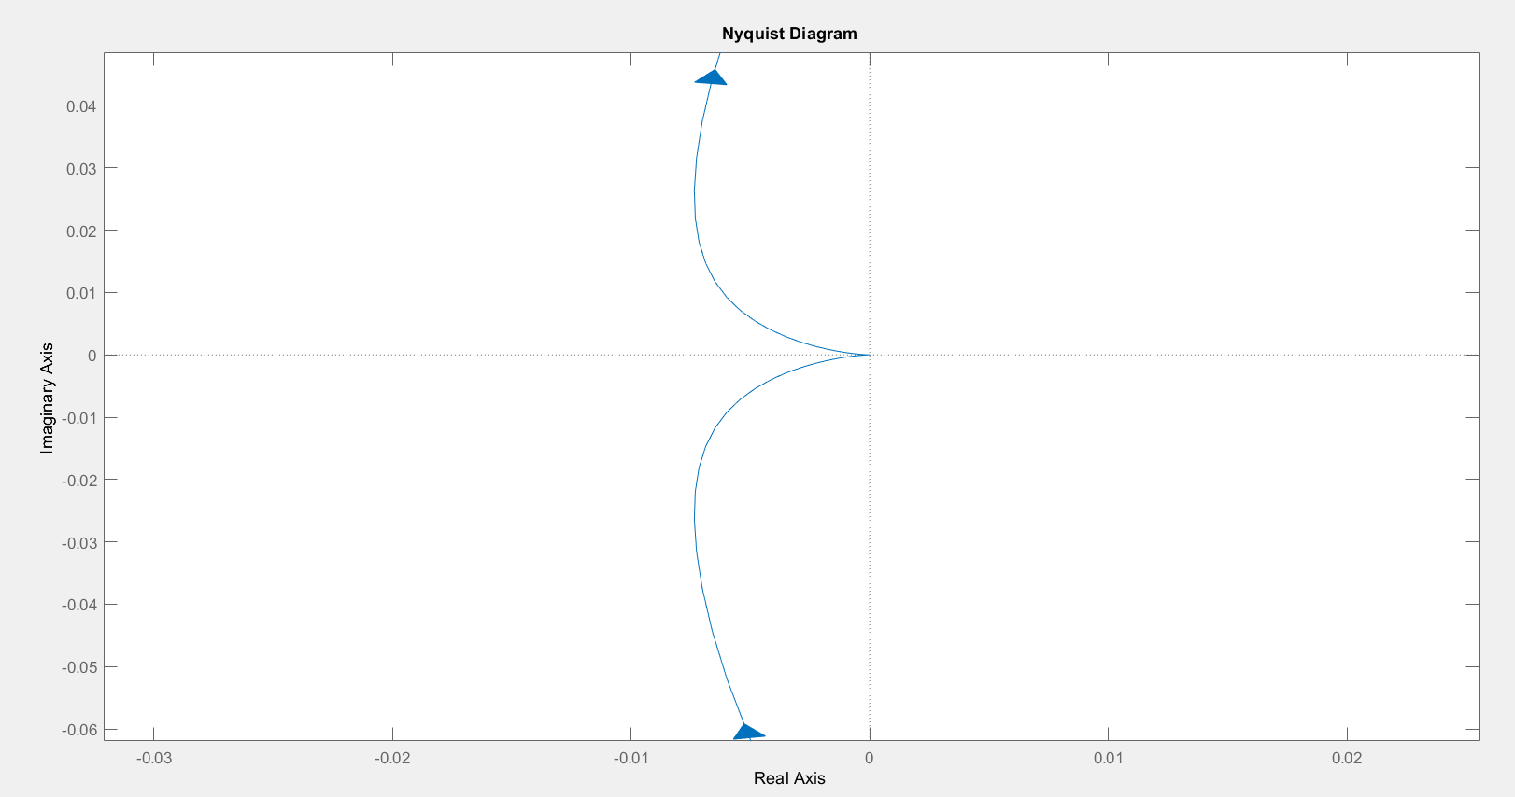
Figure 13

Bode plot

This bode plot shows the system has a gain margin of 0.13 (dB) at a frequency of 1.59 (rads). The greater the gain the more stable the system will be. As the system has a positive gain the system is stable, if the gain were negative the system would be unstable. As with gain margin the greater the phase margin the more stable the system will be. This system has a phase margin of 176 degrees, these values for gain margin and phase margin are read off the plot. [5]

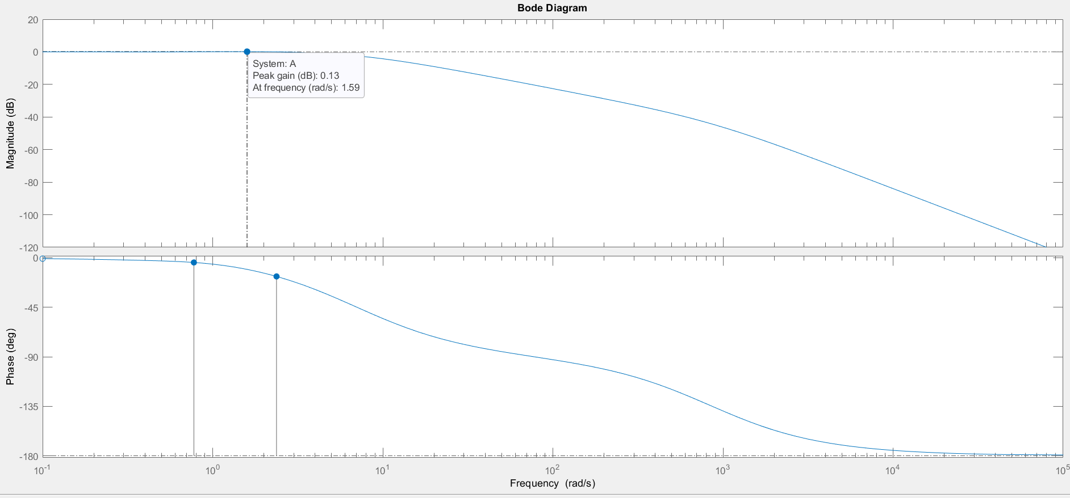
Figure 14

Discussion

The system had an initial settling time of 7.5 seconds and an overshoot of 5.91%. Once tuned the system then had a settling time of 0.864 seconds and an overshoot of 2.27%, this is within the parameters as set out in the brief. The closed loop transfer of the system was then calculated, this was verified against the simulation from task 1. As can be seen from the pole zero plots the tuned system is stable, this is shown by the poles being in the negative area on the real axis. The initial transfer function is also stable.
As two simulations were carried out, one on Simulink and one mathematically some difference can be expected between the graphs. However very little deviation between the two graphs can be seen. The mathematical calculation was a long-winded process that failed at first. Having checked all calculations a small numerical error was discovered in Equation 24, once this error was corrected the maths did not match the Simulink simulation. The input for the single transfer function was then checked. A six was missing from one of the figures, thus putting the number out. Having corrected this typographical error, the two graphs matched verifying the system.
The graphs and plots all indicate a stable system that functions as desired in the brief. A stable system is a system produces a bounded output for a given bounded input and the output is under control. [6]
MatLab and Simulink were heavily used in this report. Having never used the software before it was challenging to lean and apply new software. Further learning is required to fully understand the software and use it to its full potential.

Conclusion

The initial system had a settling time of 7.5 seconds and an overshoot of 5.91%, the tuned system fulfils the brief by coming under control in 0.864 seconds with an overshoot of 2.27%. The closed loop transfer function was calculated and verified using a MatLab simulation. Various graphs and plots were used to verify the system is stable, the pole zero diagram, bode plots and nyquist diagram show this.
Several graphs and plots were generated to verify the control system and view the stability of the system. Further reading and learning is required to fully understand all the graphs, plots and techniques used in control systems.

Bibliography

[1] | S. Mosey, Control and instrumentation lectures, Swansea: Steve Mosey, 2020.
[2] | Omega, “What is a PID Controller?,” Omega Engineering, [Online]. Available: https://www.omega.co.uk/prodinfo/pid-controllers.html. [Accessed 06 07 2020].
[3] | e. coach, “stability of control systems,” electronics coach, 2020. [Online]. Available: https://electronicscoach.com/stability-of-control-system.html. [Accessed 12 07 2020].
[4] | E. Cheever, “What Bode Plots Represent: The Frequency Domain,” Swarthmore College, 2020. [Online]. Available: https://lpsa.swarthmore.edu/Bode/BodeWhat.html. [Accessed 15 07 2020].
[5] | electronics4u, “Bode Plot, Gain Margin and Phase Margin,” electronics4u, 2020. [Online]. Available: https://www.electrical4u.com/bode-plot-gain-margin-phase-margin/. [Accessed 16 07 2020].
[6] | tutorialspoint, “Control Systems - Stability,” tutorialspoint, 2020. [Online]. Available: https://www.tutorialspoint.com/control_systems/control_systems_stability.htm. [Accessed 18 07 2020].

