Part1

Research areas 1 : Future trends in cybersecurity
In recent years, a variety of new network technologies emerge in endlessly, such as 5g, cloud computing, Internet of things and so on. At the same time, some technologies have been more widely used, such as IPv6, mobile network, WiFi and so on. In addition, more and more people have access to the Internet. This kind of reason makes people put forward more and higher requirements for network security and the development of network security A new trend.
The first one is the security of mobile network. As of the latest statistics, Almost 4.54 billion people were active internet users as of January 2020, encompassing 59 percent of the global population[1]. The number of mobile users has reached an amazing 4.18 billion, which means 92% of Internet users are mobile Internet users.

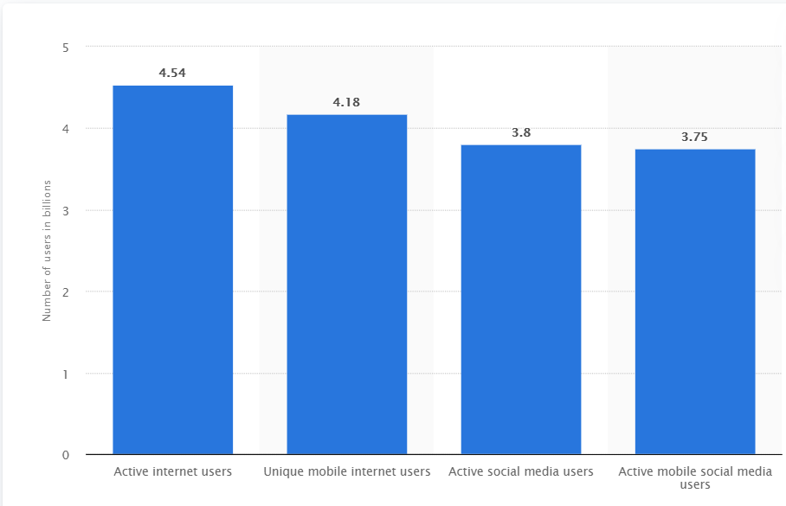
Figure 1-1 Number of users in billions
This leads to the future network security problem is mainly the mobile network security problem, so a large number of mobile network users' security needs to be guaranteed. Nowadays, people are facing a lot of mobile network security problems, and there are countless predictable future security problems, among which the most noteworthy are three. The first point is to attack and exploit the smart phone system. As we all know, people are more and more used to using smart phones to access the Internet instead of computers. Mobile phones can solve most of our online needs, such as social networking, browsing the web, watching videos, listening to music, etc., and mobile networks also provide more new functions, such as mobile payment. The result of this is that we store and publish a large number of privacy information on mobile phones, or through mobile phones, such as our photos, account passwords or important documents, which have great value, thus attracting countless criminals to attack our mobile phone system and steal these information.
As shown in the figure 1-2, Android system and apple system are the two most popular mobile phone systems at present, and the market share of the two systems together exceeds 99%.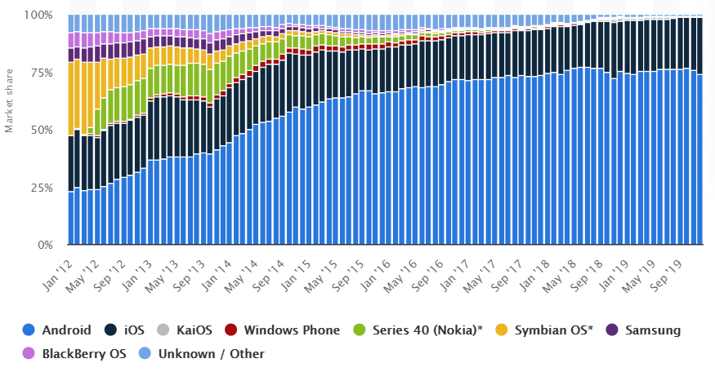
Figure 1-2 Market share of mobile OS
So in recent years, criminals frequently attack these two systems, resulting in a large number of information leakage and asset theft time, the most famous of which is the Hollywood star photo leakage. Attacks against mobile phones mainly include information or website phishing, system vulnerability attacks, malware attacks and so on. Information and website phishing belong to the attack of social engineering, which is difficult to be prevented. Usually, criminals take advantage of users' curiosity, greed and daily negligence. Nowadays, more and more criminals steal users' information through this method. Therefore, how to prevent and stop this kind of attack will be the key research direction in the future. There is a great difference between mobile phone system and computer system, so anti-virus software and vulnerability detection mechanism developed and applied for many years cannot be directly applied to mobile phone, which needs to be redeveloped, and virus library and vulnerability library are also different from those on computer. On the other hand, the development of mobile phone system is very fast. There is a big update almost once a year, and IOS system often has an update once a few months. The frequently updated system will generate new vulnerabilities, and the prevention mechanism of new vulnerabilities often cannot keep up with the development of the system, so there are more and more 0-day vulnerabilities in mobile phones. There is also a very big security threat is the malicious software on the mobile phone. The smart phone provides a large number of applications with various functions to the user, and the user also likes to download and install the software to obtain more functions, but the criminals make a large number of malicious software, or hide the back door or virus in the ordinary software, which occupies the software market Because of the openness of mobile phone system, it is very difficult to prevent this kind of software, especially on Android platform. In a word, with mobile network users becoming the main part of Internet users, and growing at a very fast speed, how to protect the security of billions of mobile network users will be one of the most important topics in the future of network security. Now, companies that develop mobile phones, such as apple, Google, Microsoft, Huawei, etc., are recruiting more and more security technicians to ensure the security of their mobile phone systems. The second is the security of the wireless network itself. Wireless connection of everything is the development trend of science and technology. Unlike before, we need to connect computers, printers and other terminal devices with network cables, now we prefer to connect WiFi, Bluetooth or mobile networks, such as 4G, or 5g technology which is developing rapidly. Although various wireless network technologies have developed for decades, all kinds of wireless network technologies have relatively perfect security protection measures, such as 2G network encrypts signaling and data of airport, and uses network to authenticate users, while 3G uses two-way authentication of network and users, while 4G uses independent key to protect data at different levels in addition to two-way authentication And signaling, because of these effective security measures, wireless network technology can get such a great development. But because the wireless network uses the radio wave for communication, and the open propagation of the radio wave causes the vulnerability of the wireless link, the security problem of the wireless communication technology is still very prominent. Especially now the new wireless network technology is developing rapidly, such as the Internet of things, which connects all things and uses a series of new technology 5g network. These technologies connect more goods and users into the network. In the face of this massive data and connected new network, the traditional network security technology will not be able to cope with it, so it is imperative to develop new security protection technology.

Another future trend of cybersecurity is the network problem of IPv6.

Rip NCC announced on November 26, 2019 that IPv4 addresses have been completely exhausted and all 4.3 billion addresses have been allocated. Although it has been predicted that the IPv4 address will be exhausted in the 1980s, and ISP has allocated many IPv6 addresses in recent years, and more and more enterprises have begun to use IPv6, but the large-scale use of IPv6 can be said that it is just beginning in 2020, and we will usher in a new network era, that is, IPv6 era. Although IPv4 and IPv6 will coexist for a long time, and IPv4 network is still the main part of the network, we must make all preparations before ushering in the new era, the most important of which is the preparation for network security. IPv6 not only expands the address range of IPv4, but also introduces many new functions. At the beginning of design, IPv6 provides many methods to solve the problems existing in IPv4. One of the main aspects is that IPv6 strengthens the security. IPv6 introduces encryption and authentication mechanism, and enforces IPSec. It implements identity authentication based on the network layer, and ensures the integrity and confidentiality of data packets. In the network layer, it implements the security requirements, but this security is not absolute. There are many reasons for this. The most important thing is that security problems include all levels and aspects, which can not be solved only by a secure network layer. If the hacker attacks from the application layer above the network layer, such as using the method of system buffer overflow or Trojan horse, even the most secure network layer is useless. Even if only from the network layer, IPv6 is not perfect. After all, it has a deep origin with IPv4. In addition, there are still many options in the original IPv4 in IPv6, such as sharding, TTL (time to live). These options have been used by hackers to attack IPv4 protocol or evade detection. It is hard to say that IPv6 can evade similar attacks. IPv6 advocates focus on protecting data security and delivering network security issues to end users. Therefore, IPv6 does not solve all the network security problems, and various network threats still exist, such as the most popular network attack virus and worm attack, this seemingly simple network attack behavior, will still exist in IPv6 network. Other attack methods still can not be effectively prevented, such as denial of service attack, SYN Flood attack against the protocol itself, password attack, buffer overflow attack and so on. At the same time, some network resources abuse, information audit lag, malicious behavior of internal users and management loopholes will seriously threaten the security of the next generation Internet[2]. First of all, the most popular network attack behavior viruses and worms, although IPv6 address space is so large that viruses or worms can not scan address segments to find other hosts with opportunities. However, the key hosts in IPv6 network will still exist, such as some DHCP servers, DNS, router's IP address will still be known easily, so these key hosts are easy to be attacked, and their security problems still exist. Therefore, we need to pay special attention to the security of key hosts, otherwise hackers will start from here to enter the whole network[3]. In addition, application layer based viruses and worms will still exist, and e-mail viruses will continue to spread. Secondly, DOS (distributed denial of service) is an attack aimed not to steal information, but to make the target (device or network) unable to operate normally. In IPv6 network, the definition of group address brings more opportunities to attackers. For example, the IPv6 address ff01:: 1 is all DHCP servers, that is, if an IPv6 message is issued to this address, this message can reach all DHCP servers in the network, so there may be some denial of service attacks that specifically attack these servers. At the same time, because IPv6 introduces encryption and authentication, it needs a certain amount of computation. For the sake of security, the key needs to reach a certain length (such as 128bit). We know that the longer the key is, the larger the amount of encryption calculation, especially in the public key system. This may create a new attack mode for the attacker[4]. At present, the trend of network development is that the growth rate of bandwidth is much faster than that of CPU. If a hacker sends a large number of seemingly correct but actually randomly filled encrypted packets to the target, the victim may be unable to respond to other users' requests due to consuming a large amount of CPU time to check the wrong packets, resulting in a denial of service. Third, the attack against TCP protocol itself, such as SYN Flood attack. In the SYN Flood attack, the hacker sends a large number of TCP syn messages with forged source addresses to the victim host. The victim host allocates necessary resources, then returns syn + ACK packets to the source address, and waits for the source to return ACK packets. Since the source address is forged, the source end will never return ACK message[5]. The victim host continues to send syn + ACK packets and puts the half connection into the port backlog queue. Although the general host has timeout mechanism and default retransmission times, due to the limited length of the half connection queue of the port, if a large number of TCP syn packets are continuously sent to the victim host Message and semi connection queue will be filled up quickly. The server rejects the new connection, which will result in the port unable to respond to the connection request made by other machines, and finally the resource of the victim host will be exhausted. This is based on the mechanism vulnerability of TCP protocol, IPv6 can not solve this attack. In addition, because IPv6 mainly introduces important encryption mechanism in IP layer, although some programs can provide convenience for transport layer, application layer encryption and identity authentication, IPv6 can not fundamentally solve all security problems. Therefore, there are still many attacks in the next generation Internet based on IPv6. The attack of application layer is obvious. Any attack against application layer, such as web server and database server, will still be effective. In a word, it is precisely because of the security defects of the Internet itself that many security problems exist in the Internet. The security problem of Internet is embodied in every link of design, implementation and maintenance. In the design stage, the security threats were not fully considered at the beginning of the Internet design, because the initial Internet was only used for a few trusted user groups[6]. Many network protocols and applications do not provide necessary security services, for example, SMTP, the protocol used by e-mail, does not provide authentication mechanism, which was once an important reason for the spread of spam, telnet protocol used by remote login transmits user name and password in plaintext, and IP The network also does not provide any quality of service control mechanism, which makes it almost powerless in the face of large-scale denial of service attacks.

Research areas 2 : Cloud-based services security issues
Cloud-based services combine a variety of existing technologies, bringing together various hardware resources, broadband resources, and virtualization technologies to create an ecosystem of cloud-based services, providing cloud computing service users with a solution that provides IT resources on demand and solves high peak usage. This solution enables users to obtain resource allocation to meet their own needs at the lowest cost. More importantly, when users use cloud based service solutions, they can also purchase the required security services or other micro services to meet their business needs according to the relevant services provided by cloud service providers, so as to greatly reduce the security issues or it issues they need to deal with or ignore due to lack of experience. With the embodiment of the advantages of cloud-based services, more and more users choose to put their services on the cloud, and cloud-based service providers have a broader market. At the same time, cloud-based services are facing more and more security problems[7]. In addition to traditional security problems, they are also facing new security challenges brought by cloud computing scenarios. According to the forecast data (Figure 2-1), by 2021, the global public cloud revenue forecast will reach 278.3 billion yuan, and the cloud management and security service revenue forecast will reach 16.3 billion yuan, an increase of 87.36% compared with 2017.
Figure 2-1 Global public cloud service revenue forecast
The representative of cloud-based services is cloud computing, which represents a new computing model, and cloud computing solution is also a new solution. So how to achieve security at all levels (for example, network, host, application and data levels) has great uncertainty, which determines that security is the top priority of cloud computing.
Driven by the industrial Internet, cloud computing technology is developing rapidly and innovatively. Cloud service providers provide users with multiple and multi-level services. At the same time, due to the shared characteristics of cloud technology, the internal layers are interrelated. More assets, services and interfaces are exposed to the public, and more users are affected, "cloud" The security issue of is elevated to a critical position. In the traditional home network or enterprise network, the attacker will enter layer by layer from the outside to the inside according to the exposed assets and services of the target, and use a relatively fixed attack path. On the cloud platform, DDoS, intrusion, virus and other security problems in the traditional network architecture are the normal problems; at the same time, new security problems such as virtual machine escape, resource abuse, horizontal penetration and so on are emerging in an endless stream for the cloud platform architecture; moreover, because of the low cost, high convenience and good scalability of cloud services, the services or resources provided by the cloud are used to attack other targets It has also become a new security issue. According to the survey data, the proportion of cloud resources as the source of attacks in China is nearly half of all the sources of attacks. In the ecosystem of cloud computing, cloud service providers use virtualization technology to abstract computing resources (CPU, storage, network, memory, application stack and database) into a shared resource pool for cloud service users to use these resources transparently through standardized methods. Through reasonable configuration, virtualization technology can provide scalable shared resource platform for all cloud service users (i.e. tenants) to support multi tenant cloud business model, and provide a dedicated resource view for each tenant. From the perspective of public cloud, virtualization technology enables cloud service resources to be transparently displayed as independent resources in various aspects (for example, operating system, storage, database, application program), which can be used by cloud service users on demand or extended when necessary. In the cloud computing ecological environment, the information exposed to attackers is basically the same as that in the traditional architecture. However, due to the increase of virtualization technology, shared resources, relatively complex architecture, and logical level in the cloud ecological environment, the available attack surface increases, and the attack path and complexity that attackers can use also greatly increases.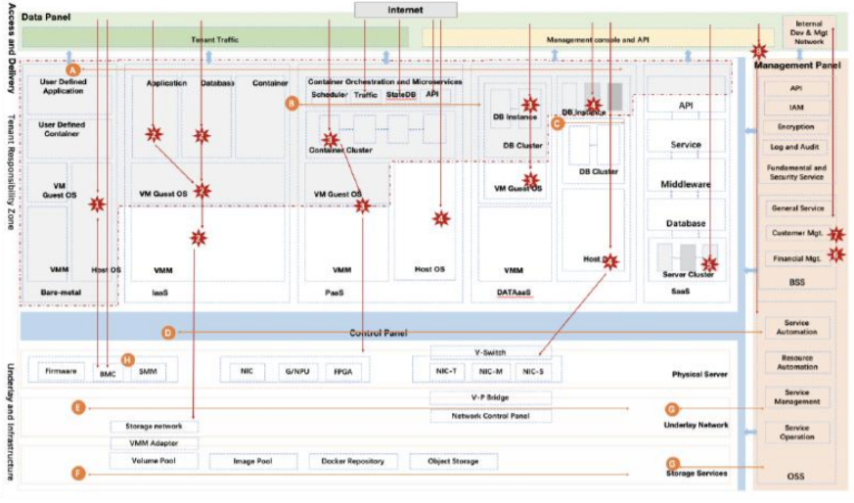
Figure 2-2 Panoramic model of attack path of cloud platform
As shown in Figure 2-2, the eight vertical attack paths refer to the attack paths that malicious attackers may attack cloud tenants and platforms (possibly the underlying resources, management software, management interface, server cluster, etc.) from the Internet environment. The specific paths include[8]
Bare metal server management interface
Tenant virtual machine escape
Container and microservice network attack in VPC instance mode of independent tenant
Shared cluster mode container and microservice network attack
SaaS service sharing cluster mode attack
Malicious attacker's bypass attack on cloud service platform business Internet
Malicious attacker's bypass attack on cloud service platform development / operation network
Attacks on cloud user console interface or open API
Cloud based services are not only booming in the Internet industry, but also have shown vigorous vitality in many fields such as finance, government affairs, health care, education, etc. with the development of the industrial Internet and the attention of various countries to network security, more field businesses will start to go to the cloud, which requires cloud service providers and users to pay attention to their security threats. Predictable industrial cloud platform security and Internet of things cloud platform security are also the focus of future security threats.

Reference
[1] J. Clement, Feb 3, 2020,Global digital population as of January 2020
[2] Andrew S. Tanenbaum Computer network (Third Edition), Beijing: Tsinghua University, December 12, 2003, 447-480;
[3] Pete LdshinIPv6 details, Beijing: China Machine Press, published on April 1, 2000: 69-79;
[4] R. Atkinson. Security Architecture for the Internet Protocol, RFC2401
[5] R. Atkinson. IP Authentication Header (AH), RFC2402
[6] R. Atkinson. IP Encapsulating Security Payload (ESP), RFC2406
[7] Chen depeng, he Daojing. Cloud computing security: the "roadblock" of cloud service development [EB / OL]. Beijing: China Science and technology paper online [2015-04-27]. Http://www.paper.edu.cn/releasepaper/content/201504-405
[8] Li Xiaoyong, Han Zhen, he Yongzhong, et al. Network security control method and cloud security gateway based on cloud service:

Part2

Task1 Black Box Pentest

1.Introduce
Black box penetration test is carried out on https://tevelcyber.com/ to understand the security of the current webpage and the possible way that the attacker may exploit, that is, vulnerability. It enables managers to understand the problems faced by the current system.
Here, the black box test uses Metasploit.

2.Information gathering
  - Whois search
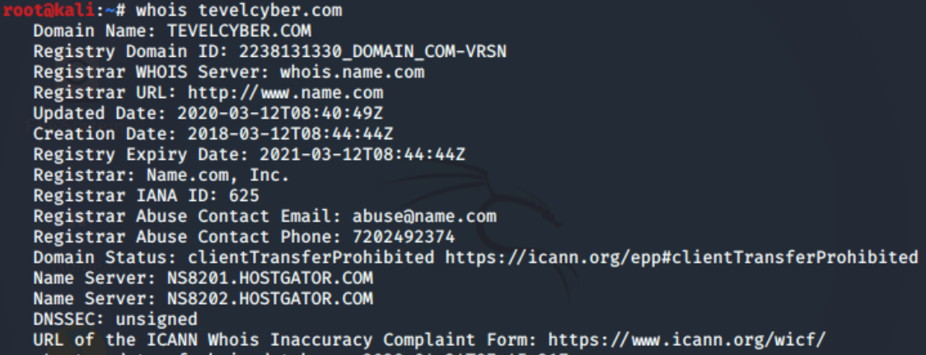
  - Collect subdomain information
  - Collect port information
  - Fingerprinting
  - Find out the real IP of https://tevelcyber.com/
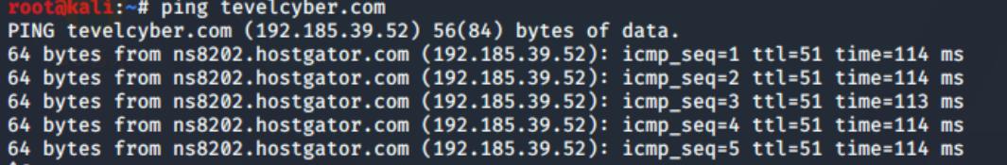
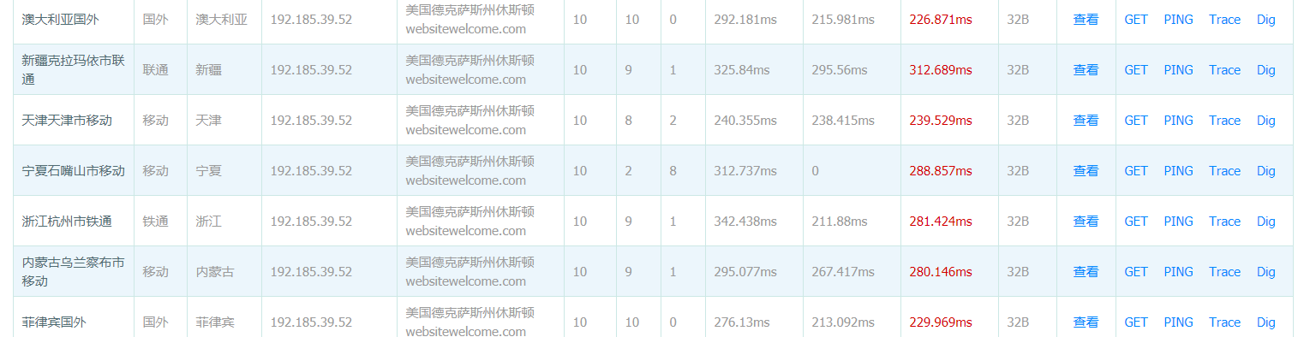

As shown in the figure, when Ping the website, the domain name resolution and website address are the same, and using the Ping tool on www.17ce.com, the resolution IP of the website is the same in different regions of the world, so the website does not use CDN service, so 192.185.39.52 is the real IP of tevelcyber.com
  - Collect sensitive catalog files
2.7 Host scan
2.7.1 Port scan
Use the auxiliary module of Metasploit for port scanning. First, search the available port scanning modules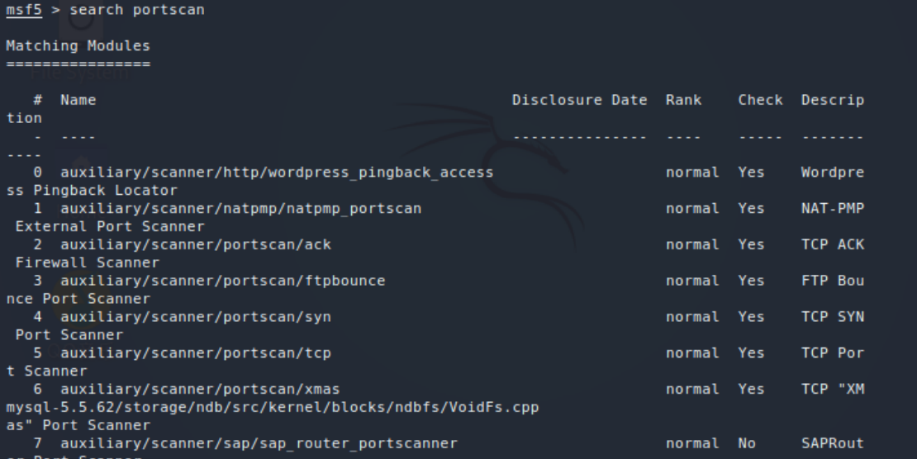
Use TCP scan here, which is 5, and check the configuration options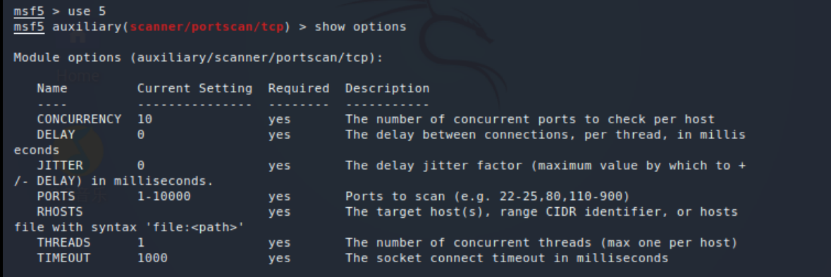
Set the scanning host address as the address of the target website 192.185.39.52, scan port 1-10000, and perform scanning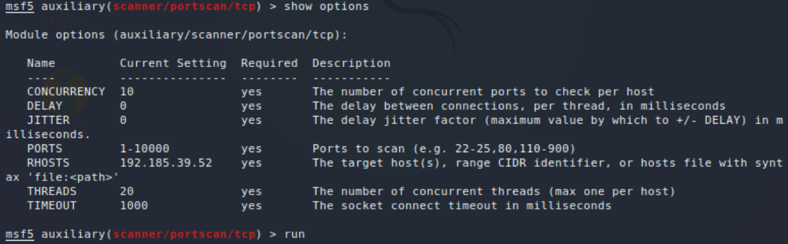
give the result as follows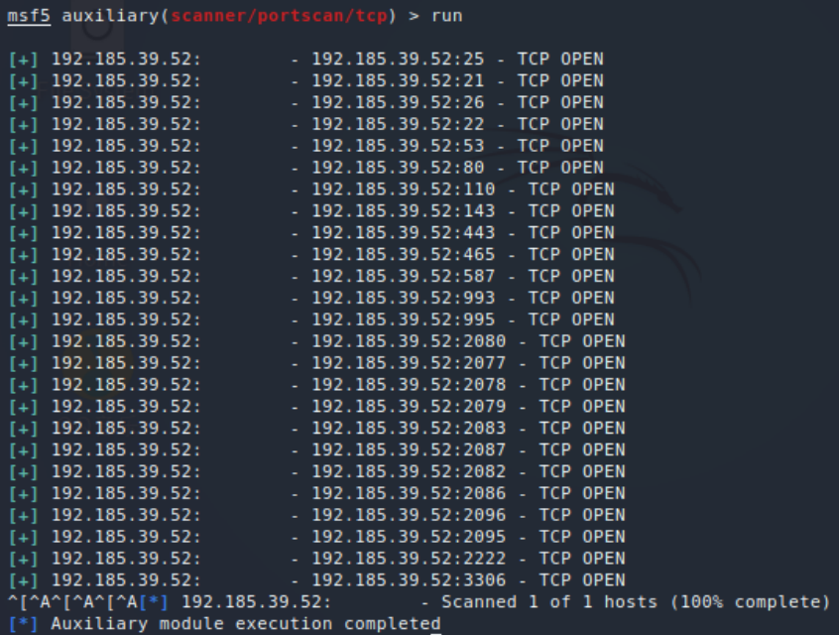
2.7.2 Service scan
2.7.3 Nmap scan
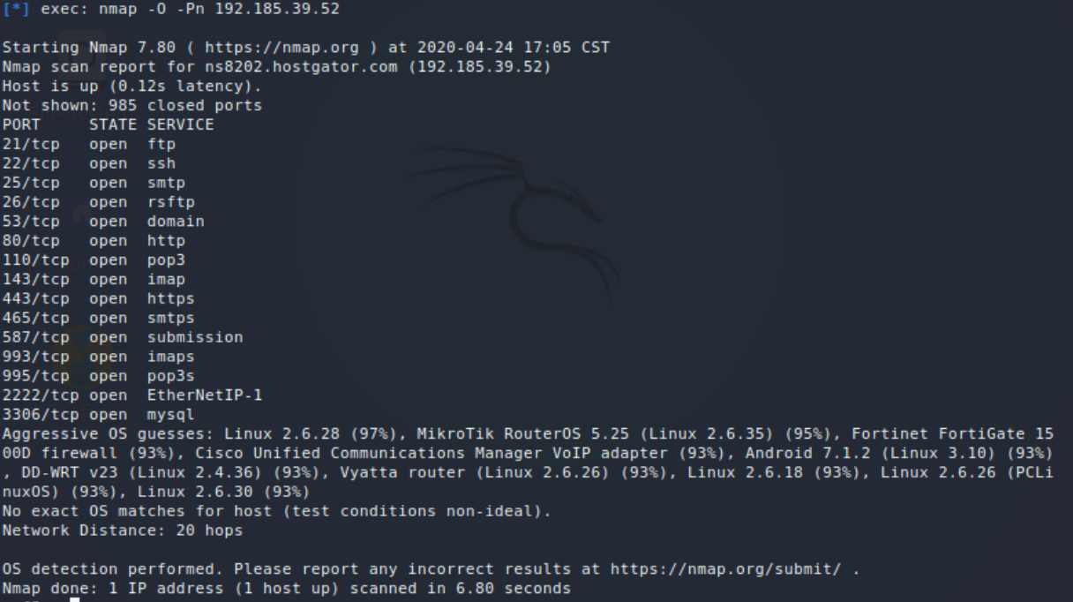

3. Scanning vulnerabilities
3.1 Use Nessus tool to scan the vulnerability of tevelcyber.com, and use the following tools 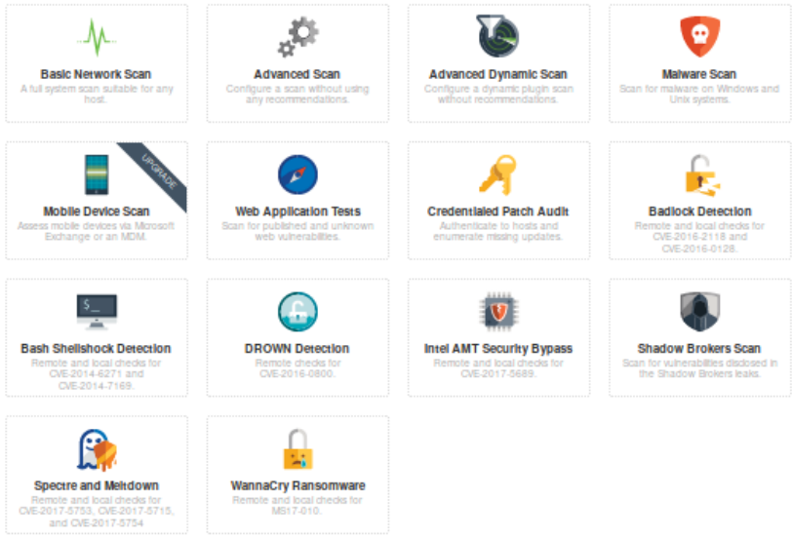
The scanning results of corresponding tools are as follows：
Web application tests: Scan for published and unknown web vulnerabilities

Basic network scan: A full system scan suitable for any host
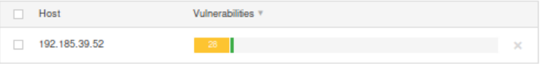
Badlock Detection: Remote and local checks for CVE-2016-2118 and CVE-2016-0128

Bash shellshock detection: Remote and local checks for CVE-2014-6271 and CVE-2014-7169
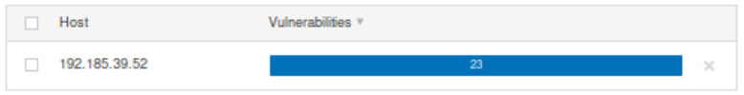
Intel AMT security by pass: Remote and local checks for CVE-2017-5689
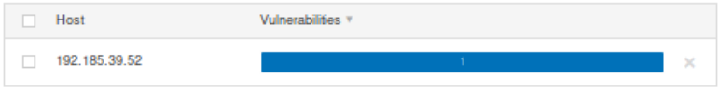
Spectre and meltdown: Remote and local checks for CVE-2017-5753,CVE-2017-5715 and CVE-2017-5754
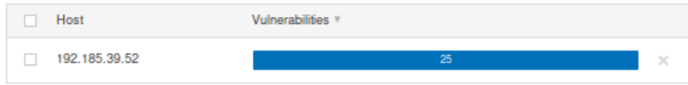
WannaCry ransomware: Remote and local checks for MS17-010
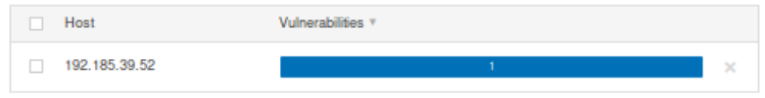
3.2 Use netsparker to scan the vulnerability of the website, and the results are as follows
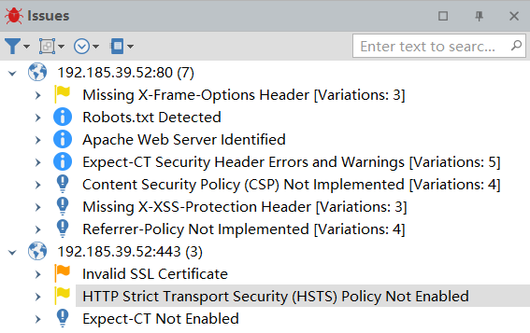

4. Vulnerabilities exploitation
The results of the exploitation are shown in the report

5. Write a report

Task2 Write a technical report of the Pentest

marking criteria and Student FEEDBACK

This section details the assessment criteria. The extent to which these are demonstrated by you determines your mark. The marks available for each criterion are shown. Lecturers will use the space provided to comment on the achievement of the task(s), including those areas in which you have performed well and areas that would benefit from development/improvement.

Common Assessment Criteria Applied (Assignment 1) | Marks available | Marks  awarded
1. Engagement with Literature Skills
Extent of research and/or own reading, selection of credible sources, application of appropriate referencing conventions.
You have covered the key concepts within your research aspect and focus on security measures. However, a number of areas lack referencing. More current and diverse peer reviewed sources need to be utilised. (Grade mark: 77.78%) | 45 | 35
2. Knowledge and Understanding Skills
Extent of knowledge and understanding of concepts and underlying principles associated with the discipline.
3. Cognitive and Intellectual Skills
Analysis, evaluation and synthesis; logic, argument and judgement; analytical reflection; organisation of ideas and evidence
You have demonstrated critical analysis of the research areas. You have discuss security and privacy issues. Good analysis linking attacks statistics to your country (China) . Conclusion was done in this section. (Grade mark: 84.44%) | 45 | 38
4. Practical Application Skills
Deployment of methods, materials, tools and techniques; application of concepts; formulation of innovative and creative solutions to solve problems.
5. Transferable Skills for Life and Professional Practice
Attributes in professional practice: individual and collaborative working; deployment of appropriate media; presentation and organisation.
Your work could do with some formatting alignment (justified). You had no cover page. No introduction. Your paragraphs are very long, try to start new arguments as a new paragraph. (Grade mark: 55.00%) | 10 | 5.5

Assignment Mark (Assessment marks are subject to ratification at the Exam Board. These comments and marks are to give feedback on module work and are for guidance only until they are confirmed. ) | Late Submission Penalties (tick if appropriate) |  | 79%
 | Up to four weeks late |  | 79%
 | First Attempt? |  | 79%

marking criteria and Student FEEDBACK

This section details the assessment criteria. The extent to which these are demonstrated by you determines your mark. The marks available for each criterion are shown. Lecturers will use the space provided to comment on the achievement of the task(s), including those areas in which you have performed well and areas that would benefit from development/improvement.

Common Assessment Criteria Applied (Assignment 2) | Marks available | Marks  awarded
1. Engagement with Literature Skills
Extent of research and/or own reading, selection of credible sources, application of appropriate referencing conventions.
2. Knowledge and Understanding Skills
Extent of knowledge and understanding of concepts and underlying principles associated with the discipline.
You have demonstrated understanding of the penetration testing and explained the methods and tools for conducting the black boxes testing on the live site. (Grade mark: 85.00%) | 20 | 17
3. Cognitive and Intellectual Skills
Analysis, evaluation and synthesis; logic, argument and judgement; analytical reflection; organisation of ideas and evidence
This section did not have a conclusion. You have discussed: The configuration changes that could be made to the site and defence strategy. You have analyse cost solutions and you have done timetable for the execution of solutions. You have done an analysis of the findings. (Grade mark: 85.00%) | 20 | 17
4. Practical Application Skills
Deployment of methods, materials, tools and techniques; application of concepts; formulation of innovative and creative solutions to solve problems.
You have discuss application of the methods, tools and technique used to carry out all your tests. Documentation of the tests were done and you have done a Pentest report. (Grade mark: 91.67%) | 60 | 55
5. Transferable Skills for Life and Professional Practice
Attributes in professional practice: individual and collaborative working; deployment of appropriate media; presentation and organisation.

Assignment Mark (Assessment marks are subject to ratification at the Exam Board. These comments and marks are to give feedback on module work and are for guidance only until they are confirmed. ) | Late Submission Penalties (tick if appropriate) |  | 89%
 | Up to four weeks late |  | 89%
 | First Attempt? |  | 89%

